Practical - 1

Practical Title: Project Initiation, Requirement Analysis, Sitemap, Wireframe, and GitHub Setup
Problem Definition: Initiate the semester-long StudentHub portal by identifying the problem scope, user roles, key modules, navigation flow, and minimum 10 pages. Create a sitemap, low-fidelity wireframe, project folder structure, README file, and GitHub repository.

Theory
  - What is URL and parts of URL?
Answer: URL (Uniform Resource Locator) is the address of a webpage or file on the internet.

Parts of a URL:

    - Protocol – Tells the browser how to access the website.
    - Domain Name – The name of the website.
    - Path – Shows the specific page or file.

  - How does HTML file process in web browser? Answer:
    - User enters the URL.
    - DNS converts the domain name into an IP address.
    - Browser sends a request to the server.
    - Server sends HTML file.
    - Browser reads HTML file.
    - Browser loads CSS, JavaScript, and images.
    - Browser displays the webpage.

  - How will page navigation flow managed among all HTML pages?
Answer: Page navigation is managed using links (<a> tags) inside navigation tag (<nav>). When a user clicks a link, the browser opens the linked HTML page.

  - How will GitHub commits be maintained after each practical?
Answer: After completing each practical, save all files, commit the changes with a meaningful message, and push them to the GitHub repository.

- Implementation/ Output/Result (Keep only one option which is suitable to practical)
Here you can add your learning code/tags/style etc. Not required in wireframe

Evidence of Work (Screenshots)
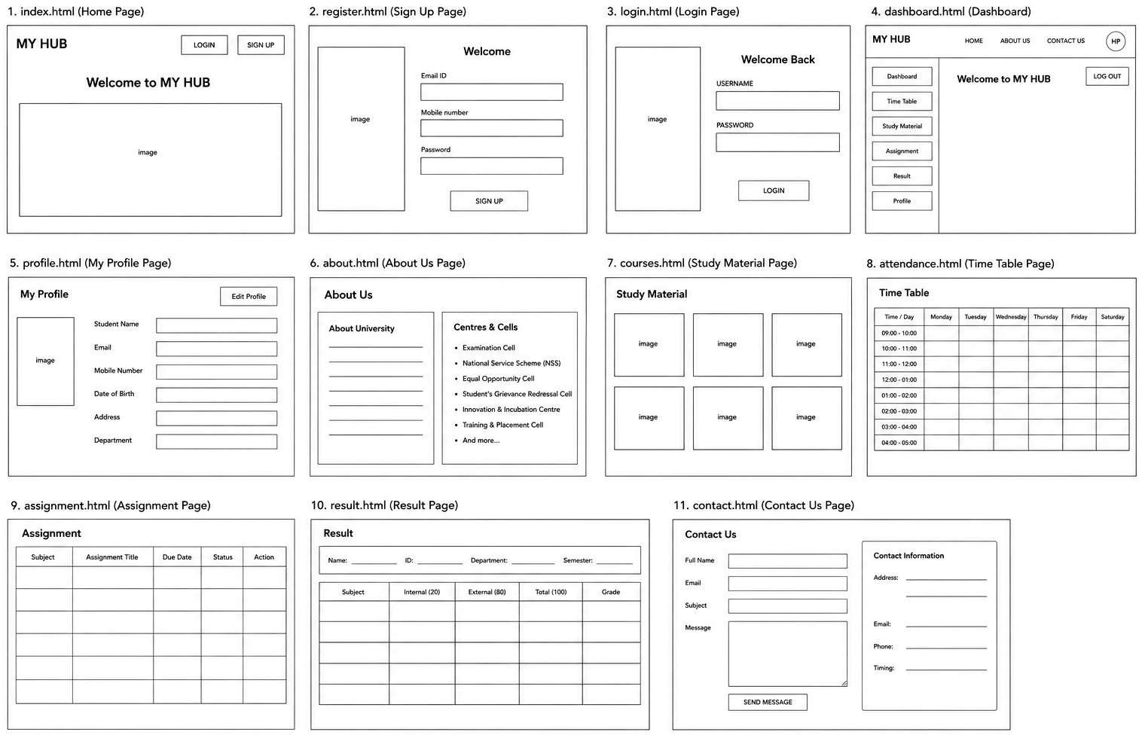

The wireframe is a simple blueprint of the Student Hub website. It shows the layout of all pages and helps plan the design, navigation, and content before development.

GitHub Repository Link:
https://github.com/hkxii/StudentHub-Portal

Challenges Faced:

I faced some challenges in planning the page layout, organizing the content, and connecting all pages properly. I solved them by improving the design step by step.

Learning Outcomes:
I learned how to create a wireframe, organize web pages, plan website navigation, and prepare the layout before starting website development.

Faculty Remarks: (Keep this blank for faculty)

