Practical - 10

Practical Title : Login/Logout with Sessions, Role-Based Access, Timeout, and Remember-Me Token
Problem Definition: Develop secure login and logout functionality using PHP sessions. Verify password using password_verify(), regenerate session ID after login, restrict dashboard access, implement role-based redirection, session timeout, and optional secure remember-me token.
Theory

Are sessions started and destroyed securely?
Answer: Sessions are started securely using session_start() and destroyed properly during logout.
- Is password_verify() used correctly?
Answer: password_verify() is used to verify the entered password against the stored hashed password.

Is unauthorized dashboard access blocked?
Answer: Unauthorized dashboard access is blocked using session authentication checks.

Is session timeout implemented?
Answer: Session timeout is implemented to automatically log out inactive users.
- Are admin and student users redirected to appropriate dashboards? Answer: Admin and student users are redirected to their respective dashboards based on their roles.

Implementation :
- Started secure PHP sessions using session_start().
- Verified passwords using password_verify().
- Regenerated the session ID after successful login using session_regenerate_id.
- Restricted dashboard access using session authentication checks.
- Implemented session timeout to automatically log out inactive users.
- Added role-based redirection for admin and student dashboards.
- Destroyed the session and logged out the user securely.

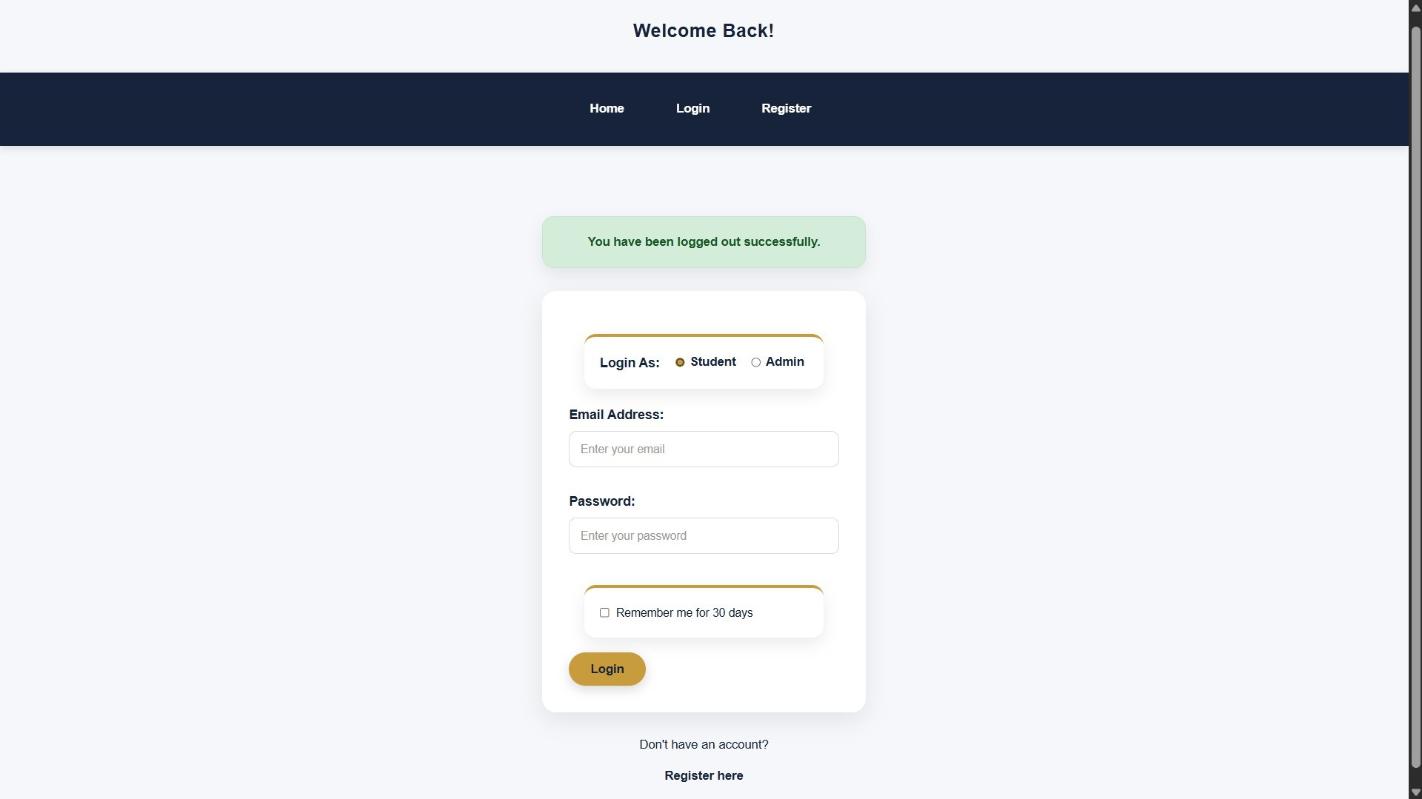
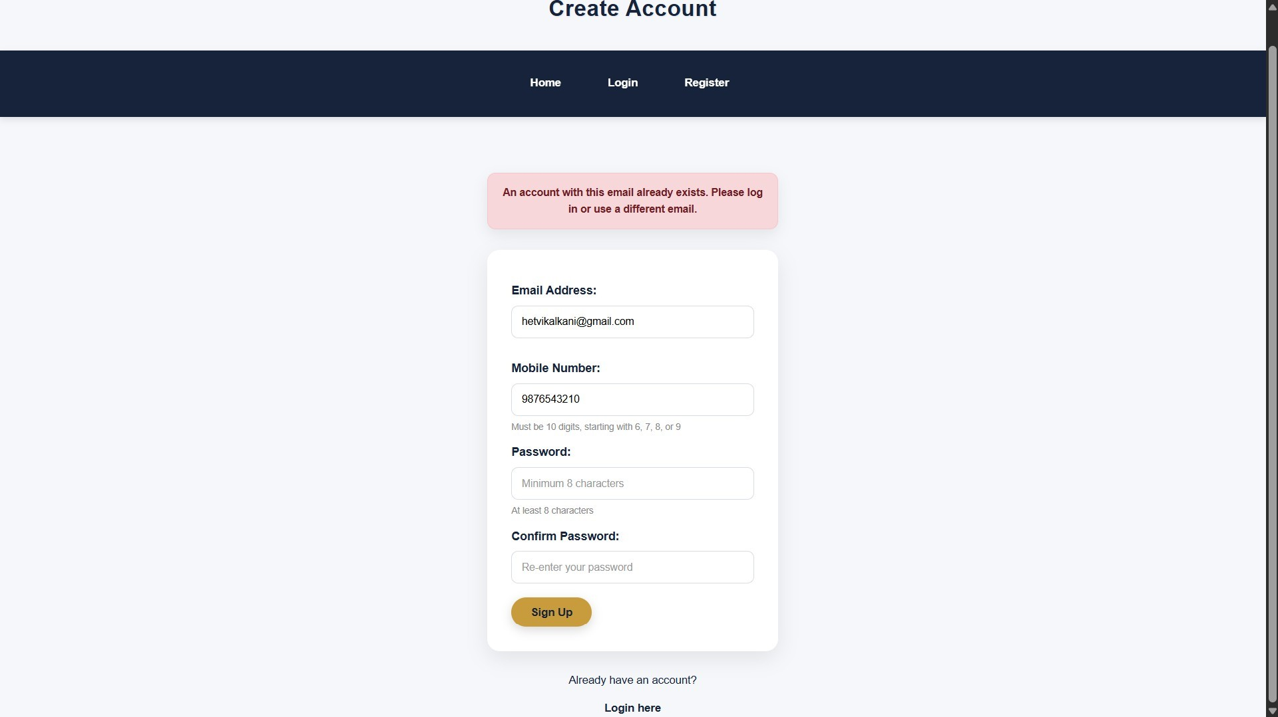
Evidence of Work (Screenshots)

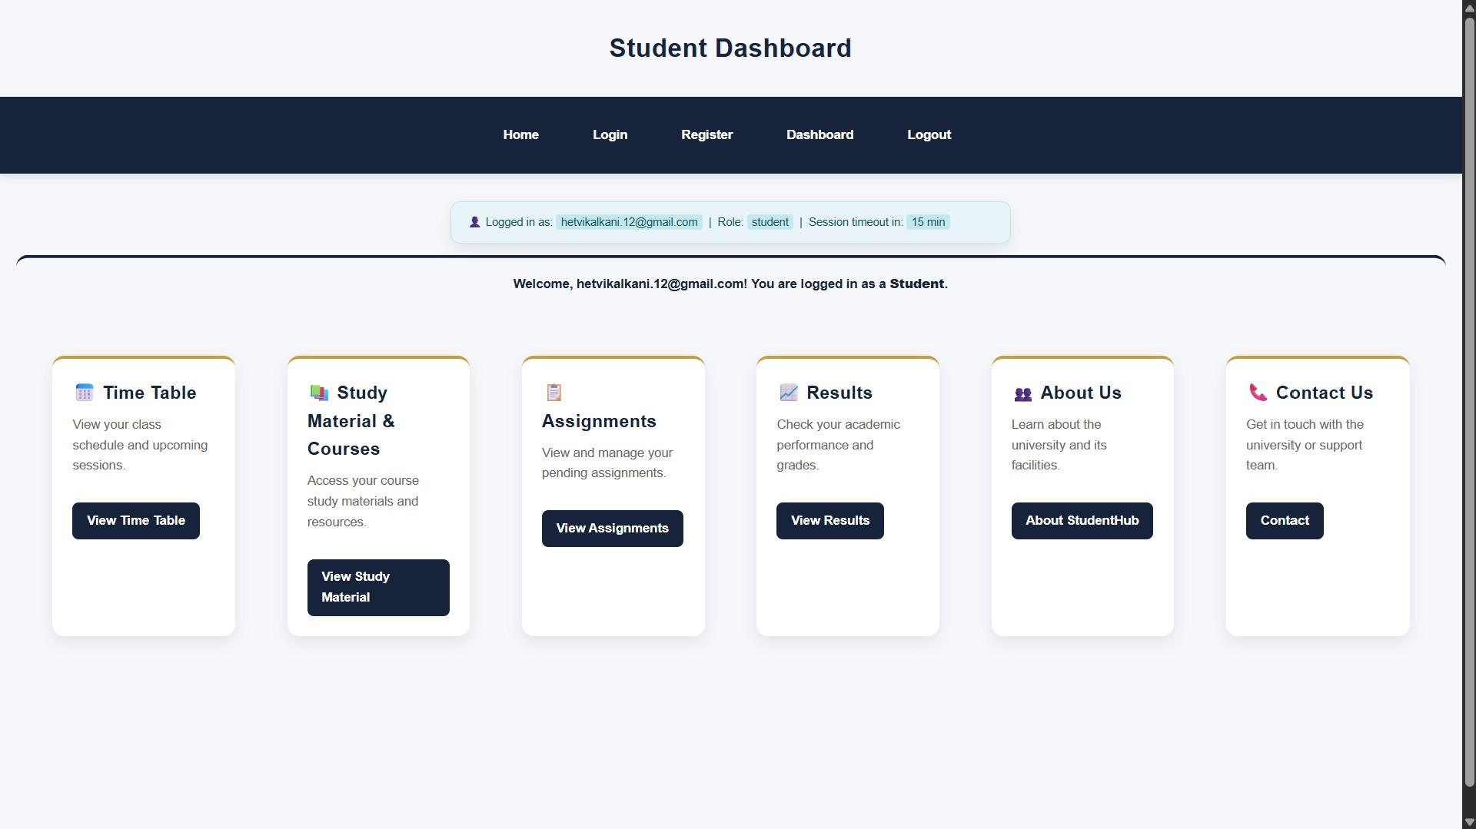
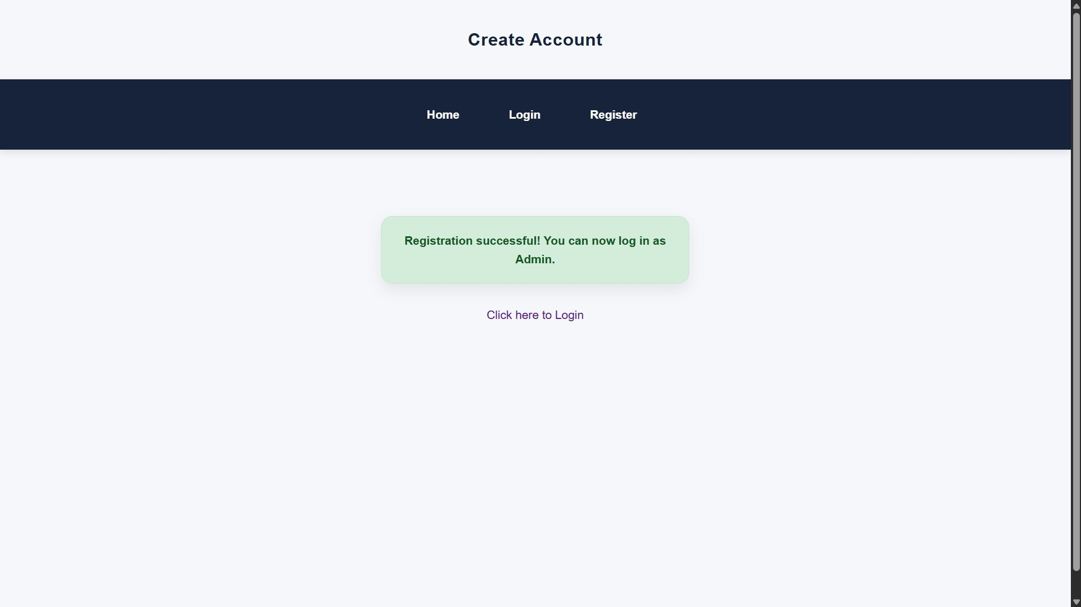

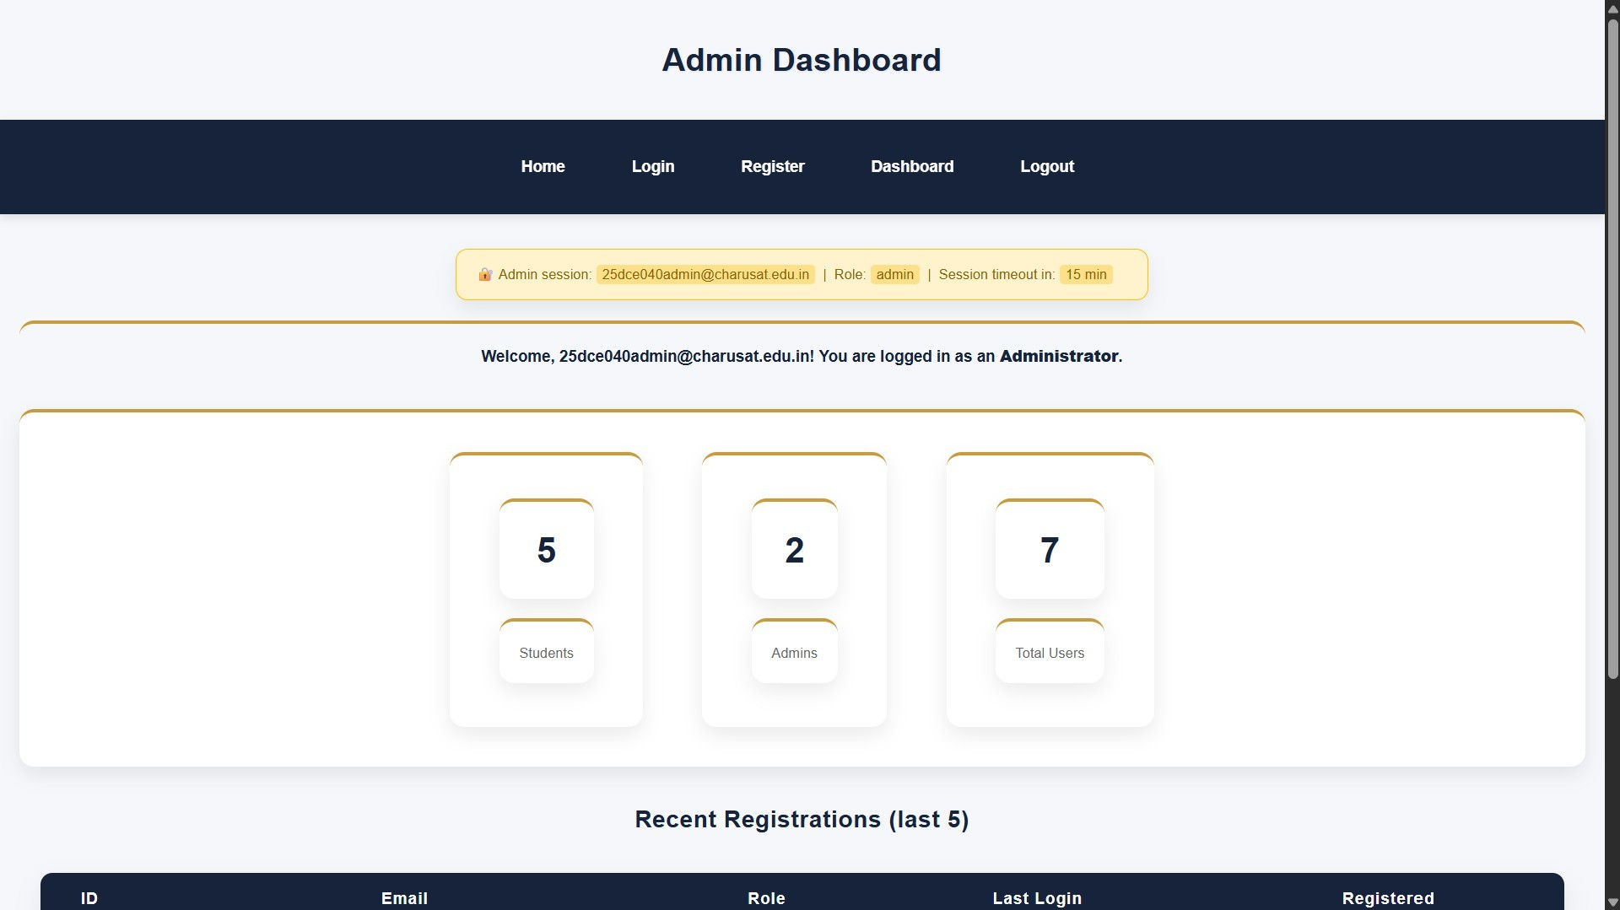
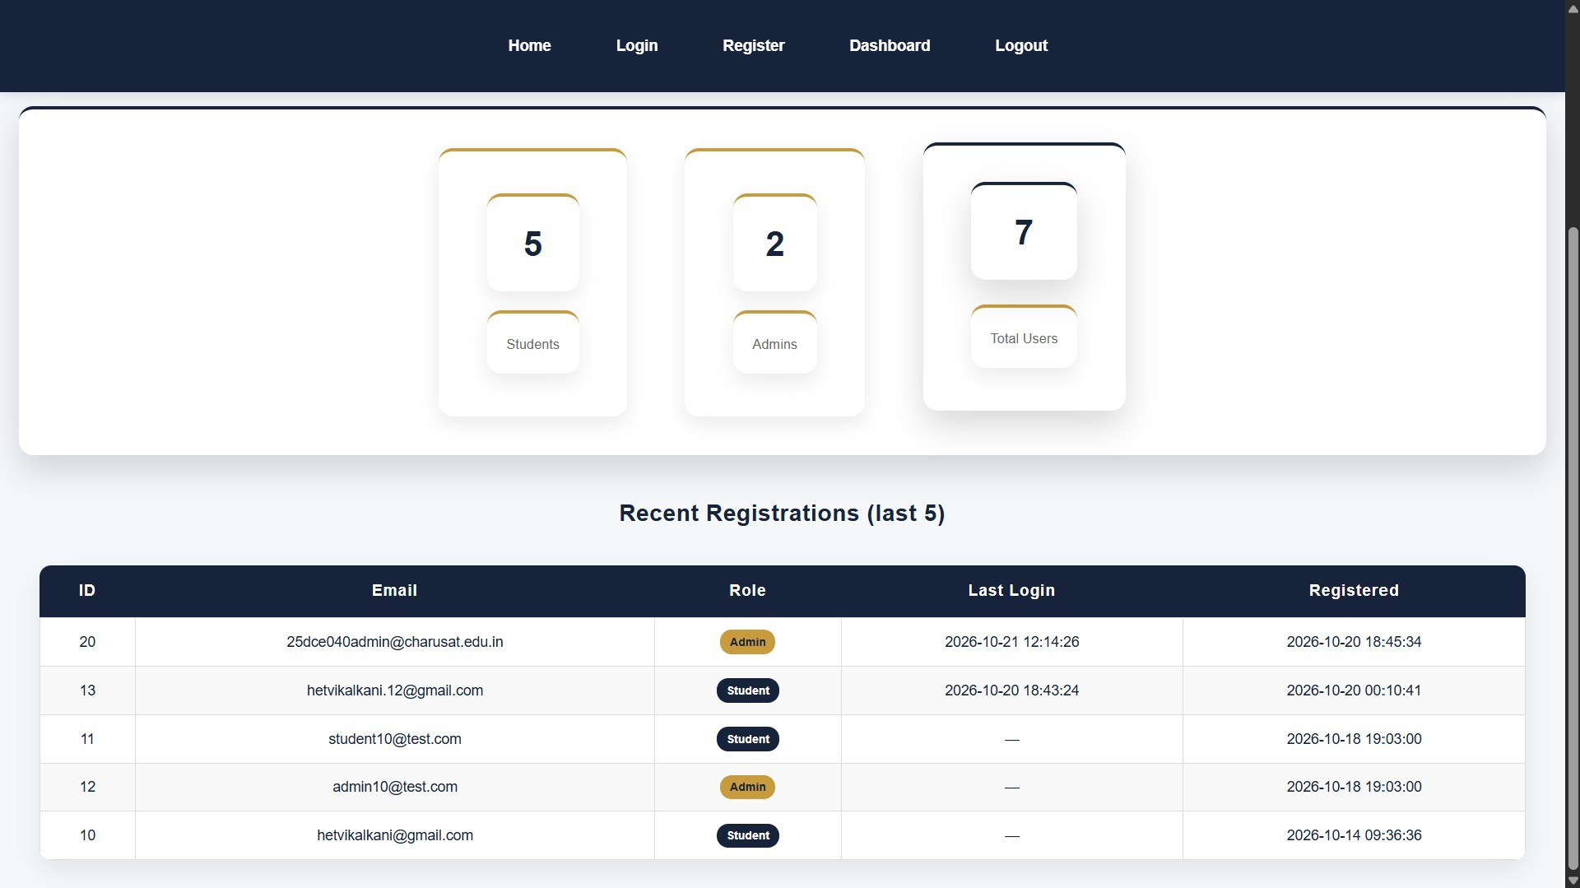

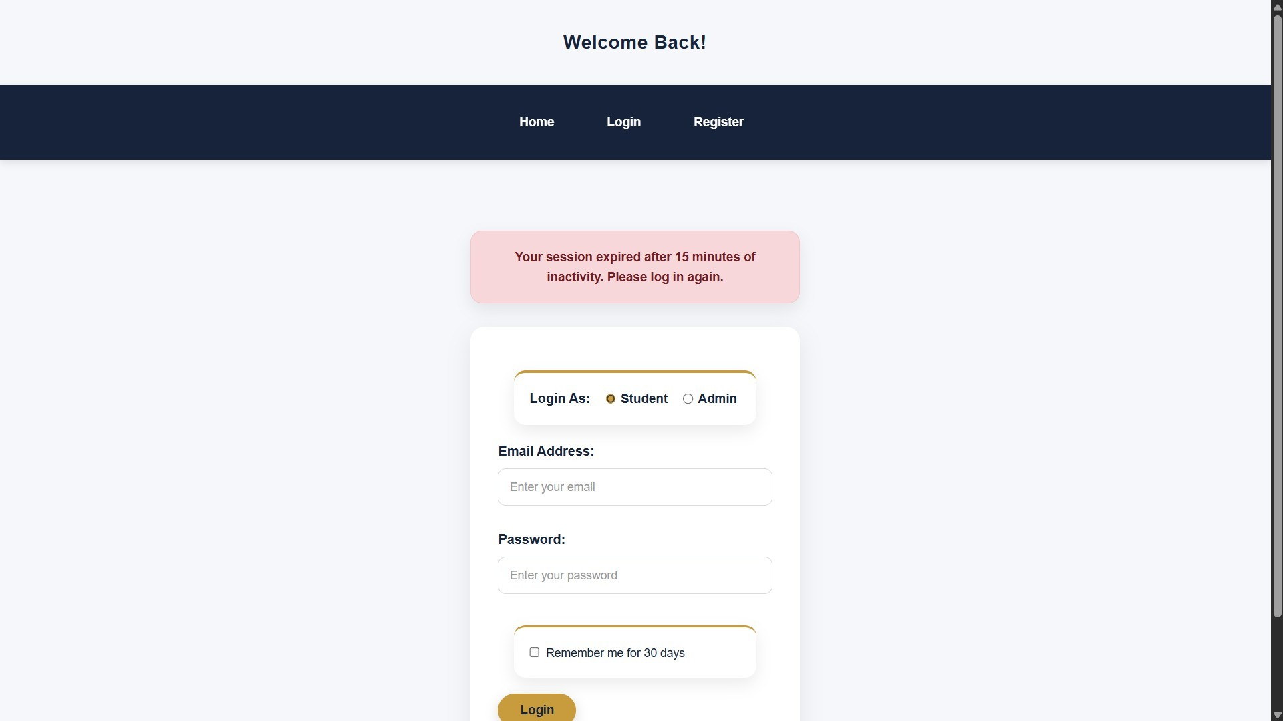
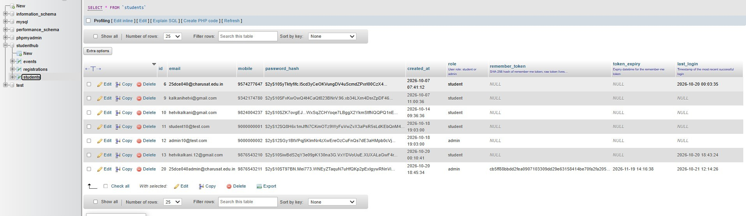

GitHub Repository Link:
https://github.com/Hetvi-K12/StudentHub-Portal/tree/main/Practical10

Challenges Faced:
  - Managing PHP sessions securely during login and logout.
  - Verifying hashed passwords correctly using password_verify().
  - Preventing unauthorized users from accessing the dashboard.
  - Implementing session timeout for inactive users.

Learning Outcomes:
  - Learned to implement secure login and logout using PHP sessions.

  - Understood password verification using password_verify().
  - Learned to protect dashboards from unauthorized access.
  - Understood how to implement session timeout for inactive users.

Faculty Remarks:

