Practical - 11

Practical Title : Student Management CRUD with Search and Filter
Problem Definition: Create a student management module to add, view, edit, delete, search and filter student records. All database operations must use MYSQLi statements and clear success/failure messages.

Theory
- Are SELECT, INSERT, UPDATE, and DELETE operations working? Answer: SELECT, INSERT, UPDATE, and DELETE operations are implemented to manage student records in the database.

Is search by name/email/course implemented?
Answer: Search functionality is implemented to find records by name, email, or course.

Are delete operations confirmed before execution?
Answer: Delete operations require user confirmation before permanently removing a record.

Implementation :

- Implemented SELECT to display student records from the MySQL database.
- Used INSERT to add new student records.
- Used UPDATE to modify existing student details.
- Used DELETE to remove student records from the database.
- Added search functionality to find students by name, email, or course.
- Added a confirmation message before deleting any student record.


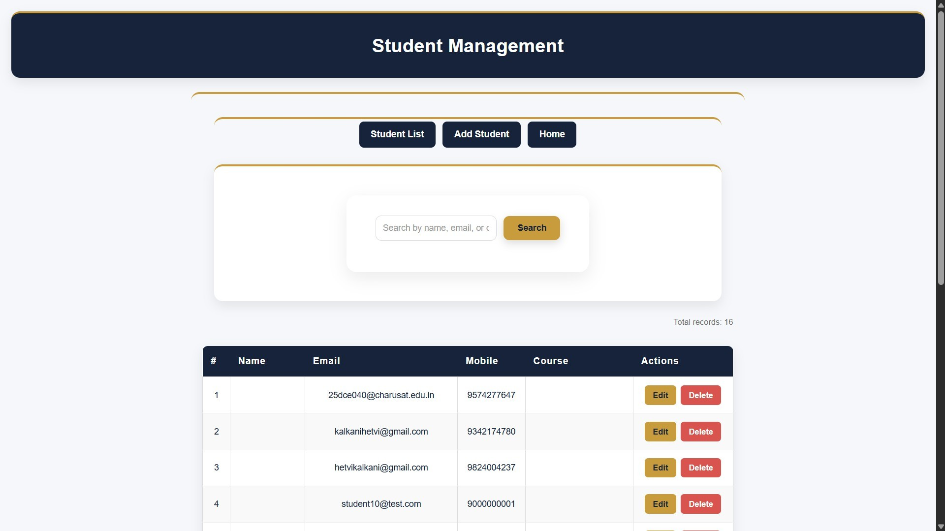
Evidence of Work (Screenshots)

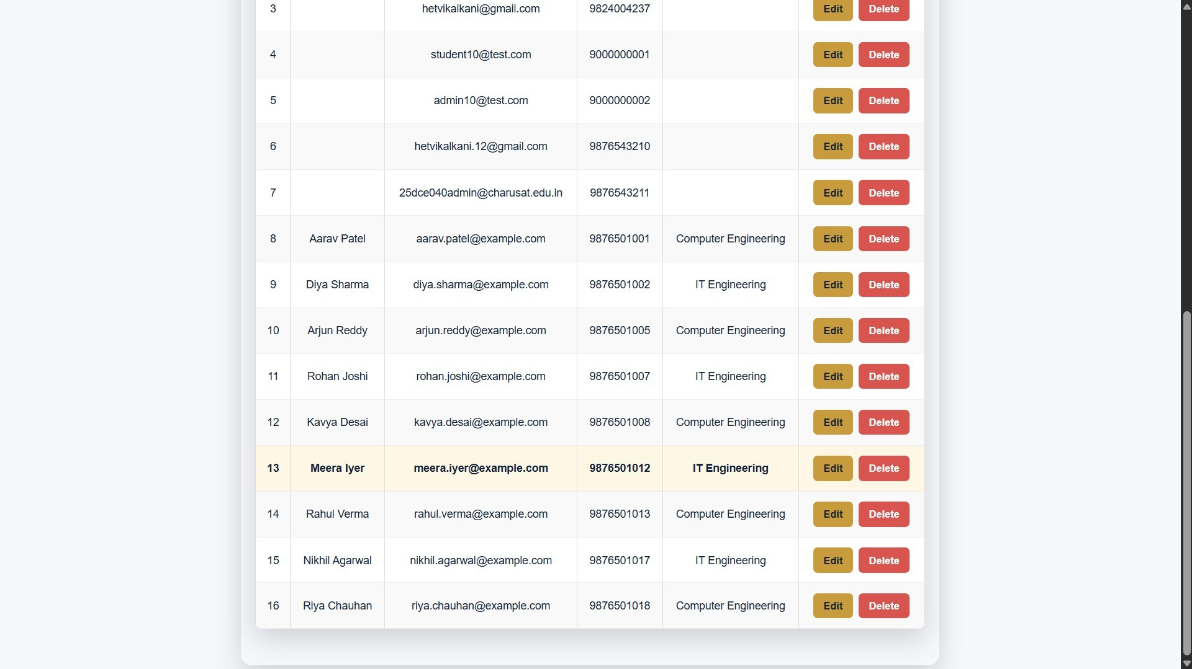
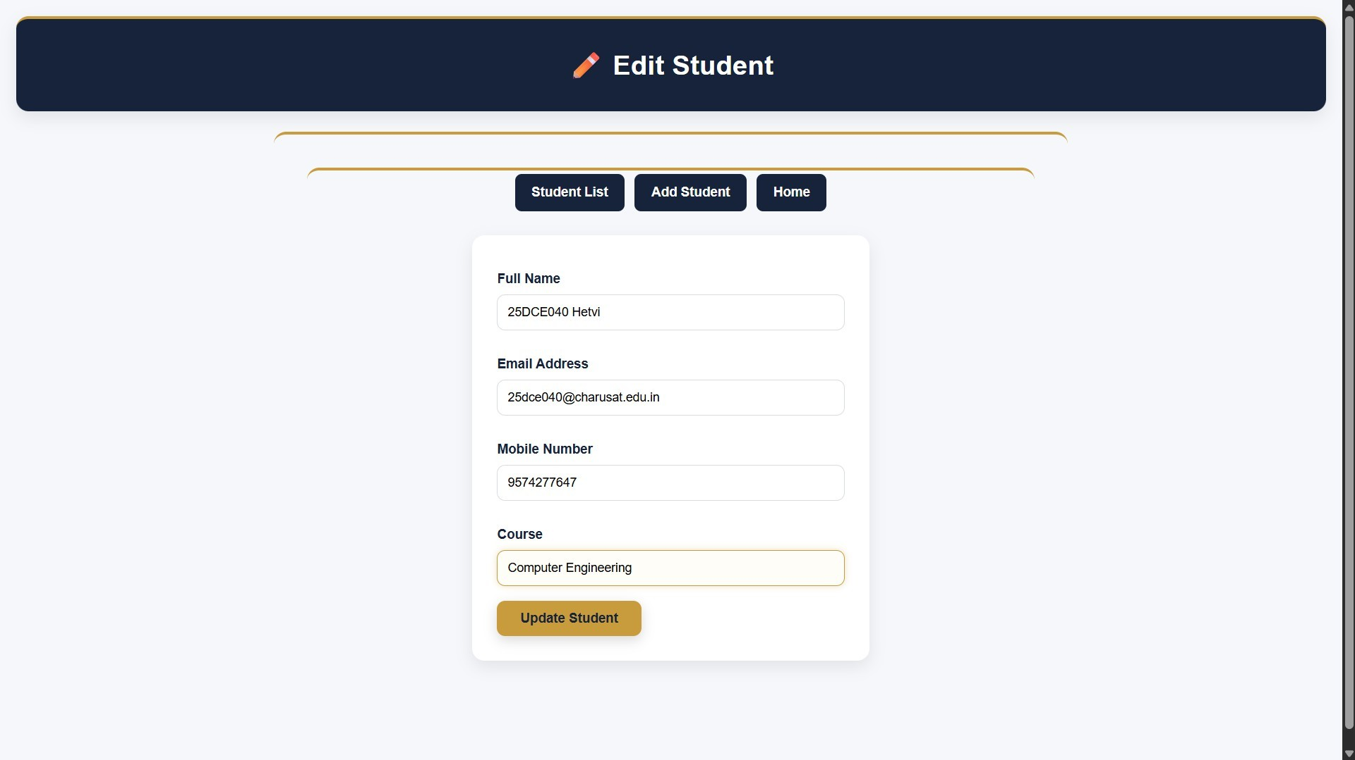

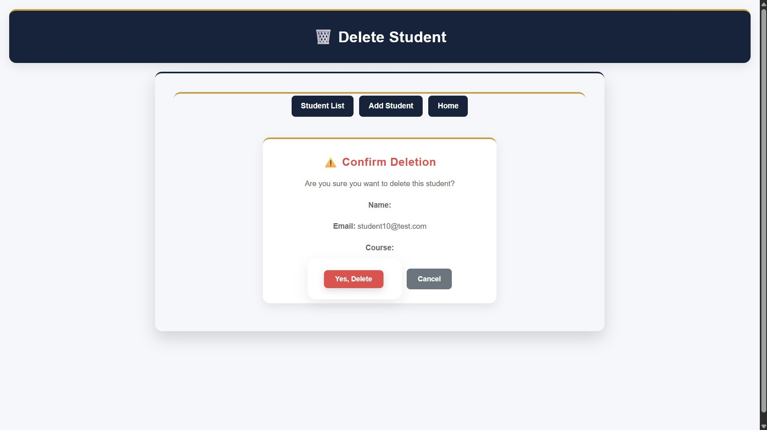
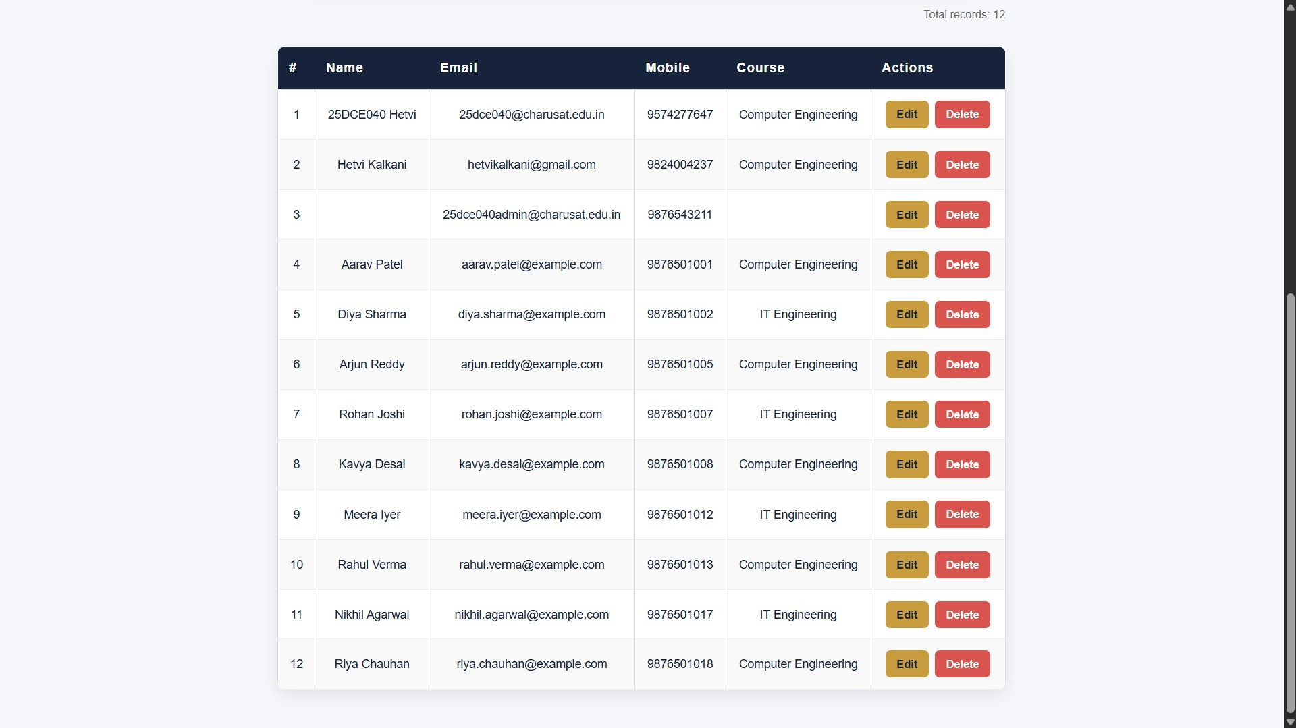

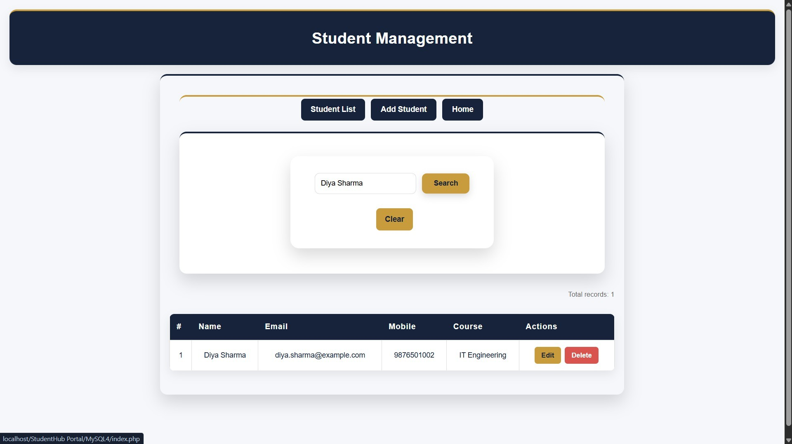
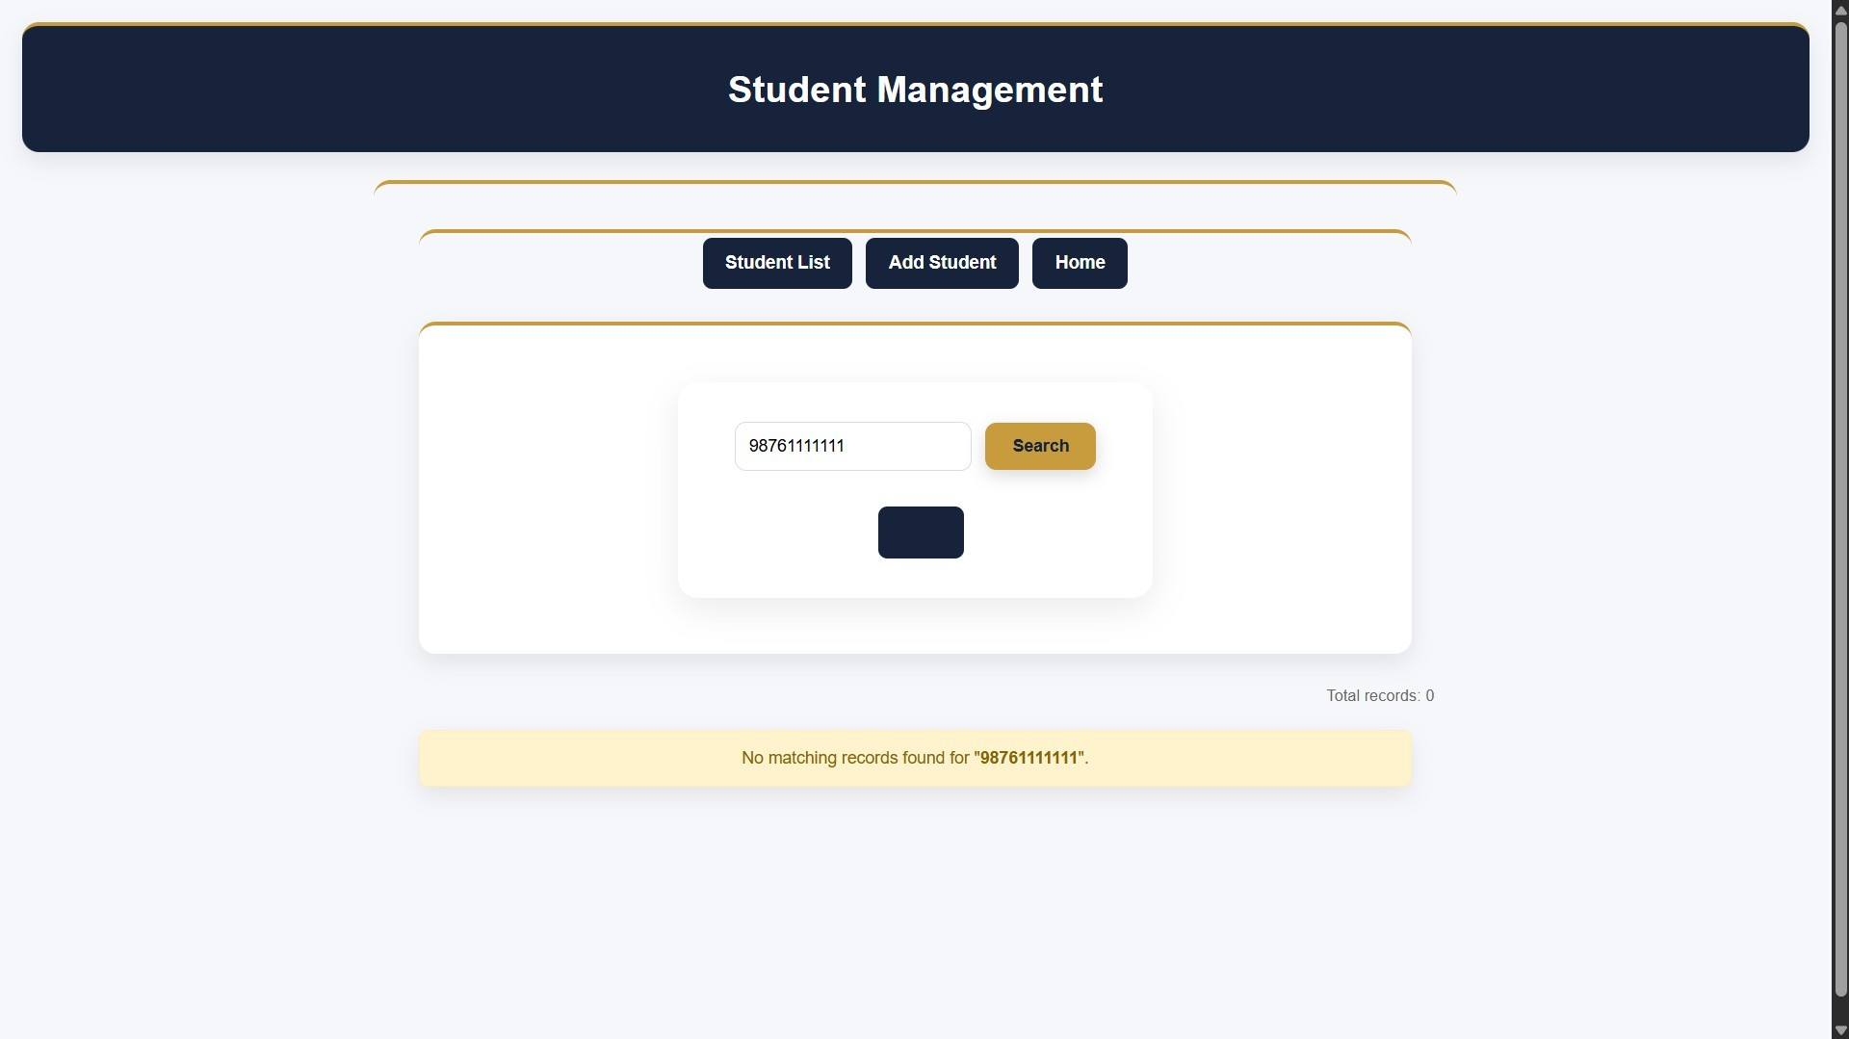

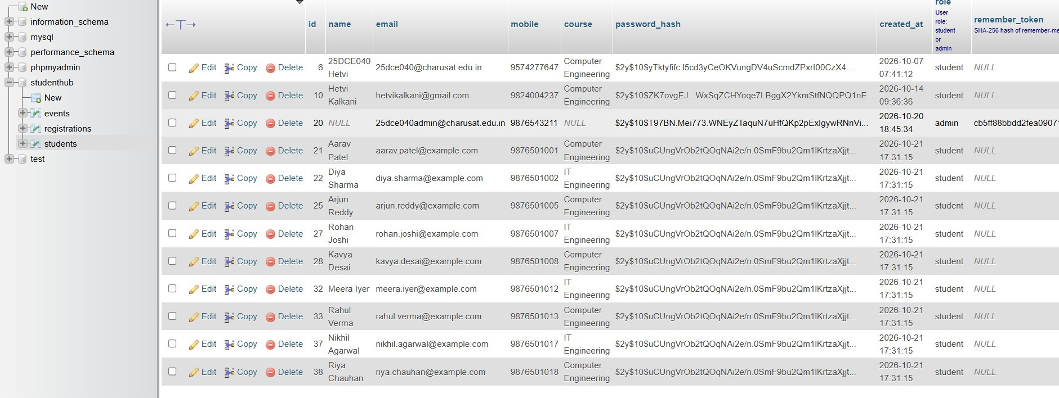

GitHub Repository Link:
https://github.com/Hetvi-K12/StudentHub-Portal/tree/main/Practical11

Challenges Faced:

  - Establishing a proper connection between PHP and the MySQL database.
  - Implementing SELECT, INSERT, UPDATE, and DELETE operations correctly.
  - Developing search functionality for name, email, and course.
  - Handling user input and validating student records.
  - Adding delete confirmation to prevent accidental data loss.

Learning Outcomes:

  - Learned to perform CRUD operations using PHP and MySQL.
  - Understood how to insert, retrieve, update, and delete student records.
  - Learned to implement search functionality by name, email, and course.
  - Gained knowledge of input validation and database management.
  - Understood how to use delete confirmation to prevent accidental data loss.

Faculty Remarks:

