Practical - 12

Practical Title : Event Management CRUD with Poster Upload and File Validation
Problem Definition: Develop event management functionality for admin users. Admin can add, view, update, delete, and upload event posters with file type and file size validation.
Theory
- Are add, update, and delete functionalities implemented correctly? Answer: Add, update, and delete functionalities are implemented to manage event records.

Is the UI linked with the database correctly?
Answer: The UI is connected to the MySQL database using PHP.

Are poster uploads validated for type and size?
Answer: Poster uploads are validated for file type and size.

Are success and failure messages displayed?
Answer: Appropriate success and failure messages are displayed for each operation.

Implementation :

- Implemented add, update, and delete functionalities to manage event details.
- Connected the user interface to the MySQL database using PHP.
- Added poster upload validation to check file type and size.
- Displayed success messages after successful operations.
- Displayed error messages when an operation fails or invalid data is entered.

Evidence of Work (Screenshots)

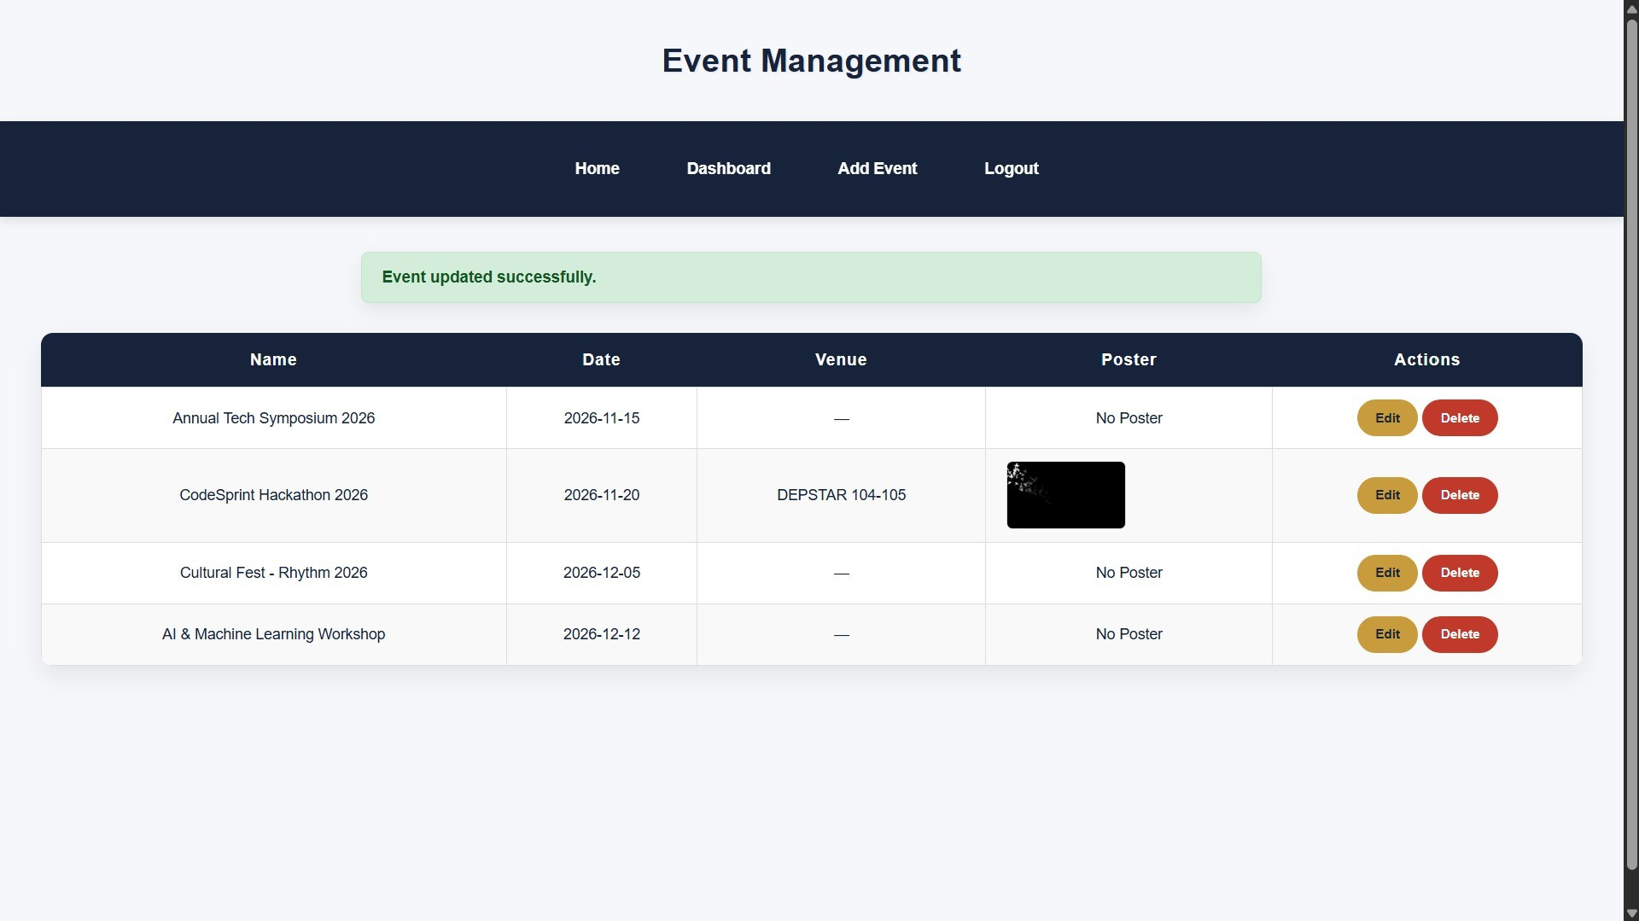
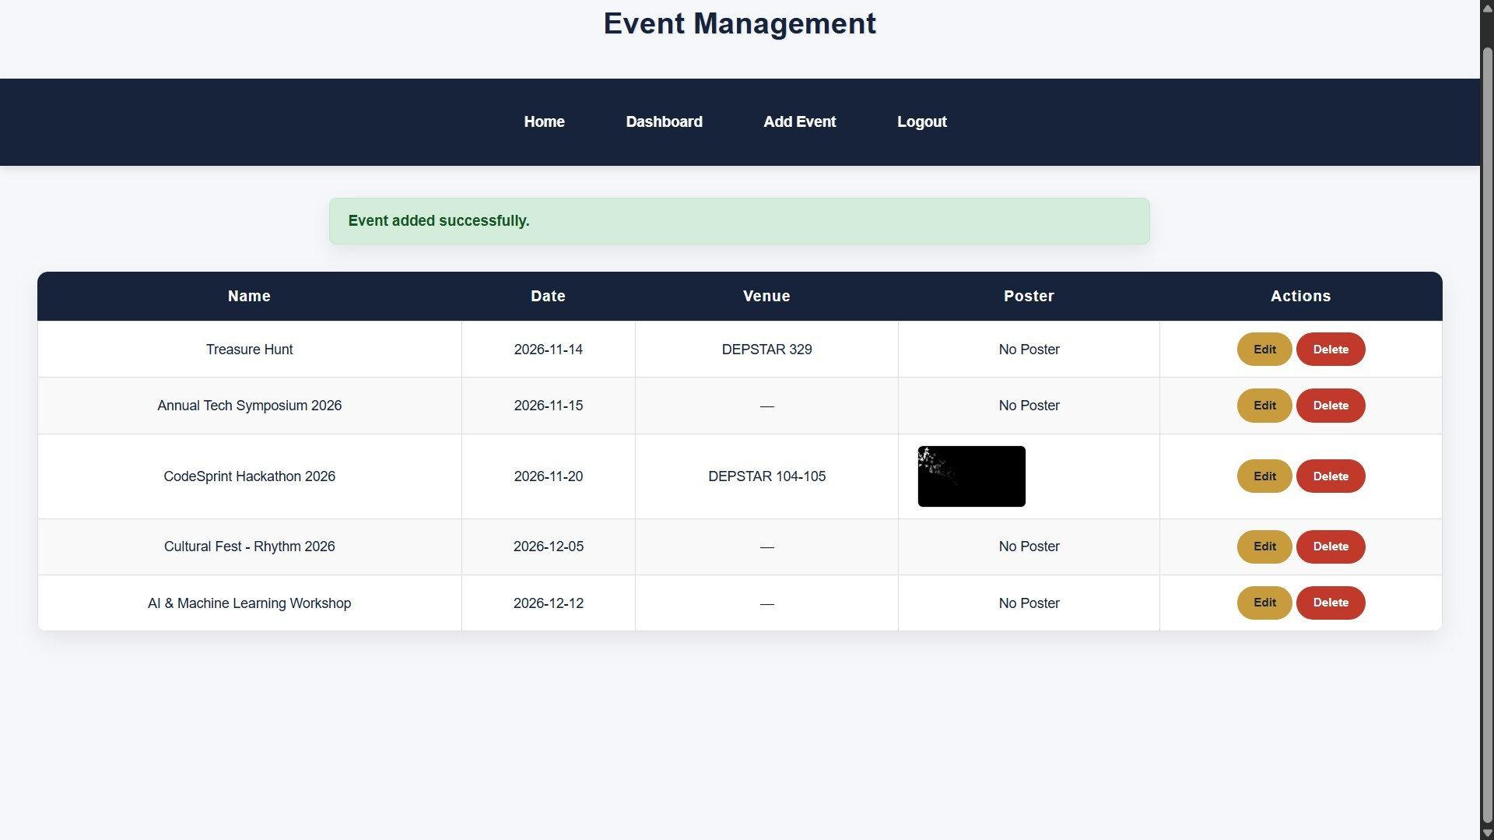
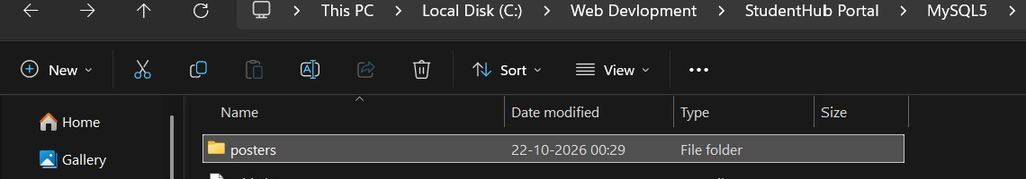

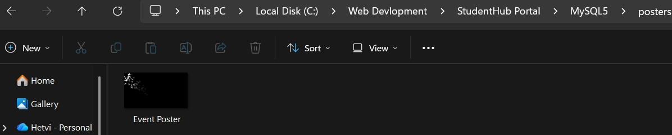
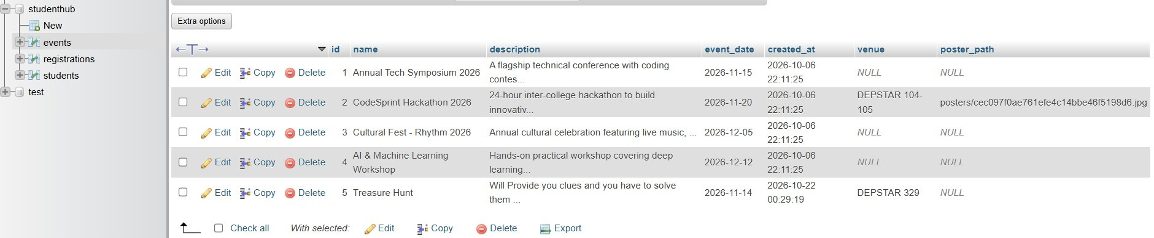

GitHub Repository Link:
https://github.com/Hetvi-K12/StudentHub-Portal/tree/main/Practical12

Challenges Faced:

  - Connecting the event management UI with the MySQL database.
  - Implementing add, update, and delete operations correctly.
  - Validating poster file types and sizes during uploads.
  - Handling file upload errors and database operation failures.
  - Displaying appropriate success and error messages to users.

Learning Outcomes:

  - Learned to implement CRUD operations for event management.
  - Understood how to connect the UI with a MySQL database using PHP.
  - Learned to validate poster uploads based on file type and size.
  - Gained experience in handling errors and displaying success messages.
  - Improved understanding of database management and file upload security.

Faculty Remarks:

