Practical - 13

Practical Title : PHP JSON API and AJAX/Fetch-Based CRUD without Page Reload
Problem Definition: Create simple PHP JSON API endpoints for events or students and consume them using Fetch API. Perform list, add, update, and delete operations asynchronously without full page reload.
Theory

Do PHP endpoints return valid JSON responses?
Answer: PHP endpoints return valid JSON responses for successful and failed requests.

Are GET and POST requests handled properly?
Answer: GET and POST requests are handled properly to retrieve and submit data.

- Are loading, success, and error states shown on the frontend? Answer: Loading, success, and error messages are displayed on the frontend.

- Is input validation performed before database operations? Answer: Input validation is performed before executing database operations to ensure data accuracy and security.

Implementation :

- Created PHP endpoints to return valid JSON responses.
- Handled GET requests to retrieve data and POST requests to submit data.
- Added loading indicators and success and error messages on the frontend.
- Implemented input validation before performing database operations.
- Connected the frontend with PHP endpoints to exchange data dynamically.

Evidence of Work (Screenshots)

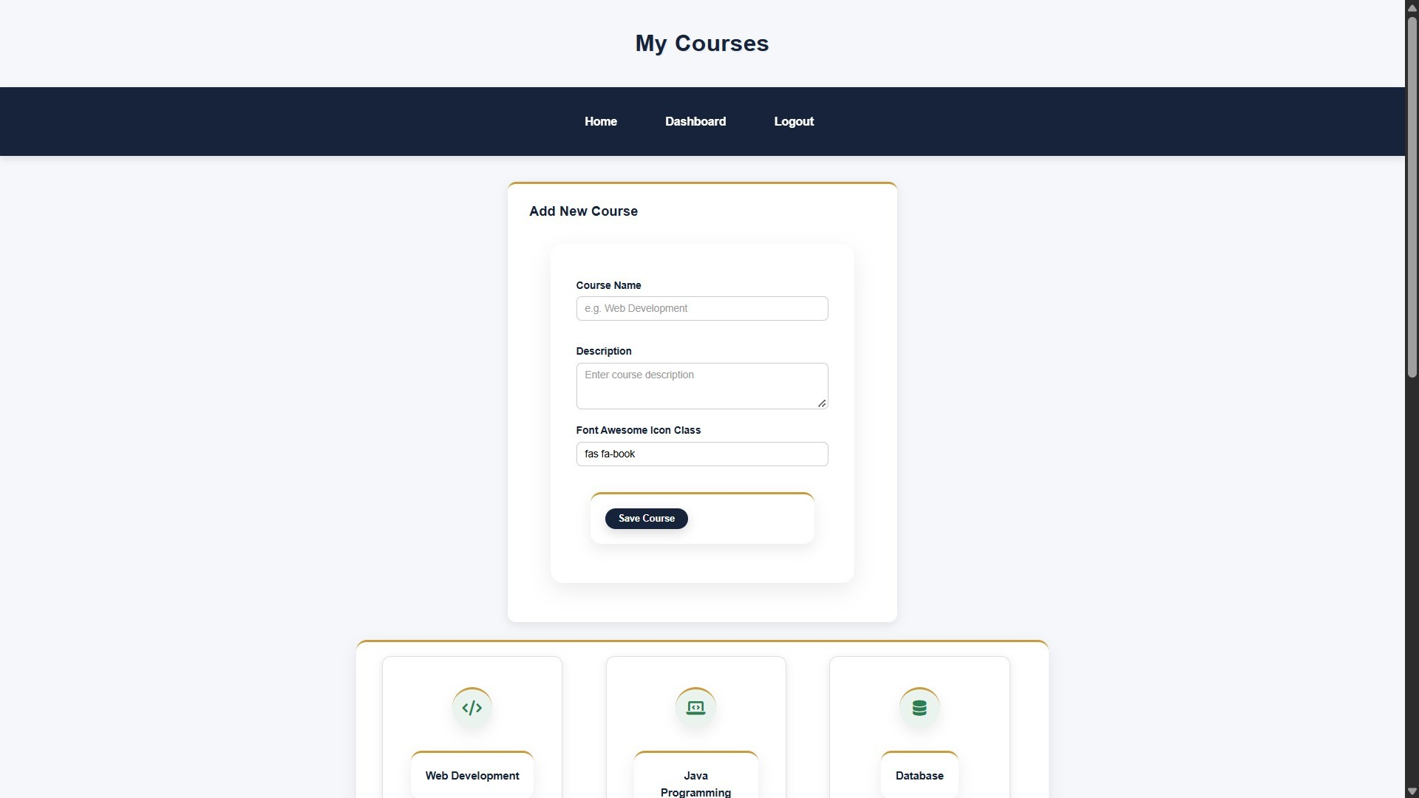

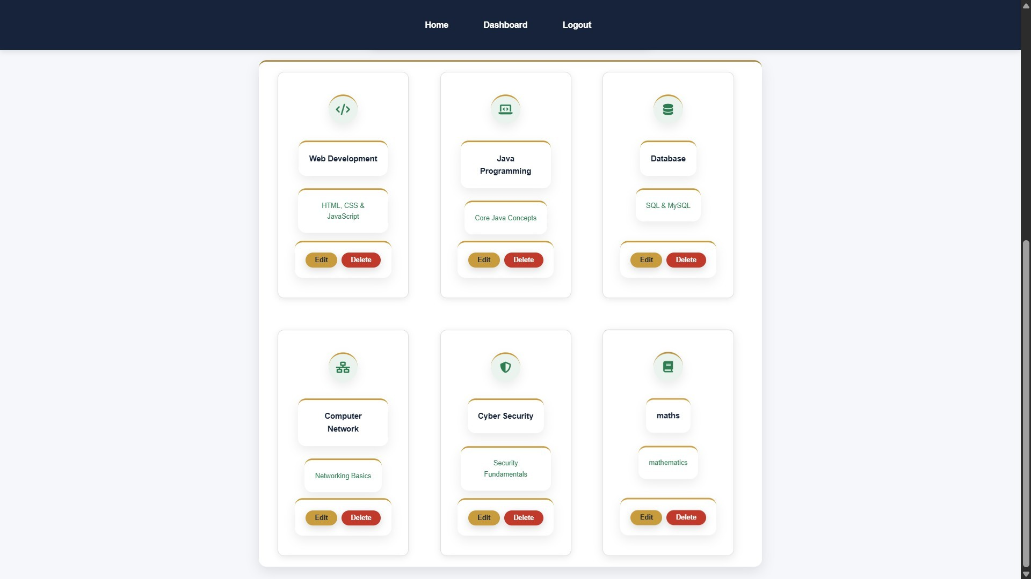

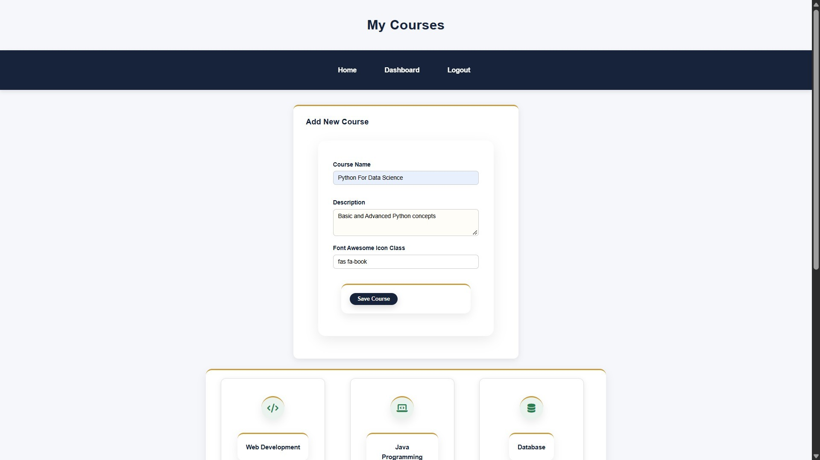
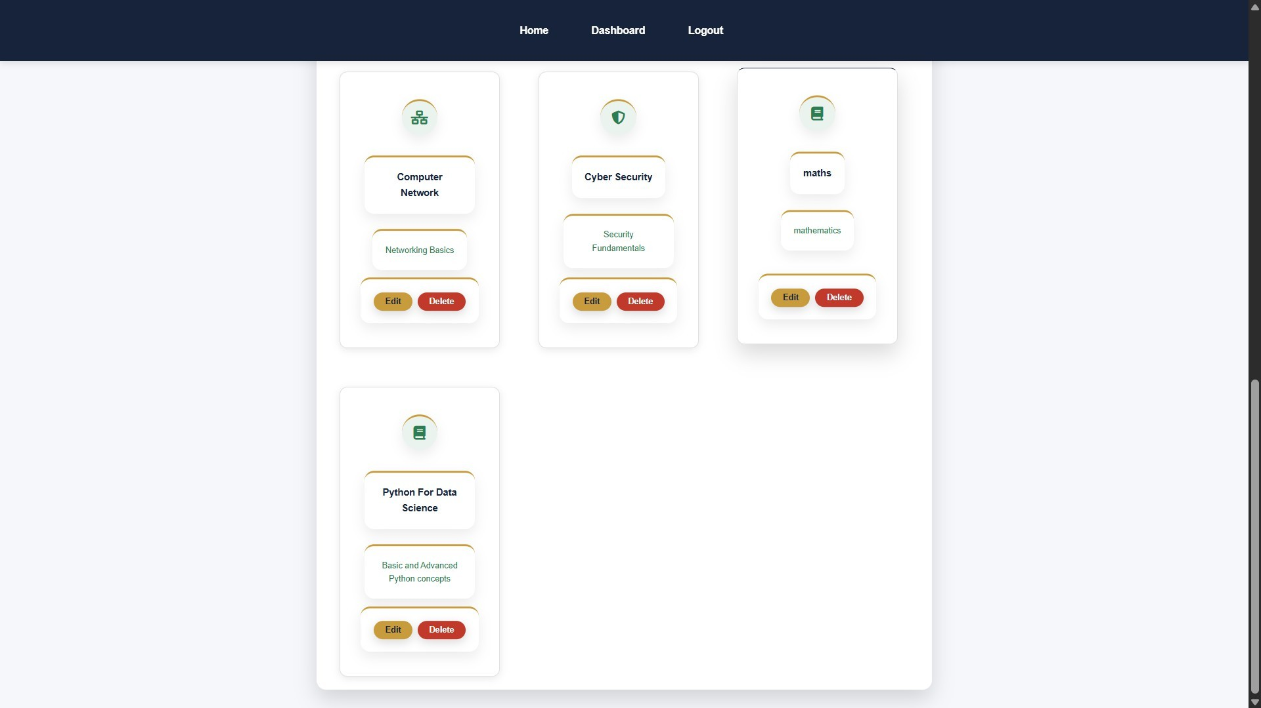
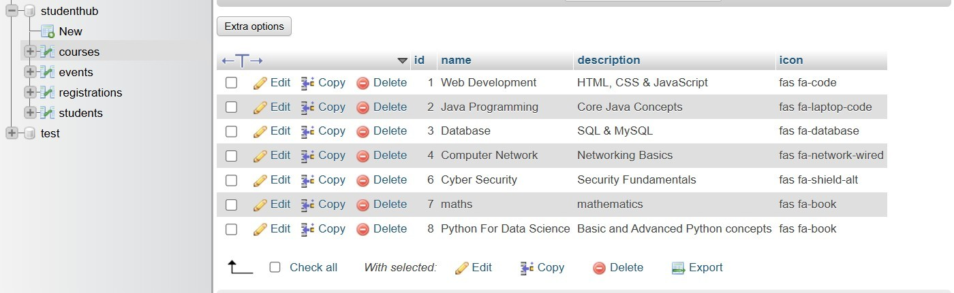

GitHub Repository Link:
https://github.com/Hetvi-K12/StudentHub-Portal/tree/main/Practical13

Challenges Faced:

  - Generating valid JSON responses from PHP endpoints.
  - Handling GET and POST requests correctly.
  - Displaying loading, success, and error states on the frontend.
  - Validating user input before database operations.
  - Managing communication between the frontend, PHP, and MySQL database.

Learning Outcomes:

  - Learned to create PHP endpoints that return JSON responses.
  - Understood how to handle GET and POST requests.
  - Learned to display loading indicators and success/error messages.
  - Gained knowledge of input validation and secure database operations.
  - Understood how to exchange data dynamically between the frontend and backend.

Faculty Remarks:

