Practical - 14

Practical Title : Admin Dashboard with Role-Based Access Control, Dynamic Menu, and Audit Log
Problem Definition: Develop an admin dashboard that displays user statistics, student count, event count and latest registrations. Restrict access to admin users only and show dynamic menu options based on role.
Theory
- Are dashboard values loaded dynamically from the database? Answer: Dashboard values are loaded dynamically from the MySQL database.

Is access restricted to admin users?
Answer: Access to the admin dashboard is restricted to authenticated admin users.

Are role-based menus working?
Answer: Role-based menus display appropriate options for admin and student users.

- Are important admin actions recorded in audit_logs?
Answer: Important admin actions, such as adding, updating, and deleting student records, are recorded in the audit_logs table.

Implementation :

  - Loaded dashboard values dynamically from the MySQL database.
  - Restricted admin dashboard access to authenticated admin users.
  - Implemented role-based menus for admin and student users.
  - Recorded important admin actions, such as adding, updating, and deleting student records, in the audit_logs table.
  - Displayed dashboard information and management options according to user roles.

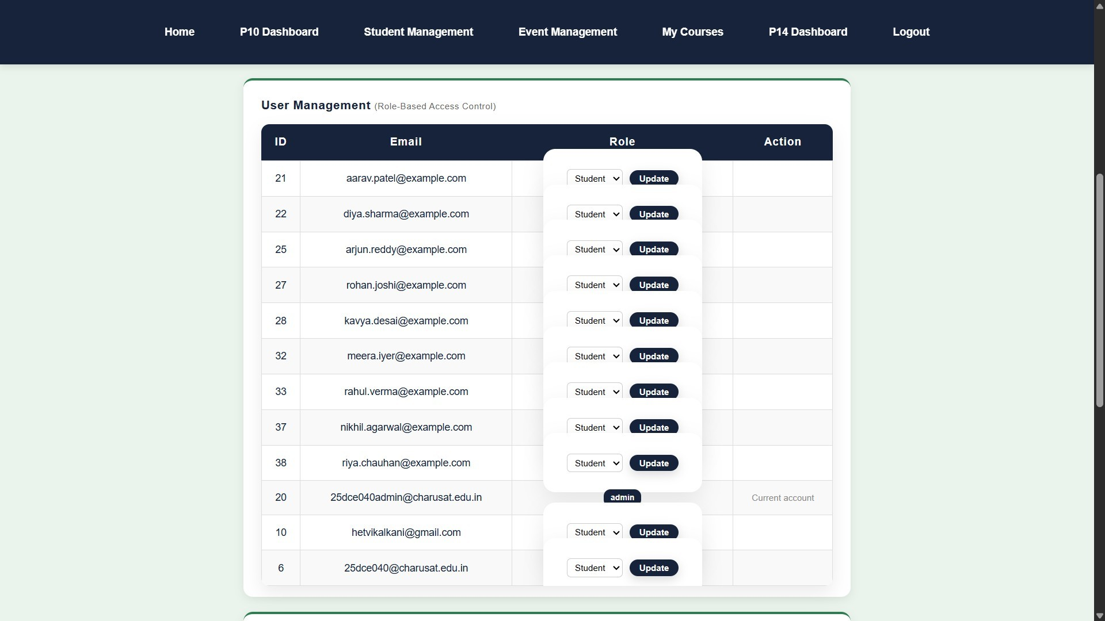
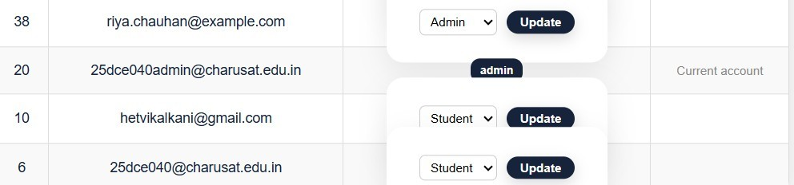
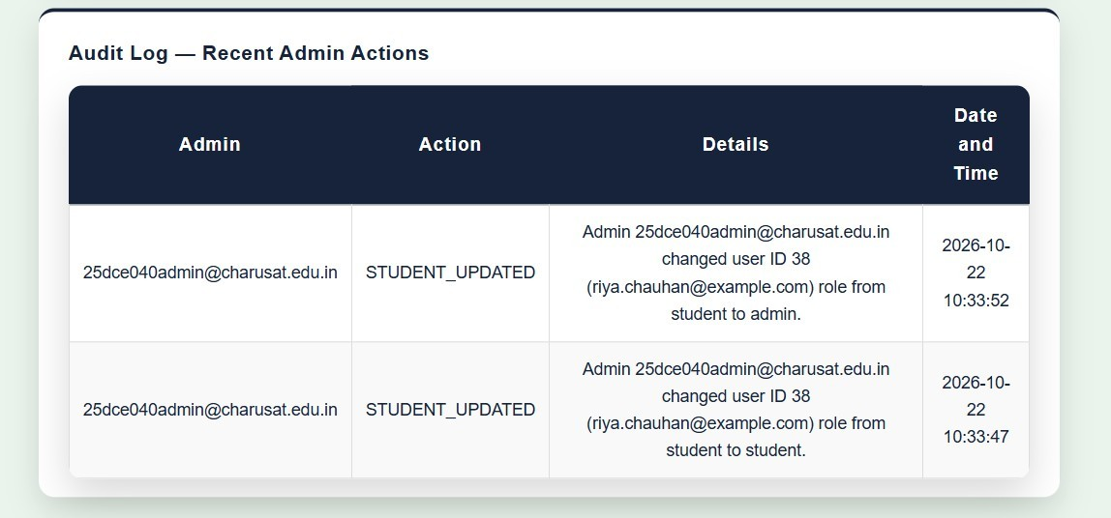
Evidence of Work (Screenshots)

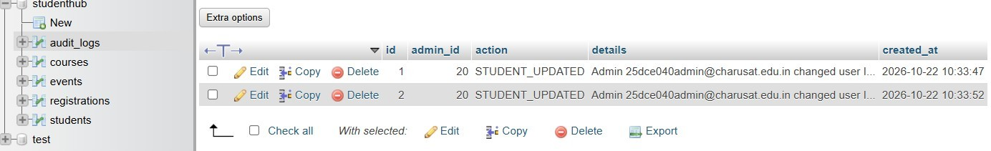

GitHub Repository Link:
https://github.com/Hetvi-K12/StudentHub-Portal/tree/main/Practical14

Challenges Faced:

  - Fetching and displaying dashboard statistics dynamically from the database.
  - Restricting dashboard access based on user roles.
  - Implementing role-based menus correctly.
  - Recording admin activities in the audit_logs table.
  - Maintaining consistency between database records and audit logs.

Learning Outcomes:

  - Learned to create dynamic admin dashboards using PHP and MySQL.
  - Understood role-based access control and dashboard security.
  - Learned to display menus according to user roles.
  - Gained knowledge of audit logging to track admin activities.
  - Improved understanding of database integration, security, and activity monitoring.

Faculty Remarks:

