Practical – 2
Practical Title: Semantic HTML5 Pages with Accessibility-Ready Structure

Theory
  - Are semantic tags such as header, nav, main, section, article, aside, and footer used properly
Answer: Yes. Semantic tags are used to give proper structure to the webpage. They make the code easy to read and understand.
  - Are form labels, headings, image alt text, and navigation links accessible?
Answer: Yes. Labels, headings, alt text, and navigation links are added so every user can use the website easily.
  - Is the page structure consistent across all pages?
Answer: Yes. All pages have the same header, navigation menu, main content, and footer, so the website looks organized.

HTML Code
Home page:
<!DOCTYPE html>
<html lang="en">
<head>
<meta charset="UTF-8">
<meta name="viewport" content="width=device-width, initial-scale=1.0">
<title>StudentHub Portal</title>
<link rel="stylesheet" href="../css/style.css">
</head>
<body>
<header>
<h1 style="text-align: center;">StudentHub Portal!</h1>
<nav>
<a href = "index.html">Home</a> &nbsp;

<a href = "login.html">Login</a> &nbsp;
<a href = "register.html">Register</a> &nbsp;
<a href = "contact.html">Contact</a> &nbsp;
<a href = "about.html">About</a>

</nav>
<h2 style="text-align: center;"> Welcome to StudentHub Portal!</h2>
</header>
</body>
</html>

Login Page:
<!DOCTYPE html>
<html lang="en">
<head>
<meta charset="UTF-8">
<meta name="viewport" content="width=device-width, initial-scale=1.0">
<title>Document</title>
<link rel="stylesheet" href="../css/style.css">
</head>
<body>
<h2>Welcome Back!</h2>

<nav>
<a href = "index.html">Home</a> &nbsp;

</nav>
<br>
<form action="dashboard.html">

<label>Username / Email:</label>
<input type="text" required>

<br><br>

<label>Password:</label>
<input type="password" required>

<br><br>

<button type="submit">Login</button>
</form>

<p>Don't have an account?</p>
<a href="register.html">Sign Up</a>

</body>
</html>

Registration Page:
<!DOCTYPE html>
<html lang="en">

<head>
<meta charset="UTF-8">
<meta name="viewport" content="width=device-width, initial-scale=1.0">
<title>Document</title>
<link rel="stylesheet" href="../css/style.css">
</head>
<body = class="register">
<h1>Welcome!</h1>
<nav>
<a href = "index.html">Home</a> &nbsp;
</nav>
<br>
<form action="dashboard.html">

<label>Email ID:</label>
<input type="email" required>

<br><br>

<label>Mobile Number:</label>
<input type="tel" required>

<br><br>

<label>Password:</label>
<input type="password" required>

<br><br>

<label>Confirm Password:</label>
<input type="password" required>

<br><br>

<button type="submit">Sign Up</button>

</form>

<p>Already have an account?</p>
<a href="login.html">Login</a>
</body>
</html>

Dashboard Page:
<!DOCTYPE html>
<html lang="en">
<head>
<meta charset="UTF-8">
<meta name="viewport" content="width=device-width, initial-scale=1.0">
<title>Document</title>
<link rel="stylesheet" href="../css/style.css">
</head>

<body>
<h1>Dashboard</h1>
<nav>
<a href = "index.html">Home</a> &nbsp;
<a href = "dashboard.html">Dashboard</a> &nbsp;
<a href = "about.html">About Us</a> &nbsp;
<a href = "contact.html">Contact Us</a> &nbsp;
<a href = "profile.html">Profile</a> &nbsp;
<br>
</nav>
<main>

<section>
<h3>Time Table</h3>
<p>View your Time Table.</p>
<a href="timetable.html">View Time Table</a>
</section>

<section>
<h3>Study Material & Cources</h3>
<p>Access your course study materials.</p>
<a href="courses.html">View Study Material</a>
</section>

<section>
<h3>Assignments</h3>

<p>View and manage your assignments.</p>
<a href="assignment.html">View Assignments</a>
</section>

<section>
<h3>Results</h3>
<p>Check your academic results.</p>
<a href="result.html">View Results</a>
</section>
</main>
</body>
</html>

About:
<!DOCTYPE html>
<html lang="en">
<head>
<meta charset="UTF-8">
<meta name="viewport" content="width=device-width, initial-scale=1.0">
<title>Document</title>
<link rel="stylesheet" href="../css/style.css">
</head>
<body>
<h1>About</h1>
<nav>
<a href = "index.html">Home</a> &nbsp;

<a href = "login.html">Login</a> &nbsp;
<a href = "register.html">Sign Up</a> &nbsp;
<a href = "contact.html">Contact</a> &nbsp;
<a href = "about.html">About</a>

</nav>
<h2>About StudentHub Portal</h2>

<p>
StudentHub is a student portal designed to provide students with easy access to important academic information and resources in one centralised platform.
</p>

<p>
The portal allows students to access their profile, study materials, timetable, assignments, and academic results. It provides a simple and user-friendly interface that helps students manage and access their academic information efficiently.
</p>

<p>
StudentHub aims to make academic information more organised, accessible, and convenient for students by bringing essential student services together in one place.
</p>

<h3>Key Features</h3>

<ul>
<li>Student Dashboard</li>
<li>Student Profile</li>
<li>Study Materials</li>
<li>Time Table</li>
<li>Assignment Management</li>
<li>Academic Results</li>
<li>Contact and Support</li>
</ul>
</body>
</html>

Contacts:
<!DOCTYPE html>
<html lang="en">
<head>
<meta charset="UTF-8">
<meta name="viewport" content="width=device-width, initial-scale=1.0">
<title>Document</title>
<link rel="stylesheet" href="../css/style.css">
</head>
<body>
<h1>Contact Us</h1>

<nav>
<a href = "index.html">Home</a> &nbsp;
<a href = "login.html">Login</a> &nbsp;
<a href = "register.html">Register</a> &nbsp;
<a href = "contact.html">Contact</a> &nbsp;
<a href = "about.html">About</a>

</nav>

<h3>Contact Information</h3>

<p>Email: support@myhub.com</p>
<p>Phone: +91 9876543210</p>
<p>Address: University Campus</p>
<p>Office Timing: 9:00 AM - 5:00 PM</p>

<label>Message:</label>
<br>
<textarea rows="5" cols="40"></textarea>

<br><br>

<button type="submit">Send Message</button>

</body>
</html>

Profile:
<!DOCTYPE html>
<html lang="en">
<head>
<meta charset="UTF-8">
<meta name="viewport" content="width=device-width, initial-scale=1.0">
<title>Document</title>
<link rel="stylesheet" href="../css/style.css">
</head>
<body>
<h1>Profile</h1>
<nav>
<a href = "dashboard.html">Dashboard</a> &nbsp;
<a href = "profile.html">Profile</a> &nbsp;
</nav>

<h2>Student Information</h2>

<pre><strong>Name :</strong> Student Name</pre>
<pre><strong>Student ID :</strong> STU001</pre>
<pre><strong>Email :</strong> student@example.com</pre>
<pre><strong>Mobile :</strong> 9876543210</pre>
<pre><strong>Department :</strong> Computer Engineering</pre>
<br>
<button>Edit Profile</button>

</body>
</html>

Assignment:
<!DOCTYPE html>
<html lang="en">
<head>
<meta charset="UTF-8">
<meta name="viewport" content="width=device-width, initial-scale=1.0">
<title>Document</title>
<link rel="stylesheet" href="../css/style.css">
</head>
<body>
<h1>Assignment</h1>
<nav>
<a href = "dashboard.html">Dashboard</a> &nbsp;
<a href = "timetable.html">Time Table</a> &nbsp;
<a href = "assignment.html">Assignment</a> &nbsp;
<a href = "courses.html">Courses</a> &nbsp;
<a href = "result.html">Result</a>
</nav>
<br>
<table border="1">

<tr>
<th>Subject</th>

<th>Assignment</th>
<th>Due Date</th>
<th>Status</th>
</tr>

<tr>
<td>Web Development</td>
<td>HTML Website</td>
<td>10 August 2026</td>
<td>Submitted</td>
</tr>

<tr>
<td>Data Structures and Algorithm</td>
<td>Binary Search</td>
<td>11 August 2026</td>
<td>Submitted</td>
</tr>

<tr>
<td>Object Oriented Programming</td>
<td>Inheritance</td>
<td>11 August 2026</td>
<td>Done Late</td>
</tr>

<tr>
<td>Computer Networking</td>
<td>Tologies</td>
<td>12 August 2026</td>
<td>Submitted</td>
</tr>

<tr>
<td>Discrete Mathematics</td>
<td>Unit 1</td>
<td>14 August 2026</td>
<td>Pending</td>
</tr>

</table>
</body>
</html>

Courses:
<!DOCTYPE html>
<html lang="en">
<head>
<meta charset="UTF-8">
<meta name="viewport" content="width=device-width, initial-scale=1.0">
<title>Document</title>
<link rel="stylesheet" href="../css/style.css">

</head>
<body>
<h1>Courses</h1>
<nav>
<a href = "dashboard.html">Dashboard</a> &nbsp;
<a href = "timetable.html">Time Table</a> &nbsp;
<a href = "assignment.html">Assignment</a> &nbsp;
<a href = "courses.html">Courses</a> &nbsp;
<a href = "result.html">Result</a>
</nav>
<h2>Study Material</h2>

<div>
<h3>Course 1</h3>
<p>Course Name: Web Development</p>
<a href="#">View Material</a>
</div>

<div>
<h3>Course 2</h3>
<p>Course Name: Data Structures and Algorithm</p>
<a href="#">View Material</a>
</div>

<div>
<h3>Course 3</h3>

<p>Course Name: Object Oriented Programming</p>
<a href="#">View Material</a>
</div>

<div>
<h3>Course 4</h3>
<p>Course Name: Computer Networks</p>
<a href="#">View Material</a>
</div>

<div>
<h3>Course 5</h3>
<p>Course Name: Discrete Mathematics</p>
<a href="#">View Material</a>
</div>
</body>
</html>

Result:
<!DOCTYPE html>
<html lang="en">
<head>
<meta charset="UTF-8">
<meta name="viewport" content="width=device-width, initial-scale=1.0">
<title>Document</title>
<link rel="stylesheet" href="../css/style.css">

</head>
<body>
<h1>Result</h1>
<nav>
<a href = "dashboard.html">Dashboard</a> &nbsp;
<a href = "timetable.html">Time Table</a> &nbsp;
<a href = "assignment.html">Assignment</a> &nbsp;
<a href = "courses.html">Courses</a> &nbsp;
<a href = "result.html">Result</a>

</nav>

<h2>Academic Results</h2>

<p><strong>Student Name:</strong> Student Name</p>
<p><strong>Student ID:</strong> STU001</p>

<table border="1">

<tr>
<th>Subject</th>
<th>Internal Marks</th>
<th>External Marks</th>
<th>Total</th>
<th>Grade</th>
</tr>

<tr>
<td>Web Development</td>
<td>24</td>
<td>56</td>
<td>80</td>
<td>A</td>
</tr>

<tr>
<td>Data Structures and Algorithm</td>
<td>24</td>
<td>64</td>
<td>88</td>
<td>A+</td>
</tr>

<tr>
<td>Object Orianted Programming</td>
<td>29</td>
<td>68</td>
<td>97</td>
<td>O</td>
</tr>

<tr>

<td>Computer Networks</td>
<td>26</td>
<td>66</td>
<td>92</td>
<td>A+</td>
</tr>

<tr>
<td>Discrete Mathematics</td>
<td>24</td>
<td>60</td>
<td>84</td>
<td>A</td>
</tr>

</table>

<br>

<button>Download Result</button>
</body>
</html>

Timetable:
<!DOCTYPE html>
<html lang="en">

<head>
<meta charset="UTF-8">
<meta name="viewport" content="width=device-width, initial-scale=1.0">
<title>Document</title>
<link rel="stylesheet" href="../css/style.css">
</head>
<body>
<h1>Time Table</h1>
<nav>
<a href = "dashboard.html">Dashboard</a> &nbsp;
<a href = "timetable.html">Time Table</a> &nbsp;
<a href = "assignment.html">Assignment</a> &nbsp;
<a href = "courses.html">Courses</a> &nbsp;
<a href = "result.html">Result</a>
</nav>
<h2>Time Table</h2>

<table border="1">

<tr>
<th>Time</th>
<th>Monday</th>
<th>Tuesday</th>
<th>Wednesday</th>
<th>Thursday</th>
<th>Friday</th>

</tr>

<tr>
<td>9:00 - 10:00</td>
<td>WDF</td>
<td>DSA</td>
<td>OOP</td>
<td>Maths</td>
<td>CN</td>
</tr>

<tr>
<td>10:00 - 11:00</td>
<td>OOP</td>
<td>WDF</td>
<td>CN</td>
<td>DSA</td>
<td>Maths</td>
</tr>

<tr>
<td>11:00 - 12:00</td>
<td></td>
<td></td>
<td><b>Break</b></td>
<td></td>

<td></td>
</tr>

<tr>
<td>12:00 - 01:00</td>
<td>Maths</td>
<td>CN</td>
<td>Maths</td>
<td>OOP</td>
<td>DSA</td>
</tr>

<tr>
<td>11:00 - 12:00</td>
<td>DSA</td>
<td>OOP</td>
<td>WDF</td>
<td>CN</td>
<td>WDF</td>
</tr>

</table>

</body>
</html>

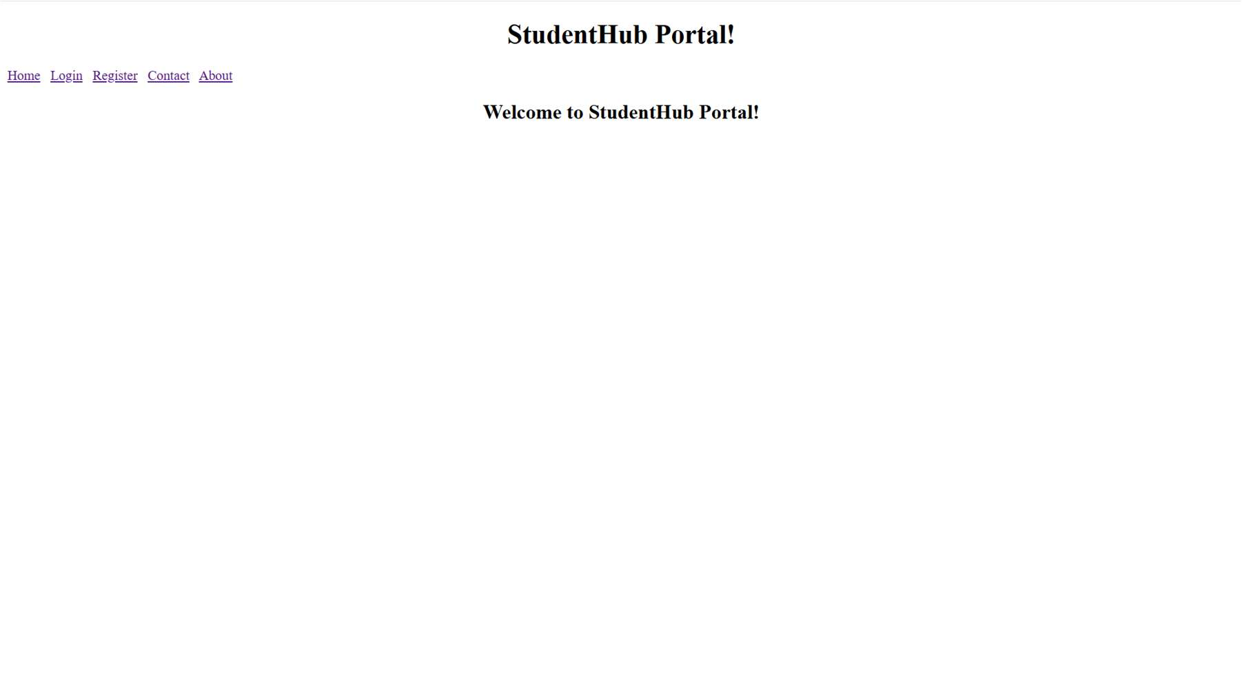
Evidence of Work (Screenshots)

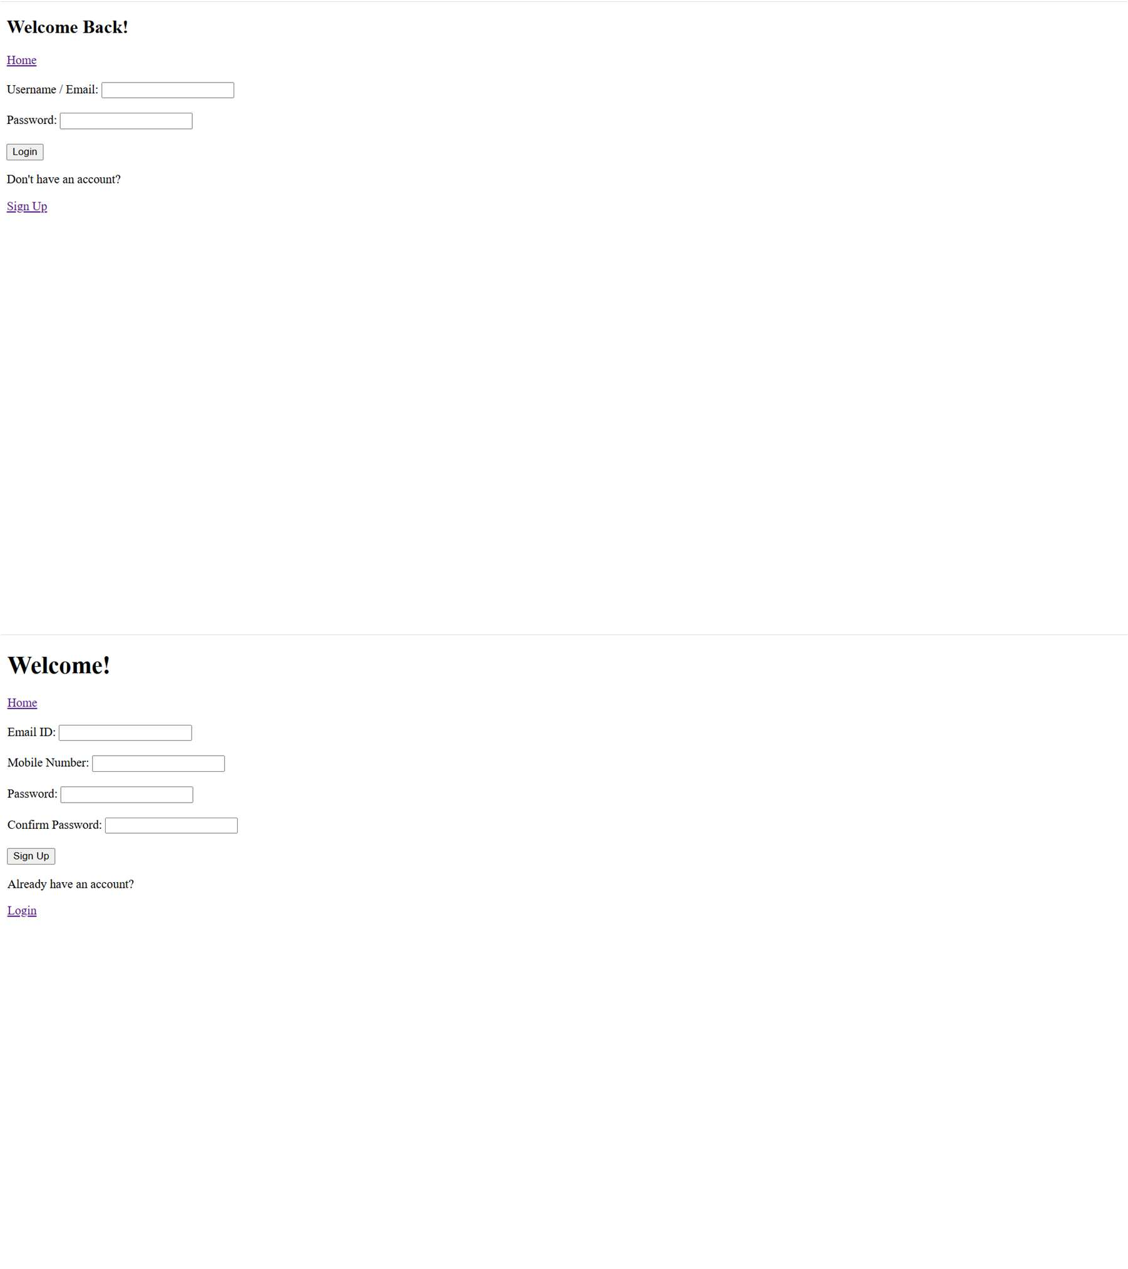

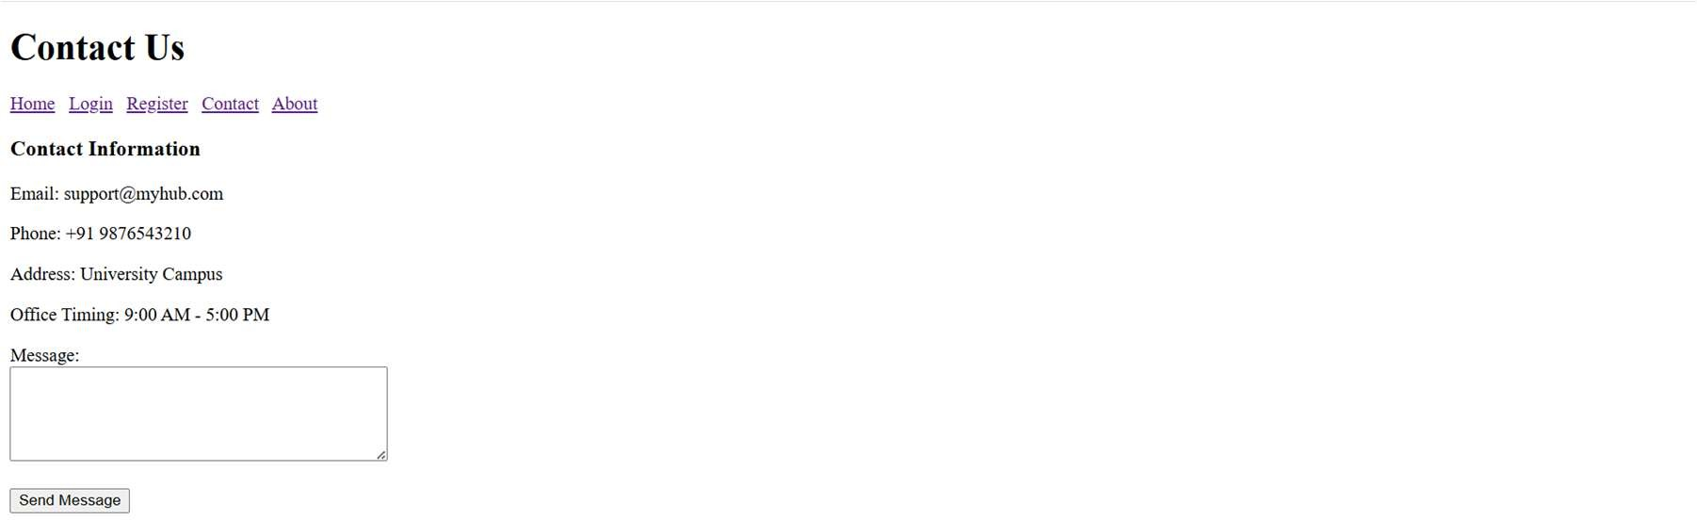

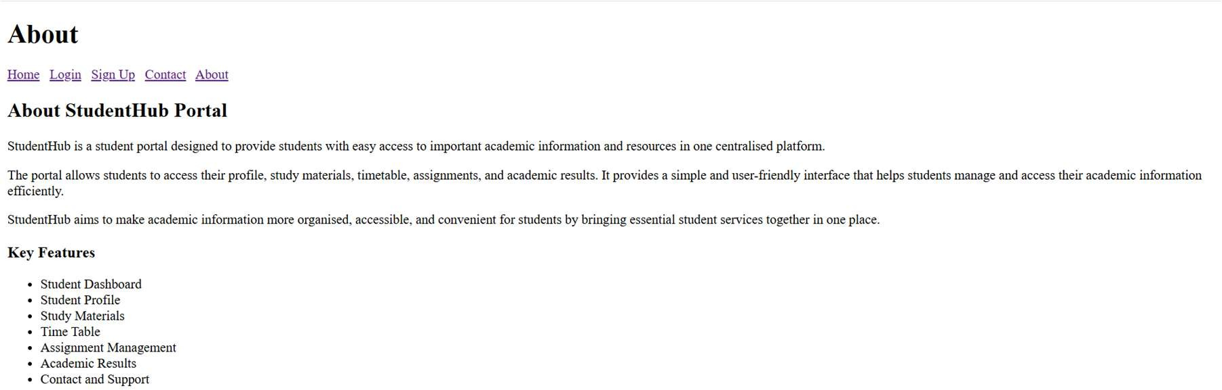

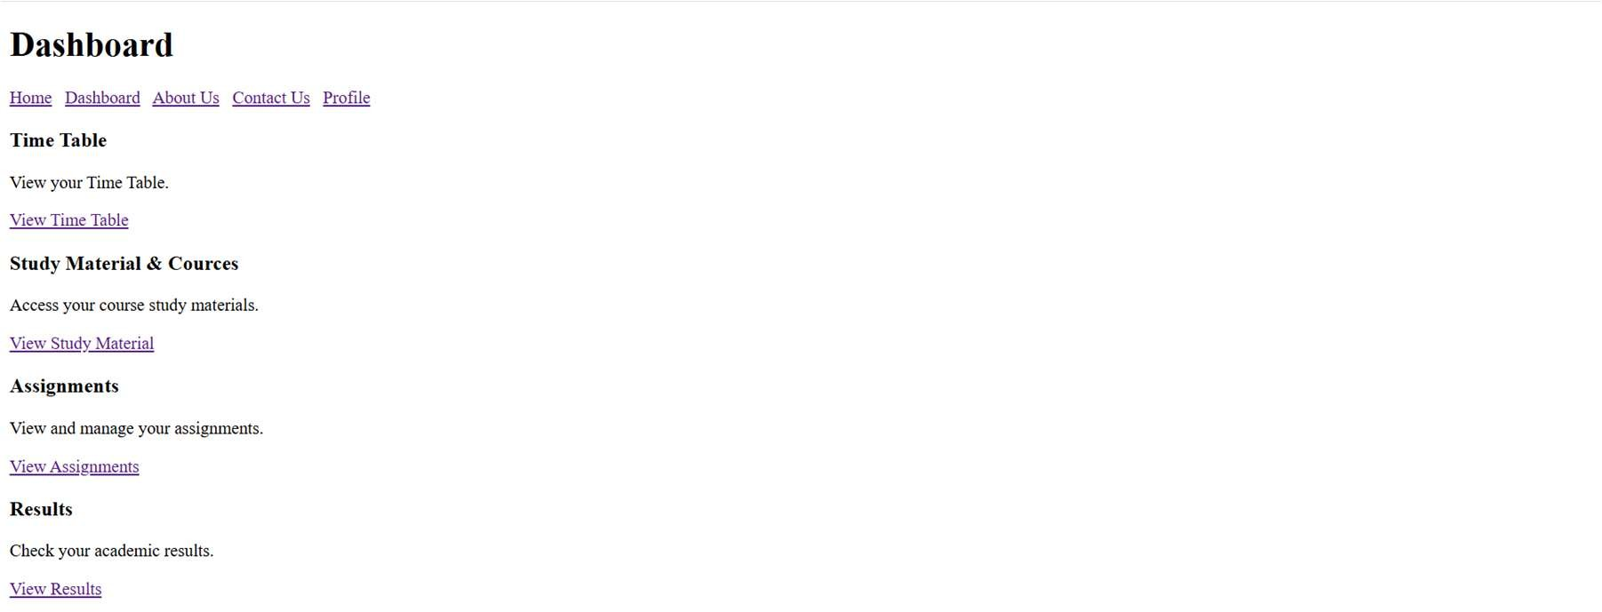

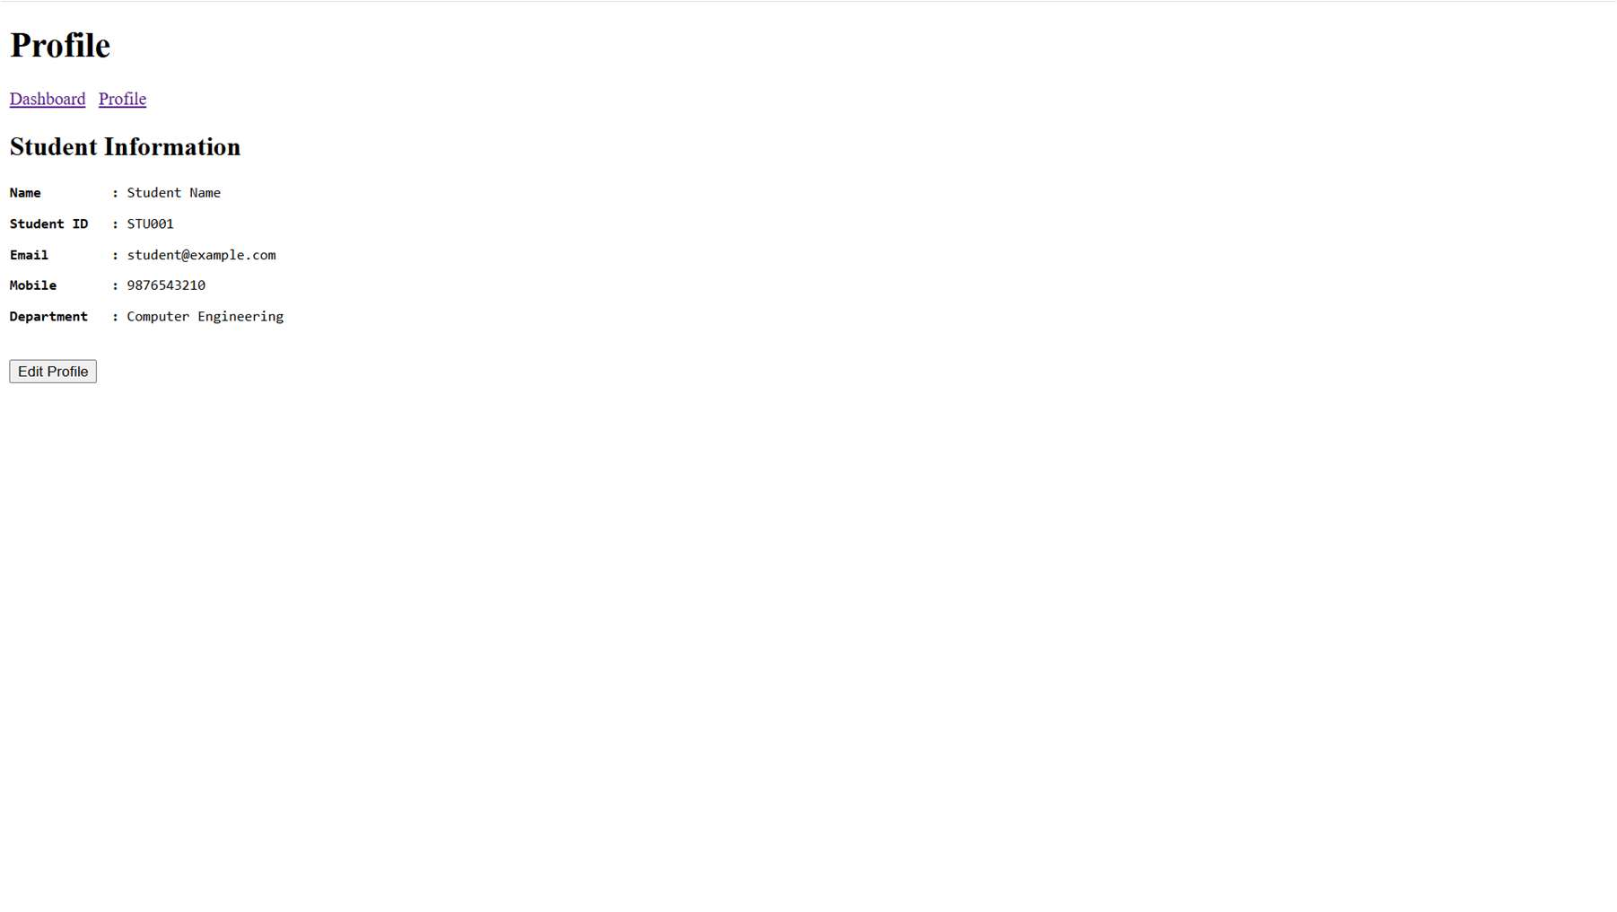

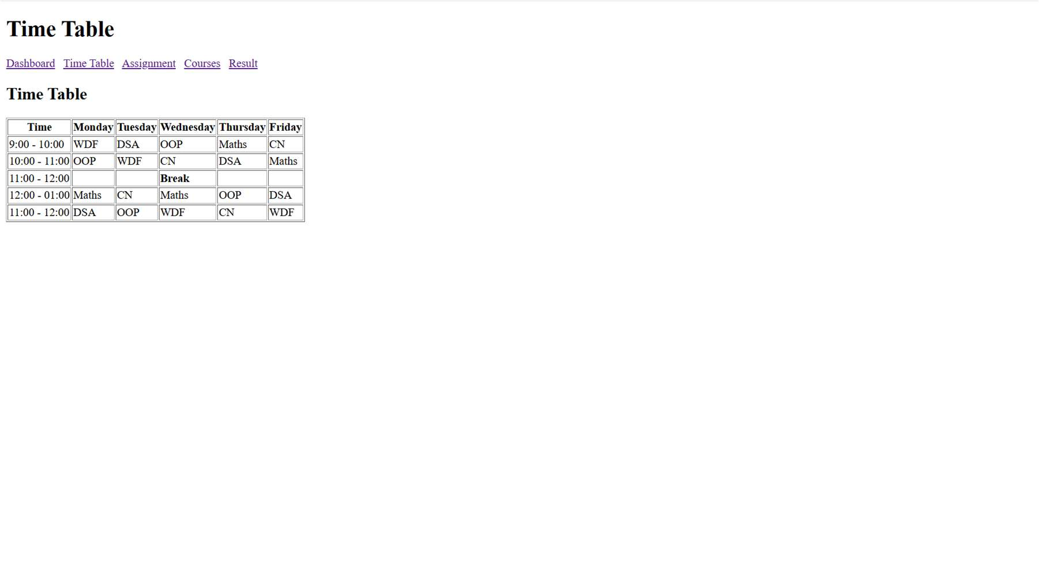
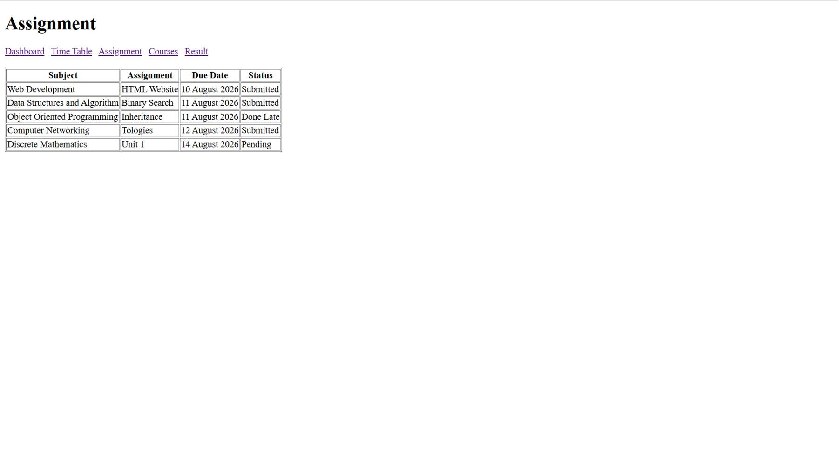



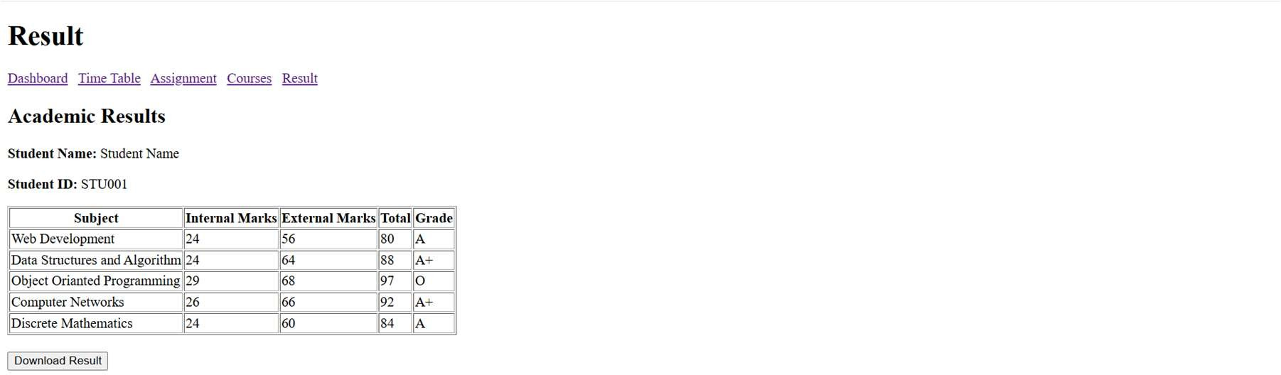

GitHub Repository Link
https://github.com/hkxii/StudentHub-Portal

Challenges Faced
I had faced challenges like Understanding semantic HTML tags, keeping the same layout on every page, linking all pages correctly, etc.

Learning Outcomes
I had learned to use HTML5 semantic tags, basic accessibility features, learned to create a well-structured website, etc.
Faculty Remarks

