Practical - 3
Practical Title: Responsive UI Design using CSS Grid, Flexbox, and Bootstrap/Tailwind

Theory
  - How does the layout adapt for mobile, tablet, and desktop screens?
Answer: The layout changes using responsive CSS and media queries so it fits different screen sizes.
  - Which layout technique is used and why?
Answer: Flexbox and CSS Grid are used because they make layouts flexible, responsive, and easy to manage.
  - Are typography, spacing, colors, and contrast readable?
Answer: Yes. Proper font size, spacing, colors, and contrast make the content easy to read.
  - Is the framework used consistently without unnecessary inline CSS?
Answer: Yes. Bootstrap/Tailwind classes are used consistently and inline CSS is kept to a minimum.

CSS Code
*{ margin:0; padding:0;
box-sizing:border-box;
font-family:Arial,Helvetica,sans-serif;
}

body{ background:#f5f7fb; color:#16233B;
line-height:1.6;
}

a{
text-decoration:none;
}

header{ background:#16233B; padding:40px 20px; text-align:center; position:relative; overflow:hidden;
}

header::before{ content:""; position:absolute; width:250px; height:250px;
background:rgba(255,255,255,.05); border-radius:50%;
left:-80px; top:-80px;
}

header::after{

content:""; position:absolute; width:220px; height:220px;
background:rgba(255,255,255,.05); border-radius:50%;
right:-60px; bottom:-80px;
}

header h1{ color:#fff;
font-size:42px; margin-bottom:15px;
}

header h2{ color:#fff;
font-size:28px; font-weight:400; margin-top:25px;
}

nav{
margin-top:20px;

text-align:center;
}

nav a{
display:inline-block; color:#fff; padding:12px 22px; margin:5px;
border-radius:30px; font-weight:bold; transition:.3s;
}

nav a:hover{ background:#C89B3C; color:#16233B;
}

body>h1, body>h2{
text-align:center; margin:35px 0; color:#16233B;
}

body>nav{ background:#16233B; padding:18px;
margin-bottom:35px;
}

body>nav a{ color:#fff;
}

body>nav a:hover{ background:#C89B3C; color:#16233B;
}

form{ width:420px; max-width:92%;
margin:30px auto; background:#fff; padding:35px; border-radius:18px;
box-shadow:0 10px 30px rgba(0,0,0,.08);
}

label{ display:block;
margin-bottom:8px; font-size:17px;
font-weight:bold; color:#16233B;
}

input{ width:100%; padding:14px;
border:1px solid #d8dce5; border-radius:10px; margin-bottom:20px;
font-size:15px; transition:.3s;
}

input:focus{ outline:none;
border-color:#C89B3C;
box-shadow:0 0 8px rgba(200,155,60,.3);
}

button{

padding:12px 28px; border:none; background:#C89B3C; color:#16233B;
font-size:16px; font-weight:bold;
border-radius:30px; cursor:pointer; transition:.3s;
}

button:hover{ background:#16233B; color:#fff;
}

form+p{
text-align:center; margin-top:20px; font-size:16px; color:#16233B;
}

form+p+a{ display:block;

text-align:center; margin-top:10px; font-weight:bold; color:#16233B;
}

form+p+a:hover{ color:#C89B3C;
}

p{
margin-bottom:15px; padding:0 20px;
}

ul{
margin:20px 50px;
}

li{
margin-bottom:10px;
}

table{ width:95%;

margin:30px auto; border-collapse:collapse; background:#fff;
box-shadow:0 10px 25px rgba(0,0,0,.08);
}

th{ background:#16233B; color:#fff; padding:14px;
}

td{ padding:12px; text-align:center;
border:1px solid #ddd;
}

tr:nth-child(even){ background:#f9f9f9;
}

tr:hover{ background:#fff7e6;
}

textarea{ width:100%; padding:12px;
border:1px solid #ddd; border-radius:10px; resize:vertical;
}

textarea:focus{ outline:none;
border-color:#C89B3C;
}

pre{ background:#fff; padding:15px; margin:12px 20px;
border-left:5px solid #C89B3C; border-radius:10px;
box-shadow:0 5px 15px rgba(0,0,0,.08); white-space:pre-wrap;
}

div{

background:#fff; padding:20px; margin:20px; border-radius:15px;
box-shadow:0 8px 20px rgba(0,0,0,.08);
}

div a{
display:inline-block; margin-top:12px; background:#16233B; color:#fff; padding:10px 18px; border-radius:8px;
}

div a:hover{ background:#C89B3C; color:#16233B;
}

section{ background:#fff; padding:25px; margin:20px;

border-radius:15px;
box-shadow:0 8px 20px rgba(0,0,0,.08);
}

section a{ display:inline-block; margin-top:15px; background:#16233B; color:#fff; padding:10px 18px; border-radius:8px;
}

section a:hover{ background:#C89B3C; color:#16233B;
}

img{
max-width:100%; display:block;
}

footer{ background:#16233B;

color:#fff; padding:20px; text-align:center; margin-top:40px;
}

@media(max-width:768px){ header h1{
font-size:34px;
}

header h2{ font-size:22px;
}

nav a{ display:block; width:200px; margin:8px auto;
}

table{
font-size:14px;
}

form{ padding:25px;
}
}
main{ width:95%;
margin:30px auto; display:grid;
grid-template-columns:repeat(auto-fit,minmax(260px,1fr)); gap:25px;
}

section{ transition:.3s; cursor:pointer;
}

section:hover{ transform:translateY(-6px);
box-shadow:0 15px 35px rgba(0,0,0,.15);
}

section h3{
margin-bottom:10px; font-size:22px;

color:#16233B;
}

section p{ padding:0;
margin-bottom:18px; color:#666;
}

section a{
font-weight:bold;
}

div{ transition:.3s;
}

div:hover{ transform:translateY(-6px);
box-shadow:0 15px 35px rgba(0,0,0,.15);
}

div h3{
margin-bottom:10px; color:#16233B;

}

div p{ padding:0; color:#666;
}

pre{
font-size:16px; line-height:2;
}

textarea:hover, input:hover{
border-color:#C89B3C;
}

table{ overflow:hidden; border-radius:12px;
}

th{
letter-spacing:1px;
}

td{ transition:.2s;
}

tr:hover td{ color:#16233B; font-weight:bold;
}

button{
box-shadow:0 5px 15px rgba(0,0,0,.15);
}

button:active{ transform:scale(.98);
}

nav a{ position:relative;
}

nav a::after{ content:""; position:absolute;

left:15%; bottom:6px; width:0; height:2px; background:#fff; transition:.3s;
}

nav a:hover::after{ width:70%;
}

body{ animation:fade .7s;
}

@keyframes fade{ from{
opacity:0; transform:translateY(20px);
}
to{ opacity:1;
transform:translateY(0);
}

}

@media(max-width:900px){

main{
grid-template-columns:1fr;
}

section, div{
margin:10px;
}

pre{
font-size:14px;
}

}

@media(max-width:600px){

body>h1{
font-size:28px;
}

body>h2{
font-size:22px;
}

table{ display:block; overflow-x:auto;
}

button{ width:100%;
}

textarea{ width:100%;
}

}
h1,h2,h3{
letter-spacing:.5px;
}

h1{
text-shadow:1px 1px 2px rgba(0,0,0,.1);
}

form{ transition:.3s;
}

form:hover{
box-shadow:0 15px 35px rgba(0,0,0,.15); transform:translateY(-3px);
}

input, textarea, button{
font-family:Arial,Helvetica,sans-serif;
}

input, textarea{
background:#fff;
}

input::placeholder, textarea::placeholder{ color:#999;
}

input:focus, textarea:focus{ background:#fffdf7;
}

label{
margin-top:10px;
}

ul{ background:#fff; padding:25px 45px;
border-radius:15px;
box-shadow:0 8px 20px rgba(0,0,0,.08);
}

li::marker{ color:#C89B3C;
}

table{ transition:.3s;
}

table:hover{
box-shadow:0 15px 35px rgba(0,0,0,.15);
}

th{
font-size:16px;
}

td{
font-size:15px;
}

pre strong{ color:#16233B;
}

section, div{
border-top:4px solid #C89B3C;
}

section:hover, div:hover{
border-top-color:#16233B;
}

section a, div a{
transition:.3s;
}

section a:hover, div a:hover{
transform:translateY(-2px);
}

button{ transition:.3s;
}

button:hover{
box-shadow:0 8px 18px rgba(0,0,0,.2);
}

button:active{ transform:scale(.97);
}

nav{ position:sticky;

top:0;
z-index:100;
}

body>nav{
box-shadow:0 4px 10px rgba(0,0,0,.1);
}

hr{ border:none; height:1px;
background:#ddd; margin:25px 0;
}

body{
min-height:100vh;
}

@media(max-width:768px){

ul{ margin:20px; padding:20px;
}

table th, table td{
padding:10px;
}

pre{ margin:10px;
}

}

@media(max-width:500px){

header{ padding:30px 15px;
}

header h1{ font-size:28px;
}

header h2{ font-size:20px;
}

body>h1{
font-size:26px;
}

body>h2{
font-size:20px;
}

nav a{ padding:10px 16px; font-size:14px;
}

form{ width:95%; padding:20px;
}

table{
font-size:13px;
}

button{ padding:10px 20px;

}

}
.logo-title{ display:flex;
justify-content:center; align-items:center; gap:15px;
margin-bottom:20px; position:relative;
z-index:2;
}

.logo{
width:200px; height:200px; object-fit:contain; margin:0;
}
.logo-title h1{ margin:0;
color: #16233B;; font-size:42px;
}
.home-title{

color:#16233B; font-size:28px; font-weight:400; margin-top:25px;
}

Evidence of Work (Screenshots)



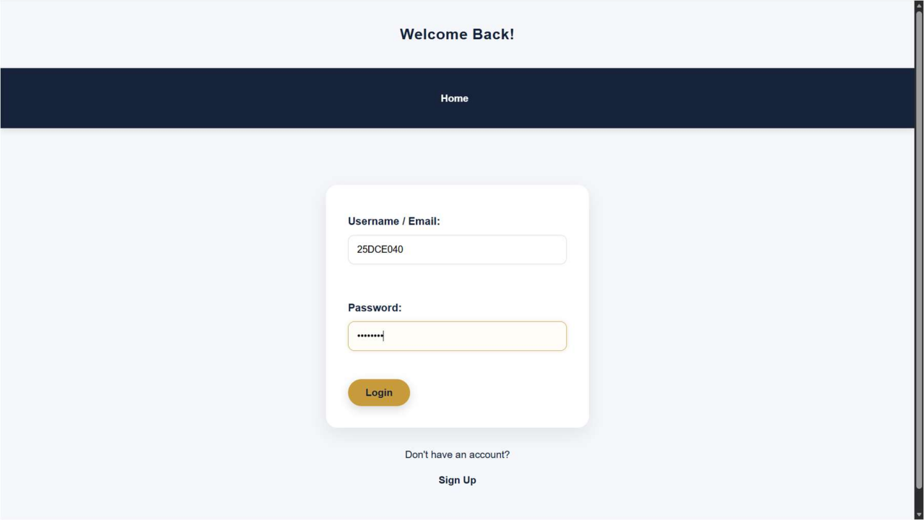

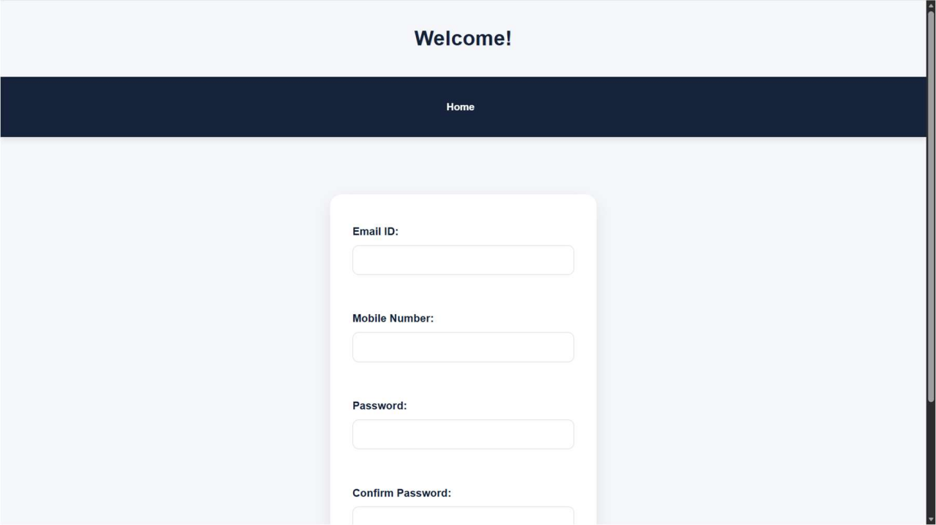

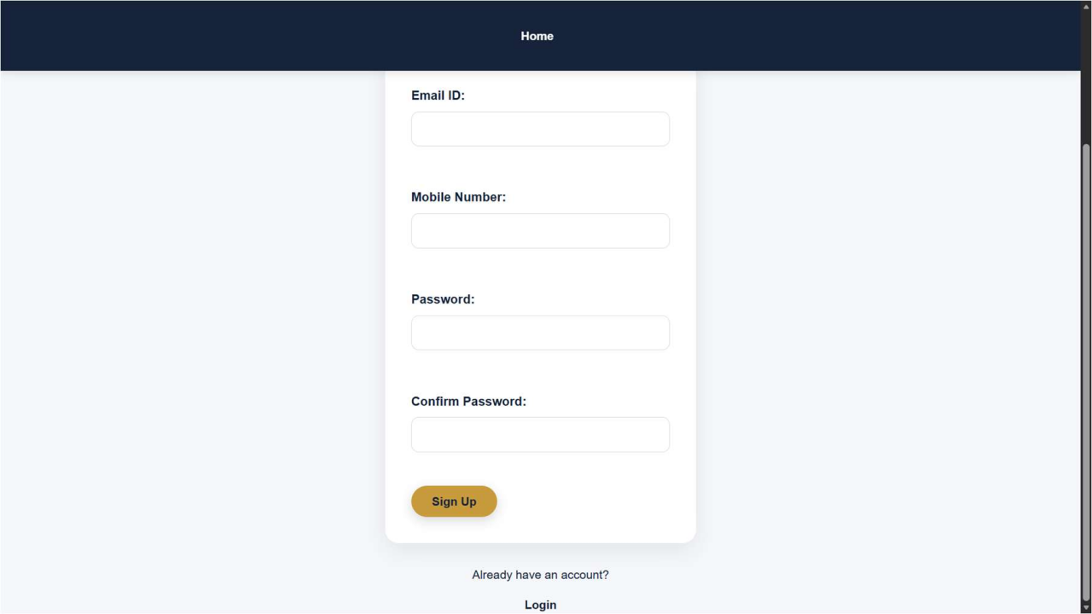

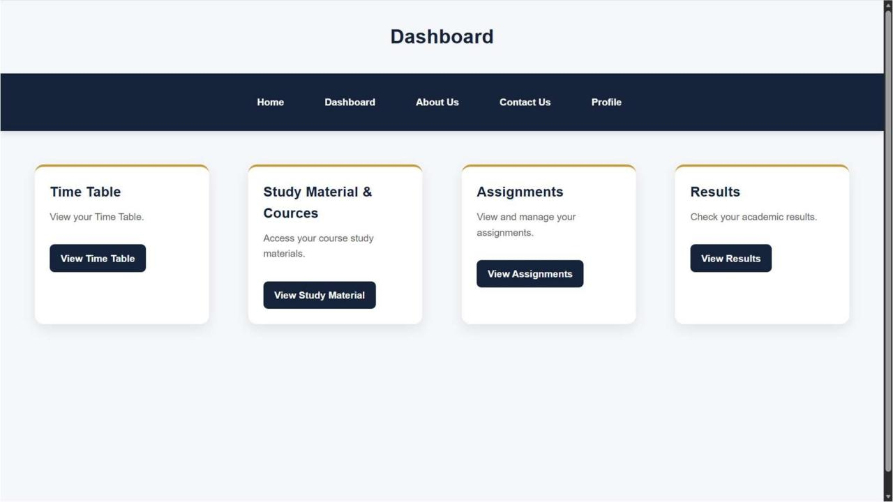

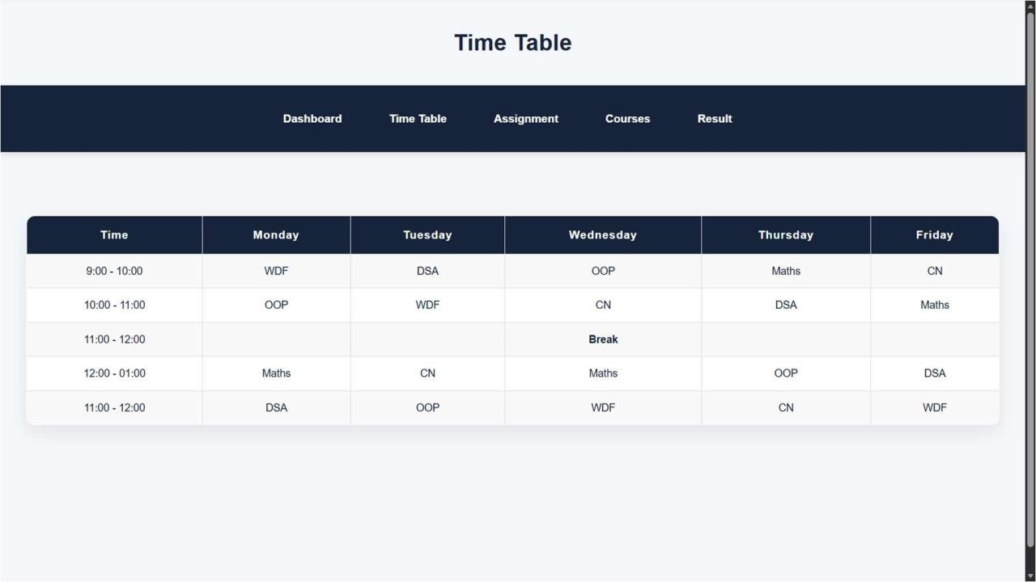

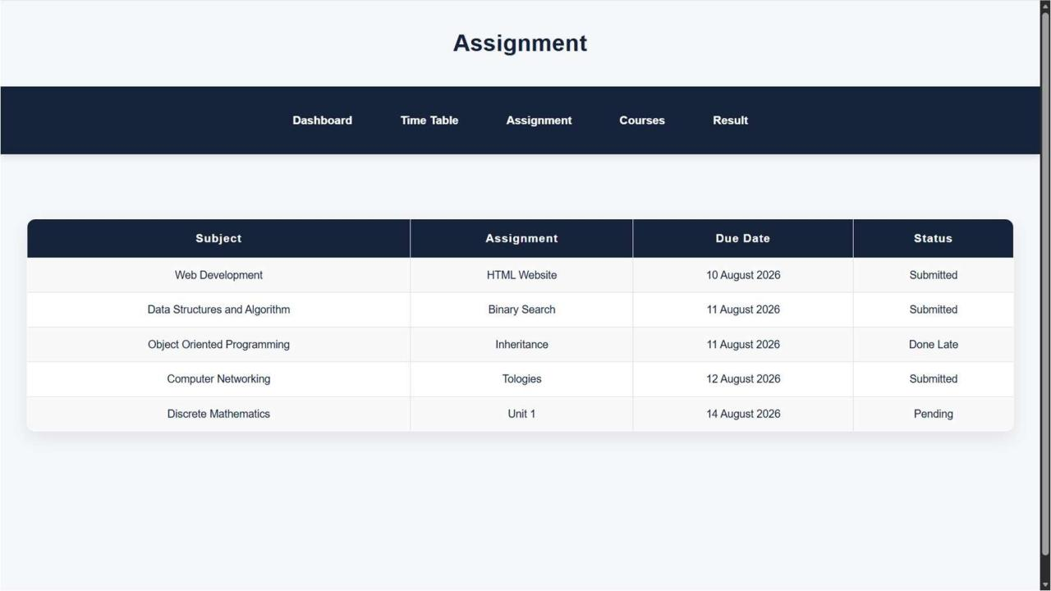

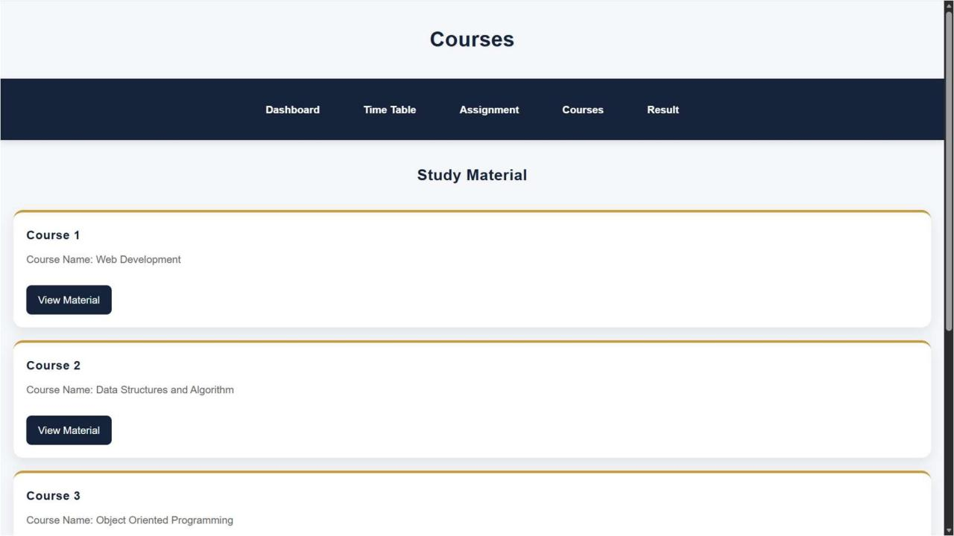

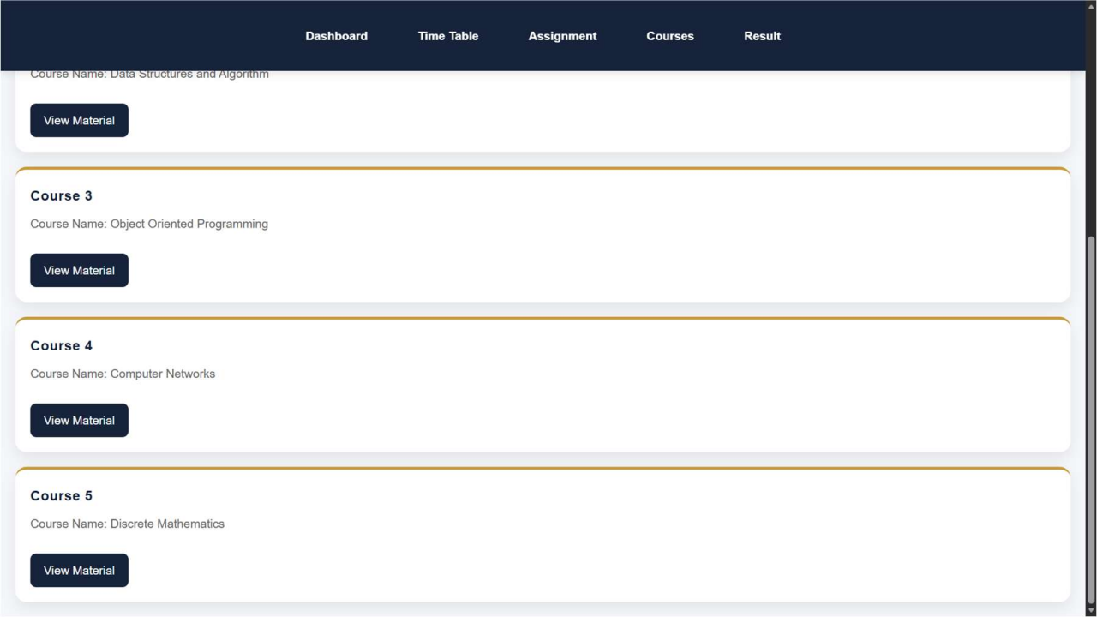

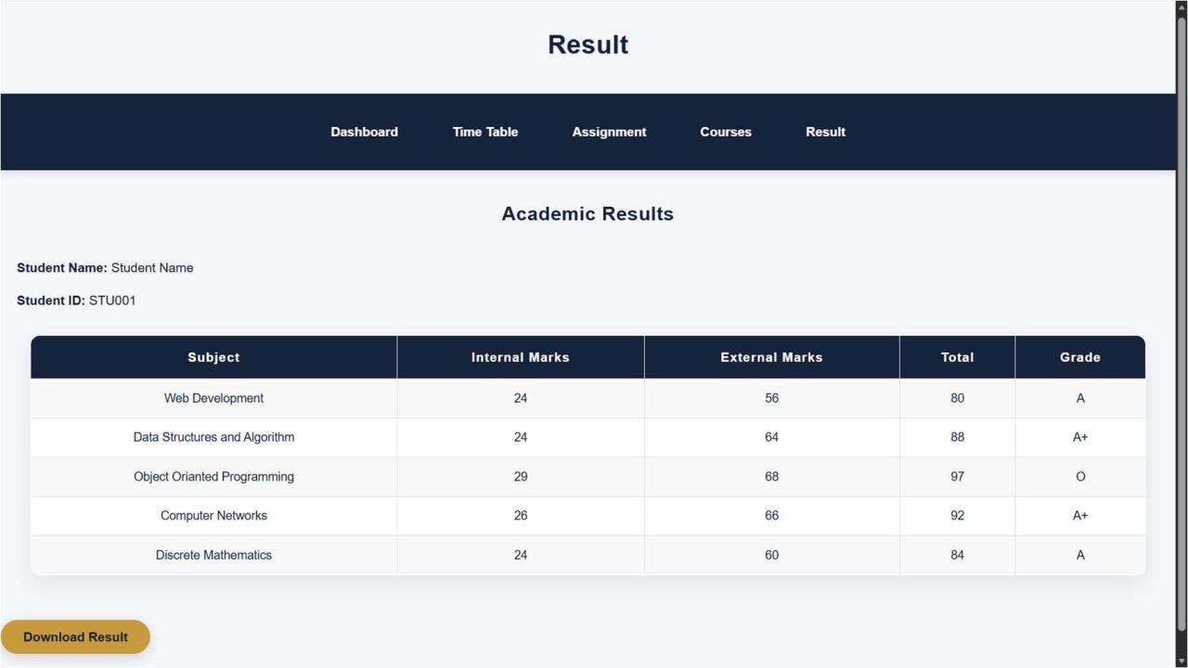

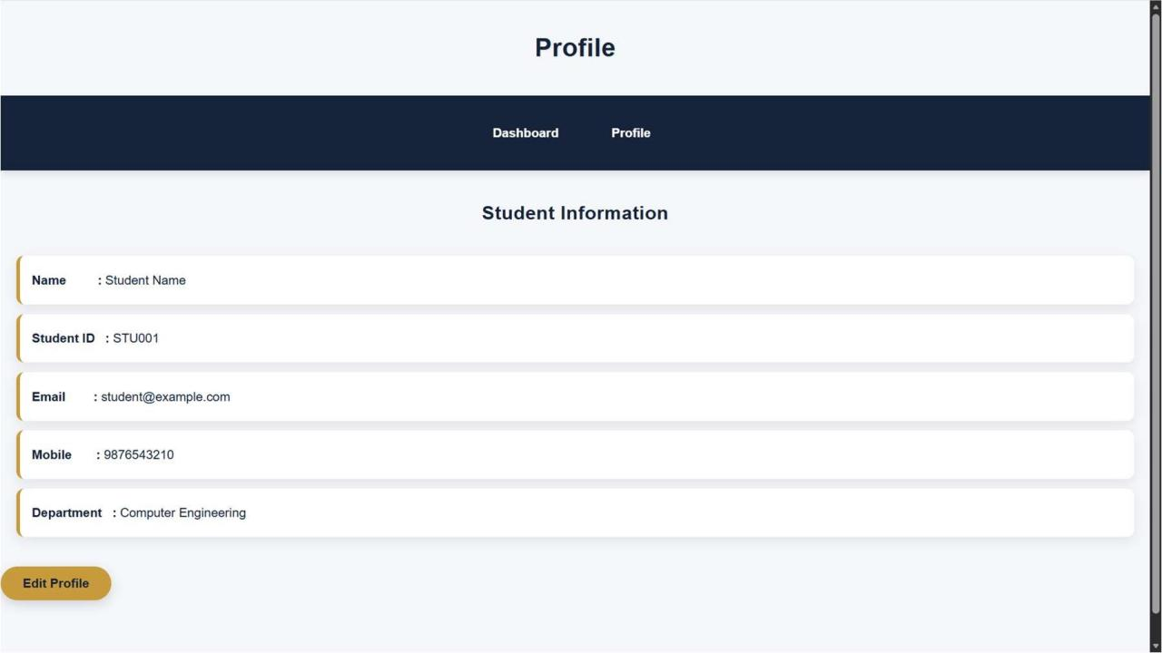

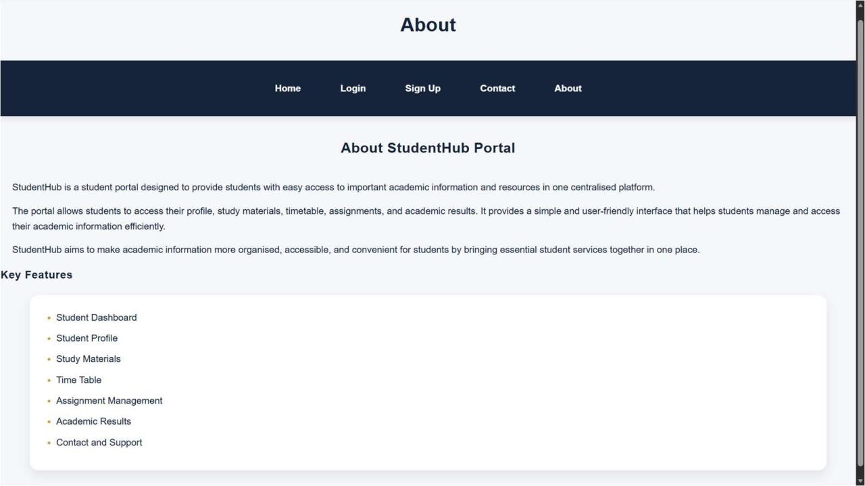

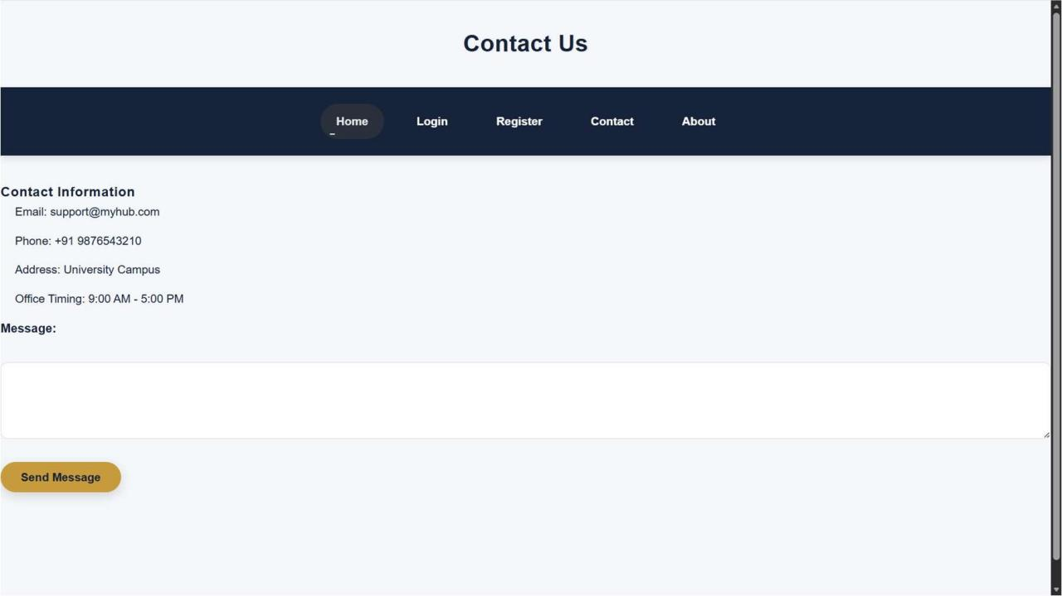

GitHub Repository Link
https://github.com/hkxii/StudentHub-Portal

Challenges Faced
I had faced challenges like making the layout responsive, adjusting spacing for different devices, setting up logo, choosing color combination, etc.
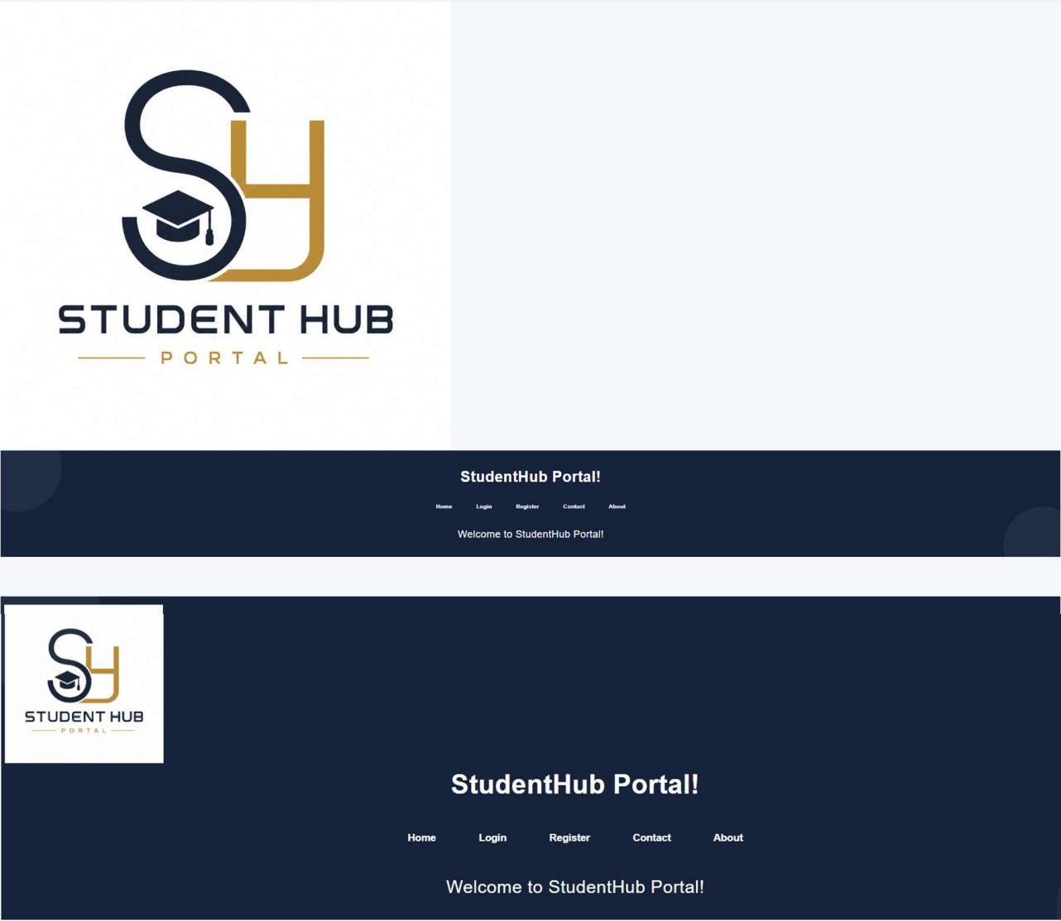


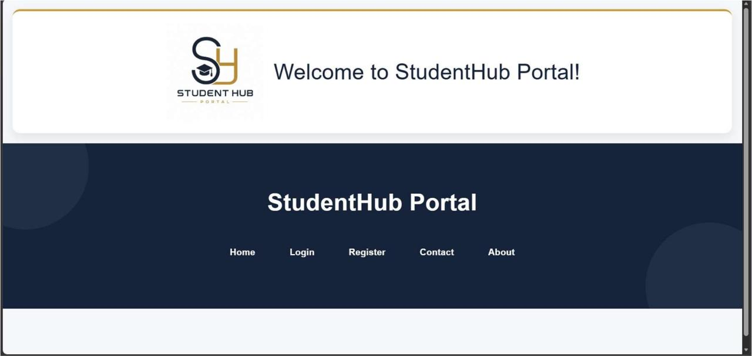

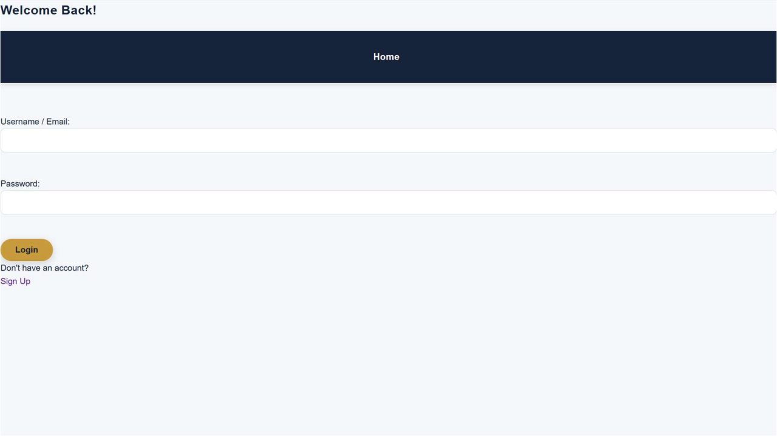

Learning Outcomes
I learned responsive web design, Bootstrap/Tailwind, improved UI design skills, How to solve problems etc.
Faculty Remarks

