Practical - 4

Practical Title: JavaScript DOM Manipulation, Event Handling, and UI Interactivity
Problem Definition: Add dynamic UI components such as collapsible FAQ, modal popup, image/content slider, notification banner, hamburger menu, and light/dark
theme switcher using JavaScript.

Theory
  - . How are DOM elements selected and modified?
Answer: JavaScript selects HTML elements using DOM methods and changes their classes or styles.

  - Are event listeners attached correctly?
Answer: Yes, an event listener is added to the theme switcher button to change the theme when clicked.

  - Is localStorage used for remembering theme choice?
Answer: Yes, localStorage saves the selected theme so it remains after refreshing or reopening the page.

  - Does interactivity improve usability without breaking accessibility?
Answer: Yes, the theme switcher makes the website more user-friendly and provides a comfortable viewing experience without affecting basic accessibility.

Implementation/ Output/Result

DOM Selection & Dynamic Node Creation
document.querySelector() / querySelectorAll(): Used to select single or multiple UI elements from the DOM, such as buttons, tables, forms, and accordion triggers.
document.createElement(): Generates dynamic HTML elements programmatically without hardcoding them in HTML, such as creating a theme button, hamburger toggle, or notification banner.
element.appendChild() / prepend(): Injects dynamically created elements at the top or bottom of container elements.

Event Handling & Listener Logic
addEventListener("click", callback): Listens for user click interactions on hamburger icons, modal buttons, slide controls, and theme toggles.
addEventListener("DOMContentLoaded", callback): Delays script execution until the browser finishes loading the full HTML DOM tree.
e.preventDefault(): Prevents default browser actions, such as form submission or jump-to-top anchor link clicks.

Class Manipulation & Animation Control
element.classList.toggle(): Switches state classes on and off, such as toggling .sidebar-open on <body> or .open on FAQ accordion cards.
element.classList.add() / remove(): Manages modal visibility states such as .active or slider dot highlights.
element.style.maxHeight / transform: Applies inline CSS adjustments for accordion heights using scrollHeight and sliding slide tracks using translateX.

Browser Storage APIs (Preferences & State)
localStorage.setItem('key', value) / getItem('key'): Stores user UI preferences in the browser so light/dark mode choices persist across page reloads.
sessionStorage.setItem('key', value): Remembers temporary states, such as keeping a dismissed notification banner hidden until the browser tab closes.

Timers & Dataset Attributes
setInterval() / clearInterval(): Handles automatic timer loops for auto-playing image sliders and resets the loop when navigation buttons are clicked.
element.dataset: Reads custom data-* HTML attributes, such as data-modal-target="#myModal", to dynamically identify which modal popup to open.

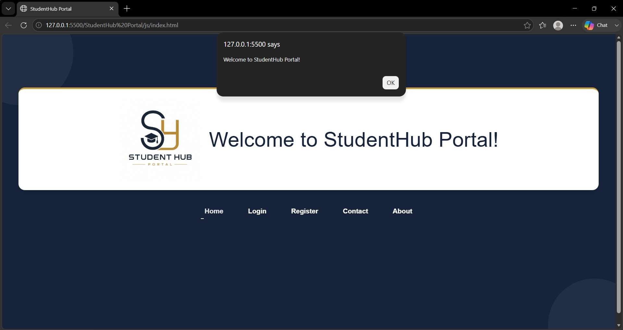
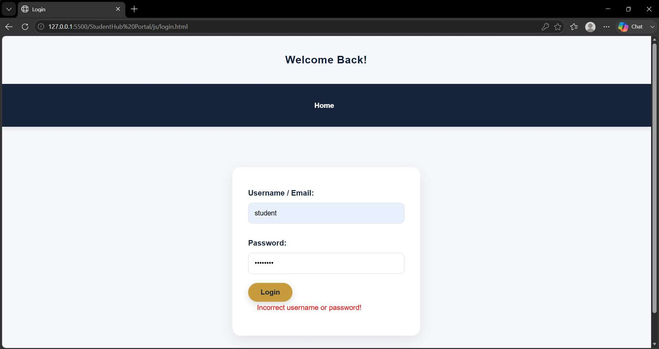
Evidence of Work (Screenshots)

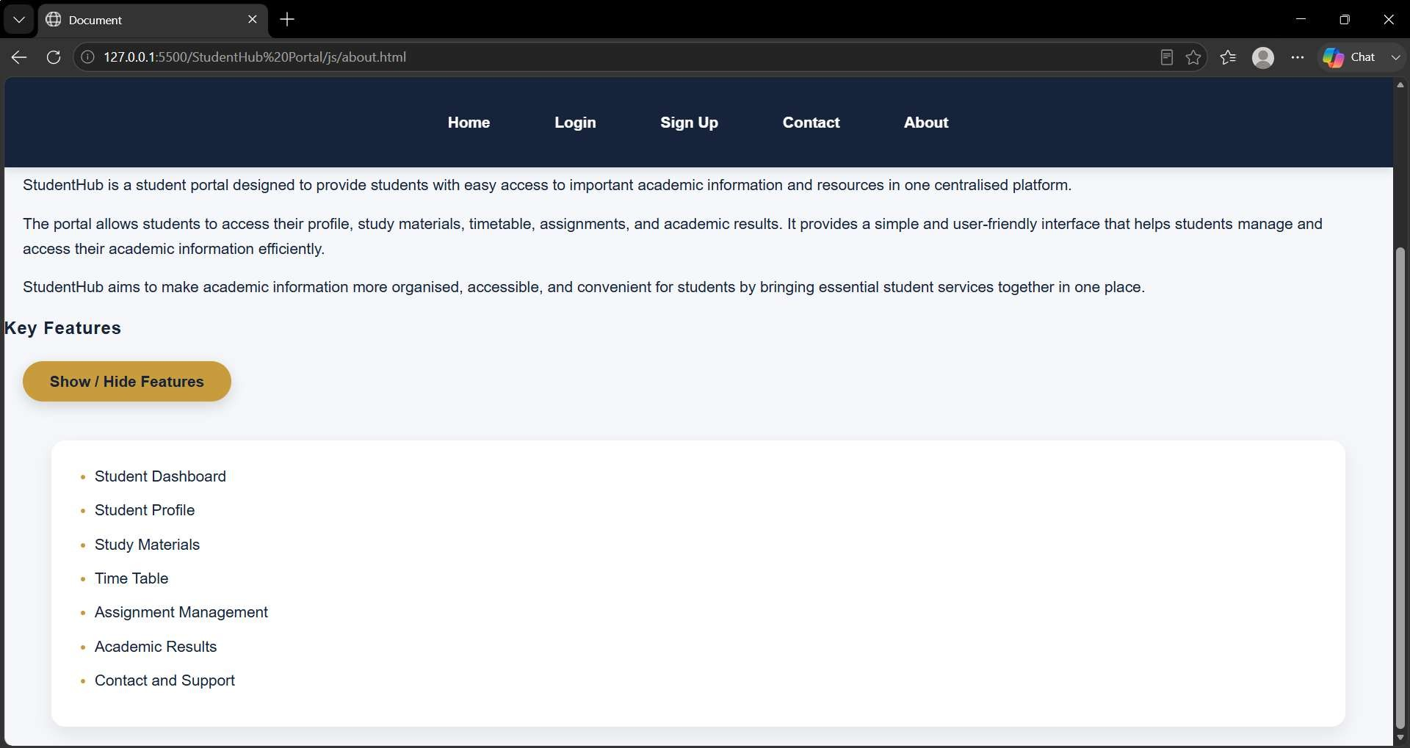
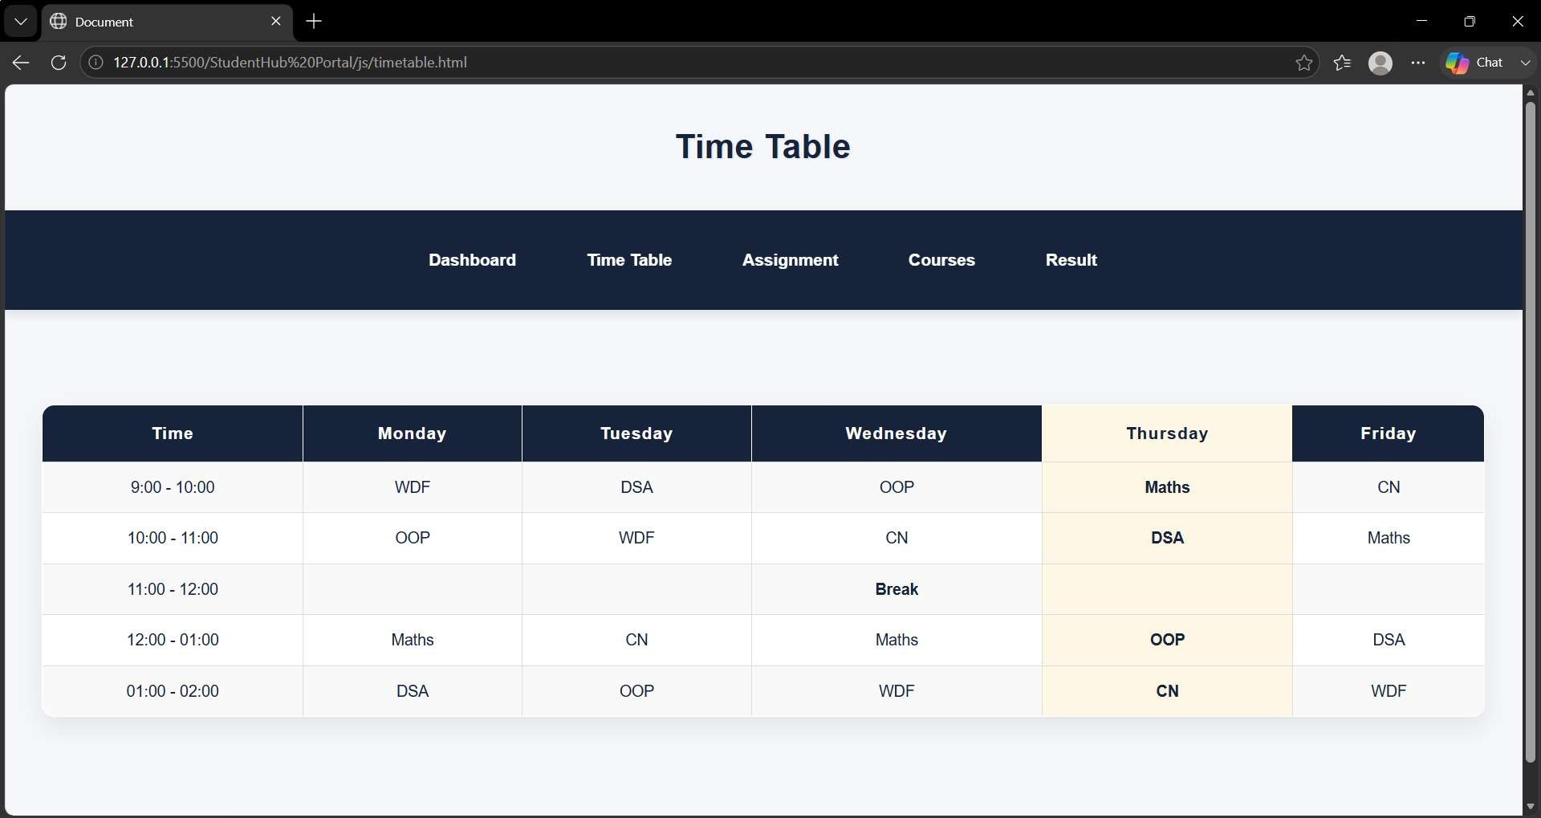

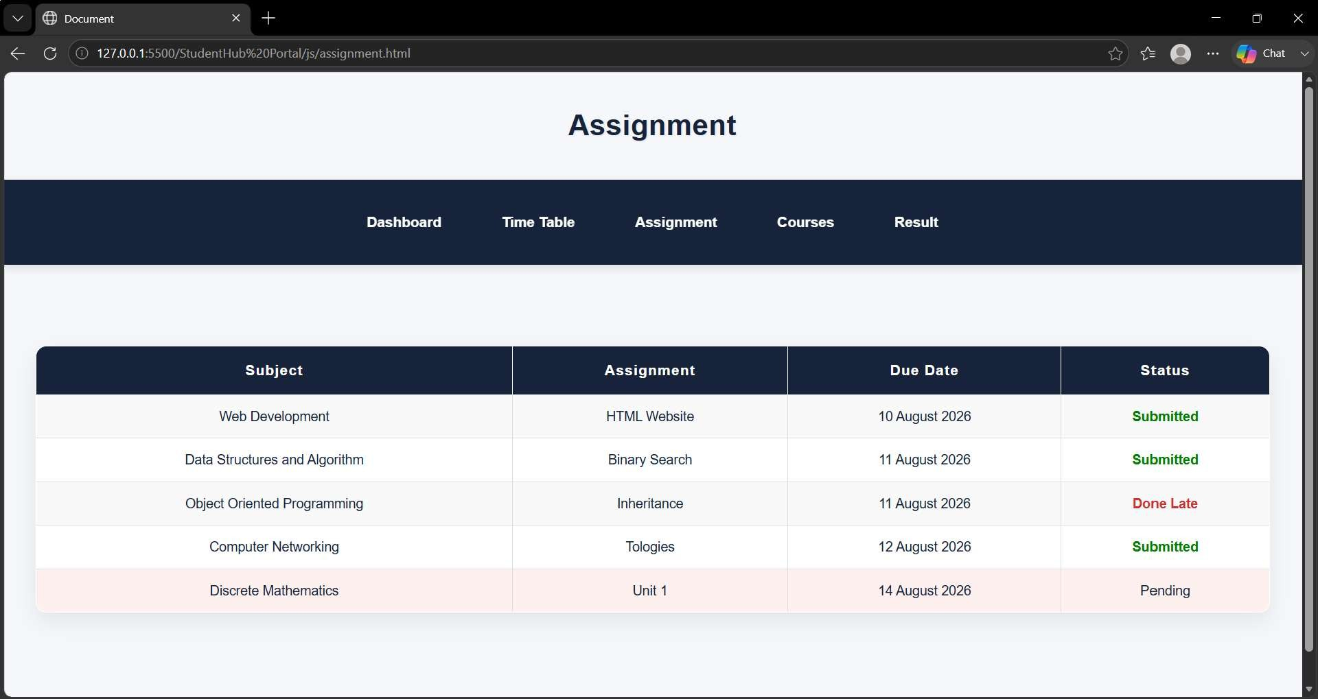
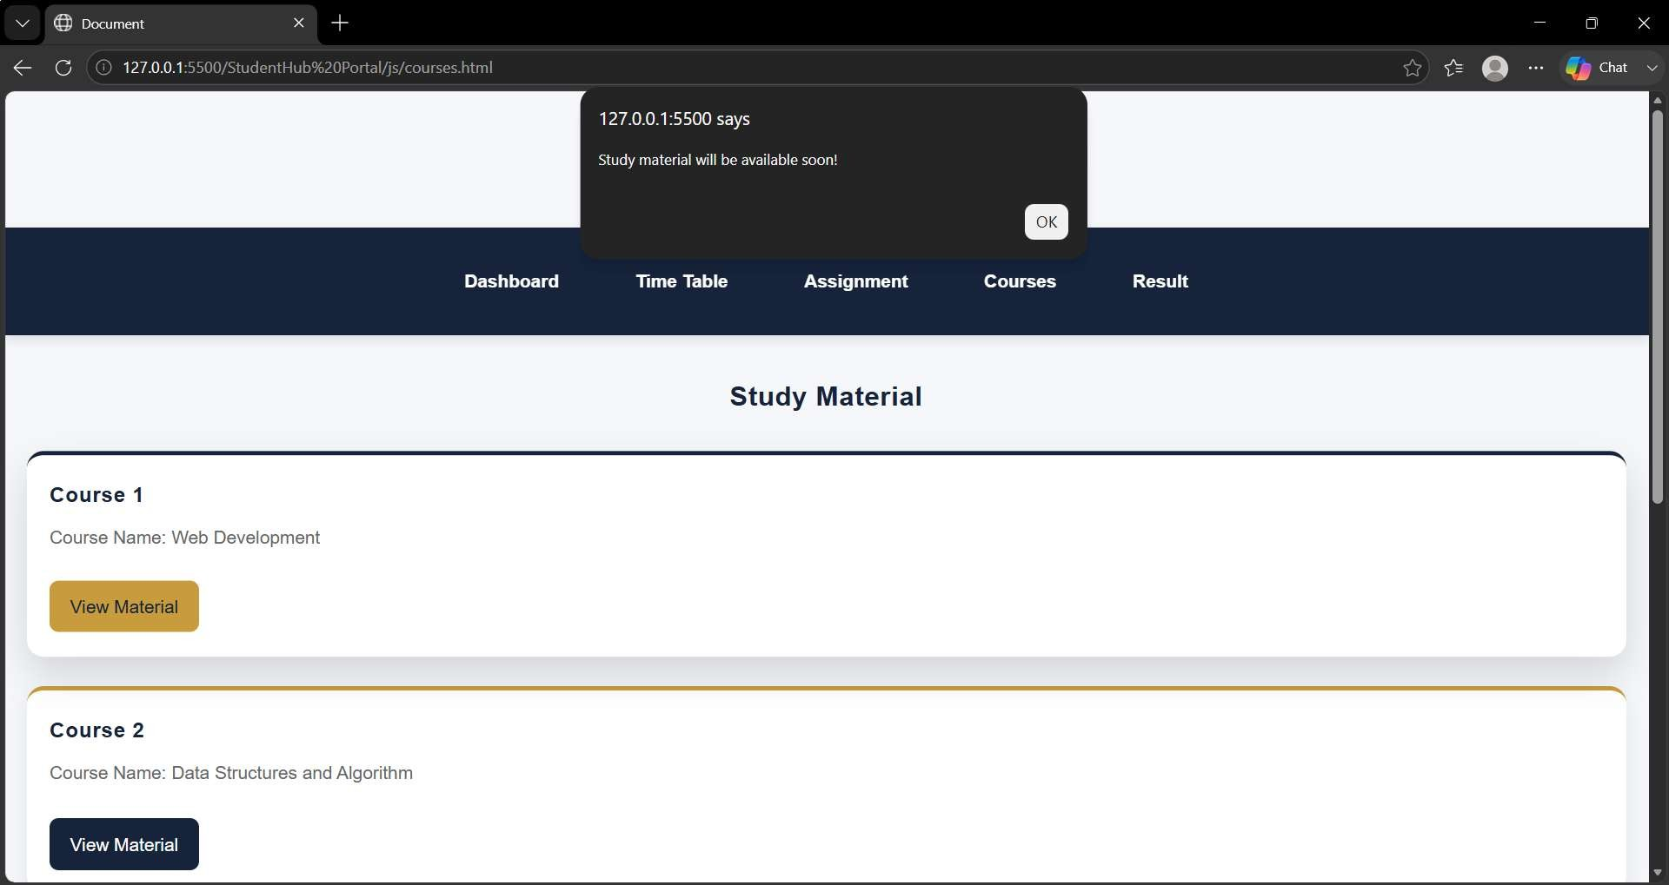

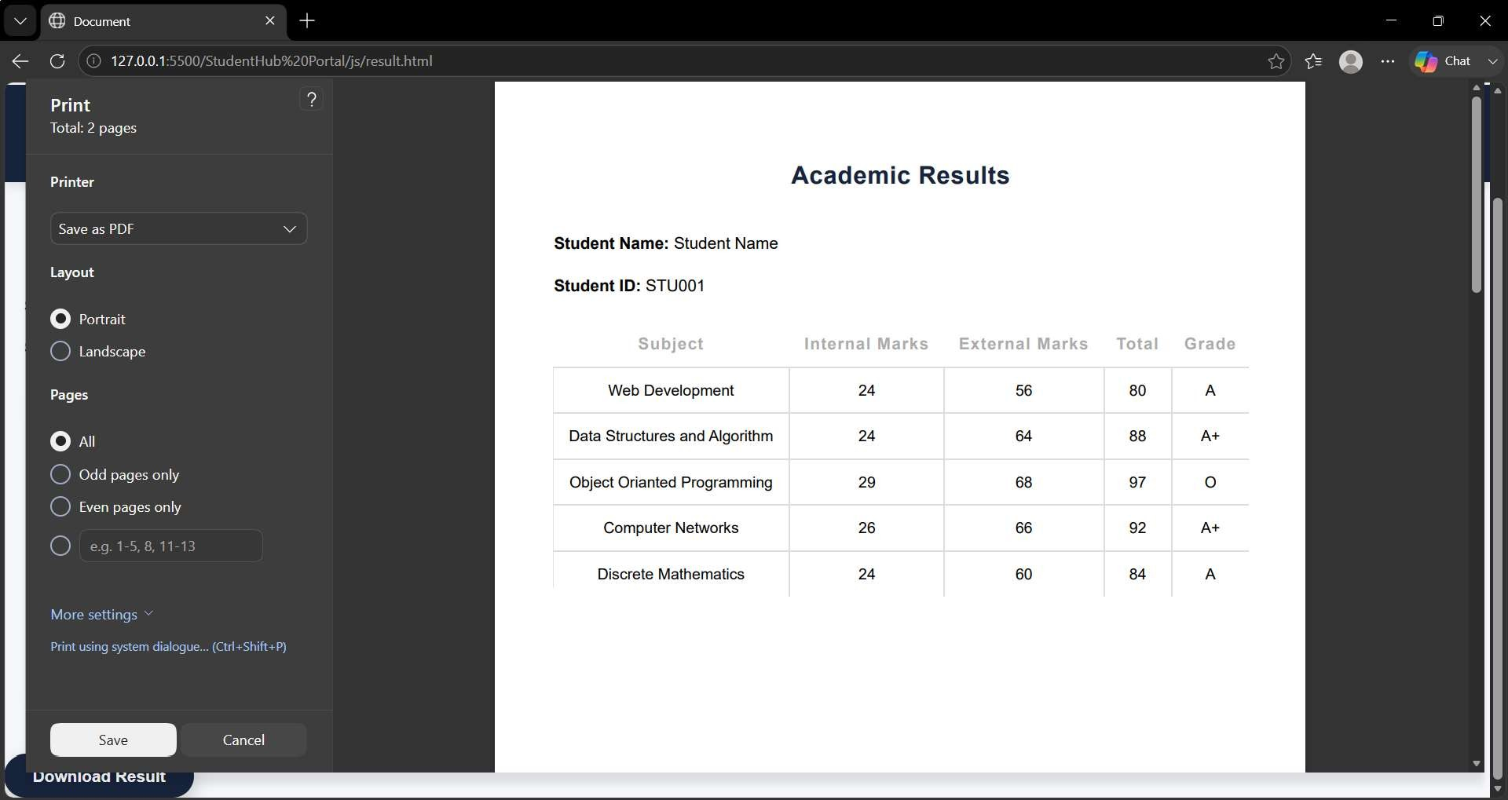
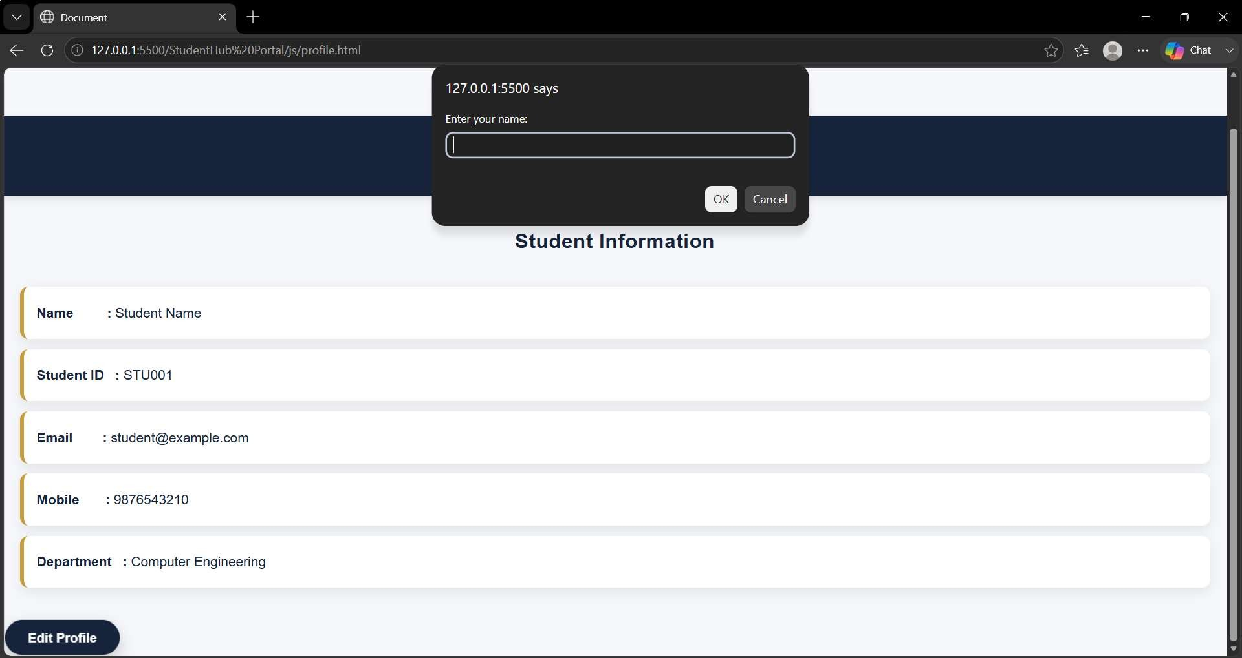

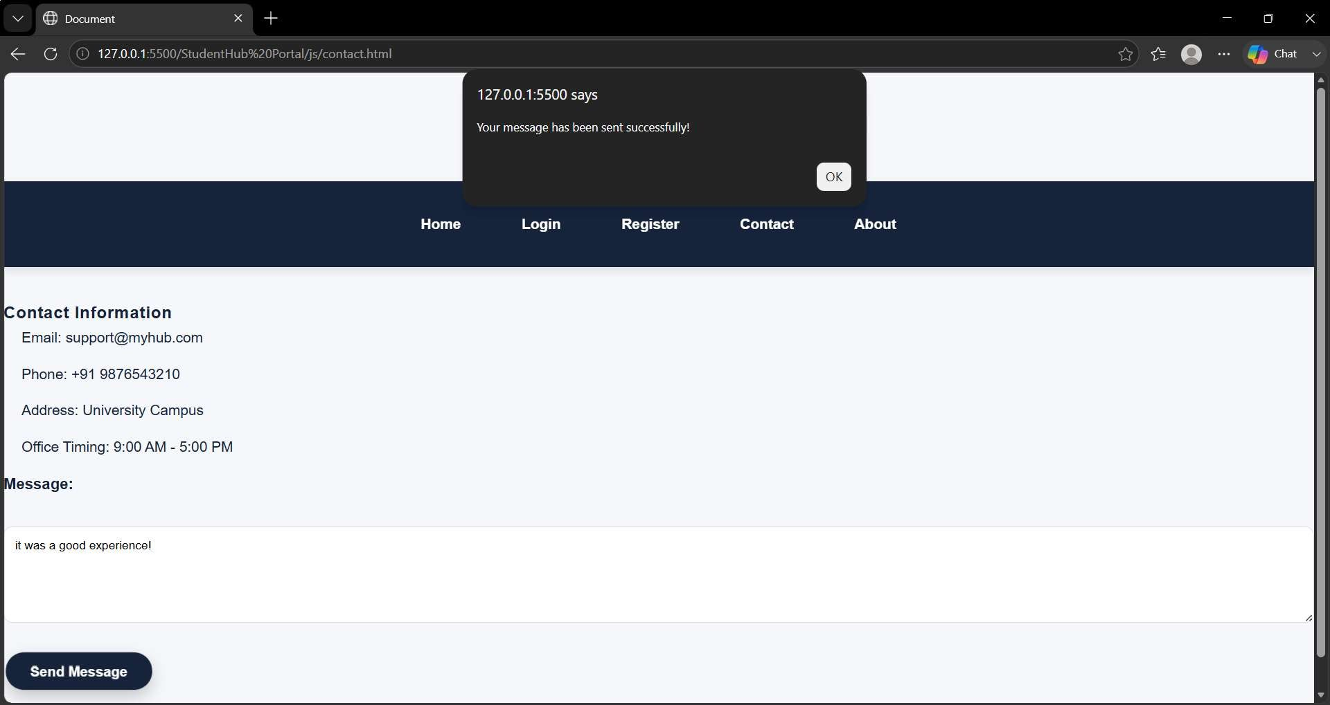
- GitHub Repository Link:
https://github.com/Hetvi-K12/StudentHub-Portal

Challenges Faced:
While implementing JavaScript features, I faced challenges in DOM selection and event handling. Managing localStorage, theme switching, modals, sliders, and dynamic elements was initially difficult. I also faced issues with CSS classes, timers, and debugging JavaScript errors, but solving these helped me understand JavaScript better.

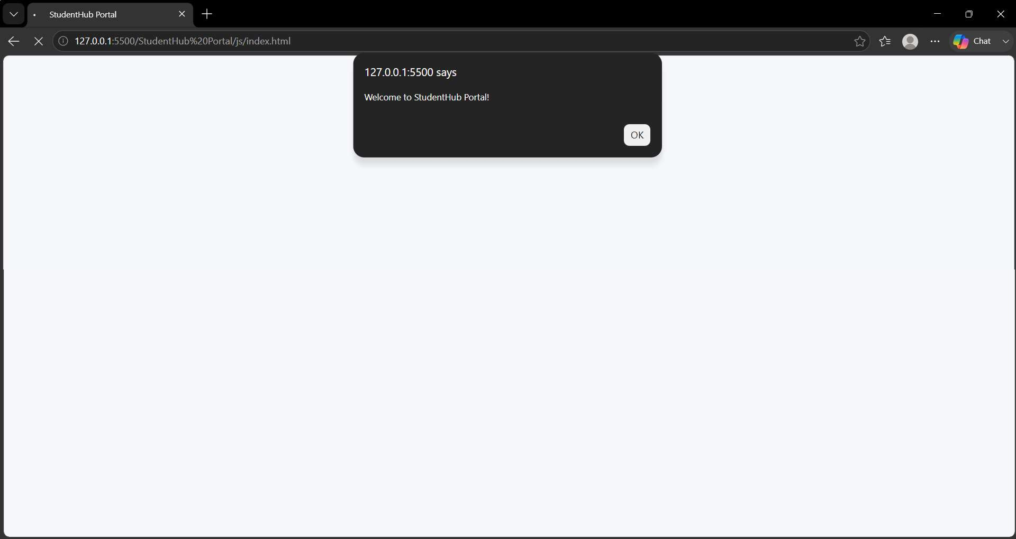

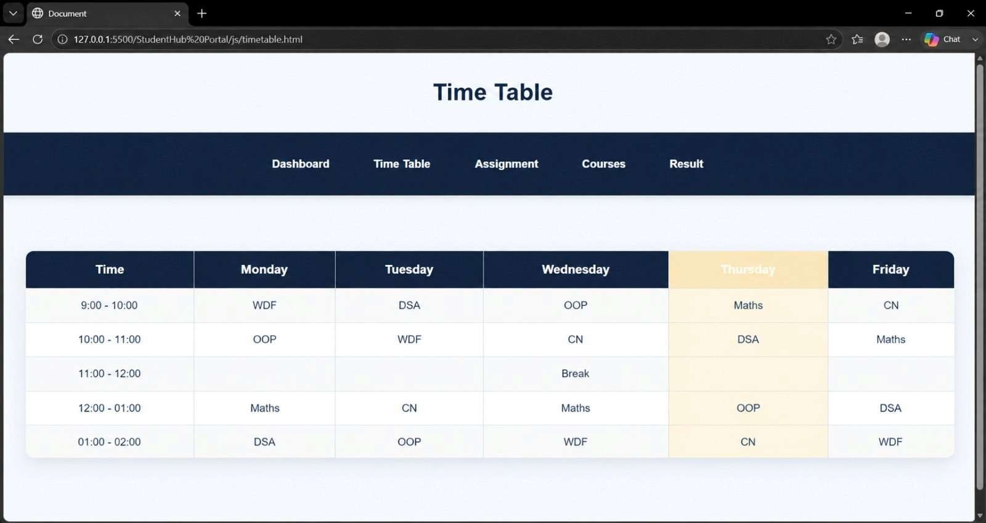
Learning Outcomes:
I faced challenges with the alert messageas it blocked the page until I clicked “OK” due to which my homepage was not visible and making the JavaScript welcome message appear automatically. and I also faced issues with the font color not being clearly visible in the highlighted row and implementing day-wise row highlighting.

