Practical 5

- Theory

Are correct input types and attributes used?
Answer: Yes. HTML5 input types and suitable attributes are used for fields such as email, mobile number, password, and other registration details.

Are validation errors displayed near the relevant fields?
Answer: Yes. Validation errors should be displayed near the relevant fields so that users can easily identify and correct invalid input.

Is password strength checked?
Answer: Yes. Password strength is checked during validation to ensure that the entered password meets the required conditions.

Is the form accessible using keyboard and screen-reader-friendly labels?
Answer: Yes. Proper labels and accessible form controls help users navigate the form using a keyboard and screen readers.
- Implementation / Output / Result
let loginForm = document.getElementById("loginForm"); if (loginForm && !loginForm.getAttribute("action")) {
loginForm.addEventListener("submit", function(event) { event.preventDefault();
let username = document.getElementById("username").value.trim(); let password = document.getElementById("password").value.trim();
let message = document.getElementById("message"); let usernameRegex = /^25DCE\d{3}$/;
let passwordRegex = /^charusat@\d{3}$/;

if (usernameRegex.test(username) &&

passwordRegex.test(password)) {

message.innerHTML = "Login successful!"; message.style.color = "green";

setTimeout(function() {

window.location.href = "dashboard.html";

}, 200);

}

else {

message.innerHTML = "Incorrect username or password!"; message.style.color = "red";

}

});
}

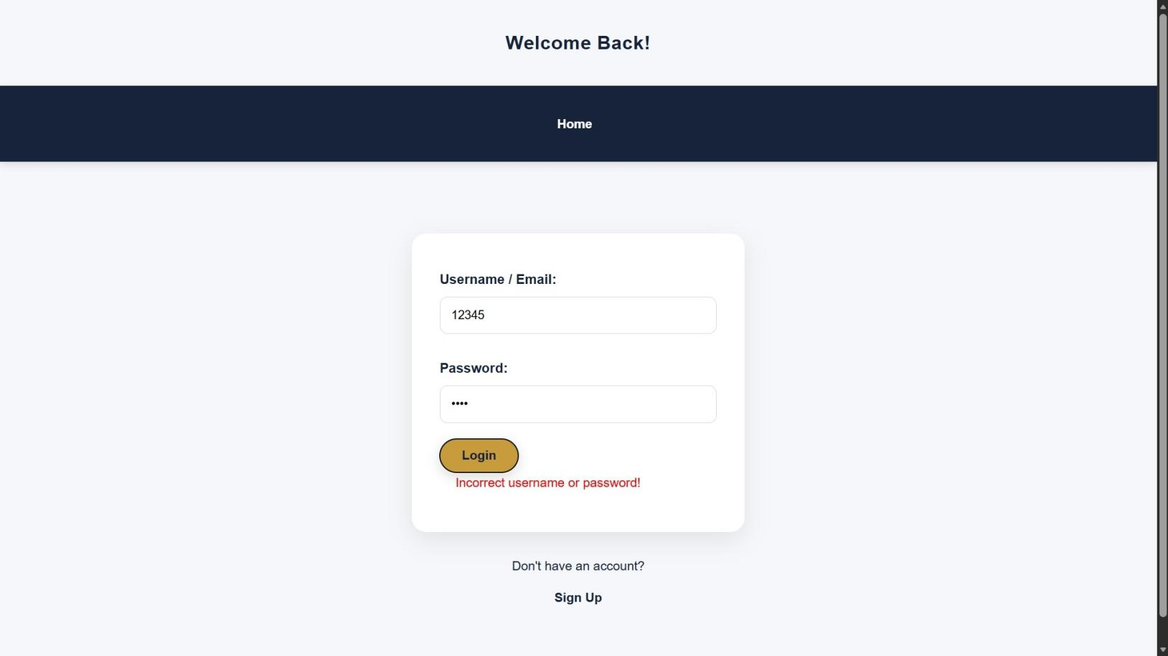
- Evidence of Work (Screenshots)

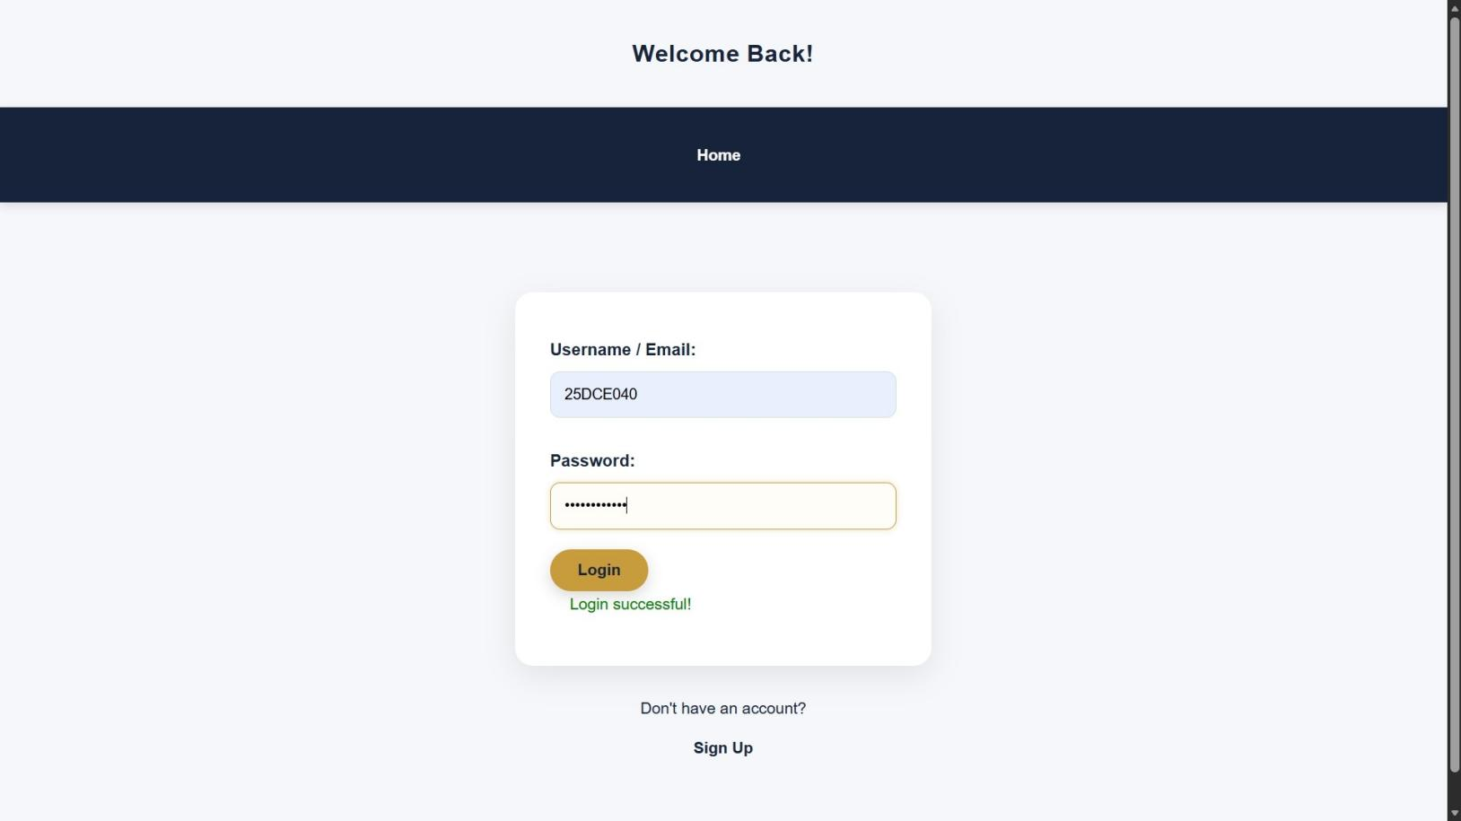

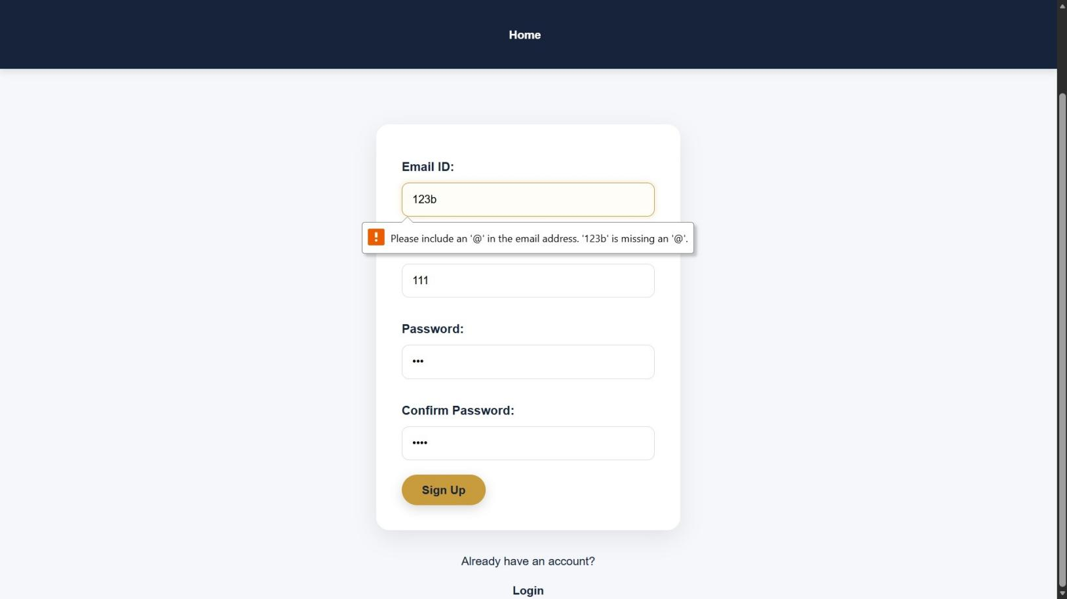

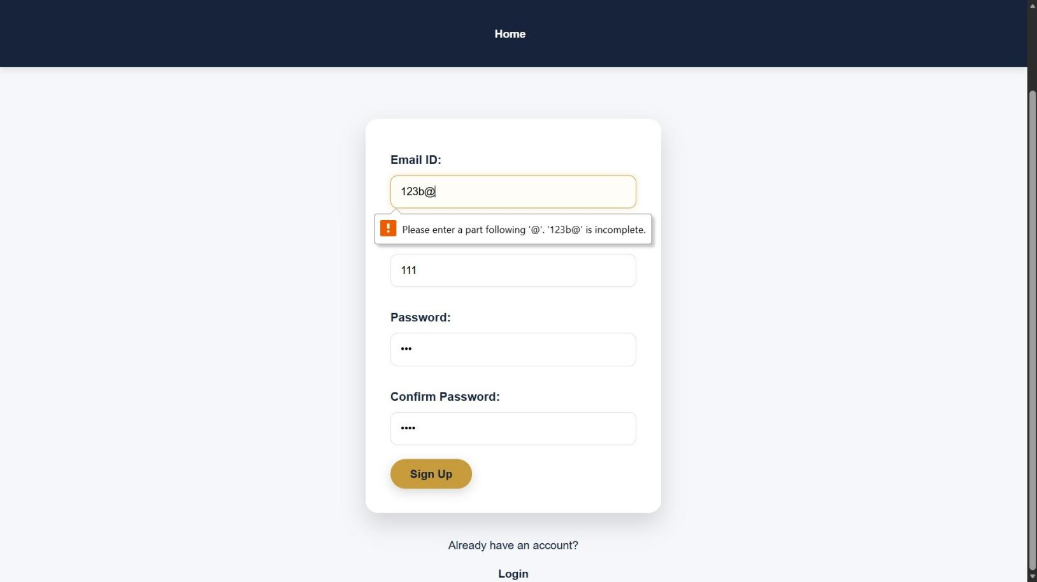
- GitHub Repository Link:
https://github.com/Hetvi-K12/StudentHub-Portal/tree/main/Practical5

- Challenges Faced:
I faced some difficulty in applying JavaScript validation to all form fields and writing the correct regular expressions. I also had challenges in displaying error messages near the relevant fields and checking password strength. After testing valid and invalid inputs, I fixed the validation issues.

- Learning Outcomes:
I learned how to create a student registration form using HTML5 and validate form data using JavaScript. I also learned how to use regular expressions, password strength validation, accessible labels, and user-friendly error messages.
Faculty Remarks:

