Practical 6:
- Theory

How is JSON fetched, parsed, and rendered?
Answer: JSON data is fetched using the Fetch API. The response is converted into JavaScript objects using response.json(), and the data is rendered dynamically in the HTML using JavaScript and array methods such as map().

Which array methods are used for search, filter, sort, and pagination?
Answer: filter() is used to search and filter records, sort() is used to arrange records, and slice() can be used to display a selected set of records for pagination. map() is used to create the rendered HTML elements.

How are loading and error states handled?
Answer: A loading message is displayed while the JSON data is being fetched. If the request fails, an error message is displayed using error handling with catch().

How is modularity maintained in JavaScript files?
Answer: Modularity is maintained by separating the main tasks into reusable functions, such as data fetching, rendering, searching, filtering, sorting, and pagination. This makes the JavaScript code easier to understand and maintain.
- Implementation / Output / Result
[
{
"subject": "Web Development", "assignment": "HTML Website", "dueDate": "18 August 2026", "status": "Submitted"
},
{
"subject": "Data Structures and Algorithm", "assignment": "Binary Search",
"dueDate": "20 August 2026", "status": "Submitted"
},
{
"subject": "Object Oriented Programming", "assignment": "Inheritance",

"dueDate": "15 August 2026", "status": "Done Late"
},
{
"subject": "Computer Networking", "assignment": "Topologies", "dueDate": "22 August 2026", "status": "Pending"
},
{
"subject": "Discrete Mathematics", "assignment": "Unit 1",
"dueDate": "12 August 2026", "status": "Submitted"
},
{
"subject": "Web Development", "assignment": "CSS Styling", "dueDate": "25 September 2026", "status": "Pending"
},
{
"subject": "Data Structures and Algorithm", "assignment": "Sorting Algorithms", "dueDate": "10 September 2026",
"status": "Submitted"
},
{
"subject": "Object Oriented Programming", "assignment": "Inheritance",
"dueDate": "20 September 2026", "status": "Pending"
}
]

- Evidence of Work (Screenshots)

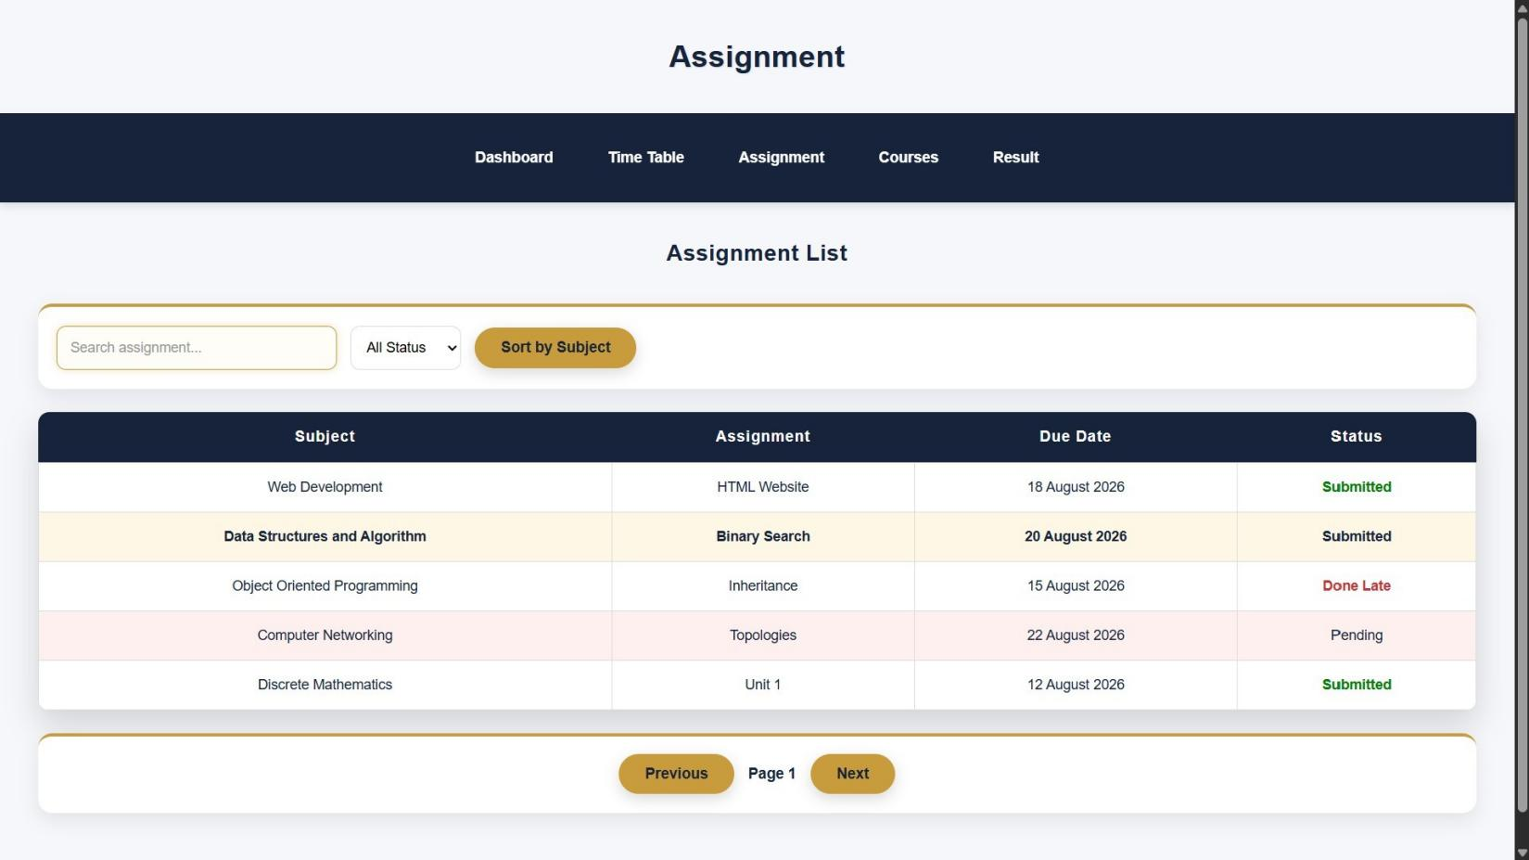
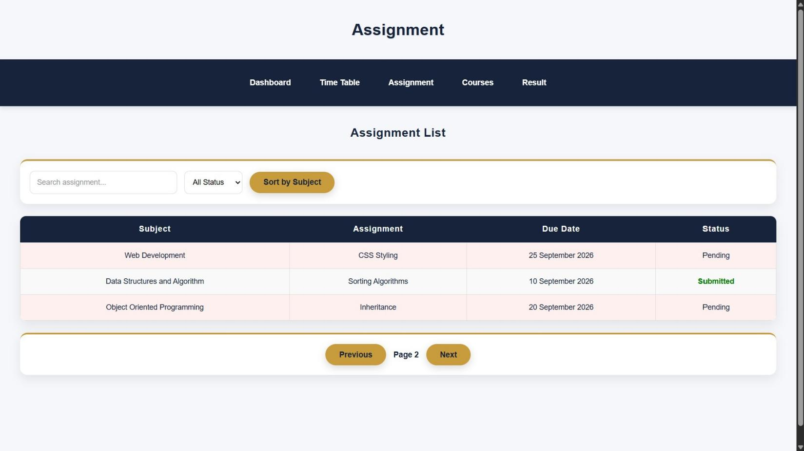

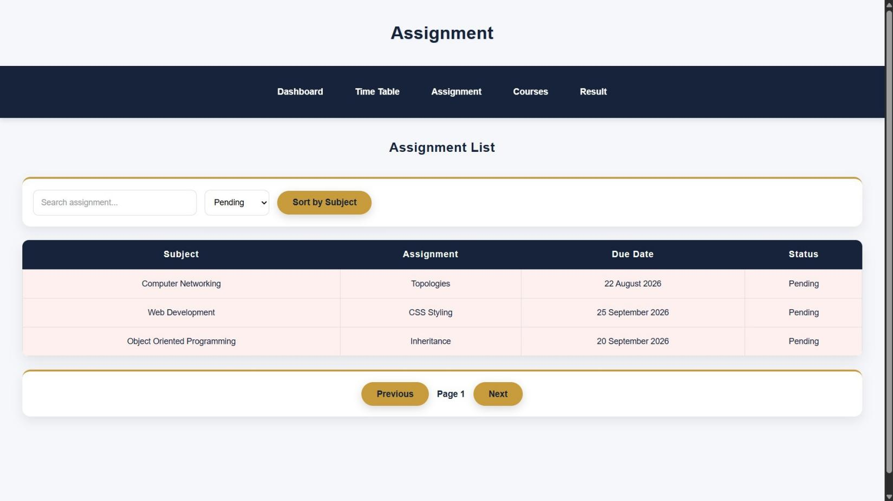
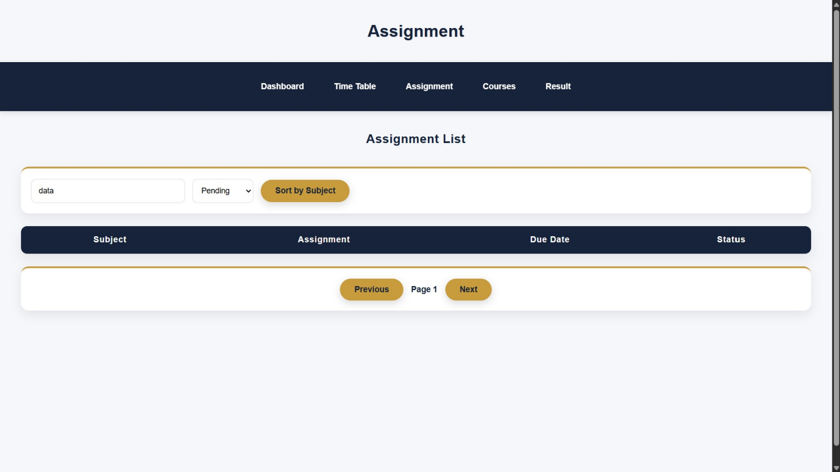

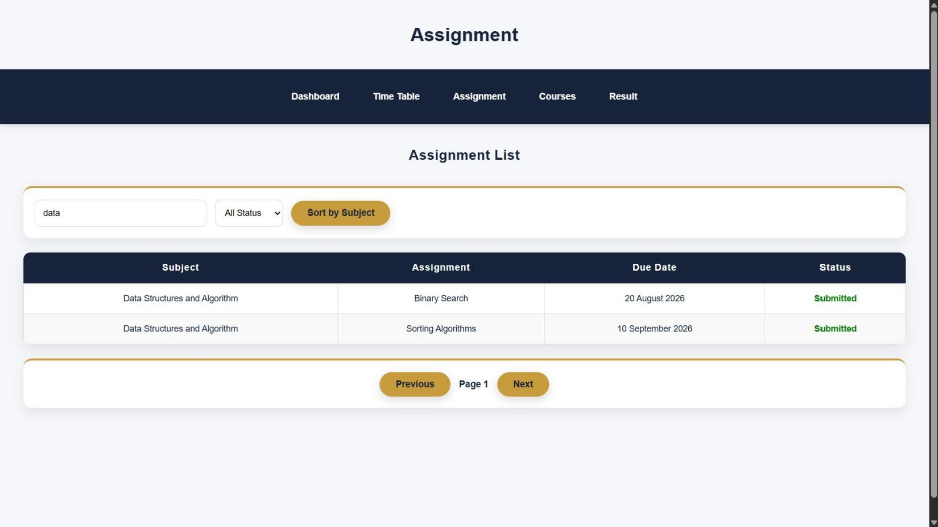
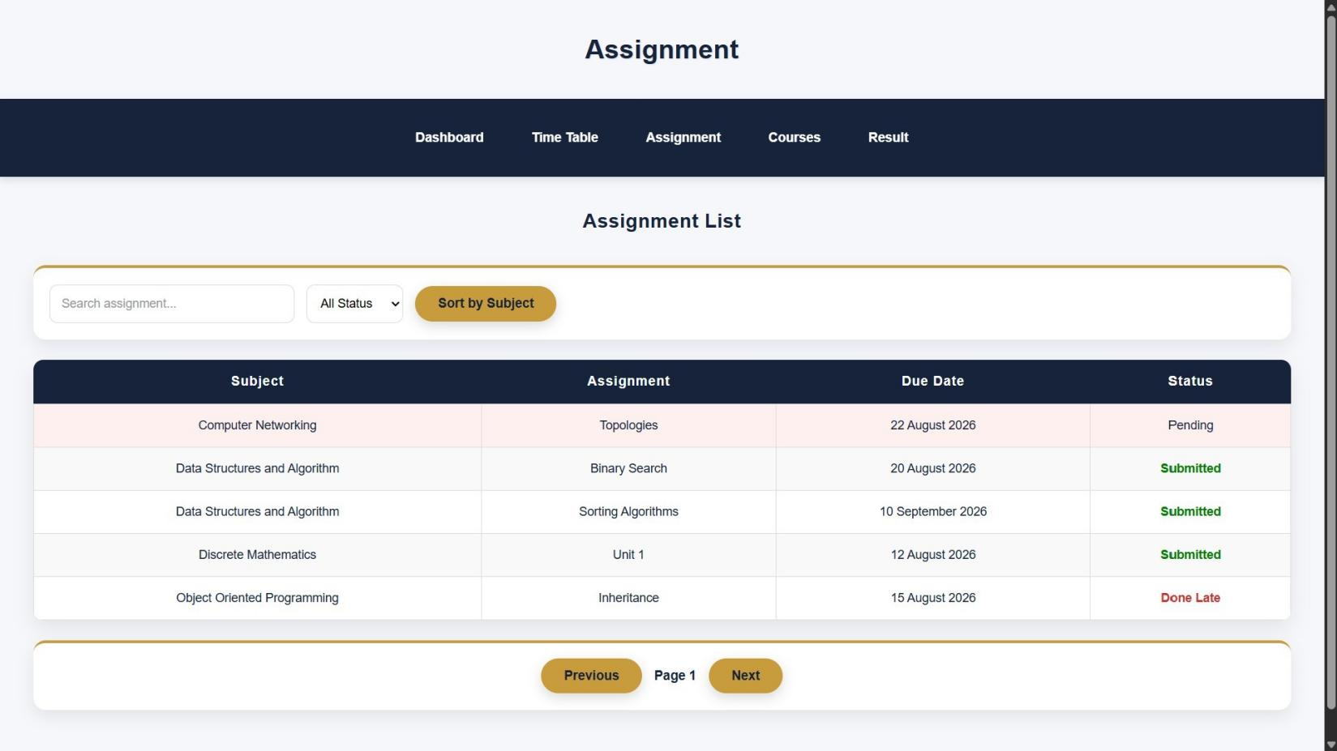

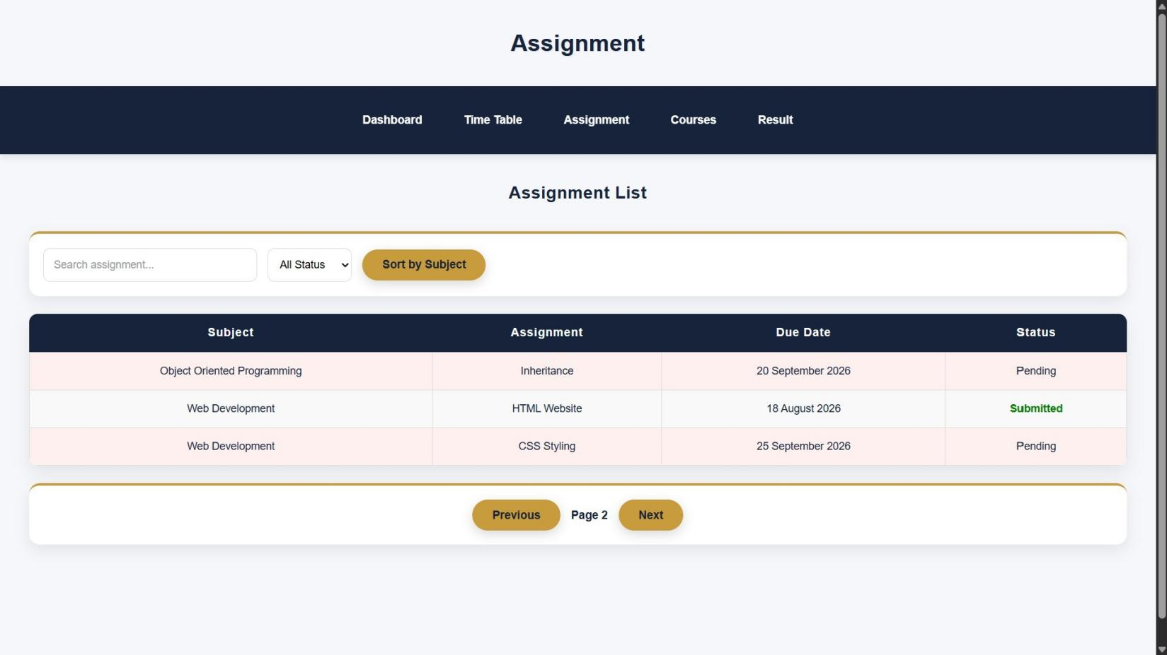
- GitHub Repository Link:
https://github.com/Hetvi-K12/StudentHub-Portal/tree/main/Practical6

- Challenges Faced:
I faced some difficulty in fetching the JSON file and displaying student data. I also faced problems while implementing search, filter, sorting.

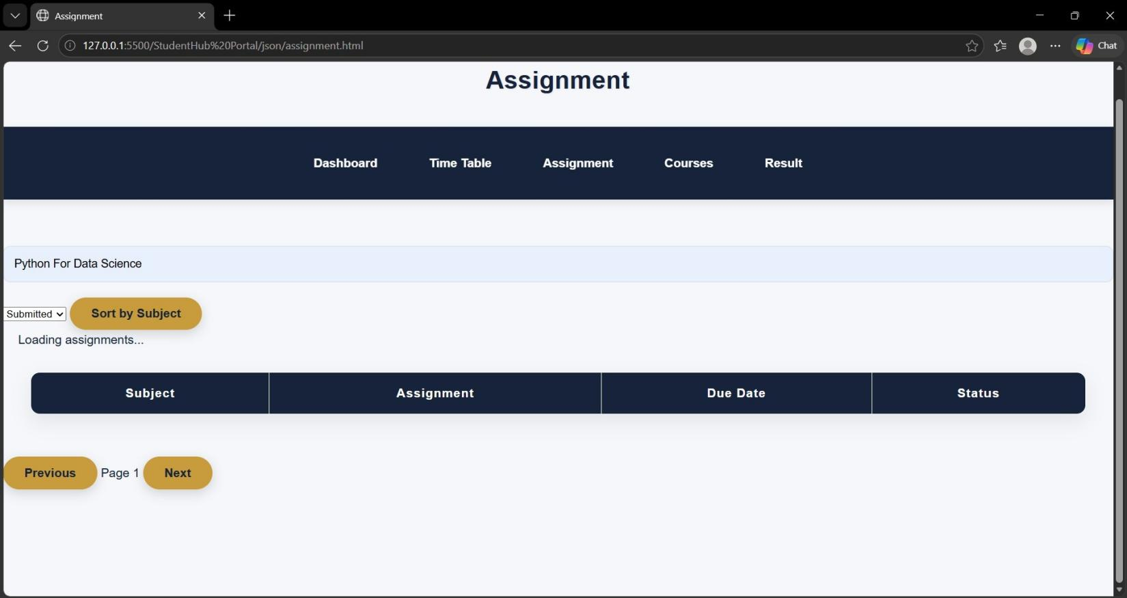
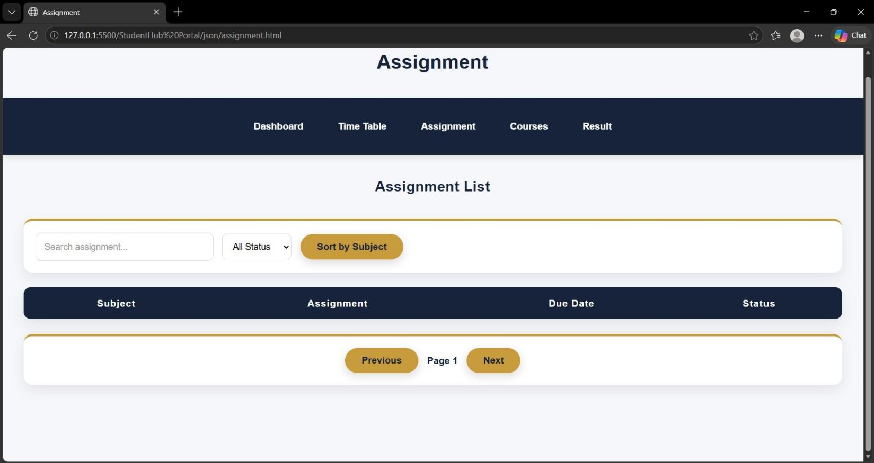

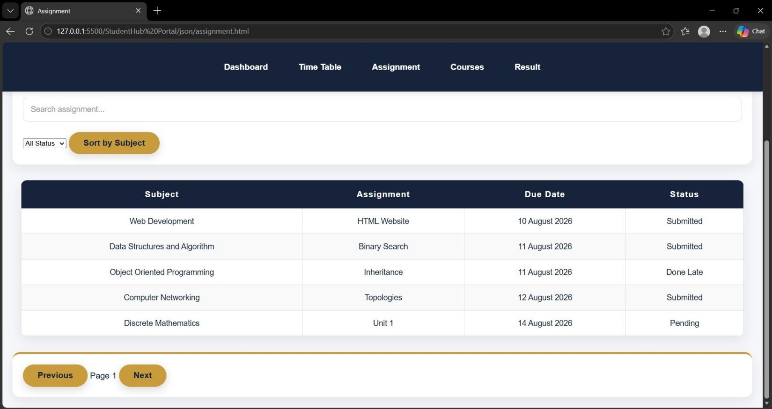
- Learning Outcomes:
I learned how to fetch JSON data using Fetch API and display it on a webpage. I also learned how to use JavaScript for search, filter, sorting.
Faculty Remarks:

