Practical 7

- Theory

Is the form submitted using POST?
Answer: Yes. The form data is received using the POST method and processed on the server.

Are inputs validated and sanitized server side?
Answer: Yes. Required fields are checked and the input values are sanitized before storing or displaying them.

Is file writing handled safely?
Answer: Yes. The submitted data is converted into JSON and stored in a JSON file using PHP file handling functions.

Are success and error responses displayed clearly?
Answer: Yes. A success message is shown when the data is stored correctly, and an error message is shown if saving fails.
- Implementation / Output / Result
Register.php
<?php
$message = '';
$status = '';
$email = '';
$mobile = '';

if ($_SERVER['REQUEST_METHOD'] === 'POST') {
$email = isset($_POST['email']) ? trim($_POST['email']) : '';
$mobile = isset($_POST['mobile']) ? trim($_POST['mobile']) : '';
$password = isset($_POST['password']) ? $_POST['password'] : '';
$confirm_password = isset($_POST['confirm_password']) ? $_POST['confirm_password'] : ''; if (empty($email)) {
$status = 'error';
$message = 'Registration Failed! Email address is required.';
} elseif (!filter_var($email, FILTER_VALIDATE_EMAIL)) {
$status = 'error';
$message = 'Registration Failed! Please enter a valid email address.';
} elseif (strlen($password) < 8) {
$status = 'error';
$message = 'Registration Failed! Password must be at least 8 characters long.';
} elseif ($password !== $confirm_password) {

$status = 'error';
$message = 'Password and Confirm Password do not match.';
} else {
$hashed_password = password_hash($password, PASSWORD_DEFAULT);
$timestamp = date('Y-m-d H:i:s');
$csv_file = DIR . '/registrations.csv';
$file_exists = file_exists($csv_file);
$is_empty = !$file_exists || filesize($csv_file) === 0;
$fp = fopen($csv_file, 'a'); if ($fp !== false) {
if ($is_empty) {
fputcsv($fp, ['Email', 'Mobile', 'Password', 'Timestamp']);
}
fputcsv($fp, [$email, $mobile, $hashed_password, $timestamp]); fclose($fp);
$status = 'success';
$message = 'Registration successful!';
$email = '';
$mobile = '';
} else {
$status = 'error';
$message = 'Unable to write to registrations.csv file.';
}
}
}
?>
<!DOCTYPE html>
<html lang="en">
<head>
<meta charset="UTF-8">
<meta name="viewport" content="width=device-width, initial-scale=1.0">
<title>Register</title>
<link rel="stylesheet" href="../css/style.css">
</head>
<body class="register">
<h1>Welcome!</h1>
<nav>
<a href = "index.html">Home</a> &nbsp;
</nav>
<br>
<?php if (!empty($message)): ?>
<div class="php-message php-<?php echo $status; ?>">
<?php echo htmlspecialchars($message); ?>
</div>
<?php endif; ?>
<form action="register.php" method="POST" novalidate>
<label>Email ID:</label>
<input type="email" name="email" value="<?php echo htmlspecialchars($email); ?>" required>
<label>Mobile Number:</label>
<input type="tel" name="mobile" value="<?php echo htmlspecialchars($mobile); ?>" required>
<label>Password:</label>
<input type="password" id="password" name="password" required>
<label>Confirm Password:</label>
<input type="password" id="confirm-password" name="confirm_password" required>
<button type="submit">Sign Up</button>
</form>
<p>Already have an account?</p>
<a href="login.html">Login</a>
<script src="script.js"></script>
</body>
</html>

Contact.php

<?php
$message = '';
$status = '';
$user_message = '';

if ($_SERVER['REQUEST_METHOD'] === 'POST') {
$user_message = isset($_POST['message']) ? trim($_POST['message']) : ''; if (empty($user_message)) {
$status = 'error';
$message = 'Submission Failed! Please enter a message.';
} else {
$timestamp = date('Y-m-d H:i:s');
$csv_file = DIR . '/contacts.csv';
$file_exists = file_exists($csv_file);
$is_empty = !$file_exists || filesize($csv_file) === 0;
$fp = fopen($csv_file, 'a'); if ($fp !== false) {
if ($is_empty) {
fputcsv($fp, ['Message', 'Timestamp']);
}
fputcsv($fp, [$user_message, $timestamp]); fclose($fp);
$status = 'success';
$message = 'Message sent successfully!';
$user_message = '';
} else {
$status = 'error';
$message = 'Unable to write to contacts.csv file.';
}
}
}
?>
<!DOCTYPE html>
<html lang="en">
<head>
<meta charset="UTF-8">
<meta name="viewport" content="width=device-width, initial-scale=1.0">
<title>Contact Us</title>
<link rel="stylesheet" href="../css/style.css">
</head>
<body>
<h1>Contact Us</h1>
<nav>
<a href = "index.html">Home</a> &nbsp;
<a href = "login.html">Login</a> &nbsp;
<a href = "register.html">Register</a> &nbsp;
<a href = "contact.html">Contact</a> &nbsp;
<a href = "about.html">About</a>
</nav>
<?php if (!empty($message)): ?>
<div class="php-message php-<?php echo $status; ?>">
<?php echo htmlspecialchars($message); ?>
</div>
<?php endif; ?>
<h3>Contact Information</h3>
<p>Email: support@myhub.com</p>
<p>Phone: +91 9876543210</p>
<p>Address: University Campus</p>

<p>Office Timing: 9:00 AM - 5:00 PM</p>
<form action="contact.php" method="POST" novalidate>
<label>Message:</label>
<br>
<textarea name="message" rows="5" cols="40"><?php echo htmlspecialchars($user_message); ?></textarea>
<br><br>
<button type="submit">Send Message</button>
</form>
<script src="script.js"></script>
</body>
</html>

- Evidence of Work (Screenshots)
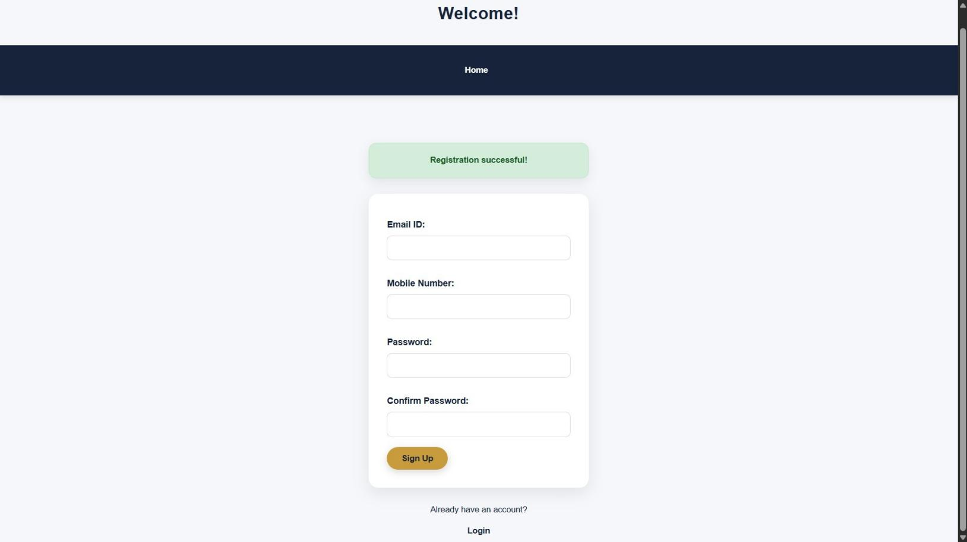

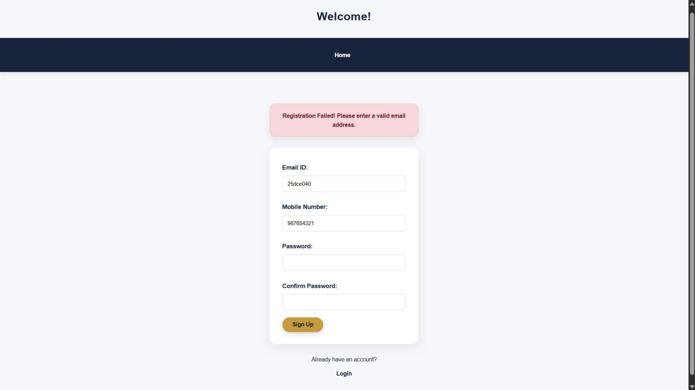
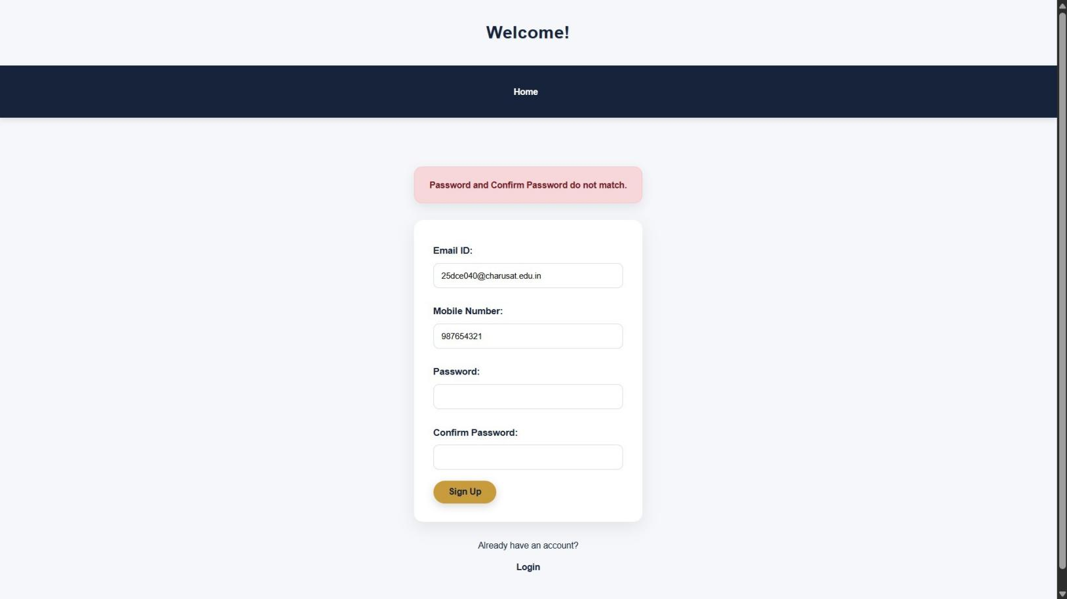

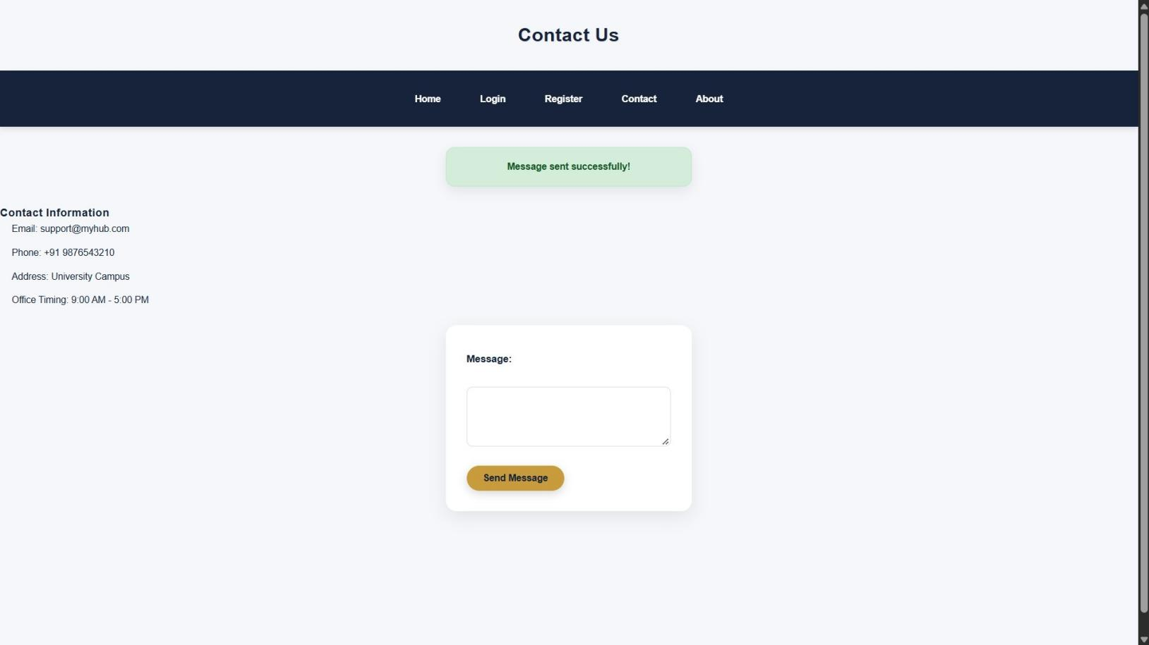
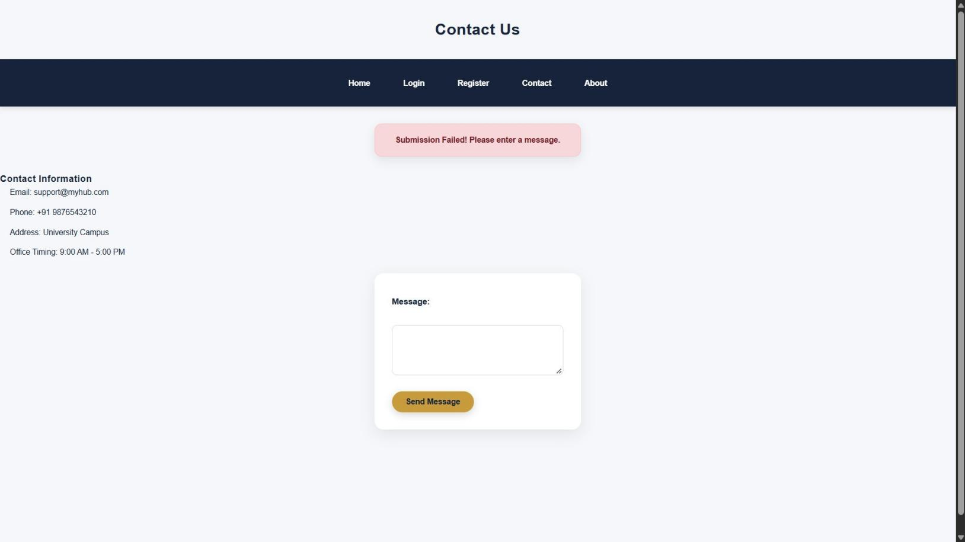

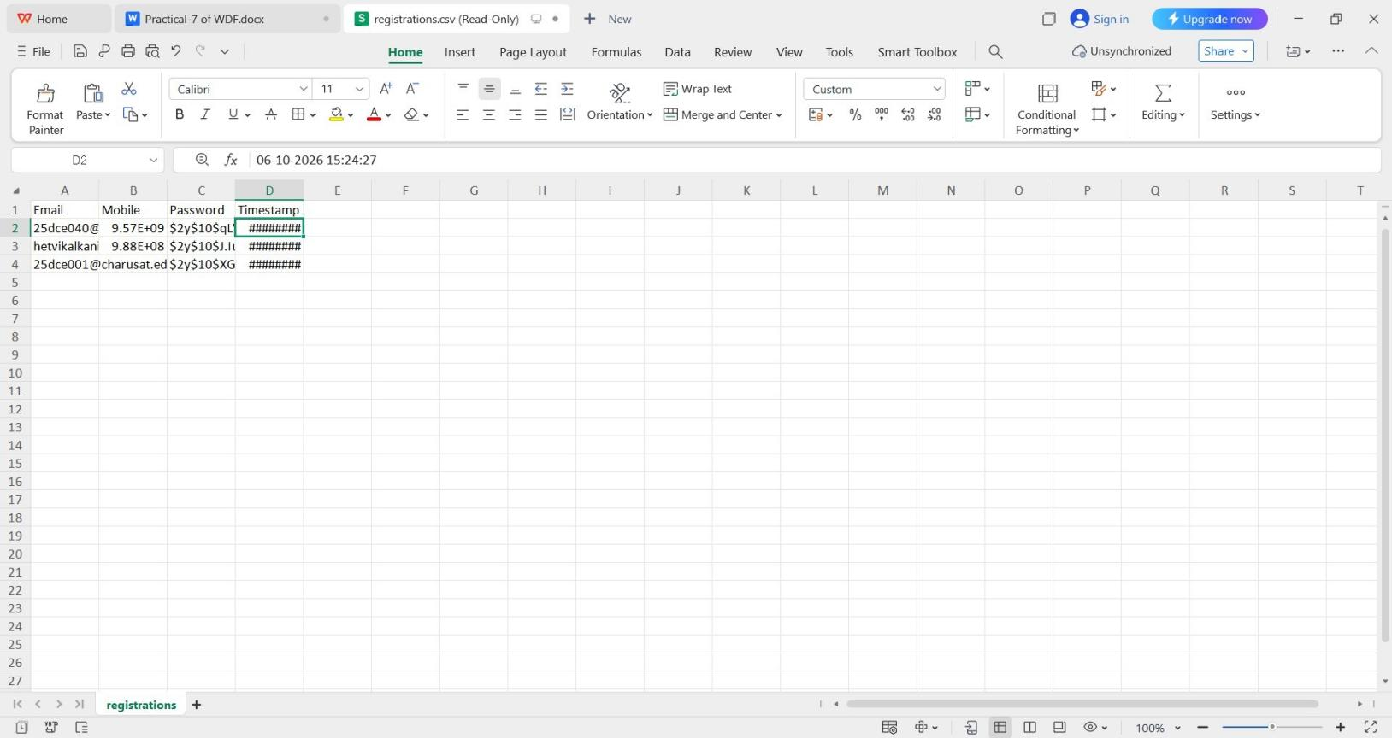
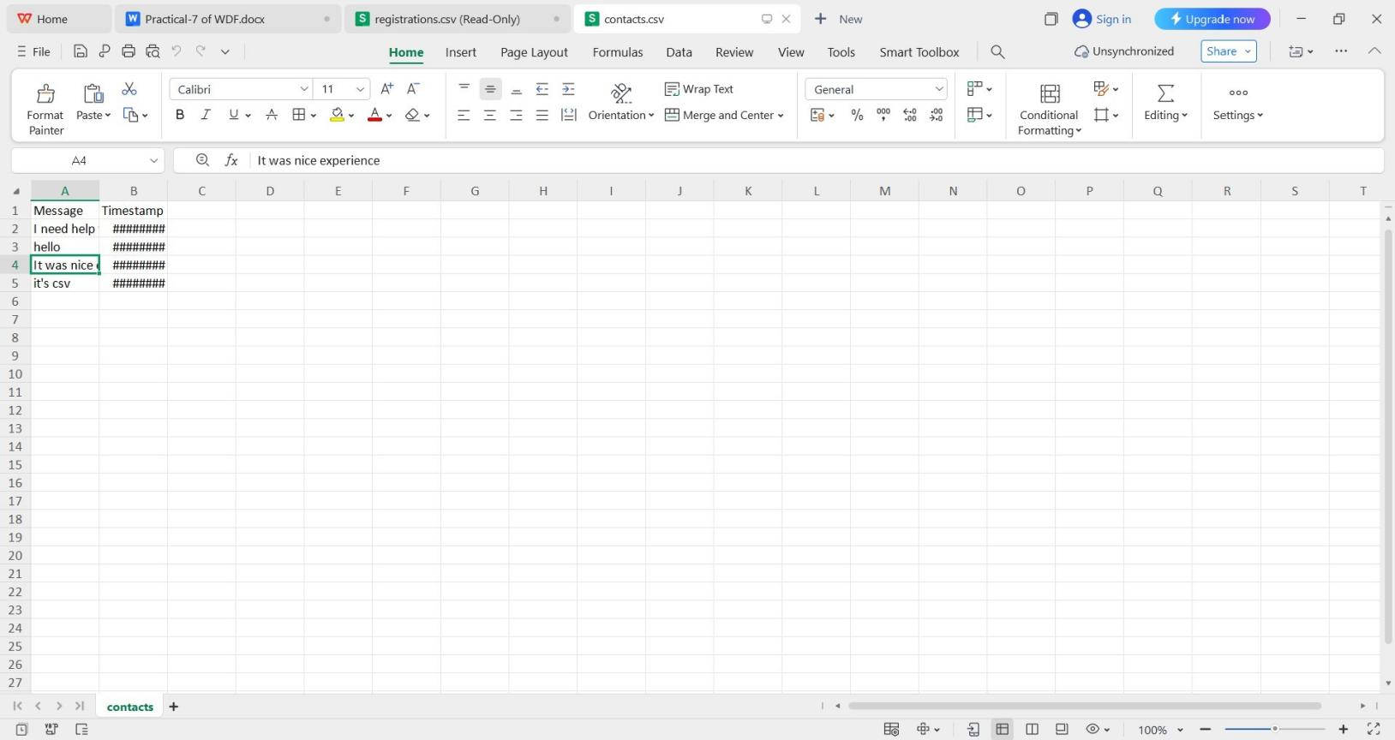

- GitHub Repository Link:
https://github.com/Hetvi-K12/StudentHub-Portal/tree/main/Practical7

- Challenges Faced:
I faced a problem while running PHP in XAMPP because the “Not Found” error was displayed. I solved this problem by placing my project folder inside the htdocs folder. After that, the PHP file worked correctly. I also faced challenge in arranging text box space properly.
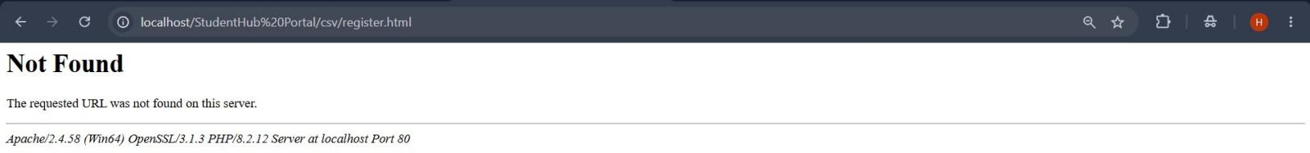

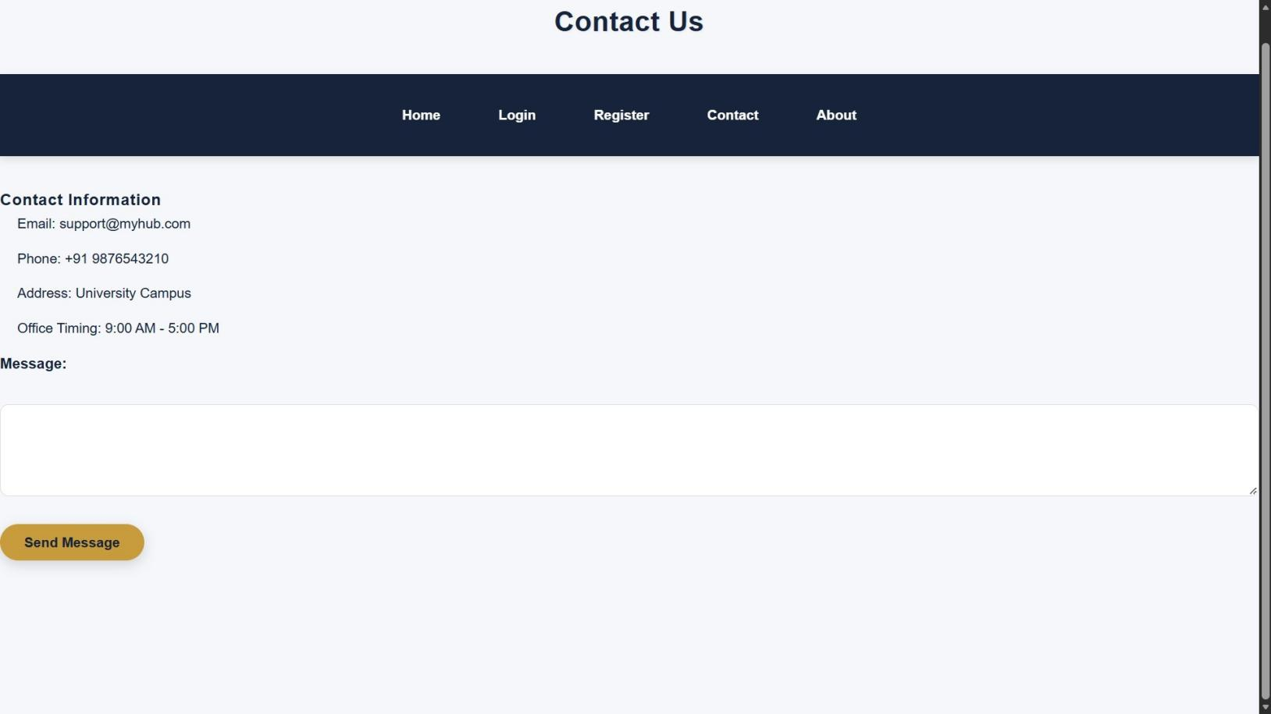

Learning Outcomes:
I learned how to process form data using PHP and the POST method. I also learned server-side validation, input sanitization, and storing data in a CSV file.
Faculty Remarks:

