Practical - 8

Practical Title : MySQL Schema Design, ER Model, PDO Connectivity, and Prepared Statements
Problem Definition: Design the database for StudentHub with students, events and registrations. Create PHP database connection using MYSQL statements.

Theory

Is the schema normalized properly?
Answer: Yes, the schema is properly normalized to reduce data duplication and maintain data consistency.

Are primary keys and foreign keys correctly defined?
Answer: Yes, primary keys uniquely identify records, and foreign keys correctly establish relationships between related tables.

Is the database connection handled securely?
Answer: The database connection should use secure credentials and prepared statements to protect against unauthorized access and SQL injection.

Implementation :

    - Created the database and required tables.
    - Defined primary keys for unique record identification.
    - Added foreign keys to establish relationships between tables.
    - Applied proper data types and constraints.
    - Implemented secure database connection.
    - Used validation and prepared statements for safer data handling.

Implementation/Output/Result

-- =======================================================================
-- STUDENTHUB PORTAL - PRACTICAL 8 MYSQL DATABASE SCHEMA & SEED DATA
-- =======================================================================

CREATE DATABASE IF NOT EXISTS `studenthub` DEFAULT CHARACTER SET utf8mb4 COLLATE
utf8mb4_unicode_ci; USE `studenthub`;
-- Drop existing tables to ensure clean initialization DROP TABLE IF EXISTS `registrations`;
DROP TABLE IF EXISTS `events`; DROP TABLE IF EXISTS `students`;

-- 1. STUDENTS TABLE (User Accounts) CREATE TABLE `students` (
`id` INT AUTO_INCREMENT PRIMARY KEY,
`email` VARCHAR(255) NOT NULL UNIQUE,
`mobile` VARCHAR(10) NOT NULL UNIQUE,
`password_hash` VARCHAR(255) NOT NULL,
`created_at` TIMESTAMP DEFAULT CURRENT_TIMESTAMP
) ENGINE=InnoDB DEFAULT CHARSET=utf8mb4;
-- 2. EVENTS TABLE (Campus Events) CREATE TABLE `events` (
`id` INT AUTO_INCREMENT PRIMARY KEY,
`name` VARCHAR(255) NOT NULL,
`description` TEXT,
`event_date` DATE NOT NULL,
`created_at` TIMESTAMP DEFAULT CURRENT_TIMESTAMP
) ENGINE=InnoDB DEFAULT CHARSET=utf8mb4;
-- 3. REGISTRATIONS TABLE (Event Registrations - Junction Table) CREATE TABLE `registrations` (
`id` INT AUTO_INCREMENT PRIMARY KEY,
`student_id` INT NOT NULL,
`event_id` INT NOT NULL,
`registered_at` TIMESTAMP DEFAULT CURRENT_TIMESTAMP,
CONSTRAINT `fk_registrations_student` FOREIGN KEY (`student_id`) REFERENCES `students` (`id`) ON DELETE CASCADE,
CONSTRAINT `fk_registrations_event` FOREIGN KEY (`event_id`) REFERENCES `events` (`id`) ON DELETE CASCADE,
CONSTRAINT `unique_student_event` UNIQUE (`student_id`, `event_id`)
) ENGINE=InnoDB DEFAULT CHARSET=utf8mb4;
-- =======================================================================
-- SEED DATA
-- Note: Passwords below are hashed for 'password123' using PHP password_hash()
-- Hash: $2y$10$uCUngVrOb2tQOqNAi2e/n.0SmF9bu2Qm1lKrtzaXjjtbg6fh31LKq
-- =======================================================================
INSERT INTO `students` (`id`, `email`, `mobile`, `password_hash`, `created_at`) VALUES (1, 'student@example.com', '9876543210', '$2y$10$uCUngVrOb2tQOqNAi2e/n.0SmF9bu2Qm1lKrtzaXjjtbg6fh31LKq', NOW()),
(2, 'john.doe@example.com', '8765432109', '$2y$10$uCUngVrOb2tQOqNAi2e/n.0SmF9bu2Qm1lKrtzaXjjtbg6fh31LKq', NOW()), (3, 'jane.smith@example.com', '7654321098', '$2y$10$uCUngVrOb2tQOqNAi2e/n.0SmF9bu2Qm1lKrtzaXjjtbg6fh31LKq', NOW());
INSERT INTO `events` (`id`, `name`, `description`, `event_date`, `created_at`) VALUES
(1, 'Annual Tech Symposium 2026', 'A flagship technical conference with coding contests, paper presentations, and tech talks.', '2026-11-15', NOW()),
(2, 'CodeSprint Hackathon 2026', '24-hour inter-college hackathon to build innovative web and AI solutions.', '2026-11-20', NOW()),
(3, 'Cultural Fest - Rhythm 2026', 'Annual cultural celebration featuring live music, dance performances, and art exhibitions.', '2026-12-05', NOW()),
(4, 'AI & Machine Learning Workshop', 'Hands-on practical workshop covering deep learning models and neural networks.', '2026-12-12', NOW());
INSERT INTO `registrations` (`id`, `student_id`, `event_id`, `registered_at`) VALUES (1, 1, 1, NOW()),
(2, 1, 2, NOW()),
(3, 2, 1, NOW());

Evidence of Work (Screenshots)
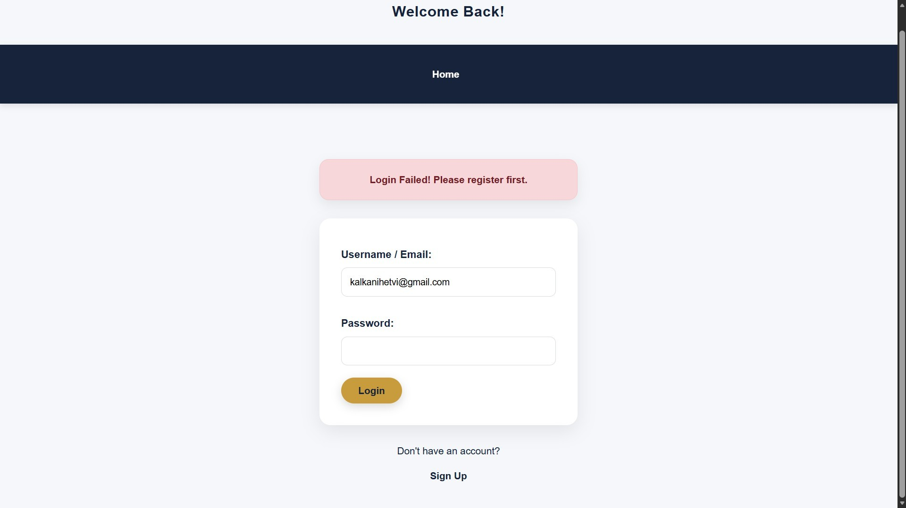
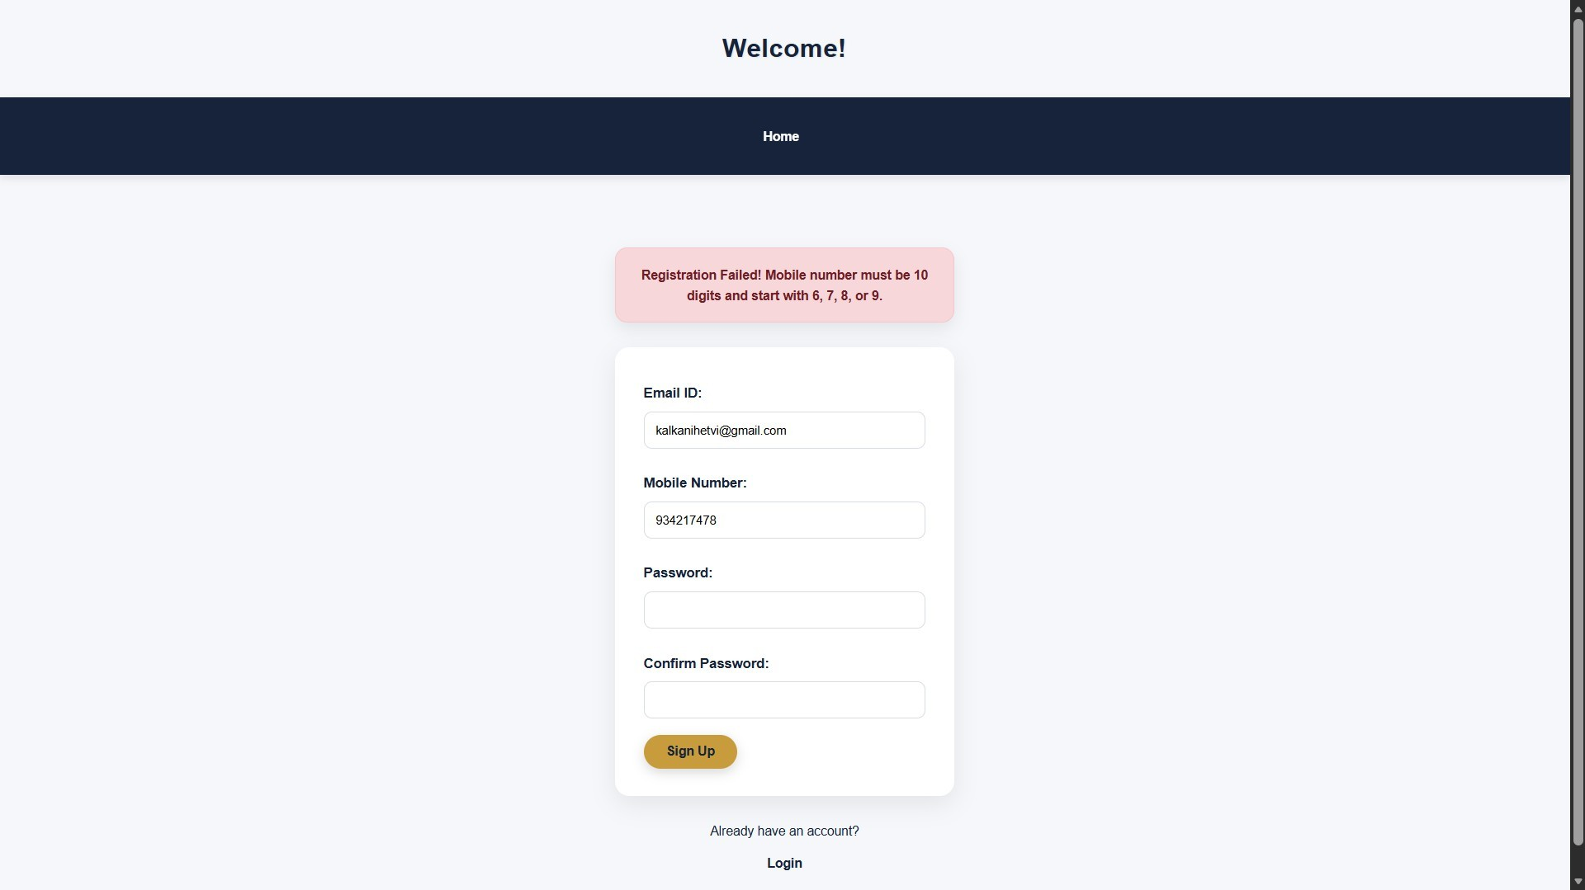

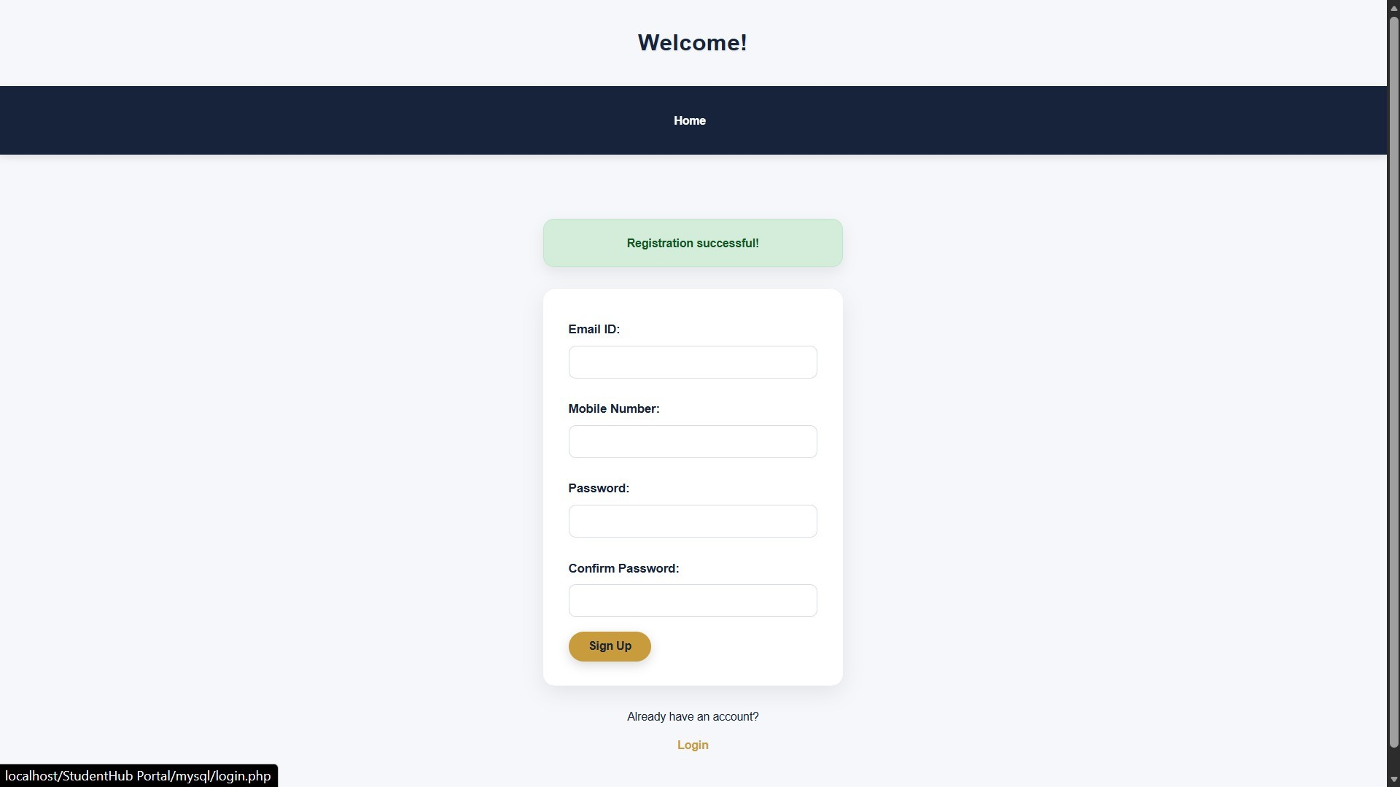
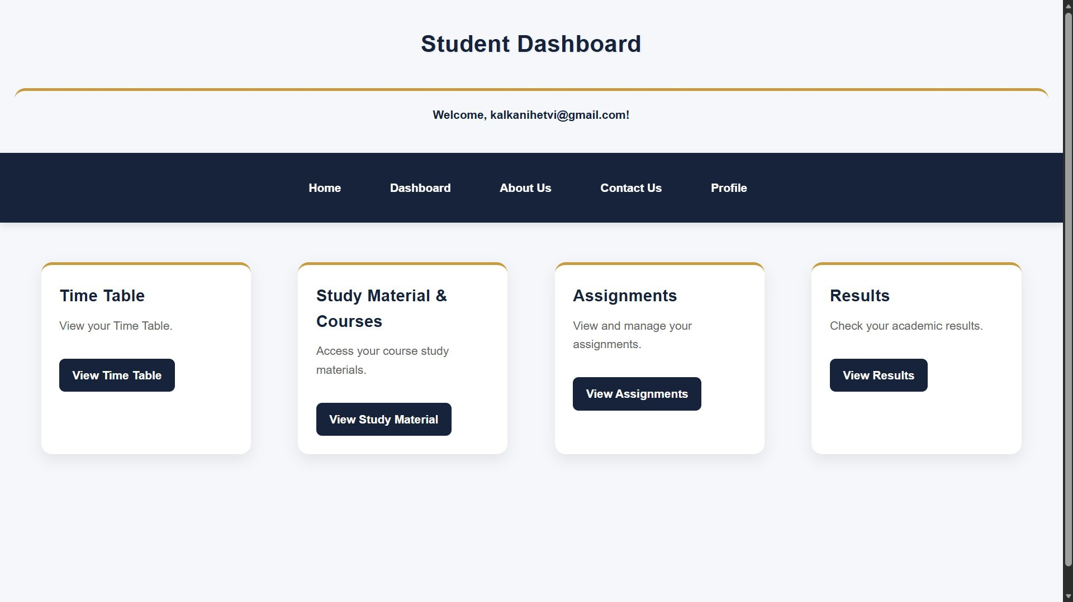

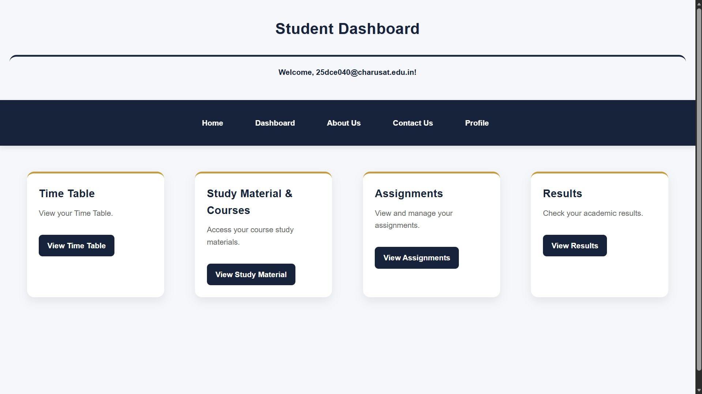
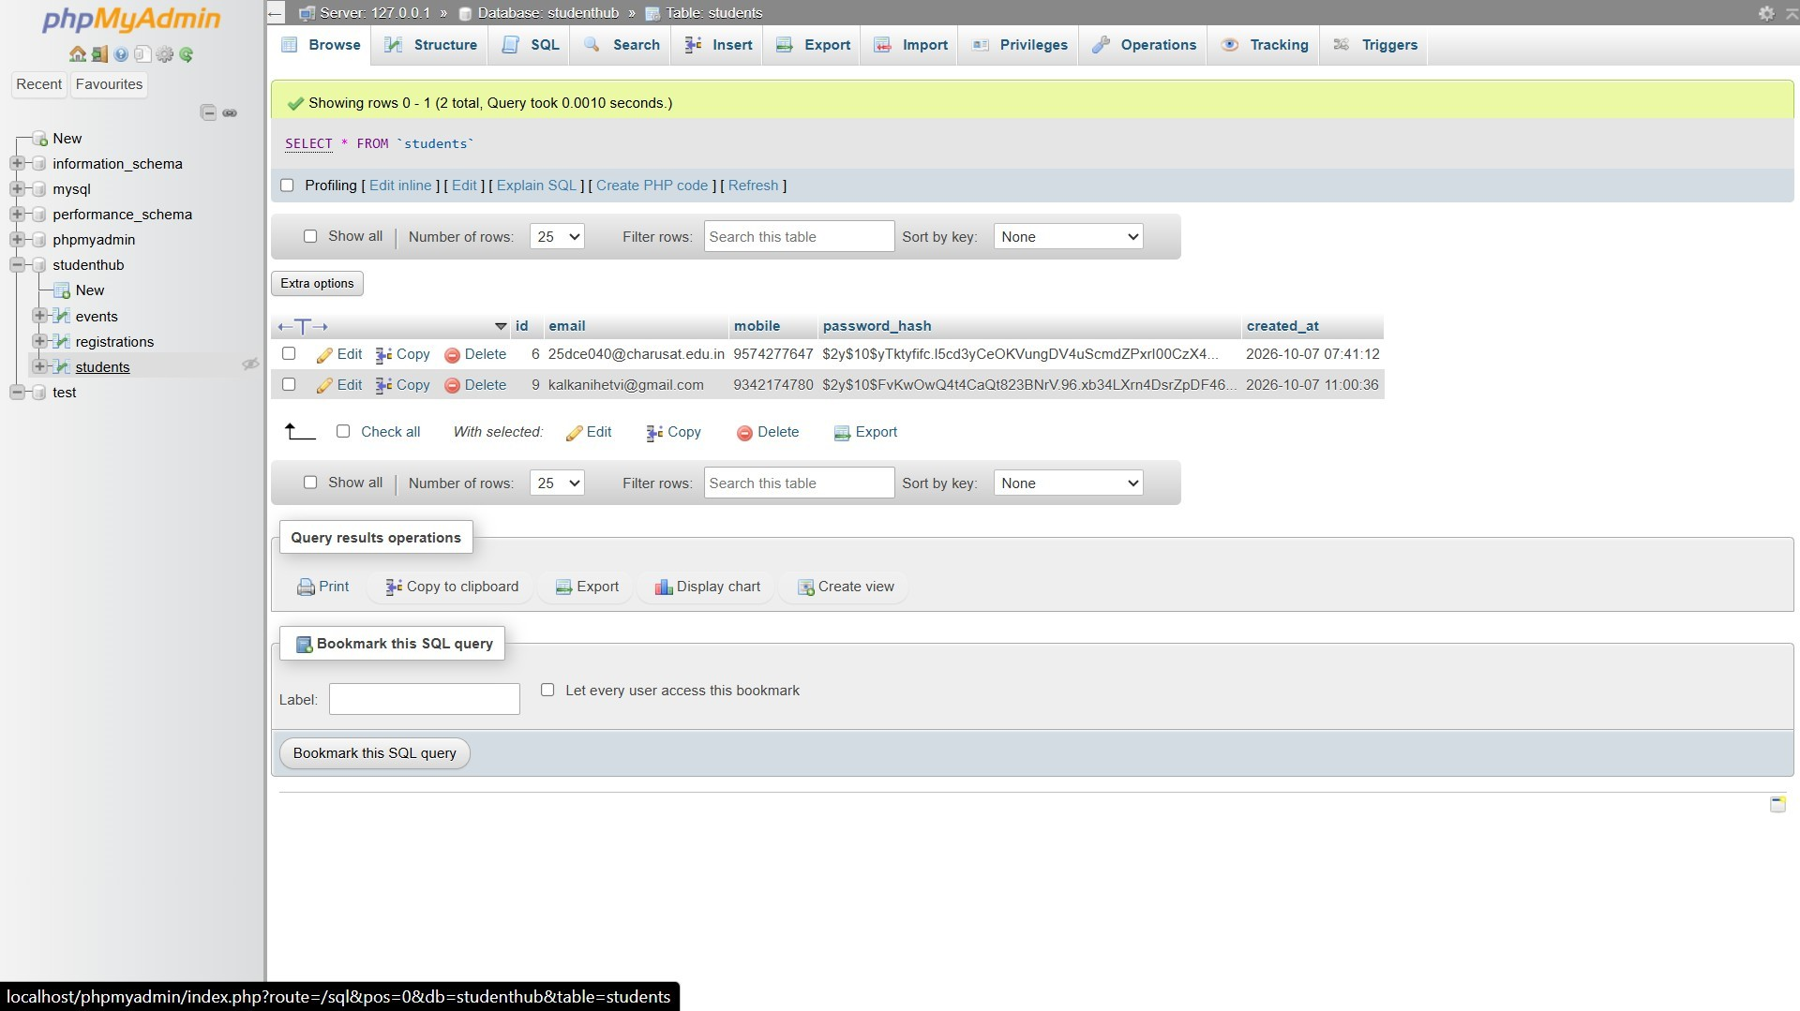

GitHub Repository Link:
https://github.com/Hetvi-K12/StudentHub-Portal/tree/main/Practical8

Challenges Faced:

I faced challenges in understanding the relationships between different tables, defining correct primary and foreign keys, maintaining proper database normalization, and handling database connection and SQL errors.

Learning Outcomes:

I learned how to design and create a database schema, understand primary and foreign keys, and apply database normalization. I also learned how to securely connect an application to a database and improved my understanding of SQL queries and data management.

Faculty Remarks:

