Samajh समझ
Project report
An offline Android app that helps Class 1 to 5 teachers check whether children understand what they read, and what to teach next
Team Runtime Terrors, VIT Pune
Status as of 21 October 2026 · App version 0.1.0 (test build)

Contents
Contents 2
1. Summary 3
2. Problem and approach 3
3. Government sources and class milestones 3
3.1 Documents read 3
3.2 Official reading-speed numbers 4
3.3 Textbooks by curriculum 4
4. What has been built 5
4.1 A check, step by step 5
4.2 Support groups 5
4.3 Practice and reports (M7) 6
4.4 Screenshots from the app 6
5. Architecture and technology 8
6. Privacy and security 9
7. Testing and quality 9
8. Known limitations 9
9. What is going to be built 10
10. Decisions and help needed from the team 10
11. Installing the test APK 10

Right-click the contents and choose Update Field if page numbers are missing.

1. Summary
Samajh lets one teacher, on one Android phone, run a four-minute reading check with a child and see reading and understanding as separate results, then get a practice plan. Six of ten milestones are complete and tested, the seventh is built, and a test APK is ready. All data so far is a fictional demo class: real children's data stays blocked until the privacy checklist and a legal review are done.
Item | Status on 21 Oct 2026
Platform | Flutter Android app (Android 8 and later), fully offline, English and Hindi
Users | The teacher, with a passcode-locked Teacher Mode; children use a locked Student Mode
Curricula | NCERT / CBSE, Uttar Pradesh, Rajasthan, or the school's own
Done | M1 to M6, plus class-wise government milestones
In progress | M7 practice and reports (built, unit-tested; screen tests written but not yet run)
Still to build | M8 privacy and consent workflow, M9 testing and performance, M10 signed release
Automated tests | 184 passing at the last full run
Data | Demo class of 10 fictional children; real data blocked by design

2. Problem and approach
A speed score alone can rank a child who understood almost nothing above a child who understood the story but reads slowly. Teachers check reading by hand, rarely, and still have to guess what to teach. Samajh checks three things in one short session and keeps them apart:
- Reading aloud: accuracy and correct words per minute, marked word by word by the teacher from a recording.
- Understanding: typed questions (fact, word meaning, why and how, main idea) and an optional retell checklist.
- Writing: a short dictation from the words the child misread, marked by the teacher.
Principles the app follows:
- The teacher is the only user. There are no child accounts, games, scores or rankings shown to children.
- Offline first. No feature needs the internet.
- Every result is explained in plain words and names its source. Nothing is invented: no benchmark, chapter or number without an official source.
- Every result ends in a teaching action.
- Privacy by design: audio and photos never leave the phone and are deleted after marking.

3. Government sources and class milestones
All learning goals and targets in the app come from official documents that were read directly. Where a document gives no number, the app says so instead of inventing one.

3.1 Documents read
Document | Used for
NCERT, Foundational Learning Study (FLS) 2022 benchmarking report | Class 3 reading bands (Hindi "meets" 35 to 54 correct words per minute with comprehension; English 35 to 53); question types
Ministry of Education, NIPUN Bharat Guidelines (2021) | National targets (Lakshya) for Classes 1 to 3 and coded learning outcomes
NCERT, Learning Outcomes at the Foundational Stage (2025) | Year-by-year outcomes for Grades 1 and 2, including dictation
NCERT, Learning Outcomes at the Elementary Stage (2017) | Hindi outcomes for Classes 3 to 5
NCF Foundational Stage 2022 and NCF School Education 2023 | Language curricular goals (CG-9 to CG-11; R1 CG-1 to CG-5)
Basic Shiksha UP NIPUN tables; UP Class 3 teacher guide 2025-26 | UP codes H101 to H516, UP targets H206, H208, H306, H308
RSCERT Udaipur Hindi teacher guides, Classes 1 to 5 (2025) | Rajasthan textbooks, lesson titles and curricular goals
NCERT textbook list 2025 and contents pages | Sarangi (1, 2) and Veena (3 to 5) chapter lists with page numbers
CBSE Circulars Acad-73/2024, Acad-12/2025, Acad-48/2025 | Which NCERT books CBSE schools use, and from when
NCERT NEP Mandate Document (quotes NEP 2020) | Foundational literacy by Grade 3 as the highest priority
PIB backgrounder on the DPDP Rules 2025 | Children's data and consent (full gazette text still to be read by a legal reviewer)

3.2 Official reading-speed numbers
Class | Official number | Source
1 | None. Reads short sentences of 4 to 5 simple words | NIPUN Lakshya
2 | About 45 to 60 correct words per minute (UP: at least 45) | NIPUN Lakshya; UP H206
3 | At least 60 correct words per minute with comprehension; 3 of 4 questions. FLS "meets" band 35 to 54 (Hindi) | NIPUN Lakshya; UP H306, H308; FLS 2022
4 | None | Checked in all documents above
5 | None | Checked in all documents above
The NIPUN guidelines contain one conflict: an example story says 30 to 35 words per minute for Class 2, while the target table says 45 to 60. The app uses the target table.

3.3 Textbooks by curriculum
Curriculum | Hindi books | Status
NCERT / CBSE | सारंगी (Classes 1, 2), वीणा (Classes 3, 4, 5) | Verified with chapter titles and page numbers
Uttar Pradesh | वीणा for Class 3 | Class 3 verified; Classes 1, 2, 4, 5 not yet (UP SCERT e-book site was down)
Rajasthan | नन्हे कदम भाग-1, 2 (Classes 1, 2); हिंदी सुमन भाग-1, 2, 3 (Classes 3 to 5) | Verified with all lesson titles (no page numbers in the source)

4. What has been built
Milestone | What it delivers | Status
M1 Audit and architecture | Project audit, plan, verified FLS benchmark, Flutter project, checkpoint system for long work sessions | Done
M2 Bilingual design system | English and Hindi interface, Inter and Noto Sans Devanagari fonts, onboarding with privacy promise and passcode | Done
M3 Teacher and Student Mode | Encrypted database, demo class, consent records, passcode lock with back-off, locked Student Mode with the Kiran mascot | Done
M4 Curriculum foundation | Curriculum registry, class settings, Devanagari akshara engine, original passage bank, grade plans | Done
M5 Reading and understanding | Full check: noise check, child reads, encrypted recording, teacher marks words, retell, questions, plain-words result | Done
Government milestones | All documents above read; Class milestones page; official targets on results | Done
M6 Writing and groups | Dictation from misread words, encrypted notebook photo, listening check, four support groups the teacher can change | Done
M7 Practice and reports | Practice engine, 10-minute group plans, decodable practice words, A4 worksheets, child report, parent report, class dashboard | Built; finishing

4.1 A check, step by step
- The teacher opens a child and taps Start a check. The app picks a passage that fits the class and runs a 3-second room-noise check. The microphone permission is asked here, never in front of the child.
- The child sees a greeting in Hindi and reads the passage. The phone records locally. There is no timer, score or red mark on the child's screen.
- The child sees "शाबाश!" and hands back the phone. Only the teacher passcode leaves Student Mode.
- The teacher plays the recording and taps each word: correct, read differently, skipped, self-corrected, repeated, or not sure. "Not sure" never counts as an error. The recording is deleted when the marks are saved.
- The teacher ticks the story points the child retold, then asks the typed questions and marks each answer. Answers in the child's home language are accepted.
- Dictation: the teacher reads out 5 items chosen from the words the child misread. The teacher marks the notebook and may photograph it. The photo is encrypted and deleted on save.
- The result says in plain words what the child can do, shows reading and understanding separately, and compares them with the official target for that class and curriculum.

4.2 Support groups
Each checked child is placed in one of four provisional groups. The teacher can move any child, with a note; the history is kept.
Group | Meaning
On track | Reads accurately and understands
Understands, needs help reading words | Understands the story but decoding holds them back
Reads words, needs help understanding | Decodes well but misses why and how
Needs help with both | Needs support with reading and understanding. A listening check that shows understanding moves the child to the second group.

4.3 Practice and reports (M7)
- Practice engine: turns each child's evidence into needs (matras, conjuncts, bindu, word reading, fluency, facts, why and how, word meanings, spelling, listening).
- Group plans: a 10-minute plan per group from an offline bank of 14 original activities in English and Hindi, plus a home activity.
- Decodable practice words: the child's misread words first, then words built only from aksharas the child has already read correctly.
- A4 worksheets: printed through Android's print screen. Hindi is drawn by Flutter's text engine because the PDF library misprints Hindi (it printed "कतिाब" instead of "किताब").
- Child report: results, gaps, recommended action, practice words, suggested recheck date, and progress only between comparable checks.
- Parent report: plain Hindi or English, no scores or rankings. It can only be printed or shared after the teacher ticks an approval box.
- Class dashboard: checked and waiting counts, group counts, most often misread aksharas, spelling issues, rechecks due, and changes between comparable checks. Empty states instead of made-up numbers.

4.4 Screenshots from the app
Real captures from the app running on a 2 GB RAM Android emulator. All children shown are fictional demo learners.
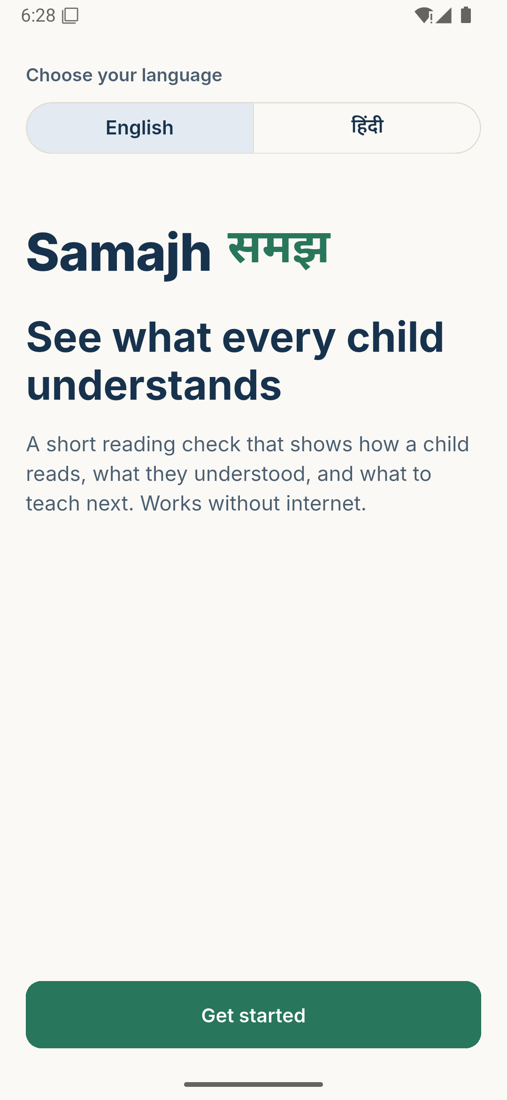  Welcome | 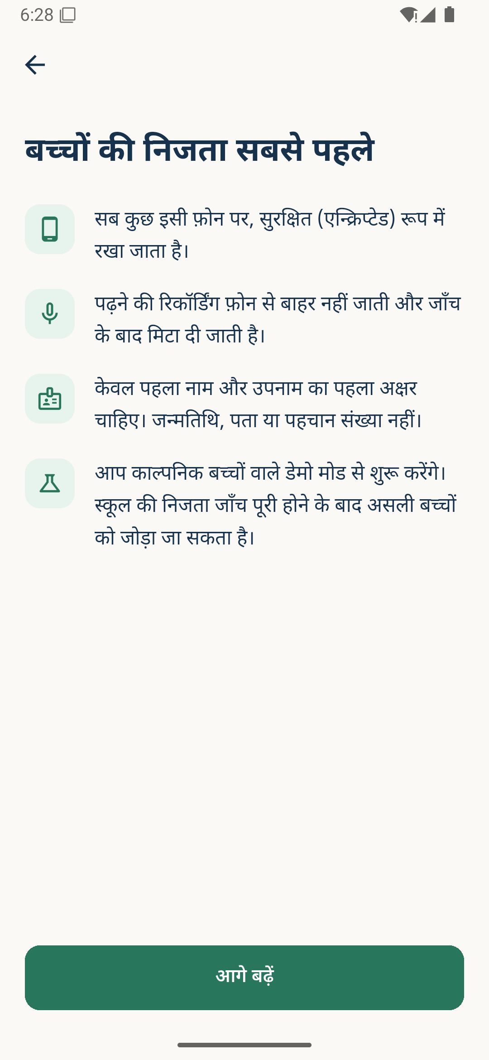  Privacy promise (Hindi) | 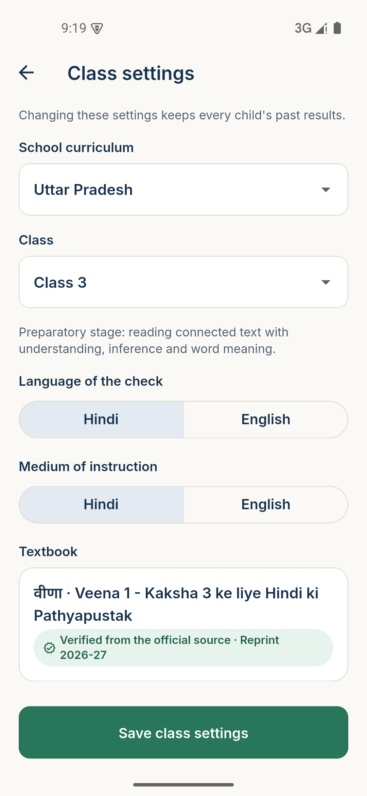  Class settings
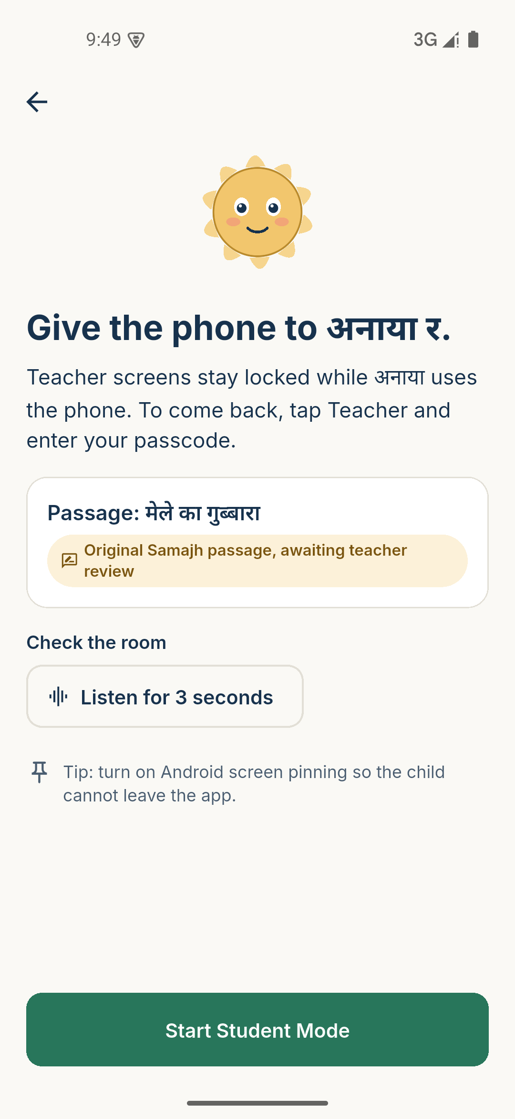  Before handing over | 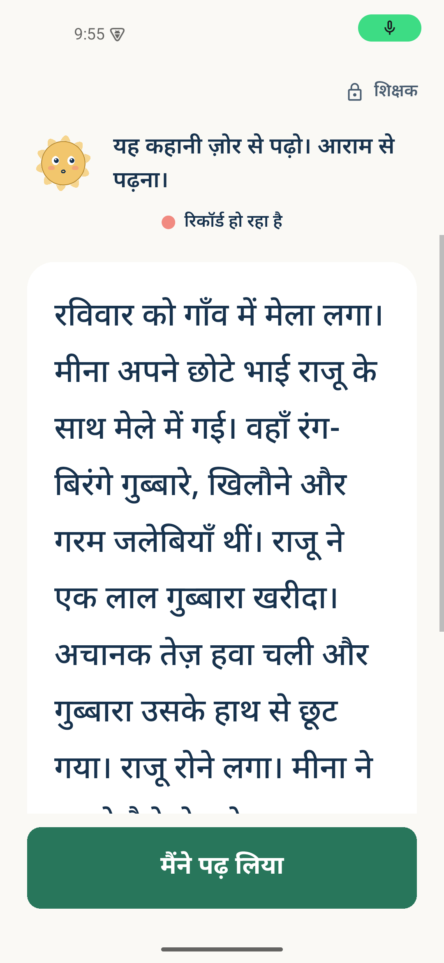  Child reads | 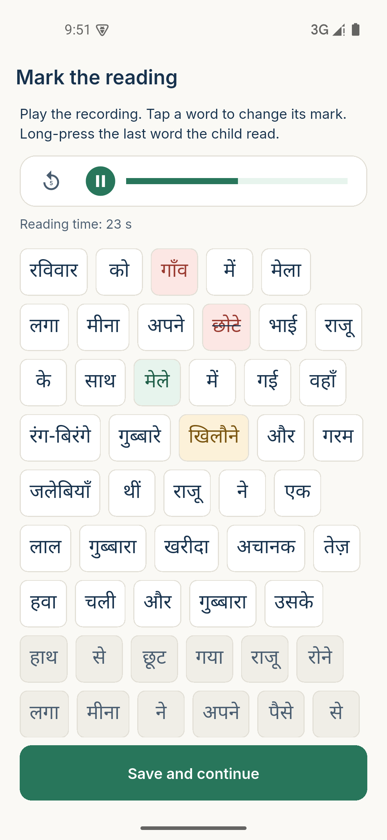  Teacher marks words
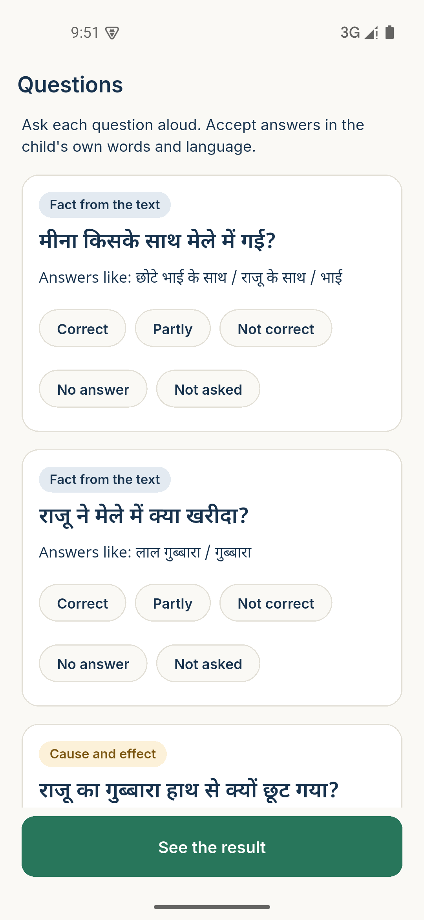  Questions | 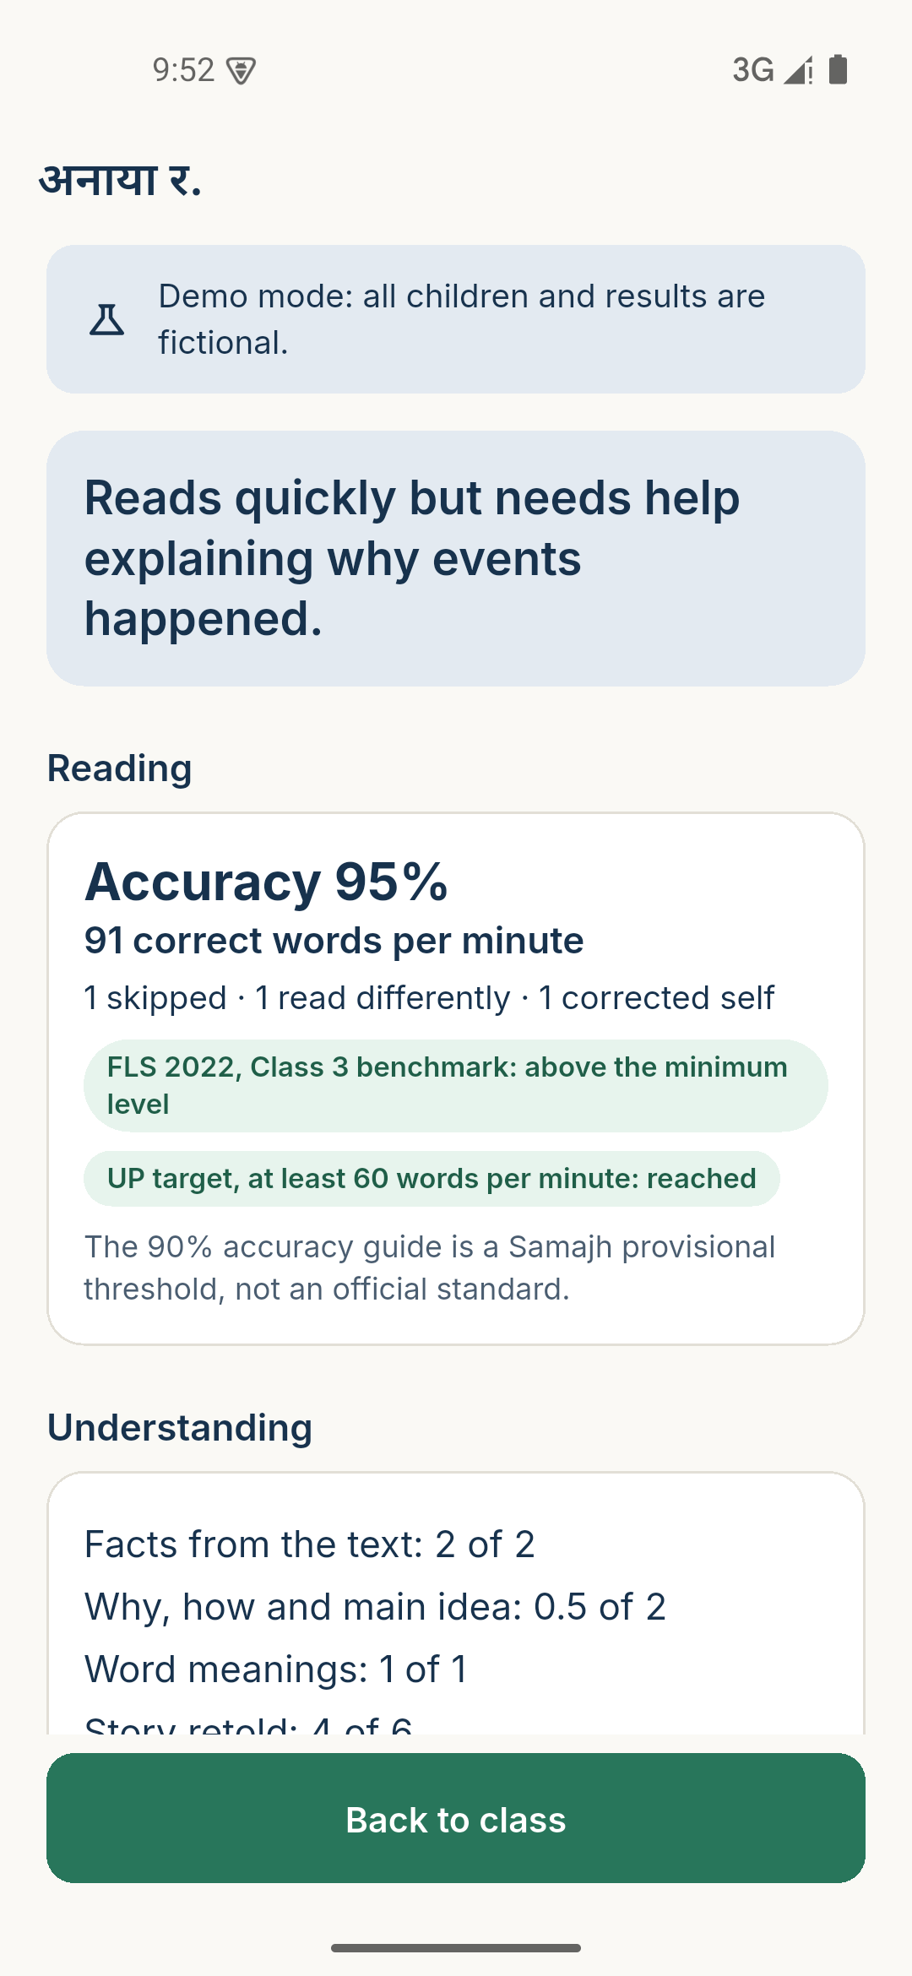  Result in plain words | 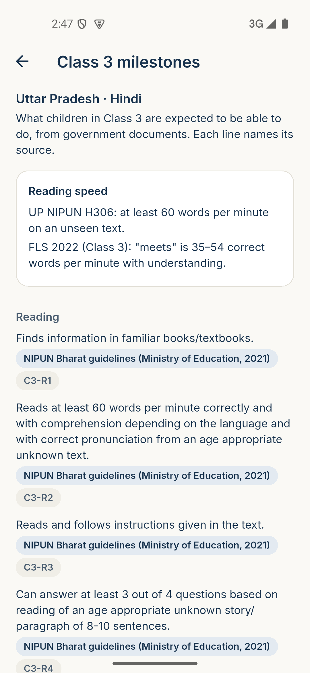  Class 3 milestones
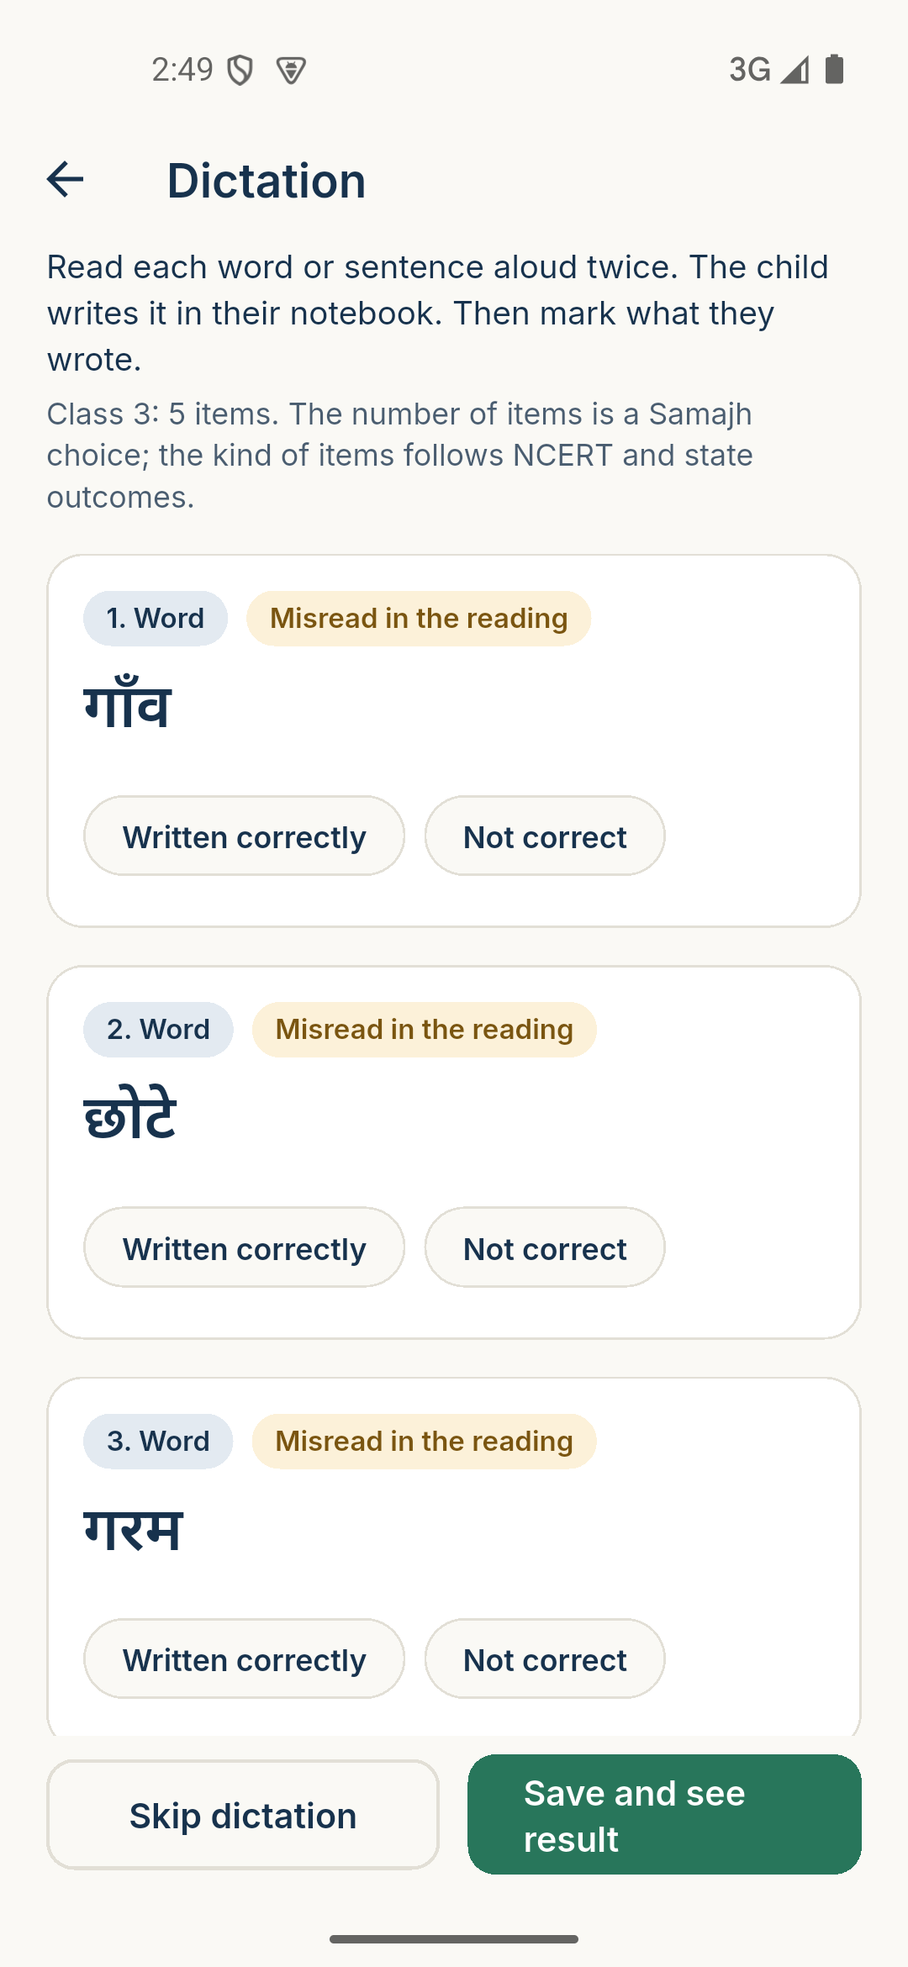  Dictation | 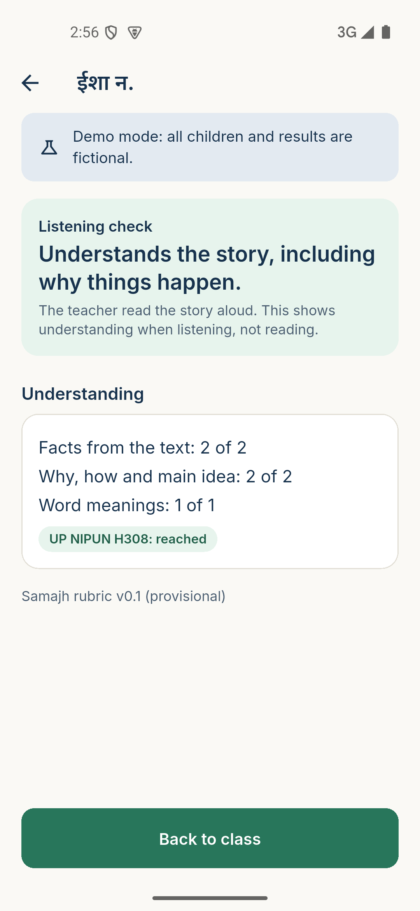  Listening check result | 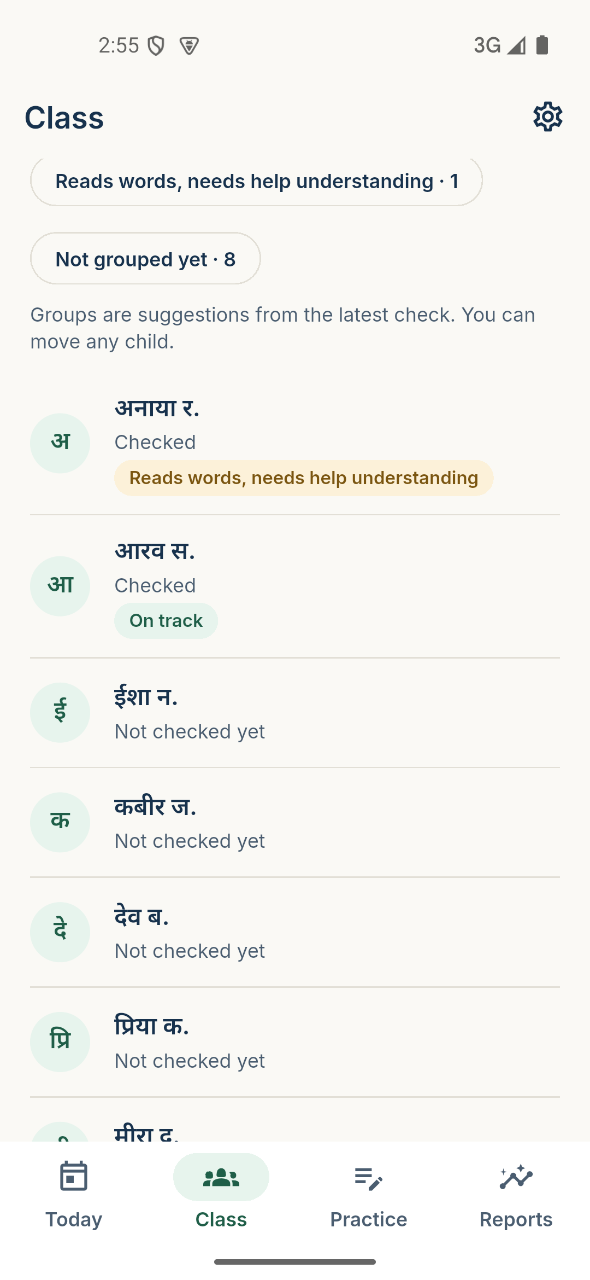  Class with support groups

5. Architecture and technology
Layer | Technology
App | Flutter 3.47 (Dart 3.13), Android 8 and later, tested on a 2 GB RAM emulator
State and navigation | Riverpod 3, go_router 18 with guards for the lock and Student Mode
Storage | drift with SQLite3MultipleCiphers (encrypted database), schema version 4 with tested migrations
Secrets | Random keys in Android Keystore-backed secure storage
Audio and photos | record (16 kHz WAV), just_audio, image_picker; AES-256-GCM vaults with separate keys
Rules engine | Pure Dart: Devanagari akshara segmentation, word comparison, scoring rubric v0.1, dictation, groups, practice, progress
Printing | pdf and printing packages; pages drawn with Flutter's text engine
Content | Curriculum registry (74 learning outcomes, 15 textbooks), benchmark registry, 9 original passages, 14 activities
Languages | English and Hindi interface through ARB files; Hindi student screens even when the teacher uses English
No backend exists yet. Claude or any cloud AI will only ever be called through a future backend, never with a key inside the app.

6. Privacy and security
Data | Where it lives | How long | Leaves the phone?
Teacher passcode | Hashed (PBKDF2) in secure storage | Until reset | Never
Child name, class, consent | Encrypted database | Until deleted | Not until a backend exists
Reading recording | Encrypted vault | Deleted when marks are saved, or after 24 hours | Never
Notebook photo | Encrypted vault (separate key) | Deleted when marking is saved, or after 7 days | Never
Marks, answers, groups | Encrypted database | Until deleted | Not until a backend exists
Checked on the device: the stored recording and photo were unreadable ciphertext, the plain copies were deleted at once, and both were deleted on save. Android backup is switched off for the app. Only first names appear on printed sheets.
Under the DPDP Rules 2025, a parent's verifiable consent is needed for a child's data unless the processing relates to essential services such as education. A qualified person must confirm whether and how that exemption applies before any real school uses the app.

7. Testing and quality
Kind | Coverage
Rules | Devanagari parser, word comparison, scoring, benchmarks, dictation, groups, practice, decodability, progress comparison
Data | Repositories, encryption on disk, recording and photo vaults, migrations v1 to v4
Screens | Onboarding, lock, Student Mode escape attempts, full check end to end, dictation, listening check, group moves, class settings, milestones
Language | Every English string has a Hindi version; no em dashes in user text
Emulator reviews | Screenshots and written reviews for M1-M2, M3, M4, M5, M6 in docs/UI_REVIEWS
Last full run: 184 automated tests passing, analyzer clean. Bugs found in emulator reviews and fixed include: a cut-off passage on the child's screen, no way back from marking, the next-child button offering a child still waiting for marking, and a reading target wrongly shown on a listening check.

8. Known limitations
- The reading timer starts when the passage appears, so a very early "done" tap gives an unrealistic words-per-minute figure.
- All 9 passages and 14 activities are original and still need review by a teacher.
- The scoring rubric (v0.1) is provisional and needs calibration against teachers' own marking in a pilot.
- There is no speech recognition and no handwriting recognition. The teacher marks reading and writing; the app does the analysis.
- Typing what a child wrote needs a Hindi keyboard on the teacher's phone.
- Uttar Pradesh textbook titles for Classes 1, 2, 4 and 5 are not verified (the official site was down).
- Marathi is not included yet.
- The test APK is signed with a debug key and is for testing only, not for the Play Store.

9. What is going to be built
Milestone | Planned work
M7 finish | Run the new screen tests, emulator review with screenshots, commit
M8 Privacy and security | Consent screens for real children; data deletion and withdrawal; the DPDP checklist with a legal reviewer; fingerprint unlock; design of an optional backend and sync
M9 Testing and optimisation | Integration and performance tests on a low-end profile, accessibility and text-size checks, results in docs/TEST_RESULTS
M10 Release | Signed release APK with the team's own key, release notes, install guide, completion report
After the hackathon | Classroom pilot and rubric calibration; more reviewed passages for every class; speech-recognition trial that only suggests marks; Marathi; optional backend for backup and school-level views

10. Decisions and help needed from the team
- A teacher to review the passages, activities, rubric thresholds and dictation counts.
- A physical 2 to 3 GB RAM Android phone for real-device testing.
- The official UP Hindi textbook list for Classes 1, 2, 4 and 5.
- A qualified person for the DPDP legal review before any real school data.
- The missing Samajh project presentation file.
- A release signing key (kept outside the repository) for M10.

11. Installing the test APK
- Copy Samajh-v0.1.0-test.apk to an Android phone (Android 8 or later).
- Open it and allow installing from this source when Android asks.
- Open Samajh, choose English or Hindi, read the privacy promise and set a 6-digit passcode.
- The app opens a demo class "3B" with 10 fictional children. Try: Class tab → a child → Start a check; the Class 3 milestones page; the Practice and Reports tabs.
This build is for testing only. It contains no real children's data and sends nothing over the internet.

