Date:

# EXPERIMENT NO. 3

#### AIM: Implement a 4-bit common bus system to interface four 4-bit registers with a common bus using i. Multiplexer and ii. Decoder and tristate buffers.

**CIRCUITS:**

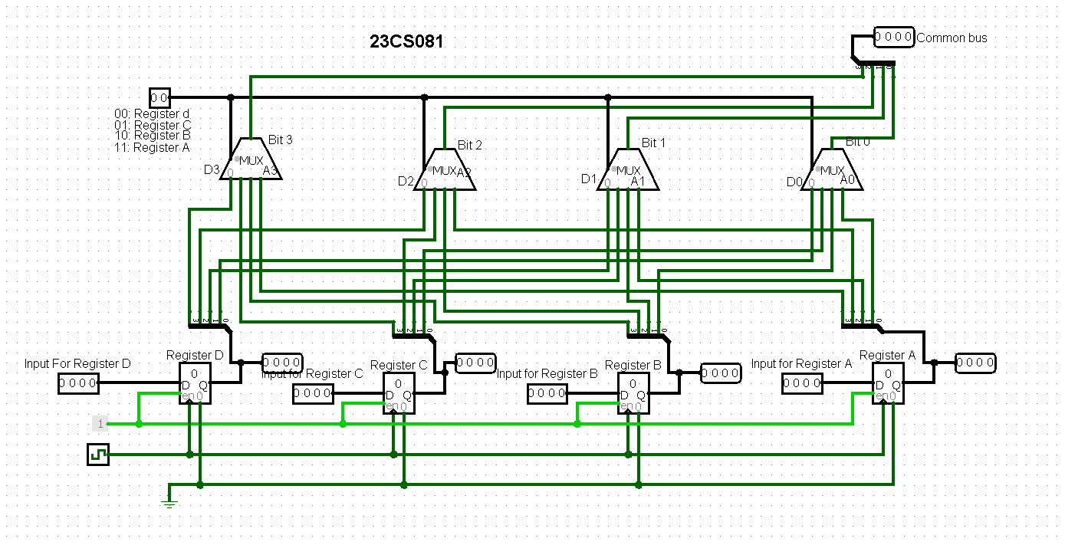

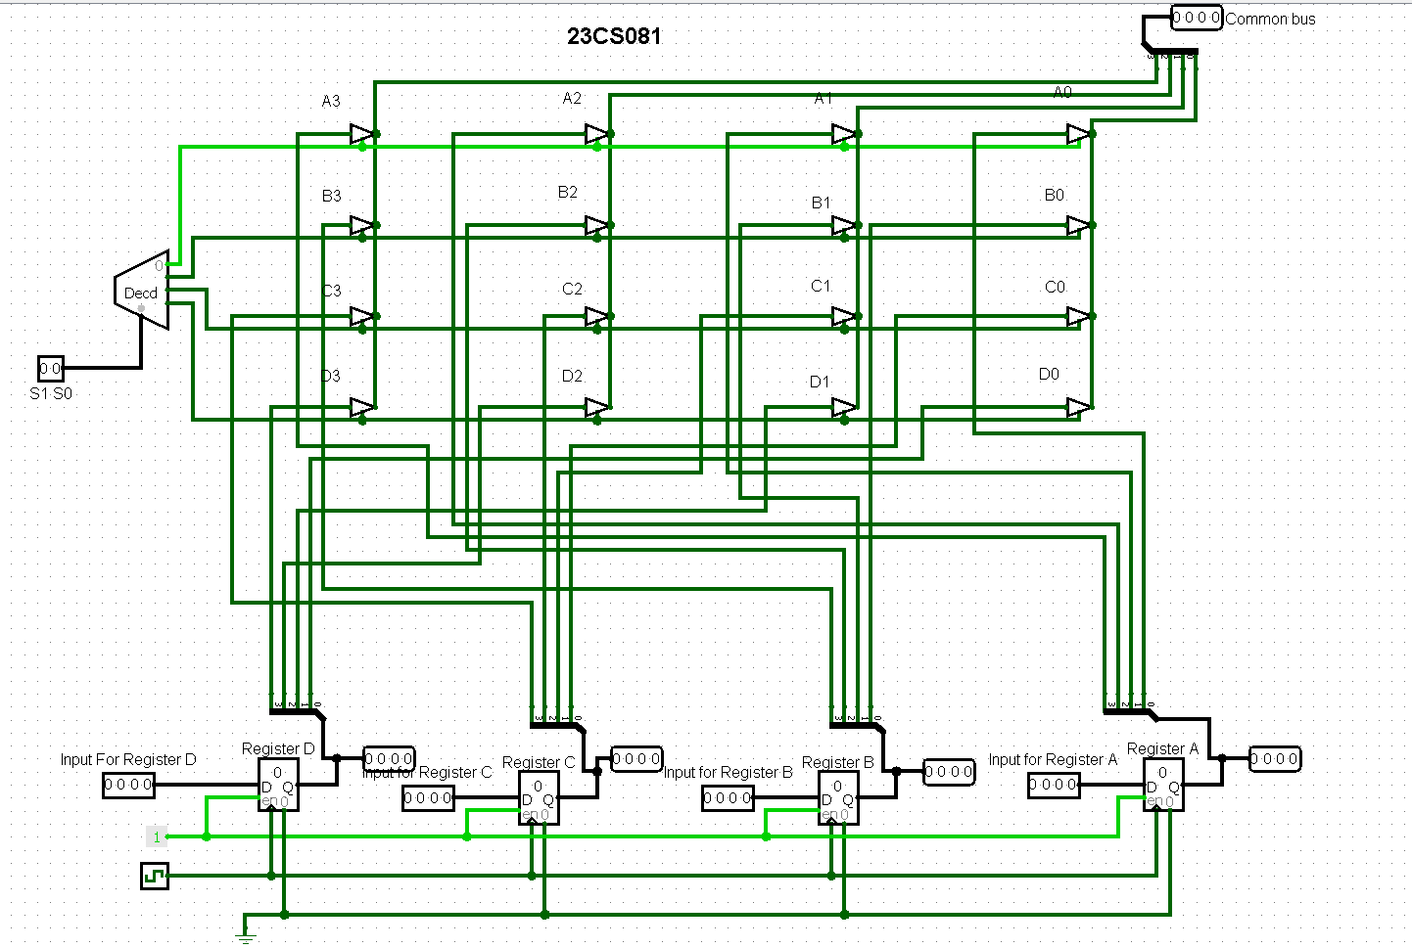

**OUTPUTS:**

**4 outputs for 1. Multiplexer:**

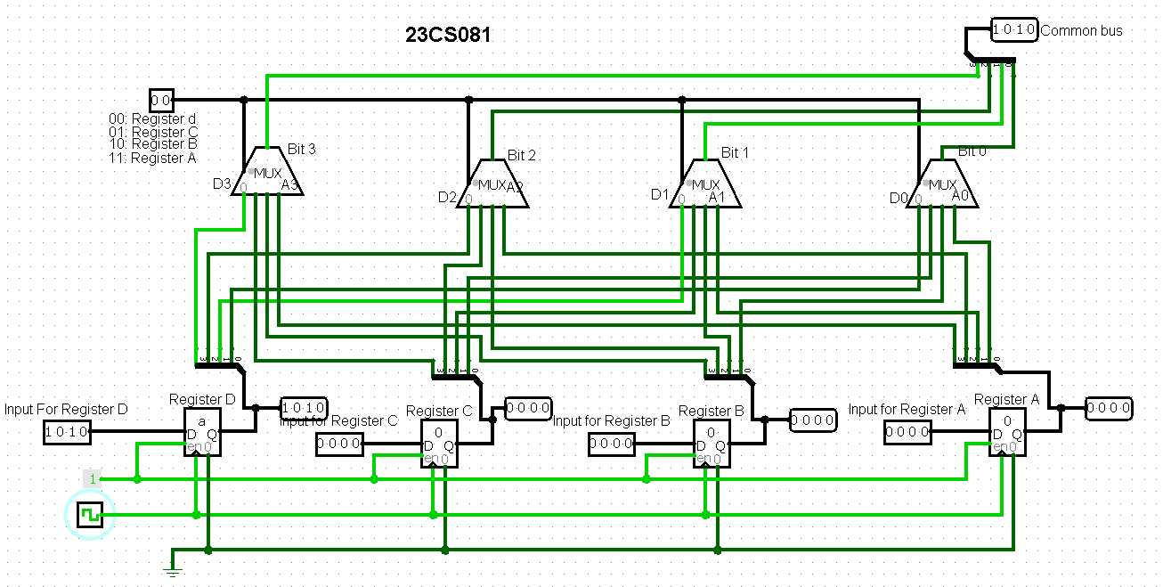

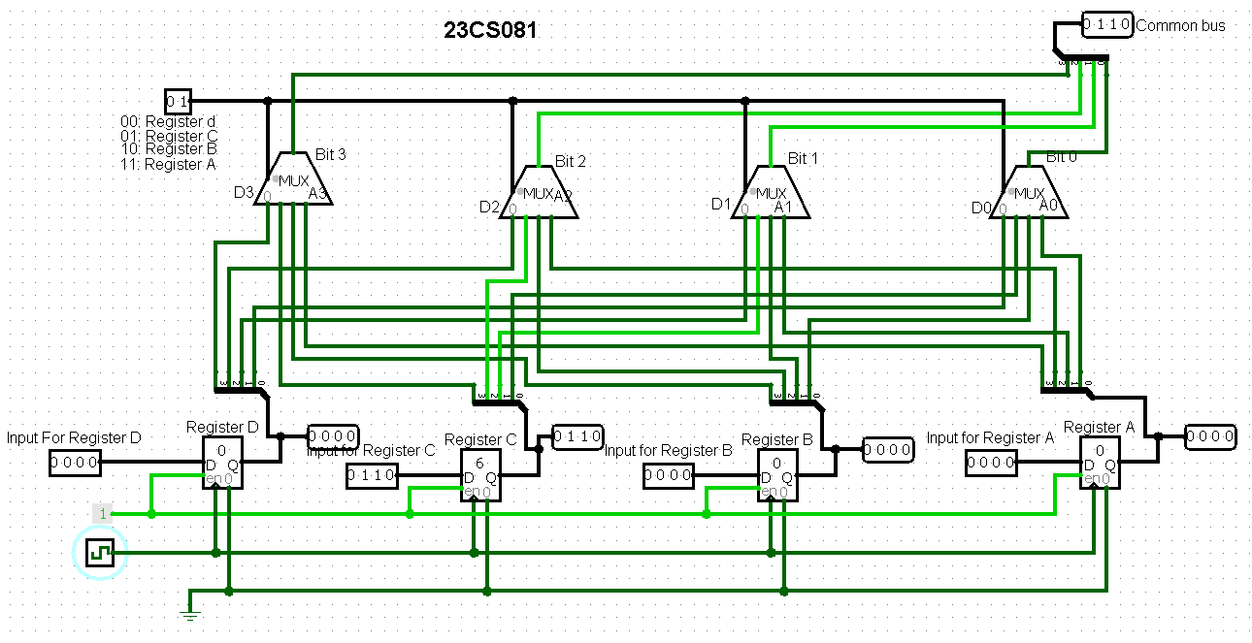

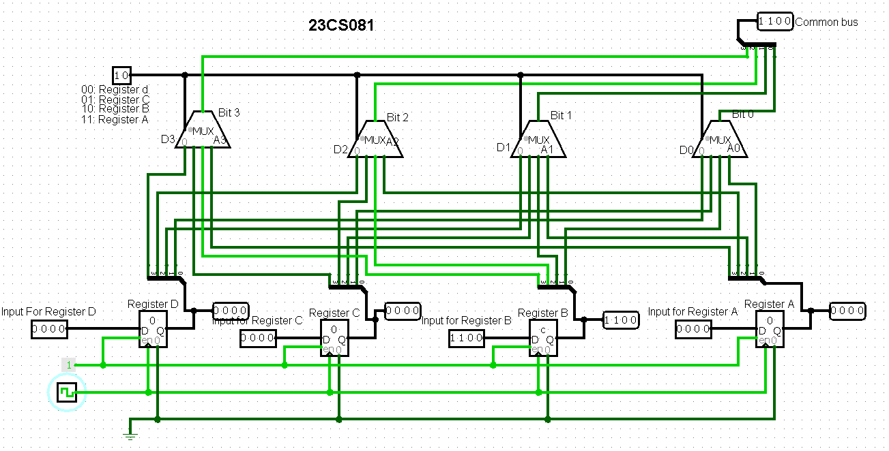

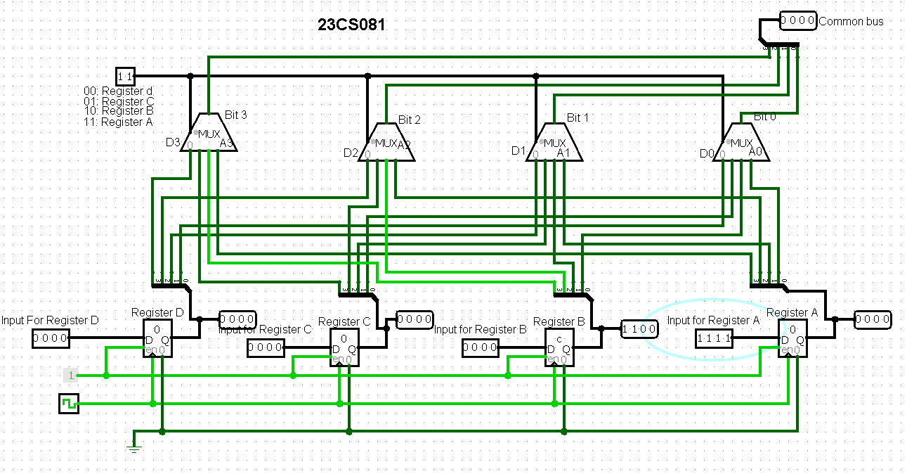

**4 outputs for 2. Decoder and tristate buffers:**

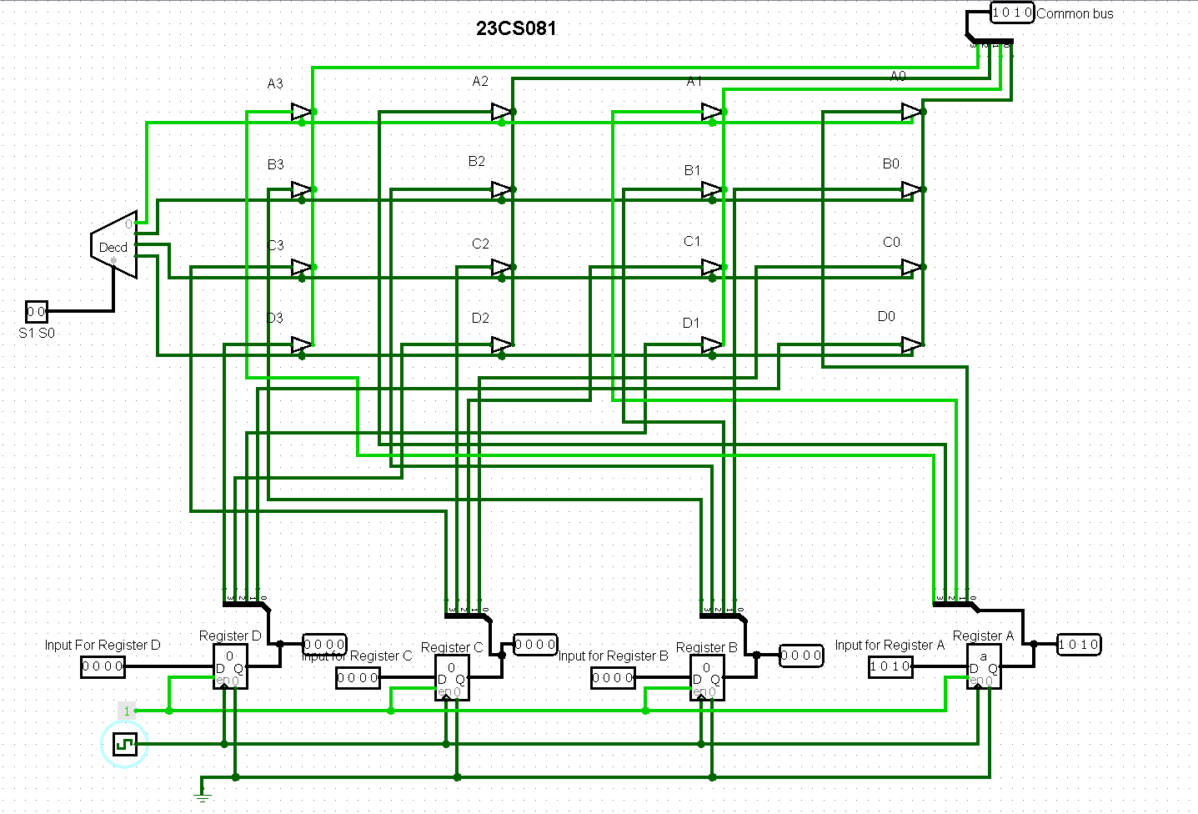

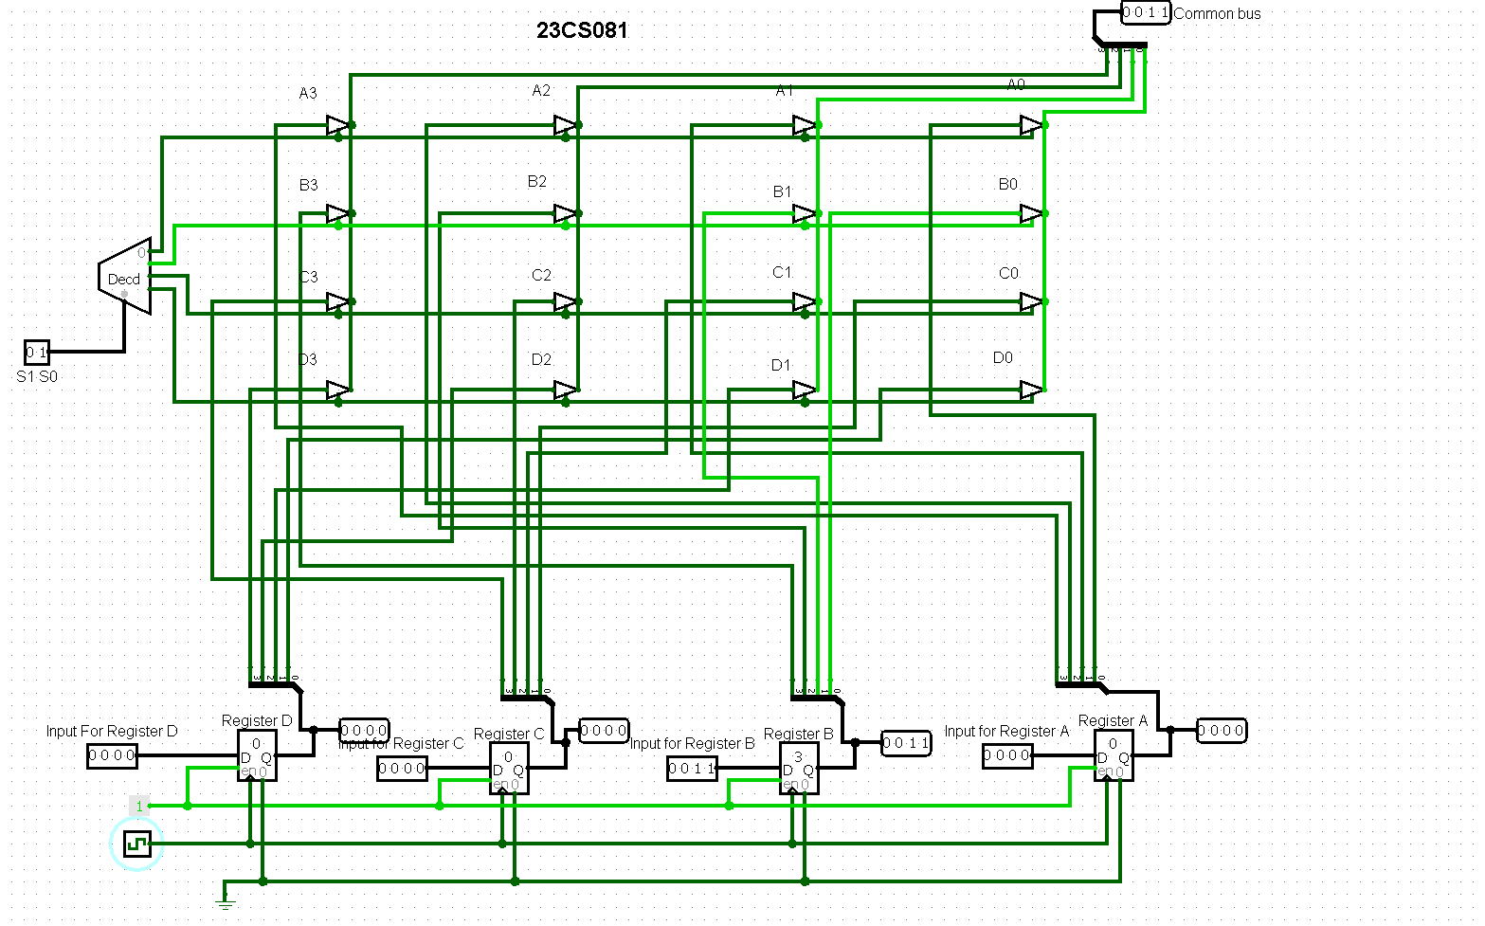

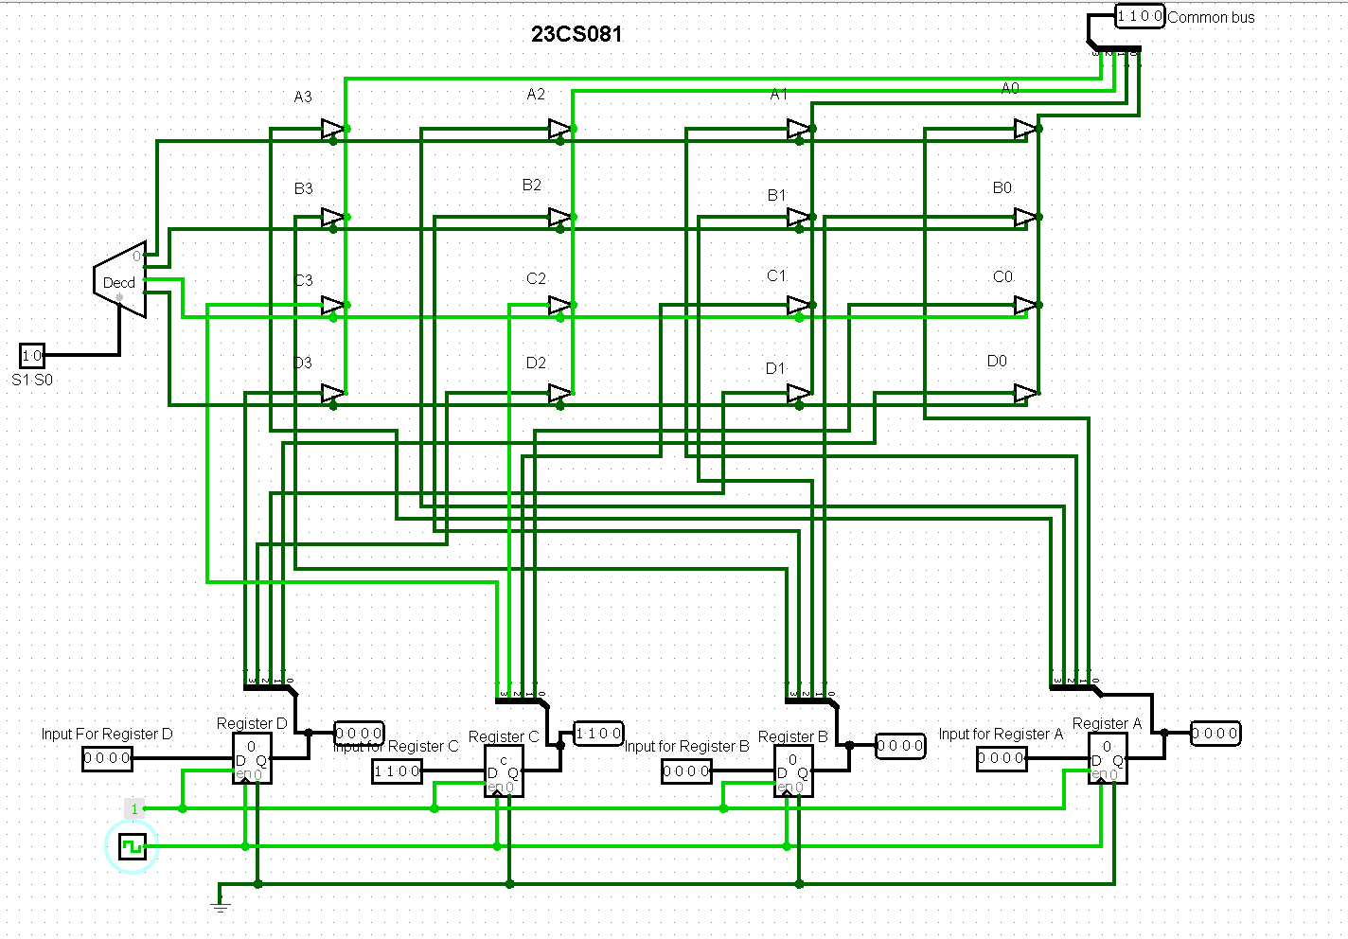

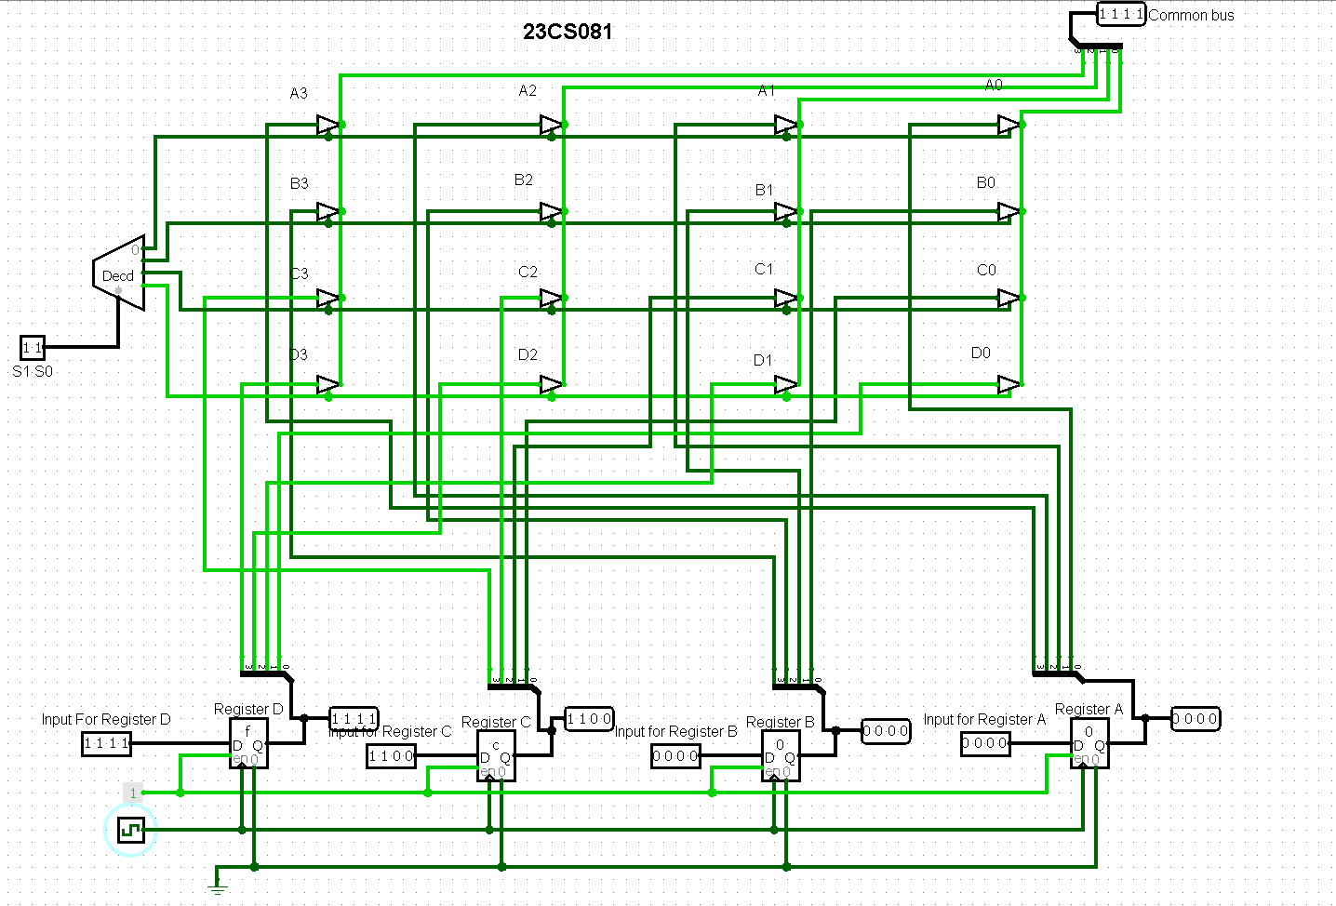

**CONCLUSION:**

**POST SESSION EXCERCISES:**

1. Find a number M=(MOD(Last Three Digits of your enrolment number, 5)+3) and find a number N=(MOD(Last Three Digits of your enrolment number, 3)+3). Implement a M-bit common bus system to interface N M-bit registers with a common bus using i. Multiplexer and ii. Decoder and tristate buffers.

M= (81%5) + 3 = 1+3 = 4

And N = (81%3) + 3 = 0+3 = 3

**4 outputs for 1. Multiplexer:**

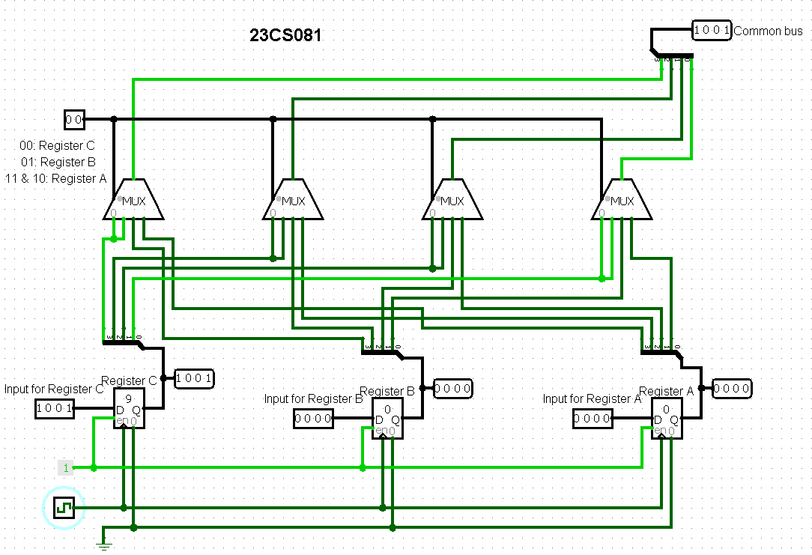

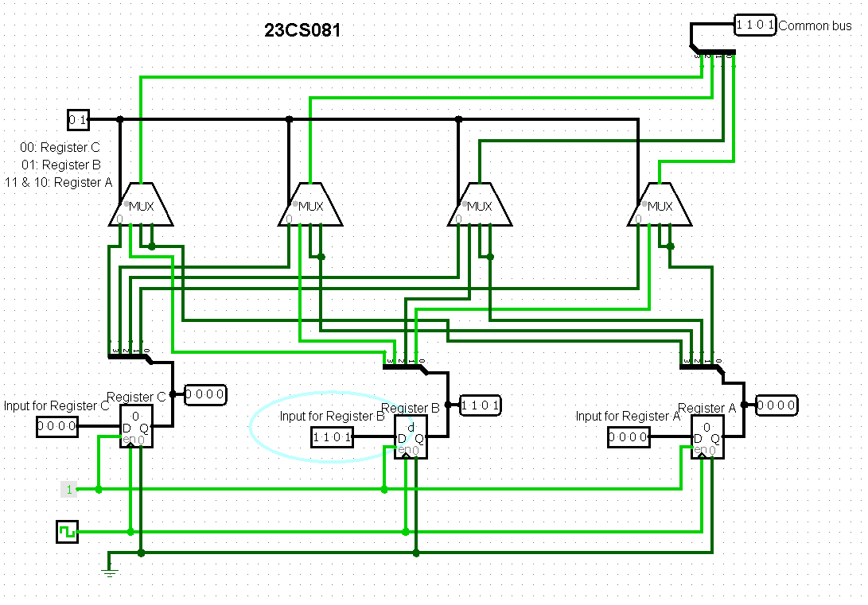 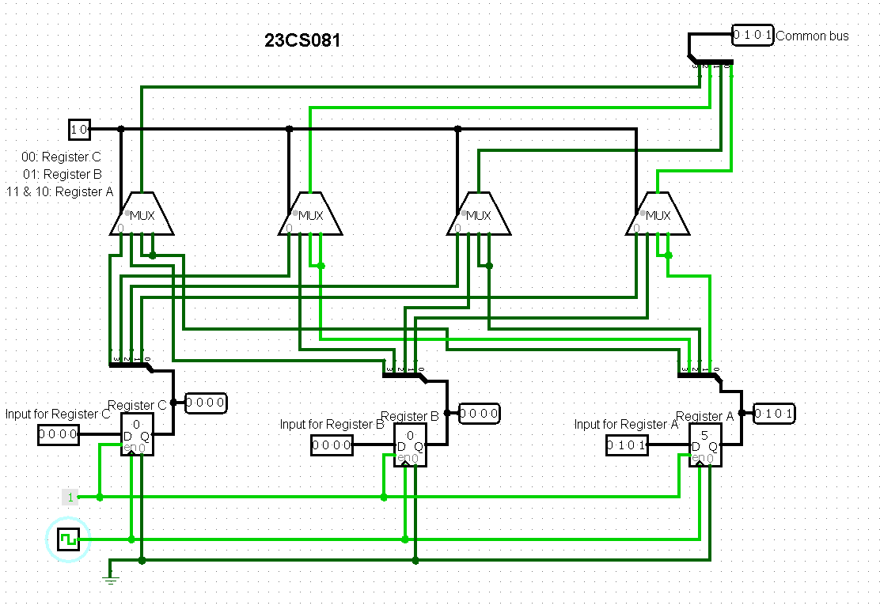

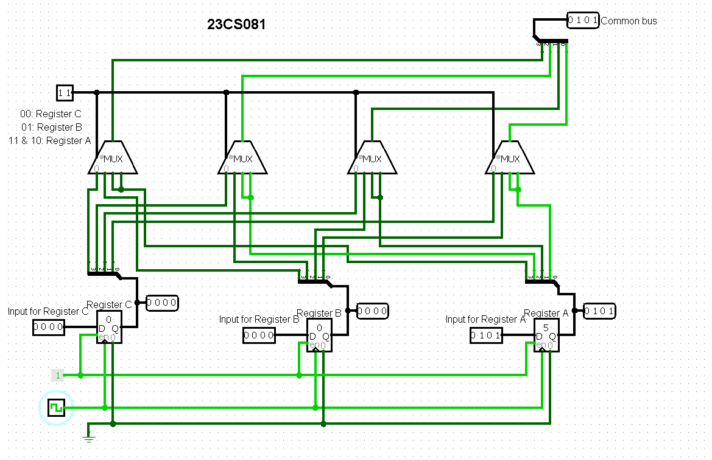

**4 outputs for 2. Decoder and tristate buffers:**

