Date:

# EXPERIMENT NO. 4

#### AIM: Implement arithmetic and logic unit circuits in Logisim.

#### OBJECTIVES:

#### Implement 1-bit, 2-bit, 4-bit and 8-bit arithmetic unit circuits

#### Implement 1-bit, 2-bit, 4-bit and 8-bit logical unit circuits for four logical functions

#### Implement 1-bit and 2-bit logical unit circuits for sixteen logical functions

#### Implement 2-bit, 4-bit and 8-bit bidirectional shifter

#### Implement 1-bit, 2-bit, 4-bit and 8-bit ALU

**CIRCUITS:**

1. **1-bit arithmetic unit circuit**

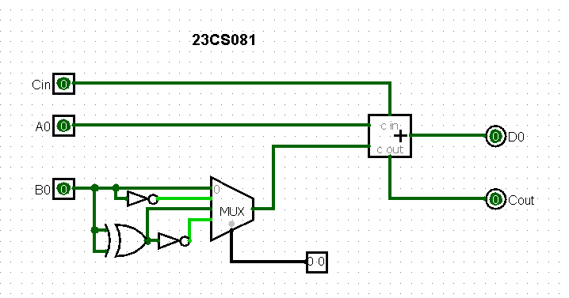

1. **2-bit arithmetic unit circuit**

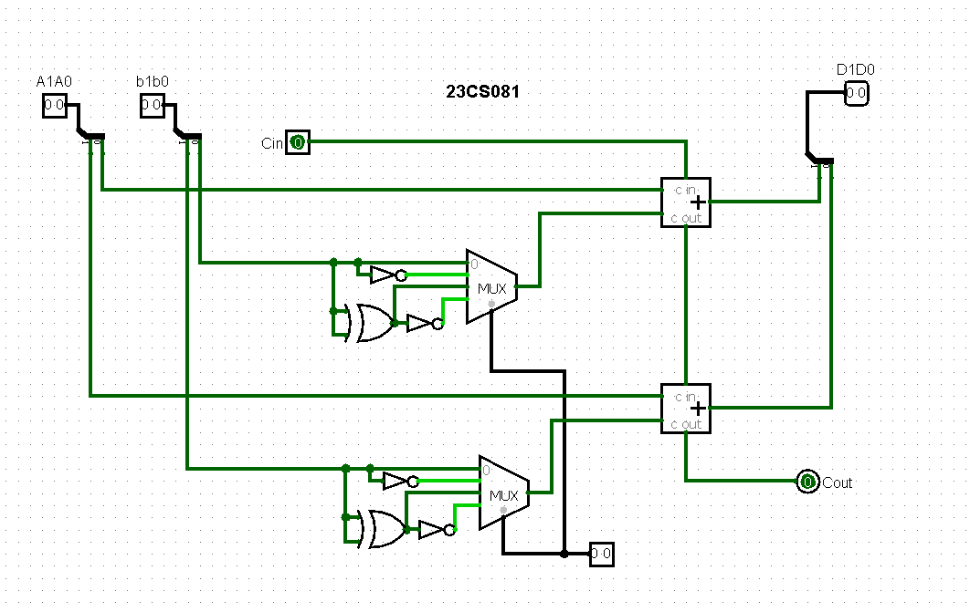

1. **4-bit arithmetic unit circuit**

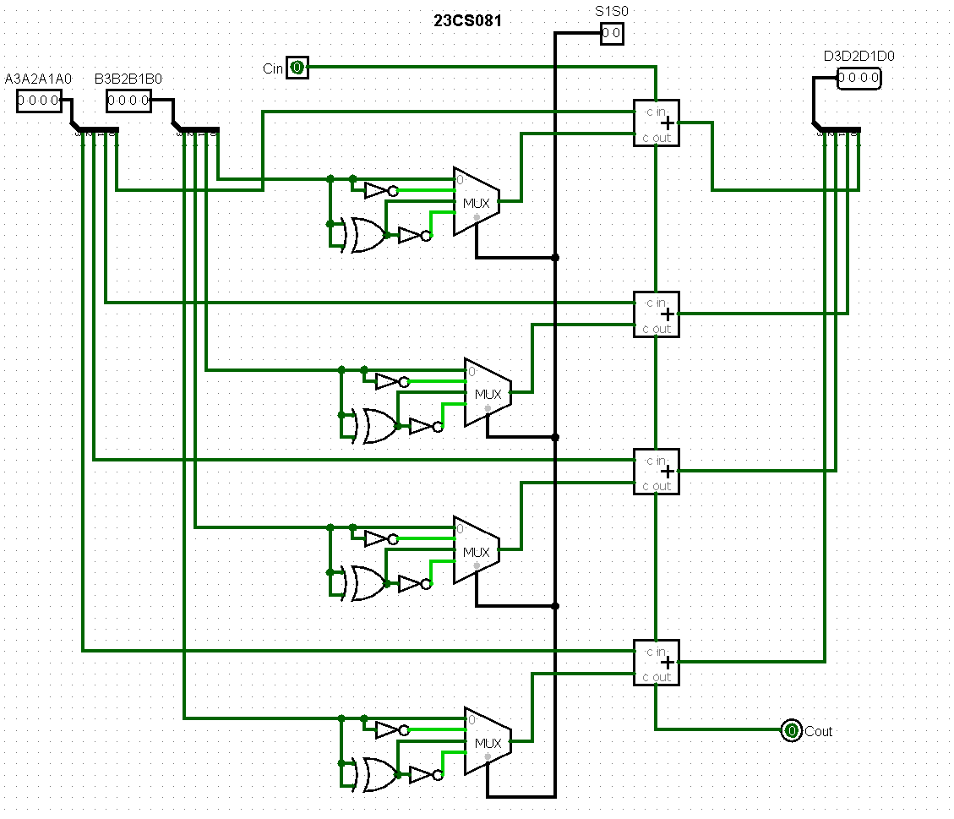

1. **8-bit arithmetic unit circuit**

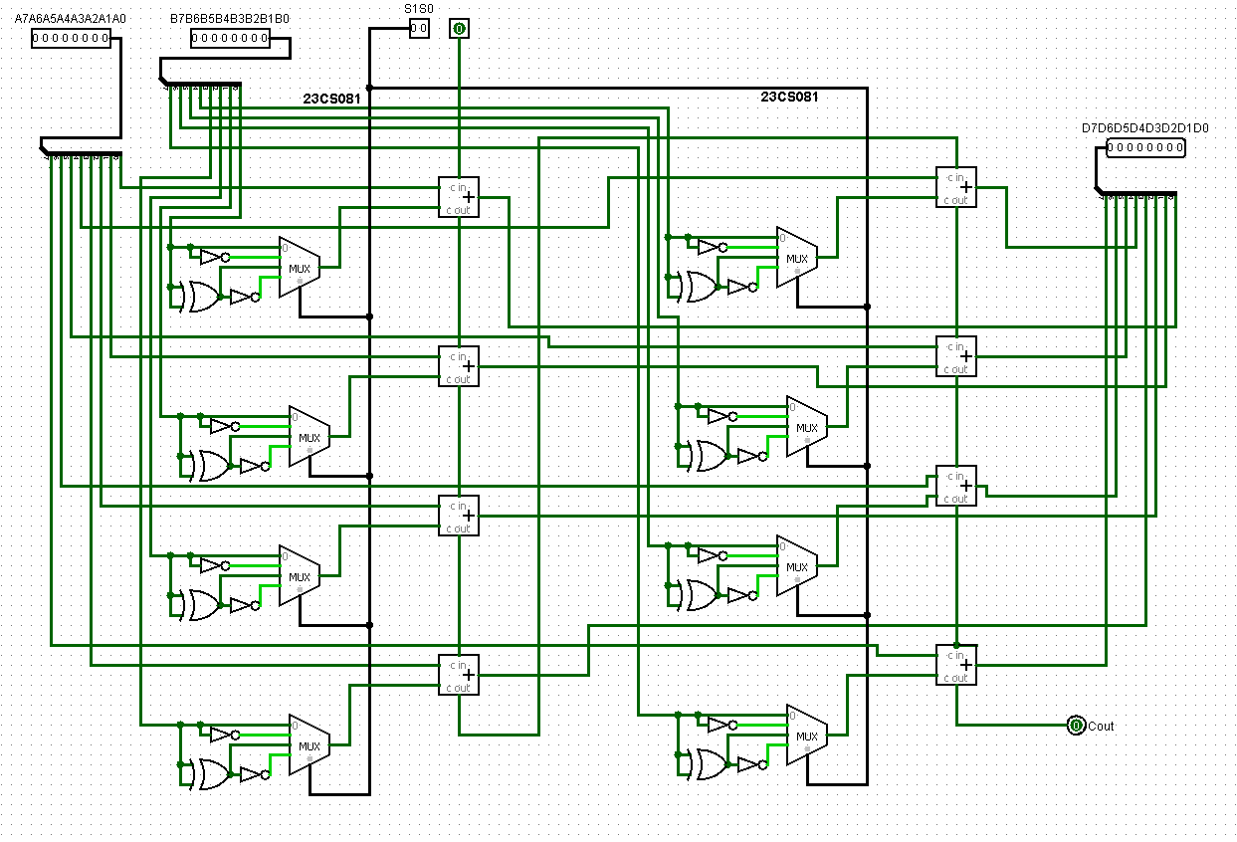

#### 1-bit logical unit circuits for four logical functions

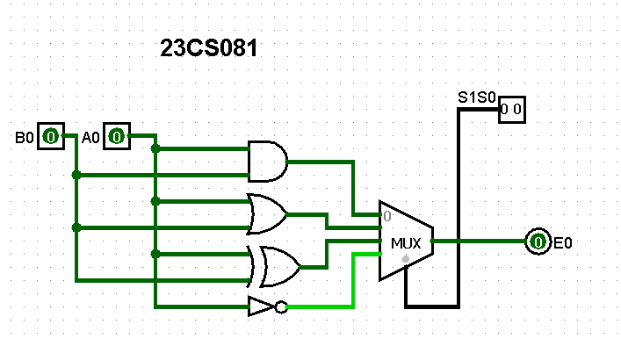

1. **2-bit logical unit circuits for four logical functions**

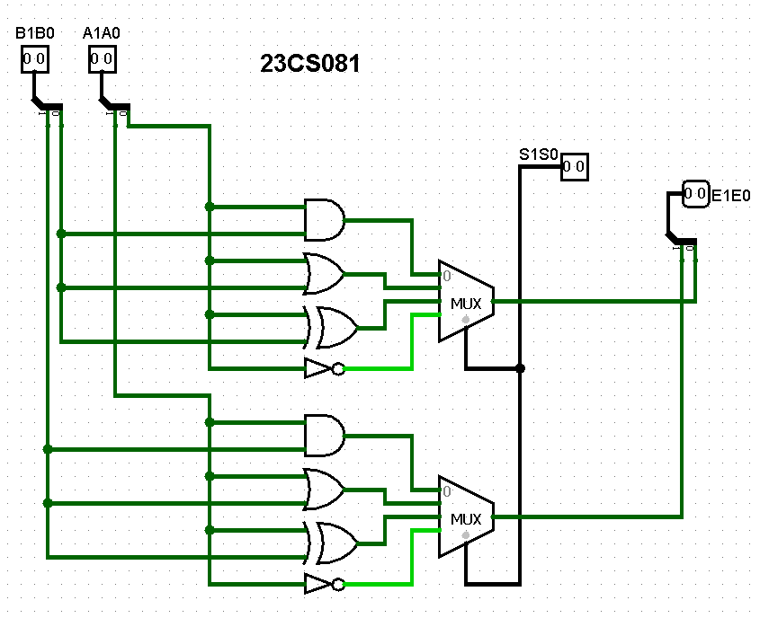

**3. 4-bit logical circuits for four logical functions**

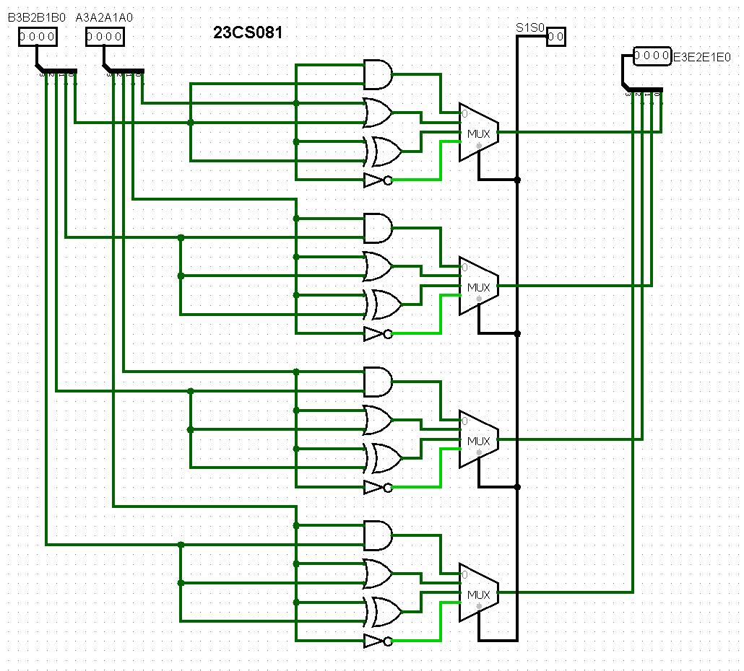

**4. 8-bit logical circuits for four logical functions**

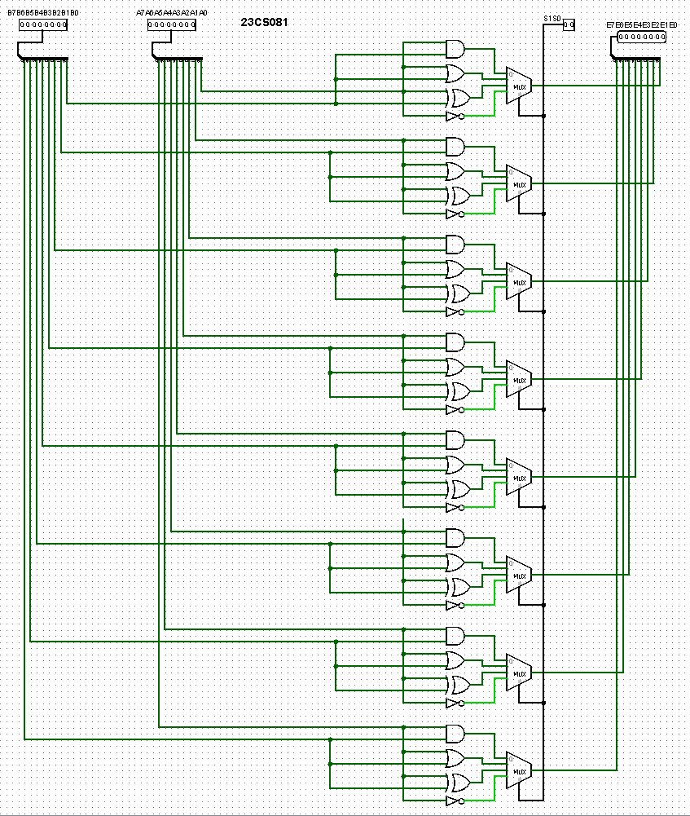

#### 1-bit logical unit circuits for sixteen logical functions

#### 

#### 2-bit logical unit circuits for sixteen logical functions

#### 

#### Implement 2-bit bidirectional shifter

#### 

#### Implement 4-bit bidirectional shifter

#### 

#### Implement 8-bit bidirectional shifter

#### 

#### Implement 1-bit ALU

#### 

#### Implement 2-bit ALU

#### 

#### Implement 4-bit ALU

#### 

#### Implement 8-bit ALU

#### 

#### 

**OUTPUTS:**

1. **1-bit arithmetic unit circuit**

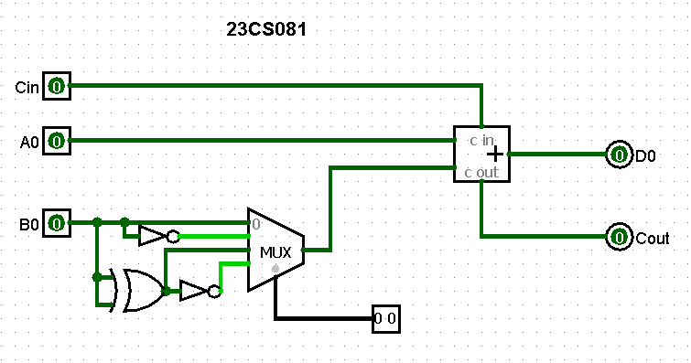 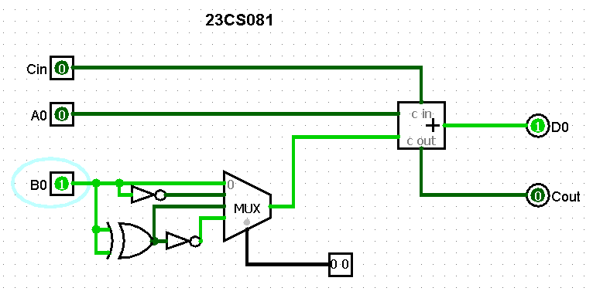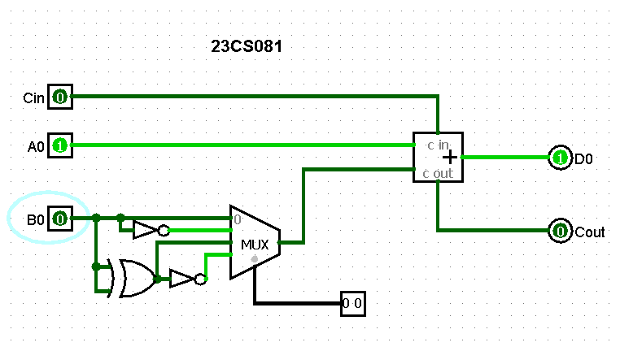 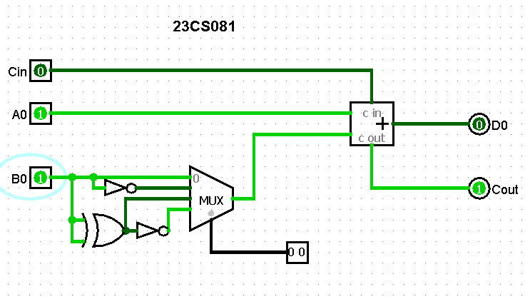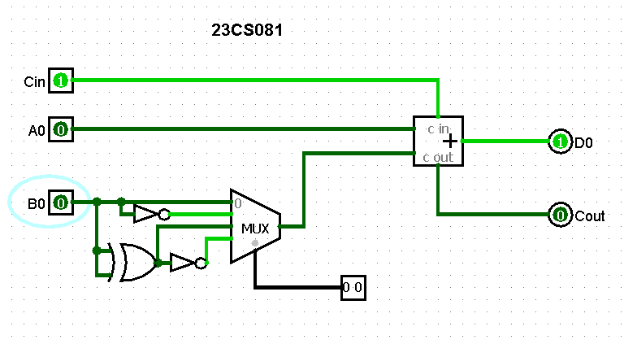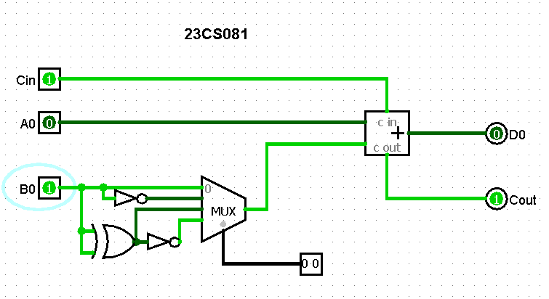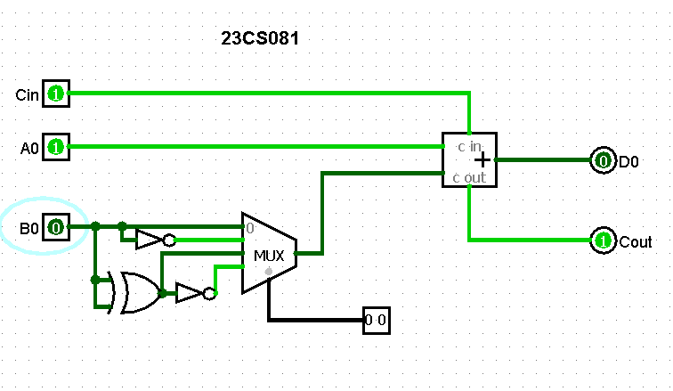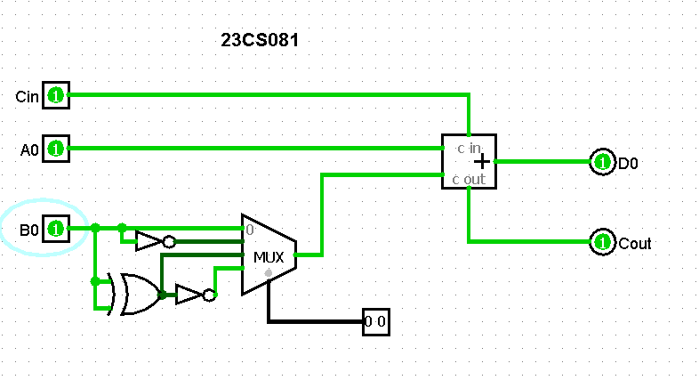

1. **8-bit arithmetic unit circuit**

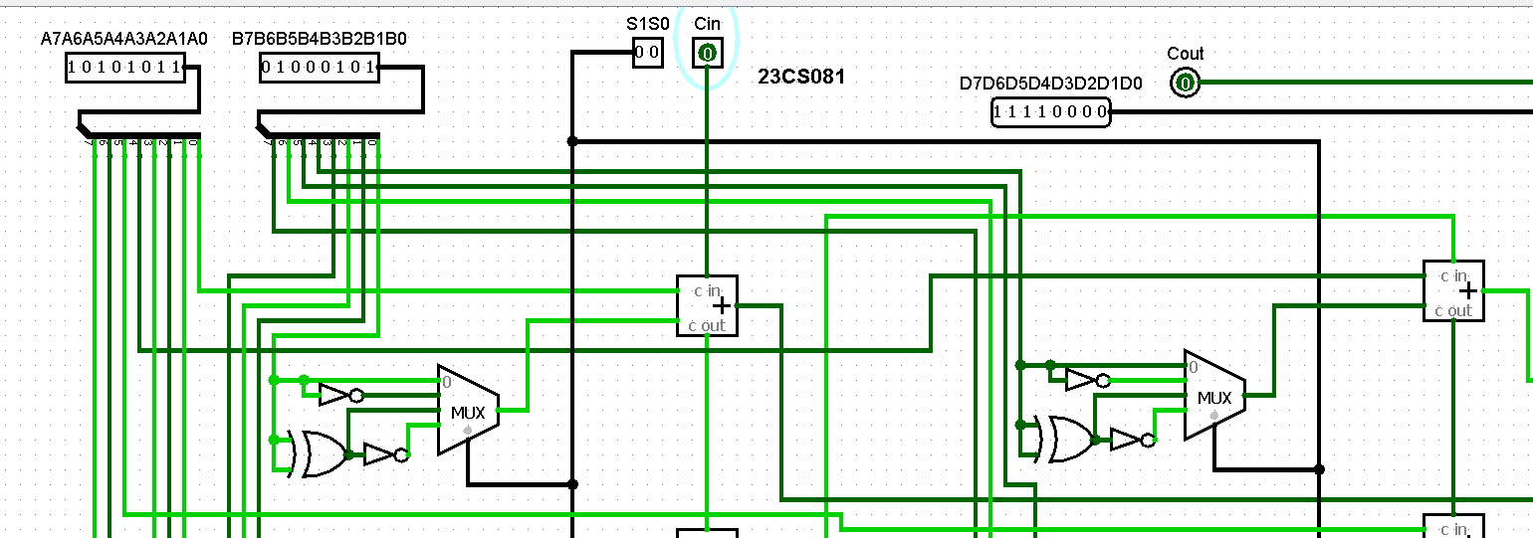

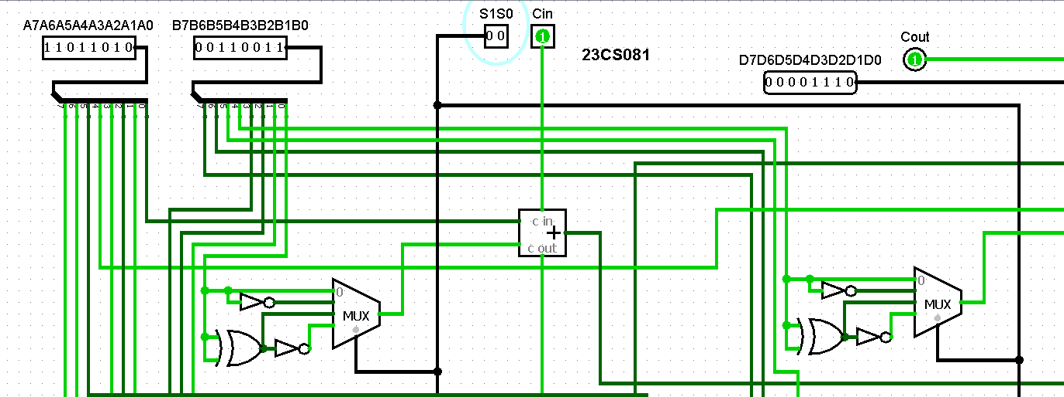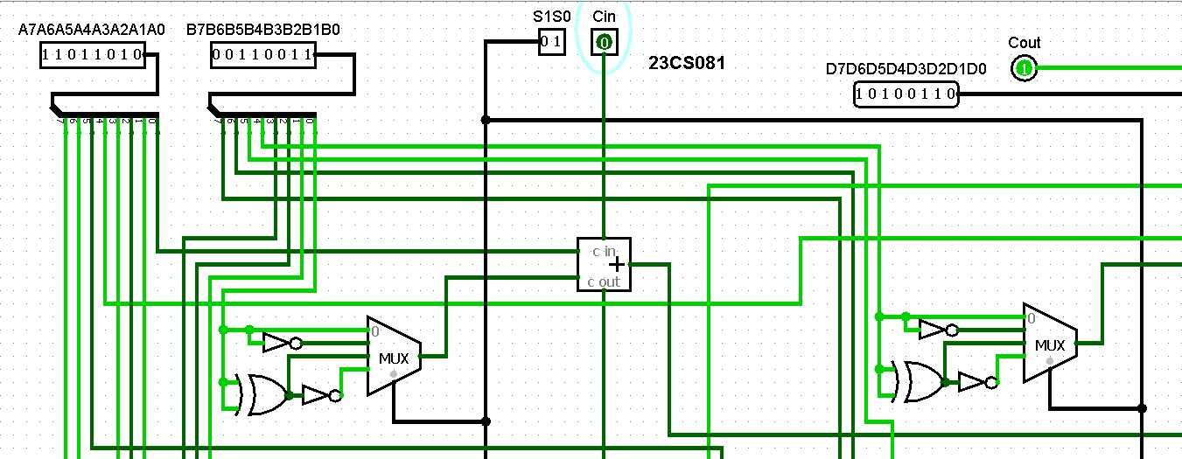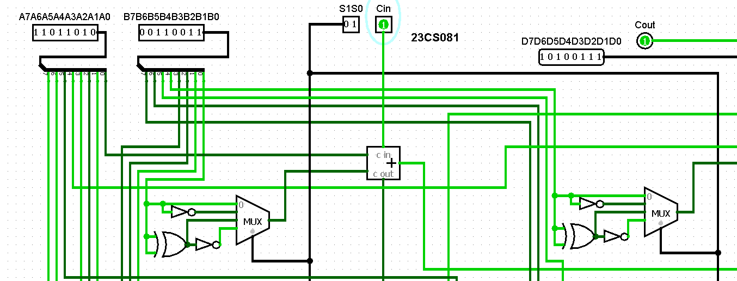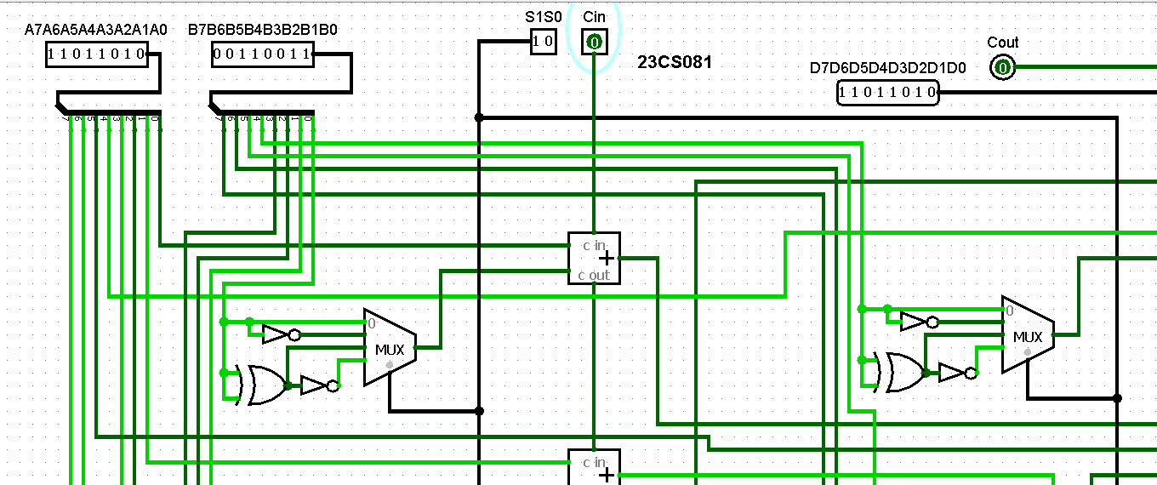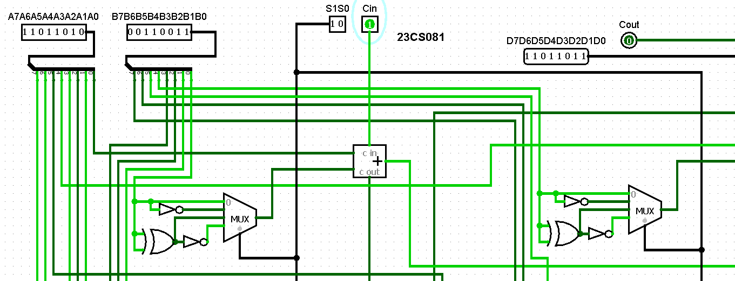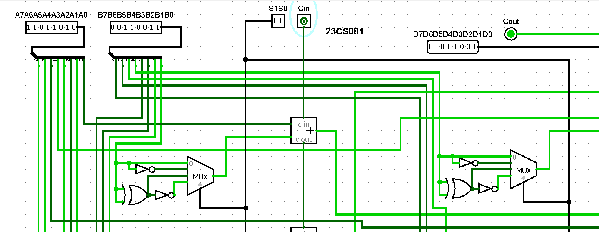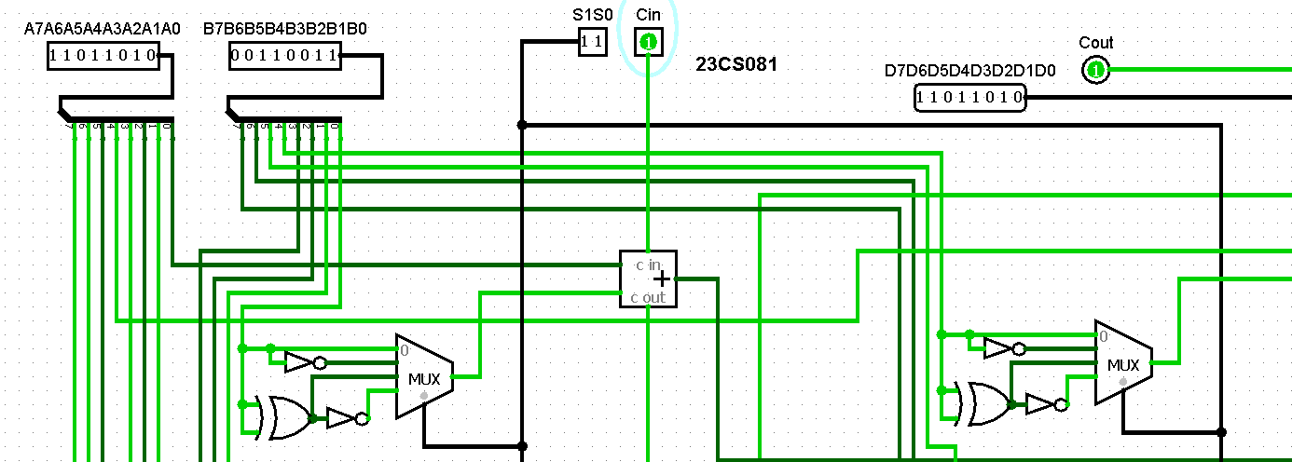

1. **2-bit logical unit circuits for four logical functions**

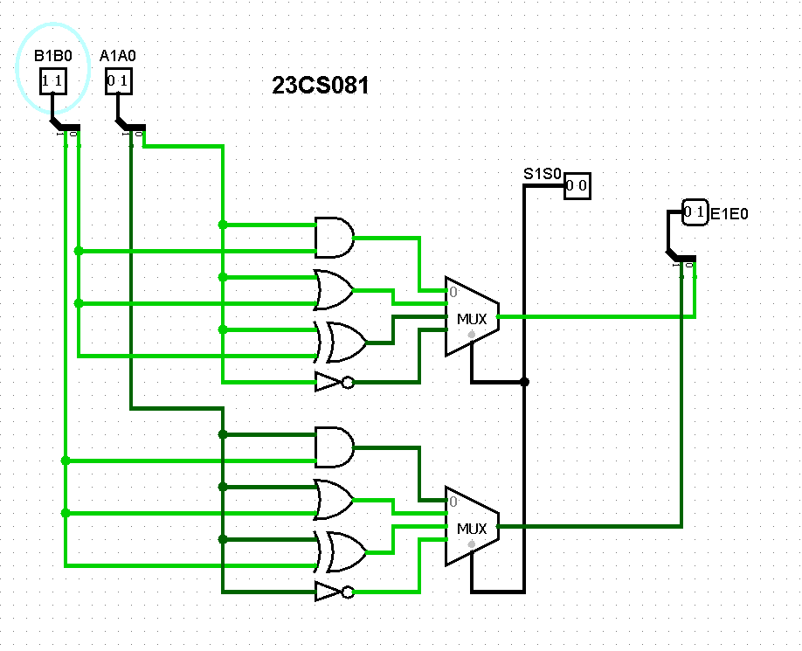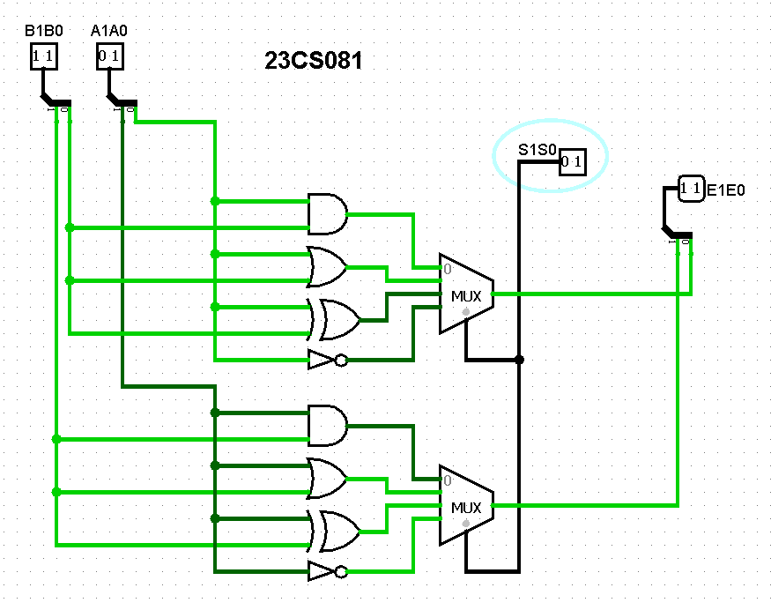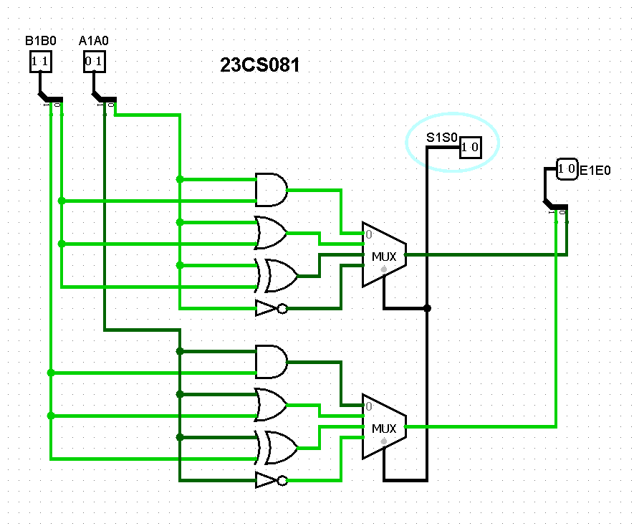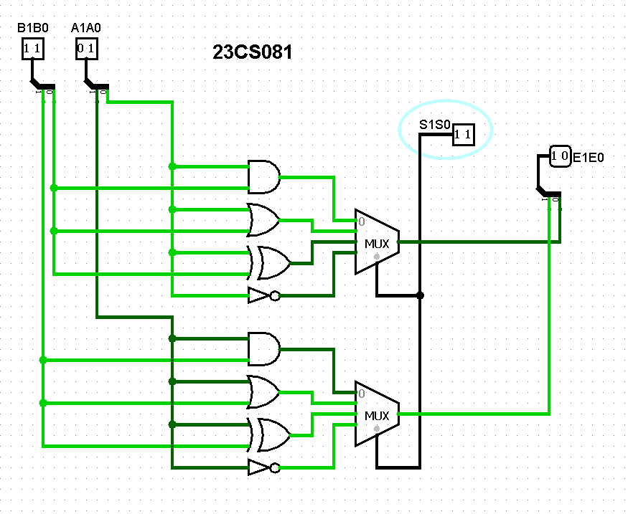

**4. 4-bit logical circuits for four logical functions**

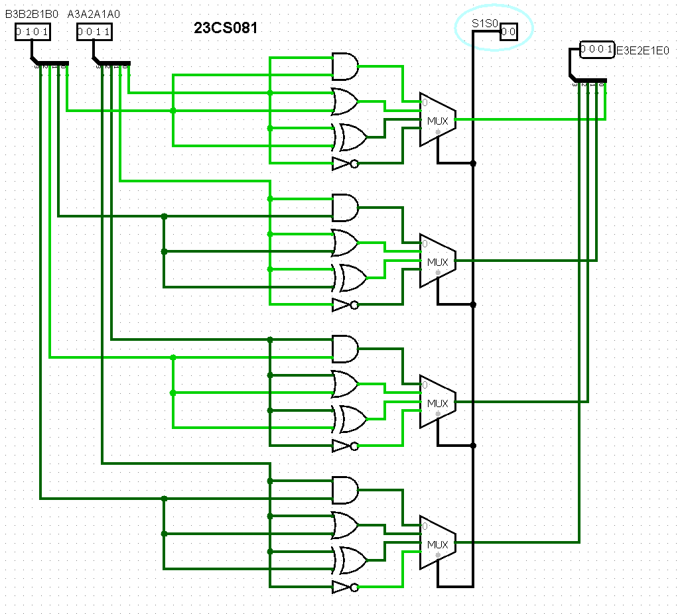

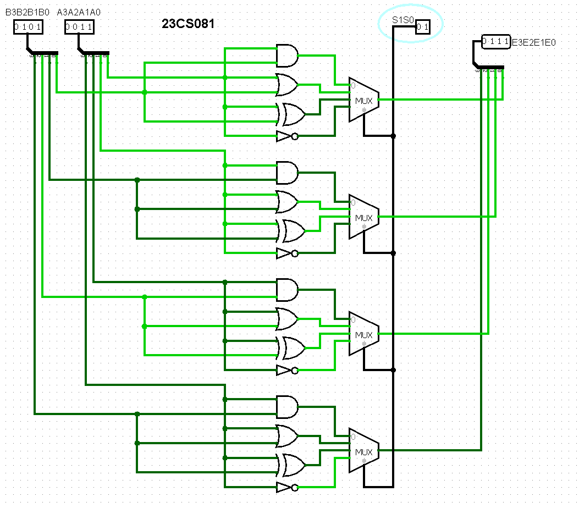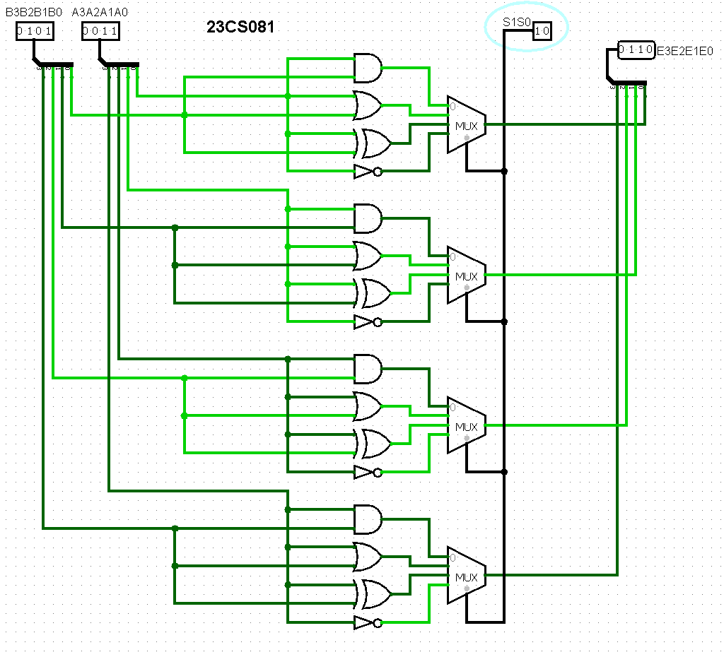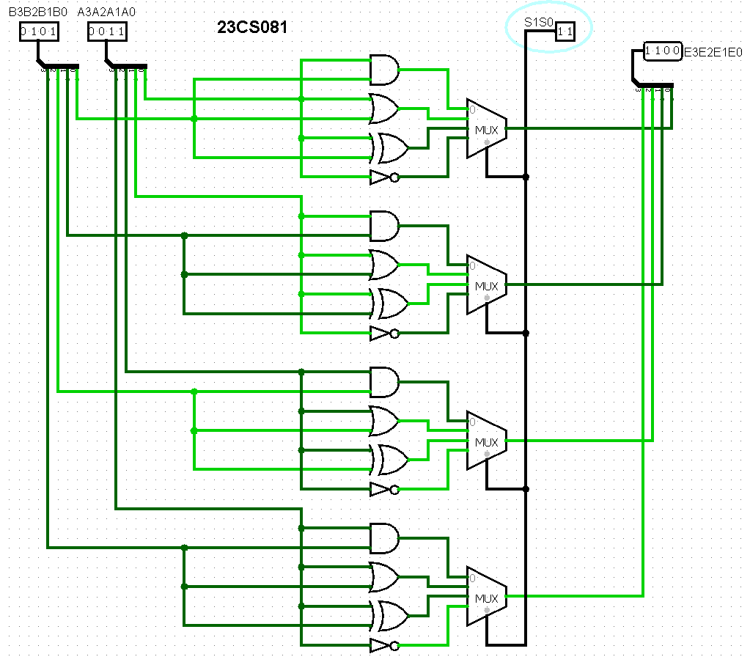

#### 1-bit logical unit circuits for sixteen logical functions

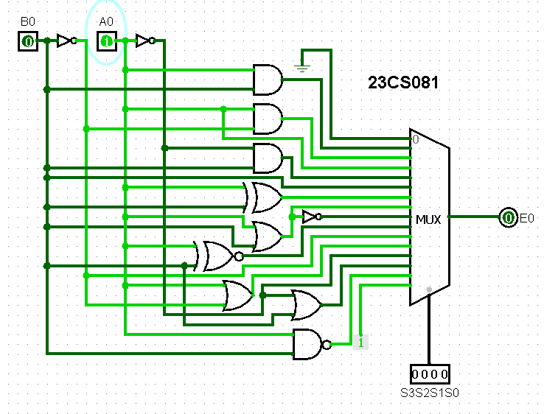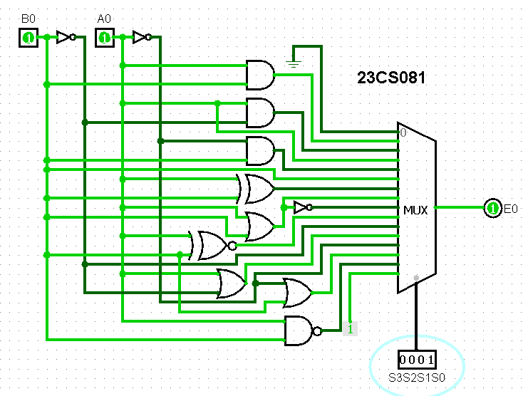

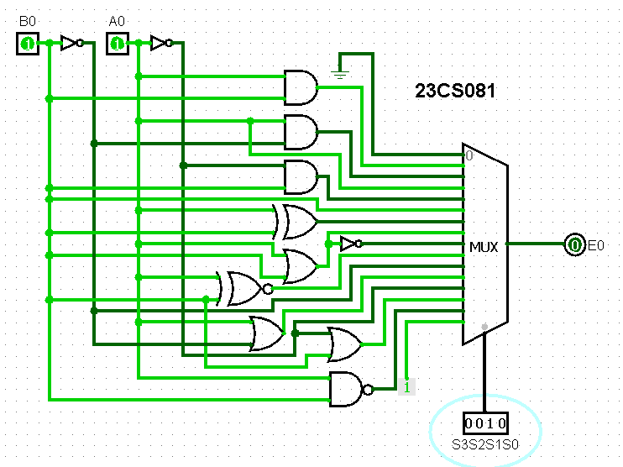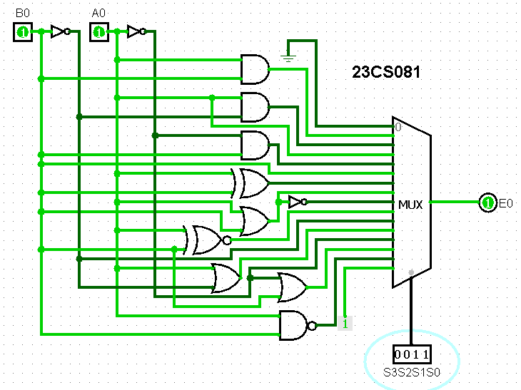

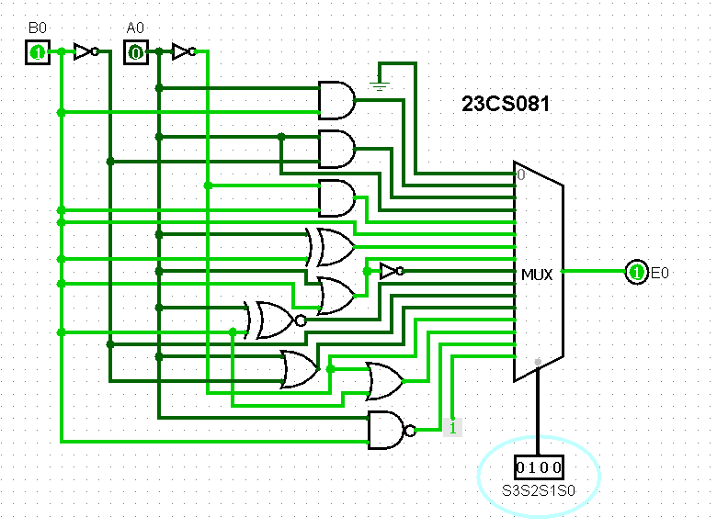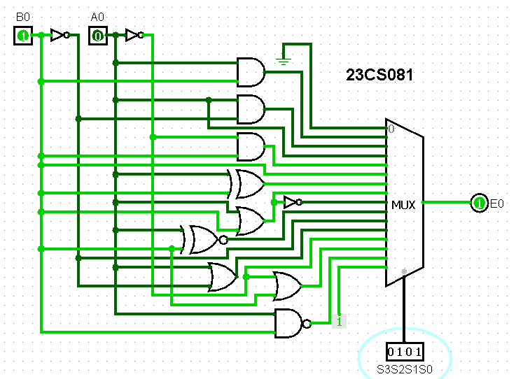

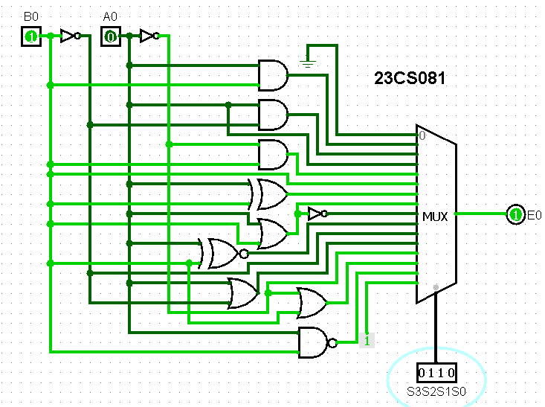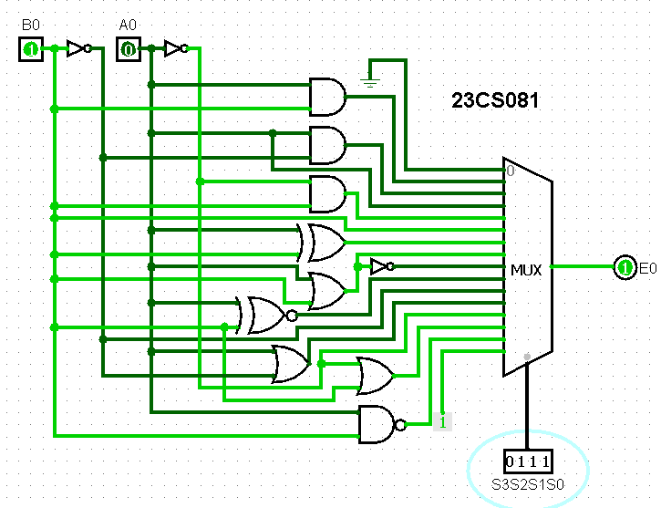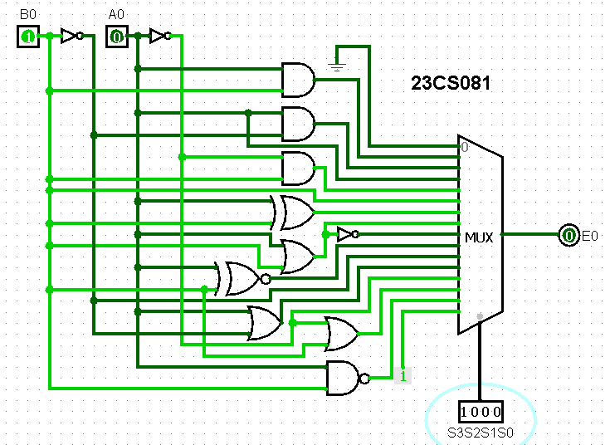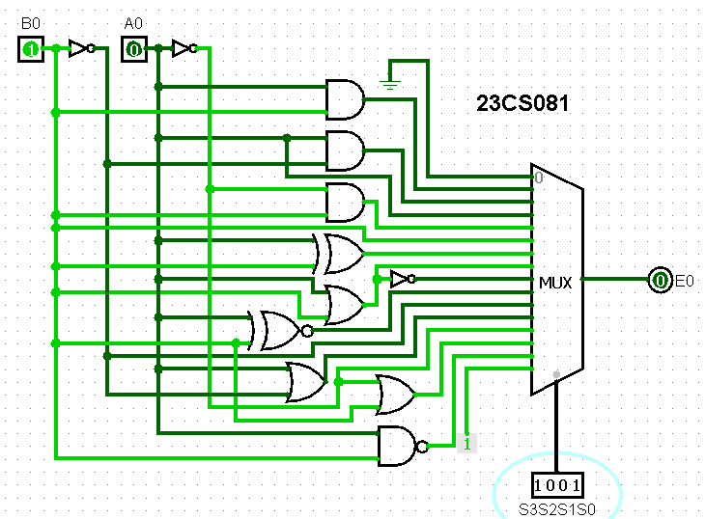

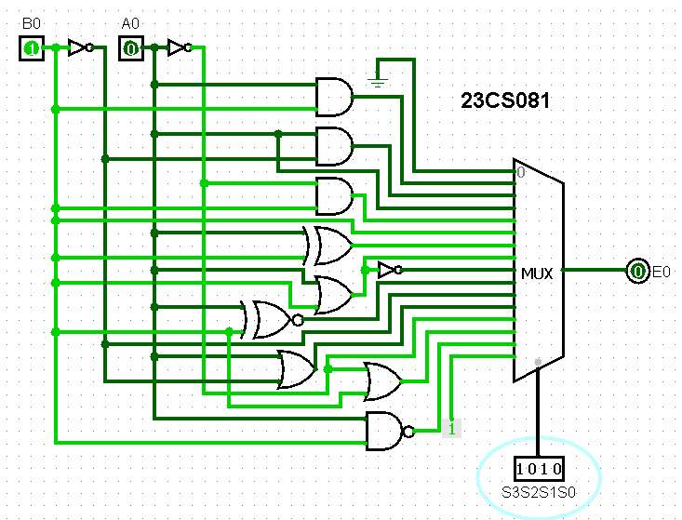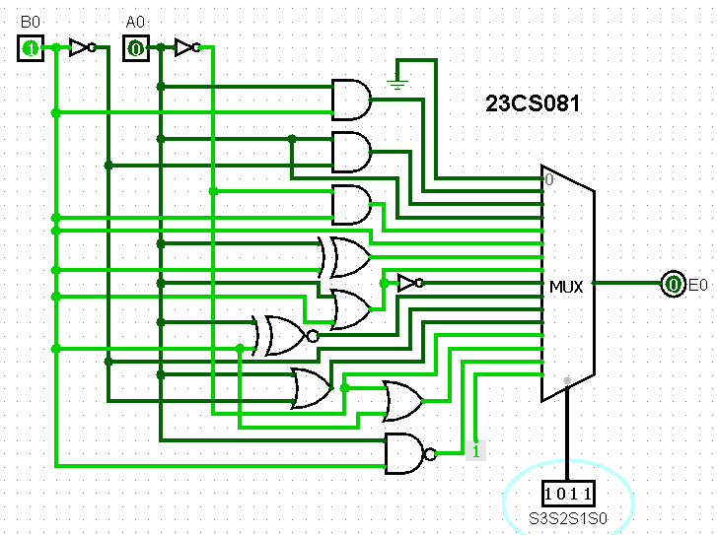

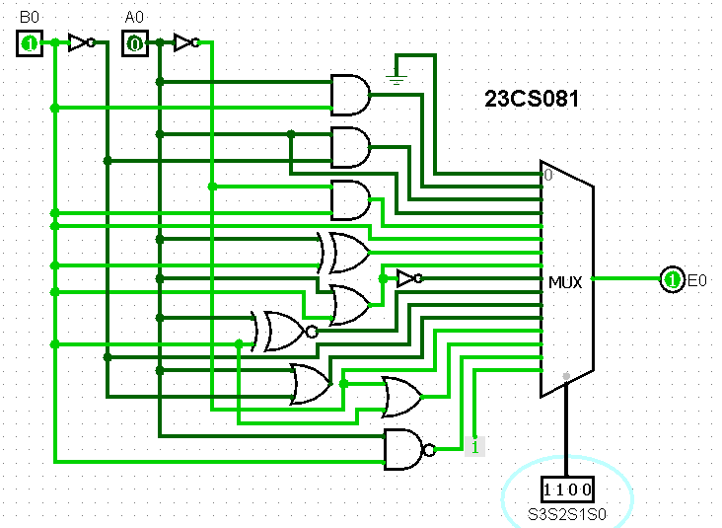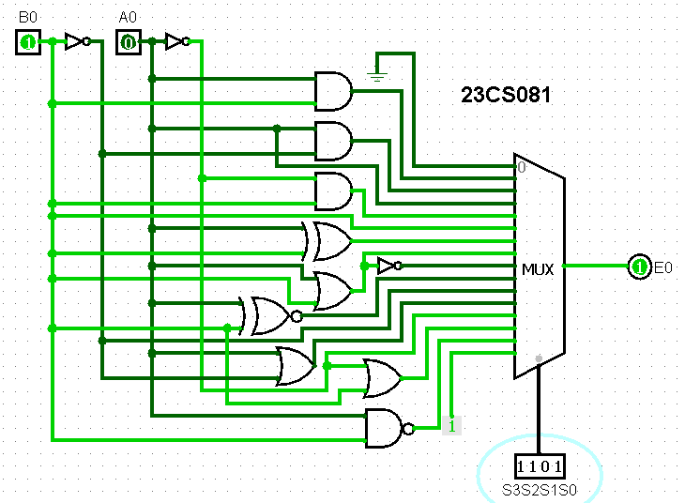

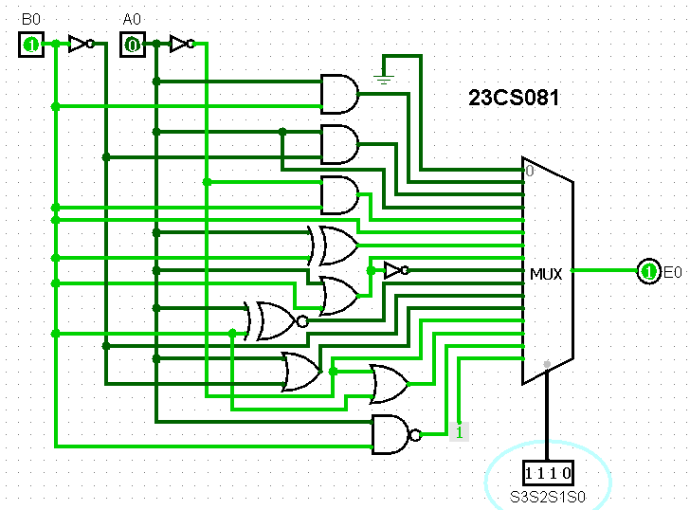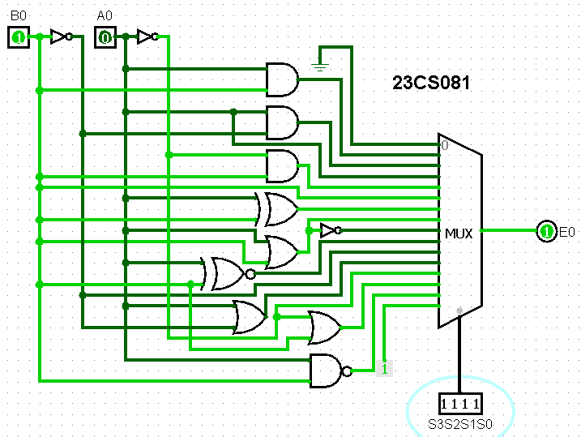

#### Implement 2-bit bidirectional shifter

#### 

#### Implement 4-bit bidirectional shifter

#### 

#### 

#### 8-bit bidirectional shifter

#### 

#### 

#### 1-bit ALU

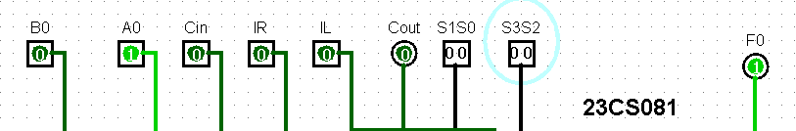 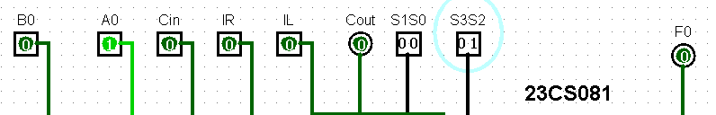

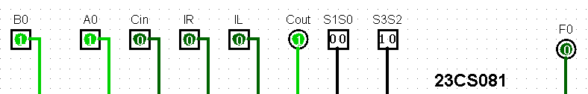

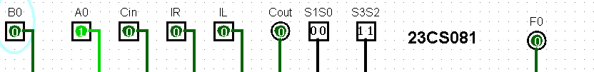

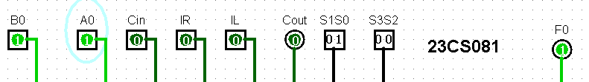

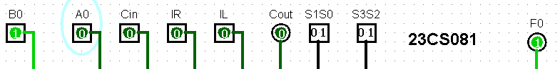

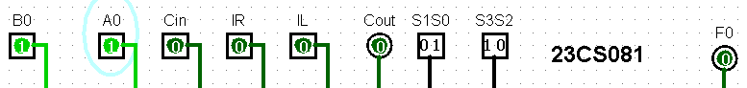

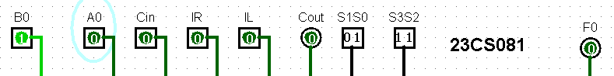



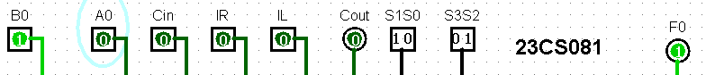

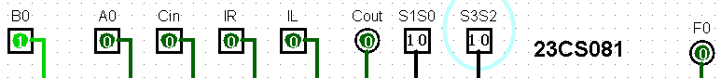

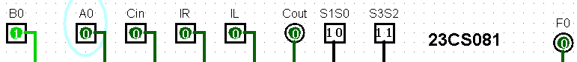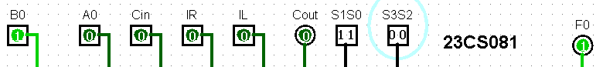 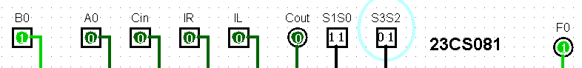

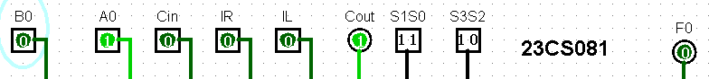 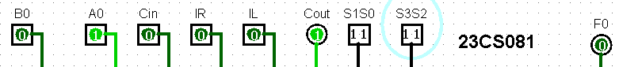

1. **8-bit ALU**

               

**CONCLUSION:**