OPE

Library Management System

Name: Patel Hetvi

En. No.:210410107004

Class: SY-I (A)

**Introduction**

The Database Library System is intended to Automate the library activities such as creating a new borrower, giving books to the borrowers, maintaining the details of all the item that were available in the books .

This also helps the librarians by providing information such as total copies available each book, list of books that belong to a particular category (Short, Long Loan, Reference items, etc).

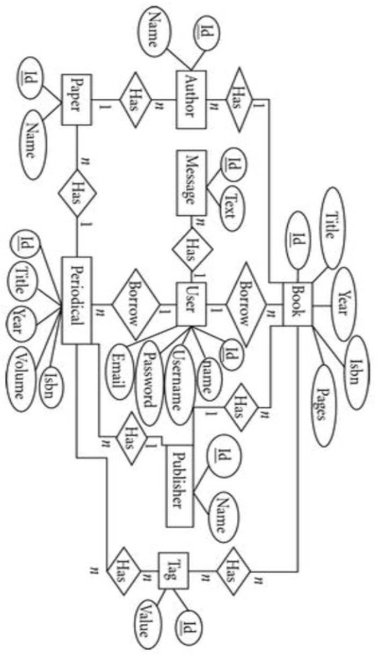

Tables

Book_Details:

This is the master table for all the books that are available in the Library. This table contains the complete list of books that are available in the library. Each Book id provided with a unique ISBN which serves as a primary key. The book details include the ISBN, Book Title, the year in which that particular book was published, the type of binding either soft cover or hard cover and the category.

Columns:

ISBN: This is unique ID given to every book. Since there may be a large no. of books with same TITLE, this ISBN no. will help us to distinguish between books of same title.

Book_Title: Provides the name of the book.

Publication_year: Contains the year of publication in ‘YY’ format (eg:2009à09)

Language: Contains the language in which this book was published.

Category_Type:

This column contains the Category ID whose details can be fetched form the category_master table. The category ID is a Unique number given to each category.

**Binding _Id:**

This column contains the Binding ID whose details can be fetched form the Binding_Detailstable.The Binding ID is a Unique number given to each type Binding.

**No_Of_Copies_Actual:** This column contains the total no. of copies of each book that were initially present.

**No_Of_Copies_Current:** This column contains the total no. of copies of each book that were currently available .

**Binding_Details:**

This table is the Master table for the binding types.This includes the binding ID and Binding Name. The Binding ID serves as a primary key.

**Columns:**

**Binding_ID:** This column contains the Unique number that was given to each type of binding.

**Binding_Name:** This column give the names of different types of binding.

**Category_Details:**

This includes the Category ID and Category Name. The Category ID servers as a primary key.

Columns:

**Category _ID:** This column contains the Unique number that was given to each type of Category.

**Category _Name:** This column give the names of different types of categories.

**Borrower_Details:**

This table contains the details of all the persons who lent a book from the library. Each Student will be given a Unique borrower ID. All the library related activity for a particular person will be captured based on the Borrower ID. This table will be used to track the borrowing records. The borrower ID will serve as a primary key here.

**Columns:**

**Borrower_ID:** Unique ID given to each Student.

**Book_ID:** This column contains the book ID which was give to the borrower.

**Borrowed_From_Date:** The date on which the book was given a particular borrower.

**Borrowed_To_Date:** The date on which that book was supposed to be returned back or should be renewed.

**Actual_Return_date:** The date on which the borrower returned the book to the library.

**Issued_by:** The ID of the Librarian who issued book to the borrower.

**Student_Details:**

This table contains the details of all the students they are eligible for availing Library facilities. Each student will be provided with a unique Student ID and Borrower ID. The student ID will be Primary Key, whereas Borrower_ID and Phone_no will be Unique.

**Columns:**

**Student_id:** Unique ID given to Each Student.

**Student_Name:** The Name of the Student.

**Sex:** Gender of the Student either Male or Female.

**Date_Of_Birth:** The Date of Birth of the student.

|  |
| --- |
| **Borrower_ID:** The borrower ID assigned to each student.  **Department:** This is contains student department. **Contact_Number:** Contact number of the student. **Creating table “Book_Details”:**  **CREATE TABLE** Book_Details |
| 1.( |
| 2. ISBN_Codeint **PRIMARY KEY**, |
| 3. Book_Titlevarchar(100), |
| 4. Language **varchar**(10), |
| 5. Binding_Idint, |
| 6. No_Copies_Actualint, |
| 7. No_Copies_Currentint, |
| 8. Category_idint, |
| 9. Publication_yearint |
| 10.) |
| **Inserting Some Data in “Book_Details” :**  **INSERT INTO** Book_details |
| 1.**VALUES**('0006','Programming Concept','English',2,20,15,2,2006); |
| **Creating table “Binding_Details”:**  **CREATE TABLE** Binding_details |
| 1.( |
| 2.Binding_idint **PRIMARY KEY**, |
| 3.Binding_Namevarchar(50) |
| 4.)  **Inserting Some data in Binding Table:**  **INSERT INTO** Binding_DetailsVALUES(1,'McGraw Hill); |
| 1.**INSERT INTO** Binding_DetailsVALUES(2,'BPB Publication'); |

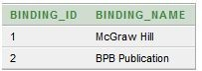 **All Data of Binding Table:**

select *from binding_Details;

|  |
| --- |
| Creating Relationship Between Book and Binding Table:  ALTER TABLE Book_details |
| 1.ADD CONSTRAINT Binding_ID_FK FOREIGN KEY(Binding_Id) REFERENCES Binding_Details(Binding_Id); |
| Checking Relationship:  selectb.Book_Title, e.binding_name |
| 1.fromBook_Detailsb, Binding_Details e |
| 2.whereb.binding_id = e.binding_id;    Creating Category Table:  CREATE TABLE Category_Details |
| 1.( |
| 2.Category_Idint PRIMARY KEY, |
| 3.Category_Namevarchar(50) |
| 4.)  Inserting some data in Category Table:  INSERT INTO CATEGORY_DETAILS VALUES(1,'Database'); |
| 1.INSERT INTO CATEGORY_DETAILS VALUES(2,'Programming  Language'); |
| Building Relationship between Book & Category Table:  ALTER TABLE Book_details |
| 1.ADD CONSTRAINT Category_Id_FK FOREIGN KEY(Category_Id) REFERENCES Category_Details(Category_Id); |
| Checking Relationship:  Select b.Book_Title,e.Category_Name |
| From Book_Details b,Category_Details e whereb.binding_id = e.Category_id; |
| Creating Borrower Table:  CREATE TABLE Borrower_Details |
| 1.( |
| 2.Borrower_Idint PRIMARY KEY, |
| 3.Book_Idint, |
| 4.Borrowed_From date, |
| 5.Borrowed_TO date, |
| 6.Actual_Return_Date date, |
| 7.Issued_byint |
| 8.)  Inserting Some data in Category Table:  Insert into BORROWER_DETAILS VALUES(1,0004,'01-Aug-2014','7-Aug- 2014','7-Aug-2014',1); |

**Insert into** BORROWER_DETAILS **VALUES**(2,6,'02-Aug-2014','8- Aug-2014',NULL,1);

|  |
| --- |
| **Building Relation Between Book & Borrower Table:**  ALTER TABLE Borrower_details ADD CONSTRAINT Book_Id_FK FOREIGN KEY(Book_Id) REFERENCES Book_Details(ISBN_Code);  **Checking Relationship:**  selectBorrower_Details.Borrower_id,Book_Details.Book_title |
| fromBorrower_Details,Book_Details where Borrower_Details.book_id=Book_Details.ISBN_Code |
| |  | | --- | | **Creating Student Table:**  **Create TABLE** Student_Details | | 1.( | | 2.Student_Idvarchar(10) **PRIMARY KEY**, | | 3.Student_Namevarchar(50), | | 4.Sex **Varchar**(20), | | 5.Date_Of_Birth **date**, | | 6.Borrower_Idint, | | 7.Department **varchar**(10), | | 8.contact_Numbervarchar(11) | | 9.) | | **Inserting Some Data in Student Table:**  **Insert into** STUDENT_DETAILS **values** ('13-23059- 1','Ahmed,Ali','Male','05-Oct-1995',1,'CSSE','01681849871'); | | 1.**Insert into** STUDENT_DETAILS **values** ('13-23301-1','Morol MD.Kishor','Male','03-Jan-1994',2,'CSE','01723476554'); | | **All Data of Student Table:**  **select** \***from** student_details    **Building Relationship between student and Borrower table:**  **ALTER TABLE** student_details | | 1.**ADD CONSTRAINT** borrower_id_FK **FOREIGN KEY**(Borrower_Id) **REFERENCES** Borrower_Details(Borrower_Id); | | **Checking Full Relationship:**  **select** student.student_id, student.student_name, book.Book_Title, staff.staff_name, b.Borrowed_To | | fromstudent_Detailsstudent, Staff_Detailsstaff, Borrower_Detailsb, book_details book wherestudent.Borrower_id = b.Borrower_id and book.ISBN_Code= b.book_id and b.Issued_by = staff.Staff_id; | |