R DATA VISUALIZATION REPORT
Order Analysis using the Maven Fuzzy Factory Orders Dataset
Visualization-focused analysis using R base plotting concepts

1. Introduction
The objective of this project is to use R to create dynamic and informative visualizations from an order dataset. Visualizations make numerical information easier to understand by showing distributions, comparisons, relationships, trends, and unusual observations. The analysis focuses on order price, cost of goods sold (COGS), products, items purchased, and order dates. Base R plotting functions are used because they are simple, reproducible, and directly suitable for the selected dataset.

2. Data Overview
The selected dataset is the orders table from the Maven Fuzzy Factory dataset. It contains 32,313 order records and 8 variables. The data covers the period from 19 March 2012 to 19 March 2015.
Variable | Type | Meaning
order_id | Integer | Unique order identifier
created_at | Date-time | Date and time when the order was created
website_session_id | Integer | Website session associated with the order
user_id | Integer | Customer/user identifier
primary_product_id | Integer | Main product associated with the order
items_purchased | Integer | Number of items purchased
price_usd | Numeric | Order price in US dollars
cogs_usd | Numeric | Cost of goods sold in US dollars

3. Data Quality Check
The dataset contains no missing values (0 missing cells) and no duplicate rows (0 duplicated rows). The order price has a minimum of $29.99, a median of $49.99, a mean of $59.99, and a maximum of $109.98. The first quartile is $49.99, the third quartile is $59.99, and the IQR is $10.00.

4. Visualization 1 – Histogram of Order Prices
A histogram was selected to show the distribution of order prices. It groups prices into intervals so that the most common price ranges can be identified quickly. The chart shows that orders are concentrated around the lower and middle price ranges, while higher-priced orders occur less frequently.
hist(orders$price_usd,
main = "Distribution of Order Prices",
xlab = "Price (USD)",
ylab = "Number of Orders")
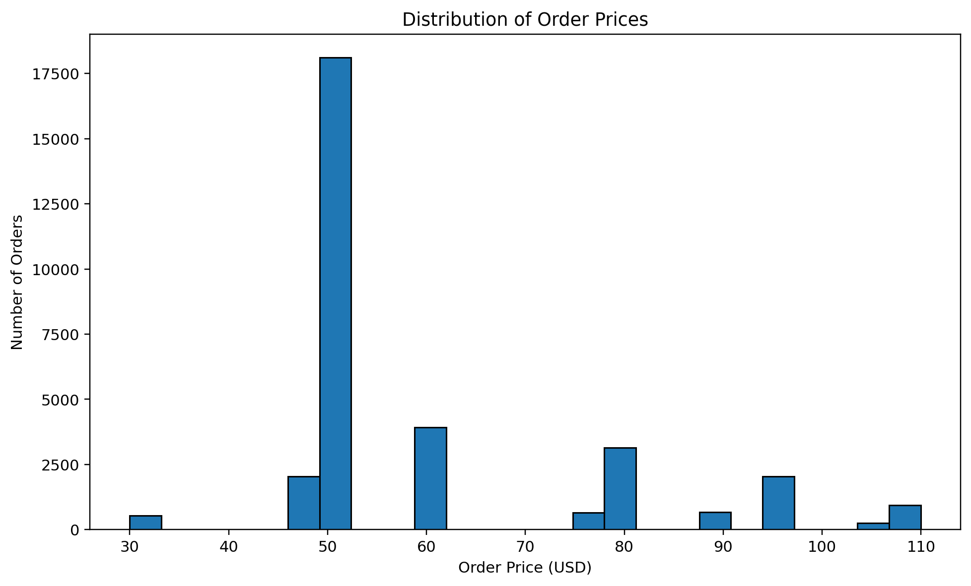
Figure 1. Distribution of order prices.

5. Visualization 2 – Boxplot of Order Price
A boxplot was used to summarize the center, spread, and potential outliers in order price. The median price is $49.99, while Q1 is $49.99 and Q3 is $59.99. Using the 1.5 × IQR rule, values below $34.99 or above $74.99 are treated as potential outliers. This rule identifies 8,246 records outside those limits. The boxplot therefore helps identify unusually low or high order prices.
boxplot(orders$price_usd,
main = "Boxplot of Order Price",
ylab = "Price (USD)")
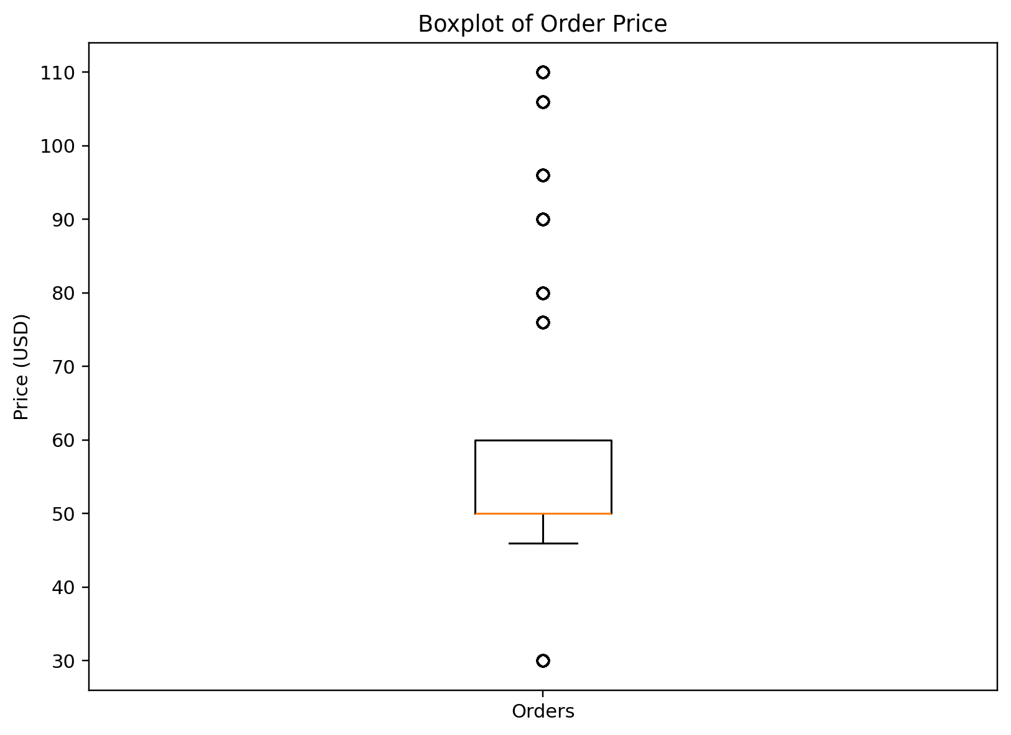
Figure 2. Boxplot showing the distribution and potential outliers.

6. Visualization 3 – Bar Chart of Orders by Product
A bar chart was selected to compare the number of orders associated with each primary product. Product 1 accounts for the largest number of orders, followed by Products 2 and 3, while Product 4 has substantially fewer orders. This visualization is useful for comparing categorical groups and immediately identifying the relative contribution of each product.
product_counts <- table(orders$primary_product_id)
barplot(product_counts,
main = "Number of Orders by Primary Product",
xlab = "Primary Product ID",
ylab = "Number of Orders")
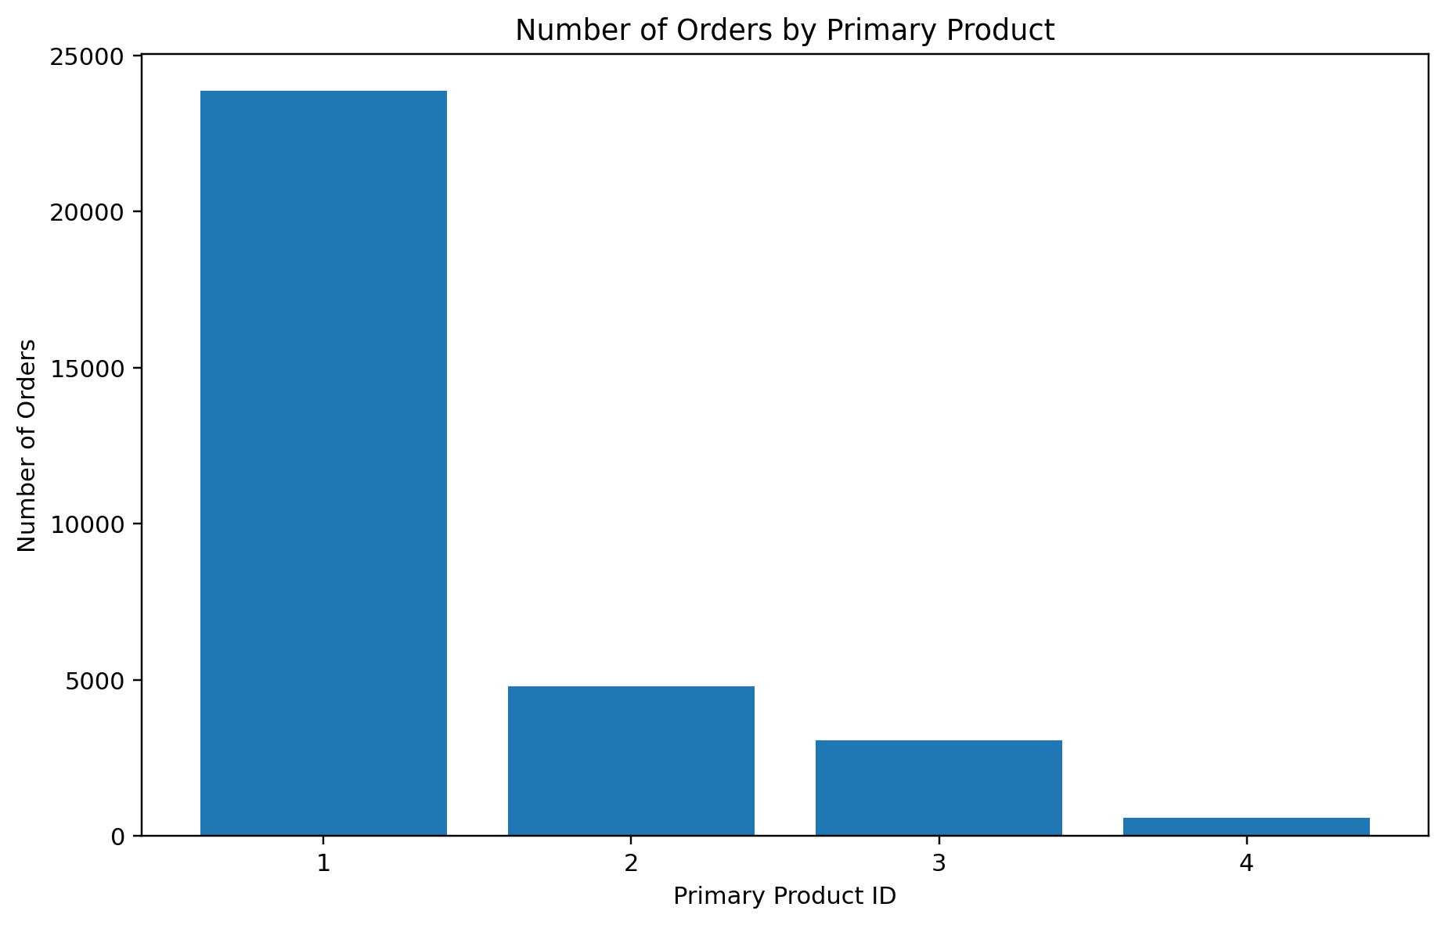
Figure 3. Number of orders by primary product.

7. Visualization 4 – Average Price by Product
A second bar chart compares the average order price across products. This visualization was chosen because the number of orders alone does not show price differences. Product 2 has the highest average order price among the four products, while Product 4 has the lowest average price. The comparison provides a different perspective from the order-count chart.
avg_price <- tapply(orders$price_usd,
orders$primary_product_id,
mean)
barplot(avg_price,
main = "Average Order Price by Product",
xlab = "Primary Product ID",
ylab = "Average Price (USD)")
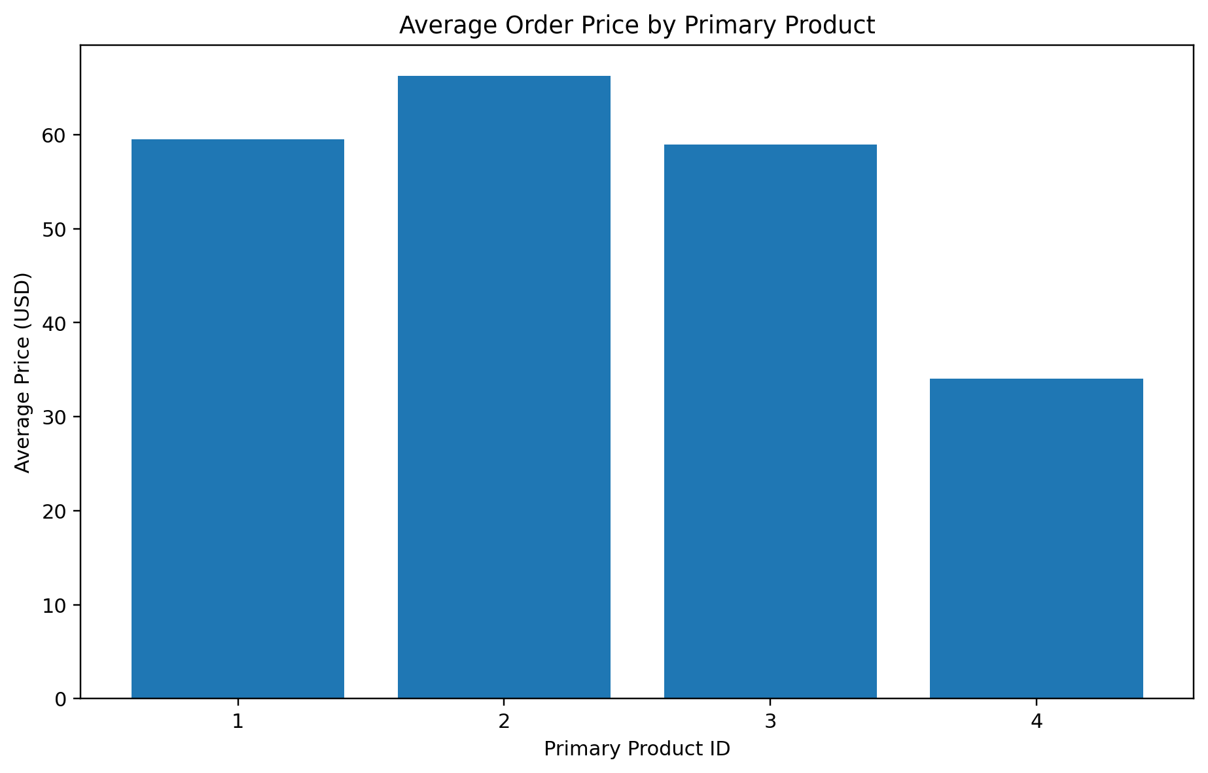
Figure 4. Average order price by primary product.

8. Visualization 5 – Line Chart of Monthly Orders
A line chart was used because order date is an ordered time variable. Monthly aggregation makes it possible to observe how order volume changes over the study period. Peaks and declines in the line can indicate periods of stronger or weaker order activity. A line chart is more appropriate than a bar chart here because the main purpose is to communicate a time trend.
orders$created_at <- as.POSIXct(orders$created_at)
monthly_orders <- aggregate(
order_id ~ format(created_at, "%Y-%m"),
data = orders,
FUN = length
)
plot(monthly_orders[,2],
type = "l",
main = "Monthly Order Volume Trend",
xlab = "Month",
ylab = "Number of Orders")
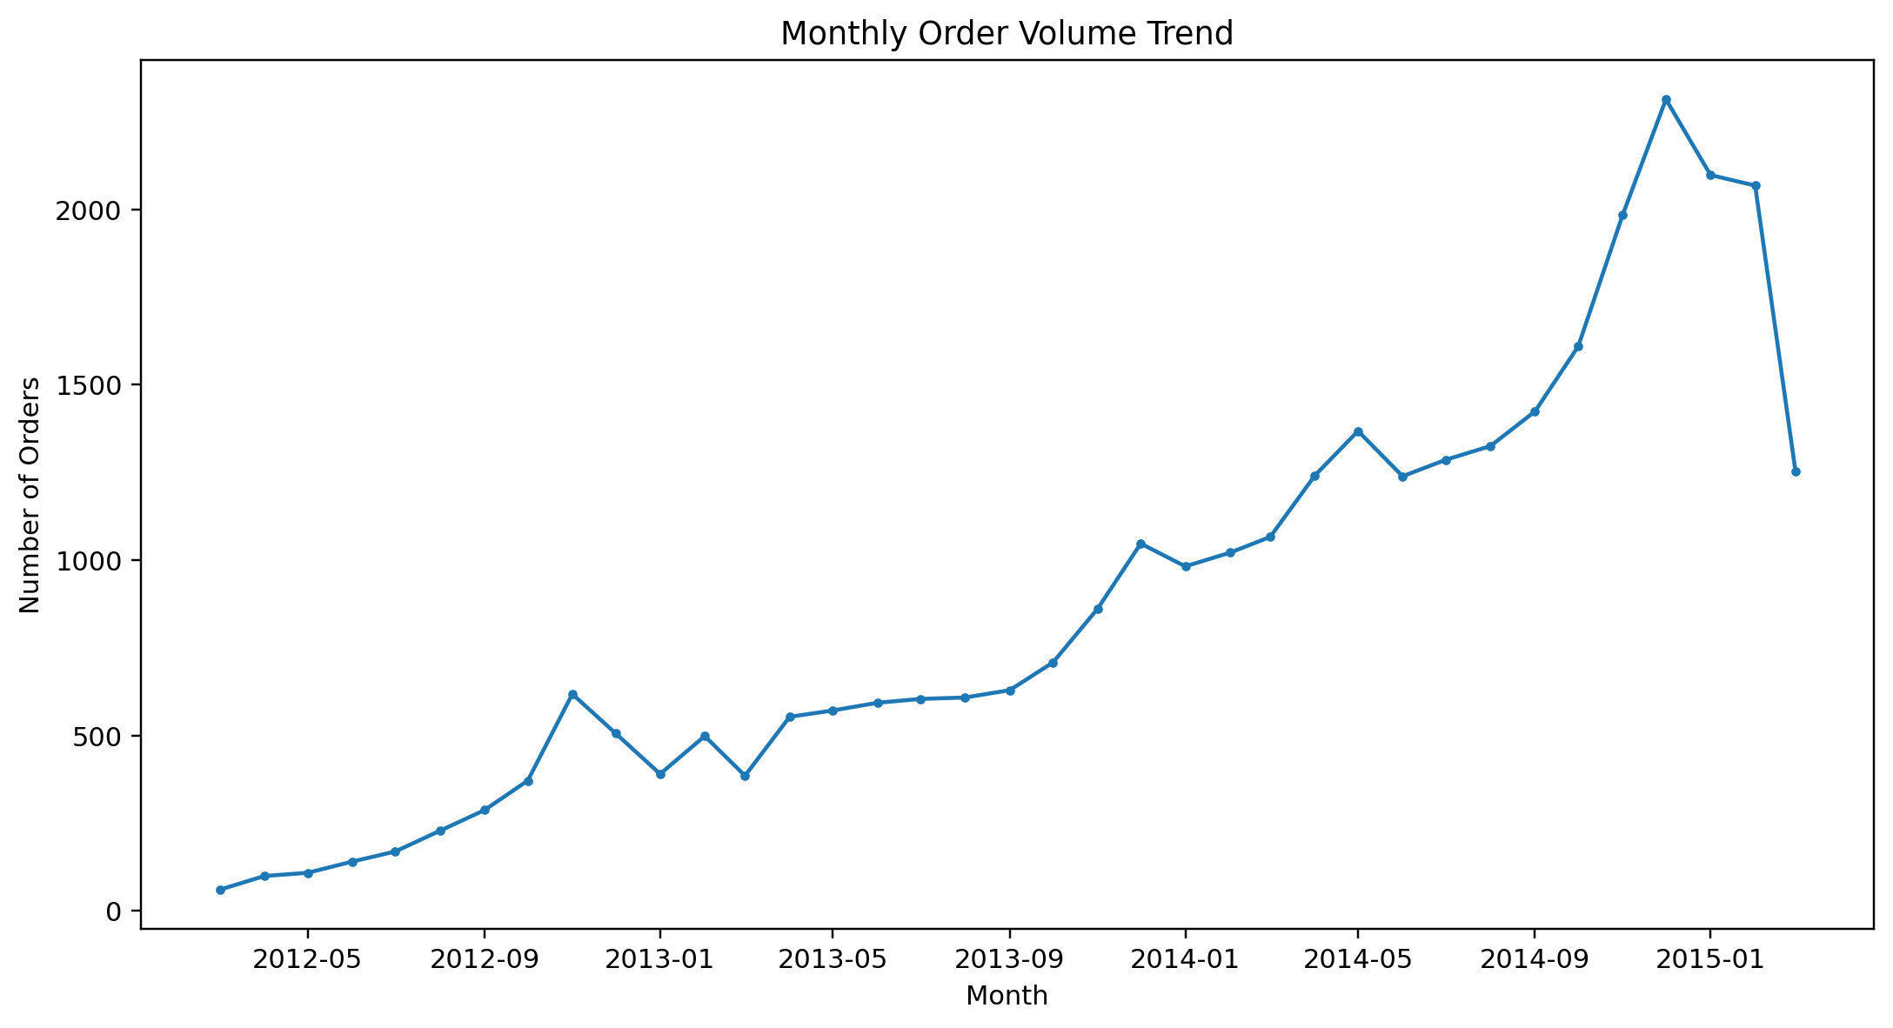
Figure 5. Monthly trend in order volume.

9. Visualization 6 – Scatter Plot of Price vs COGS
A scatter plot was selected to examine the relationship between order price and COGS. The correlation between these two variables is approximately 0.982, which indicates a strong positive linear relationship in this dataset. In practical terms, orders with higher prices generally also have higher costs. A scatter plot is effective because each point represents an individual order and the overall pattern can be seen directly.
plot(orders$price_usd,
orders$cogs_usd,
main = "Order Price vs Cost of Goods Sold",
xlab = "Price (USD)",
ylab = "COGS (USD)")
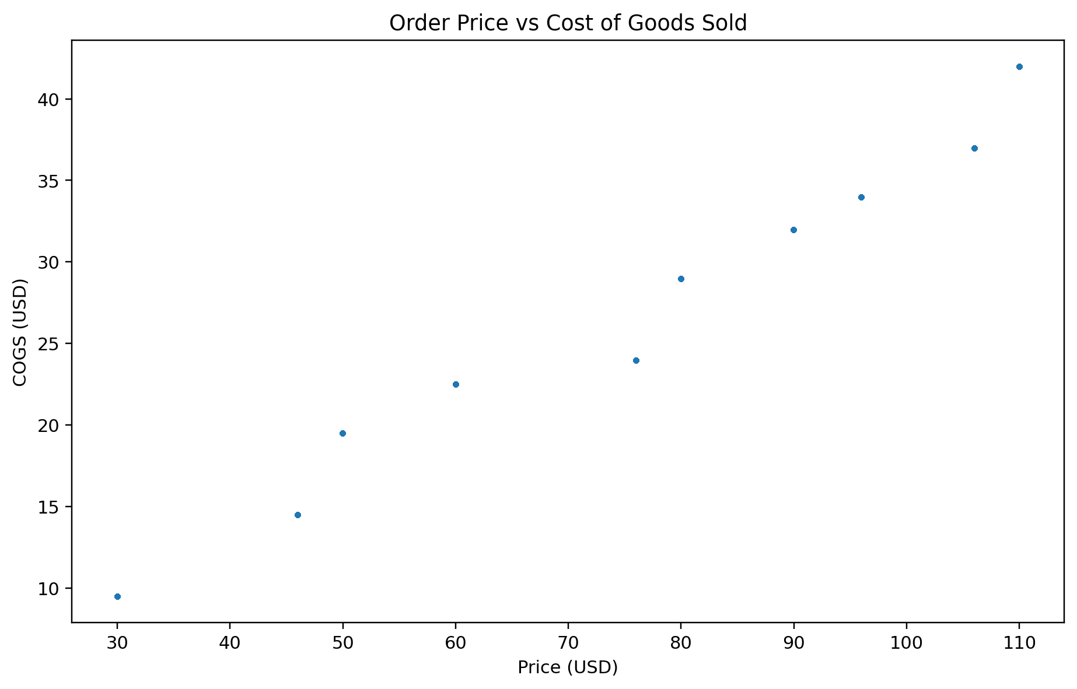
Figure 6. Relationship between order price and COGS.

10. Correlation Analysis
cor(orders[, c("items_purchased",
"price_usd",
"cogs_usd")])
The correlation between items purchased and price is 0.920. The correlation between items purchased and COGS is 0.864. The correlation between price and COGS is 0.982. These values show that the three numerical variables are positively related, with price and COGS having the strongest relationship.

11. Key Findings
- The dataset contains 32,313 orders across 8 variables.
- There are no missing values and no duplicate rows in the orders dataset.
- The median order price is $49.99, while the mean is $59.99.
- The middle 50% of order prices lie between $49.99 and $59.99.
- The 1.5 × IQR rule identifies 8,246 potential price outlier records.
- Product 1 has the highest order volume with 23,861 orders.
- Product 2 has the highest average order price at $66.23.
- Price and COGS have a strong positive correlation of 0.982.

12. Conclusion
The visual analysis demonstrates how different chart types communicate different aspects of the same dataset. The histogram explains distribution, the boxplot highlights spread and potential outliers, bar charts support category comparisons, the line chart reveals time-based movement, and the scatter plot communicates relationships between numerical variables. Together, these visualizations provide a concise and understandable view of order behavior and product performance. The R code included in this report can be reused to reproduce the analysis from the original CSV file.

13. Tools and Technologies
- R
- RStudio
- Base R plotting functions
- CSV dataset
- Microsoft Word / DOCX

14. Reproducibility
The GitHub project should contain the original orders.csv dataset, the analysis.R script containing the visualization and analysis code, and a README.md file describing the project. This allows the evaluator to reproduce the visualizations and verify the analysis.

