# Deep Learning Track -BWF

# Adil Mubashir Chaudhry Task#1 : Learning Git & Version Control

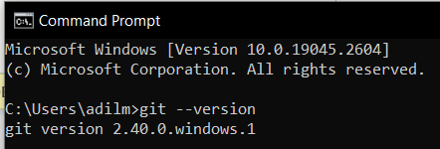

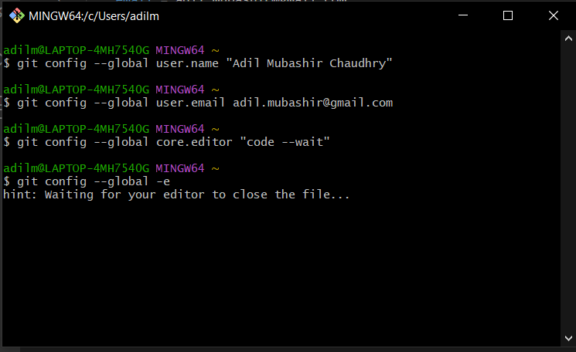

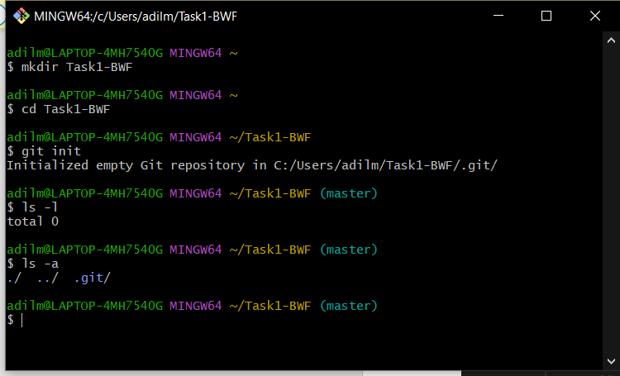 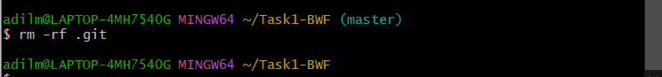

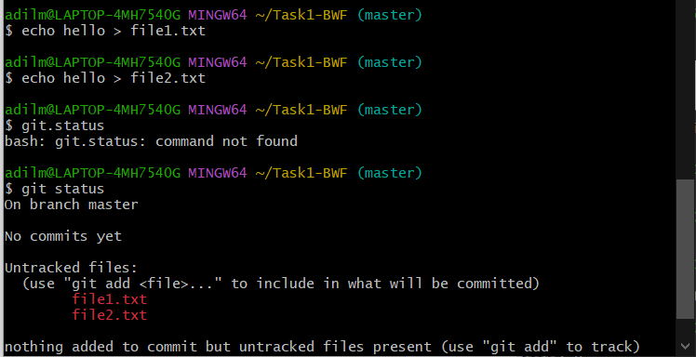 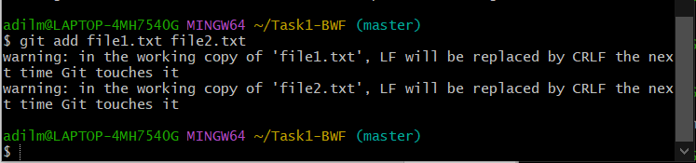

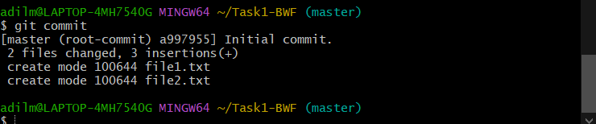

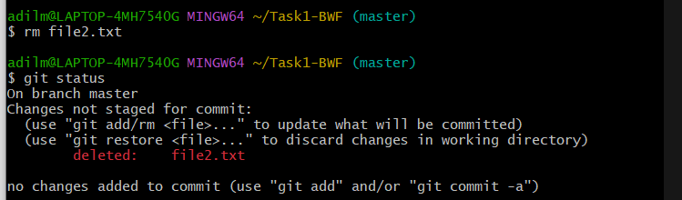

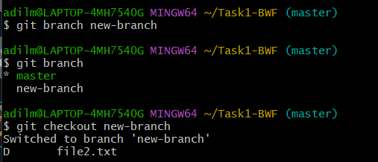

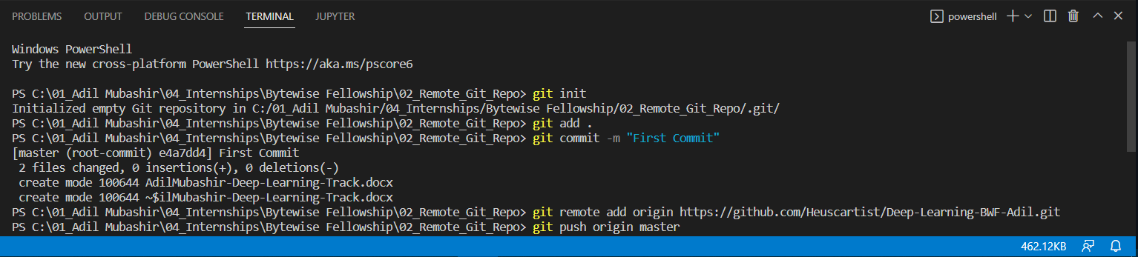

cd /c/01_Adil\ Mubashir/04_Internships/Bytewise\ Fellowship/03_Getting\ Started\ with\ Python

$ git push -u -f origin master 🡪 to push into an already existing repo