AI601 - Data Engineering for AI Systems

24280006 – Hashim Shabbir
24280007 – Adil Mubashir Chaudhry

This lab is supposed to be completed individually. Please find below an ER of a hospital management system.

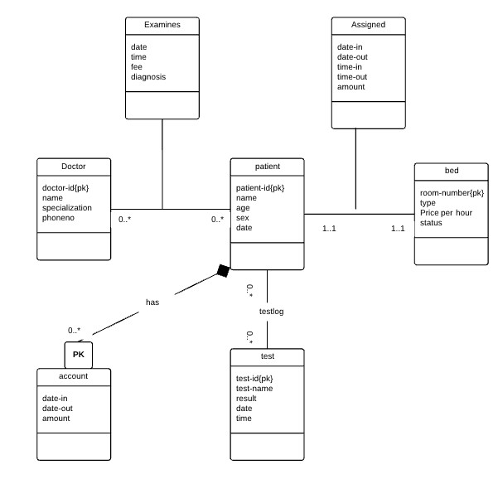
Example Analytical Questions
○ Utilization: “Which doctor has the highest patient throughput each month?”
○ Length of Stay: “What is the average length of stay per diagnosis, per month?”
○ Cost Analysis: “Which treatments drive the highest cost or revenue?”
○ Staff Metrics: “How many patients were seen by a particular doctor or specialty in a given time period?
Design a star and snowflake schema for this data model. Use any document editor or drawing
AI601 - Data Engineering for AI Systems software e.g. Draw.io
Submission:
Submit the PDF file by pushing to git and opening the PR.
Create a new branch for Lab 2:
- git checkout -b lab2
Stage and commit changes:
- git add hospital_schema.pdf
- git commit -m "Completed Lab 1 - <student_id>"
- git push origin lab2
Go to GitHub → Open a Pull Request (PR) from lab2-<studentid> to the main branch. The PR name should be "Lab 2: Student ID Part 1, 2, 3, 4" where part numbers represent the completed parts.

STAR SCHEMA

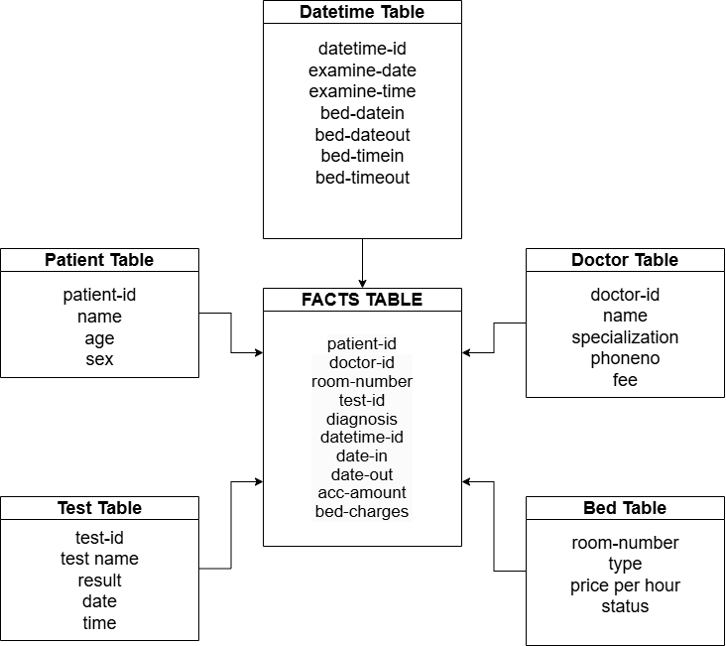

SNOWFLAKE SCHEMA

