Task 2:
Part1: 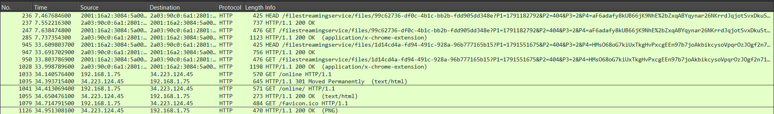
HTTP Methods: GET and HEAD requests were observed.
Response Codes: 200 OK (indicating a successful request) and 301 Moved Permanently (indicating a redirection) were received.
Traffic Example: The client (IP: 192.168.1.75) sent a GET request to the server (IP: 34.223.124.45), which successfully replied with HTTP/1.1 200 OK.

Part2:
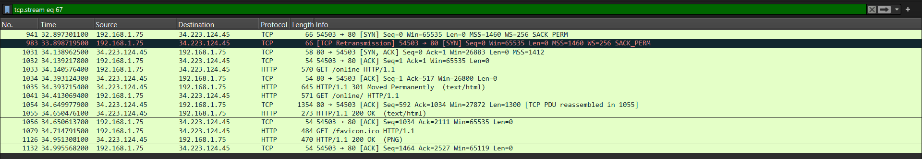
SYN (Packet 941): The client (192.168.1.75) initiates the connection to the server. The Sequence number is Seq=0. (Note: Packet 983 is a TCP Retransmission of this initial SYN request).
SYN-ACK (Packet 1031): The server (34.223.124.45) responds and acknowledges the client's request. The Sequence number is Seq=0, and the Acknowledgment number is Ack=1.
ACK (Packet 1032): The client acknowledges the server's response, successfully establishing the connection. The Sequence number is Seq=1, and the Acknowledgment number is Ack=1.
Data Transfer: Immediately after the handshake is completed, data transfer begins at Packet 1033 with an HTTP GET request.

FIN-ACK (Packet 340): The client initiates the connection termination by sending a [FIN, ACK] packet to the server on port 80. The Sequence number is Seq=1, and the Acknowledgment number is Ack=1.
FIN-ACK (Packet 377): The server responds with its own [FIN, ACK] packet, acknowledging the termination request and indicating it is also ready to close the connection. The Sequence number is Seq=1, and the Acknowledgment number is Ack=2.
ACK (Packet 378): The client sends a final [ACK] packet to acknowledge the server's FIN, successfully closing the connection. The Sequence number is Seq=2, and the Acknowledgment number is Ack=2.

Part3:
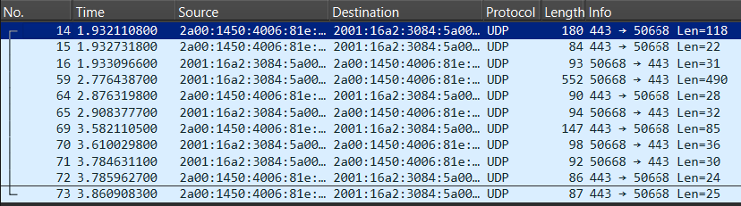
Packet Details (e.g., Packet 14): The captured UDP traffic shows communication originating from Source Port 443 to Destination Port 50668, with a data payload length of 118 bytes.
Header Comparison: Compared to TCP, the UDP header is significantly simpler and smaller. It only contains Source Port, Destination Port, Length, and Checksum. It completely lacks complex fields like sequence numbers, acknowledgment numbers, and connection state flags (like SYN or FIN) because it is a connectionless and lightweight protocol.

Part4:
Task 1: Fill in the following table and provide reasons.

 | TCP or UDP | Reasons
Reliability and Connection Establishment | TCP | Relies on a prior connection setup via the 3-way handshake. Guarantees data delivery and no data loss through retransmission mechanisms and acknowledgments.
Data Integrity and Ordering | TCP | Assigns sequence numbers to each byte to order out-of-order packets. Uses checksums to strictly verify data integrity.

Task 2: Identify the use Cases and Performance of TCP and UDP.

 | TCP | UDP
Use cases | File transfer (FTP), web browsing (HTTP/HTTPS), email (SMTP), and applications requiring high reliability. | Live video streaming, Voice over IP (VoIP), online gaming, and DNS queries.
Performance | Relatively slower due to the overhead of state tracking, acknowledgments, and flow control. | Much faster because it is connectionless, does not wait for acknowledgments, and does not retransmit lost packets, which reduces latency.

