Notes:

The idea of combining kNN with LM is not new. There have been a few research attempting this. Noticeably, their kNN is not trained. Often using a pre-trained feature extractor to get embeddings/features of a text. This may be the difference we can make in our NN-kNN case.

Maybe NN-kNN + Adaptation (CBR) can be relevant here too? Because there is not adaptation happening in these LM models. If we follow this idea, we will have to do NN-kNN + adaptation (NN-CDH) first.

TODO

[2309.01029] Explainability for Large Language Models: A Survey

Retrieval-Augmented Generation for Large Language Models: A Survey

[2304.06762] Shall We Pretrain Autoregressive Language Models with Retrieval? A Comprehensive Study

[2412.11919] RetroLLM: Empowering Large Language Models to Retrieve Fine-grained Evidence within Generation

[2310.07713] InstructRetro: Instruction Tuning post Retrieval-Augmented Pretraining

Flash-Vstream: Memory-Based Real-Time Understanding for Long Video Streams

DPR

Learning to Remember Rare Events | OpenReview

MA-LMM: Memory-Augmented Large Multimodal Model for Long-Term Video Understanding

A simple cache model for image recognition

Retrieval-augmented convolutional neural networks for improved
robustness against adversarial examples.

Deep k-nearest neighbors: Towards confident, interpretable
and robust deep learning.

DOING

DONE

RETRO paper
[2112.04426] Improving language models by retrieving from trillions of tokens (arxiv.org)
“ At a high level, our Retrieval Transformer (Retro) model splits the input sequence into chunks and retrieves text similar to the previous chunk to improve the predictions in the current chunk.”
“We introduce Retro, a retrieval-enhanced autoregressive language model (§2.2). We use a chunked cross-attention module to incorporate the retrieved text (§2.4), with time complexity linear in the amount of retrieved data. We show that retrieving based on a pre-trained frozen Bert model (§2.3) works at scale, removing the need for training and updating a retriever network.”
So they mentioned they don’t have the need to train a retriever network, maybe NN-kNN is not needed for them since it already worked?
Maybe this is because their cross-attention mechanism can be trained, which is essentially as if training a retrieval network.Cross attention is trained to pay attention to only the relevant things in the case base

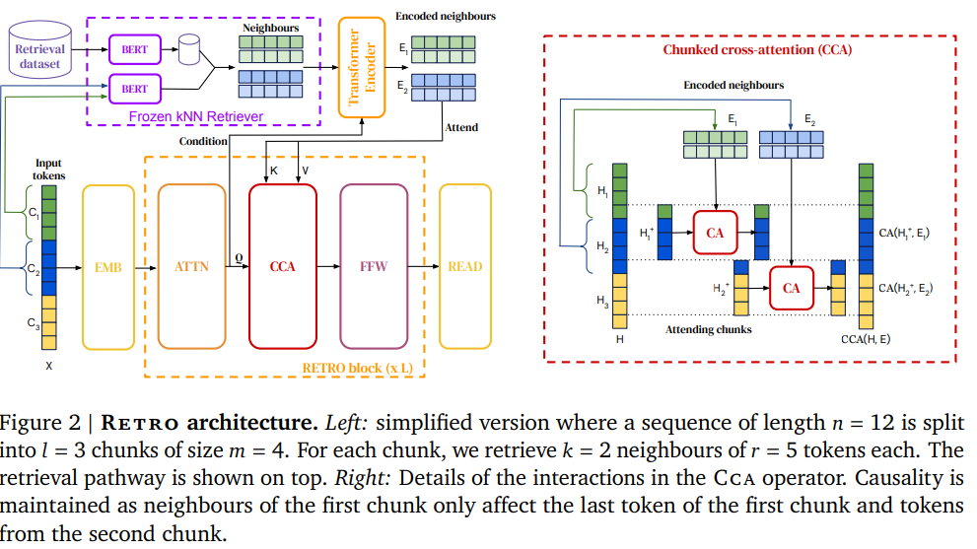
So every case in the case base actually has two parts, [N, F], neighbor chunk and continuation chunk, where the embedding of the N neighbor chunk is used as the key while F is used as the value. So just like the problem-solution pair in CBR. In their explanation, they are actually using both N and F, not just F.
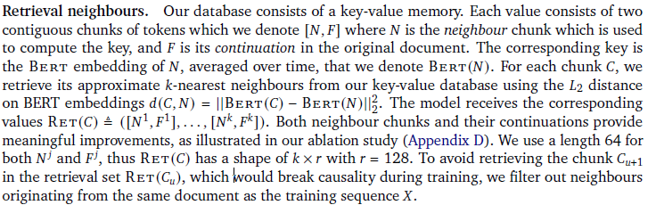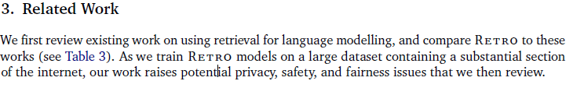
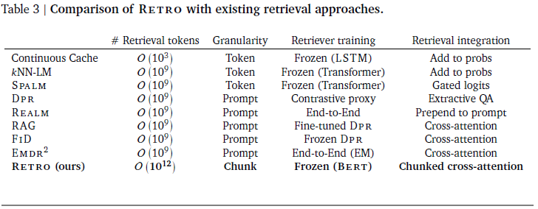
This is interesting. It is important to pay attention to the “retriever training” column and “retrieval integration” column in the table above.

3.1. Retrieval for language modelling
talks about different ways of retrieval in language. In it the most relevant is:
“retrieving systems have partly switched to dense learned representations based on a neural network’s activations”
DPR and kNN-LM seems most relevant here in their related work.

“Yes, since the introduction of the Retrieval-Enhanced Transformer (RETRO) model, there have been several advancements aimed at enhancing retrieval-augmented language models:
- InstructRetro: Building upon RETRO, InstructRetro involves continued pretraining of a 43-billion-parameter GPT model using retrieval augmentation, resulting in a 48-billion-parameter model. After instruction tuning, InstructRetro demonstrated significant improvements over its GPT counterpart across various tasks, including question answering and summarization. ​arXiv+3arXiv+3OpenReview+3
- RetroLLM: This framework integrates retrieval and generation into a unified process, enabling large language models to generate fine-grained evidence from a corpus with constrained decoding. RetroLLM introduces hierarchical constraints and forward-looking decoding strategies to enhance evidence accuracy, showing superior performance across multiple open-domain question-answering datasets. ​arXiv
- Shall We Pretrain Autoregressive Language Models with Retrieval?: This comprehensive study explores the benefits of pretraining autoregressive language models with retrieval. The findings suggest that retrieval-augmented models outperform standard GPT models in knowledge-intensive tasks and exhibit reduced degeneration in text generation. ​arXiv+1ACL Anthology+1
These developments indicate a growing interest in enhancing language models by integrating retrieval mechanisms, leading to improvements in performance, factual accuracy, and efficiency.”

review continuing from here

Case-Based Reasoning for Natural Language Queries over Knowledge Bases
CBR-KBQA
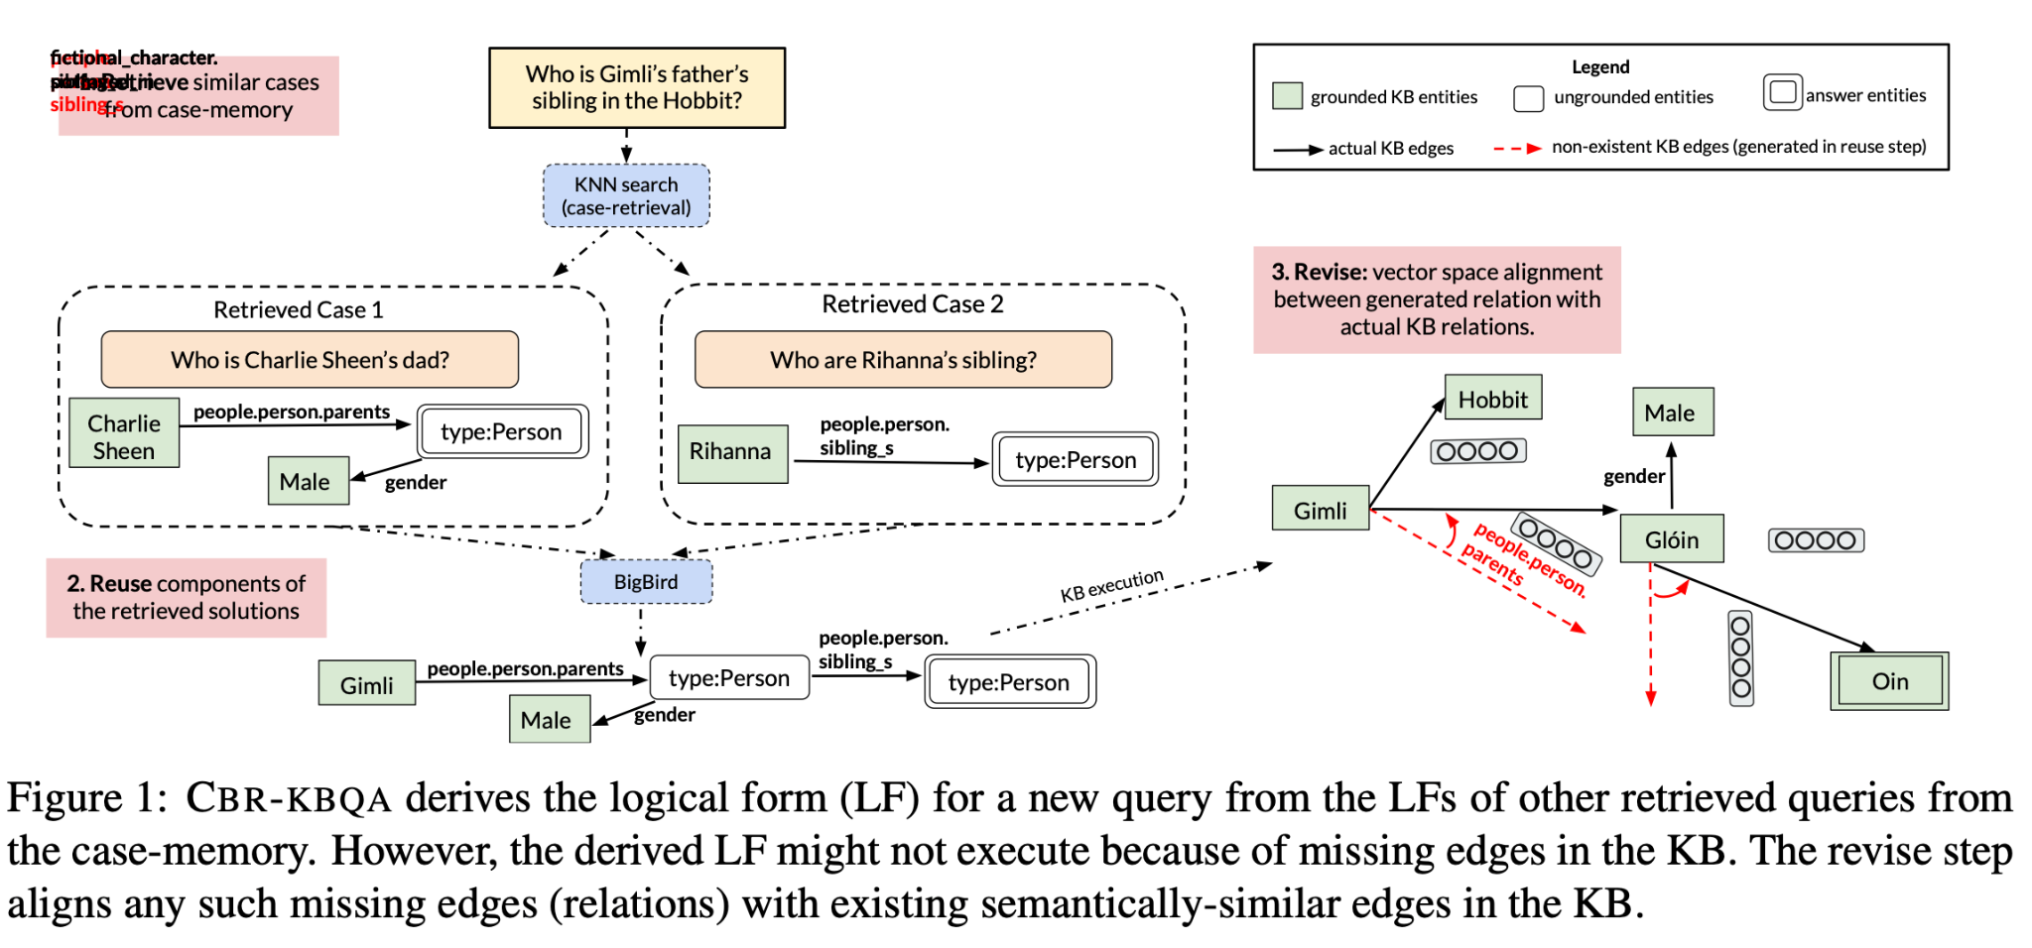
“Formal definition of task: let q be a natural lan-
guage query and let K be a symbolic KB that needs
to be queried to retrieve an answer list A contain-
ing the answer(s) for q. We also assume access to a
training set D= {(q1,ℓ1),(q2,ℓ2),...(qN ,ℓN )}
of queries and their corresponding logical forms
where qi, ℓi represents query and its corresponding
logical form, respectively. A logical form is an exe-
cutable query containing entities, relations and free
variables (Figure 2). CBR-KBQA first retrieves K
similar cases Dq from D(§ 2.1). It then generates a
intermediate logical form ℓinter by learning to reuse
components of the logical forms of the retrieved
cases (§ 2.2). Next, the logical form ℓinter is revised
to output the final logical form ℓ by aligning to the
relations present in the neighborhood subgraph of
the query entity to recover from any spurious rela-
tions generated in the reuse step (§ 2.3). Finally, ℓ
is executed against K and the list of answer entities
are returned. We evaluate our KBQA system by
calculating the accuracy of the retrieved answer list
w.r.t a held-out set of queries.”

Two things in this paper are very interesting.
- It uses logical form as the solution of cases, not a word or a simple classification. This allows the CBR system to train to retrieve cases with the correct logical forms LF. (LF are relationships such as “is parent, sibling of”)
- In section 3.4 Point-Fixes to Model Predictions, they show that they can correct a wrongly predicted query by injecting new cases. Their computational experiment to show this is essentially what I did in my old adaptation paper, remove all relevant cases and retrain the model to see how well it does.
“ Even though, CBR-KBQA is modular and has several advantages, the retrieve and reuse components of our model are trained separately. In future, we plan to explore avenues for end to end learning for CBR. ”
Ha, we are doing that!

Less Relevant Works
A Cache-Based Natural Language Model for Speech Recognition - ScienceDirect
too old, ignored

REALM
Retrieval Augmented Language Model Pre-Training
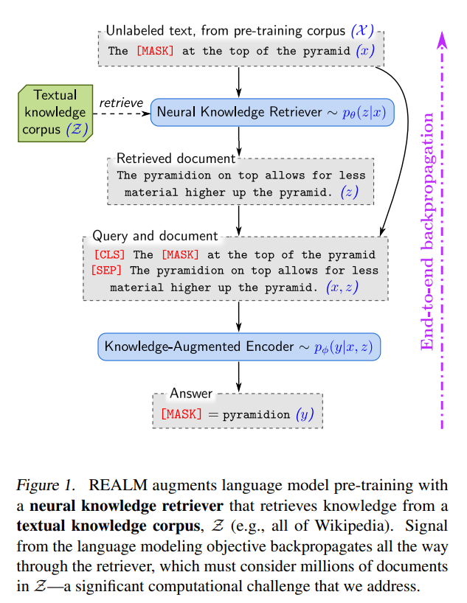
They address the issue of computational overhead, which we can borrow ideas from to tackle a similar issue in NN-kNN when the case base is big.
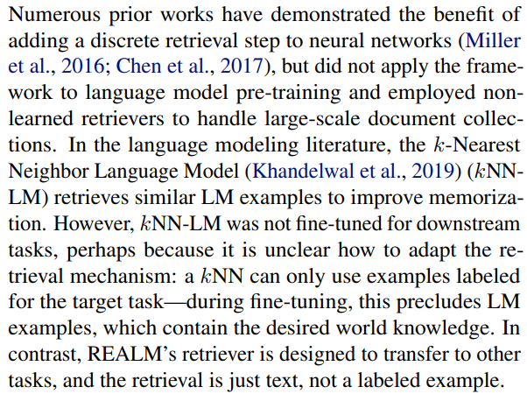
This talks about kNN-LM, which requires labels for the tasks. They say their REALM is more general and can be transferred to other tasks, as long as their retriever is being trained for the task.
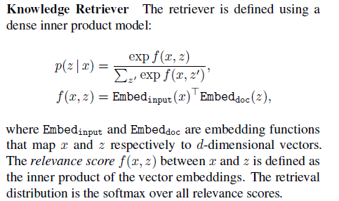
Once again, they use cosine similarity over embeddings extracted from a BERT transformer.

kNN-LM
Very, Very, Very relevant

GENERALIZATION THROUGH MEMORIZATION:
NEAREST NEIGHBOR LANGUAGE MODELS
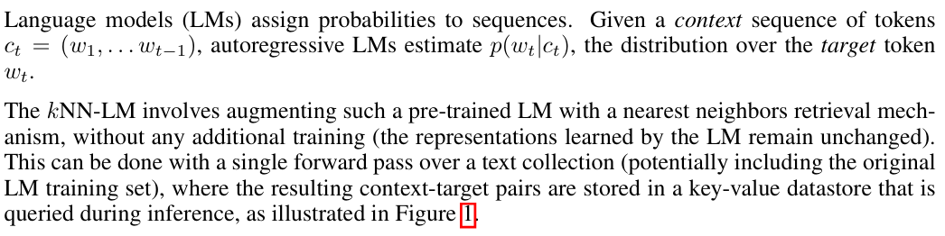
So their kNN is not trained with the LM, but simply attached to the whole process.

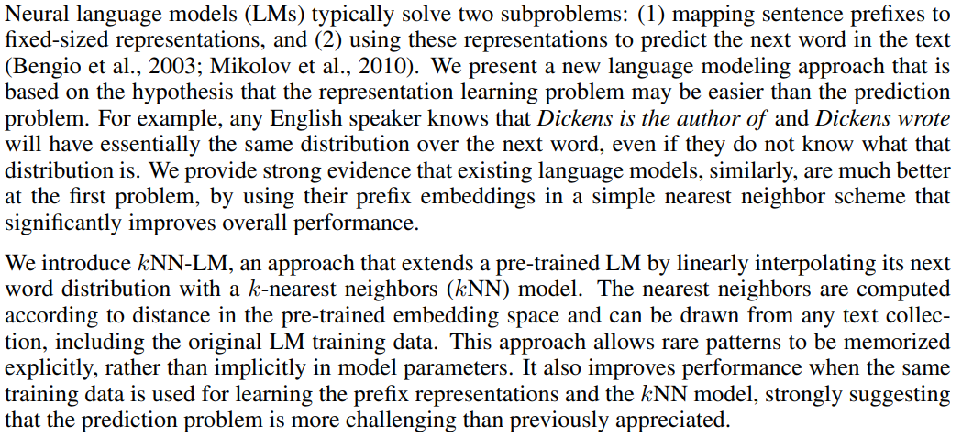
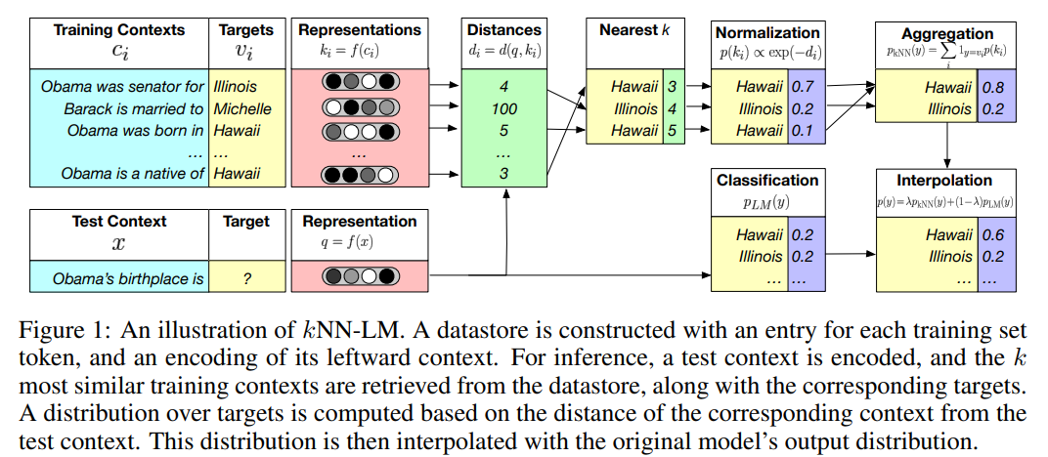
Their idea is very simple, model structure actually has some cool things I haven’t heard of. They are using adaptive softmax and adaptive input for large vocabulary.

Very interesting finding
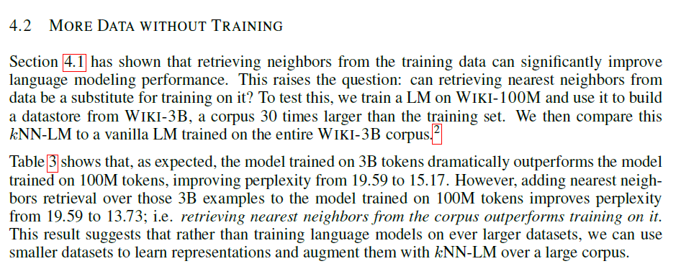
We have seen similar things before in CBR research and even just in NN-kNN experiments. Sometimes vanilla kNN or NN-kNN can outperform a NN in certain datasets.

Continuous Cache Model
Improving Neural Language Models with a Continuous Cache
pdf
Somewhat related from Neural Turing Machine and Cache Model (They hence named theirs Continuous Cache Model)
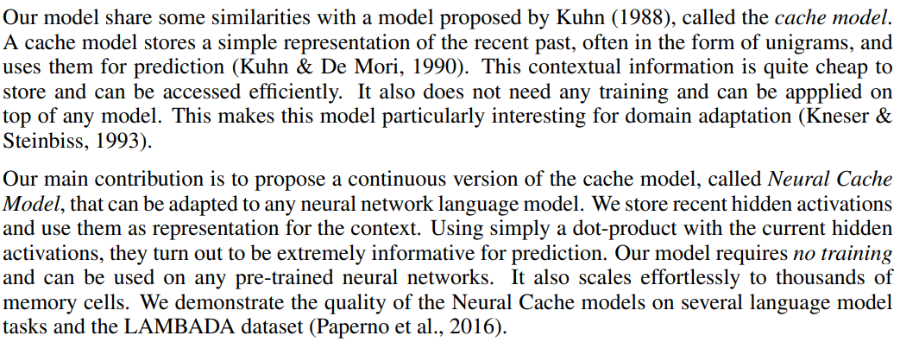
The idea is to attach a cache to any RNN, the cache will store pairs of a hidden state and the next word. It does not need to be trained, so the RNN will be trained the same way or pretrained. In testing time, the cache is used and retrieval happens based on the similarity of the hidden state (dot product). Then the next word in cache is used to help predict the next work.
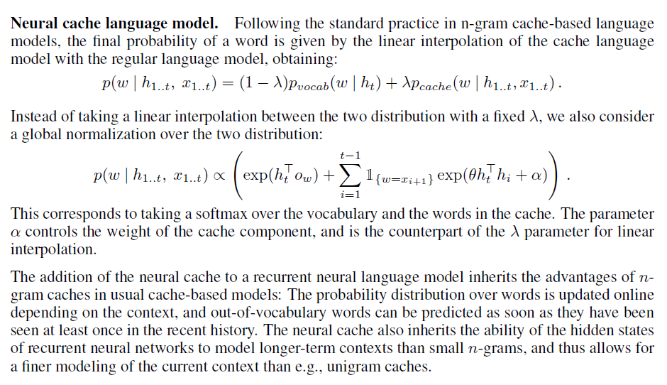
It seems that we will need to learn a parameter lambda, or alpha in validation time, which is assigning weights to the cache model prediction.
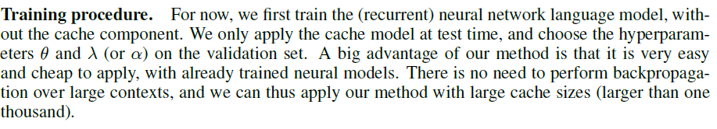

Euclidean Distance or Inner Product or Cosine Similarity

One of the the thing I realize is that, I could have used inner product or cosine similarity for similarity measure in NN-kNN, instead of using weighted euclidean distance. There is the conversation I had with chatGPT:
Yes — you absolutely can consider using the inner product instead of Euclidean distance in your NN-kNN architecture for case similarity! It would involve a conceptual shift, but has strong theoretical grounding and potential advantages, especially when your feature representations are learned embeddings (e.g., from an LSTM or CNN backbone).
Here’s a breakdown of how and why it could work for your project:

🧠 Why Inner Product Could Work as a Similarity Measure in NN-kNN

✅ 1. Inner Product Aligns with Attention and Retrieval-based Architectures
- As shown in the pointer network paper you’re reading, attention is often computed via dot products between a query and memory entries. This dot product reflects semantic alignment.
- If your NN-kNN framework incorporates a feature extractor, the output embeddings may capture semantic or contextual meanings—and inner product is excellent at comparing such vector representations.

✅ 2. Dot Product Is Learnable and Compatible with Neural Training
- Unlike Euclidean distance, which penalizes both direction and magnitude differences, the inner product can be fine-tuned to emphasize directional similarity — i.e., the angle between the query and case vector.
- It's differentiable, making it naturally compatible with end-to-end gradient-based learning.

✅ 3. Scales Better with Vector Norms in High Dimensions
- Euclidean distance becomes less informative in high-dimensional spaces due to the curse of dimensionality.
- The inner product (or its normalized variant, cosine similarity) focuses on angular closeness, which often performs better in embedding spaces learned by deep models.

🔁 How You Could Adapt NN-kNN to Use Inner Product
In your current NN-kNN model (as described in the IJCAI paper), you're using Euclidean distance. That is:
- For each feature dimension j, you compute the distance between the query and a case: delta_j = (q_j - c_j)^2.
- Then, the total distance is the weighted sum over all dimensions: Total distance = sum(delta_j * cw_j).
- Finally, case activation is computed as: activation = scaled_sigmoid(bias_c - distance), where smaller distances lead to higher activation.
To adapt this to use inner product similarity instead of distance:
- Compute similarity directly:
Replace distance with similarity between the query q and case c, using either:
  - Unnormalized inner product: similarity(q, c) = q • c
  - Or, if you want cosine similarity: cosine_similarity = (q • c) / (||q|| * ||c||)
- Update the activation logic:
Use similarity in place of negative distance:
  - activation = scaled_sigmoid(q • c - bias_c)
  - This flips the logic: higher similarity now leads to higher activation, instead of smaller distance.
- Adjust the bias term if needed:
The bias can still help control the activation threshold, just like in the original sigmoid formulation. You may need to tune or reinterpret it depending on your similarity range.

⚖️ Inner Product vs Euclidean Distance
Metric | Pros | Cons
Euclidean Distance | Intuitive, sensitive to magnitude | Degrades in high-D spaces, harder to learn on embeddings
Inner Product | Direction-sensitive, computationally efficient, works well in learned spaces | Sensitive to vector norms unless normalized
Cosine Similarity | Direction only (normalized), robust in high-D | Not naturally differentiable as a dot product (needs normalization step)

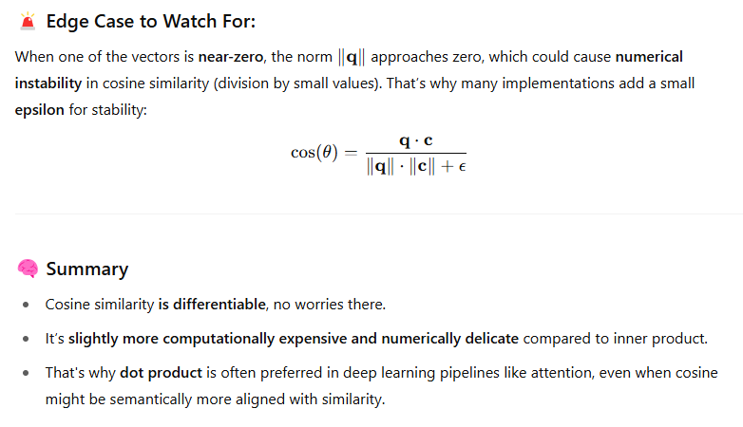

🧪 Suggested Hybrid Idea
You could make the model more flexible by letting it learn whether to use inner product or distance through a learnable similarity kernel. For example:
- Define similarity as: similarity(q, c) = qᵀ * M * c
Here, M is a learnable matrix. If M is the identity matrix, this reduces to a standard inner product. But with a trained M, the model can learn more expressive similarity functions that better capture the relationship between the query and the case.
This approach allows the system to adaptively choose the best similarity metric for your task.

🧩 Bottom Line
In your NN-kNN project:
- Yes, inner product is a valid, potentially powerful alternative to Euclidean distance.
- Especially beneficial when using deep feature embeddings.
- You can experiment with replacing distance comparisons in the activation function with inner product similarity.
If you'd like, I can help sketch out the revised equations or PyTorch code to test this idea in your model. Would that be helpful?
4o

You said:
what is high-D space?

ChatGPT said:
Great question.

🧭 "High-D" = High-Dimensional Space
When we say a model is operating in a high-D space, we mean the number of features or dimensions (D) in the vector representation is very large.

🧠 Example:
- A simple 2D space: A vector is like x=[x1,x2]\mathbf{x} = [x_1, x_2]x=[x1​,x2​]
- A high-dimensional (high-D) space: Vectors may look like x=[x1,x2,...,x512]\mathbf{x} = [x_1, x_2, ..., x_{512}]x=[x1​,x2​,...,x512​] or even thousands of dimensions
This happens all the time in deep learning:
- Word embeddings from BERT: 768-D
- Image features from ResNet: 2048-D
- Audio spectrograms, sentence embeddings, etc.

⚠️ Why High-D Spaces Are Tricky (Curse of Dimensionality)
- Distance becomes less meaningful:
  - In very high dimensions, the Euclidean distance between points tends to converge — all distances become similar, making it hard to distinguish “close” from “far.”
  - This can make k-NN or clustering fail unless feature engineering or dimensionality reduction is applied.
- Volume increases fast:
  - The space becomes sparse.
  - You need exponentially more data to cover the space well.
- Most data points are far from each other:
  - Even nearest neighbors may not be "near" in a meaningful way.

💡 Why This Matters in Your Case
Since your NN-kNN model works with deep learned features, it's already operating in high-D space (e.g., 128D, 512D, etc.). That’s why switching from Euclidean distance to inner product or cosine similarity can sometimes improve robustness and performance.

Let me know if you want to see a visual or intuition for how distances behave weirdly in high dimensions — it’s a fun and important topic in ML!
4o

You said:
what about interpretability. One reason I use NN-kNN with euclidean distance is for interpretability, knn is easily interpretable. Is inner product or cosine similarity also good for that?

ChatGPT said:
That’s an excellent point — and a very thoughtful one. When designing interpretable models like NN-kNN, interpretability of the similarity measure itself is key. Let’s explore how Euclidean distance, inner product, and cosine similarity compare in terms of interpretability:

🧠 1. Euclidean Distance: ✅ Most Interpretable

Why it’s great:
- It reflects literal spatial closeness in the feature space.
- The formula:
distance(q,c)=∑j(qj−cj)2\text{distance}(\mathbf{q}, \mathbf{c}) = \sqrt{\sum_j (q_j - c_j)^2}distance(q,c)=j∑​(qj​−cj​)2​
shows how each feature contributes to the total distance. You can explain which features differed most.
- You can break it down: “This case is far because of feature X and Y.”

Interpretability Use Case:
- You can visualize distances.
- You can trace which features caused the activation or suppression.
✅ Best for instance-based explanation of why one case is similar or not.

💡 2. Inner Product: ⚠️ Less Directly Interpretable

Why it's trickier:
- Measures alignment, not distance.
- A large inner product might be due to large vector magnitudes or direction, making it harder to interpret which features caused similarity.
similarity(q,c)=∑jqj⋅cj\text{similarity}(\mathbf{q}, \mathbf{c}) = \sum_j q_j \cdot c_jsimilarity(q,c)=j∑​qj​⋅cj​
- Not directly tied to spatial closeness. Two vectors can have a large inner product but be far apart if one is just long.

Interpretability Use Case:
- Better suited to semantic similarity, e.g., in NLP: "These sentences are similar because they activate the same semantic directions."
- But harder to explain what caused the match unless you further analyze the vector contributions.
🟡 Moderately interpretable, especially if combined with projection weights or visual tools.

📐 3. Cosine Similarity: ⚖️ More Interpretable than Inner Product

Why it’s in between:
- Measures angle between vectors:
cos⁡(θ)=q⊤c∥q∥⋅∥c∥\cos(\theta) = \frac{\mathbf{q}^\top \mathbf{c}}{\|\mathbf{q}\| \cdot \|\mathbf{c}\|}cos(θ)=∥q∥⋅∥c∥q⊤c​
- Since it’s norm-independent, it focuses on directional similarity.
- Two vectors are similar if they "point the same way", even if they’re different in magnitude.

Interpretability Use Case:
- Good for comparing abstract patterns (e.g., two text embeddings meaning similar things).
- Still lacks feature-level decomposition: hard to say “which features made them similar.”
🟡 More interpretable than raw inner product, but less so than Euclidean.

🧭 Summary Table
Metric | Intuitive? | Explains Feature Difference? | Semantic Comparison? | Best Use Case
Euclidean | ✅✅✅ | ✅✅✅ | ❌ | Instance-based, structured features
Inner Product | ⚠️ | ❌ | ✅ | Embedding alignment, deep learning
Cosine Similarity | ✅ | ⚠️ | ✅✅ | NLP, high-dimensional embeddings

👩‍🏫 For NN-kNN & Interpretability
Since your model is designed to explain decisions through similarity to past cases, Euclidean distance is the most interpretable choice — especially if your cases are structured (e.g., clinical, tabular, or feature-based).

Alternatives?
If you’re using deep embeddings and want to try inner product:
- Consider adding explanation layers (like ProtoNet-style prototypes).
- Or decompose the inner product into top contributing features.

Would you like help modifying your current NN-kNN implementation to log or visualize the feature-wise contributions to Euclidean distance for better explanation?

CBR-RAG
CBR-RAG: Case-Based Reasoning for Retrieval Augmented Generation in LLMs for Legal Question Answering
Key point: A CBR system that can retrieve similar cases, not just based on question, also based on support (from an evidence base like legal acts/terms) and entities from support.
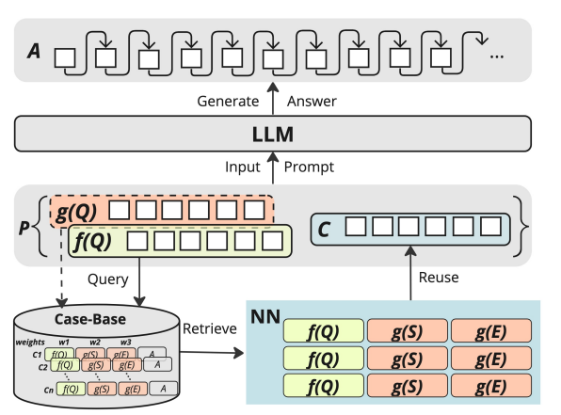
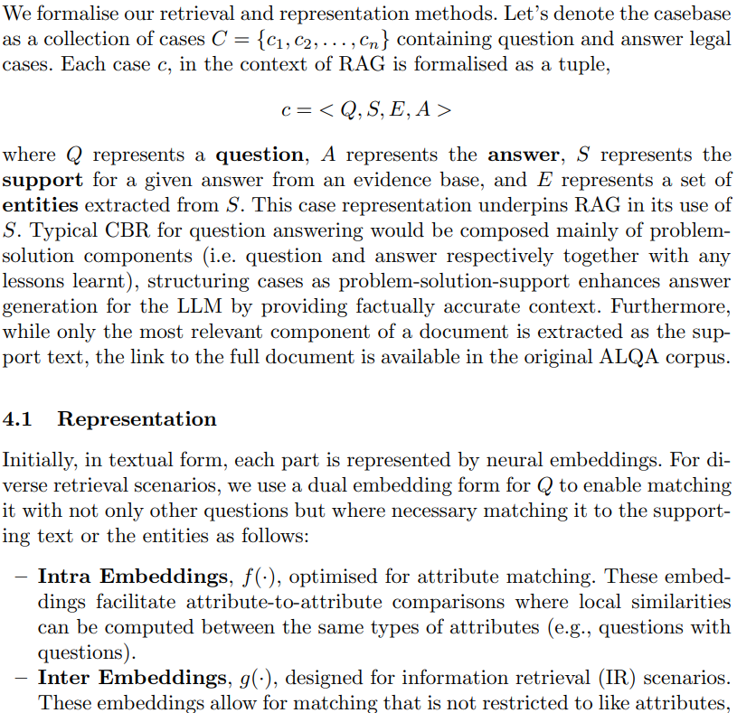

RETRO
Improving language models by retrieving from trillions of tokens - Google DeepMind
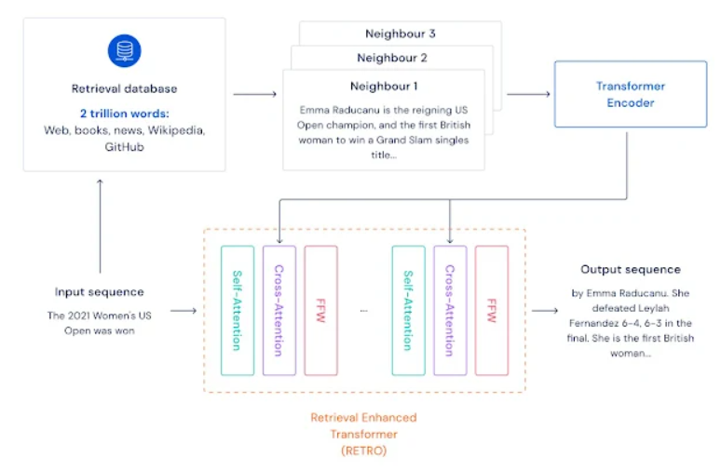
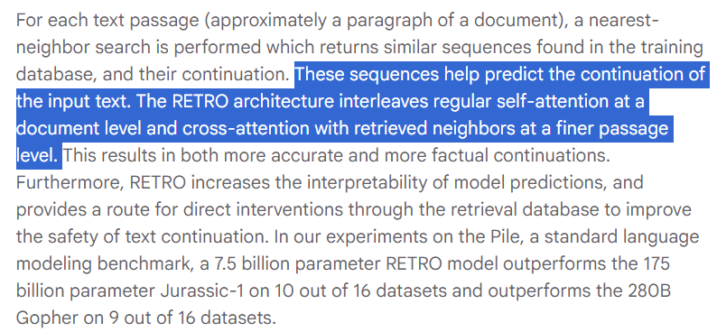

continue review from here

Neural Turing Machine
1410.5401
Their memory read/write mechanism is actually very similar to NN-kNN in terms of motivation. They are trying to read from (write into) memory, in a differentiable way.
They also understood that they don’t want to read/write everything. They want it to be like a Turing machine by read/write with specific memory. So they have a mechanism to make that attention weight sparse, we can imitate this too!
“NTM architecture uses an attentional process to read from and write to memory selectively”
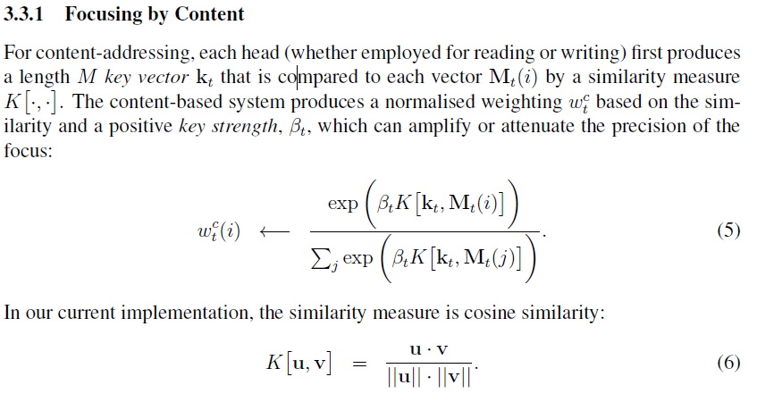
So, they are not only using a similarity measure, but also applying a “key strength” parameter to amplify or attenuate the activation and also using a softmax.

Memory Network
1410.3916
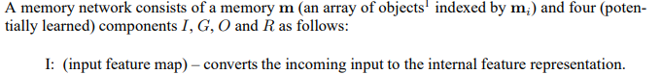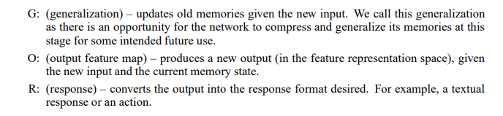
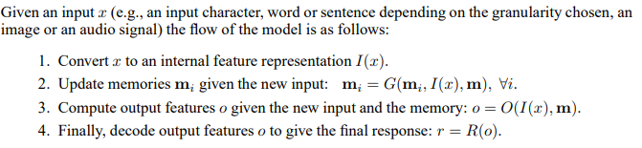

End-to-end Memory Network
1503.08895

They also did a softmax
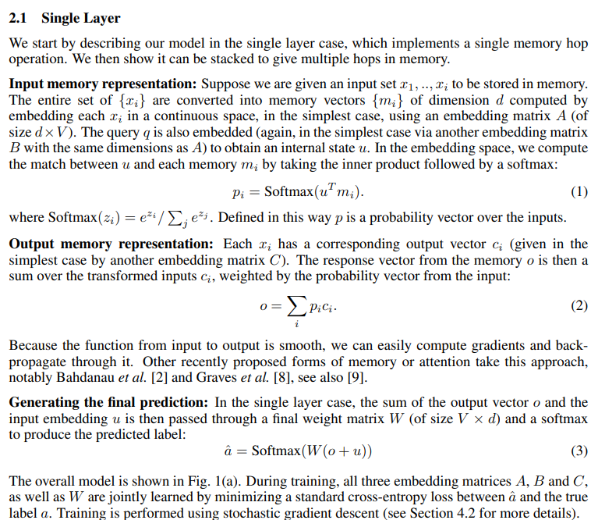
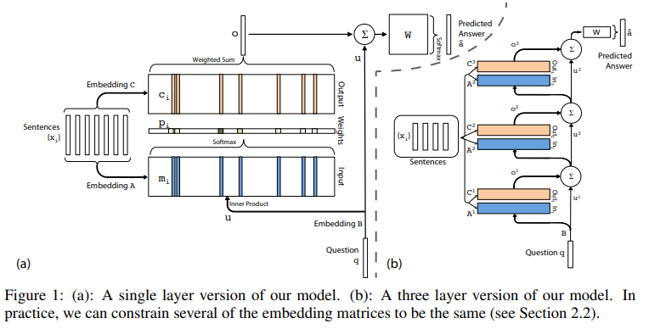
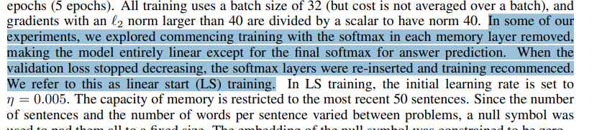
The above is very interesting. They are saying that during training, they first started without softmax, and then later instated softmax.

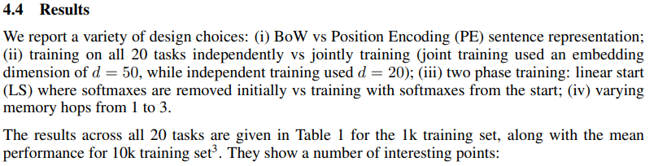
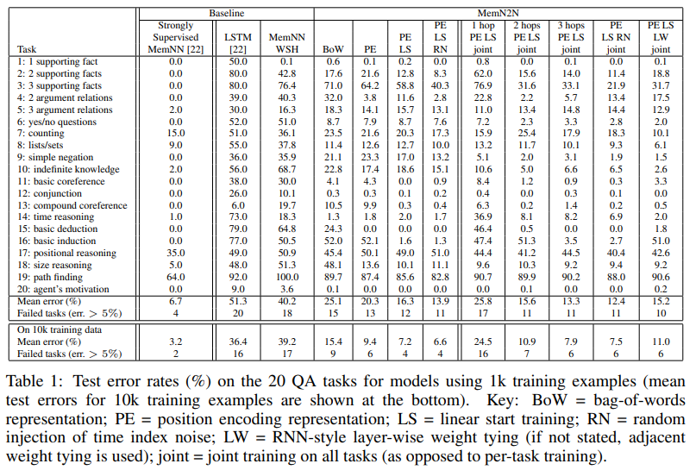
It appears that they also struggled with finding the best setting and (hyper)-parameters for the model to work. And they only did this for one dataset/task. Which is already a lot of work.

