**Image Segmentations**

**Abstract- Image segmentation is the process of partitioning a digitized image into segments for analysis. Partitioning of the image is does by considering the image as a matrix of multiple layers. While images do have two dimensions as a matrix of values, an image has a third dimension composed of red blue and green values. The red, blue and green values (RGB) and their intensities (0 to 255) create the specific colors of the image. In this report a CT-scan image of a brain cross sectional area containing a tumor is analyzed. The regions of the brain are given preassigned color values. However, for every region of the cross section there is a gradation of color. This image is used to address some fundamental challenges in image segmentation: how do are apparently ambiguous structure distinguished, and how do we determine how many image segmentations to make. This paper will focus of the later, in attempting to produce the best results for proper segmentations of the brain.**

**Keywords- CT-scan, image segmentation, RGB color space, Lab color space, grey matter, dura matter, white matter, cranium, centroid**

1. INTRODUCTION

Image segmentation is the process of partitioning a digitized image into segments for analysis. Partitioning of the image is does by considering the image as a matrix of multiple layers. While images do have two dimensions as a matrix of values, an image has a third dimension composed of red blue and green values. The red, blue and green values (RGB) and their intensities (0 to 255) create the specific colors of the image. In this report a CT-scan image of a brain cross sectional area containing a tumor is analyzed. To analyze the image the “kmeans” algorithm was utilized. This algorithm uses a method of data segmentation called clustering in which the algorithm creates groups of data from a data set. The number of data groups, the “k” in kmeans is set by the user. Each data point in the set is grouped with the nearest mean value. The means value is one of the “k”s and acts as a aggregation point for the similar data points in the array. Once all the data is group further code can be written to partition the group data into separate arrays.

1. CONSIDERATIONS

Initially an automatic segmentation code was proposed. However, such a method would be very difficult to accomplish. This is due to the variations in shapes of the brain regions. The internal brain regions would also have to be partitioned from the cranial regions and eyes. Determining where one region end and another region begins would require more advance coding techniques than kmeans. While image segmentation could also have been done in the Lab color space (lightness, color space a, color space b), the standard RGB color space (red, blue, green) is used for familiarity.

Portioning group data into separate arrays allows for the analysis of particular regions on the image. In the case of the brain CT-scan our region of interest is the tumor near the bottom right side of the brain. To segment that particular region, k-groups had to be created to hold the cranial regions. From the observed the regions: cranium, eyes, white matter, grey matter, dura matter and tumor; a value for k was determined. After portioning the region of the tumor, the size of the tumor could be determined using computer vision functions to count the number of pixels. Given that the regions are partitioned, another method to find the size of the tumor would be finding how many pixels in the image have non-zero values. Having a non-zero value in the tumor image would indicate that the particular pixel is in the tumor.

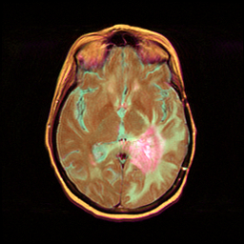

Figure 1: original Image

1. EXPERIMENTATION

Although RGB comes as default for most images. The Lab color space was in consideration for production of the initial image. Using the Lab color space would allow for the appearance of image texture as the gradient in color intensity would be emphasized. However, difficulties were experienced will using Lab. Using the Lab color space, texture and image depth were more distinguishable. Particularly on the tumor segmentation, the varying depth of the tumor was displayed. A negative aspect of using Lab was that all of the images, particularly the dura matter image came out very faint. Methods were attempted to increase color brightness and contrast. These methods however were tailored for use in grey scale images. Preprocessing filters were also attempted to smooth out the image before segmentation, but these were also tailored for grey scale images.

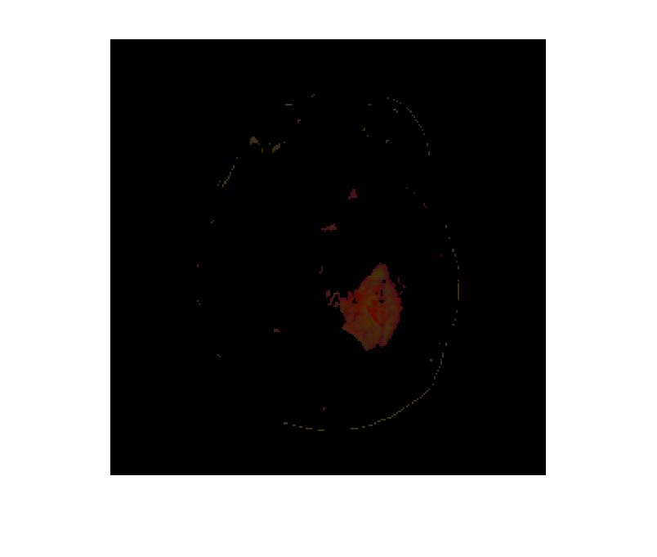

Figure 2: Lab color space tumor

Switching back to RGB color space produced more visible images. The image was then casted into the “double” data type to hold the decimal data of the individual pixels. The matrix was then reshaped from a 3-D array of row-column-color to (row*column)-color. This was to allow kmeans function to process the array as it only allows for a max dimension of two for data inputs. The kmeans would return k-group index for every pixel and the centroid value. The array was then reformed into a 3-D matrix of group index*row and column. The 3-D matrix which is the reformed image ,was then given the values of the centroids for every pixel that had a RGB near the mean value for RGB that kmeans assigns.

Segmentation of the original image into six separate images was done using logic arrays.

Of the produced group data from kmeans, indices are on particular groups were used to create arrays. Being that these were logic arrays, they only had dimensions – row and column. The image output was in black(0) and white(1) since they were all logical arrays. The logical arrays were casted a value of double to match the original image. A third dimension was added to all the logical arrays to match the original. Afterwards all the logical arrays were multiplied by the original array to give the logical array the RGB values for the indices that contain a true/white/(1) value. Doing this gave the portioned images color. Image number 3 had the marjority of the tumor. With this infomration the built in function “numel” was used with the parameters counting valuein the image not equal to 0. In actually using numel on the whole of Image 3 produces a value greater than the tumer size. Image 3 holds pixel date from other regions not asscociated with the tumor.

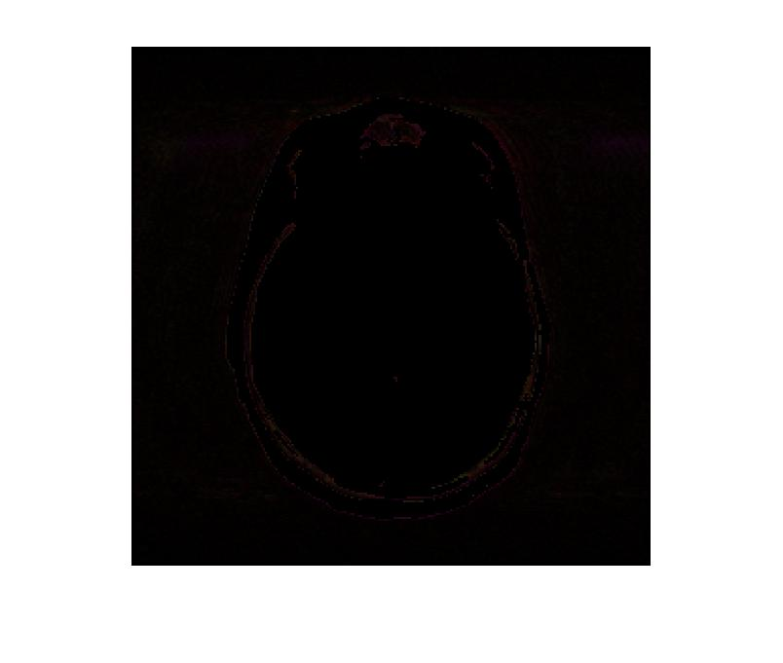

Figure : Image 1

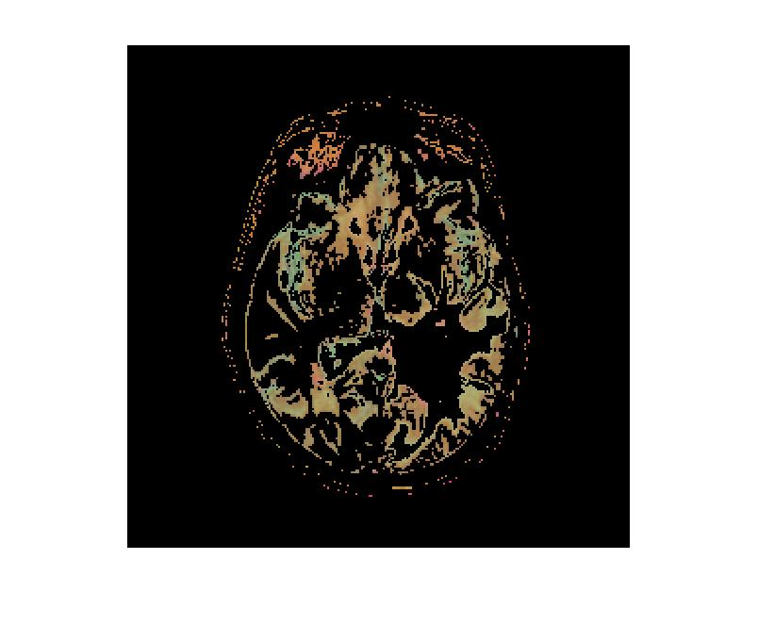

Figure : Image 2

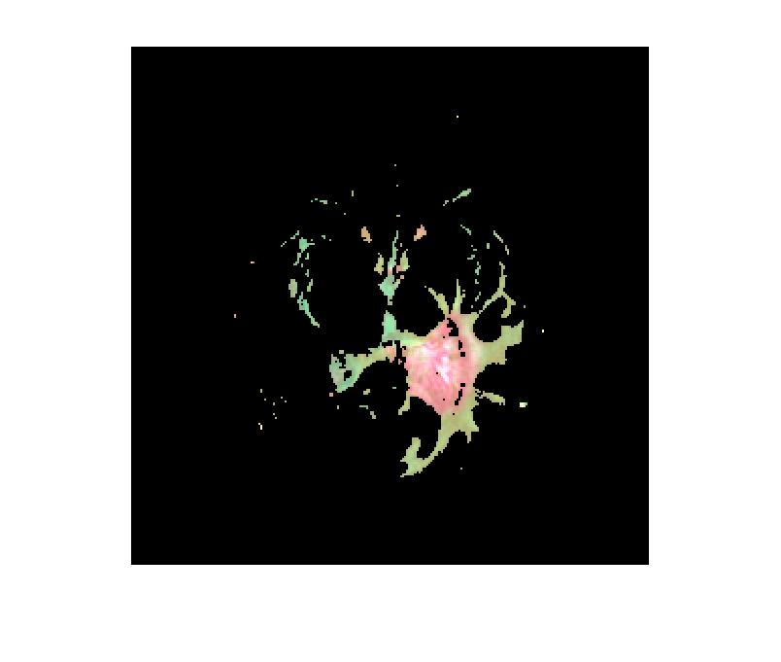

Figure : Image 3

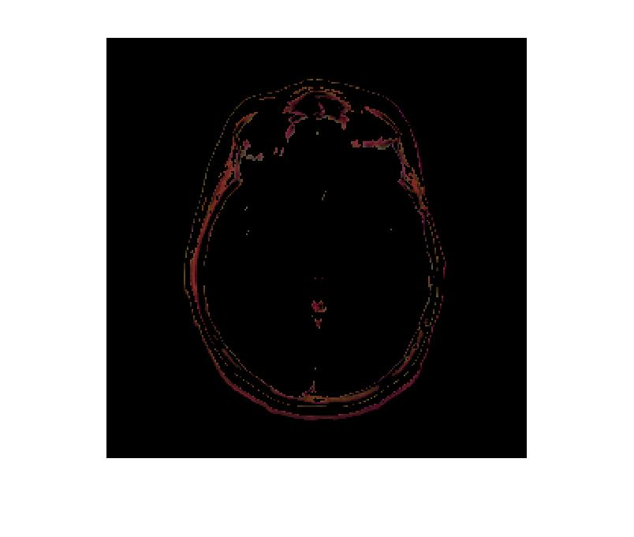

Figure : Image 4

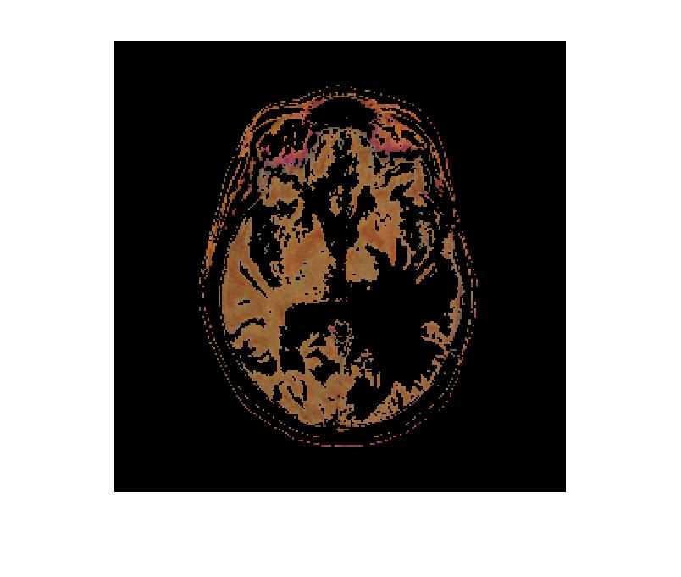

Figure : Image 5

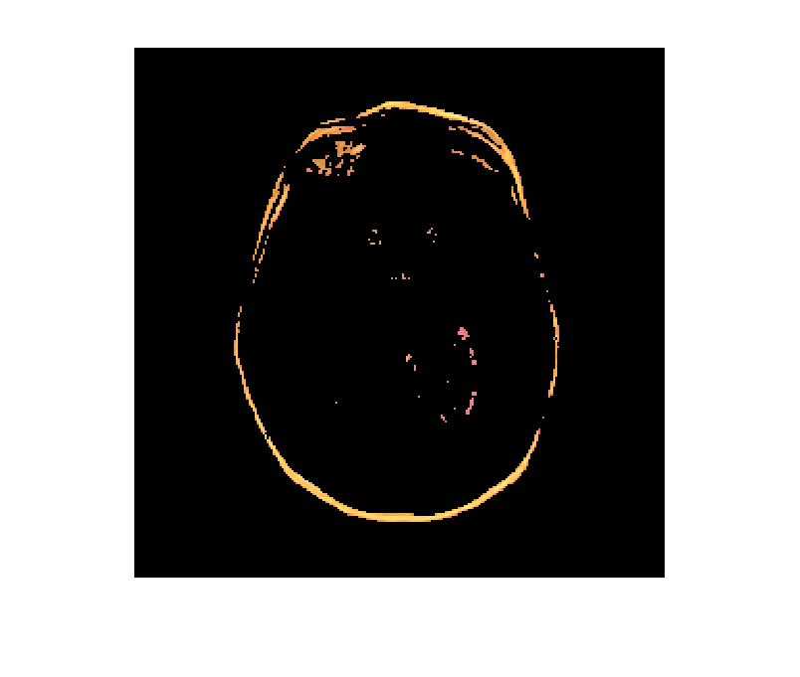

Figure : Image 6

References:

<https://www.mathworks.com/help/stats/kmeans.html#buefs04-X>

https://www.mathworks.com/matlabcentral/answers/74620-how-do-i-copy-or-import-a-figure-from-matlab-into-word-document

<https://www.tutorialspoint.com/matlab/matlab_functions.htm>