

ARBA MINCH UNIVERSITY
ARBAMINCH INSTITURE OF TECHNOLOGY (AMIT)
PathMentor – Intelligent Web-Based E-Learning & Mentorship Platform

1 | Hewan Abebe | NSR/506/15
2 | Desta Shewa | NSR/T/016/15
3 | Bethelhem Fekadu | NSR/183/15
4 | Elshaday Solomon | NSR/326/15

Advisor name: Ms.YibralemBugassa
A senior project
Submitted to Department of Computer Science and IT, Faculty of Engineering, AMIT, Arba Minch University, in Partial fulfillment for the requirement of the Degree of Bachelor Science in Computer Science
ArbaMinch, Ethiopia
December, 2025

Approval Letter
This is to clarify that the project is original and has not submitted for partial fulfillment of Bachelor of Science in computer science. Our project members and signature
Name | Signature
- Hewan Abebe | __________________________
- Desta Shewa | __________________________
- Bethlehem Fekadu | __________________________
- Elshaday Solomon | __________________________
Faculty: Faculty of computing
Program: Computer Science
I clarify that this project satisfies all the requirements as project for the degree of Bachelor of Science
Name of program coordinator Signature
……………………………… ………………………….
This is to certify that I have read this project and that in my opinion it is fully adequate, in scope
and quality, as a thesis for the degree of Bachelor of Science
Name of Advisor Signature
………………………… ………………………….

Examining committee members | Signature | Date
- Chairman __________________ | _________ | ________
- Examiner 2 ___________________ | _________ | _________
- Examiner 3 ____________________ | __________ | ___________
- Examiner 4 ___________________ | _________ | ____________
It approved that this project has been write in compliance with the formatting rules laid down by the college of the university

ACKNOWLEDGMENT
First, we would like to thank Almighty (omnipotent) GOD, for giving strength; he has given us throughout our life and the project. Secondly, we would like to express our deepest gratitude to our advisor Mrs.Yibralem Bugassa for her excellent guidance, caring, patience, and providing us with an excellent atmosphere for doing this documentation. We would also like to acknowledge the teachers and our class meet student who are help us for unclear part.

ABSTRACT
The growth of digital technologies has increased the demand for effective and structured online learning systems. However, many students face challenges such as unclear learning paths, lack of mentorship, low motivation, and limited personalized support when using existing e-learning platforms. To address these challenges, this project proposes PathMentor – An Intelligent Web-Based E-Learning and Mentorship Platform. The system is designed to guide learners through a structured learning roadmap from beginner to advanced levels while providing continuous support and progress tracking. The platform integrates artificial intelligence to offer chatbot-based learning assistance, and personalized learning recommendations. Main system functionalities such as user authentication, learning content management, and performance tracking are handled by the system, while AI is used to enhance user experience and learning support.
Keywords: Mentorship System, Personalized Learning, Learning Path, Progress Tracking

ABBREVIATION

- AI: - Artificial Intelligence
- UI: - User Interface
- DB: - Database
- PC: - Personal Computer

Chapter One

1. INTRODUCTION
Nowadays, digital system has many demands and many people want to learn it because of many reason. Field such as Web Development, UI/UX Design, AI and also Data Science are in high demand. While online learning provides flexibility and access to many resources, many learners still face challenges such as lack of proper guidance, unclear learning paths, low motivation, and absence of personalized support.
Most existing e-learning platforms provide learning materials and some have chat community but they don’t provide guidelines through a structured learning path from beginner to advanced levels. . Learners often struggle to decide what to learn first, how to continue step by step, and how to evaluate their own performance. In addition, the absence of mentorship and real-time assistance causes many students to lose motivation.
To address these challenges, we proposes the project called PathMentor – Intelligent Web-Based E-Learning & Mentorship platform. The system is designed to guide learners through a clear and structured learning roadmap while providing continuous support using artificial intelligence. The platform focuses on helping students develop professional digital skills by combining learning content, mentorship, progress tracking, and AI-based assistance in a single system.
PathMentor – Intelligent Web-Based Learning & Mentorship Platform divides learning into multiple levels, starting from beginner awareness and progressing toward advanced. Each level contains learning materials, practical exercises, and projects that help learners build skills gradually. The system tracks learner progress and performance using predefined rules and displays the results through an interactive dashboard. AI is integrated to support learning by offering chatbot-based assistance, and personalized recommendations based on learner progress.

1.1. Background Information of the organization
Arba Minch Institute of Technology (AMiT) is a premier technology institute established as part of Ethiopia's strategic efforts to address the nation's critical need for skilled engineering and technology professionals. Its origins are deeply rooted in the country's recognition of its abundant water resources and the concurrent shortage of trained human capacity to sustainably harness and manage these resources for national development. In response to this need, the Arba Minch Water Technology Institute (AWTI) was founded in 1986 in the Central Rift Valley, a region rich in natural water bodies like Lakes Abaya and Chamo.
In the 2017/18 academic year, AMiT was formally re-established as an autonomous institute under the "Directives for Autonomy of Technology Institutes, 001/2013" issued by the Ministry of Education. This autonomy was granted to enhance its operational efficiency, focus on applied research, and strengthen its role in national technological advancement. Today, AMiT is a vibrant and dynamic institute led by a Scientific Director. It comprises five faculties:
- Faculty of Architecture and Urban Planning
- Faculty of Civil Engineering
- Faculty of Computing and Software Engineering
- Faculty of Electrical and Computer Engineering
- Faculty of Mechanical Engineering
The institute runs 9 undergraduate programs and 11 postgraduate programs, including a PhD in Computer Science. It is supported by a comprehensive administrative structure encompassing offices for research, community service, industry linkage, postgraduate studies, quality assurance, and student services. AMiT stands as a testament to Ethiopia's commitment to building indigenous technological capacity and fostering innovation to drive sustainable development.

1.1.1. Vision of AMiT
To be a premier center of excellence in Africa for technology education, research, innovation, and entrepreneurship, producing competent and ethical engineering professionals who drive sustainable socio-economic transformation.

1.1.2 Mission of AMiT
- To deliver high-quality, hands-on, and industry-relevant education in engineering and technology.
- To conduct applied and problem-solving research that addresses national and global challenges.
- To foster strong university-industry linkages for technology transfer and collaborative development.
- To cultivate innovation, entrepreneurial mindset, and leadership skills in students and staff.
- To provide impactful community services and professional outreach that utilizes technological solutions for societal benefit.
- To operate as an autonomous, efficient, and globally connected institute adhering to the highest standards of academic and professional integrity.
  - Background of Project
The improvement of digital technologies and global access to the internet has significantly changed the way education and skill development are delivered. E-learning platforms have become popular tools for students who wish to learn new technical and professional skills outside traditional classroom environments. Through online resources such as tutorials, videos, and courses, learners can study at their own pace and according to their personal schedules.
Despite these advantages, many students still experience difficulties when using existing e-learning platforms. Learning materials are often scattered across different websites, and there is limited guidance on how to progress from beginner to advanced levels in a structured way. As a result, learners may feel stress, confused about learning priorities, and uncertain about their progress. Additionally, the lack of mentorship and personalized support reduces learner motivation.
Recent developments in AI have created new opportunities to improve online learning systems. AI technologies such as natural language processing and intelligent recommendation systems can improve user interaction, provide personalized learning support, and assist learners in understanding complex topics more effectively. When integrated into e-learning platforms, AI can act as a virtual mentor by offering instant feedback, learning suggestions, and simplified explanations of educational content.
The need for an integrated platform that combines structured learning paths, mentorship, progress tracking, and AI-based assistance has become highly important. Such a system can help learners follow a clear roadmap, monitor their development, and receive timely guidance throughout their learning journey. This background motivates the development of PathMentor – Intelligent Web-Based E-Learning & Mentorship Platform, which aims to provide a centralized, interactive, and supportive learning environment. The platform influence modern web technologies and AI tools to guide learners from basic awareness to advanced in a systematic and motivating way.
  - Team Composition
The following table outlines the team composition involved in the project, detailing the roles and responsibilities for each member. This classification helps clarify tasks, ensure responsibility, and workflows.
Prepared by
NO | Name | ID No | Phone | Responsibility
1 | Hewan Abebe | NSR/506/15 | 0972441284 | Backend and Documentation
2 | Desta Shewa | NSR/T/016/15 | 0986450343 | Database, Ai and Documentation
3 | Bethelhem Fekadu | NSR/183/15 | 0975591749 | Frontend and Documentation
4 | Elshaday Solomon | NSR/326/15 | 0942180340 | Frontend and Documentation
Advisor Name: |  | Mrs. Yibralem Bugassa
Table 1.1 Team Compositions

1.4. Statement of the problem
With the increasing demand for digital and technical skills, many students depend on online learning platforms to gain knowledge in areas such as web development, UI/UX design, and artificial intelligence. Even-if there are many online resources, many learners struggle to achieve their learning goals effectively.
One of the major challenges is the lack of a clear and structured learning path. Learning materials are often scattered across multiple platforms, including videos, blogs, and tutorials, without a proper sequence from beginner to advanced levels. This makes it difficult for learners to know where to start, what to learn next, and how to measure their progress.
Additionally, most traditional e-learning platforms do not provide enough mentorship or real-time support. Students often learn alone, without guidance or feedback, which leads to confusion, and low motivation. The absence of personalized learning experiences further limits the effectiveness of these platforms, as learners have different learning speeds, strengths, and goals.
And also, learners lack proper tools to track their progress and performance in a meaningful way. Without clear progress visualization and feedback, students find it difficult to stay motivated and consistent throughout their learning journey.
Therefore, there is a need for an integrated and intelligent e-learning system that provides structured learning paths, mentorship support, progress tracking, and AI-assisted guidance. Such a system can help learners follow a clear roadmap, receive personalized support, and achieve their learning goals more efficiently.

1.5. Objective

1.5.1 General Objective
The general objective of this project is to design and develop a Web-Based E-Learning & Mentorship Platform.

1.5.2 Specific Objective
To achieve the general objective, we have to done these specific objectives:
- To develop a web-based platform that provides structured learning roadmaps divided into progressive levels.
- To implement a secure user authentication system for students, mentors, and administrators.
- To enable mentors and administrators to upload, organize, and manage learning materials such as text, videos, and projects.
- To design an interactive dashboard that allows students to track their learning progress and performance.
- To integrate an AI Chabot to provide real-time assistance and answer student questions.
- To provide personalized learning recommendations based on student progress and activity.
- To improve learner motivation through progress visualization, feedback, and guided learning paths.

1.6. Feasibility Analysis

1.6.1 Operational Feasibility
Our proposed system is operationally feasible because it is designed to be user-friendly and accessible through a web browser. Students, mentors, and administrators can easily interact with the platform using familiar web interfaces. The system supports common learning activities such as reading lessons, watching videos, tracking progress, and receiving guidance, which aligns well with current online learning practices.
In addition, the integration of AI features such as chatbot assistance and personal recommendation improve usability by providing instant help and reducing learning difficulties. Since the platform is designed to simplify learning and improve guidance, users are likely to accept and actively use the system. Therefore, the project is operationally feasible.

1.6.2. Technical Feasibility
The project is technically feasible because it uses modern, widely adopted, and well-documented technologies such as React.js for the frontend, Node.js with Express.js for the backend, and MongoDB for database management. These technologies are suitable for building scalable and interactive web applications and are supported by extensive developer communities and resources.
The AI components of the system depend on pre-trained models accessed through APIs such as OpenAI and HuggingFace. This approach eliminates the need to build or train AI models from scratch, making implementation realistic and manageable. Since our team has sufficient academic background and programming knowledge to implement the required features, the project is technically feasible.

1.6.3. Economic Feasibility
As a group, we believe our project is economically feasible because it mainly uses open-source tools and cloud-based services with free. Development does not require expensive hardware or proprietary software. Most costs are related to internet access, and limited AI API usage.
The benefits of the system, such as improved learning efficiency, reduced learning confusion, and better skill development, outweigh the development and operational costs. Therefore, the project is economically feasible.

1.6.4. Behavioral Feasibility
Since our system addresses real problems faced by students, such as lack of guidance, motivation, and personalized support by providing a structured learning path, visual progress tracking, and AI-based assistance, which motivates positive user behavior and continuous engagement. There is no way to be not behavioral feasible.

1.6.5. Schedule Feasibility
The project follows an Agile development methodology, allowing the system to be developed incrementally. Core features such as user authentication, learning roadmap, and progress tracking can be implemented first, followed by AI integration and dashboard enhancements.
By limiting the scope to essential functionalities and focusing on one primary learning track during the initial phase, the project can be completed within the academic semester timeline. Therefore, the project is schedule feasible.
Tasks and Schedule
For our system, we have developed a comprehensive timeline that outlines the key tasks, start and stop dates, and estimated hours for completion. This structured approach ensures that we stay organized and focused throughout the development process.
Table 2 Schedule
NO. | Tasks | Round 1 | Round 2 | Round 3 | Round 4 | Round 5 | Round 6
NO. | Tasks | Dec 18 - Jan 16 | Jan 28 – Feb 4 | Feb 5 - 14 | Feb 16 – Apr 16 | Apr 17 – May 20 | May 21 – Jun 1
1 | Project Proposal
2 | Requirement gathering and analysis
3 | System analysis
4 | System design
5 | Coding and Implementation
6 | Testing and deployment

- Required Resource with Costs
Table 3 Required resource with cost
Resource | Description | Estimate course | Supply Source
Hardware
Lab / Personal Computers | Computer for development and testing | 25,000 and 65,000 | University Lab / Personal
Internet Connection | for development, research, deployment, and AI API access | 0 and 10,000 | University Lab / Personal
Software
Integrated Development Environment (IDE) | VS code | 0 | Personal / Lab
Database Management System | MongoDB Atals | 0 (free tier ) | Personal / Lab
UI/UX design | Figma / Canva | 0 (free tier) | Personal / Lab
AI assisted features | OpenAI / AI APIs | 0 (free tier) | Personal / Lab
Documentation Tools | MS Word | 0 | Lap / Personal
Total Estimated Cost |  | ETB 75,000

- Cost Analysis
The project cost is divided into one-time cost and recurrent cost.
Table 4 One-time cost
Item | Description | Estimated Cost
Development Tools | Open-source software (React, Node, MongoDB) | Free
Laptop/Computer | Existing personal computer | No additional cost
Initial cost | Environmental setup and testing | Minimal
Documentation & Printing | Proposal and final report | Low

Table 5 Recurrent Cost
Item | Description | Estimated Cost
Internet Access | Required for development and testing | Moderate
Cloud Hosting | Backend & frontend deployment | Free
AI API Usage | Chatbot | Low

- Cost-Benefit Analysis
Cost–benefit analysis compares the expected costs of the project with the expect benefits.
Benefits
- Structured and guided learning experience
- Improved student motivation and performance
- Reduced dependency on multiple learning platforms
- Personalized learning assistance through AI
- Scalable foundation for future expansion
Cost
- Development and operational expenses
- Internet and cloud service usage
- Optional AI API usage costs
Therefore, the benefits of the system significantly outweigh the costs, making the project economically feasible and suitable for academic implementation.

1.7. Scope and Significance

1.7.1. Scope of project
The scope of this project defines the boundaries and limitations of PathMentor – Intelligent Web-Based E- Learning & Mentorship Platform. The project focuses on designing and developing a web-based system that provides structured learning paths, mentorship support, progress tracking, and AI-assisted learning guidance.
The system primarily targets students at high school, preparatory, and university levels who are interested in learning digital and technical skills, with an initial focus on Full-Stack Web Development. The platform supports three main user roles: students, mentors, and administrators. Students can register, access learning materials, follow structured learning levels, track their progress, and receive AI-based assistance. Mentors can upload and manage learning content, while administrators oversee system management and user control.
The project includes features such as user authentication, learning roadmaps divided into progressive levels, teaching material management (text-based lessons, videos, and projects), progress and performance tracking, and an interactive dashboard for visualizing learning progress. AI is integrated to provide chatbot-based assistance, and personalized learning recommendations based on student activity and progress.
To ensure feasibility within the academic timeline, the scope of the project is limited to core functionalities and basic AI integration using pre-trained models through APIs. Advanced features such as voice-based AI mentors, complex machine learning model training, certification systems, and mobile application development are considered beyond the scope of the current project and are reserved for future enhancement.

1.7.2. Significance of the project
The significance of this project lies in its potential to improve the effectiveness and quality of online learning by combining structured education, mentorship, and artificial intelligence into a single platform. Many students struggle to learn technical skills due to unclear learning paths, lack of motivation, and absence of personalized guidance. This project directly addresses these challenges by providing a clear roadmap and continuous learning support.
PathMentor is significant for students because it provides a guided and organized learning experience. By tracking progress and visualizing performance, the system helps learners stay motivated and confident throughout their learning journey. The integration of AI chatbot assistance enables students to receive immediate help and simplified explanations, reducing confusion and learning frustration.
The project is also significant for mentors and educators, as it provides a centralized platform to organize learning materials, monitor student progress, and offer guidance more efficiently. For academic institutions, the system demonstrates how modern web technologies and AI can be applied to enhance digital education and mentorship practices.
From a technical perspective, the project is significant because it applies real-world full-stack development concepts and practical AI integration using modern technologies. It serves as a strong academic and practical foundation for future research and system expansion in intelligent learning platforms.
Generally, PathMentor contributes to improving digital learning experiences by promoting structured learning, personalized support, and efficient mentorship, making it a valuable solution for both learners and educators.

1.8. Target Beneficiaries of the system
Our system is designed to benefit multiple groups involved in digital education and skill development.
Primary Beneficiaries
- Students: are the primary beneficiaries of this project. The platform is especially beneficial for high school, preparatory, and university students who want to learn technical and digital skills such as full-stack web development, UI/UX and AI. These students often face challenges such as lack of structured learning paths, limited guidance, and low motivation. PathMentor provides them with a clear roadmap, progress tracking, mentorship support, and AI-based assistance, helping them learn more effectively and confidently.
Secondary Beneficiaries
- Mentors and educators: are also key beneficiaries of the system. The platform enables mentors to organize learning materials, guide students through structured levels, and monitor student progress efficiently. This reduces the effort required to manage learning activities and improves the quality of mentorship.

1.9. Methodology
The development of PathMentor follows the Agile Software Development Methodology, which supports iterative development, continuous feedback, and flexibility. This approach is suitable for web-based systems where requirements may evolve during development.

Methodology Phases
The methodology consists of the following phases:

Requirement Analysis
In this phase, system requirements are identified by analyzing the needs of students, mentors, and administrators. Functional requirements such as user authentication, learning roadmaps, progress tracking, and AI-based assistance are defined. Non-functional requirements such as usability, security, and performance are also considered.

System Design
During this phase, the overall system architecture is designed. This includes:
- Designing the database schema for users, learning content, and progress records
- Defining the interaction between frontend, backend, database, and AI services

Implementation
The implementation phase involves actual system development using the selected technology stack:
- UI/UX design using Canva
- Frontend development using React.js and Tailwind CSS
- Backend development using Node.js and Express.js
- Database implementation using MongoDB
- Integration of authentication and authorization mechanisms
Each feature is developed incrementally and tested during implementation.

AI Integration
In this phase, artificial intelligence features are integrated into the system. Pre-trained AI models are accessed through APIs to implement:
- AI Chabot for real-time learning assistance
- Basic recommendation logic based on student progress: this personalized learning recommendation system is implemented using a content-based and rule-based algorithm. This approach recommends learning materials based on the learner’s profile, progress, and performance rather than relying on large datasets or complex machine learning models.

Testing
Testing is performed to ensure system reliability and correctness. This includes:
- Unit testing of individual components
- Integration testing of system modules
- Functional testing to verify system requirements
- User feedback testing to improve usability

Deployment
- After testing, the system is deployed using cloud platforms:
- Frontend deployment on platforms such as Vercel
- Backend deployment on platforms such as Render or Railway
- Database hosting on MongoDB Atlas

Maintenance and Improvement
After deployment, the system is monitored for bugs and performance issues. Minor improvements and optimizations are made based on user feedback and system behavior.

1.9.1 Data Source
For our project, the system uses the following data sources:
- Primary Data Sources
Primary data is collected directly from potential users of the system, mainly students and mentors. This data helps in understanding learning challenges, user expectations, preferred learning methods, and mentorship needs. Informal interviews and discussions are used to collect this data during the requirement analysis phase.
- Secondary Data Sources
Secondary data is obtained from existing and reliable sources to support system design and implementation.

1.9.2 Fact-Finding Techniques
To ensure comprehensive and accurate data collection for the PathMentor system, the following fact-finding techniques were employed:
Interviews: Conduct interviews with students (potential users) and online teachers to gain insights into challenges related to learning guidance, mentorship availability, and career path selection. Semi-structured interview formats are used to allow in-depth discussion while maintaining focus on project objectives.
Practical Observation: Observe existing learning and guidance processes, including how students currently choose learning paths and how advice is provided manually or informally. This observation helps identify workflow gaps, inefficiencies, and real user behaviors that may not be fully captured through interviews, thereby informing system design decisions.
Document and Literature Review: Review relevant articles on career guidance systems, e-learning platforms, and mentorship models, as well as system analysis and design materials. This review helps identify best practices, common problems in existing guidance systems, and design principles that support the development of an effective and user-centered solution.

1.10. System Analysis and Design
In our project system analysis focuses on understanding user requirements, system functionality, and data flow, while system design focuses on defining how the system components interact.
During system analysis, the requirements of students, mentors, and administrators are identified. Functional requirements include user authentication, structured learning paths, progress tracking, content management, and AI-assisted support. Non-functional requirements such as usability, security, scalability, and performance are also considered.
System design involves defining the overall architecture of the platform, including frontend, backend, database, and AI service integration. The frontend handles user interaction, the backend manages business logic and data processing, the database stores user and learning data, and AI services provide intelligent assistance. The system follows a modular design approach, making it easier to maintain, test, and extend in the future.

. Development Tools
Table 6 Development Tools
Activity | Tools/Programs
Frontend | React.js and Tailwind CSS
Backend | Node.js with Express.js
Database | MongoDB
AI Integration | OpenAI API and HuggingFace
Code Editor | Visual Studio Code
Version Control | GitHub
Deployment Tools: | Vercel

. Testing Procedures
- Unit Testing: Individual components such as login, lesson access, and progress tracking are tested separately.
- Integration Testing: Interactions between frontend, backend, database, and AI services are tested to ensure proper data flow.
- Functional Testing: System features are tested to verify that they meet user requirements.
- User Acceptance Testing: Selected users test the system to provide feedback on usability and functionality.
- Error Handling Testing: The system is tested for incorrect inputs, system errors, and security issues.

. System Implementation Strategy
The project follows a partial implementation approach. Core system functionalities such as user authentication, learning roadmaps, content management, and progress tracking are implemented first. AI features such as chatbot assistance are integrated gradually after the core system becomes stable.
This approach allows the system to be tested and improved step by step, reducing risk and complexity. Partial implementation is suitable for an academic project where time and resources are limited.
Despite its advantages, the system has certain limitations:
- The system relies on internet connectivity for accessing learning materials and AI services.
- AI features depend on third-party APIs, which may have usage limits.
- The recommendation system is basic and rule-based rather than fully adaptive machine learning.
- The project focuses on one primary learning domain and does not cover multiple domains in the current version.
- Advanced features such as voice-based AI mentors and mobile applications are not included.

. Risks, Assumptions, and Constraints
In our project, several potential risks have been identified that may affect the successful development and implementation of the PathMentor - intelligent E-Learning and Mentorship platform. One possible risk is negative or limited user feedback, which may require changes in system design or learning features, potentially causing delays. To mitigate this risk, the project allows flexibility for iterative improvements based on user feedback. Another risk involves technical issues such as system bugs, server downtime, or failures in AI service integration, which could negatively impact user experience. To address this, regular testing and monitoring will be conducted throughout the development process. Additionally, there is a risk of low user adoption if learners are not motivated to use the platform consistently. This risk will be reduced by designing a user-friendly interface and providing engaging, structured learning paths.
Regarding assumptions, the project assumes that there is a genuine interest among students and mentors in using an intelligent e-learning and mentorship platform. It is also assumed that users have basic digital literacy and access to a stable internet connection. Furthermore, the project assumes that the required development tools, cloud services, and AI APIs will remain available and reliable during the development and deployment phases. It is also expected that users will actively interact with the system and provide feedback to support continuous improvement.
Finally, several constraints may influence the project outcomes. Time constraints related to the academic schedule limit the overall development and testing period, which may restrict the number of advanced features that can be implemented. Budget limitations also constrain the use of paid cloud services, advanced AI models, and large-scale deployment. In addition, technical constraints such as limited access to large training datasets and dependency on third-party AI APIs may restrict the level of intelligence and customization achievable in the current version of the system. Despite these constraints, the project focuses on delivering a functional, reliable, and scalable core system.

CHAPTER TWO
Description of Existing System

2.1. Introduction of the Existing System
Today, learning technical skills like Full-Stack Web Development, UI/UX Design, and AI is very fragmented. Learners use many different platforms, and each one supports only a small part of the learning process. There is no clear connection or guidance between them. This is what we call the “existing system”—a learning environment that is unorganized, disconnected, and inefficient.
Platforms like Coursera and Udemy mainly offer individual courses, but they are not connected to clear career paths. YouTube provides a large amount of free content, but it does not offer structured learning, progress tracking, or feedback from mentors. As a result, learners often feel confused and unsure about what to study next.
In addition, many learning platforms require payment using credit cards or MasterCard. This creates a serious challenge for Ethiopian learners, as access to international payment methods is limited. Even motivated learners may be unable to enroll in courses simply because they cannot pay.
Overall, the existing system suffers from no centralized guidance, limited personalization, poor progress tracking, high dropout rates, and payment barriers. It is less a true learning system and more a marketplace of disconnected content. While it distributes information well, it fails to guide learners step by step and expects high self-discipline from beginners.
These challenges highlight the urgent need for a platform like PathMentor—one that provides structured learning paths, personalized guidance, mentorship, measurable progress, and accessible payment options. We believe that PathMentor can transform scattered self-learning into a guided journey from beginner to mastery.

2.2. Players in the Existing System
In many E-learning platform the main players involved are:
- Students / Learners : Primary end-users seeking technical skills by use online platform to access learning materials such as video, notes, and tutorials.
- Content Creators : produce tutorials, courses, blogs, and videos. These include independent experts, universities, corporate trainers, and coding bootcamps.
- Platform Providers: host and distribute learning materials. Examples include YouTube for videos and Udemy for courses.
- Instructors/ Mentors : help learners by providing guidance and support. They may be found on paid platforms, in online communities, or in bootcamps and usually in a limited or non-interactive manner.

2.3. Major Functions/Activities in the Existing System
The current self-directed learning process is fragmented across platforms and managed manually by learners. Using the Input-Process-Output (IPO) model, the inefficiencies become clear.
Inputs
- User registration details
- Learning materials (videos, documents, links)
- Assignment submissions
- Quiz responses
Processes
- Content delivery through videos or documents
- Manual assessment of assignments
- Limited progress tracking
- Basic user management
Outputs
- Course completion status
- Quiz results
- Certificates (in some platforms)
- Basic progress reports

2.4. Business Rules in the Existing System
The existing e-learning systems operate according to a set of basic and predefined business rules that control how users interact with the platform and how learning activities are managed. Most of these rules are designed to benefit platforms and content creators—such as increasing revenue and content consumption—rather than helping learners achieve real skills and mastery.
- BR1: Mandatory Registration: users are required to register and log in before accessing learning materials. Registration is mandatory to ensure basic user identification and access control. Without successful authentication, learners are unable to view courses or participate in learning activities.
- BR2: Fixed Learning Order: Courses follow a fixed sequence decided by the content creator. Once a learner enrolls in a course, they can access the materials in a fixed sequence defined by the platform or content creator. Learners are expected to follow the same content structure regardless of their prior knowledge or learning pace.
- BR3: Completion-Based Certification: Certificates are awarded after finishing all lessons and passing basic assessments. The system applies the same completion criteria to all users, without considering individual strengths or weaknesses. Learners who fail assessments often need to repeat the same content without receiving targeted support. This focuses on course completion rather than proving real understanding or skill mastery.
- BR4: Reactive support model: Interaction between learners and mentors or instructors is limited and mostly manual. Communication may occur through discussion forums, comment sections, or scheduled sessions, but there are no automated or intelligent mechanisms to provide continuous guidance or feedback.
- BR5: Creator-Controlled Content Updates: Only content creators are responsible for updating or marking outdated materials such as videos, articles, or exercises. There is no system to automatically detect or warn learners about outdated content.
- BR6: Platform-Limited Recognition: Certificates and reputation scores are only valid within the platform that issues them. Employers often do not fully trust them, and they cannot be combined or reused across different platforms.

2.5. Reports Generated in the Existing System
Reports within the current learning ecosystem are superficial, platform-siloed, and non-actionable. They offer limited insight into true skill mastery and fail to integrate data across different learning platforms. The primary types of reports generated include:
- Platform Progress Reports: Summaries of course completion percentages, quiz scores, and time spent, generated by platforms like Coursera and Udemy.
- Certificates of Completion: Static documents listing a learner's name, course title, and completion date, issued by platforms such as Udemy and LinkedIn Learning.
- Community Reputation Reports: Dashboards on forums like Stack Overflow or GitHub displaying badges, reputation scores, and activity metrics.
- Practice Analytics Reports: Coding challenge summaries from sites like LeetCode showing problems solved, accuracy rates, and associated skill tags.
- Institutional LMS Analytics: Reports from systems like Moodle or Canvas providing grades, assignment submissions, and login frequencies for a single course.

2.6. Forms and Other Documents of the Existing Systems
The common forms and documents used include:
- User Registration Form: Used by platforms like Coursera and Udemy for new users to create an account by entering their name, email, and a password.
- Course Enrollment Form: Allows a learner to sign up for a specific course, often revealing payment options or subscription tiers only at the final step.
- Content Submission Form: Used by creators on platforms like the Udemy Instructor Portal to upload videos, articles, and quizzes by providing titles, descriptions, and files.
- Assessment Submission Form: Enables learners to answer quiz questions or submit project files, typically supporting basic formats like multiple-choice or file uploads.
- Help Request Form: Found on community forums like Stack Overflow, this form allows a user to post a question by providing a title, description, and relevant tags.
- Feedback & Review Form: Presented after course completion, this form collects a star rating and optional written feedback from the learner on their experience.

2.7. Bottlenecks of the Existing System (Using the PIECES Framework)
The PIECES framework helps us understand why the current online learning system does not work well. Many problems are connected to each other, and together they make learning difficult, slow, and frustrating for learners, mentors, and instructors.

2.7.1. Performance Bottlenecks
Many platforms do not perform smoothly, which frustrates learners and causes them to lose interest.
- Videos and coding platforms load slowly, especially when many users are online.
- Learning stops when tools like GitHub or Stack Overflow are down or lagging.
- Some platforms are hard to use on slow internet or older devices, which affects learners with limited resources the most.

2.7.2. Information & Data Bottlenecks
Learners struggle because information is messy and unreliable.
- Input problem: Anyone can upload content, so outdated, low-quality, or confusing tutorials remain online without clear checks or updates.
- Output problem: Certificates and reports only show course completion, not real skills. They do not help learners understand what they are good at or what to learn next.

2.7.3. Economics Bottlenecks
Money-related issues make online learning harder and unfair for many learners.
- Course prices are often unclear, and learners must pay extra fees for certificates or premium content.
- Many platforms only accept international payment methods like credit cards or MasterCard, which are difficult or impossible for many Ethiopian learners to access. This prevents motivated learners from joining courses even when they are willing to learn.
- Learners spend time and money without a clear guarantee that the course will help them get a job, because employers often do not fully trust platform-specific certificates.

2.7.4. Control & Security Bottlenecks
The system lacks proper rules and protection.
- Weak access controls allow learners to enroll in courses without verifying prerequisite knowledge, setting them up for failure.
- Learner data is not well protected and is locked inside platforms.
- Cheating and copied work are not properly checked, reducing the value of certificates.
- Bad behavior and misinformation are often not controlled in learning communities.

2.7.5. Efficiency Bottlenecks
Inefficient workflows consume time that should be spent on actual learning or teaching.
- Learners waste hours manually searching for resources, curating content, and tracking progress across disconnected platforms.
- Instructors and mentors lack tools to automate feedback and grading, spending excessive time on administrative tasks instead of personalized guidance.

2.7.6. Service Bottlenecks
Support and guidance are weak and inconsistent.
- Getting help through forums is slow, and answers are not always correct.
- Many platforms are not friendly to learners with disabilities.
- There is no personalized guidance to help learners before they feel stuck or quit.

2.8. Practices to Be Preserved
Although the existing e-learning systems have several limitations, they also provide valuable practices that have proven to be effective and widely accepted by users. These practices form a strong foundation for online learning and should be preserved and enhanced in the proposed PathMentor platform. Preserving these practices ensures user familiarity, continuity, and acceptance of the new system while improving overall functionality.
- Online Accessibility of Learning Materials
One important practice in existing systems is the online availability of learning materials. Learners can access content anytime and from any location as long as they have an internet connection. This flexibility is especially important for students who may have different schedules or limited access to physical learning resources. Preserving online accessibility in the proposed system ensures that learners continue to benefit from convenient, location-independent learning while gaining additional intelligent support.
- Self-Paced Learning Flexibility
Existing systems allow learners to study at their own pace, enabling them to control how fast or slow they progress through learning materials. This practice supports different learning styles and abilities, as some learners may need more time to understand concepts while others progress quickly. Preserving self-paced learning in the proposed system is essential to avoid learner pressure and to provide a comfortable learning environment, while the new system enhances this practice through structured guidance and personalized recommendations.
- Use of Multimedia Content
The use of multimedia content such as videos, images, animations, and text-based materials is another effective practice in existing systems. Multimedia learning improves understanding, engagement, and knowledge retention by presenting information in different formats. Preserving this practice in the proposed system allows learners to continue benefiting from rich learning resources, while AI features further support understanding through explanations, summaries, and interactive assistance.
- Basic Progress Tracking Features
Existing systems often provide basic progress tracking features that show completed lessons or course completion status. Even though these features are limited, they help learners stay aware of their learning activities and motivate them to continue. Preserving progress tracking in the proposed system is important because it forms the basis for more advanced tracking and analysis. The new system builds upon this practice by introducing detailed performance analysis, visual progress reports, and personalized learning recommendations.

2.9. Proposed Solution for the New System
To address the significant challenges in current online learning such as fragmented resources, lack of structure, absence of personalized guidance, and low student motivation we propose PathMentor web-based platform. This system integrates structured education, mentorship, and artificial intelligence into a cohesive, user-centric learning environment built using the MERN stack.
- Comprehensive Learning Ecosystem: The platform provides centralized access to structured roadmaps for skill tracks like Full-Stack Development, UI/UX Design, and AI Engineering, complete with curated materials, videos, and practical projects at each stage.
- Intelligent Guidance and Interaction: The system leverages OpenAI APIs to power an AI chatbot for 24/7 learning support, and a smart recommendation engine that personalizes the learning journey by using rule-based + content-based algorithm.
- Dynamic Content Management: We implement a robust backend that allows mentors and administrators to easily upload, organize, and update learning resources, ensuring content remains current and relevant.
- Motivational and Analytical Tools: The platform includes interactive dashboards with data visualization (charts, progress bars) to help learners visualize their advancement, set goals, and stay motivated through clear feedback and milestone tracking.
- Scalable and Modern Architecture: By utilizing a full-stack MERN (MongoDB, Express.js, React, Node.js) architecture with modern UI libraries like Tailwind CSS, the solution offers a responsive, high-performance, and maintainable foundation ready for future expansion into new domains and features.

2.10 Requirements of the Proposed System
Functional requirements describe what the system must do. The following functional requirements are categorized based on system behavior, input, processing, output, performance, and data storage.

2.10.1.1 Performance Requirements (Functional Behavior)
- The system shall allow users to register and login to the platform.
- The system shall allow students to access learning paths, modules, and lessons.
- The system shall allow mentors to upload, update, and delete learning materials.
- The system shall allow students to take quizzes and practical assignments.
- The system shall track student progress automatically.
- The system shall allow students to view their progress reports.
- The system shall provide AI chatbot support for learning assistance.
- The system shall recommend learning materials based on student progress.
- The system shall allow administrators to manage users and system content.
- The system shall send notifications about learning updates and milestones.

2.10.1.2 Process Requirements
- The system shall authenticate users before granting access.
- The system shall verify user roles (Student, Mentor, Admin) before allowing actions.
- The system shall process student activity and update progress records automatically.
- The system shall analyze student performance to generate recommendations.
- The system shall process AI chat requests and return responses.
- The system shall process content uploads before publishing them.
- The system shall calculate completion percentages and performance scores.
- The system shall log important user and system activities.

2.10.1.3 Input-Related Requirements
- The system shall accept input from:
- Registration forms
- Login forms
- Content upload forms
- Quiz and assignment forms
- AI chat input box
The system shall accept:
- Text
- Numbers
- Files (PDF, links)
The system shall validate all inputs before processing.
The system shall reject invalid, empty, or duplicate inputs.

2.10.1.4 Output-Related Requirements
- The system shall display:
- Learning content
- Student dashboard
- Progress charts and percentages
- Quiz results and feedback
- AI chatbot responses
- The system shall generate:
- Student progress reports
- Performance summaries
- Notifications and system messages
- The system shall display success and error messages for every operation.

2.10.1.5 Storage-Related Requirements
- The system shall store:
- User account information
- Learning materials
- Student progress data
- Assessment results
- Chat history (optional)
- System logs
- The system shall update stored data whenever a user performs an action.
- The system shall retrieve stored data whenever needed.

2.10.2 Non-Functional Requirements
Non-functional requirements define the quality attributes, performance standards, and constraints of the PathMentor platform.
Performance:
- The platform shall be highly responsive, with core interface pages loading within 2-3 seconds under standard network conditions to ensure a fluid user experience.
Usability & User Interface:
- The system shall provide a user-friendly interface that is easy to understand and navigate. User guidelines and help features shall be available to assist users in effectively using the system.
- The interface shall be fully responsive and provide an optimal, readable experience across all standard device screens (desktop, tablet, mobile).
Security:
- All user authentication shall be handled securely using industry-standard protocols.
- All sensitive user data, both in transit and at rest, shall be encrypted to protect against unauthorized access.
- The system shall implement secure session management, including automatic logout after a defined period of inactivity.
Reliability & Availability:
- The deployed application shall target 99.5% uptime, achieved through reliable cloud hosting platforms (e.g., Vercel, Railway).
- The database (MongoDB Atlas) shall be configured for automated backups and high data persistence.
Scalability:
- The system architecture shall be modular to allow for the seamless future addition of new learning tracks, a growing user base, and enhanced AI features without significant re-engineering.
Storage Requirements
The system shall store all user data, learning content, assessment results, and progress records in a centralized database. All learning activities shall be recorded for tracking and reporting purposes.

CHAPTER 3

System Analysis

3.1. Introduction
System analysis is an important step in developing the proposed E-Learning platforms. It helps to clearly understand how the system should work, what functions it should have, and what is required for it to operate successfully. It focuses on understanding system requirements and modeling both the existing and proposed systems using standard modeling techniques. Unified Modeling Language (UML) diagrams are used to visually represent system interactions, processes, and structure.
During this process, current e-learning platforms are examined to understand their strengths and weaknesses. This helps identify the problems and gaps in existing solutions. The findings are then used to design a better system that can overcome these limitations. The system is broken down into its main components to make the design clear and to support efficient development.
The chapter includes use case diagrams, use case documentation, sequence diagrams, activity diagrams, class diagrams, and user interface prototypes. These models help clarify system functionality and ensure that system requirements are well understood before implementation.

3.2. System Requirement Specification (SRS)
The System Requirement Specification (SRS) document describes the detailed requirements of our platform. It acts as a complete guide that explains what the system should do, how it should perform, and the limits and interfaces it must follow. The SRS helps ensure that everyone involved—developers, project supervisors, and end users—has the same understanding of the system’s goals and how it should work.
The system requirements are divided into two main types: Functional Requirements (FR) and Non-Functional Requirements (NFR). Functional requirements explain the features and services the system must provide. Non-functional requirements describe the quality of the system, such as performance, ease of use, security, reliability, and scalability.

3.3. Use Case Diagrams
Use case diagrams are an important tool in system analysis and software engineering. They are used to identify, describe, and organize system requirements. Use case diagrams show how users, called actors, interact with the system to complete specific tasks or goals. By clearly illustrating these interactions, use case diagrams help explain how the system is expected to function and how users will work with it.
- Actors
Actors represent users or external systems that interact with the platform, In our system/ platform we have three actors. These are: Student, Mentors, Administrators and AI-model.

Figure 1 Actor
- Use Cases
Use cases describe the specific functions or services the system provides to actors. Each use case represents a goal-oriented interaction, Main use cases in our platform are:
- User Registration
- User Login
- Access Learning Content
- Take Assessment
- View Progress Report
- Receive Personalized Recommendation
- AI Chat Support
- Manage Learning Material
- Manage Users

- System Boundary
The system boundary defines the scope of the application and separates internal system functionalities from external entities. Represent by rectangle.
- Relationship
Relationships show how actors and use cases are connected in a use case diagram. They explain how different actions and users relate to each other.
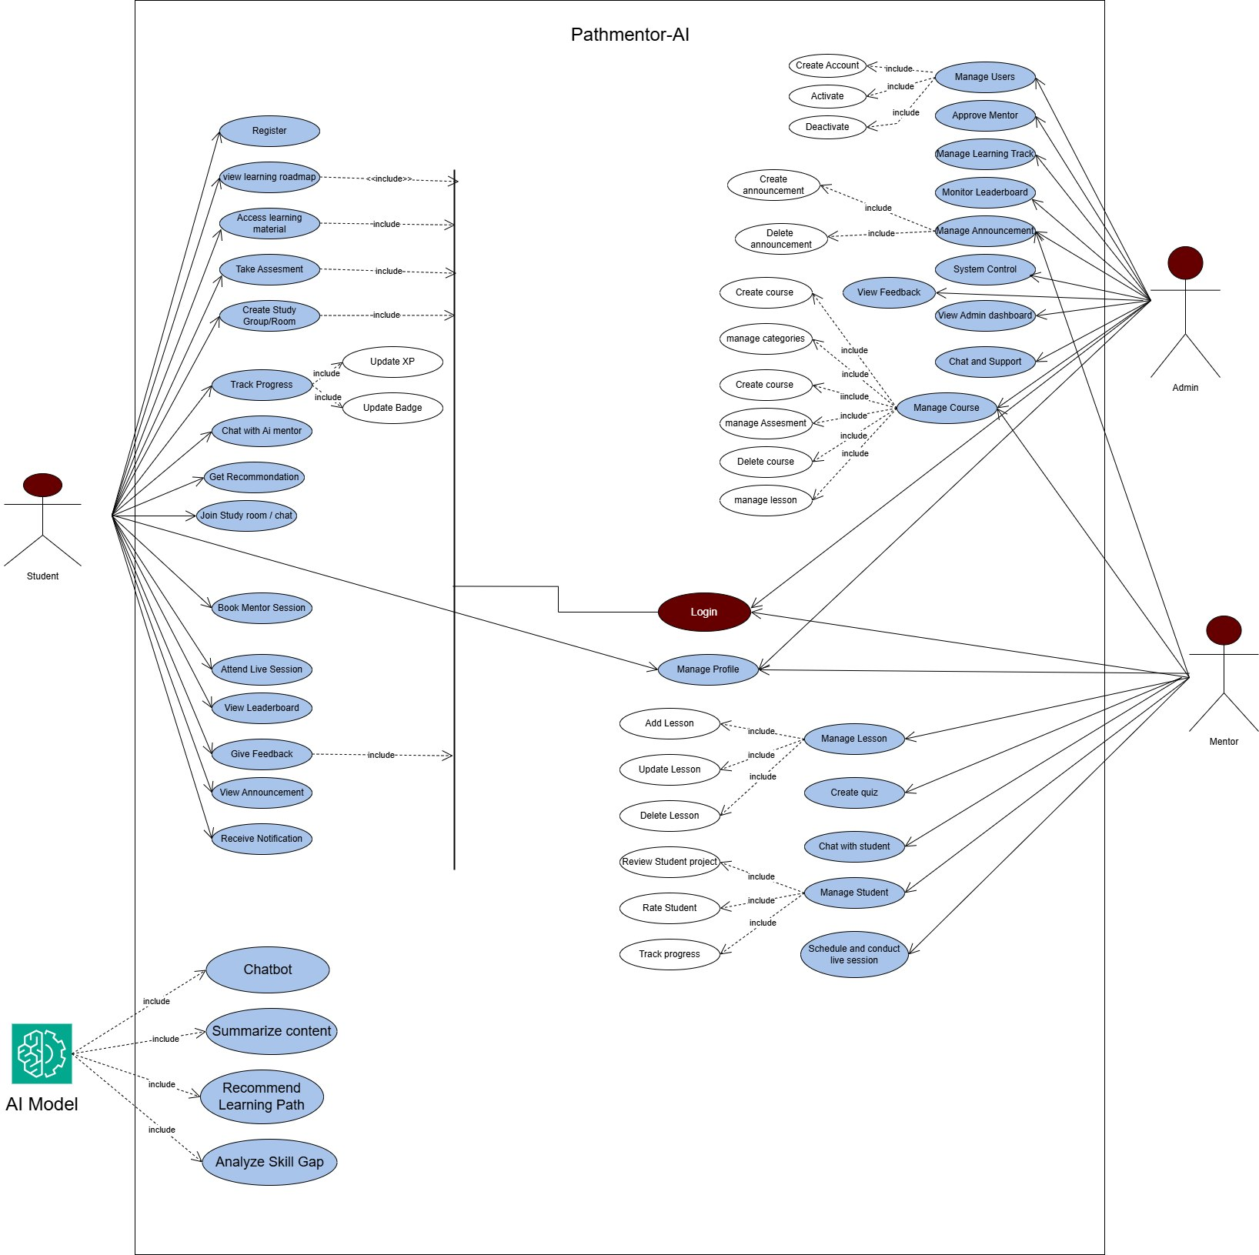
Figure 2 Use Case diagram

3.3.1 Use Case Documentation
Use case documentation provides a detailed textual description of how users interact with the system. Each use case explains the actor involved preconditions, main flow, alternative flow, and post conditions.
Table 7 Use Case description for Registration
Use Case | Registration
Use Case ID | UC-001
Description | Allows new students or mentors to create an account by providing basic details.
Actors | Student/Mentor
Preconditions | - The application must be operational.  - User must not have an account.
Post-conditions | - New account stored in the database.  - User can login to access the dashboard.
Main Flow | - User go to website  - Users click "Sign Up".  - Users enters their details (name, email, password, role)  - If not registered, the system creates a new account and confirm registration  - Redirected to login page.
Alternative Flow | 1. If user details already exist, display error and prompt for different email.

Table 8 Use Case Description for Login
Use Case | Login
Use Case ID | UC-002
Actor | User
Description | The User provides credentials to gain access to protected areas of the system.
Pre-conditions | - The User has a registered account.  - The User is on the Login Page.
Post-conditions | - User is authenticated and redirected to the Dashboard.  - A secure session is established.
Main Flow | The user opens website.  - The user selects the "Login" option.  - The user enters their email and password.  - The system validates the credentials.  - If valid, the user is directed to the dashboard.  - If invalid, an error message is displayed.
Alternate Flows | Forgot Password:  - The user selects the "Forgot Password" link.  - The user enters their registered email or other criteria.  - The system sends a password reset link to the email.

Table 9 Use Case Description for Access Learning Content
Use Case | Access Learning Content
Use Case ID | UC-003
Actor | Student
Description | Allows students to access available learning materials such as courses, modules, videos, and documents provided through the PathMentor AI platform.
Pre-conditions | - Student must be registered and logged into the system.  - Learning content must be available in the system
Post-conditions | - Selected learning content is successfully displayed to the student.  - Student’s access activity is recorded for progress tracking
Main Flow | - Student logs into the system.  - Student navigates to the learning content or learning path section.  - System displays a list of available courses or modules.  - Student selects a specific learning content.  - System retrieves the selected content.  - System displays the learning content to the student
Alternate Flows | - If the selected content is unavailable or restricted, the system displays an appropriate message.  - If the student is not logged in, the system redirects the user to the login page.

Table 10 Use Case Description for Track Progress

Use Cases | Track Progress
Use Case ID | UC-004
Actor | Student
Description | Allows students to monitor their learning progress.
Pre-conditions | Student must be logged in and start learning.
Post-conditions | Progress information is displayed
Main Flow | - Student accesses dashboard  - System retrieves progress data  - System displays progress metrics
Alternative Flow | - If no progress data exists, system displays 'No progress recorded yet.

Table 11 Use Case Description for Chat with AI
Use Cases | Chat with AI
Use Case ID | UC-005
Description | Allows students to ask questions and get real-time summaries or explanations.
Actors | Student, AI Engine
Preconditions | Student must be active within a learning level.
Post-conditions | Student receives an AI-generated response relevant to the context.
Main Flow | - Student types a query in the chat box.  - System processes query with context from the current lesson.  - AI Engine returns a simplified explanation.  - System displays the response in the chat UI.
Alternative Flow | 1. If AI service is unavailable, system displays 'AI assistant is currently offline, please try again later.

Table 12 Use Case Description for Manage Learning Materials/ Content
Use Case | Manage Learning Content
Use Case ID | UC-006
Description | Allows Mentors to upload and categorize educational materials into the 5-level structure.
Actors | Mentor
Preconditions | The user must be logged in with Mentor privileges.
Post-conditions | New content is available for students in the specified level.
Main Flow | - Mentor navigates to "Content Management".  - Mentor selects "Upload Resource".  - Mentor attaches file (PDF/Video link) and selects the target level  - System saves publishes the content and
Alternative Flow | - If file format is unsupported, system displays an error message.

Table 13 Use Case Description for Logout
Use Case | Logout
Use Case ID | UC-006
Description | Allows users to securely terminate their session.
Actors | Users
Preconditions | The user must be logged in.
Post-conditions | The session is cleared, and the user is redirected to the login screen.
Main Flow | - User selects the "Logout" option from the profile menu.  - System displays a confirmation dialog.  - User confirms logout.  - System terminates the session.
Alternative Flow | - User cancels logout in confirmation dialog; session remains active.

Table 14 Use Case Description for Take Assessment
Use Case | Take Assessment
Use Case Name | Take Assessment
Actors | Student
Description | Allows the student to answer quizzes or practical exercises at the end of a learning level to test their understanding.
Pre-condition | Student must be logged in and have completed the required learning materials for that level.
Post-condition | Assessment data is saved, and the system triggers the result generation.
Normal Flow | 1. Student selects a specific module/level assessment  - System displays the quiz questions or project instructions.  - Student provides answers or uploads project files.  - Student clicks "Submit".  - System validates and records the submission.
Alternative Flow | - Student cancels the assessment before submission; no data is saved.

Table 15 Use Case Description for View Result
Use Case | View Result
Use Case Name | View Result
Actors | Student, Mentor, Administrator
Description | Allows users to view performance scores, feedback, and progress summaries after assessments.
Pre-condition | Student must have submitted an assessment.
Post-condition | User gains insight into performance; system may provide recommendations.
Normal Flow | - User navigates to the "Performance" or "Dashboard" section.  - System retrieves assessment scores and feedback from the database.  - System displays visual reports (charts or progress bars).  - User reviews the results and feedback.
Alternative Flow | - If no data exists, the system displays a "No assessments taken yet" message.
Table 16 Use Case Description for Chat History
Use Case | Chat History
Use Case Name | View Chat History
Actors | Student
Description | Allows students to review previous interactions and learning assistance provided by the AI Chabot.
Pre-condition | Student must have previous chat sessions with the AI assistant.
Post-condition | Previous learning explanations and support are displayed for review.
Normal Flow | Student opens the AI Chat interface.  - Student selects the "History" or "Previous Chats" option.  - System fetches historical chat records from the database.  - System displays the conversation list organized by date or topic.  - Student selects a specific conversation to read.
Alternative Flow | - If no history is found, the system displays an empty chat list.

3.4. Sequence Diagrams
Sequence diagrams are a type of Unified Modeling Language (UML) diagram used to represent the dynamic behavior of a system. They illustrate how objects, components, or actors interact with each other over time to complete a specific process or functionality. By showing the sequence of messages exchanged between system components, sequence diagrams help clarify the flow of control and data within the system. For our platform the followings are :

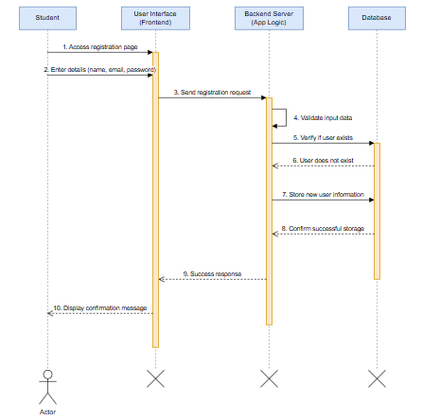
Figure 3 Sequence diagram for Registration
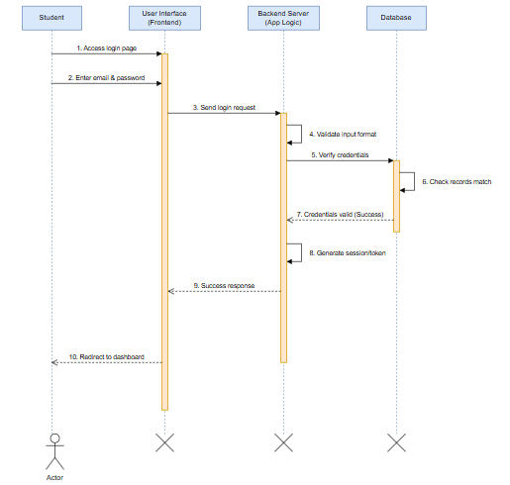
Figure 4 Sequence diagram for Login
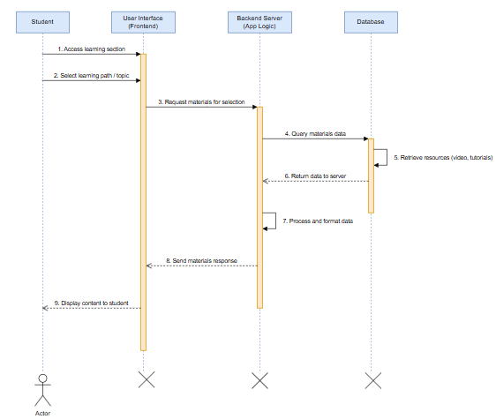

Figure 5 Access Learning Materials
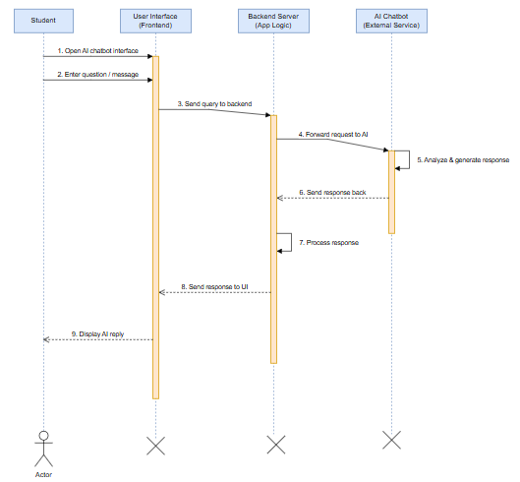
Figure 7 Chat with Ai
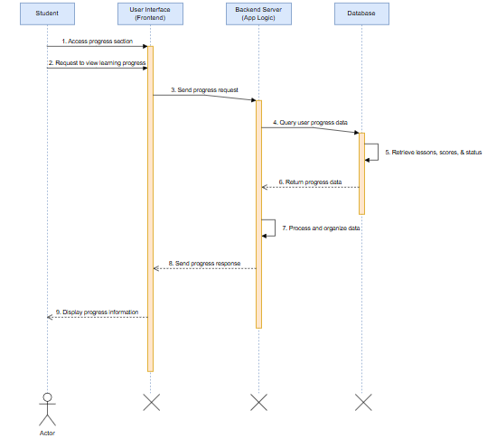
Figure 6 Track Progress
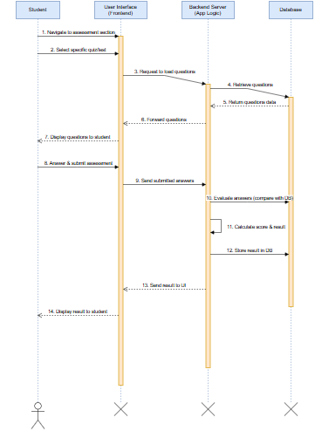
Figure 10 Take Assessment

3.5. Activity Diagram
An activity diagram is a tool used in system analysis to show how activities flow within a system. It explains the step-by-step process of how a task is completed, including the order of actions, decision points, and actions that can happen at the same time. Activity diagrams are especially helpful for understanding complex processes.
These diagrams are used to show user workflows such as account registration, course enrollment, learning progress, taking assessments, and receiving feedback. They clearly show how each activity starts, what actions happen next, and how the process ends. They also include decisions made by the user or system and the system’s response at each step.
Activity diagrams help developers and stakeholders understand how the system works internally. They make it easier to find problem areas, improve efficiency, and ensure smooth task execution. They are also useful for testing and checking whether the system behaves as expected. Overall, activity diagrams play an important role in designing a user-friendly, efficient, and flexible AI-powered learning platform.
The main symbols used in activity diagrams include rounded rectangles to represent actions, diamonds to show decision points, a filled black circle to mark the start of the workflow, and a black circle with an outer ring to show the end of the workflow.
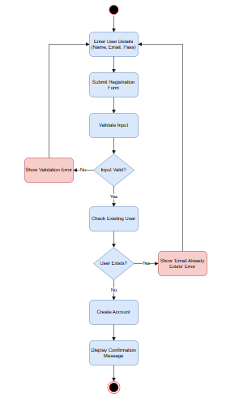
Figure 13 Activity Diagram for Registration

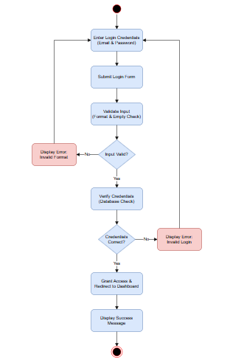
Figure 14 Activity Diagram for Login

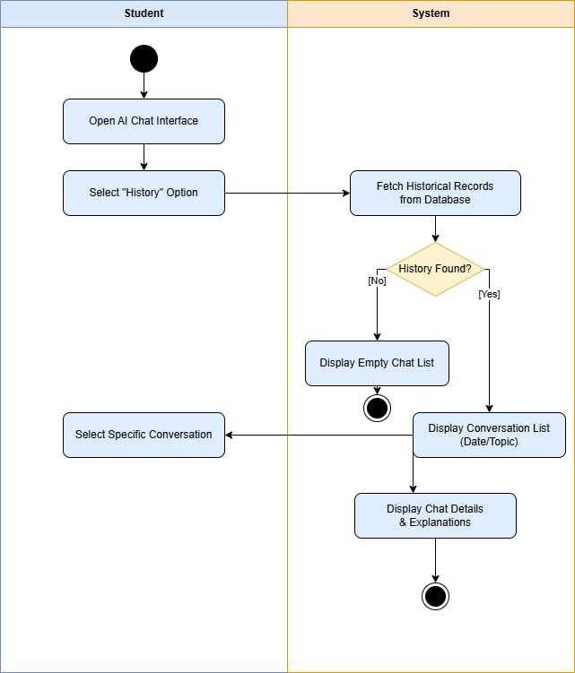
Figure 22 Chat History

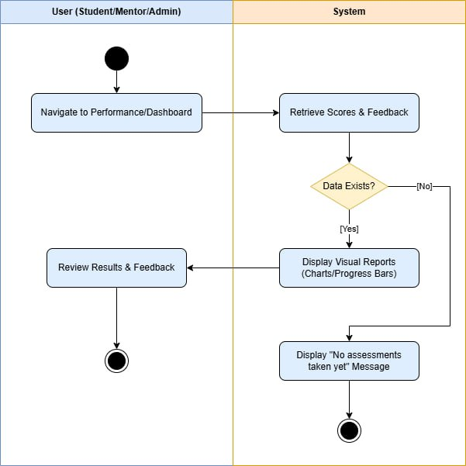
Figure 21 View Result
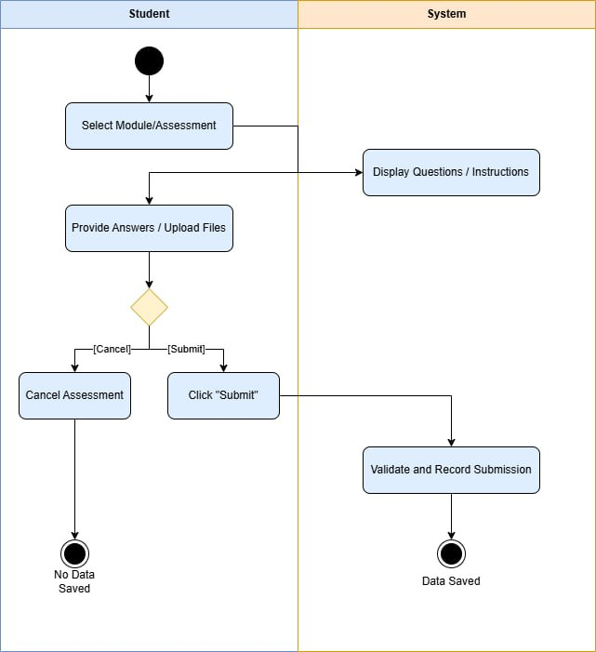
Figure 20 Take Assessment

3.6. Analysis Level Class Diagram (Conceptual Modeling)
An analysis-level class diagram, also known as a conceptual class diagram, is used during the system analysis phase to represent the high-level structure of the system. It focuses on identifying the key classes, their attributes, relationships, and associations without emphasizing implementation details.
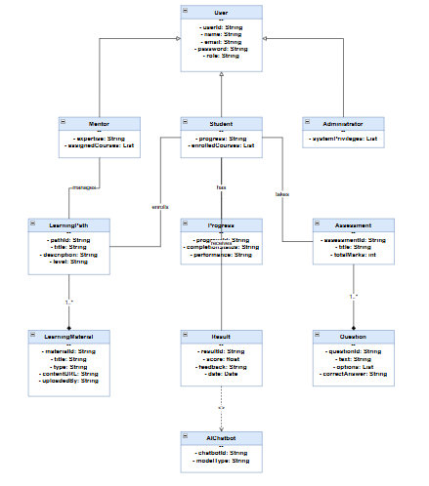
Figure 23 Class Diagram (Conceptual Model)

3.7. User Interface Design
User interface design focuses on how users interact with the system and how information is presented to them. It aims to create a user-friendly, efficient, and visually appealing interface that enhances user experience. A well-designed interface ensures easy navigation, consistency, and accessibility for all users.
For the proposed PathMentor System, the user interface is designed based on system requirements and user roles identified in earlier chapters. The design supports interaction for students, mentors, administrators, and AI chatbot communication. The interface follows modern web design principles using responsive layouts and intuitive navigation.

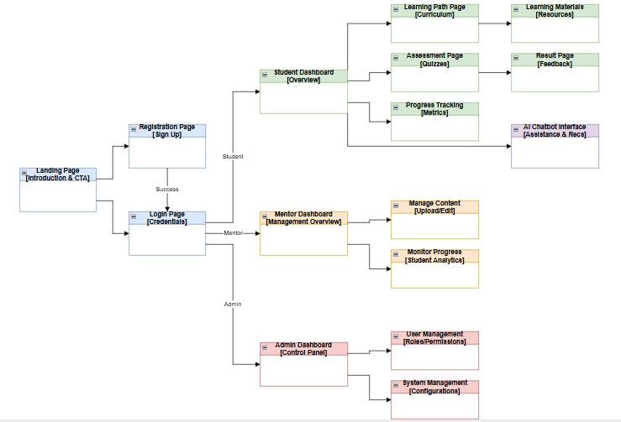
Figure 24 Prototyping Interface

3.8 .Supplementary Specifications
Supplementary specifications describe system requirements that are not clearly explained in use cases or functional requirement lists. These requirements cover additional rules, quality standards, and system-wide conditions that are important for the proper operation of the proposed AI-powered learning platform.
This section mainly focuses on non-functional requirements, such as performance, usability, reliability, security, scalability, and maintainability. These requirements ensure that the system not only works correctly but also runs efficiently, is easy to use, remains stable, and can grow over time. They also help define how the system should behave in different situations and environments.
User interface requirements are also emphasized in this section. The platform is designed to be simple, user-friendly, and visually appealing. This helps create a comfortable and motivating learning environment where users can easily find courses, track their progress, and interact with learning content.
In summary, supplementary specifications provide a clear guide for the overall quality of the AI-powered learning platform. They ensure the system meets both functional and quality standards while delivering a secure, efficient, reliable, and engaging user experience. By addressing performance, security, usability, and accessibility, these specifications play an important role in the long-term success of the platform.

4.1 Introduction
System design is a crucial phase in software development that focuses on transforming system requirements into a structured and organized solution. It defines how the system will be built, how different components will interact, and how data will be managed. This phase provides a clear blueprint for implementing the system efficiently and effectively.
For the proposed PathMentor System, system design is derived from the analysis and requirements specified in Chapter Three. The design phase focuses on creating a scalable, maintainable, and user-friendly web-based platform that supports personalized learning, mentorship, and AI-based assistance.
The system is designed using a layered architecture approach to ensure separation of concerns, modularity, and flexibility. Each layer is responsible for specific functionalities, allowing easier development, testing, and maintenance. The design also incorporates modern web technologies to support efficient communication between the frontend, backend, database, and external AI services.
This chapter presents the detailed design of the system, including class type architecture, class modeling, state chart modeling, collaboration modeling, component modeling, deployment modeling, persistence modeling, and user interface design.
Overall, the system design ensures that the PathMentor platform meets functional and non-functional requirements while providing a robust and scalable solution for users.

4.2 Class Type Architecture
Class type architecture defines the structural organization of the system by dividing it into different layers, where each layer has specific responsibilities. This layered approach improves system modularity, maintainability, scalability, and separation of concerns. Each layer interacts with others in a controlled manner to ensure efficient system operation.
For the proposed PathMentor System, the architecture is designed using a multi-layered structure that includes the following layers: User Interface Layer, Controller/Process Layer, Business/Domain Layer, Persistence Layer, and System Layer.

User Interface Layer
The user interface layer is responsible for handling all user interactions with the system. It provides the visual components through which users communicate with the application.
In the PathMentor system, this layer includes web pages such as registration, login, dashboard, learning materials, assessments, and chatbot interface. It captures user inputs and displays outputs received from the system. The interface is designed to be user-friendly, responsive, and easy to navigate.

Controller / Process Layer
The controller or process layer acts as an intermediary between the user interface and the business logic. It handles incoming requests from the user interface, processes them, and forwards them to the appropriate services in the business layer.
In this system, the controller manages operations such as user authentication, handling requests for learning materials, processing assessments, and managing chatbot interactions. It ensures that the correct workflow is followed for each user action.

Business / Domain Layer
The business or domain layer contains the core logic of the system. It defines how data is processed, validated, and manipulated according to system requirements.
In PathMentor, this layer handles functionalities such as managing learning paths, evaluating assessments, tracking student progress, and generating recommendations. It enforces rules and ensures that system operations are performed correctly.

Persistence Layer
The persistence layer is responsible for data storage and retrieval. It interacts directly with the database to store and manage system data.
In this system, the persistence layer manages user information, learning materials, assessments, results, and progress records using a database (such as MongoDB). It ensures data consistency, integrity, and efficient access.
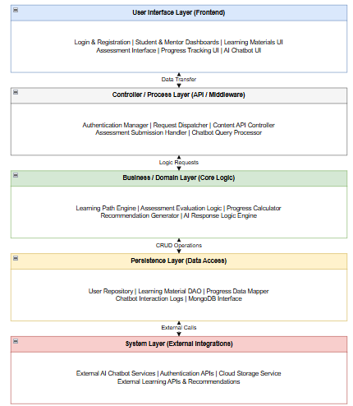
Figure 23: Layered Class-Type Architecture

4.3 Class Modeling
Class modeling is a fundamental part of system design that represents the static structure of the system. It defines the main classes, their attributes, methods (operations), and the relationships between them. The class model provides a clear blueprint of how data and functionalities are organized within the system.
For the proposed PathMentor System, class modeling is derived from the system requirements and use cases identified in Chapter Three. The model captures the core entities involved in user management, learning paths, learning materials, assessments, progress tracking, and AI-based interaction.
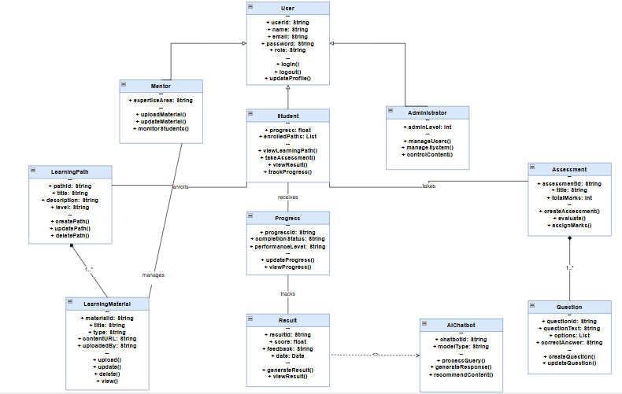
Figure 23: Class model

4.4 State Chart Modeling
State chart modeling describes the dynamic behavior of the system by showing the different states of an object and how it transitions from one state to another based on events or actions. It helps to understand how a system reacts over time, especially for key processes that change state during execution.
For the proposed PathMentor System, state chart diagrams are used to model important system behaviors such as user interaction, learning activities, assessment processes, and AI communication. These states clearly define how objects move through different conditions during system operation.

4.4 State Chart Modeling
State chart modeling describes the dynamic behavior of the system by showing the different states of an object and how it transitions from one state to another based on events or actions. It includes initial states, final states, transitions, and conditions that control system behavior.
For the proposed PathMentor System, the following state chart models represent key system processes.
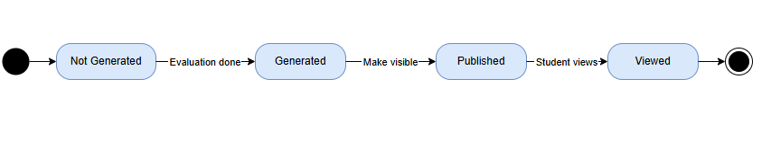
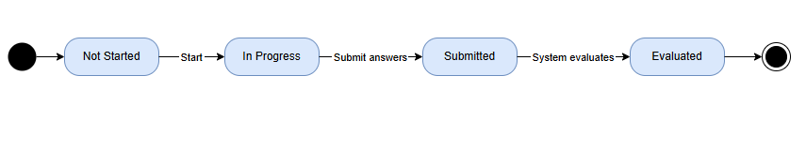
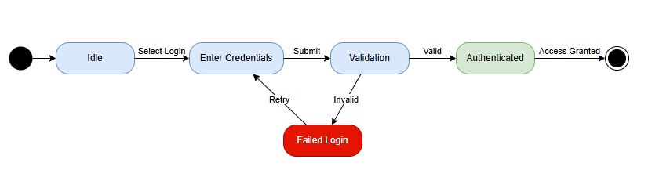

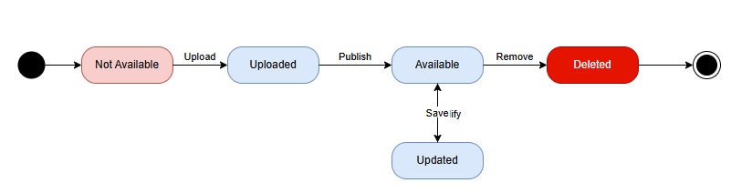

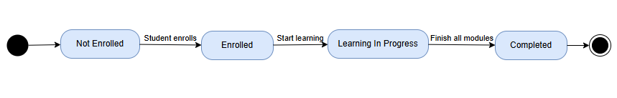

4.5 Collaboration Modeling
Collaboration modeling (also known as communication modeling) describes how different objects in the system interact with each other to accomplish a specific functionality. It focuses on the exchange of messages between objects and the relationships among them. Collaboration diagrams help to understand how responsibilities are distributed across system components.
For the proposed PathMentor System, collaboration modeling is derived from the use cases and sequence diagrams identified in Chapter Three. The following collaboration models represent key interactions within the system.
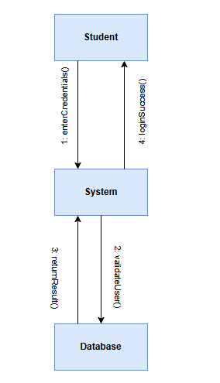
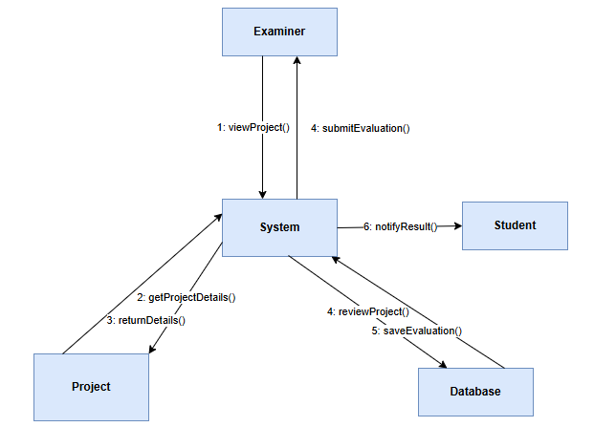

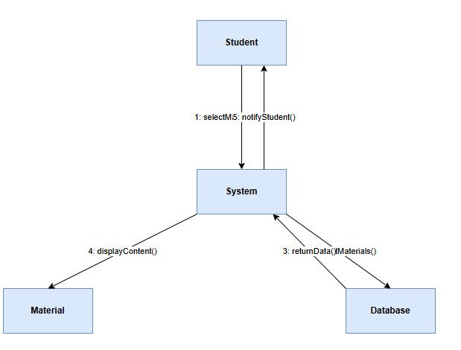

4.6 Component Modeling
Component modeling represents the physical structure of the system by showing how software components are organized and interact with each other. It identifies the major system modules, their responsibilities, and the dependencies between them. Component diagrams help in understanding system implementation and deployment structure.
For the proposed PathMentor System, the component model is designed based on the system architecture defined in Section 4.2. It includes frontend components, backend services, database components, and external system integrations such as the AI chatbot.
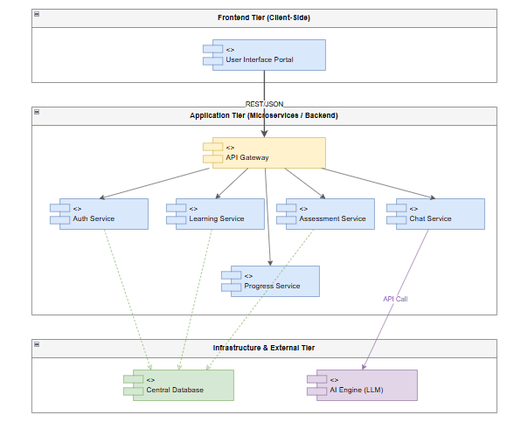

4.7 Deployment Modeling
Deployment modeling describes the physical arrangement of hardware and software components in the system. It shows how different parts of the application are deployed across various nodes such as client devices, servers, and external services. This model helps in understanding system distribution, communication, and execution environment.
For the proposed PathMentor System, the deployment model is designed based on a web-based architecture where users access the system through browsers, and the application is hosted on a server with database and external AI service integration.
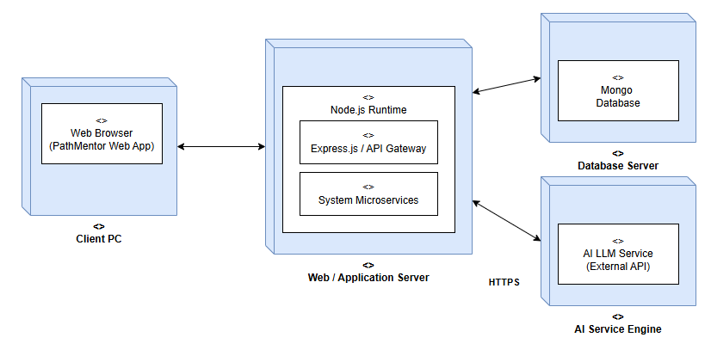

4.8 Persistence Modeling
Persistence modeling describes how data is stored, managed, and maintained within the system. It focuses on the organization of data in the database, including entities, relationships, and data access mechanisms. This model ensures that system data is stored efficiently, securely, and can be retrieved when needed.
For the proposed PathMentor System, persistence modeling is based on the system requirements and class modeling defined earlier. The system uses a database (such as MongoDB) to store user information, learning content, assessments, results, and progress data.
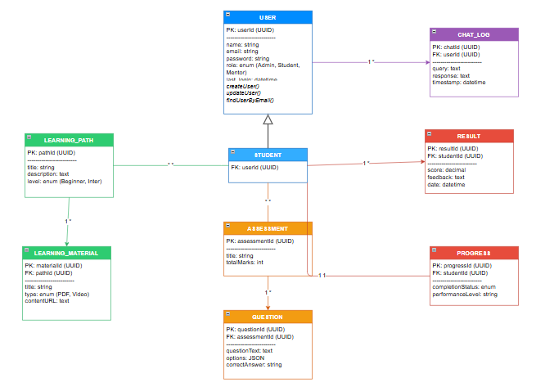

4.9 User Interface Design
User interface design focuses on how users interact with the system and how information is presented to them. It aims to create a user-friendly, efficient, and visually appealing interface that enhances user experience. A well-designed interface ensures easy navigation, consistency, and accessibility for all users.
For the proposed PathMentor System, the user interface is designed based on system requirements and user roles identified in earlier chapters. The design supports interaction for students, mentors, administrators, and AI chatbot communication. The interface follows modern web design principles using responsive layouts and intuitive navigation.
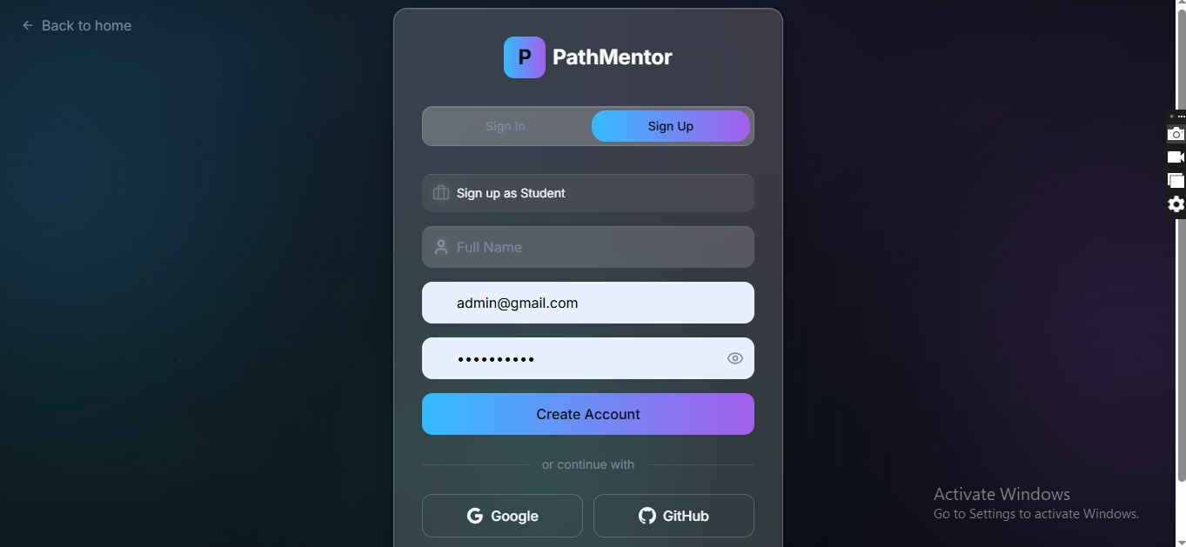
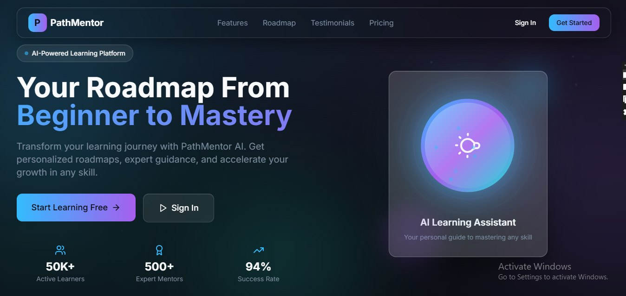

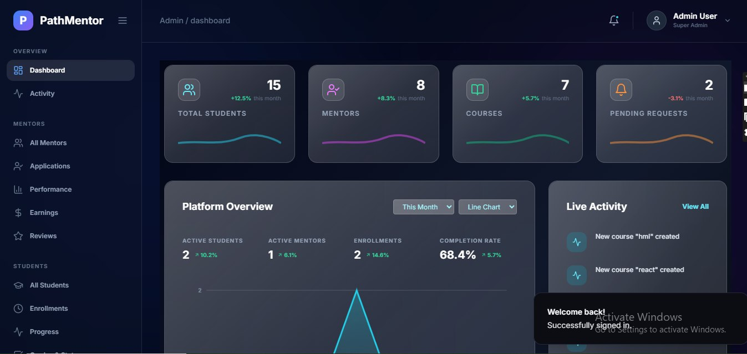

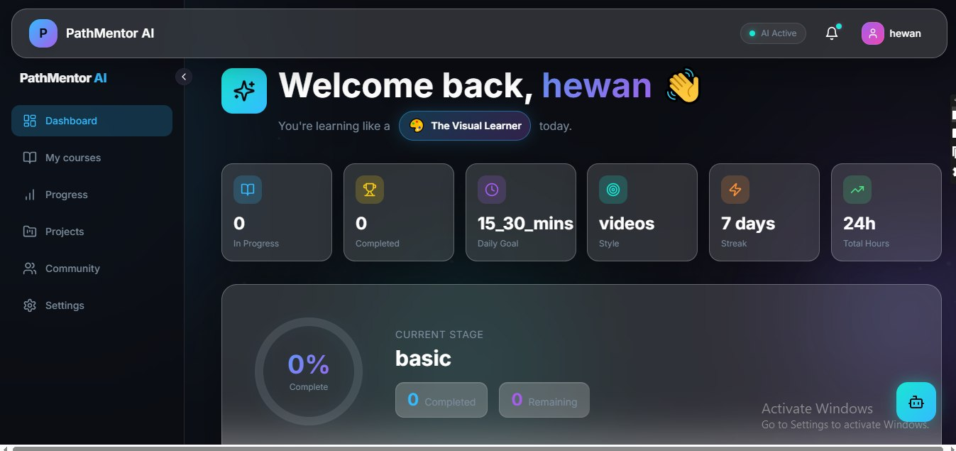

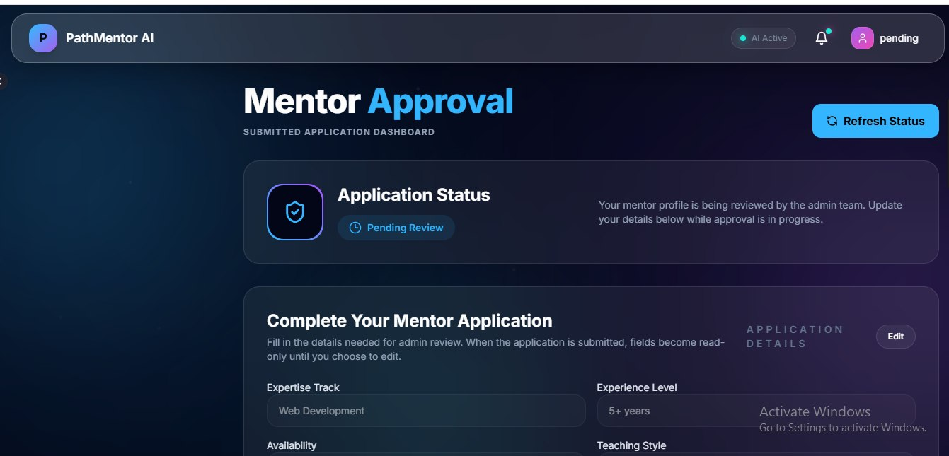

5.1 Introduction
Implementation and testing are critical phases in the system development life cycle that focus on transforming the system design into a working application and ensuring that it functions correctly according to the specified requirements. This phase involves coding, integration of system components, and rigorous testing to verify system performance, reliability, and usability.
For the proposed PathMentor System, the implementation phase involves developing the system using modern web technologies. The frontend is implemented using React.js to provide an interactive and user-friendly interface, while the backend is developed using Node.js and Express.js to handle application logic and communication with the database. MongoDB is used as the database to store and manage system data efficiently.
During implementation, different modules such as user authentication, learning management, assessment handling, progress tracking, and AI chatbot integration are developed and integrated to ensure smooth system operation. Each component is tested individually and then combined to form a complete system.
The testing phase ensures that the system meets both functional and non-functional requirements. Various testing methods such as unit testing, integration testing, and user acceptance testing are conducted to identify and fix errors, improve performance, and enhance user experience.
This chapter presents the implementation process, testing procedures, required hardware and software resources, user manual preparation, training approach, installation process, and system start-up strategy.
Overall, this phase ensures that the PathMentor system is reliable, efficient, and ready for deployment in a real-world environment

5.2 Final Testing of the System
Final testing of the system is conducted to ensure that all components of the PathMentor system function correctly and meet the specified requirements. This phase verifies that the integrated system operates as expected and that all identified errors during earlier testing stages have been resolved.
For the proposed PathMentor System, final testing is performed after completing the implementation and integration of all modules, including user authentication, learning management, assessment, progress tracking, and AI chatbot interaction. The system is tested using real user scenarios to ensure reliability, accuracy, and usability.

Testing Approach
The final testing process includes the following approaches:
Functional Testing
Ensures that all system features operate according to the requirements. Each function such as registration, login, accessing learning materials, taking assessments, and chatbot interaction is tested.
Integration Testing
Verifies that different modules of the system work together correctly. It checks communication between frontend, backend, database, and AI services.
User Acceptance Testing (UAT)
Conducted with actual users (students and mentors) to confirm that the system meets user expectations and requirements.
Performance Testing
Evaluates system responsiveness and ensures that the system performs efficiently under normal usage conditions.

5.3 Hardware and Software Acquisitions
Hardware and software acquisitions refer to the resources required for the development, deployment, and operation of the PathMentor system. These resources ensure that the system runs efficiently and supports all functionalities such as user interaction, data processing, and AI integration.
For the proposed PathMentor System, both hardware and software requirements are identified based on system needs, scalability, and performance considerations.

Hardware Requirements
The following hardware components are required for system development and usage:
Development Machine
- Processor: Intel Core i5 or higher
- RAM: Minimum 8 GB
- Storage: 256 GB SSD or higher
- Purpose: Used by developers to build and test the system
Server Machine
- Processor: Intel Core i7 or higher
- RAM: Minimum 16 GB
- Storage: 512 GB SSD or higher
- Purpose: Hosts the backend server and database
Client Devices
- Devices: Desktop, Laptop, or Smartphone
- RAM: Minimum 4 GB
- Purpose: Used by students, mentors, and administrators to access the system
Network Requirements
- Stable internet connection for communication between client, server, and AI services

Software Requirements
The following software tools and technologies are required:
Operating System
- Windows, Linux, or macOS
Frontend Technologies
- React.js
- HTML, CSS, JavaScript
- Tailwind CSS
Backend Technologies
- Node.js
- Express.js
Database
- MongoDB
Development Tools
- Visual Studio Code
- Git and GitHub (version control)
- Postman (API testing)
Web Browser
- Google Chrome, Microsoft Edge, or Firefox
AI Integration
- External AI API service for chatbot functionality

5.4 User Manual Preparation
User manual preparation is an important part of system implementation that provides guidance to users on how to effectively use the system. It includes clear instructions, procedures, and descriptions of system functionalities to help users interact with the system بسهولة and efficiently.
For the proposed PathMentor System, the user manual is designed for all system users including students, mentors, and administrators. It explains how to access the system, perform key tasks, and utilize available features such as learning materials, assessments, progress tracking, and AI chatbot interaction.

Purpose of the User Manual
The user manual aims to:
- Help users understand how to use the system
- Provide step-by-step instructions for key functionalities
- Reduce user errors and improve system usability
- Serve as a reference guide for system operations

User Guide for Main Functions
1. Registration
- Open the PathMentor system in a web browser
- Click on the “Register” button
- Enter required details (name, email, password)
- Submit the form
- Receive confirmation message
2. Login
- Open the login page
- Enter registered email and password
- Click “Login”
- Access the dashboard upon successful authentication
3. Access Learning Materials
- Navigate to the learning section
- Select a learning path
- Choose a topic or material
- View videos, tutorials, or documents
4. Take Assessment
- Go to the assessment section
- Select a quiz or test
- Answer the questions
- Submit the assessment
- View results after submission
5. Track Progress
- Open the progress dashboard
- View completion status and performance metrics
6. Chat with AI
- Open the chatbot interface
- Enter a question or request
- Receive AI-generated response

Administrator Functions
- Manage users (add, update, delete)
- Manage learning materials
- Monitor system activities

5.5 Training
Training is an essential phase in system implementation that ensures all users understand how to effectively use the PathMentor system. It focuses on equipping students, mentors, and administrators with the necessary skills to operate the system confidently and efficiently.
For the proposed PathMentor System, training is conducted after system development and testing. It ensures that users can fully utilize system features such as registration, login, learning materials access, assessments, progress tracking, and AI chatbot interaction.

Training Objectives
The main objectives of training are:
- To familiarize users with the system interface
- To explain the functionality of each module
- To ensure smooth and error-free system usage
- To improve user confidence and efficiency
- To reduce operational mistakes during system use

Targeted User Groups
The training program is designed for the following groups:
Students
Learn how to access learning materials, take assessments, track progress, and use the AI chatbot.
Mentors
Learn how to upload learning materials, manage content, and monitor student progress.
Administrators
Learn how to manage users, system settings, and overall platform operations.

Training Methods
The following methods are used during training:
Practical Demonstration
Users are shown step-by-step system operations in real-time.
Hands-on Practice
Users are allowed to interact with the system and perform tasks themselves.
Guided Sessions
Instructors guide users through key functionalities and answer questions.
Documentation Support
User manuals and guides are provided for reference.

Training Content
Training covers the following system areas:
- System login and registration process
- Navigation of dashboards
- Learning materials usage
- Assessment and result viewing
- Progress tracking
- AI chatbot interaction
- Administrative functions

5.6 Installation Process
The installation process describes the steps required to set up and deploy the PathMentor system in a real environment. It ensures that all system components are properly configured, connected, and ready for use by end users. This process involves both backend and frontend deployment, database setup, and integration of external services.
For the proposed PathMentor System, the installation is carried out in a structured manner to ensure smooth deployment and system stability.

Pre-Installation Requirements
Before installation, the following requirements must be ensured:
- Stable internet connection
- Installed Node.js runtime environment
- MongoDB database setup
- Code editor (e.g., Visual Studio Code)
- Git installed for version control
- Access to AI service API (for chatbot integration)

Installation Steps
The installation process of the PathMentor system follows these steps:
1. Source Code Setup
- Clone the project repository from GitHub
- Extract and open the project in a code editor
2. Backend Setup
- Navigate to the backend directory
- Install dependencies using npm install
- Configure environment variables (database URL, API keys)
- Start backend server using npm start
3. Frontend Setup
- Navigate to the frontend directory
- Install dependencies using npm install
- Configure API base URL
- Start frontend application using npm start
4. Database Configuration
- Start MongoDB server
- Connect backend to MongoDB database
- Verify database collections and connectivity
5. AI Service Integration
- Configure AI API key in backend
- Test chatbot endpoint connectivity
- Ensure proper response generation
6. System Testing After Installation
- Test login and registration
- Test learning materials access
- Test assessment and result functionality
- Test AI chatbot interaction

Deployment Environment
The system is deployed in a web-based environment where:
- Frontend runs on a web browser
- Backend runs on a server environment
- Database runs on MongoDB server
- AI service runs via external API integration

5.7 Start-up Strategy
The start-up strategy defines the procedure for launching and making the PathMentor system operational after successful installation and testing. It ensures that the system is properly initialized, monitored, and made available to users in a controlled and stable manner. This phase is important for ensuring system readiness and smooth transition into a live environment.
For the proposed PathMentor System, the start-up strategy is designed to gradually activate system components and ensure that all services are functioning correctly before full user access is granted.

System Initialization
The system initialization process includes:
- Starting the backend server to activate system logic
- Launching the frontend application for user access
- Connecting the system to the MongoDB database
- Activating AI chatbot service integration
- Verifying environment configuration files

Startup Sequence
The system is started using the following sequence:
- Start MongoDB database server
- Launch backend server (Node.js/Express)
- Initialize API services and middleware
- Start frontend application (React.js)
- Connect frontend with backend APIs
- Activate AI chatbot service
- Perform system health checks

System Verification
After startup, the following checks are performed:
- Verify user authentication system
- Test learning materials loading
- Confirm assessment functionality
- Validate progress tracking accuracy
- Test AI chatbot responses
- Check database connectivity and performance

User Access Activation
Once the system is verified:
- System is opened for student access
- Mentors are granted content management access
- Administrators monitor system performance
- User accounts are activated for live usage

Monitoring and Support
During initial startup phase:
- System performance is continuously monitored
- Errors and bugs are logged and fixed immediately
- User feedback is collected for improvements
- Server load and response time are observed

6.1 Conclusions
The development of the PathMentor System was aimed at designing and implementing a web-based learning and mentorship platform that integrates learning management, assessment, progress tracking, and AI-based assistance. The system was successfully analyzed, designed, implemented, and tested following structured software engineering principles.
Throughout the project, different modeling techniques such as use case diagrams, sequence diagrams, class diagrams, activity diagrams, collaboration diagrams, component modeling, deployment modeling, and persistence modeling were applied to ensure a complete and well-structured system design. These models helped in clearly defining system behavior, structure, and interactions among components.
The implementation phase demonstrated that the system can effectively support users including students, mentors, and administrators in performing their respective tasks. Students can access learning materials, take assessments, track their progress, and interact with an AI chatbot for assistance. Mentors can manage and upload learning content, while administrators can manage users and system operations.
The testing phase confirmed that the system meets both functional and non-functional requirements. All major functionalities were tested successfully, and the system showed reliable performance, proper integration between modules, and user-friendly interaction.
In conclusion, the PathMentor system provides an efficient and intelligent solution for improving personalized learning experiences. It enhances accessibility to educational resources and supports students in achieving their learning goals through structured guidance and AI-powered assistance.

6.2 Recommendations
Based on the analysis, design, implementation, and testing of the PathMentor System, several recommendations are proposed to improve the system’s performance, scalability, and user experience in future development.

System Enhancement
It is recommended to further enhance the system by adding more advanced features such as personalized learning recommendations using machine learning algorithms. This would improve the accuracy of learning path suggestions based on student performance and behavior.

Mobile Application Development
Developing a mobile version of the PathMentor system is highly recommended. This will increase accessibility and allow students to access learning materials, assessments, and AI chatbot services anytime and anywhere.

AI Chatbot Improvement
The AI chatbot can be improved by integrating more advanced natural language processing models. This will enable the system to provide more accurate, contextual, and intelligent responses to student queries.

Security Enhancement
It is recommended to strengthen system security by implementing advanced authentication methods such as two-factor authentication (2FA) and role-based access control improvements to protect user data and system resources.

Performance Optimization
To ensure better performance under high user load, the system should be optimized through caching mechanisms, database indexing, and load balancing techniques.

Future Integration
The system can be extended by integrating with external educational platforms, online libraries, and video learning services to enrich available learning materials.

User Feedback Integration
A continuous feedback system should be implemented to collect user suggestions and improve system usability based on real user experiences.

Appendix
The appendix section contains supplementary materials that support the main content of the PathMentor system documentation. These materials provide additional clarity on system design, implementation, and testing, and are included to give a complete understanding of the project structure.

Appendix A: System Screenshots
This section includes visual representations of the PathMentor system interfaces:
- Login Page Interface
- Registration Page Interface
- Student Dashboard Interface
- Mentor Dashboard Interface
- Learning Materials Page
- Assessment Interface
- Result Display Page
- AI Chatbot Interface
- Progress Tracking Page
- Admin Dashboard Interface

Appendix B: Sample Database Structure
The system database (MongoDB) includes the following main collections:
- Users Collection
Stores user details such as userId, name, email, password, and role.
- LearningPaths Collection
Stores learning path information including title, description, and level.
- LearningMaterials Collection
Stores uploaded educational resources such as videos, documents, and tutorials.
- Assessments Collection
Stores quiz and test information including questions and marks.
- Results Collection
Stores student scores and feedback after assessments.
- Progress Collection
Stores learning progress data for each student.
- ChatLogs Collection
Stores AI chatbot interactions including queries and responses.

Appendix C: API Endpoints (Sample)
The backend system provides the following REST API endpoints:
- POST /api/auth/register → User registration
- POST /api/auth/login → User login
- GET /api/learning-paths → Retrieve learning paths
- GET /api/materials → Retrieve learning materials
- POST /api/assessment/submit → Submit assessment answers
- GET /api/results/:id → Retrieve assessment results
- GET /api/progress/:userId → Retrieve user progress
- POST /api/chat → AI chatbot interaction

Appendix D: Tools and Technologies Used
- Frontend: React.js, HTML, CSS, Tailwind CSS
- Backend: Node.js, Express.js
- Database: MongoDB
- AI Integration: External AI API service
- Development Tools: Visual Studio Code, Git, GitHub
- Testing Tools: Postman, Browser Developer Tools

Appendix E: System Modules Overview
- User Management Module
- Learning Management Module
- Assessment Module
- Progress Tracking Module
- AI Chatbot Module
- Admin Management Module

References (APA Format)
Albahari, J., & Albahari, B. (2021). C# 9.0 in a nutshell: The definitive reference. O’Reilly Media.
Beck, K. (2004). Extreme programming explained: Embrace change (2nd ed.). Addison-Wesley.
Fielding, R. T. (2000). Architectural styles and the design of network-based software architectures (Doctoral dissertation, University of California, Irvine).
Gamma, E., Helm, R., Johnson, R., & Vlissides, J. (1994). Design patterns: Elements of reusable object-oriented software. Addison-Wesley.
Gupta, P. (2022). Web development with React and Node.js. Packt Publishing.
Harrington, J. L. (2016). Relational database design and implementation (4th ed.). Morgan Kaufmann.
Pressman, R. S., & Maxim, B. R. (2020). Software engineering: A practitioner’s approach (9th ed.). McGraw-Hill Education.
Ramakrishnan, R., & Gehrke, J. (2003). Database management systems (3rd ed.). McGraw-Hill.
Sommerville, I. (2016). Software engineering (10th ed.). Pearson.
W3C. (2023). HTML & CSS standards documentation. https://www.w3.org/
MongoDB Inc. (2024). MongoDB manual documentation. https://www.mongodb.com/docs/
OpenAI. (2024). OpenAI API documentation. https://platform.openai.com/docs/
Oracle. (2023). JavaScript and Node.js documentation. https://nodejs.org/en/docs/
React Team. (2024). React documentation. https://react.dev/

