考研英语作文练习

2010年英语二作文一：

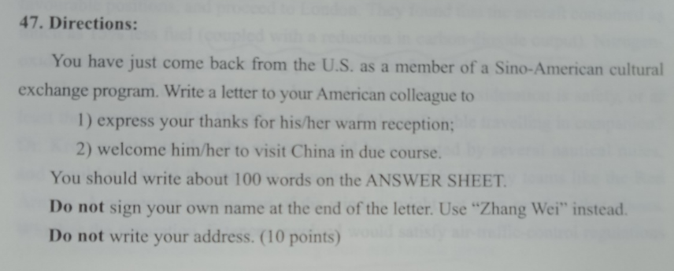

计时：（15:07-15:20）

Dear colleague:

I am writing to tell you that I ‘ve arriaved in my hometown safe and sound. During my journey back, （可以直接开头）retrospecting my trip in the US, I couldn’t help feeling gald, Therefore, I wrote to you as soon as I settled.（我一切愉快体验都离不开你们的陪伴、虚拟语气）

I have received overwhelmed welcome when I first landed（alighted） in the US, I still feel so thankful for that（不要代词后指，用宾语从句）. As I was（is） somehow shy and afraid of giving my opinion during group discussion, （强调句）my partnar（your） encouraged me and helped my expression （convey）in English, that was my most impressed experience.(kindness\hospitality\) break the nut of my anxiety.

(强调我。。)China also has large amount of culture exchange programs, including that held by universities, corporates, and society groups. I am sure you will run into even more cordial reception if you visit China for further course.learning

Look forward to your coming!

Zhang Wei.

参考范文：

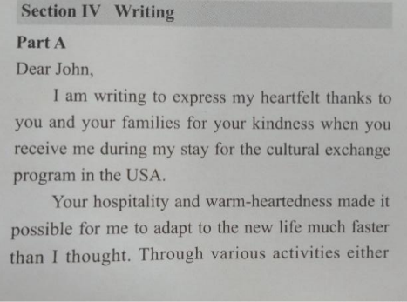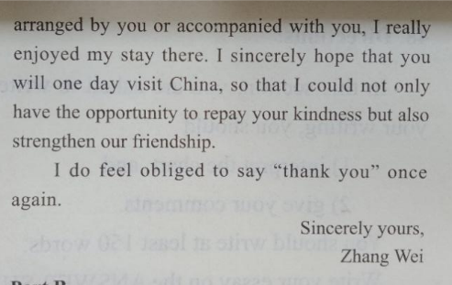

2011年作文一：

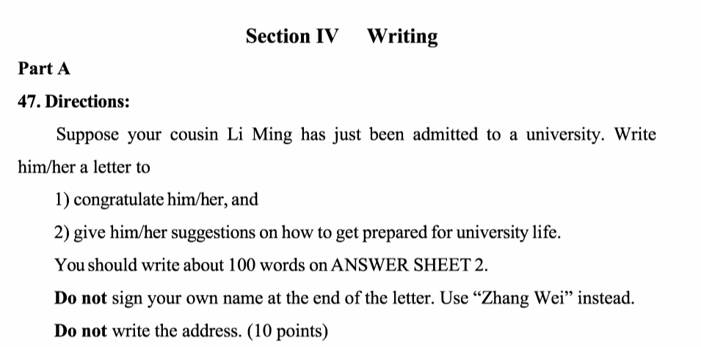

Dear Li Ming:

Welcome to the University stage of life! I just got the news from the family group to know that you are admitted to a university, and write to say congratulations as soon as possible.（without hesitation）

since you are going to step into a new stage, university, i am writing to offer a certain of suggestions for your reference.

I may not give you so much advice that you can avert all the trouble you are gonna run into during the next four years, but some basic things to do for preperation are essential. （连接词）You must figure out exactly when to register, must bring your significant belongings like the ID card. （要有因果逻辑）You need to pay attaintion to your school’s all kinds of activities and get information possitively.(try to read, schedule your time,)

first and foremost, you are supposed to make it clear that when to resgister and what to bring

in addition, it is the ability of collecting information will contribute to your ... that...

Looking forward to seeing your happy and meaningful university life!

delighted enjoyable pleasant relish（v）

Zhang Wei

2012年作文二：

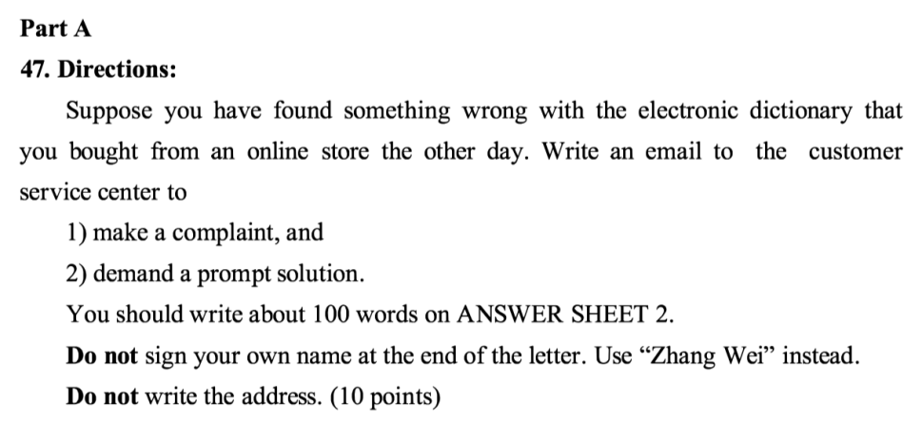

Dear Customer Service Center:（亲爱的先生或女士）

I’m writing to make a complaint about （something wrong）the electronic dictionary I bought from your online store the other day. Prompt reaction is needed as it’s impairing my working efficiency right now.

After I installed the application, logged in and input the activate code at first time, it shut down instead of functioning correctly. However(what's worse), the next time I input my activate code, it didn’t activate my application successfully. I pledge（swear） that I acted accurately following the brochour（manual）, even after I restarted my PC.

I need immediate solutions(被动语态、urgency) as I am working on my paper, which cannot move on wihtout （indispensible）the dictionary. Whether providing another activate code or another(alternative) application is ok with me, please reply as soon as possible.

Zhang Wei

2013年作文一：

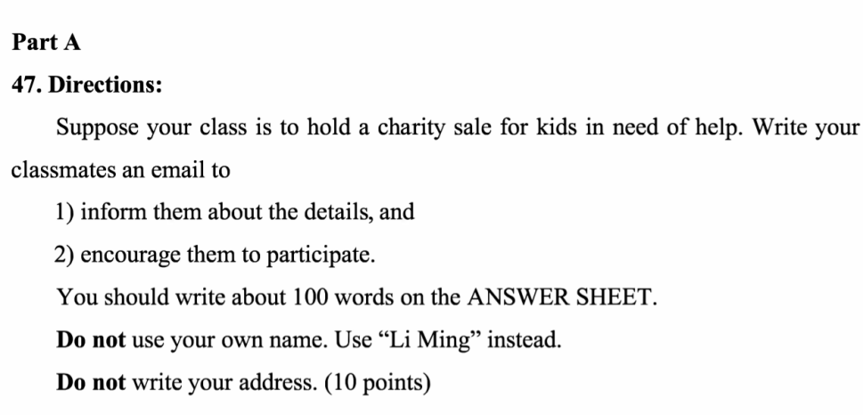

计时：19.05-19.26

Dear Classmates:

With the popose of helping kids in poor area of Guizhou, our class is due to hold a charity sale expecting the whole grade to give their kindness on the next Monday.（具体时间、对象、货物、捐款方式、）

raise our hand

give aid to

appeal to participate ..., which 日期

We are dividing the activity into three departments: sale, goods support and

commodity/ necessisity

management, each having their own specific jobs to accomplish. We need sale department to deal with expressing

strike a chord/spread /share

the idea to everyone and encourage more participants. Goods support department is going to interact with the school’s management department while our management members to arrange all the belongings inorder.

As the group leaders are way in need of assistance, we want more volunteers to attend our activity and make some difference for kids.?(呼吁参加、表示感谢)

Sincerely Yours ,

Li Ming.

2014 英语作文一：

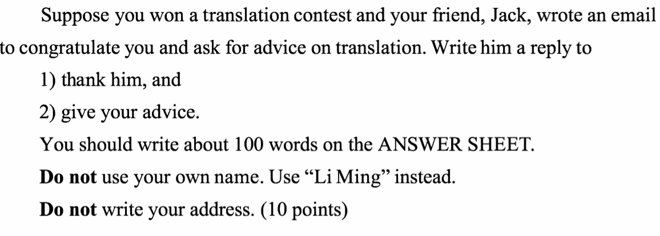

计时：18.47-19.12

Dear Jack：

Thank you for the congratulation! I had been working on English-to -Chinese traslation for the whole semester, and the consequnce made me filled with joy.

A large amount of efficient translation skills are accumulated during my practice,which I believe could help you avert most translation vice. To begin with, your words are supposed to accurately correspond with the original sentence, so that we pick up all the information the writer is trying to convey. Secondly, since there are much deficiency between when we speak in Chinese and in English, we need to figure out and handle the specific difference. Last but not least, the translated sentence shell be in good shape,which means even native people couldn’t discern whether it is traslated or not.

Hope your translation level soar as expected.

Sincerely yours,

Li Ming

2015年英语二作文：

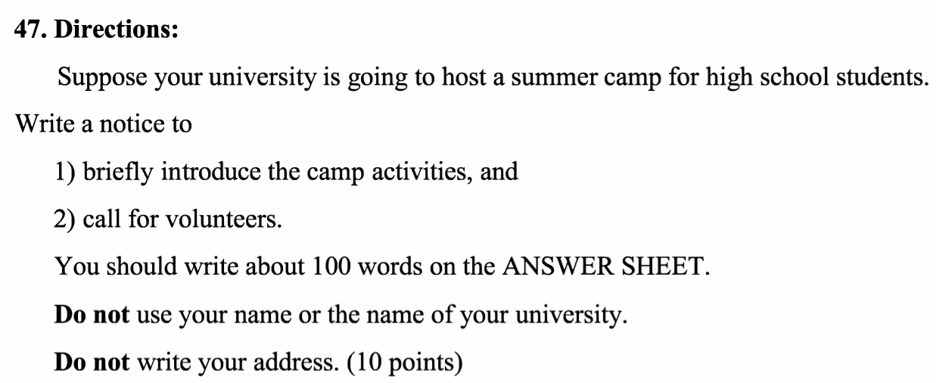

计时：21.47~22.09

Notice（居中）

The annual summer camp for high school student is imminent, which is an significant event for the incoming semester. High school student could acquire primary acknowledge of our university presently.

A brief introduce of the activities is as follows. Firstly, Students will arrive next Monday morning, gather at the lawn near the South entry to register and visit the campus by groups following our volunteers. In the evening, they are encouraged to attend the student non-leading discussion or could choose to prepare for the test next day. It is the three-hour synthesis test and 30-minites interview that will give a fair gredes to our young visiters and provide them with some priorities during admission.

With the purpose of creating regulary and sortful camp for all of the participants, we sincerely call for volunteers. Please sign in via the link below and thank you for your engagement!

2018年英语二小作文

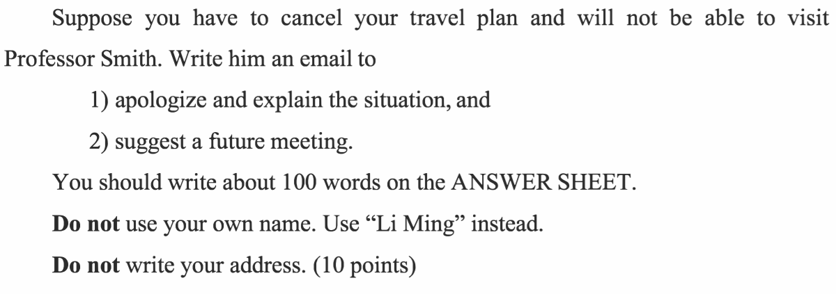

计时：08.59-9.22

Dear Professor Smith:

I’m terribly sorry that I couldn’t make it to visit you next month, because I am obliged to stay in my country before the epidemics sitiation totally turn better.

Back to Janurary, when I first planned to travel in the US, I made a specific schedual and attached significant importance to the meeting with you, as you permitted via the last letter. However, the Corona Virus invaided China from the beginning of burst of infectual cases in WuHan during early of Feburary, which brought a great shock to every Chinese. A good many of flight and railway traffic have been cancelled and countrywide residents’ out-door activities have been restricted to fight the Virus.

I am confident that our country willl defeat the Virus and the sociaty will revive vigerously soon, and I am looking forward to meeting you then.

Sincerely yours,

Li Ming

2011年大小作文练习：

计时：19.16-21.13

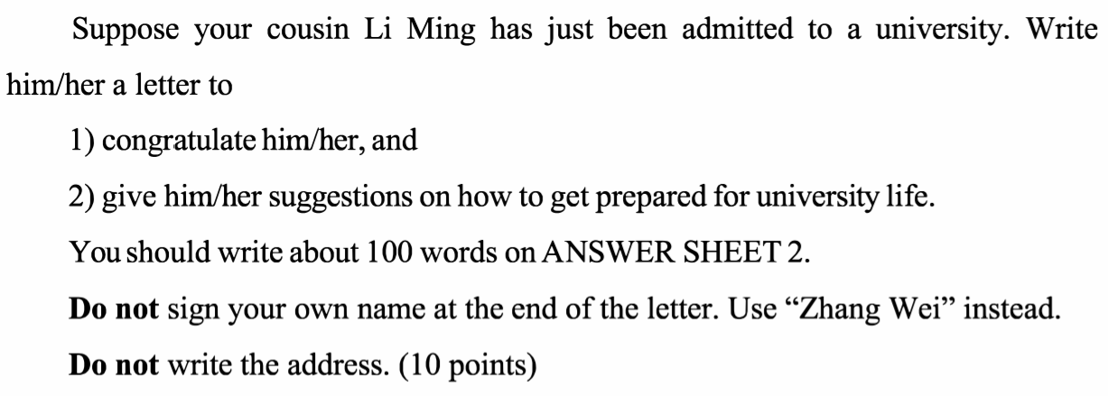

Dear Li Ming:

Congratulations! I just noticed from the family group that you have been admitted to Lanzhou University, which brings everyone concerned great delight! I’m writing to express my heartfelt congratulation and give some practical suggestions for you.

To begin with, the most magnitude is to have a more profound understanding of your self. What kind of personality do you have natually? What abilities are you proud of? Secondly, based on your comprehensive view upon forementioned questions, you are supposed to intellectually figure out your whole four-year ambitions, including your academic goals, admiring physical shape and all you want to achieve. Last but not least, it is practice and getting your feet wet that can actually bring about remarkable improvement.

Wish you a fasinating university life!

Sincerely yours

Zhang Wei

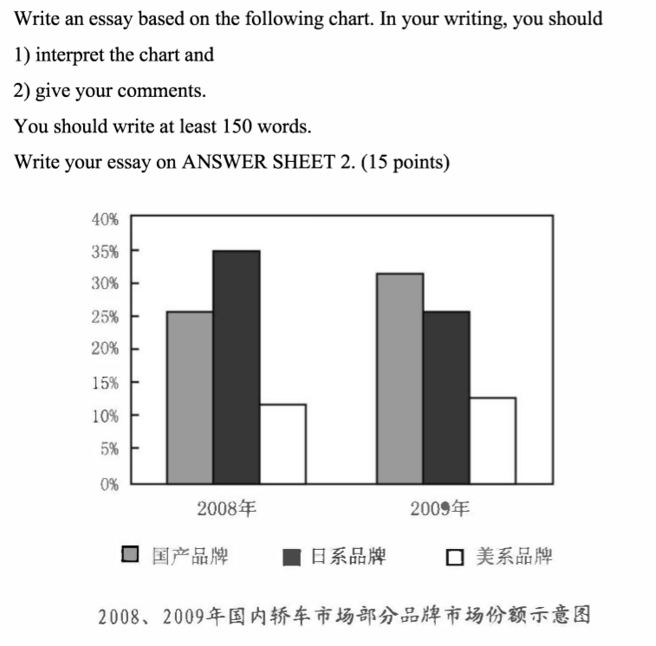

The column chart clearly shows the proportions of automobile market that different brands won in the two years. In 2008, brands from Japan take 35% and domestic brands take 25%, both rate higher than that from the USA. After the year, domestic brands surpassed Japanese brands by 5% while American brands consistently take 10%.

      While it can be inferred that there are other kinds of brands in our car market, we citizens seem to be more fond of Chinese and Japanese cars. To illustrate the phenomenon, Japan has been doing well in both car manufacturing and saling in the late 20th century, which sets an implict view in the Chinese mind that Japanese cars are worth-buying. Besides, our car industry has been thriving since the Reform and Opening as well and can compete with foreign cars nowadays. Surpassing Japanese proportion is the most remarkable sign.

As regards to car brands from the USA, I am surprised that they held the portion during the severe depression, which brought the whole world a striking financial crisis that lasts until now. One contribution to that, in my view, is the efficient united policy of our country that retains the domestic economy.

      All in all, Chinese car market is expected to be more resonable and more conducive to our people via diligience of the car industry and every taxpayer.

2010年大作文

计时：18.17~18.47

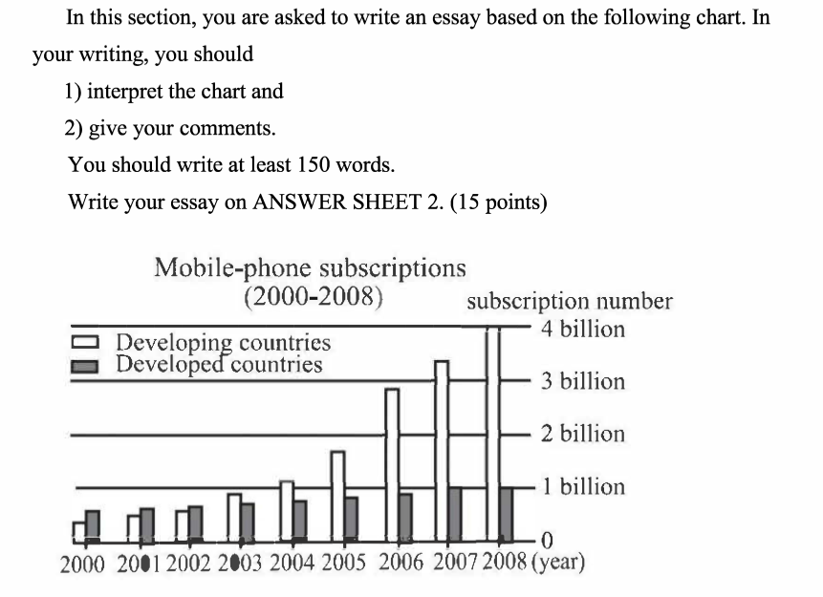

//原因：人口基数，基础设施发展；

//思考：手机入网并不能代表所有的科技水平，发展中国家仍应。。

The column chart clearly illustrates the comparison of mobile-phone subscriptions between developed and developing countries during last decades. Subscription number of developed countries rose from approximately 0.6 billion to 1 billion while that of developing countries from less than 0.5 billion to 4billion. The statistics provide us with specific support of following points of view.

      To begin with, the new century demands developing countries to attach magnitude to infrastructure facilities, which contains the supply of every citizens’ right of correspondent and cyber-life. Given that the population of developing countries is almost eight times that in developed countries, it is not surprising to see such surpass in the year of2003. Meanwhile, the thriving number of subscription also shows that most people in developing countries have got their new identities as a member of the connected world.

      However, a caveat must be posed that mobile-phone subscription is not the main contribution to actual economy effect. Signning up on the internet is not a rather high-tech business, and could even be the vicious controling strategy of other countries. Developing countries that wonder better economies should move on to be more competetive in technology and gross power of itself.

2012年英语二大作文：

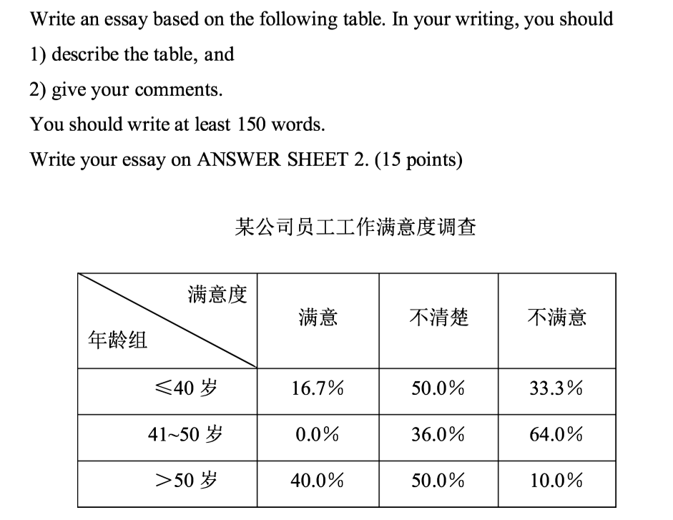

计时：20.12~

对工作的满意程度取决于工作的压力、时间、状态等综合因素，不同的人对这些因素的敏感性不同

The chart clearly illuastrates the gratification level of a certain company. Staff of the three age groups have rather different attitude. Half of workers under 40 have no clear view, while one third are not satisfied with their work and the rest feel satisfied. None workers between 41 to 50 are satisfied and most of them dislike their jobs. On the other hand, workers above 50 have the highest gratification and only 10% of them feel some malign sides.

Two conclusions can be drawn from the forementioned statistics. To begin with, people don’t actually give a specific view upon their work attitude, with nearly half of them choosing the moderate option. Compared to skills, family relationships and physical health, it goes without saying that whether you like the job or not is not something magnitude. Meanwhile, people in their middle age would detest their jobs mainly because they are experiencing a very hard stage and just couldn’t give optimistic attitude.

All in all, people have gratification level with much difference due to their sensiness about work and vairous stages of life.

2013年英语二作文：

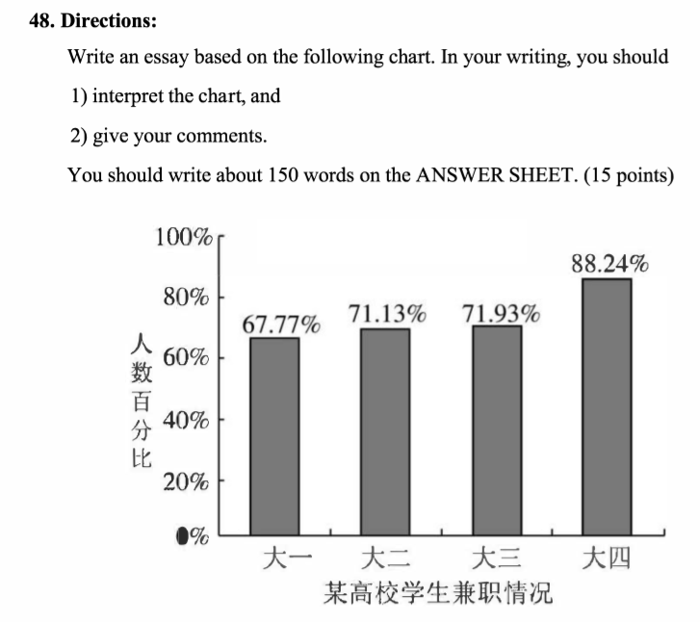

计时：16点31分~16点52分

The column chart(histogram) clearly illustrates the part-time job ratio of different grades at a certain university. (As many as )two-thirds of freshmen are engaged in part-time jobs. The ratios of Sophomore and third grades gain a moderate increase(increase slightly), while that of under-gratuates takes a leap to 88.24%. Two conclusions can be (evidently)drawn from the statistics above.

To begin with, students are enthusiastic in various of activities from the beginning of university. It can be inferred that even more students attend (participate in)other kinds(forms) of social practice, since taking a part-time job is just one way to experience university life. As far as I see, it is getting their feet wet in practice and engagement that fill students’ lives with meaning and merit.( In my opinion, engaging in practical exercise can make them better integrate with modern society)

On the other hand, when students are confronted with graduation, their experiences are crucial and will decide(determine) whether they can step in a ideal company. For that reason, students usually somehow(to some extent) put their academic tasks aside and do their best to get more adundent(sufficient\adequate)social working experience.

2014年英语二作文二：

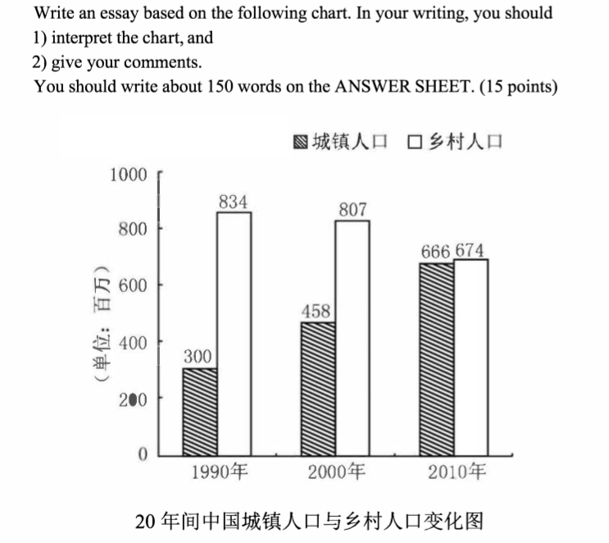

计时：先不计时了 写到哪儿算哪儿

As the histogram shows, the structure of Chinese rural and urban population has undergone great change during these 20 years. From 1990 to 2010, rural population fell off(decreased) from 834 millions to 674 millions, while that of cities rose from 300m to 666m. Two conclusions can be evidently illustrated via the statistics above.

To begin with, people are persuing(continue to persue) more convenient and connected living environment, given that their incomes have risen remarkablly(significantly). Unremitting efforts and continuous struggle have brought sufficient material and rich culture to the Chinese people. As a result, increasing numbers of people living in rural areas would like to move to cities.

On the other hand, a caveat must be posed that rural construction is still a crucial project for China, which needs a good many of(a large number of) advanced talents. Youngsters should be encouraged to contribute to the grossroots of the society. Volunteering and devoting spirit should still burn deep in our heart.

2015年两篇作文：计时：20.14~20.46

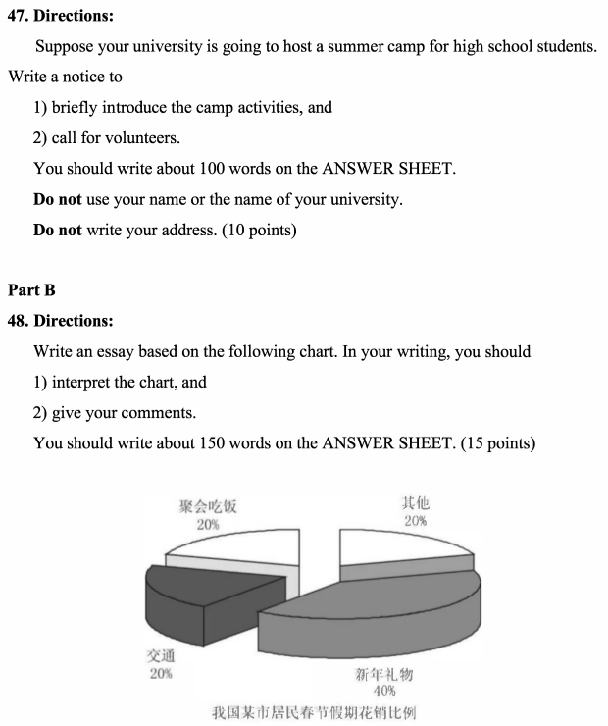

Notice

The annual summer camp is approching! It is a siginifant activity for high school students to get information and experience university life. Some details are as follows.

To begin with, students from all over the country will gather at the South Gate on the morning of Augest 1th. After registering and taking their cards, volunteers will lead a tour of the school museum. In the evening, they are encouraged to join our singing evening. They can also choose to relax and prepare for tomorrow’s exam. The test will assess their comprehensive abilities and privide them with an early admission.

Volunteers are needed for this event! If you would like to contribute to this, please contact us via the following email. 11.29.2022



The pie chart clearly shows the consumption ratio of residents in a certain city during the spring festval. 40% of the cost goes to buying gifts, and 20% each for parties and transportation. 20% of money are otherwise intented. Two conclusions can be evidently illustrated via the above statistics.

To begin with, New Year’s gifts are still the most magnitude for Chinese. Bringing fancy present to friends or family members is the best way to express sincere wishes and warm thanks. With higher income and better living standard, we are more willing to surprise them with more valuable gifts. Gifts seem to initialise the new year for us.

On the other hand, the proportion of transportation expenses are decreasing in recent years. Although dinner parties are still a lar amount of expense for people, due to construction of China’s infrustructure, transportation is becoming an easy thing, at least the problem of grabbing train tickets has gone. At last, the spirit of diligence and practicing economy shoud still burn deep in our heart.

2016年英语二作文：计时：19点37分~20点15分

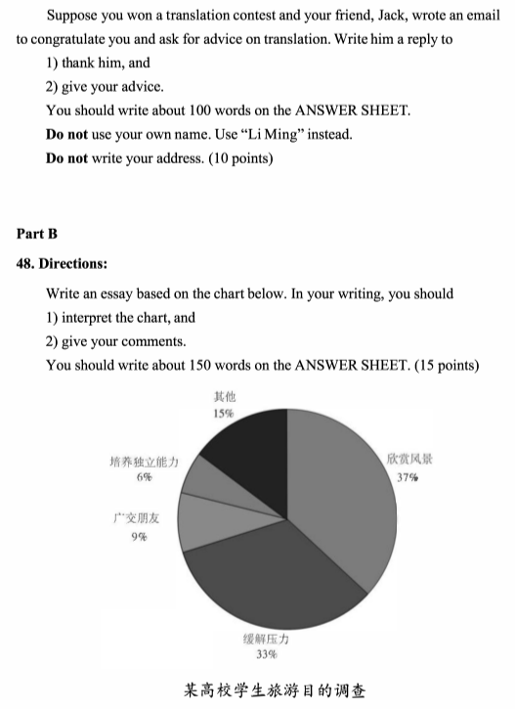

Dear Jack:

Thank you for your writing! I am so delighted that you agree with（认可：recognise） my efferts and translating skills. As regard to advice, my shallow suggestions are as follows.

To begin with, interest is the best teacher. We try to translate because the love and enthusiasm(passion) in our deep heart, not tring to obtain some kind of fame. I believe you love translating as I do. Secondly, we should keep a regular practice routine. I translate a passage(an article) everyday after lunch, which indeed helped me in my vocabulary and understanding precision of long sentence. Last but not least, we should have our own system of method. Having your own methodology facilitate not only translating, nut also our comprehension of English.

Hope you make progress in translating!

Sincerely yours,

Li Ming



The pie chart clearly illustrates various traveling purposes of students at a university. 37% students travel to enjoy nature, and 33% to alleviate stress. Making friends and cultivating independent ability accounted for 9% and 6% repectively, and 15% students had other intentions. Two conclusions can be drawn evidently via the statistics above.（这里不应该说得到两条结论，而应该是一条直接推导出来的结论加一段自己的评价或建议，因此换成“A conclusion can be drawn eveidently via the statistics above, and I have some deep thoughts and shallow suggestions on this.”）

To begin with, the original goal of accessing nature remains the most important purpose of traveling. With the development of information and media, people are not as fond of landscapes as before. A good many of teenagers have realised the problem and they encourage each other to get back into the natural embrace, which helps to restore our energy. Traveling is the best way to get practical and feel ourselves.

In the other hand, traveling is becoming a kind of social occasion, given that students can share their stories and scout partners through various social media. People try their best to take splendid pictures and record every interesting happenings during their tour, looking forward to fancy interactions with their online acquaitance. At last, a warning must be isssued: be safe and sound when traveling.

2017年英语作文：

计时：21点37分~22点36分

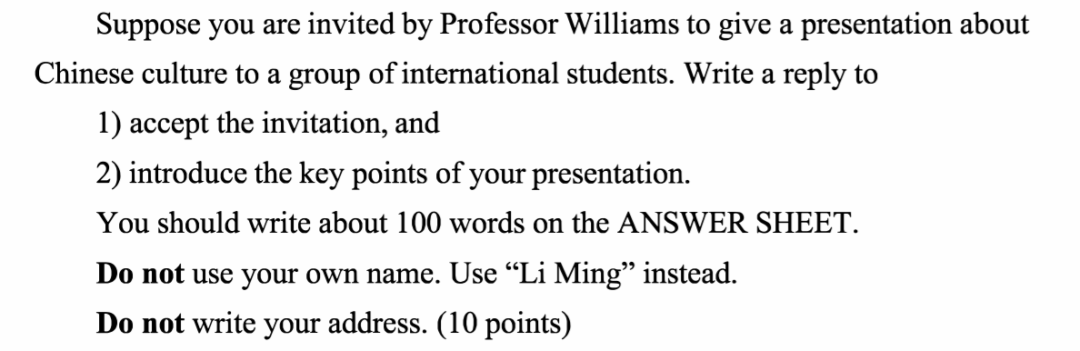

Dear professor Wiliams:

I am honored to give a presentation about Chinese culture to our internation group. And I made a brief introduction on the issue of Chinese architecture as follows.

To begin with, I am going to show some pictures to demostrate the basic features of Chinese traditional architecture, which can be concluded to be wood-basing construction. Secondly, I will introduce Chinese architecture since mordern age, including our first architects returning from learning abroad. It was the development of western architecture that helped to establish the mordern Chinese architecture. Last but foremost, I would like to try to compare architecture between China and Eroup, which is a very popular topic these years.

Hope you can give some advice on the key points above, which will definitely help me a lot.

Yours sincerely,

Li Ming.

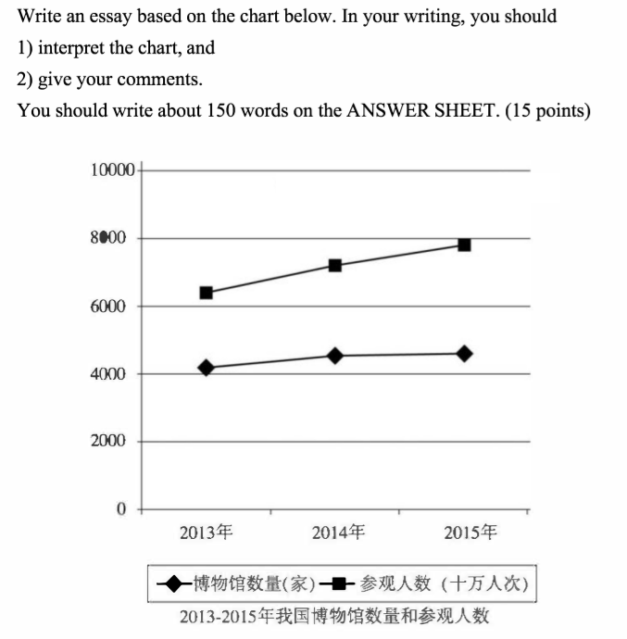

The chart clearly illustrates the museum and visiting number in our country during these years. (第一句套路)We had about 4000 museums in 2013, and the number rose slightly in 2014 and 2015. Meanwhile, visiting numbers of museum rose sharply from about 650 millions in 2013 to nearly 800 millions in 2015. （第二句，说明数据）One conclusion can be evidently drawn via the statistics above, and it made me saturate in deep thought.（第三句套路）

To begin with, people are more and more willing to visit and study, while the supply of museums can not suffice.（第一句结论） 4000 museums in such country with a large territory and massive population is not sufficient at all, because that means 3 millions persons would own one museum averagely. （第二句说明）In addition, increase of visiting numbers is much more than museum amount, which will decrease the averagement further. （第三句进一步说明）

On the other hand, we must penetrate the surfice and perceive the essence. （第一句套路）People are visiting museum more than before not only because they have more money, but also because thay want more advanced culture and history learning material. （第二句分析本质）Of course , it demand more museums to be built, more significantly, it means we are supposed to build museums with more technology and better learning environment.（第三句给出浅薄的意见）