



**Version 1.0**

HPE SimpliVity integration for Citrix Cloud

User Guide

**User guide**

Table of Contents

Introduction 1

Release Notes 1

Hyper-V/SCVMM 1

Requirements 1

Citrix Cloud Requirements 1

VM Template Requirements 1

Versions: 2

Microsoft Hyper V - Citrix Cloud Connector Installation 2

Registration 2

Operations 4

Configuration 6

Deconfigure/Plug(Out) 8

Logs 10

Proxy 10

VMware vSphere - Citrix Cloud Connector plugin 11

Glossary 17

For more information HPE Converged Infrastructure Library 17

# 

# Introduction

Citrix cloud connector acts as an interface between the Citrix cloud and resource location. This helps in managing the hosts and virtual desktops from the cloud by removing the need for complex solutions and networking. Each resource location is recommended to have more than one cloud connector to provide high availability (HA). However, it is laborious to configure or de-configure cloud connector whenever a resource location is created or deleted.

This document is a step by step guide to automate the installation of cloud connectors using **HPE** **SimpliVity Citrix Plugin** by deploying virtual machines (VMs), adding them to Active Directory (AD), downloading Citrix cloud connector and installing it.

Target audience: Software architects, solution engineers and end users using Hyper Converged infrastructure for virtual desktops. It is recommended to have a brief understanding on HPE SimpliVity and Citrix cloud.

Document purpose: The purpose of this document is to provide a step by step process to use HPE SimpliVity Citrix cloud connector for Microsoft Hyper-V and VMware vSphere.

# Release Notes

This is the first version of HPE SimpliVity plugin for Citrix cloud which installs and configures Citrix cloud connector. Major aspects of this plugin that are covered in this release are:

* Proxy implementation is a preview feature (beta) in version 1.0
* Secure SSL/HTTPS enabled on SimpliVity OmniCube controller (OVC) IP address to connect using REST APIs
* VM template with Windows 2016 Operating System.

## Hyper-V/SCVMM

Few caveats that are specific to SCVMM/Hyper-V plugin

* SCVMM templates are not stored in SimpliVity and base VM satisfying the template requirements are used to perform SimpliVity clone
* Hosts in SimpliVity clone are automatically selected during deployment. Live migration should be working in the SCVMM setup to migrate VM to the user specified host. If live migration is not supported, VM placement is not guaranteed to reside on the specified host
* SCVMM should run on default port 8100)

# Requirements

In order to use this plugin, there are a few pre requisites that need to be configured prior to running this.

## Citrix Cloud Requirements

In order to access and manage Citrix cloud remotely, client id and key should be created. The key is used along with the organization to deploy cloud connector in a resource location.

Refer the following link on how to create client id and key.

<https://docs.citrix.com/en-us/citrix-cloud/citrix-cloud-management/identity-access-management.html>

If the given resource location is not present, this application creates a new resource location in the Citrix Customer (Organization) and tags cloud connector to the new resource location. For existing resource location, cloud connector is automatically tagged to it

## VM Template Requirements

Following requirements should be taken care while generating VM template for cloud connector installation.

1. It is recommended to use Windows Server 2016 to create a template that is used for connecting Citrix cloud and resource location.
2. Windows remote management feature should be enabled to access the virtual machines from SCVMM plugin.
3. The template should not join the AD domain. The plugin creates the VM and joins to AD.
4. Since the IP address of VM(s) created by the plugin is assigned from the DHCP server, user has no option to assign static IP.

# Versions:

**Microsoft Hyper-V**

Citrix cloud connector installation on HPE SimpliVity storage using Microsoft SCVMM plugin is tested on the following versions:

|  |  |  |
| --- | --- | --- |
| Product | Component | Version |
| HPE SimpliVity | OmniCube Controller | 3.7.0.46 |
| API Version | 1.8 |
| Microsoft SCVMM | Client | Windows 2016 |
| Build | 4.0.2314.0 |

**VMware vSphere:**

Citrix cloud connector installation on HPE SimpliVity storage using VMware vSphere plugin is tested on the following versions:

|  |  |  |
| --- | --- | --- |
| Product | Component | Version |
| HPE SimpliVity | OmniCube Controller | 3.7.0.260 |
| API Version | 1.8 |
| VMware vSphere | Client | Windows 2016 |
|  | Build | Version 6.5.0 Build 4944578 |

# Microsoft Hyper V - Citrix Cloud Connector Installation

## Registration

Download the HPE SimpliVity Citrix Cloud Connector plugin (**connector plugin**) and import the Add-In to System Center Virtual Machine Manager (SCVMM)

1. Extract the plugin to C:\Users\Public
2. Login to SCVMM Manager and upload the ‘CitrixSimplivity.zip’ Add-in from the path C:\Users\Public\HpeCitrixPlugin
3. Close and reopen the SCVMM Management console to reflect to access the new plugin

Figure 1: Add-in import

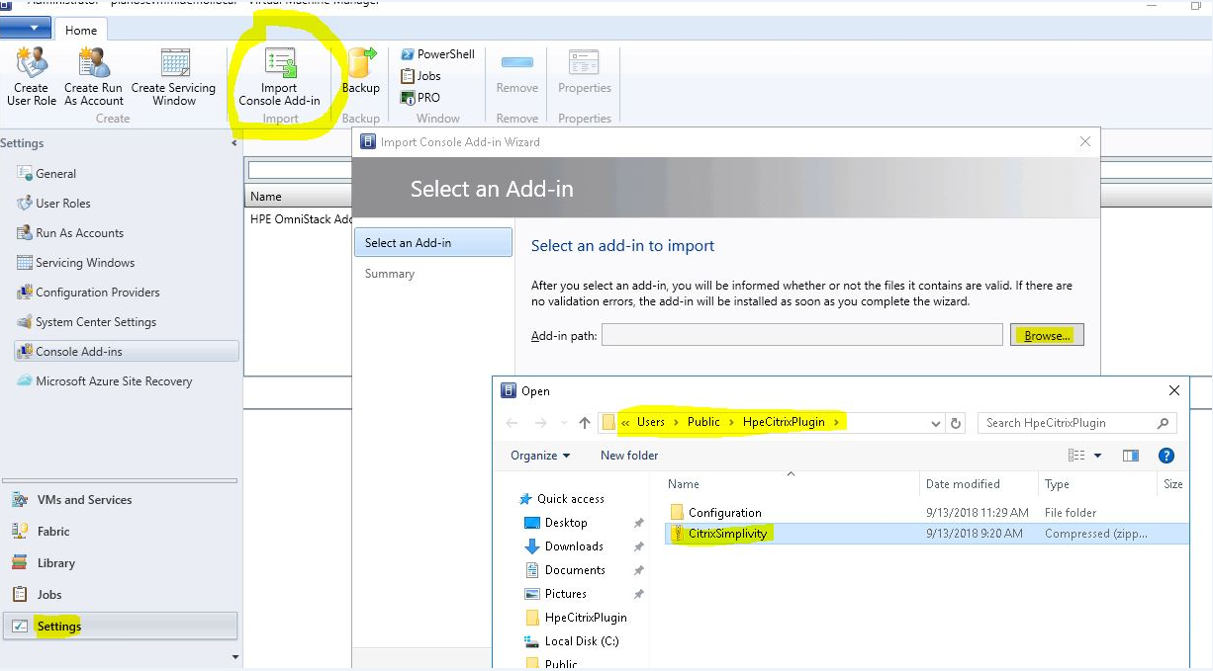

## Operations

The plugin can perform different operations to configure and de-configure cloud connector virtual machines. If the plugin is successfully installed ‘SimpliVity-Citrix Connector’ application is visible in the **VMs and Services** of SCVMM as shown in the following figure:

Figure 2: HPE SimpliVity-Citrix Connector

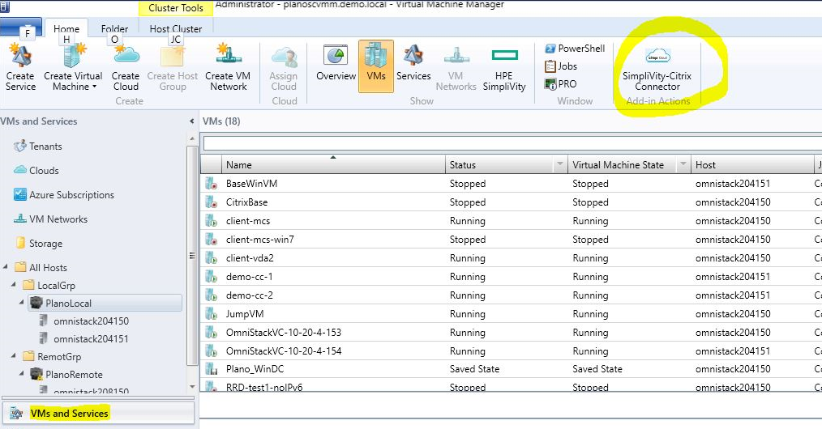

The list of supported operations using this plugin are

1. **Plug(in):** Deploy Citrix Cloud Connector
2. **Plug(out):** Remove Citrix Cloud Connector
3. **Proxy:** Proxy information to access internet
4. **Log:** Logging output of the installation and uninstallation process
5. **Exit:** Exit the Citrix Connector app

Figure 3: HPE SimpliVity Citrix Cloud Connector Plugin

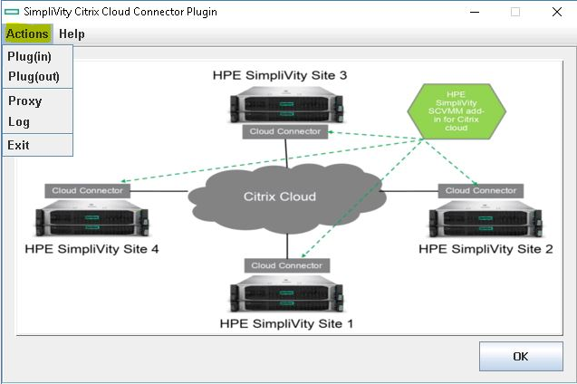

The details of OmniCube controller and SCVMM are requested when the **Plug(in)** or **Plug(out)** is selected for the first time.

Figure 4: Plugin node information

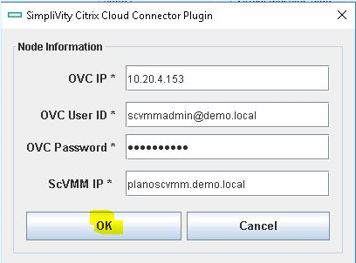

Note

* The username and password for the OmniCube controller and SCVMM Management are the same
* Basic validation of SCVMM and OVC are implemented to check invalid login access

## Configuration

Plugin option is used to deploy virtual machines, join the VMs to active directory (AD) domain, downloads and installs Citrix cloud connector for a resource location. Provide these details of AD domain, Citrix Identity access, and HPE SimpliVity and Microsoft SCVMM information to deploy the virtual machines.

Figure 5: HPE SimpliVity Citrix Cloud Connector Plugin Configuration screen

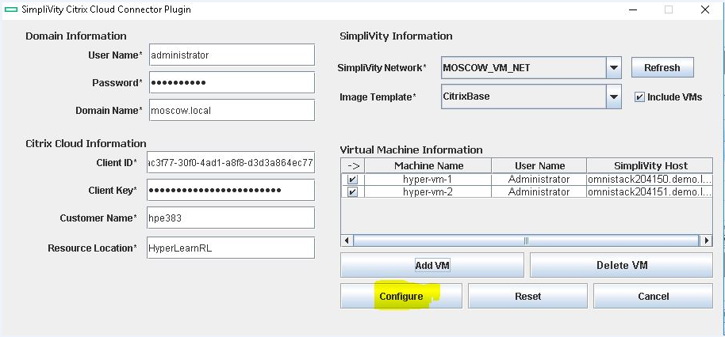

Note

* Kindly check the pre-requisites section for more information of Citrix cloud options
* There is a check box ‘Include VMs’ to display the SimpliVity virtual machines along with SimpliVity template

Ideally there will not be any SimpliVity templates because SCVMM uses Library server (non SimpliVity node) to store templates. Performing SimpliVity clone on templates created on non SimpliVity node will not work. To overcome this problem, include VM check box is provided to deploy Citrix cloud connector VMs from the existing virtual machines.

The virtual machine used for image template should support all the pre-requisites required for the template.

Figure 6: HPE SimpliVity Citrix Cloud Connector Plugin - Virtual Machine Information

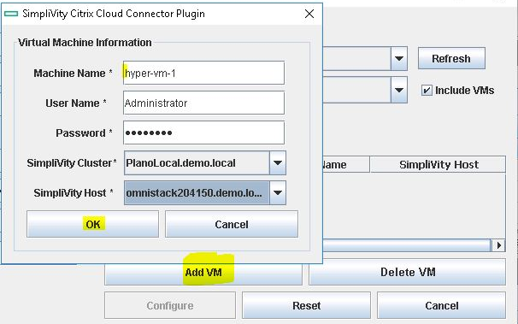

Add the details of Virtual Machine such as name, credentials, host and so on to deploy cloud connector VM.

Use **Add VM** button to deploy multiple VMs with this plugin. Click on ‘Configure’ button to start the Citrix cloud connector process.

Note: The username and password of the VM should be exactly the same as the selected image template. These credentials are used for initial login and VM to AD.

If the installation is successful, all the VMs are deployed and Citrix cloud connector will be installed successfully.

Figure 7: HPE SimpliVity Citrix Cloud Connector Plugin

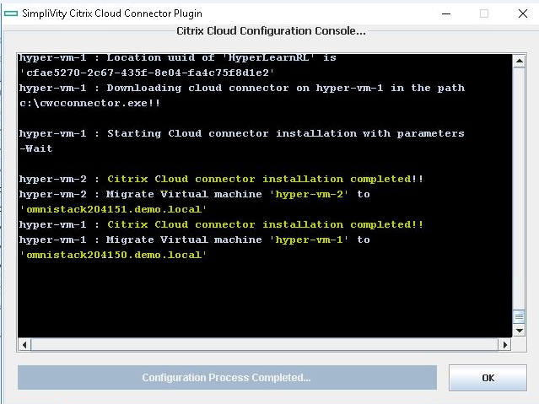

The cloud connector VMs are also visible in the resource location of Citrix cloud portal.

Figure 8: Citrix cloud portal

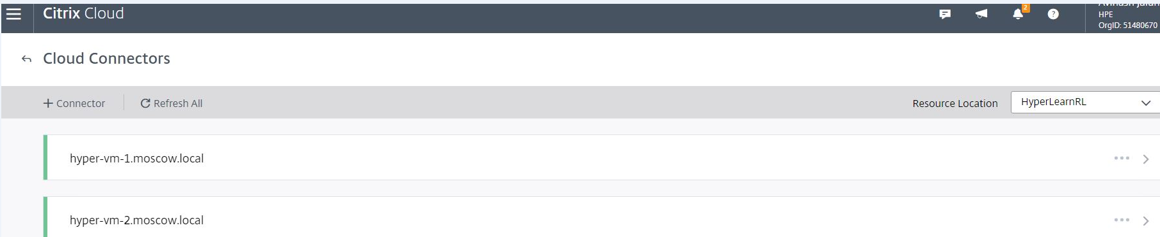

## Deconfigure/Plug(Out)

Using this plugin, the cloud connector of a resource location can be removed, unjoin from domain and delete the virtual machines from SCVMM. To start the de-configure, select the Plug(Out) option in Actions.

1. Select the cloud connector VM to uninstall
2. Enter the password of AD Domain and Virtual Machine and click on Update (other fields are pre populated)
3. Select De-configure option to complete the uninstallation

Figure 9: HPE SimpliVity Citrix Cloud Connector Plugin - Deconfigure

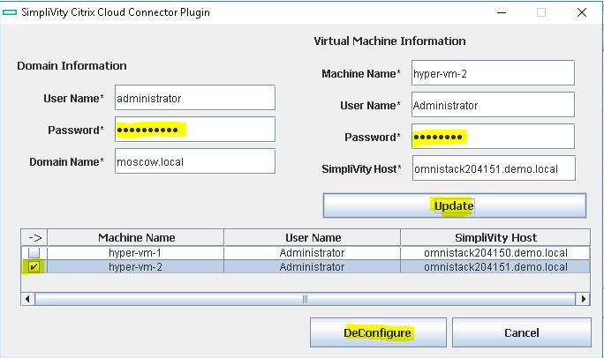

After successful plug out, the selected VM is removed from the Citrix cloud of a resource location.

Figure 10: Successful plug out screen

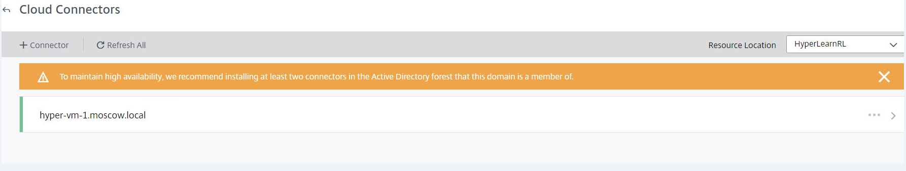

## Logs

The execution and failures of this plugin are logged in a file and is visible from the application. Select **Logs** in the Action section to display all the information. A filter **Error Log** can be used to display only the error logs

Figure 11: HPE SimpliVity Citrix Cloud Connector Plugin - Log screen

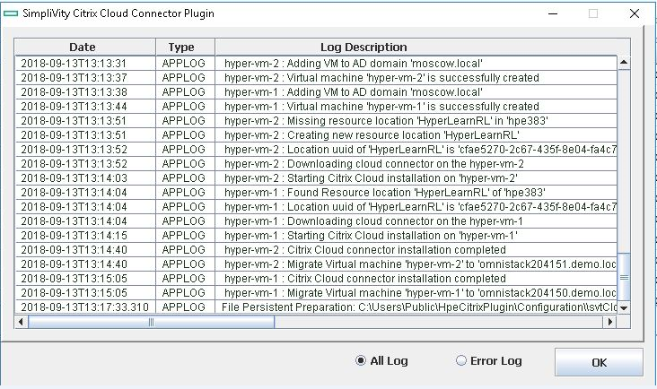

## Proxy

If the datacenter requires proxy to connect to internet, a proxy option has be enabled to access Citrix cloud, download and install Citrix cloud connector of a resource location.

Skip this section, if the environment does not require any proxy to connect to internet.

Figure 12: HPE SimpliVity Citrix Cloud Connector Plugin - Proxy information

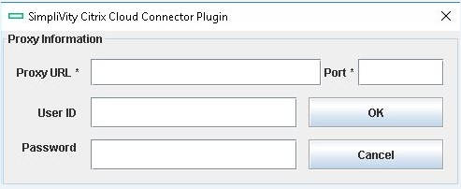

# VMware vSphere - Citrix Cloud Connector plugin

**Prerequisites:**

1. This plugin supports VMware 6.5 flex.
2. Configuration file (input file) need to place under “C:\Users\Public” path.
3. One should create a VM template with external network connectivity.

**Installation prerequisites:**

1. Java ( >1.6 version) has to be installed.
2. Create new login credentials for VMware portal and download vsphere-client-sdk-6.5.0-4602587.
3. To register the plugin follow the instruction from “Getting_Started_with_HTML_Client_SDK” pdf file

**How to register/integrate plugin to vCenter Server:**

vCenter server plug-in registration tool

The SDK includes a tool to help you register your plug-in as a vCenter server extension. It is available in

html-client-sdk\tools\vCenter plugin registration. The prebuilt directory contains the main script extension-registration which lets you register or unregister an extension with the vCenter server of your choice. In addition the tool allows you to update the registration of an existing extension. It uses the default implementation from the local .jar file.

The project directory contains the source code and a build script to recompile extension-registration.jar

You can use this code to extend or customize the existing logic for your own business purpose. Run extension-registration.[sh,bat] from the command line with the following parameters:

● -action - the action to complete: registerPlugin , unregisterPlugin , isPluginRegistered

● -k <key> - unique extension key which should match your plug-in package id

● -url <vc url> - the URL of vCenter server (ending with /sdk ) where your plug-in will be registered.

● -p <vc password> and -u <vc user> - the vCenter server credentials

And also add these parameters for registerPlugin

● -v <version> - the plugin extension version, which should match the version in plugin-package.xml

● -pu <plugin url> - the URL from which the plug-in package .zip will be downloaded.

● -st <thumbprint> - the thumbprint of the server hosting the plug-in package (required when the URL is

https)

./extension-registration.sh -url https://<vCenter Server IP>/sdk -username <Username> -password

<Password> -action registerPlugin -key <Plug-in Key> -version <Plug-in Version> -pluginU rl

https://<Host Location>/<Plug-in Package>.zip -serverThumbprint <Thumbprint Data>

Note: special characters require quoting the word or escaping the character. For instance instead of foo!23 you need to use 'foo!23' or foo\!23

Example:

./extension-registration.sh -url https://10.23.222.35/sdk -username administrator@vsphere.local

-password administrator -action registerPlugin -key com.acme.myplugin -version 1.0.0 -pluginU rl

https://150.20.23.254/MyPluginpackage.zip -serverThumbprin t

99:FD:2B:0D:12:85:37:AA:DA:A0:08:E1:F4:3B:4A:E6:08:AC:49:C D

For help with the full list of parameters run the script without any arguments.

Once the plug-in is registered test that the deployment works correctly from that URL by doing a new login to the HTML client. If the plug-in is not visible check for errors in the Virgo log.

Notes:

● using an http plug-in URL instead of https is ok for development but not recommended for production. It is not secure and requires including the flag allowHttp=true in vSphere Client’s webclient.properties .

● You can review all vCenter extensions with the MOB interface at

https://VC_IP/mob/?moid=ExtensionManager

● To update your plug-in extension info you must first unregister it. If you try to register the same plugin twice you will get the error: A specified parameter was not correct: extension Key

**How to Use:**

Go to Home page click on “SimpliVity Citrix” plugin icon.

Figure 13: HPE SimpliVity Citrix Plugin

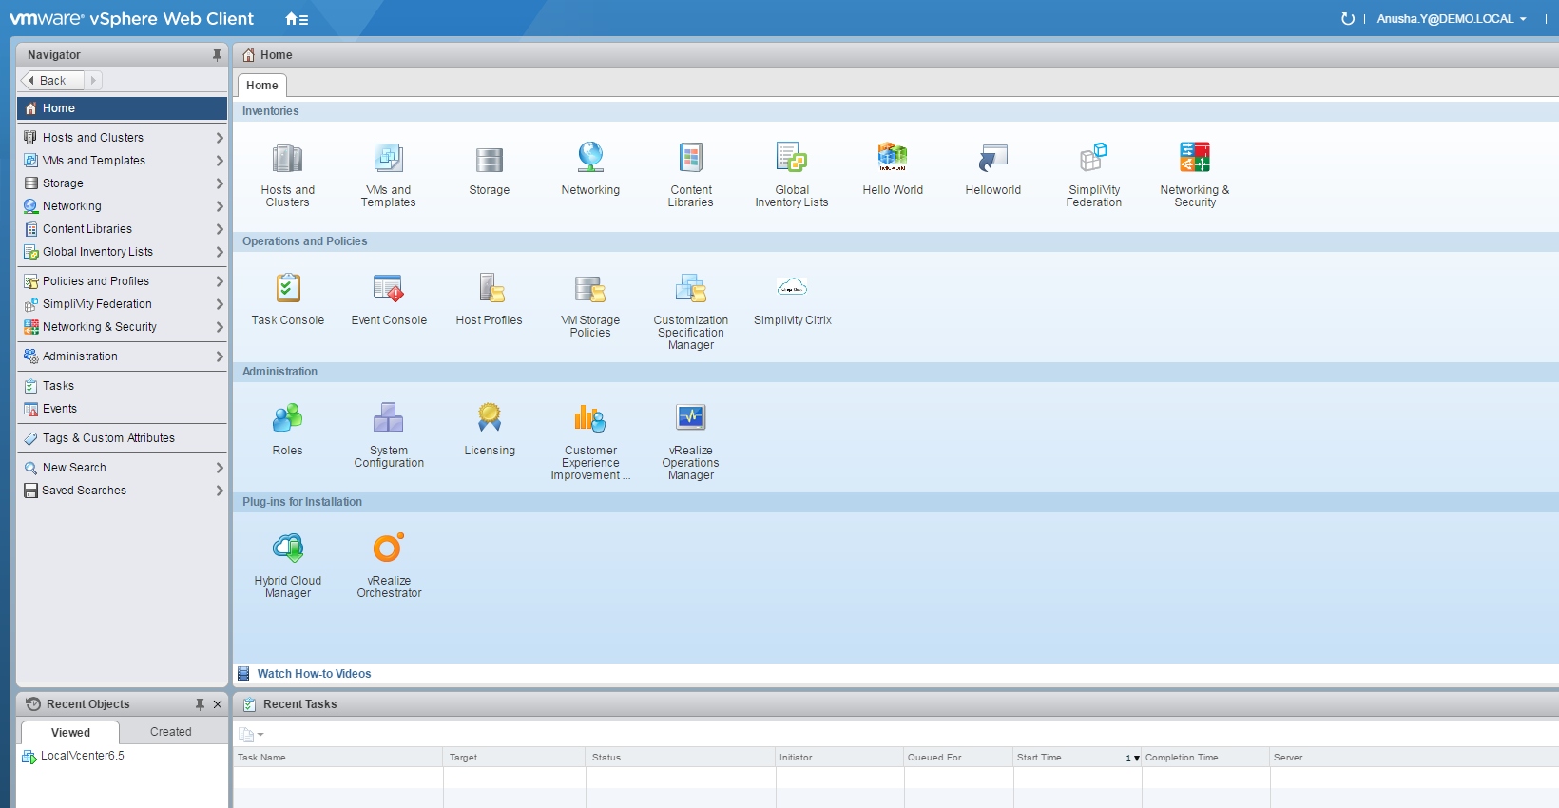

Proxy information page,

If the datacenter requires proxy to connect to internet, a proxy option has be enabled to access Citrix cloud, download and install Citrix cloud connector of a resource location.

Skip this section, if the environment does not require any proxy to connect to internet.

Note: Proxy information is a beta feature in v1.0.

Figure 14: HPE SimpliVity Citrix plugin - Proxy Information

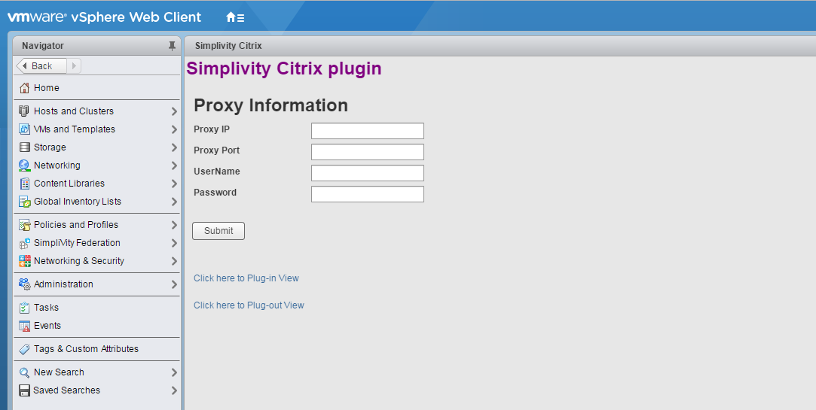

Click on “Click here to plug-in View” page.

**Configure /Plug –in:**

Figure 15: HPE SimpliVity Citrix Plugin Configuration information screen

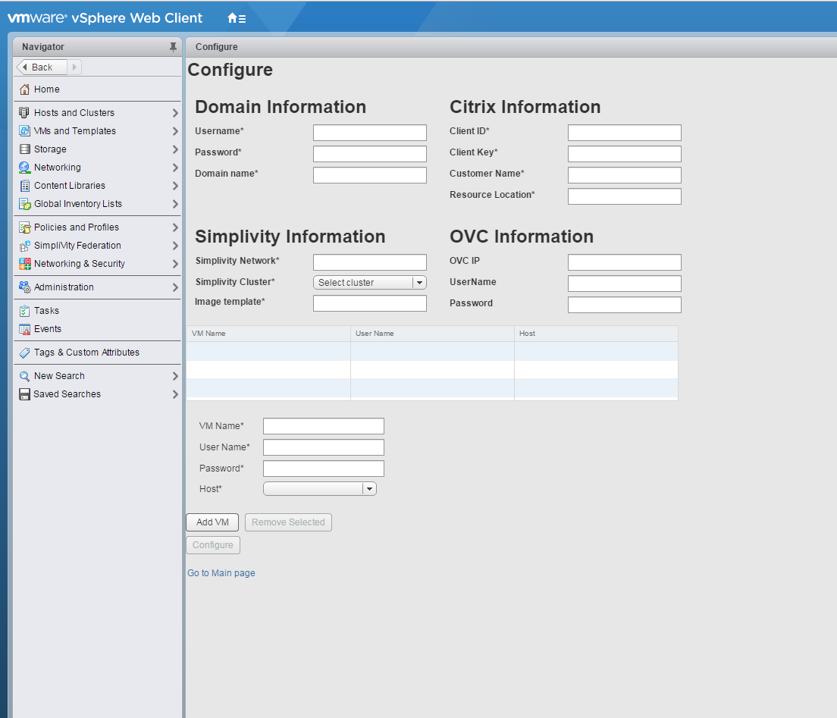

1. Provide the necessary details such as Domain information Citrix information, SimpliVity Information, OVC information.
2. Add the VM details which needs to created (Note : template UserName and Password and VM’s UserName and Password has to be same )
3. Select the host where you want to create the VM.
4. Once you provide all the information click on “Configure” button.

The Cloud connector VMs are visible under resource location of the Citrix cloud portal once the configuration is complete.

Figure 16: HPE SimpliVity Citrix Cloud Connectors

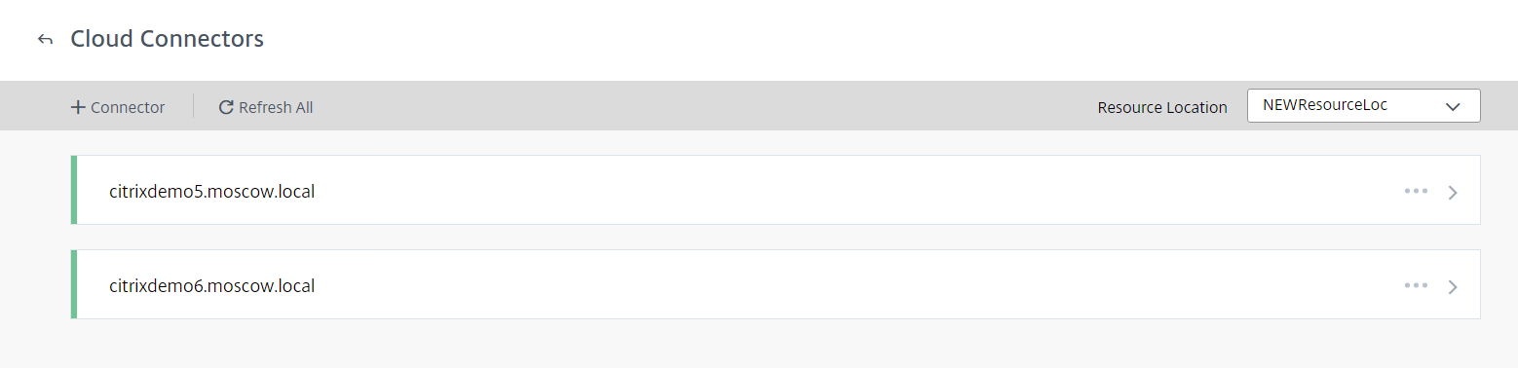

**Deconfigure /Plug –out:** from the main page click on the “Click here to plug-out View” link to navigate to Deconfigure page.

1. Table will list the all the VM’s which were created using this plugin .select the VM which you wanted to deconfigure
2. Provide user name and password for the VM which you wanted to deconfigure.
3. Provide password for the domain under the Domain Information.
4. Once the VM is selected click on Deconfigure button.

Figure 17: HPE SimpliVity Citrix Deconfiguration

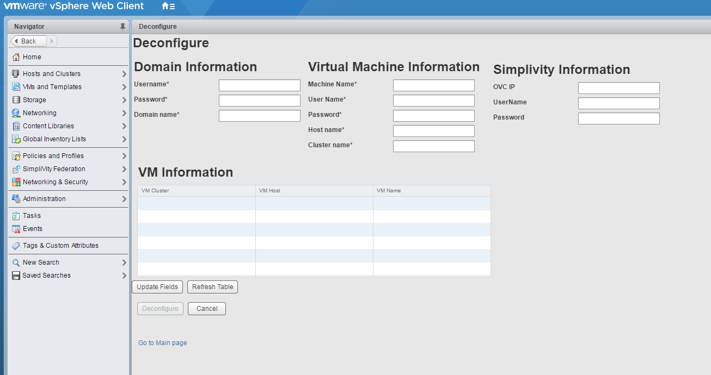

After successful Deconfiguration, the selected VM is removed from the Citrix cloud of a resource location.

Figure 18: HPE SimpliVity Citrix successful deconfiguration

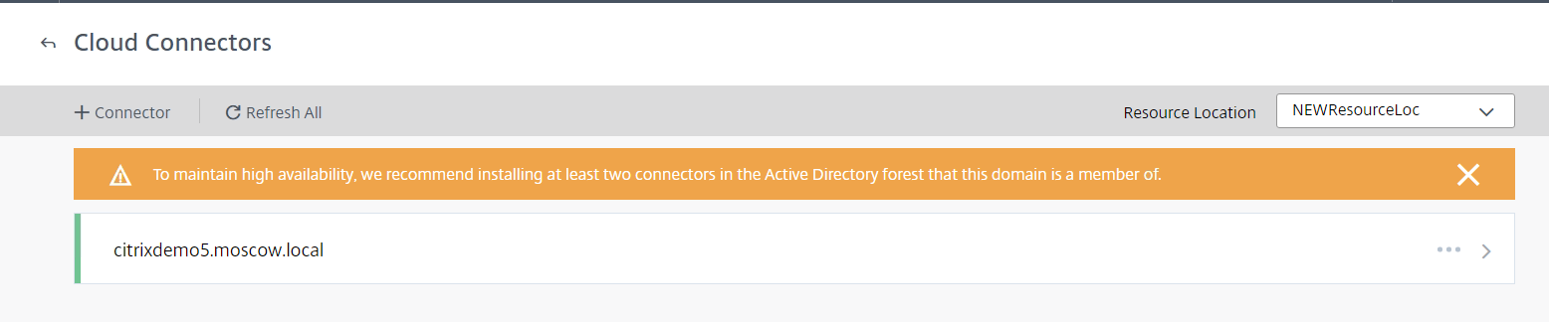

**Log file path:**

C:\\ProgramData\\VMware\\vCenterServer\\logs\\vsphere-client\\logs\\CitrixPluginLog.log

## Glossary

HPE – Hewlett Packard Enterprise

SCVMM - System Center Virtual Machine Manager

OVC – SimpliVity OmniCube Controller

AD – Windows Active Directory

VM – Virtual Machines

# For more information HPE Converged Infrastructure Library

hpe.com/info/convergedinfrastructure

HPE Servers

hpe.com/servers

HPE Storage

hpe.com/storage

HPE Networking

hpe.com/networking

HPE Technology Consulting Services

hpe.com/us/en/services/consulting.html

To help us improve our documents, please provide feedback at hpe.com/contact/feedback.