OCS cluster test cases

1. Enter invalid vault password.



1. Invalid OCP cluster user name:

Example: "OPENSHIFT_USERNAME": "Invalid username"

Expected Result: 6th test case result

1. Invalid OCP cluster password:

Example: "OPENSHIFT_PASSWORD": "Invalid Password"

Expected Result: 6th test case result

1. Invalid OCP cluster domain name:

Example: "OPENSHIFT_DOMAIN": "api.wrong.twentynet.local"

Expected Result: 6th test case result

1. Invalid OCP cluster port number:

Example: "OPENSHIFT_PORT": "64430"

Expected Result: 6th test case result

1. Invalid OCP installation path:

Example: "OPENSHIFT_CLIENT_PATH": "/invalid/oc/installation/path"

Expected Result:

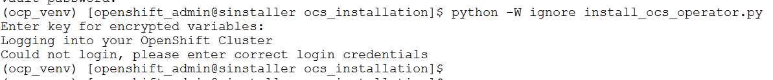

1. All user valid input parameters:

Expected output:

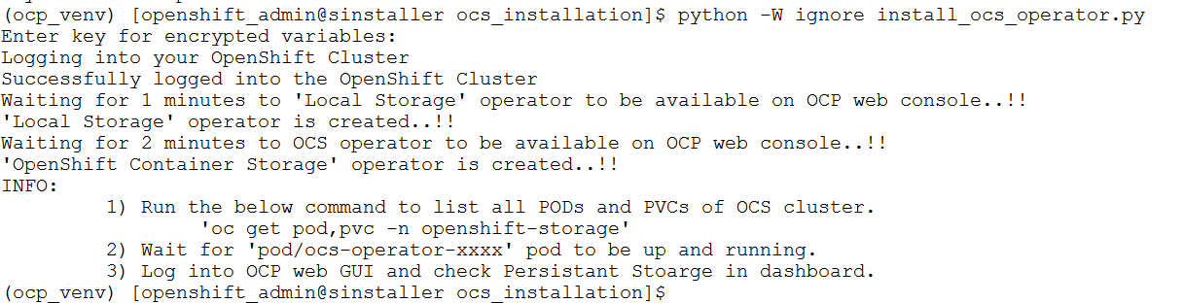

1. Any other than these test scenarios other test scenarios.

Example:

8.1) "LOCAL_STORAGE_VERSION": "4.x" 🡪 Invalid version

8.2) "OPENSHIFT_CONTAINER_STORAGE_VERSION" : “x.x” 🡪 Invalid version

8.3) "OPENSHIFT_CONTAINER_STORAGE_FILESYSTEM_STORAGE": "/dev/invalid/disk/configuration/path"

**Expected Result: OCS cluster can’t be created using three worker nodes**