Facial Expression Detection From Image Using Convolutional Neural Network (CNN)

Mahmudul Hasan
Department of Computer Science and Engineering (DIU)
Dhaka, Bangladesh
mahmudul15-8257@diu.edu.bd

Abstract— In this project i have develop a CNN network to recognize the facial expression and we have use 7 types of facial expression from the ‘cohn-kanade facial expression dataset’. To reduce the overfitting of the models, we utilized different techniques including dropout and batch normalization in addition to RelU
.

Methods
At First I take all the images and convert it into 80x80 px grayscale image and then i am converting all the images data to numpy array and it is saved by the pickle for future uses.
Then for the CNN network we take the Numpy array set and we tried to train our model using these data. The basic CNN structure is as follows:
Convolution -> Pooling -> Convolution -> Pooling -> Fully Connected Layer -> Output

Convolution is the act of taking the original data, and creating feature maps from it. Pooling is down-sampling, most often in the form of "max-pooling," where we select a region, and then take the maximum value in that region, and that becomes the new value for the entire region. Fully Connected Layers are typical neural networks, where all nodes are "fully connected." The convolutional layers are not fully connected like a traditional neural network.

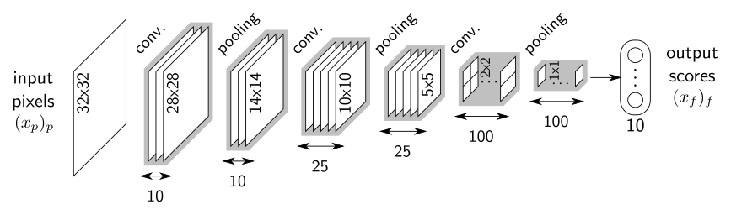
I am using also the sigmoid function that allows the output in between -1 and 1.

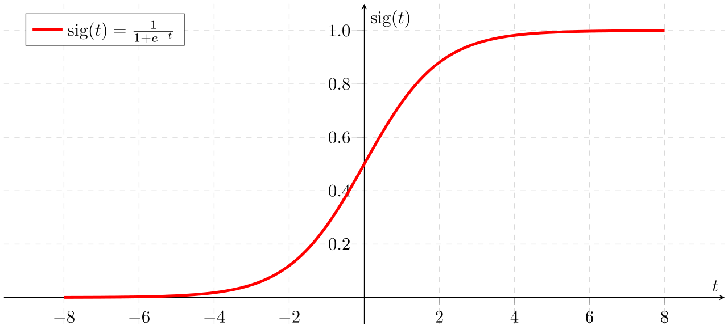

After all the process i am using the tensorboard feature to visualize my train model that is help me to tweaking the model.
Here is the some screenshot of my model from tensorboard

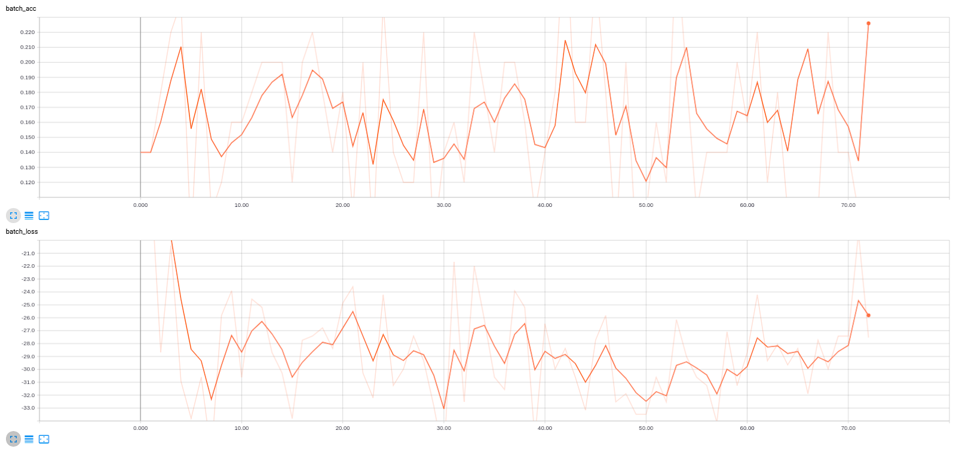

Dataset and features
In this project, we used a dataset provided by “Cohn-Kanade/Cohn-Kanade+”, which consists of about 4025 well-structured 80 × 80 pixel gray-scale images of faces. The images are processed in such a way that the faces are almost centered and each face occupies about the same amount of space in each image.
Each image has to be categorized into one of the seven classes that express different facial emotions. These facial emotions have been categorized as:

categories = ['Angrily Disgusted', 'Annoyed', 'Disgust', 'Fearfully Surprised', 'Happy', 'Surprised']

In addition to the image list number (a number between 0 and 6), the given images are divided into three different sets which are training, validation, and test sets. There are about 4025 training images, 3600 validation images, and 400 images for testing. After reading the raw pixel data, we normalized them by subtracting the mean of the training images from each image including those in the validation and test sets.

results

Epoch 1/1
3622/3622 [================] - 59s 16ms/step -
loss: -28.2492 - acc: 0.1687 - val_loss: -28.9969 - val_acc: 0.1836

I plotted the loss history and the obtained accuracy in these models,
After all things i am not getting the expected outcome at all.
Only 20% accuracy is not enough for a neural network. I will work on it in few days and tweaking and tuning it and accuracy must be increased.

References

- Y. Tian, T. Kanade, and J. Cohn. Recognizing action units for facial expression analysis. IEEE Transactions on Pattern Analysis and Machine Intelligence, 23(2), 2001.

- https://www.kaggle.com/c/challenges-inrepresentation-learning-facial-expressionrecognition-challenge/data

- http://scikit-learn.org/stable/

