**CS3524 Assessment Report**

**Stefan Rudvin 51549217**

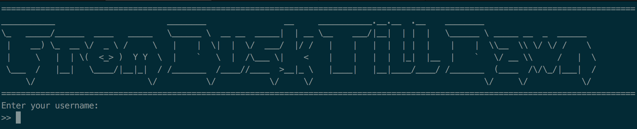A MUD game created using the Java RMI for the course CS3524, Distributed Systems and Security. The submission implements all of the required functionality, as well as extra functionality described in the ‘features’ section. While the source code is available via the included PDFs, the GitHub repository at: <https://github.com/StefanRudvin/DuskTillDawn> is also available.

**Note:** To clear the console, the ASCII code: “\033[H\033[2J" is used. This may not work correctly on windows platforms, so a UNIX terminal is recommended.

**Requirements**

* Java 1.8
* Java RMI
* RmiRegistry

**Instructions**

1. make mud -B
2. rmiregistry 50010
3. java mud.MUDServerMainline 50010 50014
4. java mud.MUDClient [your hostname] 50010

**Features**

CGS D:

* Implemented MUD game server, remote interface with implementation and a server mainline
* User can move in a direction

CGS C:

* User can move to all directions (North/East/South/West)
* User can see other objects and players in the MUD
* User can pick up things in the MUD

CGS B:

* Three instances of MUDs are created on startup
* User is shown all MUDs at startup and has the option of choosing which one to join

CGS A5:

* User can create new MUDs with custom names at runtime with 'createmud'
* Number of total players, number of players per MUD and number of total MUDs is restricted

CGS A4-A1:

* Amount of MUDs created can be changed by a constant in the server (i.e. user can create any number of MUDs)
* User can drop items
* User can see contents of his/her inventory
* User can exit game, which drops his/her items on the ground
* User can see a help menu which shows available commands
* User can see which MUDs are available at any time
* User can create a new MUD while playing the game
* User can change MUD at any time
* User can query total number of players, MUDs and number of players in current MUD during runtime
* Server and client has a polling solution, which times out and exits clients that have quit
* Users are notified when other users exit, are timed out or enter the game
* User can change maximum limits of total players, players per MUD and MUDs at any time

**Game Screen**

