ESP Siesta Clock with Matrix Display
Instructables Publication Draft - Animated Final
2026 by HexOhm
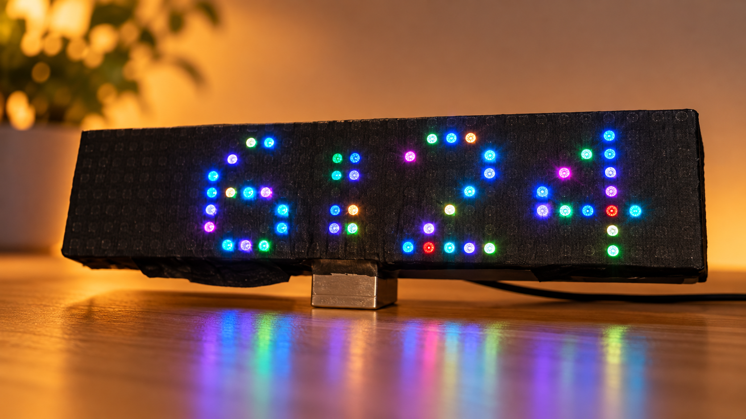

Introduction
The ESP Siesta Clock is a WiFi-assisted RGB matrix clock built around an ESP8266, DS3231 RTC and a 32 x 8 WS2812 matrix. It is designed primarily as a bedside or bedroom clock: bright and colorful when wanted, but exceptionally dark during the configured night period.
It also understands seasonal Siesta quiet hours, weekends and public holidays, while the DS3231 keeps the clock running independently of a permanent Internet connection.

Supplies
Part | Indicative price / note
ESP8266 D1 mini | €3.84
DS3231 RTC | €3.52
SSD1306 OLED | €3.40
32 x 8 WS2812 matrix | €9.11
IR remote + receiver | €1.12; recommended for one build
IR receiver 10-pack | €2.66; optional
Tactile switch | €0.31 / 10 pcs
General-purpose PCB | €0.96 / 2 pcs
USB-C female | €0.13
330 Ω resistor | 1
4.7 kΩ resistors | 2
100 µF electrolytic | 1
1000 µF electrolytic | 1
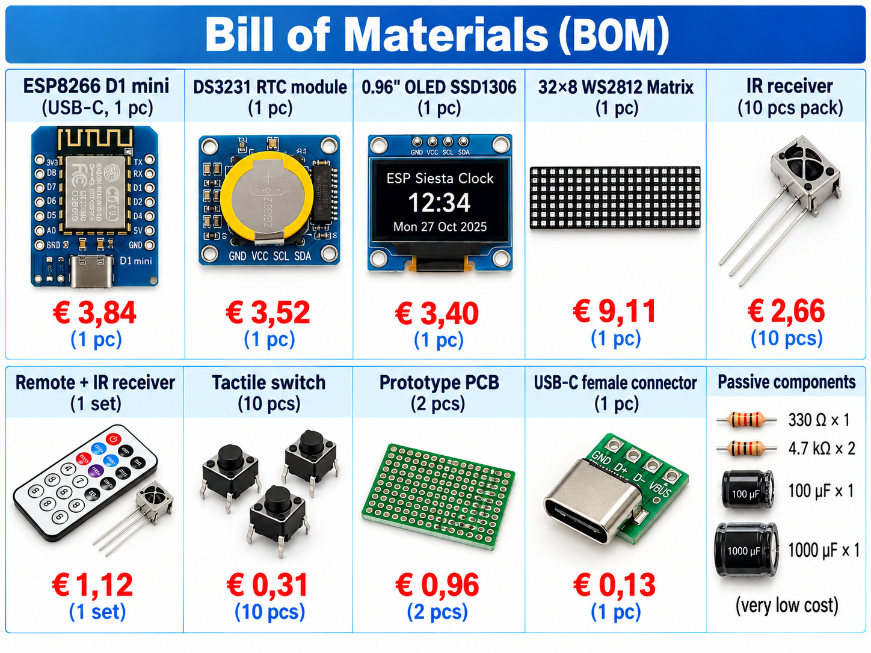

Step 1 - Understand the architecture
The DS3231 is the continuous time source. The OLED and RTC share I2C. The matrix uses D7/GPIO13 through 330 Ω. The IR receiver uses D5/GPIO14. The boot/config button uses D3/GPIO0.
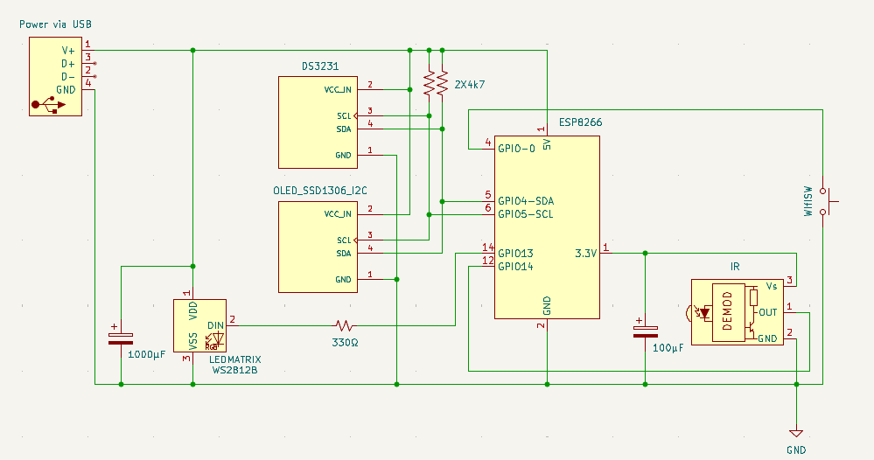

Step 2 - Assemble and inspect the electronics
- Check 5 V polarity and common ground.
- Observe electrolytic capacitor polarity.
- Verify matrix DATA IN direction.
- Verify the exact IR receiver pinout.
- Check SDA/SCL and soldering before applying power.

Step 3 - Firmware and first boot
Use Siesta_WiFi_Clock_HOLIDAYS_WEEKENDS_ANIMATED_FINAL.ino. The final tested file has 8,210 lines, 182,412 bytes and SHA-256 8f3d867dc6df555c29daf55e5889b521067dd3d46866f3558864752d70b486a9.
Required libraries: WiFiManager, NTPClient, Adafruit NeoPixel, U8g2 and RTClib, plus the ESP8266 core headers used by the firmware.
Hold the hardware configuration button during boot to start AutoConnectAP; connect and open 192.168.4.1.

Step 4 - Night Mode and Siesta
Night Mode is the brightness authority and forces the matrix to its minimum brightness during the configured interval.
Season | Day quiet period | Night quiet period | Dates
Summer | 15:00-17:30 | 23:00-07:00 | 01/04-30/09
Winter | 15:30-17:30 | 22:00-07:30 | 01/10-31/03
The clock intentionally has no simple Siesta Off option. Its purpose is to make the quiet-hour state visible; users who want different behavior can edit the Siesta periods themselves.

Step 5 - Holidays and weekends
Public Holidays, Saturdays and Sundays are independent rules. A matching rule changes only the effective Night Mode end time.

Step 6 - Display modes
- Mono Color - one of 16 fixed colors.
- Solid Color - one generated daily color.
- Colorful - separate daily colors for the digits and accent.
- Funny - fixed per-pixel rainbow-like distribution.
- Animated - the Funny concept in motion: every lit LED smoothly transitions to independently changing colors without a short repeating loop.
- Dynamic - the existing time-dependent dynamic behavior.

Step 7 - Infrared remote control
The original build uses a NEC remote with address 0x00FF. The firmware decodes NEC directly.
Function | Command
MENU | 0x47B8
TEST / Power | 0x45BA
UP | 0x40BF
DOWN | 0x19E6
LEFT | 0x07F8
RIGHT | 0x09F6
ENTER | 0x15EA
BACK | 0x43BC
CANCEL | 0x0DF2
0 | 0x16E9
1 | 0x0CF3
2 | 0x18E7
3 | 0x5EA1
4 | 0x08F7
5 | 0x1CE3
6 | 0x5AA5
7 | 0x42BD
8 | 0x52AD
9 | 0x4AB5

Step 8 - Using a different remote
If you do not have the original remote or the FNRST LCR-P1 tester used during development, load the supplied IR_Remote_Tester.ino temporarily. Press one button at a time and record the reported NEC address and clock-compatible command word, then replace only the corresponding IR constants in your own firmware copy.
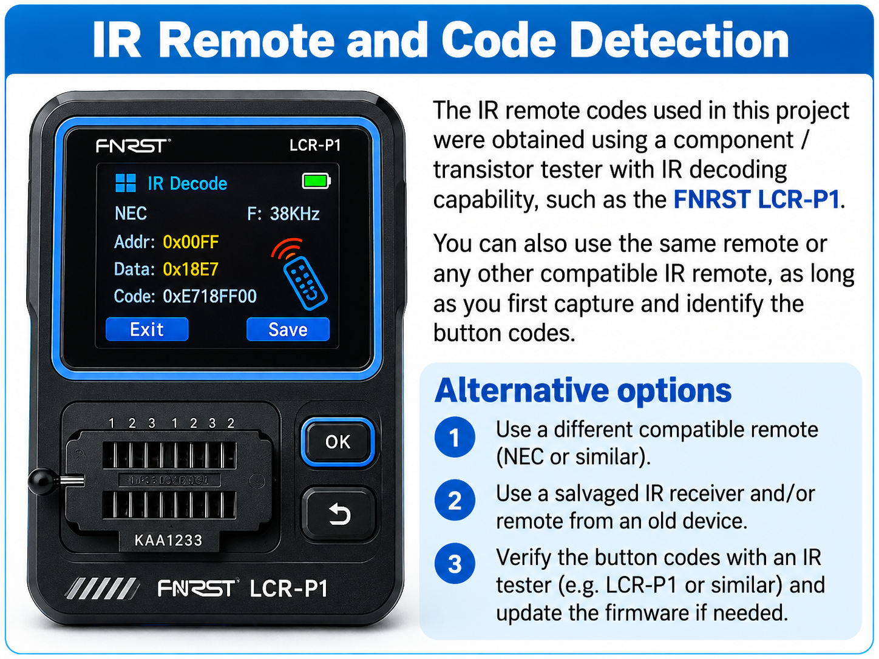

Step 9 - Troubleshooting
Symptom | Check
Matrix dark | 5 V, common ground, DATA IN, 330 Ω, D7/GPIO13
OLED blank | Power, SDA/SCL, D2/D1
Wrong time | DS3231, timezone, SYNC NOW
Remote not responding | Receiver pinout, D5/GPIO14, battery, NEC codes
No WiFi setup | Hold config button during boot and join AutoConnectAP

Step 10 - Demonstration videos
Two short vertical demonstration videos are included with the project. They show the ESP Siesta Clock in a bedside setting and illustrate the sleep-oriented presentation of the project: the colorful clock is shown first, then the room becomes progressively darker as the person goes to bed.
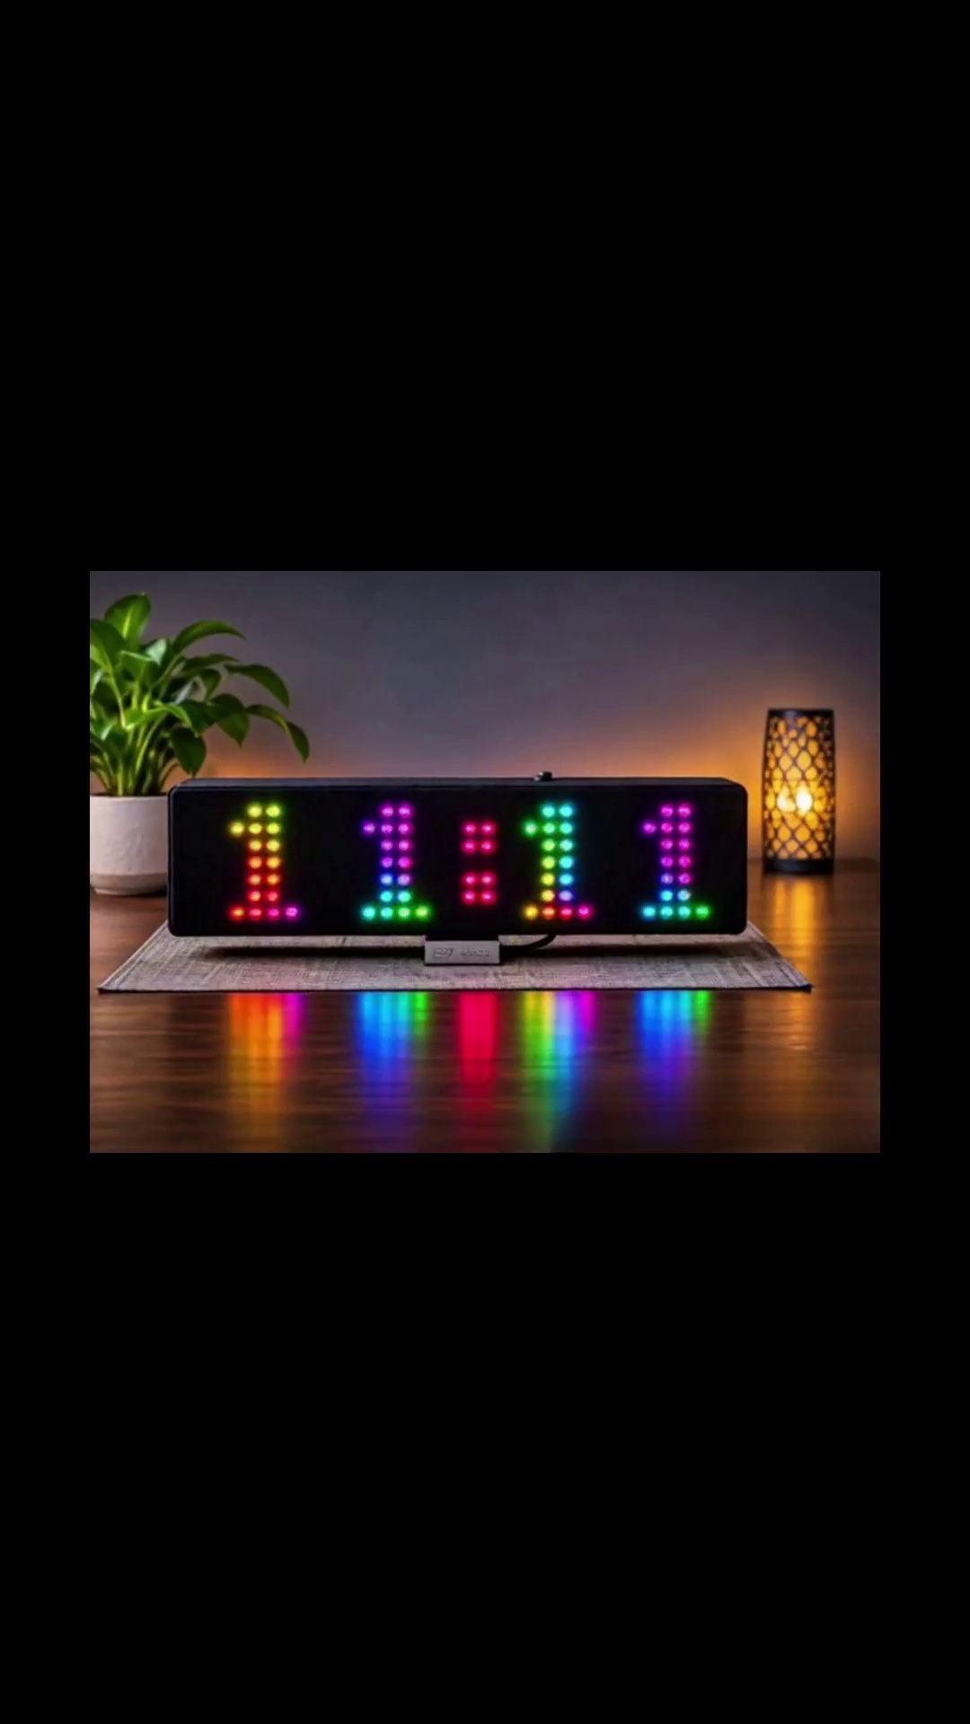
- ESP_Siesta_Clock_Sleep_Promo_FullHD.mp4 - 1080 x 1920, 6.5 seconds.
- ESP_Siesta_Clock_Sleep_Promo_720p.mp4 - 720 x 1280, 6.5 seconds.
The two files contain the same short sequence at different resolutions. Use the version that best suits the publication or hosting platform.

Project files
- Siesta_WiFi_Clock_HOLIDAYS_WEEKENDS_ANIMATED_FINAL.ino
- IR_Remote_Tester.ino
- clock.kicad_sch
- SCHEMATIC_ESP_CLOCK.png
- English and Greek user manuals
- English and Greek technical references
- ESP_Siesta_Clock_Sleep_Promo_FullHD.mp4
- ESP_Siesta_Clock_Sleep_Promo_720p.mp4

Final result
The ESP Siesta Clock combines accurate RTC-first timekeeping, controlled WiFi use, seasonal quiet-hour awareness, holiday/weekend rules, remote control and several display personalities - now including the smoothly animated per-pixel mode.

