ESP Siesta Clock with Matrix Display
Technical Reference - English
2026 by HexOhm

1. System overview
The final firmware is an ESP8266 clock controller integrating a 256-pixel WS2812 display, DS3231 RTC, SSD1306 OLED, direct NEC IR decoder, EEPROM configuration, bounded WiFi/NTP sessions, public-holiday caching, weekend rules and the new Animated daytime color mode.

2. Architecture and pins
Subsystem | Role
ESP8266 | State machine, display, editor, networking and IR decode
DS3231 | Continuous time source
WS2812 32 x 8 | Primary display
SSD1306 128 x 64 | Configuration/status UI
NEC IR | Primary user input
GPIO0 button | Boot-time WiFiManager setup
EEPROM 128 bytes | Persistent settings and holiday cache
Signal | GPIO
WS2812 data | 13 / D7
IR receiver | 14 / D5
Config button | 0 / D3
OLED/RTC SDA | 4 / D2
OLED/RTC SCL | 5 / D1

3. Canonical schematic
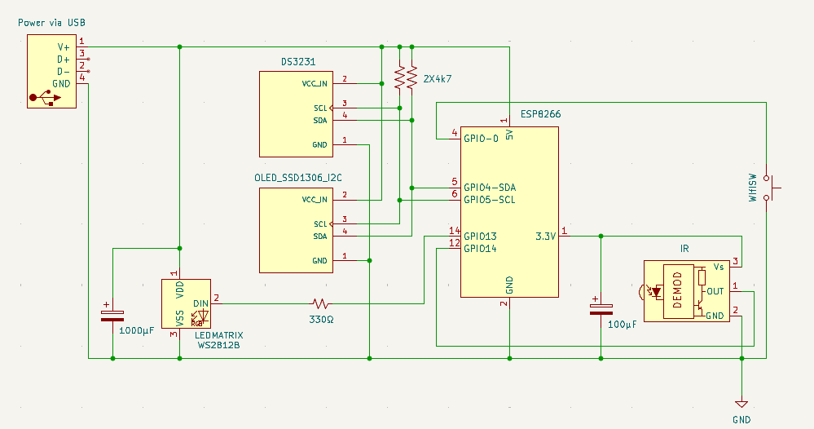

4. Display and brightness
The logical matrix is 32 x 8. Standard digit positions are x=2, 8, 19 and 25 with DIGIT_Y=1. The central breathing separator uses columns 15 and 16. Brightness is 1-30 and fresh-install day brightness is 6. Night Mode remains the final brightness authority.

5. Timekeeping, WiFi and holidays
DS3231 is the continuous time source. Normal boot makes a bounded saved-network connection attempt. If successful, NTP updates the RTC, optional public-holiday data is refreshed, and WiFi is shut down. GPIO0 low at boot enters WiFiManager. AUTOSYNC default is 24 hours.
Country and timezone remain intentionally separate. Holiday rules independently support nationwide Public Holidays, Saturdays and Sundays; a matching rule changes only the effective Night Mode end time.

6. Seasonal Siesta engine
Season | Day | Night | Calendar
Summer | 15:00-17:30 | 23:00-07:00 | 01/04-30/09
Winter | 15:30-17:30 | 22:00-07:30 | 01/10-31/03

7. Color mode engine
Value | Mode | Behavior
0 | MONO | Selected fixed user color
1 | SOLID | One daily generated color
2 | COLORFUL | Separate daily digit/accent colors
3 | FUNNY | Fixed per-pixel palette permutation
4 | DYNAMIC | Existing time-dependent dynamic color behavior
5 | ANIMATED | Per-pixel smooth interpolation toward independently changing pseudo-random palette targets
Animated is inserted in the OLED Multi Color list immediately after Funny and before Dynamic. Dynamic keeps its previous numeric value 4, preserving existing EEPROM selections.
Animated refresh is limited to approximately 25 fps (40 ms) only when the editor is inactive and Animated mode is selected. Each transition segment is 1800 ms and uses smoothstep interpolation. A pixel's next segment starts exactly from its previous target, producing continuous motion without a short repeating sequence.
Existing priority rules remain unchanged: editor purple override, Siesta daytime orange and Night Mode behavior take precedence over normal daytime color modes.

8. EEPROM map
Address | Content
0-3 | Night Mode start/end
4 | Day brightness
5 | Legacy timezone byte
6-9 | Reserved legacy Siesta
10 | Mono color
11 | AUTOSYNC hours
12-14 | Unused
15-16 | Day color mode + magic
17-41 | Seasonal Siesta + magic
42-44 | 12/24, font, display magic
45-46 | OLED language + magic
47 | Country
48 | Holidays master
49-50 | Holiday override HH:MM
51 | Holiday settings magic
52-55 | Holiday cache metadata
56-101 | 366-day holiday bitmap
102-104 | Extended timezone + magic
105 | Holiday rule mask
106 | Holiday rule magic
107-127 | Unused

9. Direct NEC remote
The final firmware keeps the direct NEC decoder and requires no IRremote dependency. The separate IR_Remote_Tester.ino helper intentionally uses Arduino-IRremote only as a temporary diagnostic utility for alternative remotes.

10. Dependencies
- ESP8266WiFi.h
- ESP8266HTTPClient.h
- WiFiClientSecureBearSSL.h
- TZ.h
- WiFiManager.h
- NTPClient.h
- WiFiUdp.h
- Adafruit_NeoPixel.h
- EEPROM.h
- U8g2lib.h
- RTClib.h

11. Source identity
Property | Value
Filename | Siesta_WiFi_Clock_HOLIDAYS_WEEKENDS_ANIMATED_FINAL.ino
Lines | 8,210
Bytes | 182,412
SHA-256 | 8f3d867dc6df555c29daf55e5889b521067dd3d46866f3558864752d70b486a9

