ESP Siesta Clock with Matrix Display
User Manual - English
2026 by HexOhm
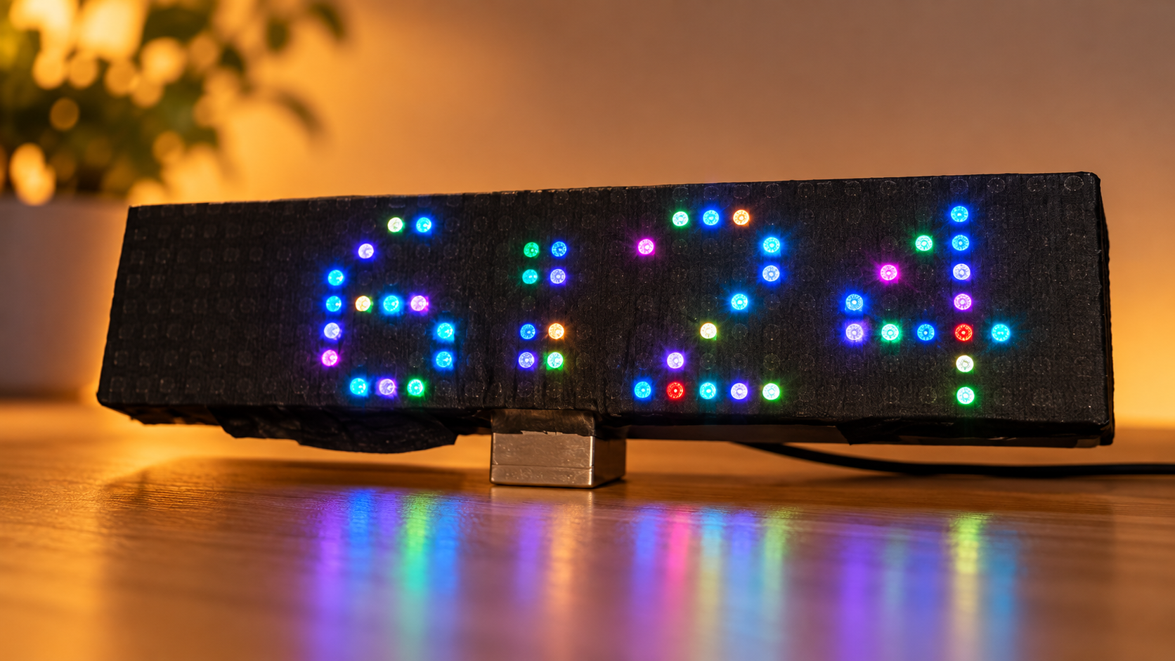

1. What this clock is
The ESP Siesta Clock is a WiFi-assisted RGB matrix clock built for comfortable everyday use, especially at night. The 32 x 8 WS2812 matrix shows the time; a small OLED is used for menus, status and setup. A DS3231 keeps time continuously, so the clock does not depend on a permanent Internet connection.
Its defining feature is its sleep-first behavior: during Night Mode the display brightness is forced to the minimum setting and other display effects are not allowed to make it brighter.
In Greece violating quiet/siesta hours can result in police intervention, fines or legal consequences, so loud music, construction, shouting, etc. should be avoided, and the clock helps remind the user of those hours.

2. Everyday use
- Power the clock normally. It reads its saved settings and DS3231 time.
- If saved WiFi is available, the clock makes a limited connection attempt, synchronizes time, updates the RTC, refreshes public-holiday data when required, and then turns WiFi off.
- If WiFi is unavailable, the clock continues from the DS3231.
- The OLED normally remains off outside setup/status activity; this is normal.

3. Remote control
Key / label | Action
MENU | Open the SIESTA CLOCK editor
+ / UP | Move up or increase a value
- / DOWN | Move down or decrease a value
Previous / << | Move cursor left
Next / >> | Move cursor right
Play / ENTER | Open, toggle, confirm or save
Return arrow / BACK | Go back
C / CANCEL | Cancel / leave an edit
0-9 | Enter time/date digits directly
TEST / Power | Show clock information/status

4. Main menu
Menu item | What it changes
Country | Country used for public-holiday data
Time Zone | Civil-time / DST rule
Time | Manual RTC time
12/24 Hour | Clock display format
Fonts | One of six matrix font styles
Siesta | Summer/Winter quiet-hour schedules
Night Mode | Normal dim start/end
Holidays | Public/Saturday/Sunday override rules
Dimmer | Day brightness, 1-30
AUTOSYNC | Automatic synchronization interval, 1-255 hours
SYNC NOW | Immediate WiFi/NTP/RTC synchronization
Mono Color | Select one of 16 fixed colors
Multi Color | Solid Color, Colorful, Funny, Animated or Dynamic
Language | English or Greek OLED UI

5. Night Mode - the super-dark mode
The default Night Mode is 23:00 to 07:00. During this period the firmware forces brightness to 1. This rule has priority: editor colors and daytime effects cannot raise the brightness while Night Mode is active. Day brightness is adjustable from 1 to 30; the fresh-install default is 6.

6. Holidays and weekends
Turn Holidays On to use Public Holidays, Saturdays, Sundays and an alternative end time. The three date rules are independent. If any selected rule matches today, the configured Holidays time replaces only the normal Night Mode end time. The Night Mode start time and all other clock behavior remain unchanged.

7. Siesta / quiet hours
Season | Day quiet period | Night quiet period | Dates
Summer | 15:00-17:30 | 23:00-07:00 | 01/04-30/09
Winter | 15:30-17:30 | 22:00-07:30 | 01/10-31/03
The Siesta editor uses eight screens. The complete Summer/Winter configuration is validated before it is stored, so an invalid unfinished schedule does not replace the saved configuration.
This clock has deliberately no off for siesta because it beats the cause of existence of this clock. There are billions of clocks out there that just tell the time. If one needs it off there is the siesta editing menu to adjust hours as needed.

8. WiFi setup and synchronization
- Hold the hardware configuration button during boot to configure or replace WiFi credentials.
- Join AutoConnectAP and open 192.168.4.1.
- AUTOSYNC is adjustable from 1 to 255 hours; the internal default is 24 hours.
- SYNC NOW performs an immediate network synchronization. WiFi is shut down again afterwards.

9. Display styles and color modes
- 6 selectable clock font styles.
- 12-hour or 24-hour display.
- 16 mono colors.
- Solid Color: one daily color for the complete time display.
- Colorful: separate daily colors for the four digits and accent.
- Funny: each illuminated LED has its own fixed per-pixel color pattern.
- Animated: Funny-style per-pixel colors continuously and smoothly transition toward independently changing colors. The animation has no short repeating loop.
- Dynamic: the display color evolves with time according to the existing Dynamic behavior.
- A breathing two-column separator sits between hours and minutes.

10. Using another NEC remote
The original remote is not mandatory. The supplied IR_Remote_Tester.ino can be loaded temporarily on the ESP8266 to identify a compatible NEC remote. It prints protocol, address, command and the 16-bit address/command words used by this project, allowing the corresponding firmware constants to be replaced in the builder's own copy.
Function | Command
MENU | 0x47B8
TEST / Power | 0x45BA
UP | 0x40BF
DOWN | 0x19E6
LEFT | 0x07F8
RIGHT | 0x09F6
ENTER | 0x15EA
BACK | 0x43BC
CANCEL | 0x0DF2
0 | 0x16E9
1 | 0x0CF3
2 | 0x18E7
3 | 0x5EA1
4 | 0x08F7
5 | 0x1CE3
6 | 0x5AA5
7 | 0x42BD
8 | 0x52AD
9 | 0x4AB5

11. Firmware identity
Property | Value
Filename | Siesta_WiFi_Clock_HOLIDAYS_WEEKENDS_ANIMATED_FINAL.ino
Lines | 8,210
Bytes | 182,412
SHA-256 | 8f3d867dc6df555c29daf55e5889b521067dd3d46866f3558864752d70b486a9

