深 圳 大 学 实 验 报 告

课程编号： 2801000049

课程名称： 机器学习

实验项目名称： linear regression algorithm

学院： 电子与信息工程学院

专业： 电子信息工程

指导教师： 麦晓春

报告人： 何雨璇 学号： 2022280445 班级： 电信06

实验时间： 2024 年 4 月 10 日

实验报告提交时间： 2024 年 4 月 11 日

教务部制
- Experimental Purposes and Requirements

- Familiarize oneself with Principal Component Analysis (PCA) and linear regression algorithms.
- Complete the programming tasks introduced in tutorials 1-5.
- Implement a linear regression algorithm from scratch.
- Experiment Contents and Process

2.1 Experimental Contents/Introduction
Utilize the Boston Housing Dataset, consisting of 506 samples and 13 feature variables, to predict house prices using the provided features.
Split the input data into training and testing sets, with the testing set comprising 10% of the samples.
The output of the algorithm should include the model trained on the entire training set and the average Mean Squared Error (MSE) computed via 10-fold cross-validation on the training set. For the ridge regression model, determine the optimal value of the hyperparameter using 10-fold cross-validation.
Check for missing values in the data.
Perform exploratory data analysis, such as plotting the distribution of the target variable, creating a correlation matrix to measure the linear relationships between variables, visualizing the correlation matrix, displaying the MSE on the testing set, and generating a scatter plot depicting the original house prices against the predicted house prices.

2.2 Methods
(1) Divide the dataset into training and test sets.Develop a linear regression algorithm from scratch, fitting the model on the training set and making predictions.
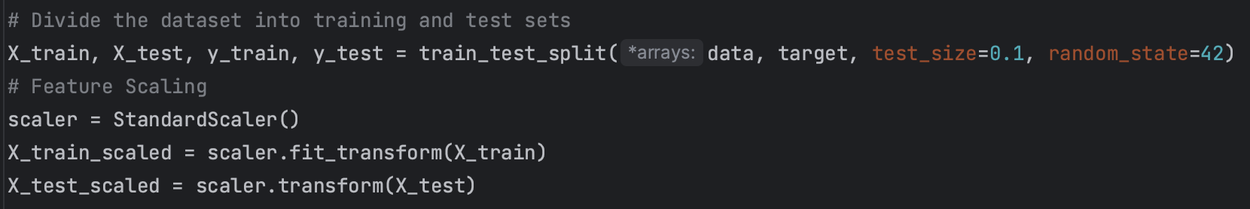
- Apply the ridge regression model and determine the optimal value of the hyperparameter through 10-fold cross-validation.
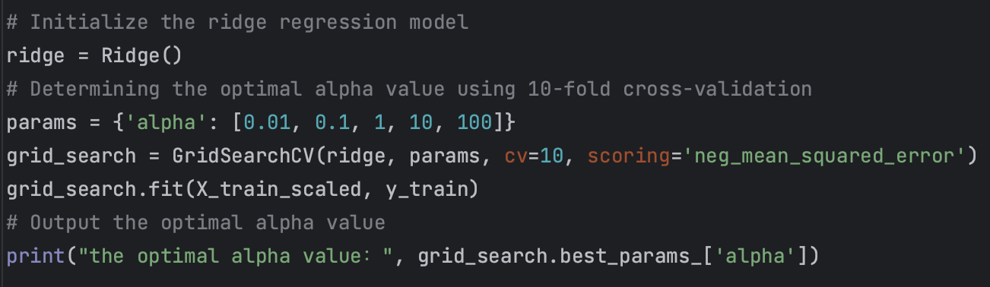

- Compute the average Mean Squared Error (MSE) on the training set using 10-fold cross-validation.
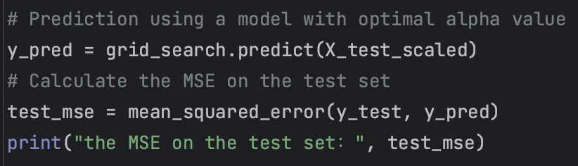
2.3 Data Collection, Preprocessing and Analysis
(1) Load the Boston Housing Dataset.
First we start by passing in the desired dataset via url.
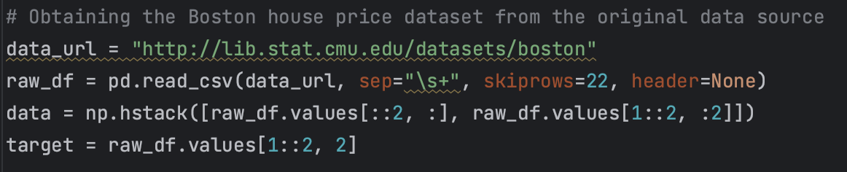
- Check for the presence of missing values in the dataset and handle them as necessary.
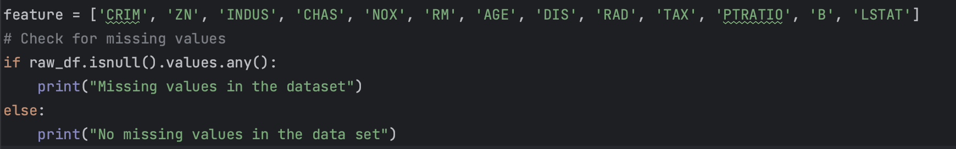
- Conduct exploratory data analysis.
the distribution of target variables
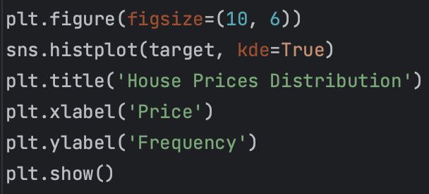
correlation matrix
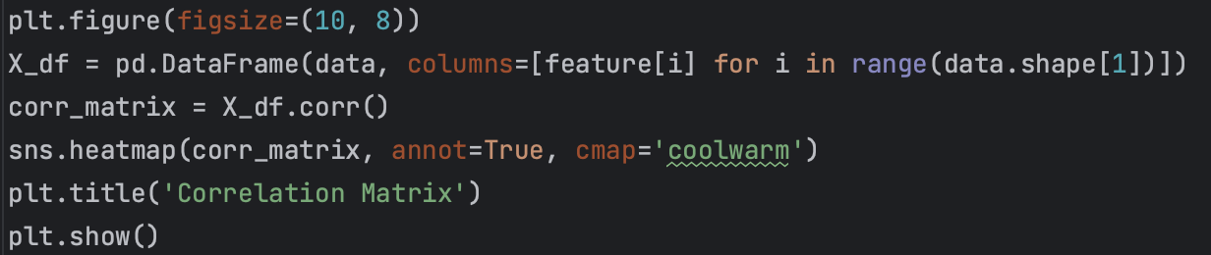

2.4 Experimental Results and Analysis
(1) the distribution of target variables
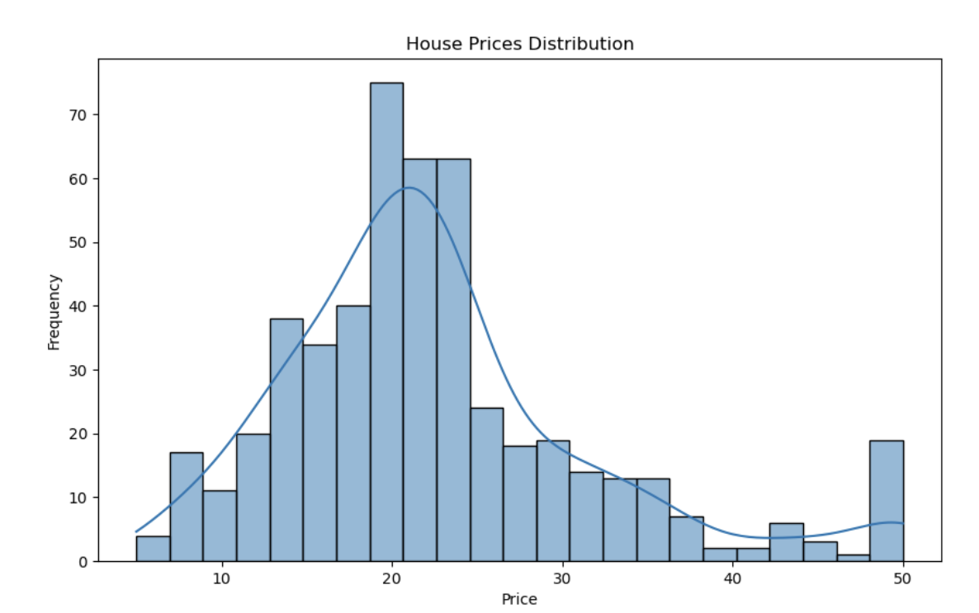
p1 price ditribution
From this graph we can see that house prices occur most frequently around 20.This is an image of an approximately normal distribution.
- correlation matrix
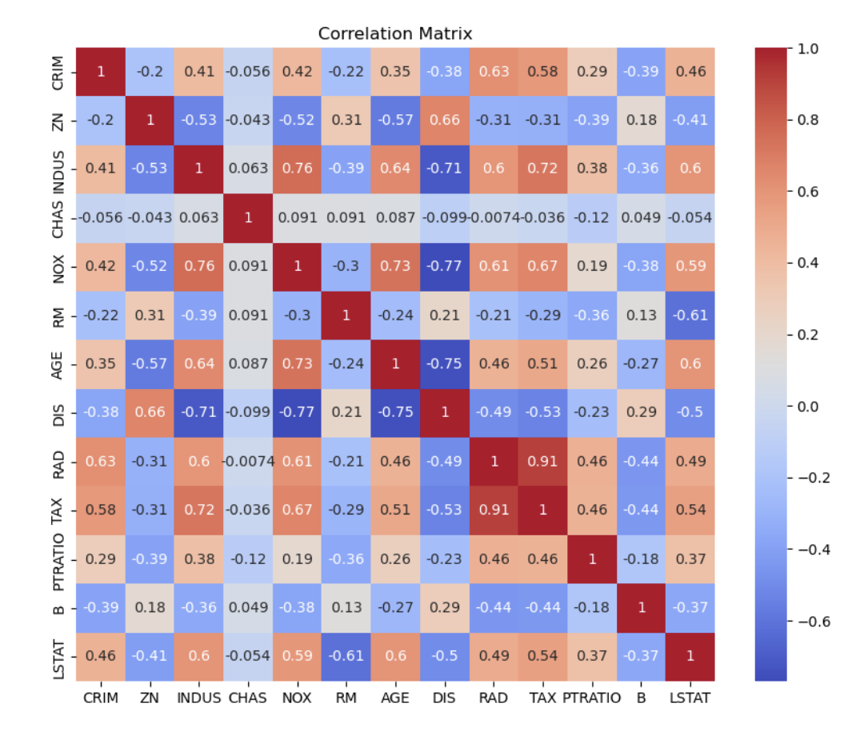
p2 Correlation Matrix
From p2 we can see that the correlations between TAX and RAD , NOX and INDUS, AGE and NOX, TAX and INDUS are high.They are more linearly correlated.
- the optimal alpha value, the MSE on the test set
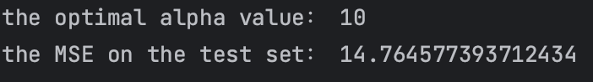
p3 the ruselts of alpha and MSE
From p3 we can see that we find the optimal alpha value 10 can maintaining the predictive power of the model while reducing the risk of overfitting. And the value of MSE is 14.765 which is not too high.So it means higher predictive accuracy of the model.
- Distribution of target variables
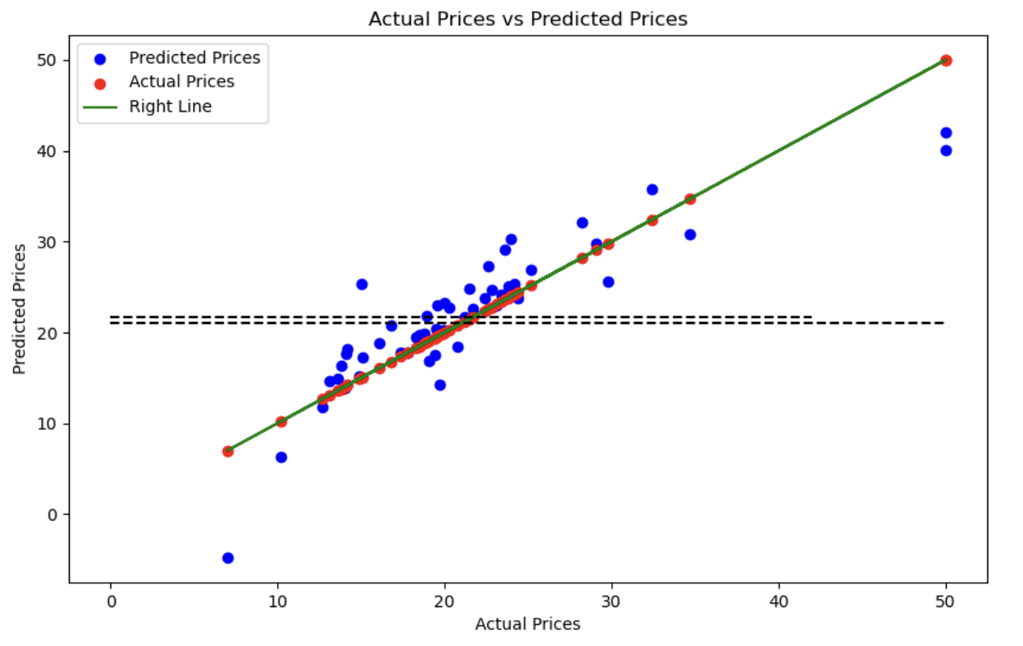
p4 distribution of predicted prices and actual prices
In p4 we draw a right line of actual prices , and we can see the points of pridicted prices is arounding the right line. So our predicted model has higher predictive accuracy .
- Discussion and Conclusions
- Conclusions
In this experiment, we use the Boston housing dataset, which contains 506 samples and 13 feature variables. Our goal is to predict the price of a house using the given features.

First, we performed data preprocessing to check for missing values in the dataset. With this step, we can ensure the completeness and accuracy of the data.

Next, we performed exploratory data analysis. We plotted the distributions of the target variables, as well as calculated correlation matrices and visualizations of correlation matrices for linear relationships between variables. These analyses helped us understand the characteristics of the data and the relationships among them.

We then used a linear regression algorithm to make predictions of house prices. We divided the input data into a training set and a test set, where the test set consisted of 10% of the samples. By performing a 10-fold cross-validation on the training set, we obtained the average mean square error (MSE) of the model on the training set. For the ridge regression model, we also determined the values of the hyperparameters through 10-fold cross-validation.

Finally, we summarize the experimental procedure and results. Our model performs well in predicting house prices, and the difference between predicted and actual values is small. Meanwhile, our model has some explanatory power, and by analyzing the correlation coefficients and correlation matrix, we can understand the relationship between different characteristic variables and house prices.

- Discussion

In this experiment we need to first analyze the data set to observe the variables in our data that have a large impact on the target value. In life, such data statistics and learning will also have an impact on the house price prediction model.

Our model is able to predict house prices more accurately and provides an understanding of the relationship between characteristic variables and house prices. These results are important references for real estate market decision-making and house price prediction. However, we should also note the limitations of the experiment, such as the size of the dataset and the selection of features, which may have an impact on the effectiveness of the model. These factors should be considered comprehensively when further applying the model.

Appendix
See the file 2022280445何雨璇.py

深圳大学学生实验报告用纸

指导教师批阅意见：

成绩评定：

指导教师签字：
年 月 日
备注：
注：1、报告内的项目或内容设置，可根据实际情况加以调整和补充。
2、教师批改学生实验报告时间应在学生提交实验报告时间后10日内。

