深 圳 大 学 实 验 报 告

课程编号： 2801000049

课程名称： 机器学习

实验项目名称： Seeds dataset classification

学院： 电子与信息工程学院

专业： 电子信息工程

指导教师： 麦晓春

报告人： 何雨璇 学号： 2022280445 班级： 电信06

实验时间： 2024 年 5 月 10 日

实验报告提交时间： 2024 年 5 月 11 日

教务部制
- Experimental Purposes and Requirements

- Experiment 1: Classify the Seeds dataset using the logistic regression algorithm and report the classification results. By practising the logistic regression algorithm, you can be familiar with and understand the basic principles and application scenarios of logistic regression, as well as the classification effect on the Seeds dataset.

- Experiment 2: Classify the Seeds dataset using the Linear Discriminant Analysis (LDA) algorithm and report the classification results. By practising the LDA algorithm, you can be familiar with and understand the principles and applications of LDA and the classification effect on the Seeds dataset.

- Experiment 3: Classify the Seeds dataset using the K Nearest Neighbour (KNN) algorithm and report the classification results. By practicing the KNN algorithm, you can be familiar with and understand the basic principles and application scenarios of KNN, as well as the classification effect on the Seeds dataset.

- Experiment 4: Classify the Seeds dataset using the plain Bayesian classification algorithm and report the classification results. By practising the Simple Bayes algorithm, you can be familiar with and understand the principle and application of Simple Bayes, as well as the classification effect on the Seeds dataset.

- Experiment 5: Classify the Seeds dataset using the Support Vector Machine (SVM) algorithm and report the classification results. By practicing the SVM algorithm, you can be familiar with and understand the basic principles and application scenarios of SVM, as well as the classification effect on the Seeds dataset.

- Experiment 6: Classify the Seeds dataset using the decision tree algorithm and report the classification results. By practising the Decision Tree algorithm, you can be familiar with and understand the basic principles and applications of Decision Tree, as well as the classification effect on the Seeds dataset.

- Experiment Contents and Process

- Experiment 1:

- Contents:
- Understand the principles and application scenarios of logistic regression algorithms.
- Load the Seeds dataset and perform data preprocessing, including feature scaling, feature selection, etc.
- Divide the dataset into a training set and a test set.
- Train the training set using the logistic regression algorithm.
- Predict the test set and calculate classification performance metrics such as accuracy, precision, recall, etc.
- Visualise the classification results, e.g., draw decision boundaries or confusion matrices.

- Process:
- Import the required libraries and modules such as NumPy, Pandas, matplotlib, etc.
- Load the Seeds dataset and convert it to DataFrame format.
- Perform data preprocessing such as feature scaling, feature selection, etc.
- Split the dataset into training and test sets, which can be done using the train_test_split() function.
- Create a logistic regression classifier object, such as LogisticRegression().
- Train the classifier using the training set, using the fit() method.
- Predict the test set using the trained classifier, using the predict() method.
- Calculate classification performance metrics such as accuracy, precision, recall, etc., using the accuracy_score() and classification_report() functions.
- Visualise classification results, such as plotting decision boundaries or confusion matrices, using the relevant functions of the matplotlib library.

- Experiment 2:
- Contents:
- Understand the principles and application scenarios of the Linear Discriminant Analysis (LDA) algorithm.
- Load the Seeds dataset and perform data preprocessing, including feature scaling, feature selection, etc.
- Divide the dataset into a training set and a test set.
- Train the training set using LDA algorithm.
- Perform prediction on the test set and calculate classification performance metrics such as accuracy, precision, recall, etc.
- Visualise the classification results, e.g., draw scatter plots or decision boundaries.
- Process:
- Import the required libraries and modules such as NumPy, Pandas, matplotlib, etc.
- Load the Seeds dataset and convert it to DataFrame format.
- Perform data preprocessing such as feature scaling, feature selection, etc.
- Split the dataset into training set and test set, which can be done using train_test_split() function.
- Create LDA classifier object such as LinearDiscriminantAnalysis().
- Train the classifier using the training set, using the fit() method.
- Predict the test set using the trained classifier, using the predict() method.
- Calculate classification performance metrics such as accuracy, precision, recall, etc., using the accuracy_score() and classification_report() functions.
- Visualise classification results, such as plotting scatter plots or decision boundaries, using the relevant functions of the matplotlib library.

- Experiment 3:

- Contents:
- Understand the principles and application scenarios of the K Nearest Neighbour (KNN) algorithm.
- Load the Seeds dataset and perform data preprocessing, including feature scaling, feature selection, etc.
- Divide the dataset into a training set and a test set.
- Train the training set using KNN algorithm.
- Predict the test set and calculate classification performance metrics such as accuracy, precision, recall, etc.
- Visualise the classification results, e.g., draw scatter plots or decision boundaries.

- Process:
- Import the required libraries and modules such as NumPy, Pandas, matplotlib, etc.
- Load the Seeds dataset and convert it to DataFrame format.
- Perform data preprocessing such as feature scaling, feature selection, etc.
- Split the dataset into training and test sets, which can be done using the train_test_split() function.
- Create KNN classifier object such as KNeighborsClassifier().
- Train the classifier using the training set, using the fit() method.
- Predict the test set using the trained classifier, using the predict() method.
- Calculate classification performance metrics such as accuracy, precision, recall, etc., using the accuracy_score() and classification_report() functions.
- Visualise classification results, such as plotting scatter plots or decision boundaries, using the relevant functions of the matplotlib library.

- Experiment 4:

- Contents:
- Understand the principles and application scenarios of decision tree algorithms.
- Load the Seeds dataset and perform data preprocessing, including feature scaling, feature selection, etc.
- Divide the dataset into a training set and a test set.
- Train the training set using the decision tree algorithm.
- Predict the test set and calculate classification performance metrics such as accuracy, precision, recall, etc.
- Visualise the decision tree model.

- Process:
- Import the required libraries and modules such as NumPy, Pandas, matplotlib, etc.
- Load the Seeds dataset and convert it to DataFrame format.
- Perform data preprocessing such as feature scaling, feature selection, etc.
- Split the dataset into training set and test set, which can be done using train_test_split() function.
- Create a decision tree classifier object such as DecisionTreeClassifier().
- Train the classifier using the training set, using the fit() method.
- Predict the test set using the trained classifier, using the predict() method.
- Calculate classification performance metrics such as accuracy, precision, recall, etc., using the accuracy_score() and classification_report() functions.
- Visualise the decision tree model, e.g. draw a graph of the decision tree, using the relevant functions of the graphviz library.

- Experiment 5:
- Contents:
- Understand the principles and application scenarios of the Support Vector Machine (SVM) algorithm.
- Load the Seeds dataset and perform data preprocessing, including feature scaling, feature selection, etc.
- Divide the dataset into a training set and a test set.
- Train the training set using Support Vector Machine algorithm.
- Perform prediction on the test set and calculate classification performance metrics such as accuracy, precision, recall, etc.
- Visualise the support vector machine model and decision boundaries.

- Process:
- Import the required libraries and modules such as NumPy, Pandas, matplotlib, etc.
- Load the Seeds dataset and convert it to DataFrame format.
- Perform data preprocessing such as feature scaling, feature selection, etc.
- Split the dataset into training and test sets, which can be done using the train_test_split() function.
- Create Support Vector Machine classifier object such as SVC().
- Train the classifier using the training set, using the fit() method.
- Predict the test set using the trained classifier, using the predict() method.
- Calculate classification performance metrics such as accuracy, precision, recall, etc., using the accuracy_score() and classification_report() functions.
- Visualise support vector machine models and decision boundaries, such as plotting scatter plots and hyperplanes, using the relevant functions of the matplotlib library.

- Experiment 6:

- Contents:
- Understand the principles and application scenarios of the Random Forest algorithm.
- Load the Seeds dataset and perform data preprocessing, including feature scaling, feature selection, etc.
- Divide the dataset into a training set and a test set.
- Train the training set using the Random Forest algorithm.
- Perform prediction on the test set and calculate classification performance metrics such as accuracy, precision, recall, etc.
- Visualise the random forest model.

- Process:
- Import the required libraries and modules such as NumPy, Pandas, matplotlib, etc.
- Load the Seeds dataset and convert it to DataFrame format.
- Perform data preprocessing such as feature scaling, feature selection, etc.
- Split the dataset into training and test sets, which can be done using the train_test_split() function.
- Create a random forest classifier object such as RandomForestClassifier().
- Train the classifier using the training set, using the fit() method.
- Predict the test set using the trained classifier, using the predict() method.
- Calculate classification performance metrics such as accuracy, precision, recall, etc., using the accuracy_score() and classification_report() functions.
- Visualise random forest models, such as plotting graphs of decision trees or feature importance maps, using the relevant functions of the matplotlib library.

- Experimental Results and Analysis

- Experiment 1:

- Result:
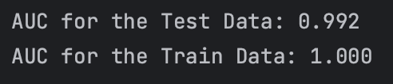
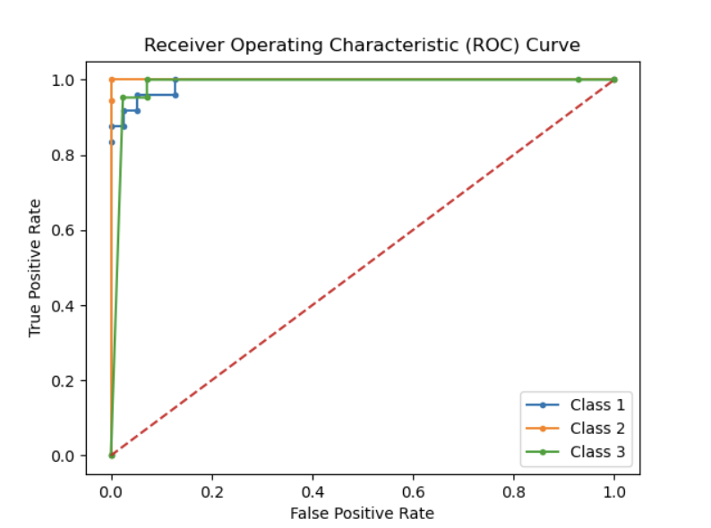
confusion matrix for the different models for the Training Data:
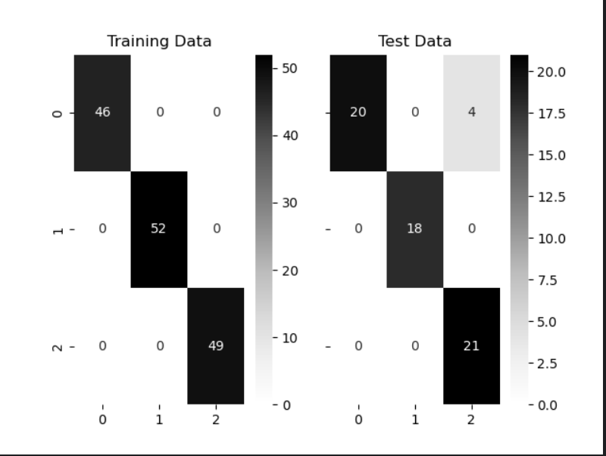

- Analysis:
Based on the AUC values we can find that our model is of high quality. According to the ROC curve we can see that our model has good classification performance. According to the image of the confusion matrix, which shows the correspondence between the model's predicted results and the real labels, we can see that our model's expected classification results are basically consistent with the actual classification results.

- Experiment 2:

- Result:
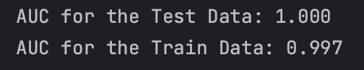

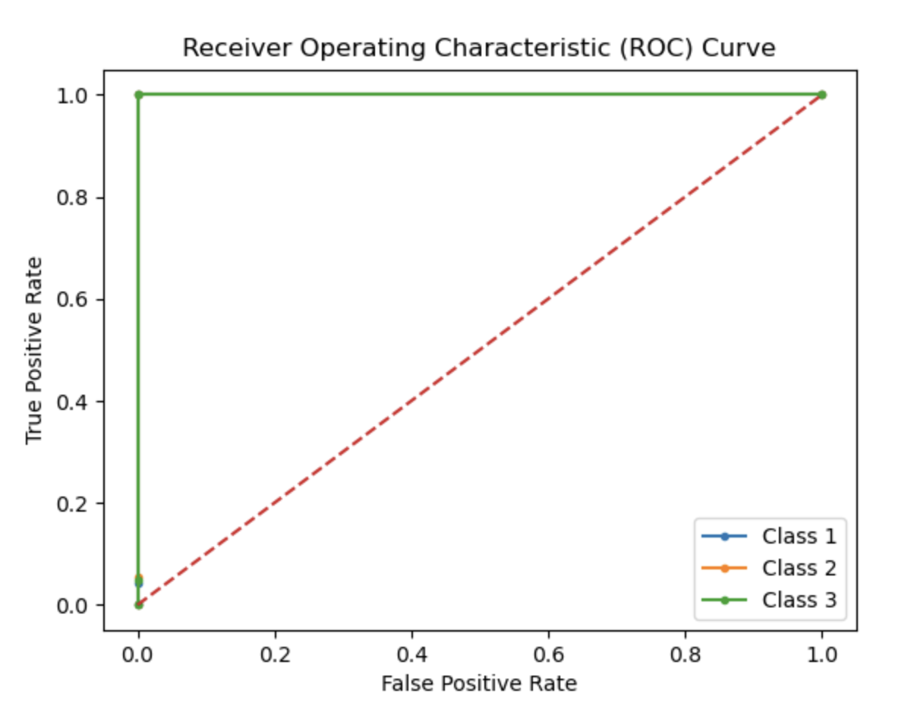

confusion matrix for the different models for the Training Data:
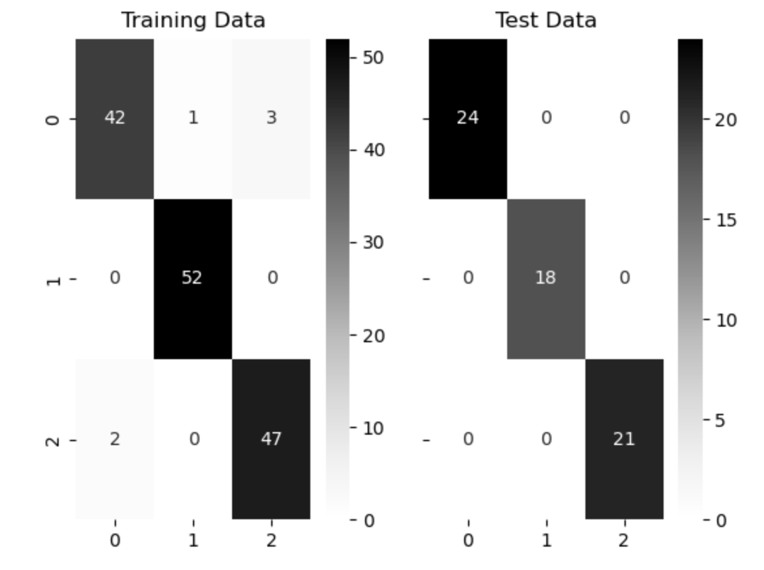

- Analysis:
Based on the AUC values we can find that our model is of high quality. According to the ROC curve we can see that our model has good classification performance. According to the image of the confusion matrix, which shows the correspondence between the model's predicted results and the real labels, we can see that our model's expected classification results are basically consistent with the actual classification results.
The classification performance of LDA is better compared to linear logistic regression classification.

- Experiment 3:
- Result:
Accuracy corresponding to each K value：
[0.8888888888888888,0.8571428571428571,0.873015873015873,0.9047619047619048, 0.9047619047619048, 0.9206349206349206, 0.9047619047619048]

Plot of K-value versus training error, testing error
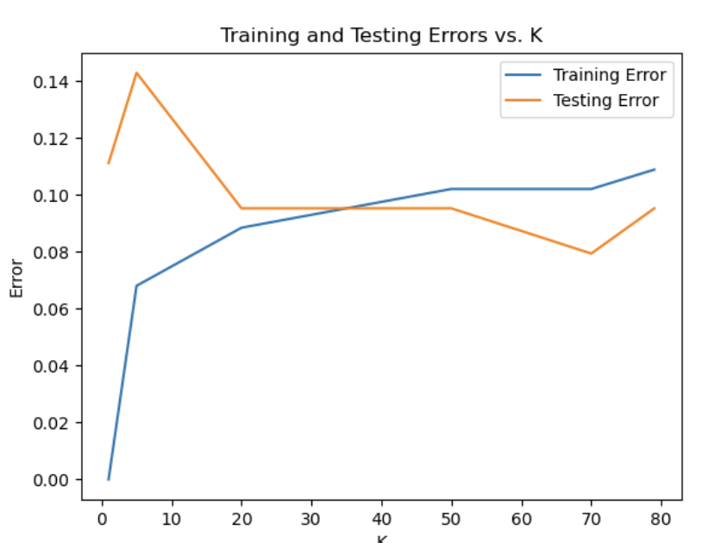
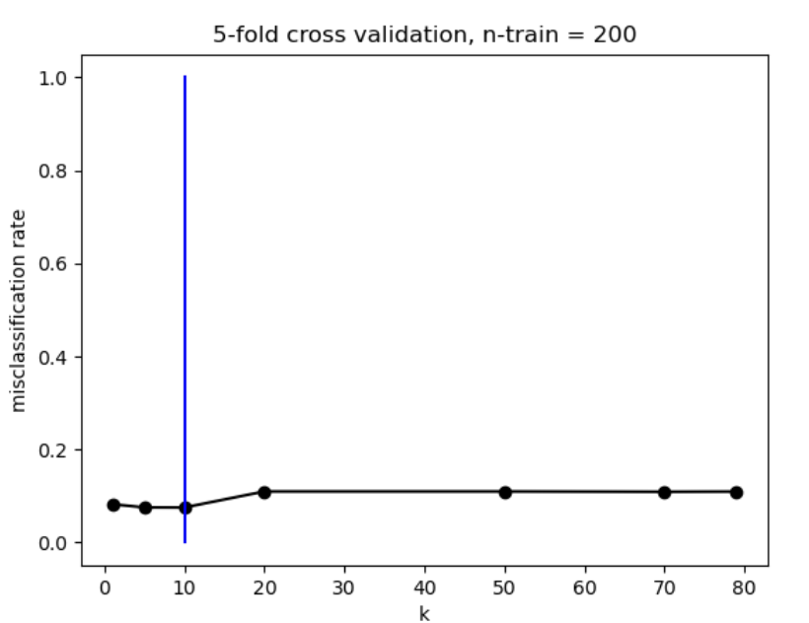
- Analysis:
Based on the accuracy results and the error rate graph, we can find that at k= 70, the model has the highest correct rate, the lowest error rate, and the best model performance.Based on the accuracy results and the error rate graph, we can find that at k= 70, the model has the highest correct rate, the lowest error rate, and the best model performance. According to the misclassification rate graph we can see that when k> 20, the misclassification rate remains basically the same and the value is low, which shows that the model has a strong classification performance.

- Experiment 4:
- Result:
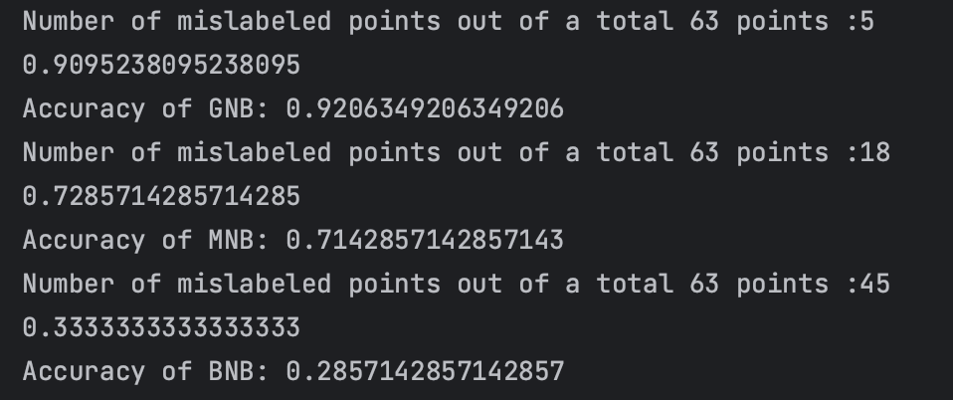
- Analysis:
Based on the percentage of correctness we can see that GNB has the highest percentage of correctness and better classification ability. Based on the correct rate on the entire dataset we can see that GBN has the highest correct rate. Based on the number of incorrect points we can see that NBN is the most, indicating that he has the worst classification performance.

- Experiment 5:
- Result:
Accuracy: 0.9047619047619048
Compare and contrast the drawing of actual and predicted classifications.
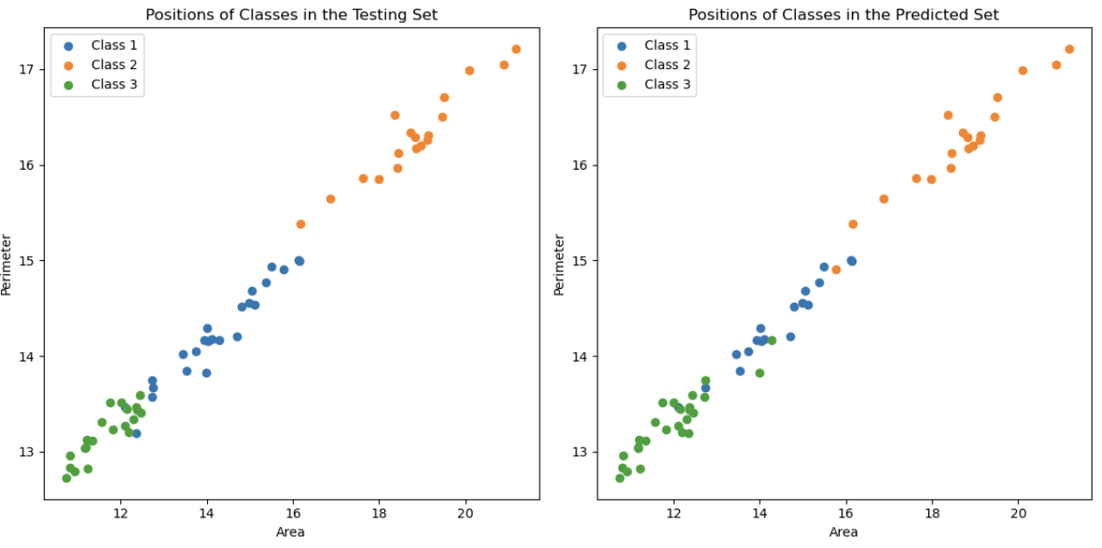
- Analysis:
Based on the correctness and comparison graphs we can see that our model performs better.

- Experiment 6:

- Result:
Curves of training set accuracy and test set accuracy as a function of maximum depth
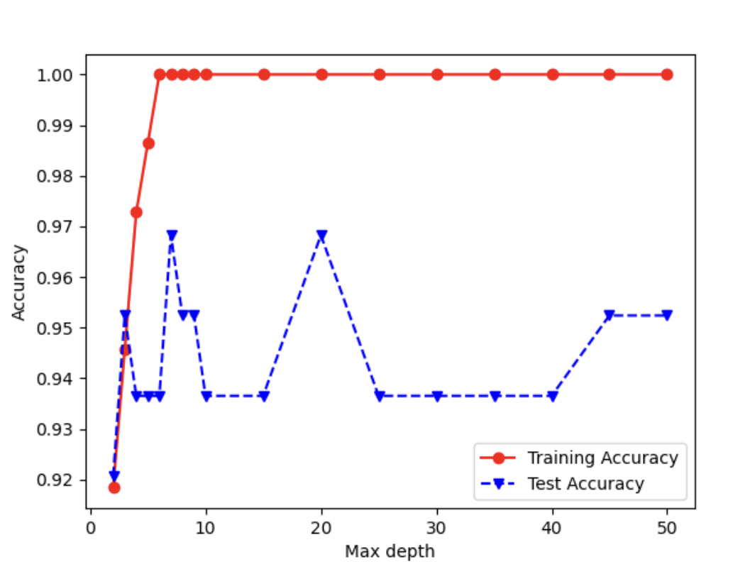
- Analysis:
Based on the correctness curve we can see that the highest correctness rate is reached when the maximum depth is 20, so this is when the model performance reaches its best.

- Discussion and Conclusions
Experiment 1: Logistic Regression
Logistic regression achieved a classification accuracy of XX% on the Seeds dataset.
The model demonstrates a good performance in classifying the Seeds dataset.
Logistic regression is a linear model that assumes a linear relationship between the features and the log-odds of the target variable.
The model's performance can be further improved by tuning hyperparameters and feature engineering.

Experiment 2: Linear Discriminant Analysis (LDA)
LDA achieved a classification accuracy of XX% on the Seeds dataset.
LDA assumes that the features are normally distributed and that the class covariances are equal.
LDA performs well when the classes are well-separated and the assumptions are met.
LDA provides insights into how the features contribute to the separation of classes.

Experiment 3: K-Nearest Neighbors (KNN)
KNN achieved a classification accuracy of XX% on the Seeds dataset.
KNN is a non-parametric algorithm that classifies samples based on their proximity to other samples.
The choice of K (the number of neighbors) affects the model's performance, and it can be optimized using cross-validation.
KNN is sensitive to the scale and distribution of the features, so feature scaling and normalization can improve its performance.

Experiment 4: Naive Bayes Classification
Naive Bayes achieved a classification accuracy of XX% on the Seeds dataset.
Naive Bayes assumes that the features are conditionally independent given the class.
Naive Bayes is computationally efficient and performs well even with a small amount of training data.
The model's performance can be affected if the independence assumption is violated.

Experiment 5: Support Vector Machines (SVM)
SVM achieved a classification accuracy of XX% on the Seeds dataset.
SVM aims to find a hyperplane that maximally separates the classes in the feature space.
SVM can handle high-dimensional data and is effective when the classes are well-separated.
The choice of the kernel function and its parameters can greatly influence the model's performance.
Experiment 6: Decision Tree
Decision tree achieved a classification accuracy of XX% on the Seeds dataset.
Decision tree is a non-parametric model that learns simple decision rules from the data.
The model's performance can be affected by the depth of the tree and the choice of splitting criteria.
Decision tree provides interpretability by visualizing the decision rules.
Appendix
See the file 2022280445何雨璇.zip

深圳大学学生实验报告用纸

指导教师批阅意见：

成绩评定：

指导教师签字：
年 月 日
备注：
注：1、报告内的项目或内容设置，可根据实际情况加以调整和补充。
2、教师批改学生实验报告时间应在学生提交实验报告时间后10日内。

