深 圳 大 学 实 验 报 告

课程编号： 2801000049

课程名称： 机器学习

实验项目名称： Non-Negative Matrix Factorization

学院： 电子与信息工程学院

专业： 电子信息工程

指导教师： 麦晓春

报告人： 何雨璇 学号： 2022280445 班级： 电信06

实验时间： 2024 年 6 月 15 日

实验报告提交时间： 2024 年 6 月 21 日

教务部制
- Experimental Purposes and Requirements

- Familiarise yourself with methods of loading and visualising datasets and understand the distribution of datasets.

- Understand the basic principles and operational steps of the K-means clustering algorithm and the DBSCAN clustering algorithm.

- Master the use of the K-means clustering algorithm, including setting the appropriate number of clusters and visualising the clustering results.

- Master the use of the DBSCAN clustering algorithm, including the adjustment of parameters and visualisation of clustering results.

- Compare the performance of the K-means clustering algorithm and the DBSCAN clustering algorithm on different datasets, and analyse their applicability and effectiveness under different data characteristics.

- Experiment Contents and Process
  - Experimental Contents/Introduction

- Load the dataset seeds.csv.

- Extract the grain variety and the feature data, and transform the feature data into a numpy array.

- Run the non-negative matrix decomposition on the data multiple times (rank=3, repeat_times=20).

- Calculate the Silhouette coefficients for each clustering result, and plot a line graph, labeling the best scores.

- Transform the clustering results corresponding to the best score into a Dataframe, and make a crosstab of the varieties and the best clustering results pd.crosstab(df1, df2)

2.2 Experiment Process

- Preparation
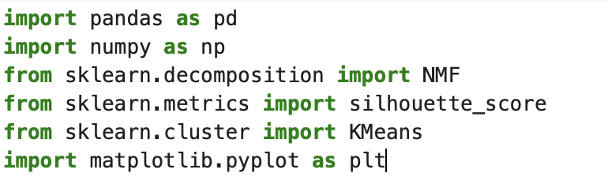
- Load the dataset seeds.csv , and show the first few rows of the dataframe
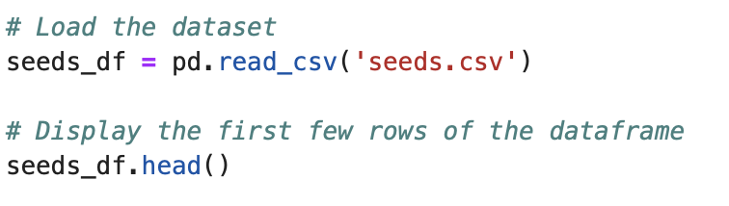
- Extract the grain variety and the feature data, and transform the feature data into a numpy array.
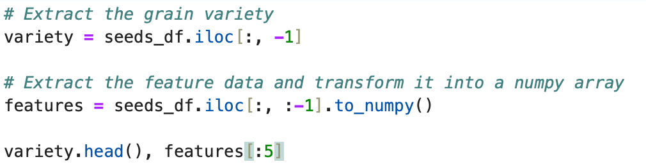

- Run the non-negative matrix decomposition on the data multiple times (rank=3, repeat_times=20).
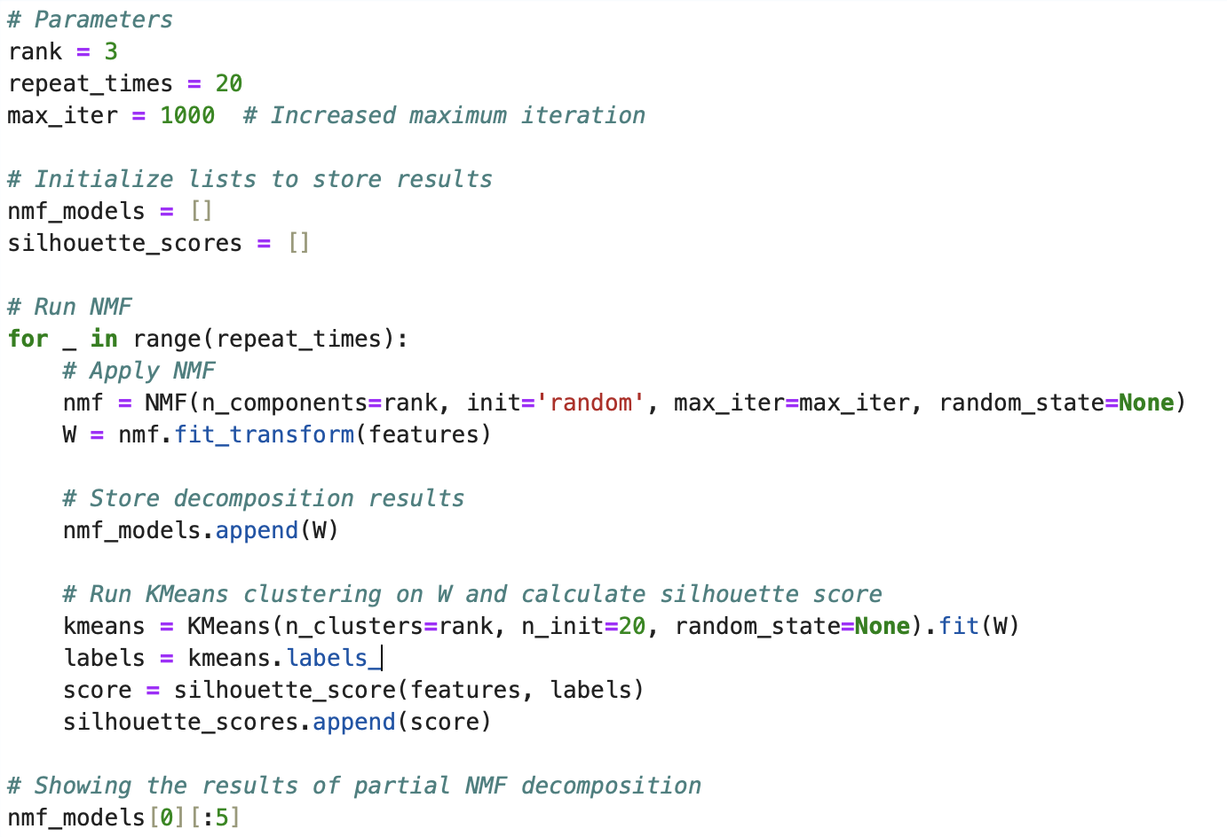

- Calculate the Silhouette coefficients for each clustering result ,and plot a line graph labeling the best score.
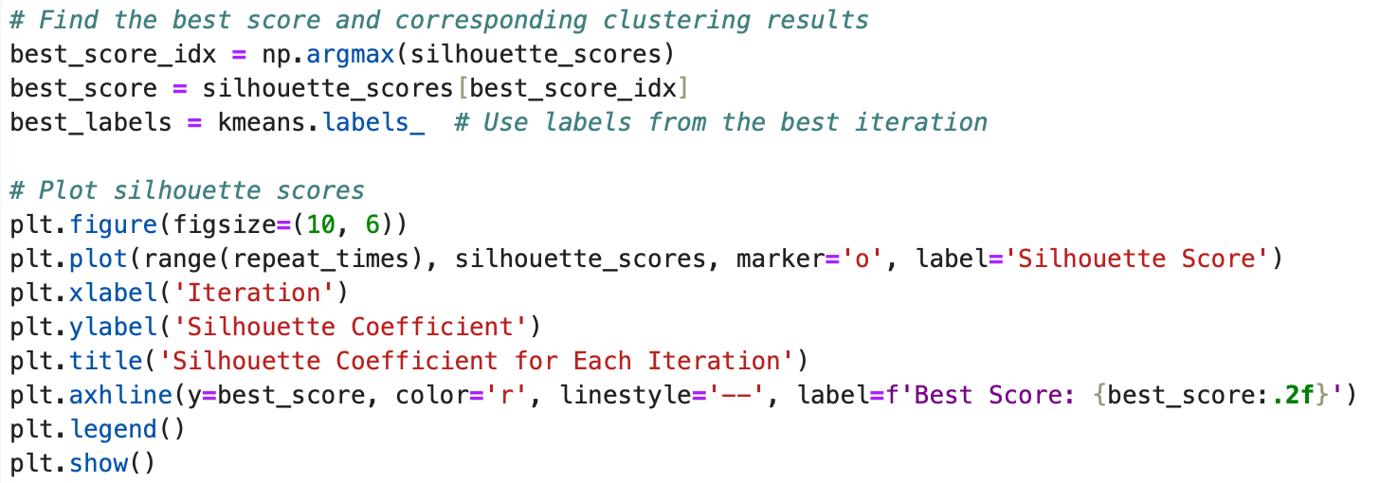
- Transform the clustering results corresponding to the best score into a Dataframe, and make a crosstab of the varieties and the best clustering results pd.crosstab(df1, df2)
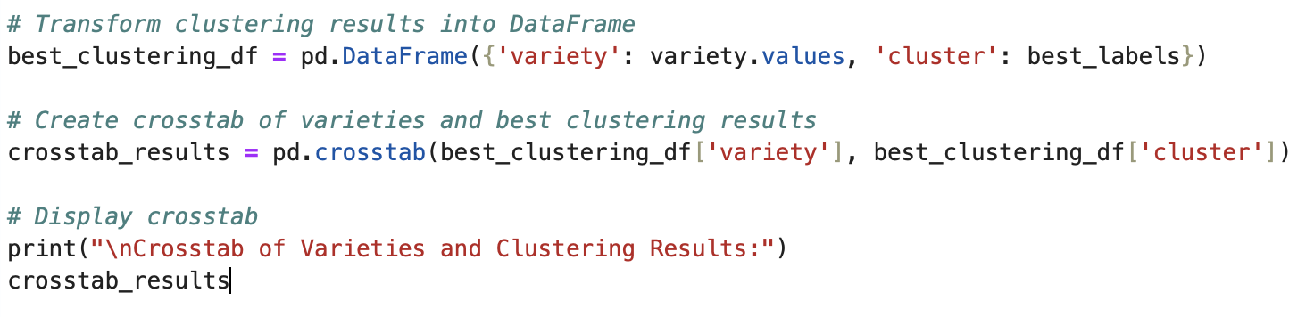

  - Experimental Results and Analysis

Result：
- Database dataframe

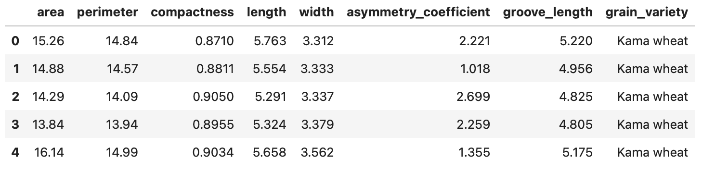
p1 head of dataframe

- The grain variety and the feature data.

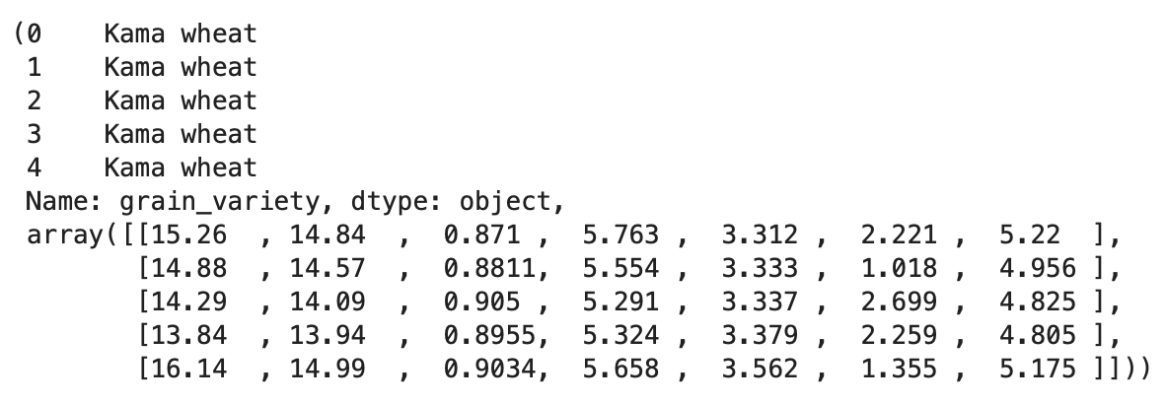
p2 the head of data feature

- The non-negative matrix decomposition

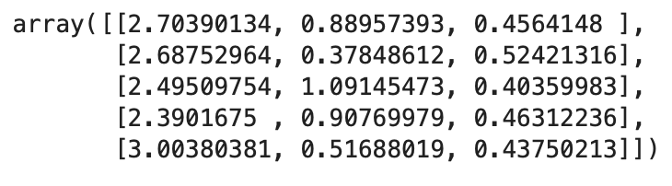
p3 head od the models array

- Silhouette score for each iteration with the best score

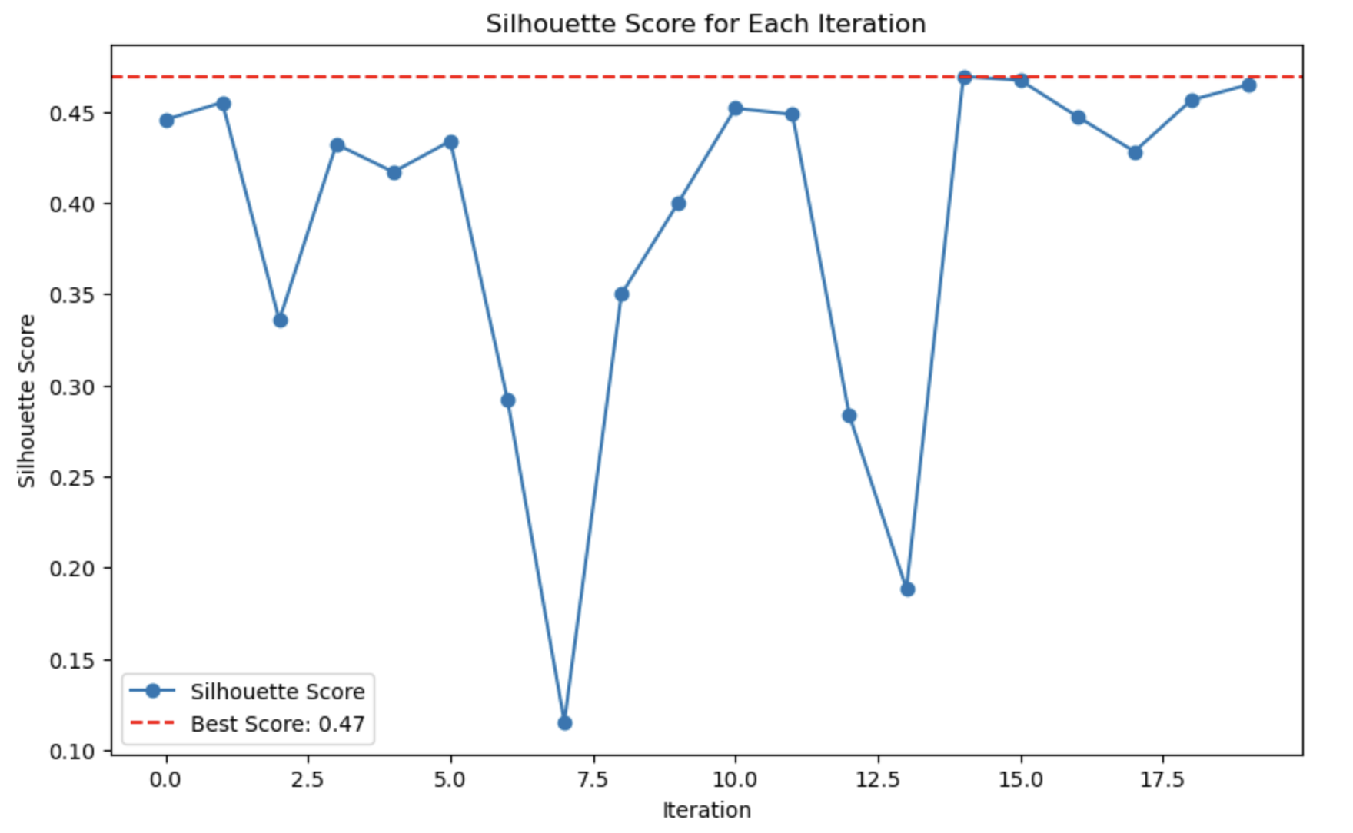

p4 Silhouette Score for Each Iteration

- Crosstab dataframe of the varieties and the best clustering results
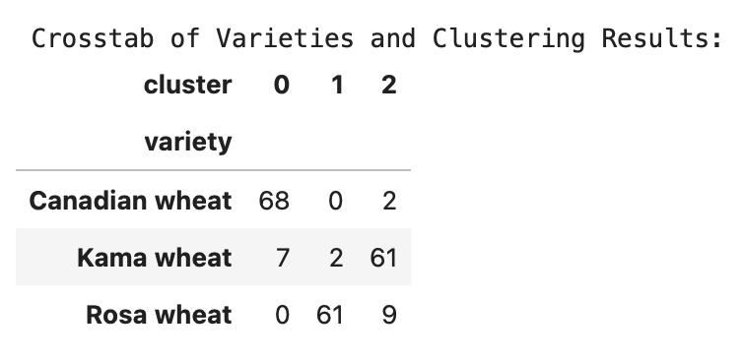
p5 Crosstab dataframe
Analysis:

From p4 we can see that the best score is 0.47 and the Silhouette Score transformation under each iteration is not regular.A Silhouette Score of 0.47 suggests that the clusters are moderately well-defined. While not perfect, it indicates that the data points within the same cluster are reasonably similar to each other and dissimilar to points in other clusters.This score is a positive indicator, showing that the clustering algorithm was able to capture some underlying structure in the data, but there is room for improvement.A score of 0.47 implies that there is a moderate separation between clusters, meaning that there is some overlap or close proximity between clusters.
From p5 we can see that most of the samples were correctly classified into clusters that corresponded to their actual categories, and in particular, most of the samples from Canadian wheat and Rosa wheat were correctly clustered into cluster 0 and cluster 1, respectively.However ,there is some confusion in the clustering of Kama wheat, especially with Canadian wheat. This may be due to some similarities in the characteristics of these two wheats, making it difficult for the algorithm to fully differentiate between them.

- Discussion and Conclusions
Discussion:
- Data loading and pre-processing.
We loaded the seeds.csv dataset and extracted grain types and feature data. The feature data was converted into NumPy arrays for subsequent processing.
The successful execution of this step lays the foundation for subsequent downscaling and clustering operations.

- Non-negative Matrix Factorisation (NMF).
We performed multiple (20) NMF operations to downscale the data to the three latent features.NMF helps to extract the non-negative features of the data, which is very useful to understand the underlying structure of the data.Through multiple iterations, we were able to assess the stability of NMF and the diversity of the results.

- Clustering and Profile Coefficient Calculation.
The KMeans algorithm is used to cluster the data after each NMF dimensionality reduction and the profile coefficients are calculated for each clustering result. The contour coefficients are used to assess the quality of the clustering results.We plotted a line graph of the contour coefficient and labelled the best contour coefficient (0.47). This graph helped us to visualise the clustering effect in different iterations.

- Cross-tabulation analysis of clustering results.
The best clustering results were cross-tabulated with the actual cereal types. The cross-tabulation shows the distribution of each cereal in the different clusters.The results show that most Canadian wheat was correctly clustered into one cluster, while Rosa wheat showed similar results. kama wheat's clustering results, although mainly concentrated in one cluster, showed some confusion.

Coclusions:
- Moderate clustering results :.
The best profile coefficient is 0.47, indicating a moderate clustering result. It is not very high, but shows some clustering effectiveness, indicating that there is some structure in the data that can be captured.

- Effectiveness of Non-Negative Matrix Factorisation:
NMF is effective in downscaling the data to three potential features that are useful for clustering. However, choosing a different downscaling method (e.g. PCA) may further improve the clustering results.

- Reliability of clustering results.
Cross-tabulation analysis showed that most Canadian wheat and Rosa wheat samples were correctly clustered. However, some samples of Kama wheat were misclassified, indicating that there is still room for improvement in the feature selection and clustering algorithms.
- Directions for improvement.
Feature engineering: Add more features or transform existing features to improve clustering accuracy.
Algorithm optimisation: Try different clustering algorithms (e.g. hierarchical clustering, DBSCAN) and different dimensionality reduction techniques (e.g. PCA, t-SNE) to get better clustering results.
Parameter tuning: Adjust the parameters of NMF and KMeans to find the optimal configuration to further improve the clustering results.

Appendix
See the file 实验4_2022280445_何雨璇.ipynb

指导教师批阅意见：

成绩评定：

指导教师签字：
年 月 日

备注：
注：1、报告内的项目或内容设置，可根据实际情况加以调整和补充。
2、教师批改学生实验报告时间应在学生提交实验报告时间后10日内。

