**Little Gem / Ruby + 1 Knob Fuzz Design Doc.**

**1 Knob Fuzz**:

<https://guitarpcb.com/wp-content/uploads/2018/06/BD_One-Knob-Fuzz-1.pdf>

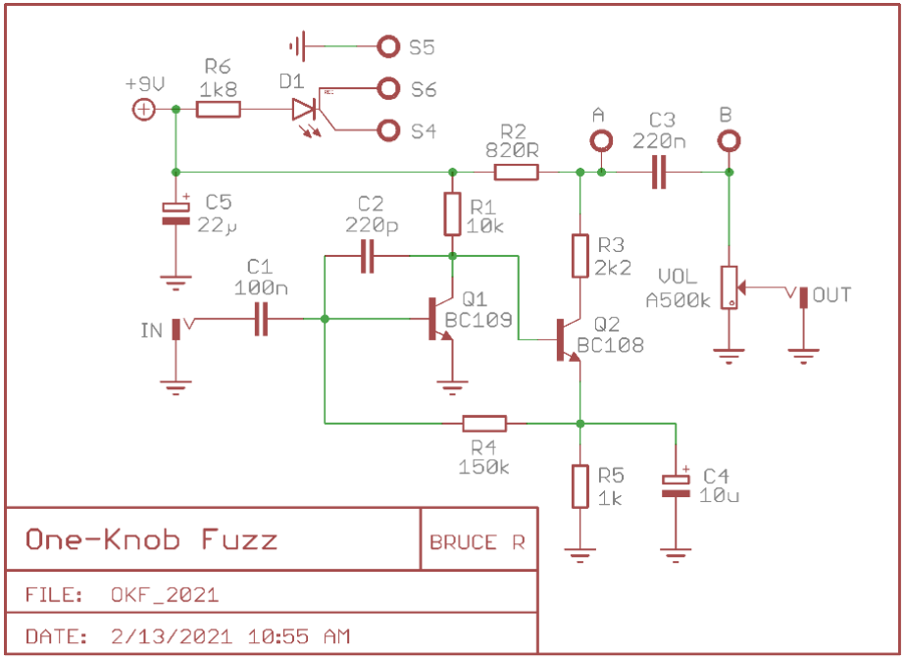

**Notes**:

1. Q1 and Q2 can be replaced with 2N3904 (but design with sockets so many different transistors can be tried out)
2. A and B output ports can be removed

**Little Gem**:

https://www.electrosmash.com/little-gem-analysis

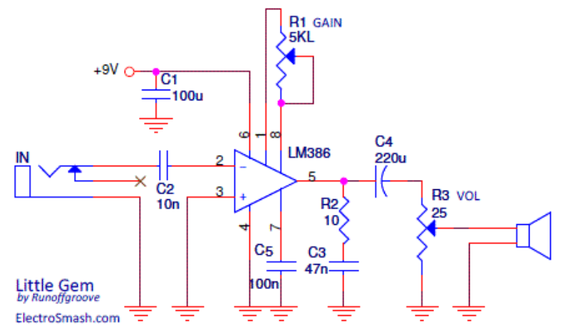

**Notes**:

1. For the Zobel network (R2+C3), R2 should be chosen to match the impedance of the speaker (32ohm, 8ohm, 4ohm, etc). C4 should be calculated as C3=Le/R2 (where Le = inductance of the speaker coil)
2. The Zobel network should either be as close as possible to pin 5 of the LM386, or MORE preferably, mounted to the actual binding posts of the speaker

**Ruby**:

<https://www.electrosmash.com/ruby-amp-analysis>

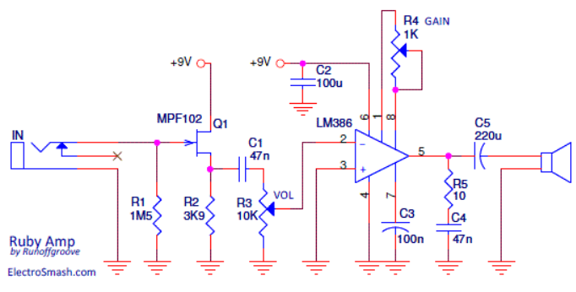

**Notes:**

1. For the Zobel network (R5+C4), R5 should be chosen to match the impedance of the speaker (32ohm, 8ohm, 4ohm, etc). C4 should be calculated as C4=Le/R5 (where Le = inductance of the speaker coil)
2. The Zobel network should either be as close as possible to pin 5 of the LM386, or MORE preferably, mounted to the actual binding posts of the speaker
3. C1 controls how much low frequency is allowed into the LM386, lower C1 values = less bass at the speaker output. Too much bass and the sound becomes “farty”, so bass (low-end frequencies) needs to be tightly controlled
4. Q1 can be any JFET
5. R3 is logarithmic
6. R4 is linear, and can be increased to 2.2k as an experiment

**Ruby Mods:**

**Ruby Hiwatt (cut bass, improved high frequency response for a Pete Townsend kind of sparkly sound)**

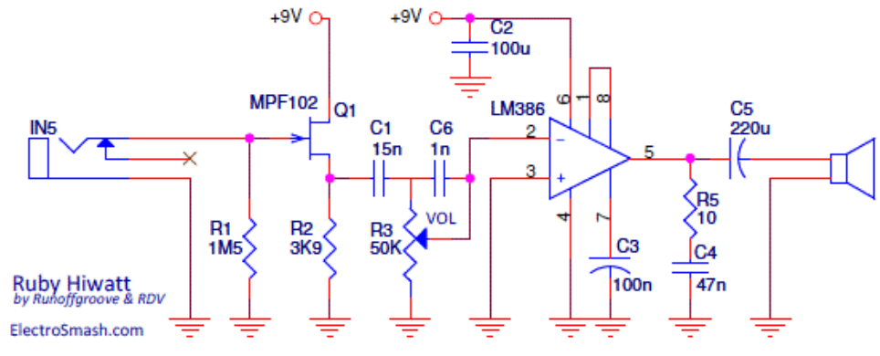

**Hiwatt Notes**:

1. The left-most circled region is what controls the frequency response entering the LM386. C1 cuts a lot of the bass out, and C6 is a “bleed” cap that helps retain high-end clarity at lower volumes. Notice that R3 volume knob has also increased from 10k to 50k in the original design
2. The right-most circled region controls the gain, since the C1/C6 caps cut a lot of volume, the gain is set to max (shorted) to try to get some of that volume back

**Nice to have mods after circuit is working:**

1. **Adding a headphone jack:**

