**0Practical 04 Digital Presentation**

**Representing colour in RGB**

1. 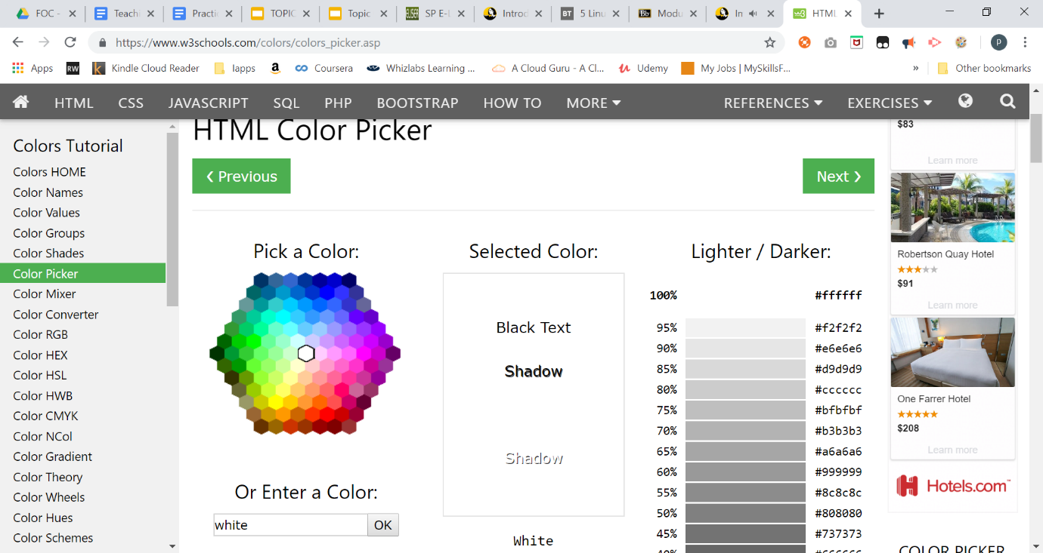Go to web site <https://www.w3schools.com/colors/colors_picker.asp>

|  |  |  |
| --- | --- | --- |
| **Colour** | **RGB in decimal** | **RGB In Hex** |
| Black | **0** | **#000000** |
| White | **16777215** | **#FFFFFF** |
| Your favourite colour (Gold) | **16766720** | **#FFD700** |

Access the File Header

1. Using notepad, create a text file named “file1.txt”

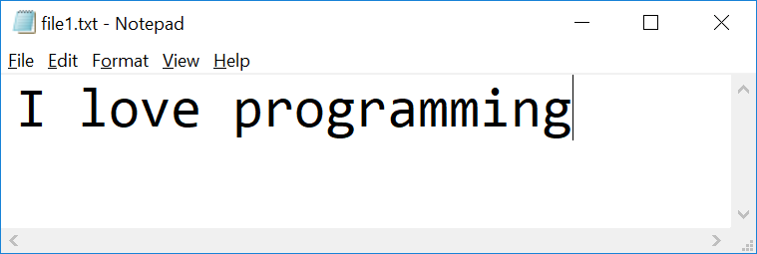

1. Check the file properties

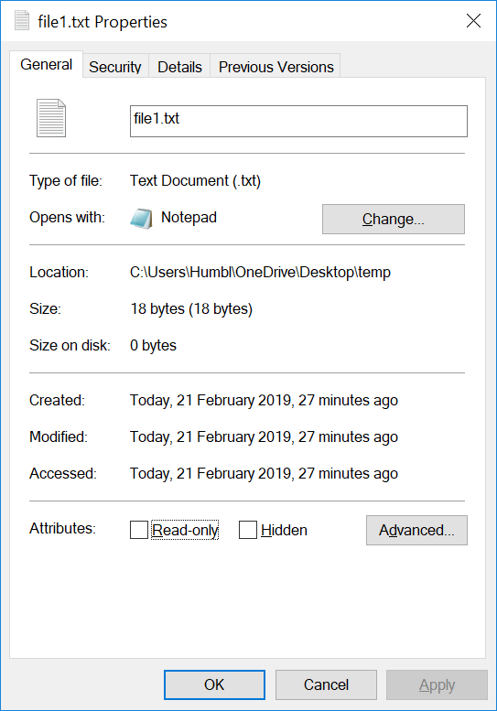

What is the size of the file in bytes?

|  |
| --- |
| 18 bytes |

1. Visit HexEd at <https://hexed.it/>

or download HxD Hex Editor

<https://download.cnet.com/HxD-Hex-Editor/3000-2352-10891068.html?part=dl-HxDHexEdi&subj=uo&tag=button>

1. Open file1.txt using HxD
2. Observe the Hex code  
   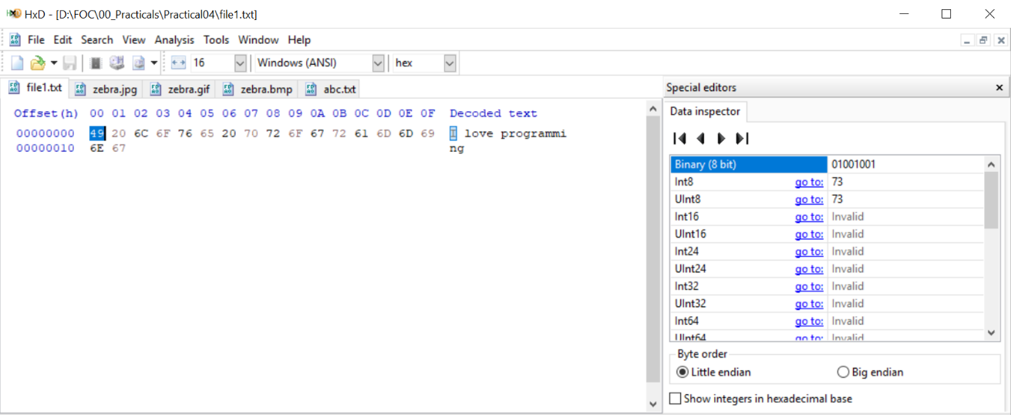

|  |  |  |
| --- | --- | --- |
| **Character** | **Hex** | **Binary(8 bit)** |
| I | 49 | 01001001 |

1. Using HxD to observe how character “o” and space character are represented

|  |  |  |
| --- | --- | --- |
| **Character** | **Hex** | **Binary(8 bit)** |
| o | 6F | 01101111 |
| space | 20 | 00100000 |

1. 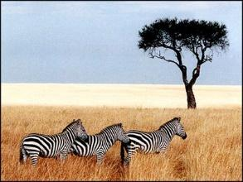Download the following image and save it as zebra.**jpg**, zebra.**gif** and zebra.**bmp**
2. Open **zebra.gif** in HxD

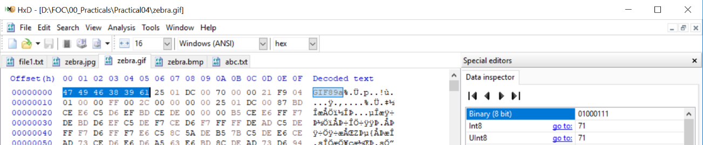Observe the Hex code

What are the **first 6 bytes** decoded?

|  |  |  |  |  |  |  |
| --- | --- | --- | --- | --- | --- | --- |
| **offset** | **00** | **01** | **02** | **03** | **04** | **05** |
| Byte | 47 | 49 | 46 | 38 | 39 | 61 |
| Character | G | I | F | 8 | 9 | a |

1. Visit web site <https://en.wikipedia.org/wiki/List_of_file_signatures> to find out the meaning of above hex code

|  |
| --- |
| GIF89a – gif extension, Image file encoded in the Graphics Interchange Format (GIF). |

1. Open **zebra.jpg** in HxD  
     
   Observe the Hex code

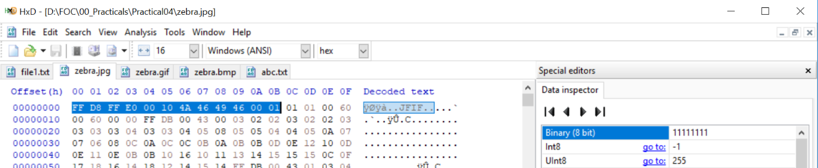

What are the **first 12 bytes**?

|  |  |  |  |  |  |  |  |  |  |  |  |  |
| --- | --- | --- | --- | --- | --- | --- | --- | --- | --- | --- | --- | --- |
| **offset** | **00** | **01** | **02** | **03** | **04** | **05** | **06** | **07** | **08** | **09** | **0A** | **0B** |
| Byte | FF | D8 | FF | E0 | 00 | 10 | 4A | 46 | 49 | 46 | 00 | 01 |
| Character | ÿ | Ø | ÿ | à | ␀ | ␐ | J | F | I | F | ␀ | ␁ |

1. Visit web site <https://en.wikipedia.org/wiki/List_of_file_signatures> to find out the meaning of above hex code

|  |  |  |
| --- | --- | --- |
| |  | | --- | | ÿØÿà␀␐JFIF␀␁ | |  |   jpg – JPEG raw or in the JFIF or Exif file format |

1. Open **zebra.bmp** in hex editor

Observe the Hex code   
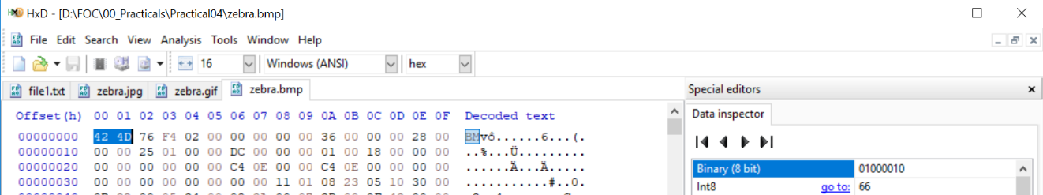

What are the **first 2 bytes**?

|  |  |  |
| --- | --- | --- |
| **offset** | **00** | **01** |
| Byte | 42 | 4D |
| Character | B | M |

1. Visit web site <https://en.wikipedia.org/wiki/List_of_file_signatures> to find out the meaning of above hex code

|  |
| --- |
| BM  BM – BMP file, a bitmap format used mostly in the Windows world. |

1. (optional)  
   Download the file at <https://drive.google.com/open?id=1vf0SBkI1LdWQvYmK9yM5AyJ0fHKE6DHR>

How can you view it as an image?

|  |
| --- |
| Download abc as abc.txt from google drive. Use an online tool like Convertio to convert the txt file to jpg. Download the converted jpg file and view it. |

**Hint:**

* Open the file using HxD
* Visit web site <https://en.wikipedia.org/wiki/List_of_file_signatures> to find out the meaning of above hex code
* Rename the extension of the file

*End of Practical*