# Introduction

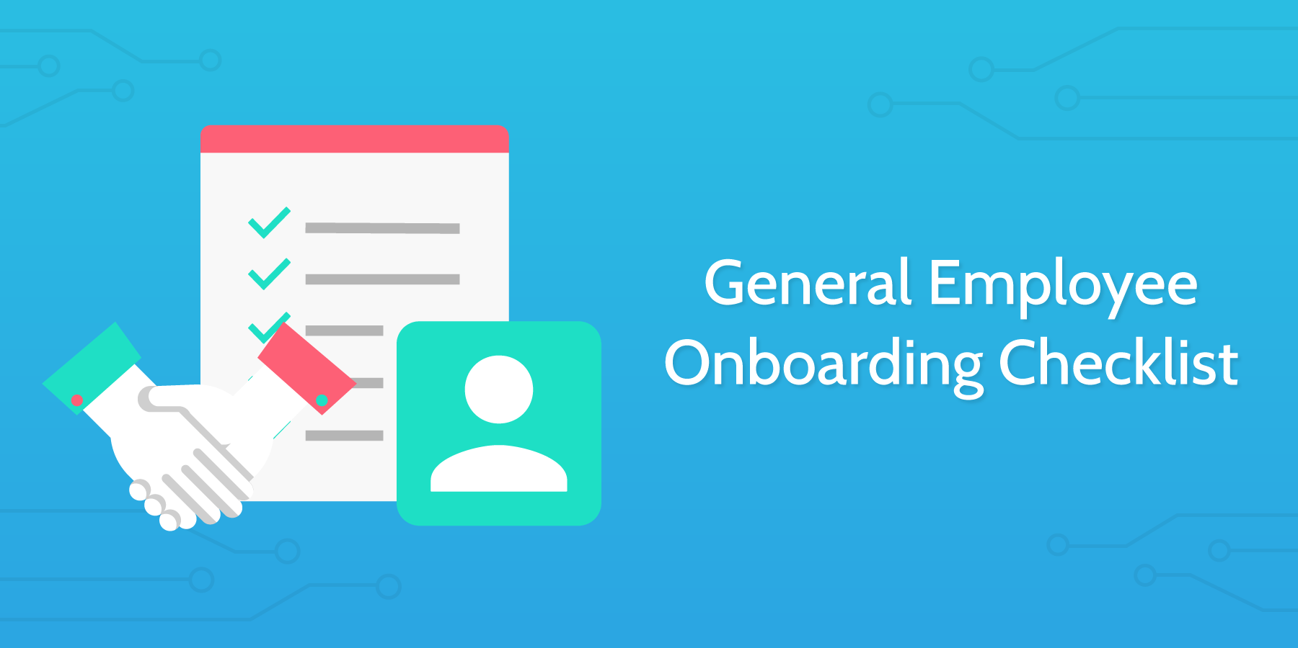

If you've ever joined a new company and been unsure how you fit in, you'll know **the benefits of employee onboarding**. For managers, however, the gains are more quantifiable. They include:

1. Better job performance
2. Greater commitment to the organization
3. Reduced stress
4. Higher job satisfaction
5. Better retention (and associated cost savings)

The cost of hiring a new employee [averages around $65,000](http://www.investopedia.com/financial-edge/0711/the-cost-of-hiring-a-new-employee.aspx) and it takes are 5 months of full time employment to bring new hires up to full productivity. **Failure to properly onboard a new hire will cost significant amounts of time and money**.

A quality process, like the one outlined in this employee onboarding checklist, costs a fraction of the resources and aims to **ramp an employee up to full productivity in under 90 days**, depending on the complexity of the role.

So, let's get underway with the process and run through this employee onboarding checklist with your new hire.

# Before first day:

# Prepare paperwork

To kick off the employee onboarding checklist, you need to **prepare the relevant paperwork and information**prior to the employee's first day. Start by **recording** the employee's **basic information** in the **form fields**below.

**Employee First Name**

**Employee Last Name**

**Date of Hire**

Date will be set here

**Employee Contact Details**

**Employee Extra Information**

This part of the process is called **transactional onboarding** and focuses on completing all the necessary**forms and documents** so your new employee can **legally start working**.

Some of the forms you need to prepare are:

* 1
* W-4
* 2
* I-9
* 3
* Insurance forms
* 4
* Direct deposit forms
* 5
* The non-disclosure agreement

However, there are more forms you might need, **specific to your company**. Good software to use is [Applicant PRO](http://www.applicantpro.com/) which operates like **CRM for onboarding** including all the necessary forms and documents and stores them in an **online database**.

(Source: [applicantpro.com](http://www.applicantpro.com/products/onboarding/))

# Discuss role, goals and projects with supervisor

During the training period, your new employee should **work closely with a supervisor or mentor**. A supervisor ensures the new employee is **oriented in the organization, policies, facilities** and more.

To ensure this process goes well, you should **discuss the new employee's role** with their supervisor. Discuss the **goals you have set for the new hire** and think of **appropriate projects** that would be beneficial for the training period. Note all of these in the **appropriate form fields** below.

(Source: [managementhelp.org](http://managementhelp.org/supervision/roles.htm#anchor234351))

**Employee Role**

**Employee Goals**

**Appropriate Projects**

# Prepare employee's workstation



When preparing the workstation ensure it follows the [comfort and health guidelines](http://www.humanscale.com/citigroup/ergotips.pdf). **Prepare the employee's workstation** before they arrive to **avoid any delays on their first day**. Include items like:

* Furniture (desk, chair)
* Telephone
* Computer
* Desk supplies (business card, stapler, letterhead, paper, pens etc.)

If you really want to impress your new employee, add items like **branded pens, backpack, t-shirt or mug** on your employee's desk.

(Sources: [expertsupervisor.com](http://www.expertsupervisor.com/article.aspx?ID=pub_OrientingNew&scope=pub) & [commongoodcareers.org](http://commongoodcareers.org/articles/detail/best-practices-for-employee-onboarding))

# Give access to any tools they will need

Before your employee arrives, it is important to **prepare the necessary tools** and ensure your new hire will be able to access them. **Fill in (or add to)** the **form fields** below as necessary.

**Wifi Password**

**Email List of Co-Workers**

**Department Phone Numbers**

Also consider details like (but not limited to):

* Keys to rooms they will need access to
* Company mobile phone

To make sure you provide your employee with all the necessary items, you can **note down the steps you take**each day and what tools you use. You can also **make a checklist** here on [Process Street](https://www.process.st/) that you can also use in future when distributing tools to new employees **ensuring you remember everything**.

# Create accounts

No self-respecting employee onboarding checklist would be complete without making sure that you **create all the accounts required by the new employee**. **Fill in (or add to)** the **form fields** below as necessary.

**Employee Company Email**

**Employee Username (first initial, last name e.g. bbrandall)**

**Employee Company Phone Line**

**Employee Company Social Accounts**

As shown above, create accounts on all **social platforms your company uses**. Your employee should have their own **email and phone line**. If your company uses apps like [Slack](https://slack.com/) or [Trello](https://trello.com/) you should create an account there as well.

# Assign required reading

Each job comes with its own **tricks and strategies**. Often a company will want to have certain **books or articles** read by the employees to **keep everyone on the same page**.

These books should be **relevant to the job position**.

For example, when hiring someone to create checklists you can offer them to read [The Checklist Manifesto](https://www.bookdepository.com/Checklist-Manifesto-Atul-Gawande/9780312430009) or [The Checklist Manifesto Quotes](https://www.process.st/2015/06/the-checklist-manifesto-quotes/).

# Prepare benefits package



It is important for every employee to know which **benefits packages come with the job**. Here is some commonly required information your employee will want to know:

* Explain **how the position is funded**. You might have already discussed it in the interview, but your **employee will appreciate a confirmation**.
* Let your employee know **what benefits package they will receive** based on their level of experience and current job market. Let them know some **details about the budget** so they are aware of the **potential promotions and salary range**.
* Inform your employee on **vacation time and health benefits** they will receive.

Provide a **summary of this information** in writing; **upload a** **copy** of this summary to the **form field below**.

**Benefits Package**

File will be uploaded here

To help them understand the benefits package better, go over it at their own pace, perhaps share it with their partner and help them plan their financial situation.

Ensuring a financial stability and **informing your employee on the exact monetary situation** is a good way to make them feel comfortable and worry-free, therefore making sure they focus on their work and **feel appreciated as workers**.

(Source: [idealistcareers.org](http://idealistcareers.org/closing-the-deal-salary-and-benefits-negotiation/))

# Provide a job description with responsibilities

You have discussed the job in more detail **during the interview**, but now it's time to give **specific instructions**on what you expect your employee to do. **Upload a copy** of this specific job description to the **form field**below.

**Detailed Job Description**

File will be uploaded here

If you would like a guideline for this document, see above for a detailed job description template.

Note the **necessary qualifications**, you can use this place to mention the **required reading**. You should also list your new employee's key **responsibilities and a short description**.

This form can later be used as a **guideline for employee evaluation**. You can see if the goals you set have been made, responsibilities executed and your employee's skills are sufficient for the task.

# First day:

# Welcome to the team

Often a new employee will arrive during a busy working week. In this case welcoming the new hire is overlooked and they are not **caught up to speed with the team or new role**. To avoid this, you should **clear your schedule** and make the new employee the **number one priority** for the day.

You should **introduce them to the team** - talk about their role, tell them why you selected them - this will help the rest of the **team remember them** better. Notify your team in advance that the new employee is arriving so they can **schedule some time to get to know them**.

(Source: [miningman.com](http://www.miningman.com/Blog/January-2010/How-to-Welcome-a-New-Employee-to-the-Team))

# Tour of the office

Take your employee on a **tour around the office**. Let them know where all the **important and common areas**are. Make sure they know where to find:

* Kitchen
* Reception
* Bathroom
* Their workspace
* Support desk
* HR area
* Their mentor's office

There might be more areas such as the IT department, sales department and others more **specific to your company**. If you practice an **open door system** you can show the new employee where **your office** is and encourage them to **visit you if they have any questions**.

# Assign training material

Send your introductory training material, or add the employee to your LMS and assign the relevant courses.

# Explain your expectations

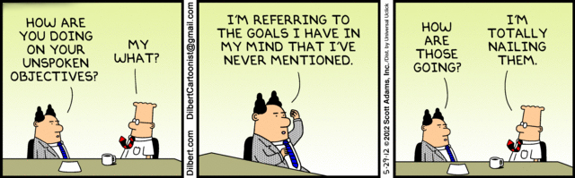

If you want your **employees to perform well** you need to **let them know what you expect**. Outline the **general areas of knowledge and skills** required to ensure your employee is **successful in his/her job**. Think about:

* What **goods and services** should the job produce?
* What **impact** should the work have on the organization?
* How do you expect the employee to **act with clients, colleagues, and supervisors**?
* What are the **organizational values** the employee must demonstrate?
* What are the **processes, methods, or means** the employee is expected to use?

(Source: [hrweb.berkeley.edu](http://hrweb.berkeley.edu/guides/managing-hr/managing-successfully/performance-management/planning/expectations))

# Induct into company culture

Usually, this step is covered by the **HR team**. Have them **contact your new employee to explain** details such as:

* When s/he must **arrive** at the office
* Where s/he must **park**
* How s/he will **access** the building
* What your company’s **dress code** is

(Source: [hrpulse.co.za](http://www.hrpulse.co.za/first-months2/induction/229077-why-is-induction-so-important))

# Assign a mentor

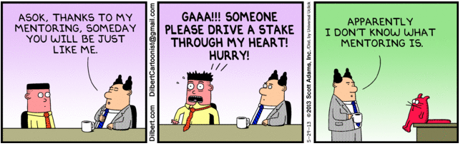

To ensure your new employee has the opportunity to **seek help and work productively,** you should assign a mentor.

**Employee Mentor**

They will ensure the employee **quickly learns about the job** and has **assistance throughout** the process.

It is important to **find a good candidate for mentoring**, you can check out these 15 [characteristics of a successful mentor](http://humanresources.about.com/od/coachingmentori2/qt/formal_mentor.htm) to ensure you find the right fit.

(Source: [humanresources.about.com](http://humanresources.about.com/od/glossarym/g/mentoring.htm))

# Take out to lunch

You should **take your new employee out for lunch**. If you have already introduced them to their mentor it might be a good idea to **have lunch with both of them**.

Avoid discussing work during this time, it should be **purely about getting to know one another**.

# First week:

# Assign first project

Once your new employee has settled in, got to know the team and feels comfortable in the workplace you should **assign their first project**.

This will ensure they **learn the job hands on** and **feel valuable** to the company, **rather than doing menial tasks**.

# Explain expectations for the following month

You have already explained the **overall expectations,** but now it's time to let your employee **know the specifics**.

Refer to the **job description** and **make a plan for your employee** to follow; let them know exactly **what they will be expected to do**. If possible, notify them of any **upcoming projects and predicted workflow**.

# Meet to check over paperwork

Schedule a meeting with the **employee and a member from the HR team** to ensure all the **forms are filled and correct**. **Record the date** of the meeting in the **form field** below.

**First Week Meeting**

Date will be set here

Use this time to let your employee know if there is **any other paperwork** for them to fill in including **tax forms**.

Ask a member from the HR team to **explain everything** to your employee and **tell them about the specifics**. Let the new employee know he/she is **encouraged to ask any questions** and can use this time to **discuss any and all work related paperwork issues**.

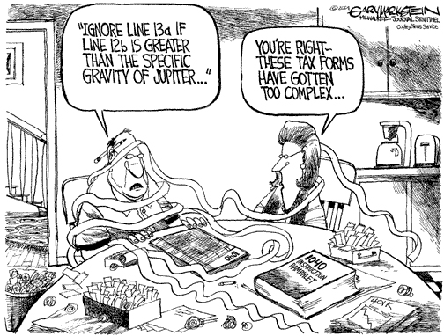

# First month:

# Plan check-in meetings

You should schedule meetings with the employee **for the first month**. Use this time to address any **issues and concerns** your employee might have. You should also spend the meetings offering some **constructive criticism and advice** on different tasks.

A good way to schedule these meetings is by using [Google Calendar](https://www.process.st/2014/05/how-to-manage-small-business-calendars-in-the-cloud/). Add your employee to the event and make sure you are **both ready for the meeting**.

# Explain long-term goals

There are some **long term goals** your company is moving towards. You should let your employee know **where s/he fits in the picture**.

Letting your employee know that he/she is involved in some long term goals will **make them feel more secure**and understand the mission **they are working to achieve**.

# Provide reading material for personal growth

Now that you have decided **where exactly your new employee fits in** you should encourage them to **further their knowledge** in the field. Ask them to **read books, articles and magazines** about the appropriate themes.



# Encourage them to socially interact with the team

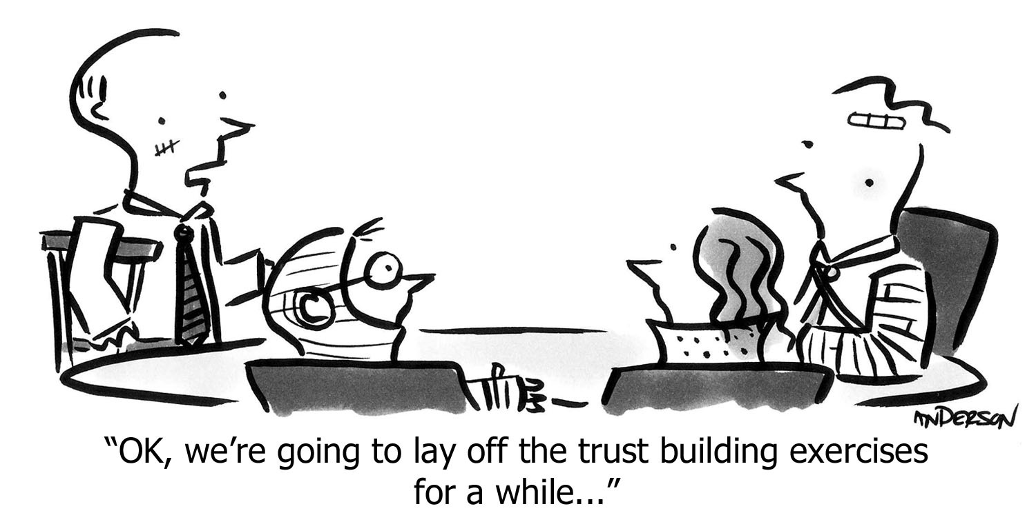

Have your new employee **interact with the team**. If the team members interact with each other they will **work together much better**. Perhaps you can organize some **out of work activities** for the team to make sure they **build good relationships** and **enjoy operating as a team**.

# Review onboarding process over the next 60 days



Once the employee is settled in and feels more comfortable in the workplace it's time for you to **review your onboarding process**. Evaluate the steps that **do and don't work** for you.

Ask your employee for their opinion, perhaps **create a survey** and hear their thoughts to **improve your onboarding** process in the future.

Once you've got your results, create a new employee onboarding checklist here in [Process Street](https://www.process.st/checklist/employee-onboarding-checklist/process.st) to work through in the future.

# Sources:

[Applicant PRO](http://www.applicantpro.com/) - [Employee Onboarding](http://www.applicantpro.com/products/onboarding/)

[Carter McNamara](https://www.linkedin.com/pub/carter-mcnamara-mba-phd/10/537/978) - [Roles and Responsibilities of a Supervisor](http://managementhelp.org/supervision/roles.htm#anchor234351)

[Expert Supervisor](http://www.expertsupervisor.com/) - [New Employee Orientation Checklist](vhttp://www.expertsupervisor.com/article.aspx?ID=pub_OrientingNew&scope=pub)

[Commongood Careers](http://commongoodcareers.org/) - [Best Practices for Employee Onboarding](http://commongoodcareers.org/articles/detail/best-practices-for-employee-onboarding)

[Idealist Careers](http://idealistcareers.org/) - [Closing the Deal: Salary And Benefits Negotiation](http://idealistcareers.org/closing-the-deal-salary-and-benefits-negotiation/)

[Mining Man](http://www.miningman.com/) - [How to Welcome a New Employee to the Team](http://www.miningman.com/Blog/January-2010/How-to-Welcome-a-New-Employee-to-the-Team)

[Berkley HR](http://hrweb.berkeley.edu/) - [Performance Expectations = Results + Actions & Behaviors](http://hrweb.berkeley.edu/guides/managing-hr/managing-successfully/performance-management/planning/expectations)

[HR Pulse News Desk](http://www.hrpulse.co.za/component/contact/contact/11-uncategorised/11) - [Why is induction so important](http://www.hrpulse.co.za/recruitment1/induction/229077-why-is-induction-so-important)

[Susan Heathfield](https://twitter.com/SusanHeathfield) - [Use Mentoring to Develop Employees](http://humanresources.about.com/od/glossarym/g/mentoring.htm)

# Relevant Checklists:

[Restaurant Employee Onboarding Checklist](https://www.process.st/checklist/restaurant-employee-onboarding-checklist/)

[Salesperson Onboarding Checklist for Startups](https://www.process.st/checklist/salesperson-onboarding-checklist-for-startups/)

[Developer Onboarding Checklist for Startups](https://www.process.st/checklist/developer-onboarding-checklist-for-startups/)

[Call Center Employee Onboarding Checklist](https://www.process.st/checklist/call-center-employee-onboarding-checklist/)

[Retail Employee Onboarding Checklist](https://www.process.st/checklist/retail-employee-onboarding-checklist/)

[Employee Onboarding](https://www.process.st/checklist/employee-onboarding)