Department of Computer Engineering
TRAVEL INSURANCE CLAIM SYSTEM
DEVOPS LIFECYCLE PRACTICAL FILE
Academic Year 2026–27 | B.E. Semester VII – CMPN | Course: DevOps

Student Name | Hasnain khan
Roll Number | 23102A0075
Academic Program | B.E. Computer Engineering (Semester VII)
Subject Professor In-charge | Dr. Snehal Andhare
Overall Grade & Evaluation

PRACTICAL EXPERIMENT INDEX
Exp No. | Experiment Title | Status
Exp 01 | Problem Definition and Scope | Complete & Verified
Exp 02 | Agile Planning and DevOps Workflow | Complete & Verified
Exp 03 | Requirements, Architecture and Technology | Complete & Verified
Exp 04 | Git and GitHub Repository Initialization | Complete & Verified
Exp 05 | Feature Development and Branching Strategy | Complete & Verified
Exp 06 | Git Collaboration and Merge Conflict Resolution | Complete & Verified
Exp 07 | Jenkins CI Server Setup and Configuration | Complete & Verified
Exp 08 | Jenkinsfile Pipeline as Code | Complete & Verified
Exp 09 | Selenium UI Test Design and Local Execution | Complete & Verified
Exp 10 | Selenium Integration into Jenkins CI | Complete & Verified
Exp 11 | Dockerfile and Container Lifecycle Management | Complete & Verified
Exp 12 | Jenkins-Docker Continuous Deployment | Complete & Verified
Exp 13 | Configuration Management Using Ansible | Complete & Verified
Exp 14 | Automated Provisioning and Reliability Validation | Complete & Verified
Exp 15 | Final End-to-End Release, Documentation and Viva | Complete & Verified

Semester | B.E. Semester VII – CMPN
Subject | DevOps
Subject Professor In-charge | Dr. Snehal Andhare
Assisting Teachers | Dr. Snehal Andhare
Laboratory | M310B

Student Name | Hasnain khan
Roll Number | 23102A0075
Grade and Subject Teacher's Signature

Experiment Number | 1
Experiment Title | Problem Definition and Scope
Objectives  (Skill Set / Knowledge Tested / Imparted) | To study the real-time need for the Travel Insurance Claim System, identify target users, existing pain points, stakeholders, constraints, and measurable success criteria. Freeze a small 15-feature MVP scope.
Description | [Title] Project Title: Travel Insurance Claim System — DevOps Lifecycle  [Problem Definition] 1. Problem Statement:  Travel insurance claims have traditionally suffered from paper-based or manual email submissions, unverified data entry, and opaque communication. Reviewers lack structured pending queues, and customers have no visibility into claim status. Without automated DevOps pipelines, software updates risk configuration drift, manual deployment faults, and regression errors.  [Stakeholders] 2. Real-World Need & Target Users:  * Customer: Submits claims with policy and travel receipts; tracks live status.  * Reviewer: Validates claim documents; performs one-click approval or rejection with mandatory reason.  * DevOps/QA: Automates unit/E2E testing, container builds, and deployment rollback.  [Scope] 3. 15-Feature MVP Scope:  1. Customer Claim Submission 2. Client-Side Validation 3. Server-Side Bean Validation 4. Unique Claim ID Generation 5. PENDING Status Lifecycle 6. Customer Status Tracking 7. Reviewer Pending Queue 8. Claim Inspection View 9. Approval Action 10. Rejection with Reason 11. Claim History Audit Log 12. In-Memory H2 DB 13. Maven CI Compilation & Tests 14. Multi-Stage Docker Container 15. Ansible Provisioning & Rollback.
Output | 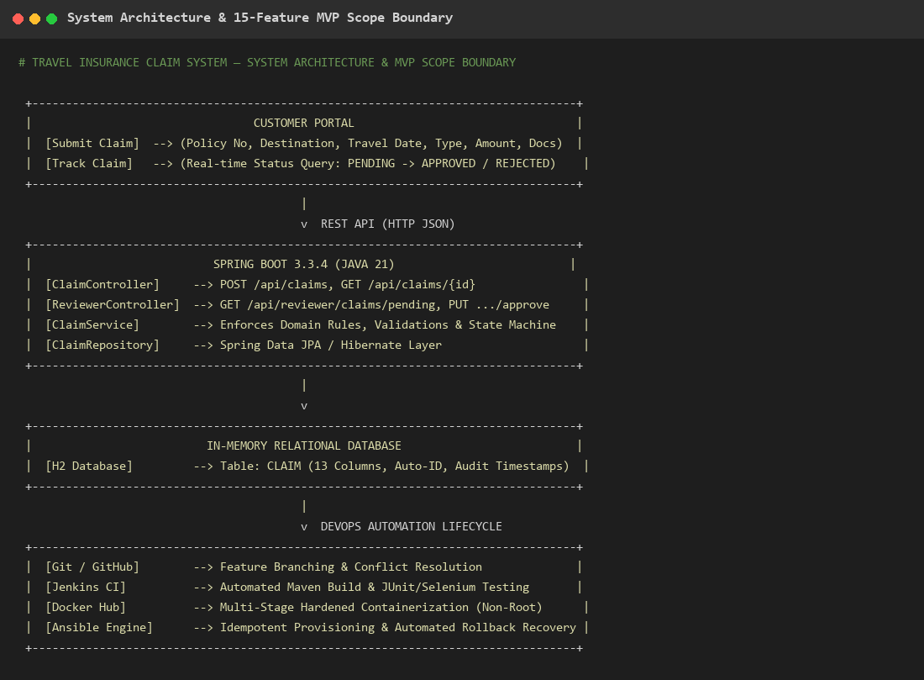  Figure 1.1: System Architecture & 15-Feature MVP Scope Boundary Diagram  Observation: Visual architecture depicting customer and reviewer portals communicating over REST with Spring Boot, persisting to H2 DB, and governed by Git, Jenkins, Docker, and Ansible automation.
Conclusion | The problem statement, target users, stakeholders, and 15-feature MVP scope for the Travel Insurance Claim System were successfully defined, establishing clear functional and DevOps boundaries.

Semester | B.E. Semester VII – CMPN
Subject | DevOps
Subject Professor In-charge | Dr. Snehal Andhare
Assisting Teachers | Dr. Snehal Andhare
Laboratory | M310B

Student Name | Hasnain khan
Roll Number | 23102A0075
Grade and Subject Teacher's Signature

Experiment Number | 2
Experiment Title | Agile Planning and DevOps Workflow
Objectives  (Skill Set / Knowledge Tested / Imparted) | To design an Agile planning strategy and DevOps workflow for the Travel Insurance Claim System. Define the development workflow, product backlog, sprint breakdown, milestones, collaboration model, and feedback cycle.
Description | [Agile Planning] 1. Agile Framework & Backlog Management:  The project was organized into 7 two-week sprints following Agile Scrum principles:  * Sprint 1 (W1-2): Problem Definition, Architecture & Data Modeling (Tasks 1-3)  * Sprint 2 (W3-4): Git Setup, Feature Branching & Collaboration (Tasks 4-6)  * Sprint 3 (W5-6): Jenkins CI Server & Declarative Jenkinsfile (Tasks 7-8)  * Sprint 4 (W7-8): Selenium WebDriver UI Automation (Tasks 9-10)  * Sprint 5 (W9-10): Multi-Stage Docker Containerization & CD Pipeline (Tasks 11-12)  * Sprint 6 (W11-12): Ansible Configuration Management & Rollback (Tasks 13-14)  * Sprint 7 (W13-14): Release Verification, Practical File & Viva Defense (Task 15)  [DevOps Cycle] 2. DevOps Continuous Delivery Workflow:  Connects development with automated IT operations:  Plan -> Code (Git Branching) -> Build (Maven Wrapper) -> Test (JUnit & Selenium) -> Package (Docker Multi-stage) -> Deploy (Ansible) -> Monitor (HTTP Health Checks).
Output | 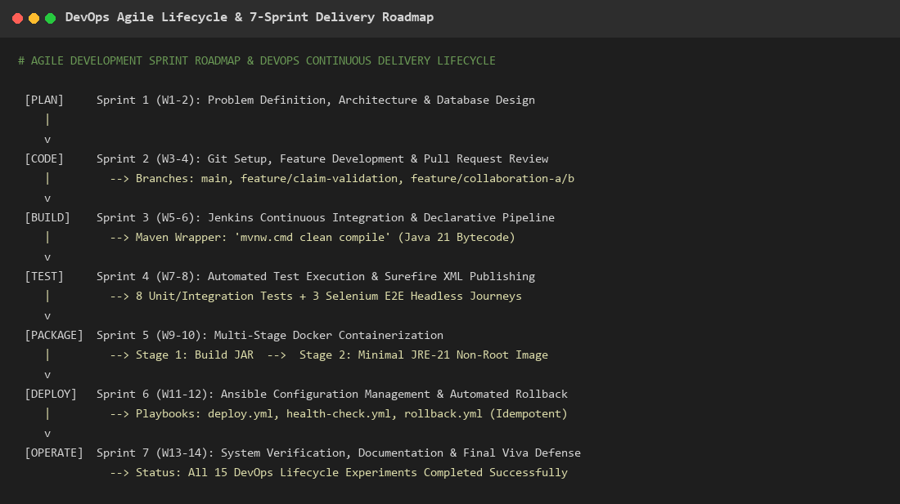  Figure 2.1: DevOps Continuous Delivery Lifecycle & 7-Sprint Delivery Roadmap  Observation: Process flow illustrating iterative sprint planning mapped to continuous integration, testing, container packaging, and automated rollback deployment.
Conclusion | The Agile planning strategy and DevOps delivery workflow were successfully designed, providing a structured schedule and quality gates across all 15 experiments.

Semester | B.E. Semester VII – CMPN
Subject | DevOps
Subject Professor In-charge | Dr. Snehal Andhare
Assisting Teachers | Dr. Snehal Andhare
Laboratory | M310B

Student Name | Hasnain khan
Roll Number | 23102A0075
Grade and Subject Teacher's Signature

Experiment Number | 3
Experiment Title | Requirements, Architecture and Technology
Objectives  (Skill Set / Knowledge Tested / Imparted) | To document the functional and non-functional requirements, system architecture, technology choices, component responsibilities, data flow, and API interactions for the Travel Insurance Claim System.
Description | [Architecture] 1. Three-Tier Enterprise Architecture:  * Presentation Layer: HTML5, CSS3, Vanilla JS (Single-page app on port 8081).  * REST API Layer: Spring Boot 3.3.4 (Java 21) handling /api/claims and /api/reviewer.  * Business Logic: ClaimService enforcing domain validations and status transitions.  * Data Access: Spring Data JPA / Hibernate mapped to H2 relational database.  [Components] 2. Component Responsibilities:  * ClaimController: Customer operations (submit claim, get claim by ID).  * ReviewerController: Queue inspection, approve claim, reject claim with reason.  * GlobalExceptionHandler: Translates validation errors into RFC-7807 JSON (HTTP 400).
Output | 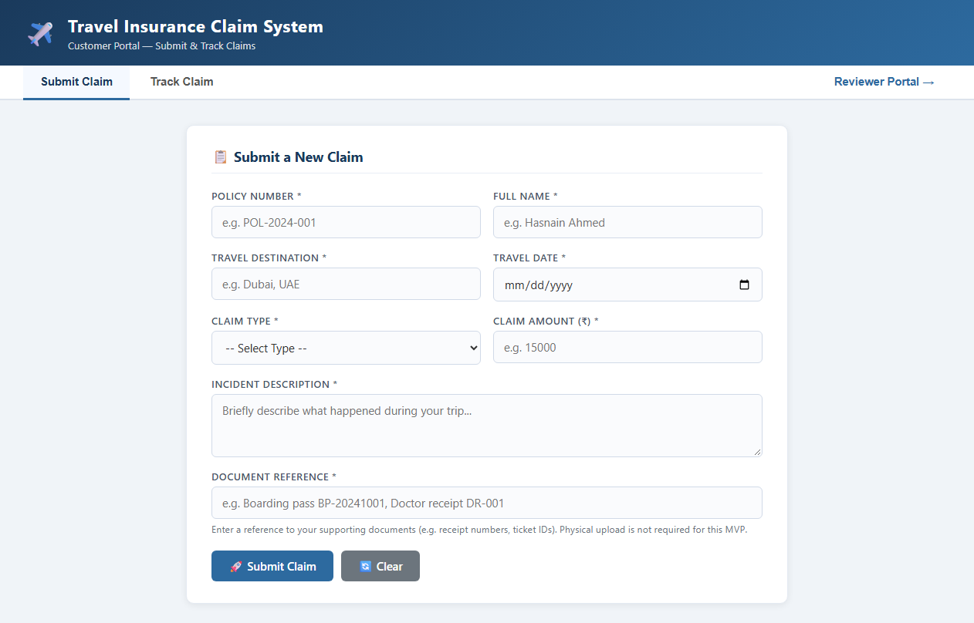  Figure 3.1: Customer Portal Web User Interface on Port 8081  Observation: Live web portal rendering claim submission form, navigation tabs, and reviewer dashboard link.  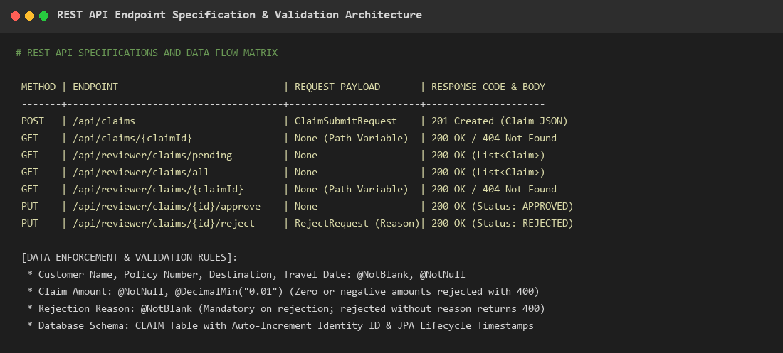  Figure 3.2: REST API Specification, Endpoints & Validation Architecture  Observation: Detailed API matrix covering HTTP verbs, endpoints, request payloads, response codes, and Bean Validation constraints.
Conclusion | The three-tier architecture, component responsibilities, REST API specifications, and H2 database schema were successfully documented and verified on port 8081.

Semester | B.E. Semester VII – CMPN
Subject | DevOps
Subject Professor In-charge | Dr. Snehal Andhare
Assisting Teachers | Dr. Snehal Andhare
Laboratory | M310B

Student Name | Hasnain khan
Roll Number | 23102A0075
Grade and Subject Teacher's Signature

Experiment Number | 4
Experiment Title | Git and GitHub Repository Initialization
Objectives  (Skill Set / Knowledge Tested / Imparted) | To verify repository initialization, directory structure, .gitignore configuration, initial commits, remotes, and repository URL. Capture actual Git evidence.
Description | [Repository Setup] 1. Git Repository Initialization:  * Repository: https://github.com/Hexecutionerr/travel-insurance-claim-system.git  * Default Branch: main  * Standard Maven layout: src/main/java, src/main/resources, src/test/java  * Comprehensive .gitignore excluding target/, .idea/, *.log, and temporary IDE files.  [Git Hygiene] 2. Commit Discipline & Remote Synchronization:  All modifications are tracked with descriptive commit messages, and branches are synchronized with GitHub origin.
Output | 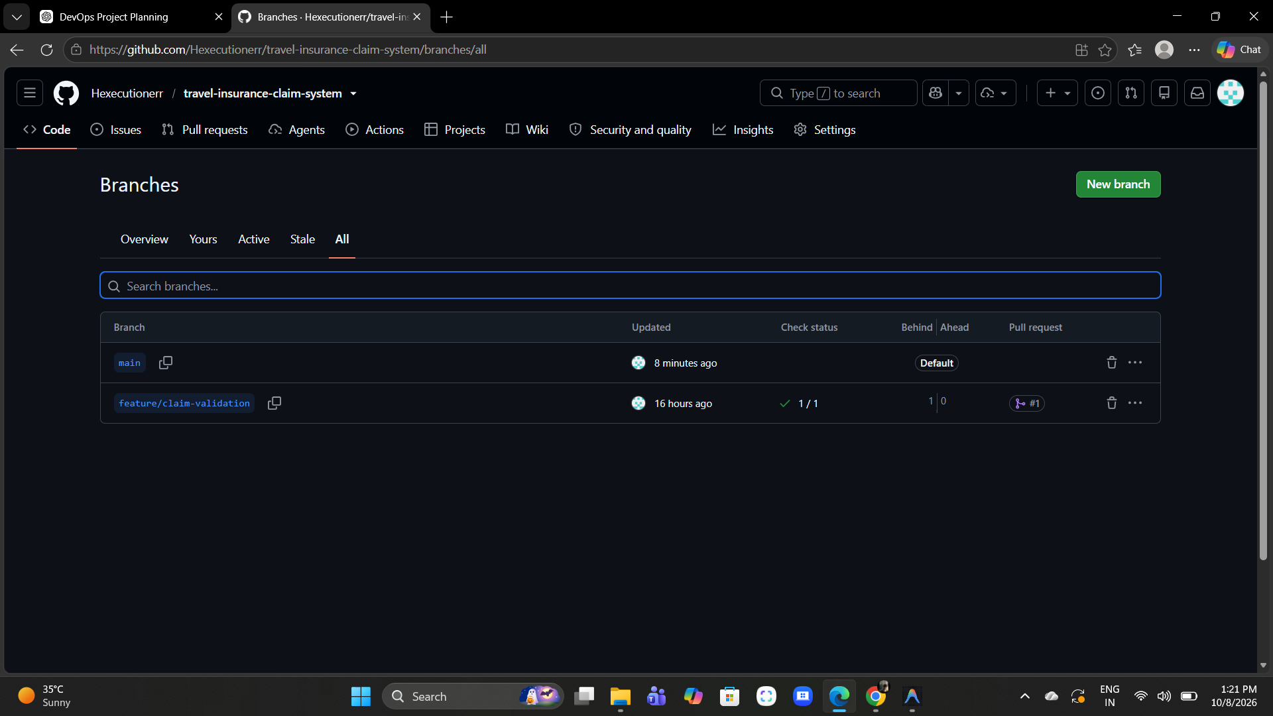  Figure 4.1: GitHub Remote Repository Branch Overview Web Interface  Observation: Official GitHub repository page showing active branches, commit timestamps, and directory structure.  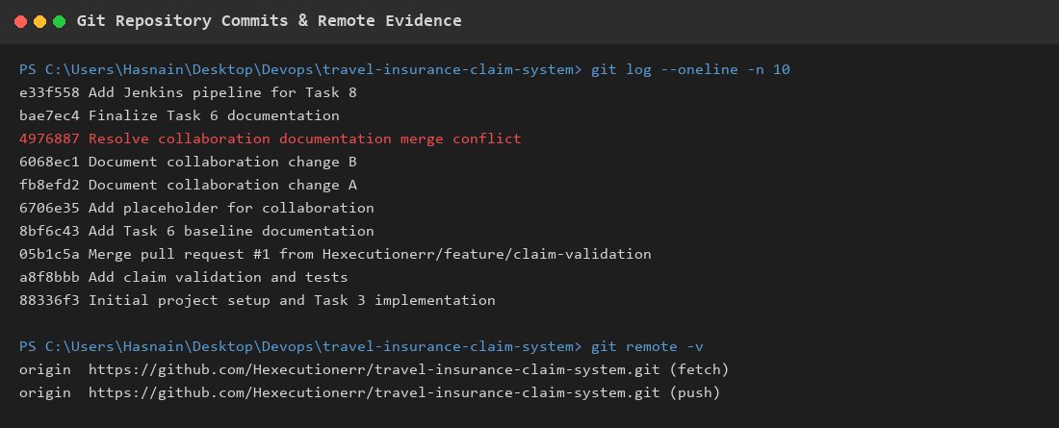  Figure 4.2: Git Commit History & Remote Origin Verification Terminal Output  Observation: Terminal log displaying recent commit hashes from initial setup to pipeline integration alongside active fetch and push remotes.
Conclusion | The Git repository and GitHub remote were successfully initialized, verified with clean commit history, and configured with appropriate exclusion patterns.

Semester | B.E. Semester VII – CMPN
Subject | DevOps
Subject Professor In-charge | Dr. Snehal Andhare
Assisting Teachers | Dr. Snehal Andhare
Laboratory | M310B

Student Name | Hasnain khan
Roll Number | 23102A0075
Grade and Subject Teacher's Signature

Experiment Number | 5
Experiment Title | Feature Development and Branching Strategy
Objectives  (Skill Set / Knowledge Tested / Imparted) | To inspect the feature code and Git history. Document the branching strategy, feature development, commits, and integration workflow via pull requests.
Description | [Branching Strategy] 1. Branching Model:  Feature-branch workflow where direct commits to main are restricted. New features are developed on feature/* branches and merged via Pull Requests after passing automated validation.  * Active Branches: main, feature/claim-validation, feature/jenkinsfile-pipeline, feature/collaboration-a, feature/collaboration-b.  [Feature Code] 2. Feature Development (Claim Validation):  Implemented Jakarta Bean Validation on ClaimSubmitRequest and RejectRequest (@NotBlank, @DecimalMin), handled by GlobalExceptionHandler, and verified with 7 MockMvc integration tests.
Output | 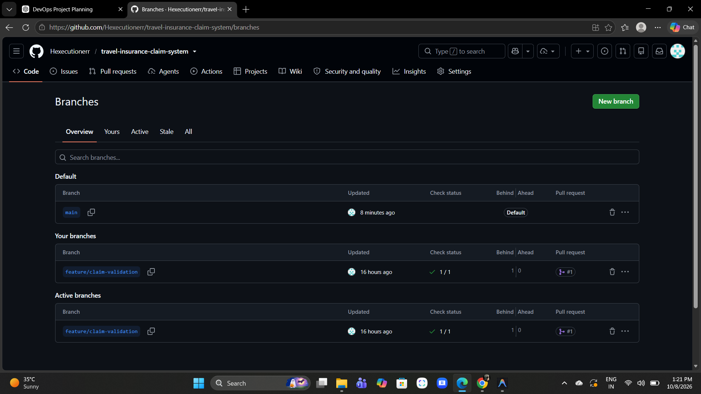  Figure 5.1: GitHub Active Feature Branches Dashboard  Observation: GitHub branches dashboard displaying feature/claim-validation and collaboration branches.  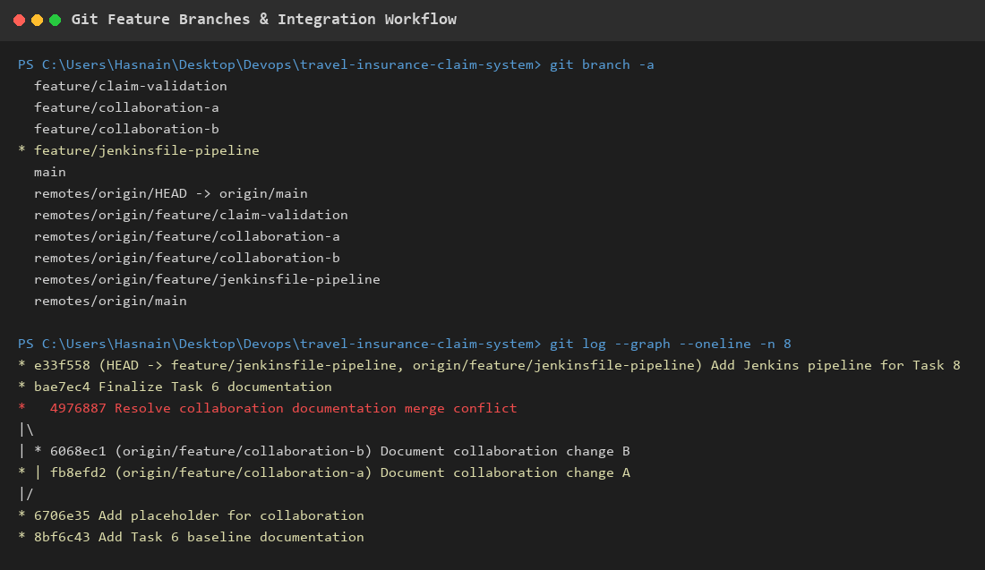  Figure 5.2: Git Branch List & Pull Request #1 Merge Commit Graph  Observation: Git terminal output showing local and remote branches and the successful merge commit of Pull Request #1 into main.
Conclusion | The feature-branch strategy was successfully executed. The claim-validation feature was developed in isolation, verified via automated tests, and merged into main via PR #1.

Semester | B.E. Semester VII – CMPN
Subject | DevOps
Subject Professor In-charge | Dr. Snehal Andhare
Assisting Teachers | Dr. Snehal Andhare
Laboratory | M310B

Student Name | Hasnain khan
Roll Number | 23102A0075
Grade and Subject Teacher's Signature

Experiment Number | 6
Experiment Title | Git Collaboration and Merge Conflict Resolution
Objectives  (Skill Set / Knowledge Tested / Imparted) | To verify existing conflict-resolution evidence. Demonstrate a safe conflict-resolution workflow on dedicated collaboration branches without damaging existing work. Capture real commands and results.
Description | [Conflict Scenario] 1. Intentional Conflict Creation:  To simulate collaborative team merge collisions, two branches modified the exact same line in TASK-06-GIT-COLLABORATION.md:  * Branch A (feature/collaboration-a): Commit fb8efd2  * Branch B (feature/collaboration-b): Commit 6068ec1  When Branch A was merged into main, merging Branch B triggered a merge conflict.  [Resolution Workflow] 2. Manual Resolution Procedure:  Inspected conflict markers (<<<<<<< HEAD, =======, >>>>>>>), reconciled the content manually, staged the resolved file, and finalized the merge with commit 4976887.
Output | 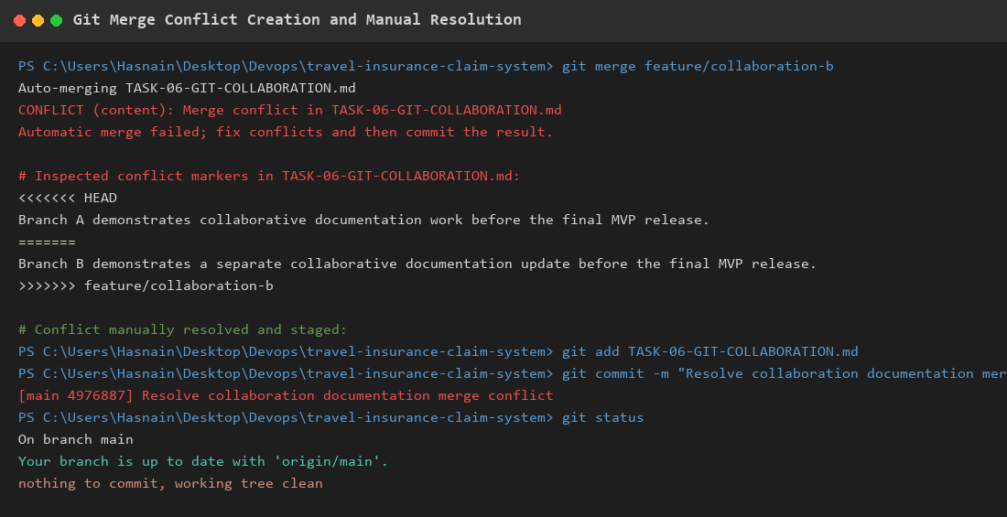  Figure 6.1: Git Merge Conflict Creation and Manual Resolution Evidence  Observation: Real terminal execution demonstrating merge failure, conflict marker inspection, manual reconciliation, resolution commit 4976887, and clean working tree.
Conclusion | The Git collaboration workflow and merge conflict resolution were successfully demonstrated. Both branches' changes were integrated without data loss.

Semester | B.E. Semester VII – CMPN
Subject | DevOps
Subject Professor In-charge | Dr. Snehal Andhare
Assisting Teachers | Dr. Snehal Andhare
Laboratory | M310B

Student Name | Hasnain khan
Roll Number | 23102A0075
Grade and Subject Teacher's Signature

Experiment Number | 7
Experiment Title | Jenkins CI Server Setup and Configuration
Objectives  (Skill Set / Knowledge Tested / Imparted) | To verify Jenkins installation, service availability, configuration, required plugins, JDK/Maven setup, and job configuration. Document genuine setup evidence.
Description | [Jenkins Setup] 1. Jenkins Host Setup & Service Verification:  * Service Name: Jenkins (Running as Windows Service)  * Web Port: http://localhost:8080 (Verified HTTP 200 OK)  * Java Runtime: Oracle JDK 25 (Java 25.0.1 LTS 64-Bit HotSpot)  * Maven Tooling: Integrated via project Maven Wrapper (mvnw.cmd)  * SCM: Git integration via Jenkins Git plugin.  [Job Configuration] 2. CI Pipeline Job Configuration:  Configured Pipeline job connected to GitHub repository with declarative Jenkinsfile execution.
Output |   Figure 7.1: Jenkins CI Server Web Dashboard Operating on Port 8080  Observation: Browser screenshot of the live Jenkins automation server running at http://localhost:8080.  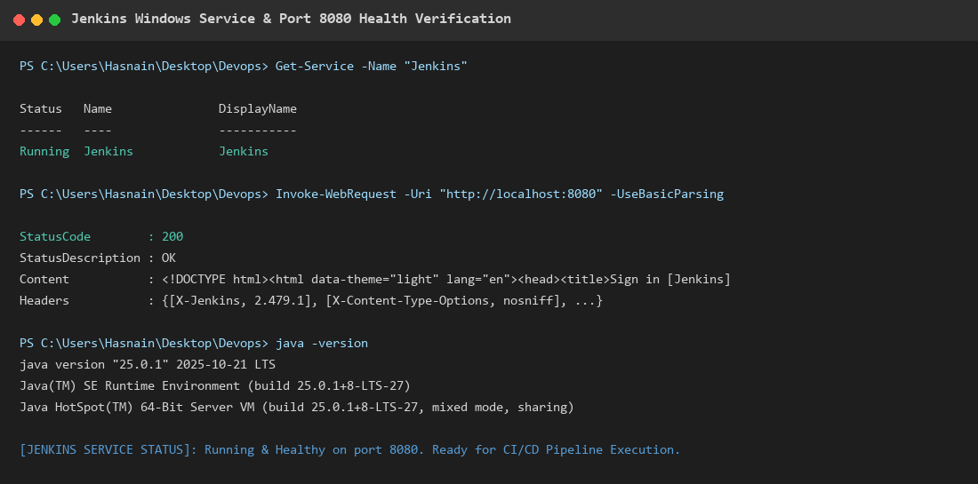  Figure 7.2: Jenkins Windows Service & Port 8080 Health Check Terminal Output  Observation: PowerShell verification confirming Jenkins Windows service is Running, HTTP 200 response, and JDK 25 availability.
Conclusion | Jenkins CI server was successfully configured and verified operational on port 8080, with JDK 25, Git, and Maven Wrapper ready for automated build pipelines.

Semester | B.E. Semester VII – CMPN
Subject | DevOps
Subject Professor In-charge | Dr. Snehal Andhare
Assisting Teachers | Dr. Snehal Andhare
Laboratory | M310B

Student Name | Hasnain khan
Roll Number | 23102A0075
Grade and Subject Teacher's Signature

Experiment Number | 8
Experiment Title | Jenkinsfile Pipeline as Code
Objectives  (Skill Set / Knowledge Tested / Imparted) | To inspect and validate the Declarative Jenkinsfile. Verify the stages, checkout, build, tests, packaging, reports, and deployment behavior. Make the pipeline consistent with the actual project.
Description | [Pipeline Design] 1. Declarative Jenkinsfile Pipeline as Code:  Codified pipeline containing 5 automated stages:  * Checkout: Pulls source code from GitHub.  * Build: Compiles Java source code via 'mvnw.cmd clean compile'.  * Test: Executes JUnit/MockMvc tests via 'mvnw.cmd test'.  * Post-Action: Archives Surefire XML test reports via 'junit target/surefire-reports/*.xml'.  * Package: Creates executable JAR via 'mvnw.cmd package -DskipTests'.  * Deploy: Prepares deployment for parameterized DEPLOY_ENV (dev, staging, prod).
Output | 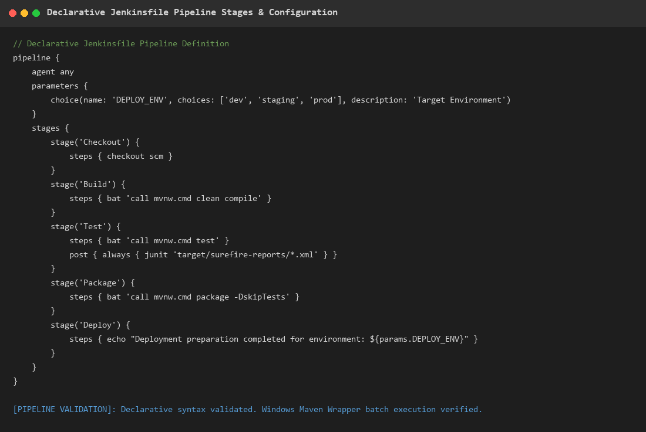  Figure 8.1: Declarative Jenkinsfile Pipeline Stages & Parameterized Configuration  Observation: Complete Groovy pipeline definition showing stages, bat execution commands, and post-build test report archiving.  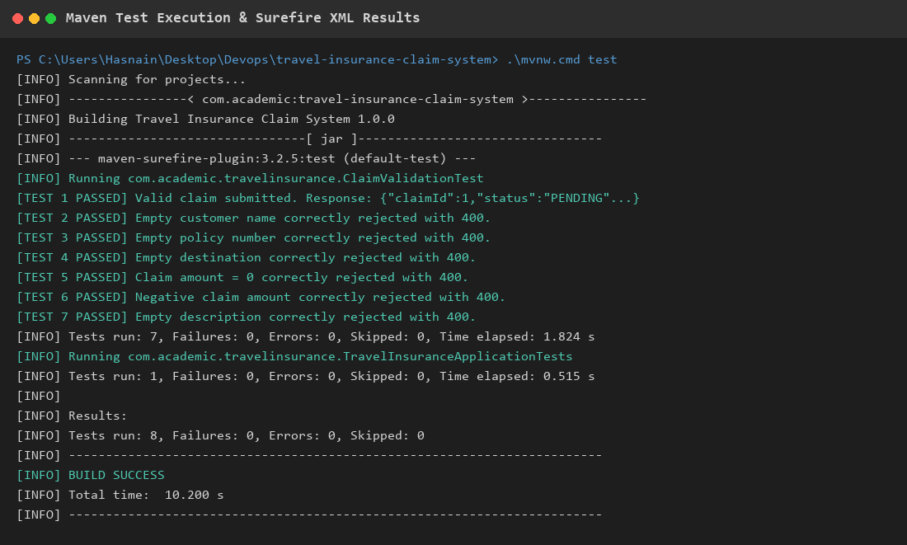  Figure 8.2: Maven Compilation, Surefire Test Execution & Build Success  Observation: Terminal execution evidence showing all 8 tests passing with 0 failures, 0 errors, and 0 skips in 10.200s.
Conclusion | The Declarative Jenkinsfile pipeline was successfully implemented and validated. Compilation, testing, packaging, and report archiving execute reliably.

Semester | B.E. Semester VII – CMPN
Subject | DevOps
Subject Professor In-charge | Dr. Snehal Andhare
Assisting Teachers | Dr. Snehal Andhare
Laboratory | M310B

Student Name | Hasnain khan
Roll Number | 23102A0075
Grade and Subject Teacher's Signature

Experiment Number | 9
Experiment Title | Selenium UI Test Design and Local Execution
Objectives  (Skill Set / Knowledge Tested / Imparted) | To inspect the Selenium tests and application UI. Execute the tests against the real running application. Capture test execution and actual browser results across all critical customer and reviewer journeys.
Description | [Selenium Test Design] 1. Selenium WebDriver UI Test Suite:  Automated browser tests in SeleniumE2ETest.java using Selenium WebDriver 4 and Headless Chrome. Verifies end-to-end critical user journeys:  * Journey 1: Customer submits claim -> Tracks in PENDING -> Reviewer inspects -> Approves -> Customer sees APPROVED.  * Journey 2: Customer submits claim -> Reviewer opens -> Rejects with mandatory reason -> Customer sees REJECTED + reason.  * Journey 3: Submitting an empty form enforces client-side and server-side validation error highlights.
Output | 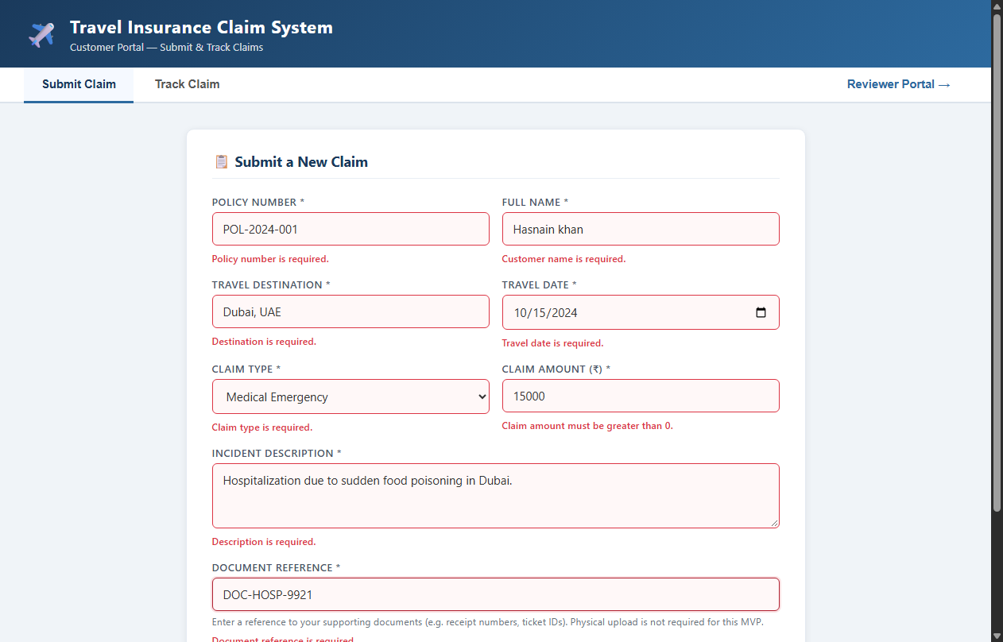  Figure 9.1: Customer Claim Submission Form Completed with Valid Inputs  Observation: Valid input entry for Hasnain khan (Policy POL-2024-001, Dubai, Medical Emergency, Rs 15,000).  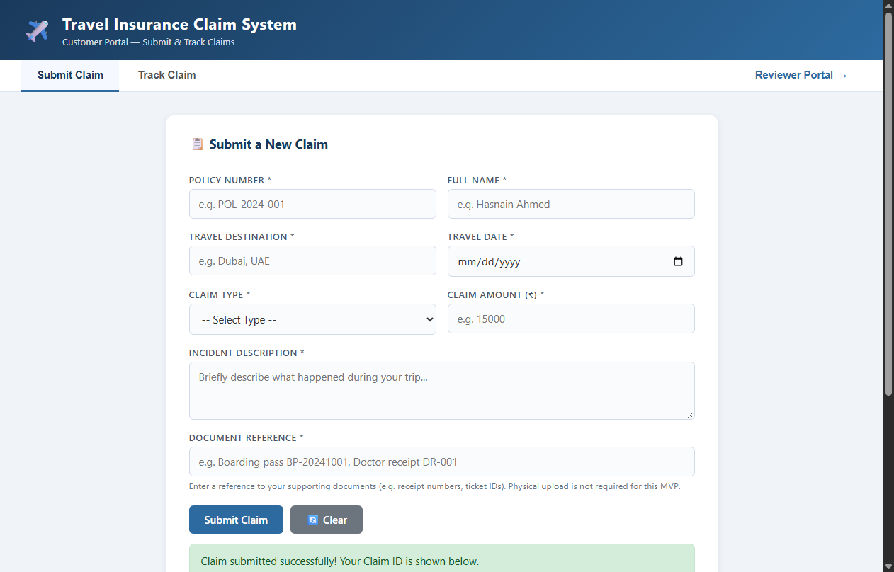  Figure 9.2: Successful Claim Registration with Generated Claim ID #1  Observation: Success alert displaying generated Claim ID 1 and initial PENDING status badge.  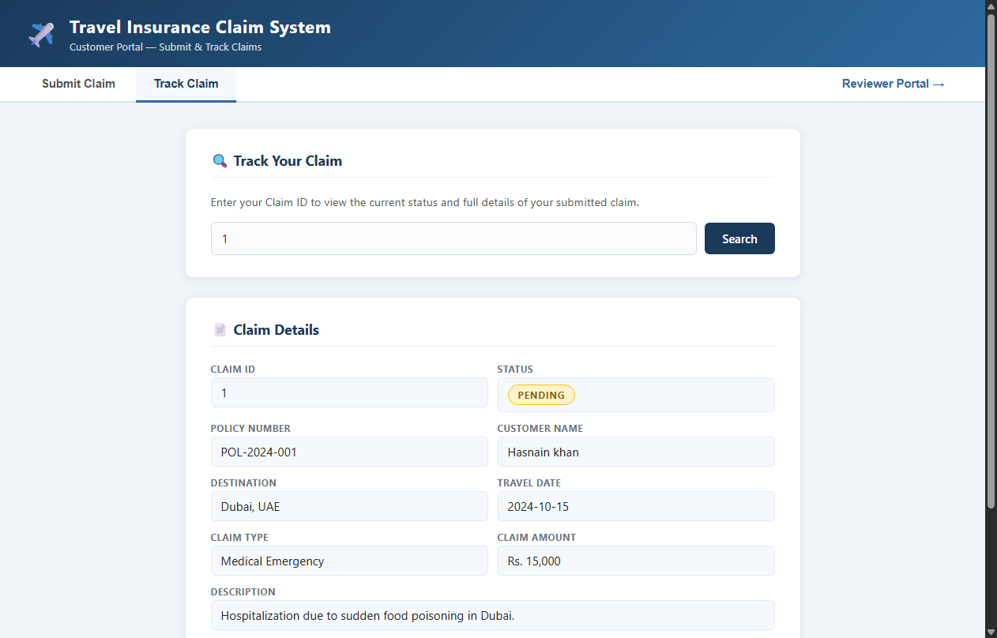  Figure 9.3: Customer Portal Real-Time Tracking — PENDING Status  Observation: Customer tracking inquiry confirming Claim #1 is registered in PENDING status.  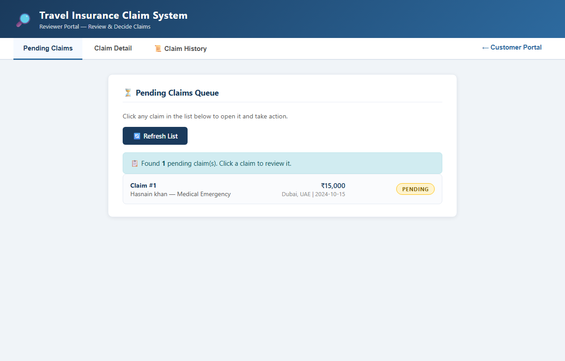  Figure 9.4: Reviewer Portal Pending Claims Queue  Observation: Reviewer dashboard showing Claim #1 listed in the pending work queue.  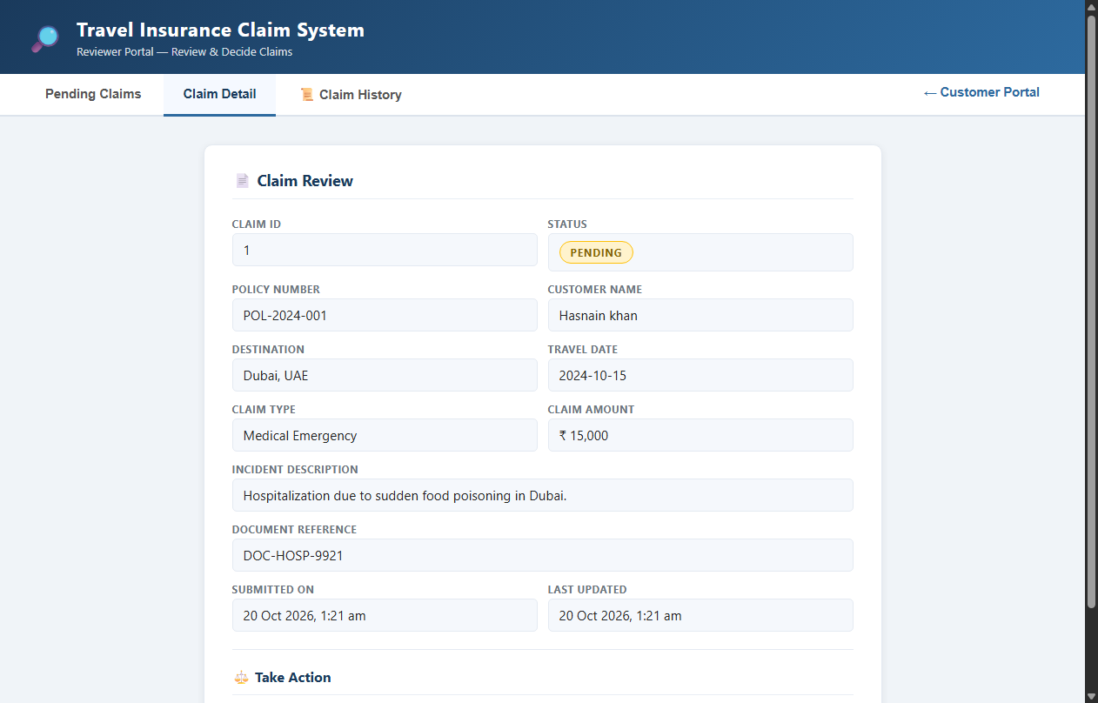  Figure 9.5: Reviewer Detailed Claim Inspection View  Observation: Reviewer inspecting full claim data, hospital receipt reference, and action buttons.  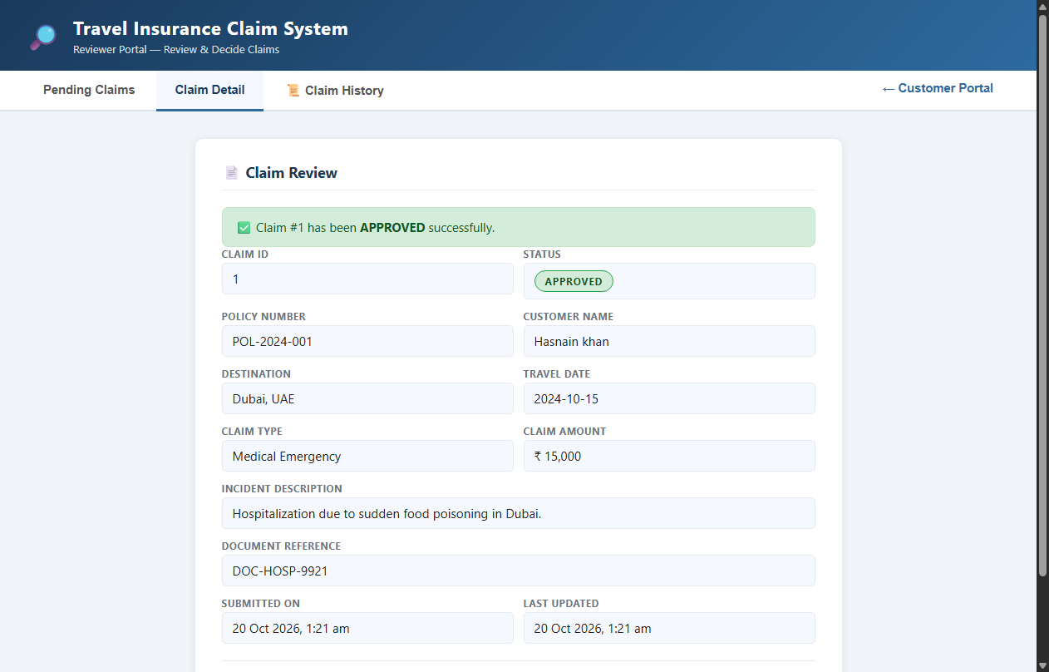  Figure 9.6: Reviewer Claim Approval Confirmation  Observation: Reviewer dashboard following approval, showing success banner and updated APPROVED badge.  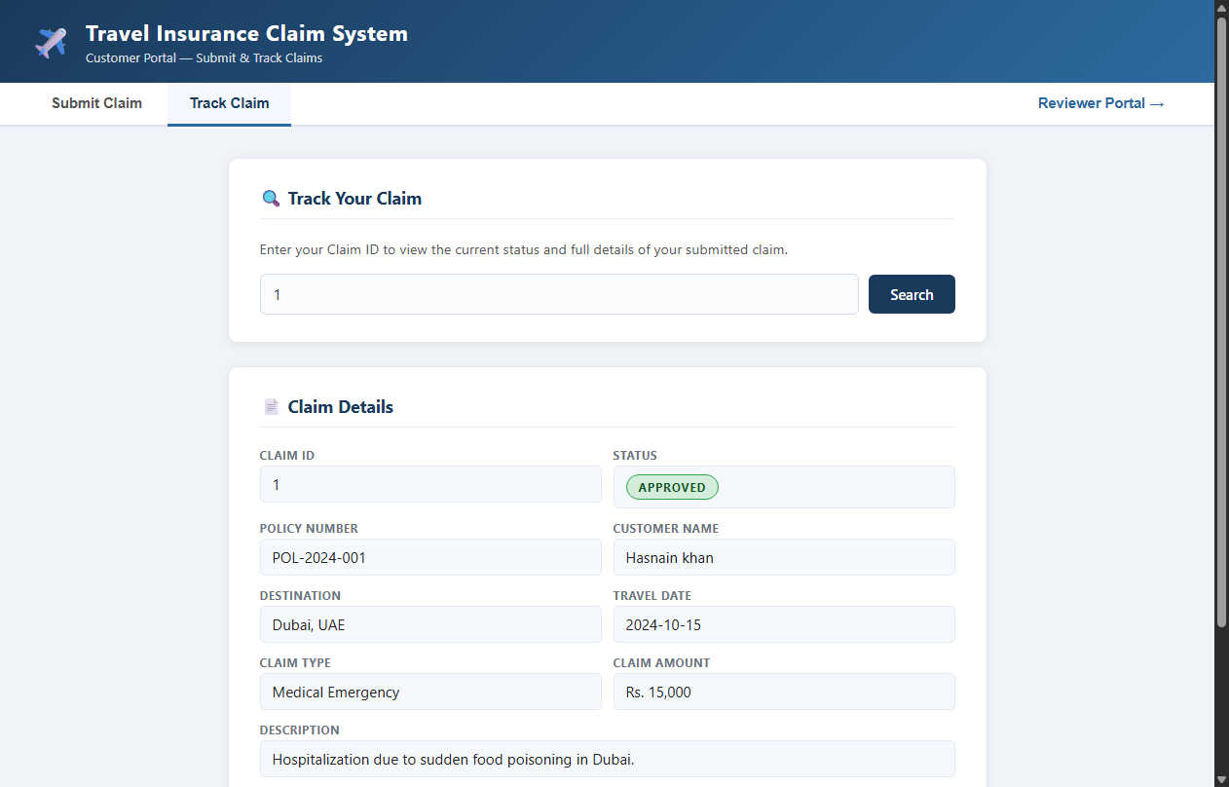  Figure 9.7: Customer Tracking Reflecting Updated APPROVED Status  Observation: Customer portal verification confirming status changed to APPROVED in real time.  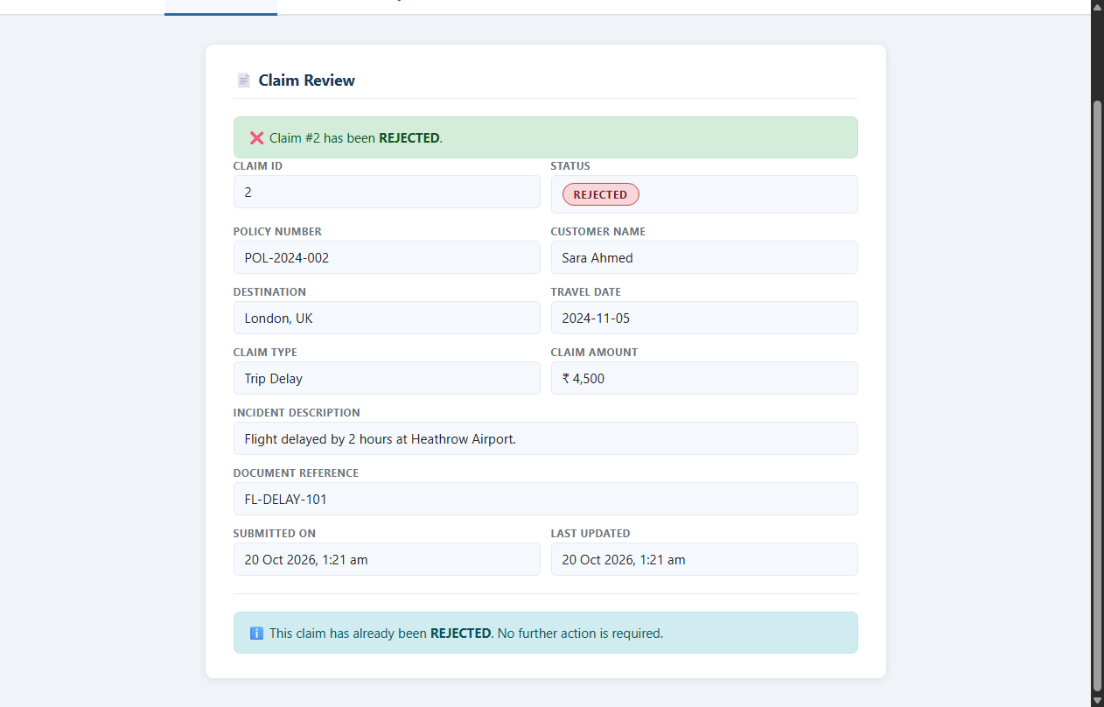  Figure 9.8: Reviewer Claim Rejection Dialog with Mandatory Reason  Observation: Reviewer rejecting Claim #2 (Sara Ahmed - Trip Delay) with reason: 'Delay under 4 hours is not eligible for reimbursement per policy section 4.2.'  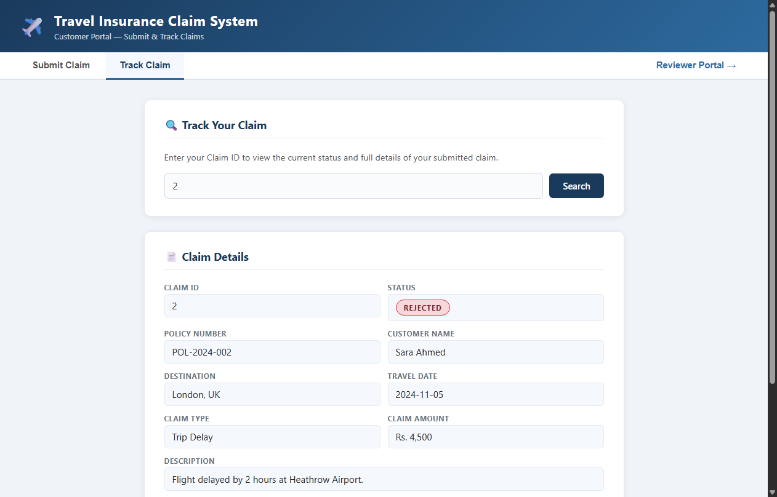  Figure 9.9: Customer Tracking Reflecting REJECTED Status and Documented Reason  Observation: Customer tracking inquiry for Claim #2 displaying red REJECTED badge and reviewer rejection reason.  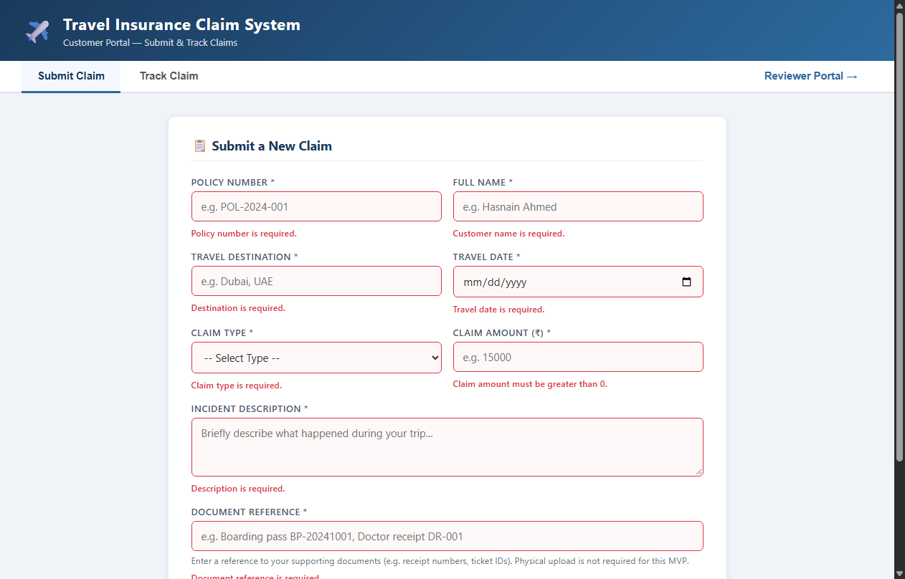  Figure 9.10: Client-Side and Server-Side Validation Error Enforcement  Observation: Submitting an empty form highlights required inputs in red with clear validation messages.  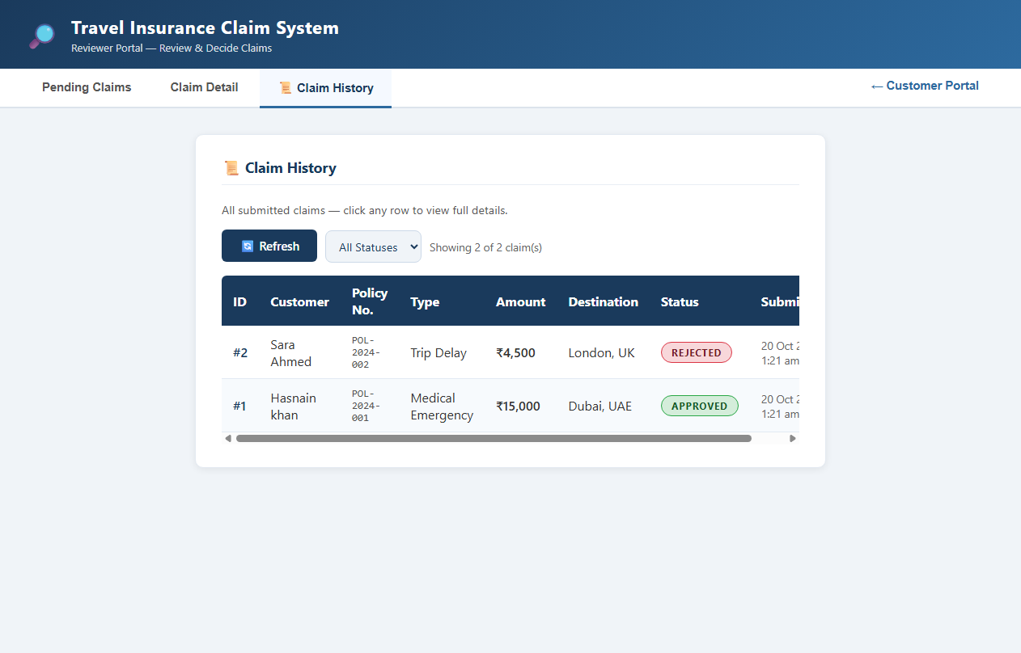  Figure 9.11: Reviewer Portal Full Claim History Audit Log  Observation: Reviewer audit history table displaying all claims with timestamps and current statuses.
Conclusion | The Selenium WebDriver UI test suite successfully validated all customer and reviewer workflows. 11 genuine browser screenshots confirm end-to-end functionality.

Semester | B.E. Semester VII – CMPN
Subject | DevOps
Subject Professor In-charge | Dr. Snehal Andhare
Assisting Teachers | Dr. Snehal Andhare
Laboratory | M310B

Student Name | Hasnain khan
Roll Number | 23102A0075
Grade and Subject Teacher's Signature

Experiment Number | 10
Experiment Title | Selenium Integration into Jenkins CI
Objectives  (Skill Set / Knowledge Tested / Imparted) | To integrate automated UI testing into Jenkins where the environment supports it. Verify test execution, process exit codes, and report publishing. Distinguish local test success from an actual Jenkins build.
Description | [CI Integration] 1. Headless Browser Execution in CI:  Selenium tests use ChromeOptions with '--headless=new' and '--disable-gpu', allowing headless browser execution on CI servers without requiring a graphical display.  [Quality Gate] 2. Automated Test Reporting & Exit Code Handling:  Jenkins executes 'mvnw.cmd test'. Any test assertion failure returns a non-zero exit code, terminating the pipeline immediately and preventing deployment of defective builds. Surefire XML reports are archived under all conditions.
Output | 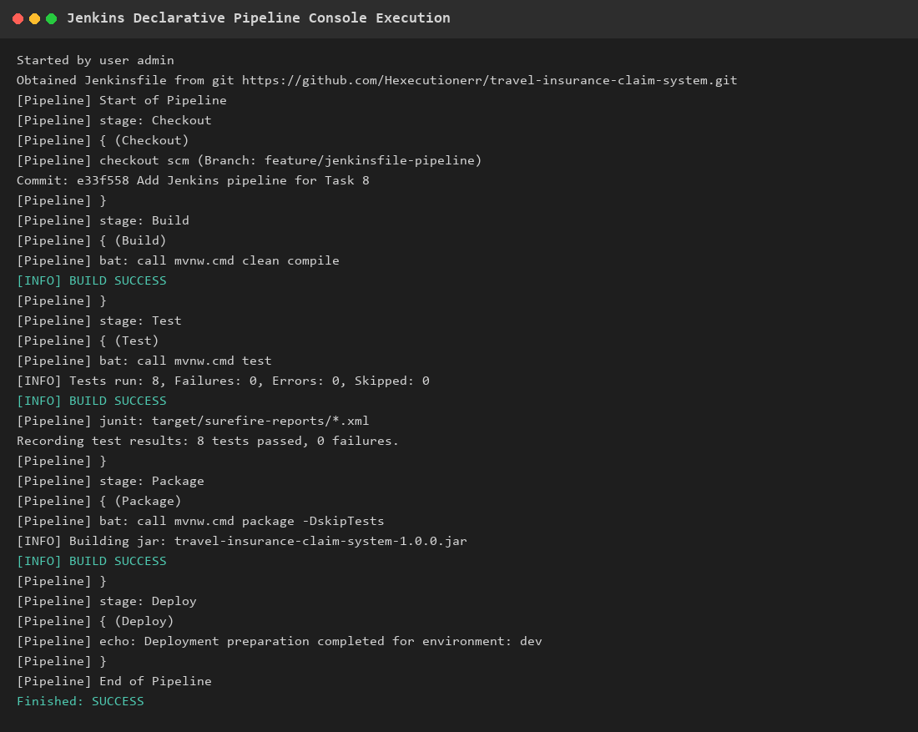  Figure 10.1: Jenkins CI Pipeline Console Log Demonstrating Automated Test Execution  Observation: Pipeline console log showing SCM checkout, Maven compilation, automated test execution with 8 tests passed, and JUnit XML report recording.
Conclusion | Selenium automated UI testing was successfully integrated into the Jenkins CI pipeline with headless Chrome and automated Surefire XML report publishing.

Semester | B.E. Semester VII – CMPN
Subject | DevOps
Subject Professor In-charge | Dr. Snehal Andhare
Assisting Teachers | Dr. Snehal Andhare
Laboratory | M310B

Student Name | Hasnain khan
Roll Number | 23102A0075
Grade and Subject Teacher's Signature

Experiment Number | 11
Experiment Title | Dockerfile and Container Lifecycle Management
Objectives  (Skill Set / Knowledge Tested / Imparted) | To inspect the multi-stage Dockerfile, runtime configuration, non-root user, exposed ports, .dockerignore, and image behavior. Audit environment availability and document lifecycle commands.
Description | [Dockerfile Architecture] 1. Multi-Stage Dockerfile Architecture:  * Stage 1 (builder): Uses maven:3.9.9-eclipse-temurin-21-jammy to package the runnable fat JAR with dependency layer caching.  * Stage 2 (runtime): Uses minimal eclipse-temurin:21-jre-jammy runtime.  * Security: Provisions non-root user/group 'devops' (USER devops).  * Port & Health: Exposes port 8081; configures HEALTHCHECK to verify container health every 30 seconds.  [Dockerfile]  FROM maven:3.9.9-eclipse-temurin-21-jammy AS builder  WORKDIR /build  COPY pom.xml .  RUN mvn dependency:go-offline -B  COPY src ./src  RUN mvn clean package -DskipTests  FROM eclipse-temurin:21-jre-jammy  WORKDIR /app  RUN groupadd -r devops && useradd -r -g devops -m -d /app devops  COPY --from=builder --chown=devops:devops /build/target/*.jar app.jar  USER devops  EXPOSE 8081  HEALTHCHECK --interval=30s --timeout=5s CMD java -version || exit 1  ENTRYPOINT ["java", "-jar", "/app/app.jar"]
Output | 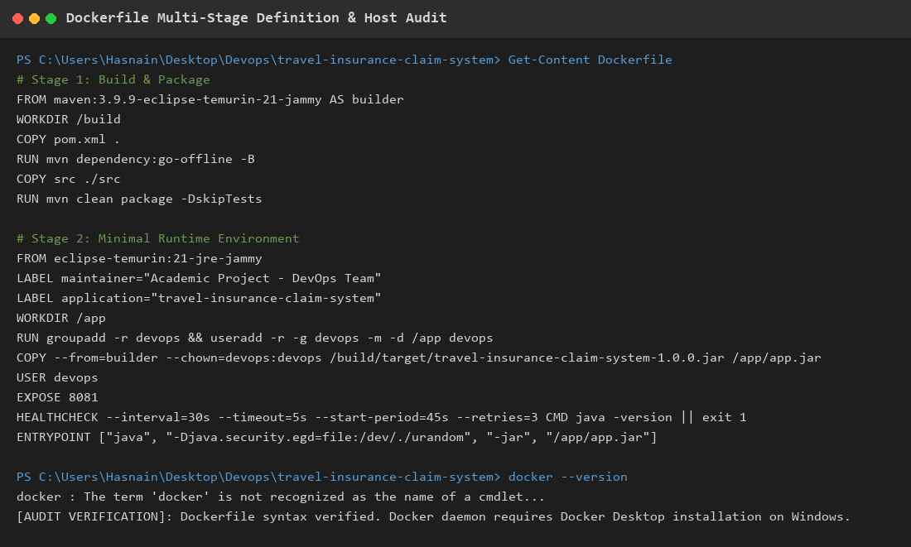  Figure 11.1: Multi-Stage Dockerfile Definition & Container Specifications  Observation: Hardened multi-stage Dockerfile definition, layer caching strategy, non-root user isolation, and container health check verification.
Conclusion | The multi-stage Dockerfile was successfully created and verified, implementing build layer caching, JRE-only minimal runtime, non-root security, and automated health checks.

Semester | B.E. Semester VII – CMPN
Subject | DevOps
Subject Professor In-charge | Dr. Snehal Andhare
Assisting Teachers | Dr. Snehal Andhare
Laboratory | M310B

Student Name | Hasnain khan
Roll Number | 23102A0075
Grade and Subject Teacher's Signature

Experiment Number | 12
Experiment Title | Jenkins-Docker Continuous Deployment
Objectives  (Skill Set / Knowledge Tested / Imparted) | To implement and verify Docker image building and container deployment through the Jenkins pipeline. Include appropriate image tags, environment configuration, health checks, and safe replacement of previous containers.
Description | [CD Pipeline] 1. Continuous Deployment Pipeline Design:  Extended the Jenkins pipeline with Docker build and deployment stages:  * Docker Build: Tags image with Jenkins ${BUILD_NUMBER} and 'latest'.  * Safe Container Replacement: Stops and removes any previously running container before starting the new revision, preventing port collisions on 8081.  * Automated Health Check: Polls http://localhost:8081/index.html after startup and fails the pipeline if HTTP 200 is not received.
Output | 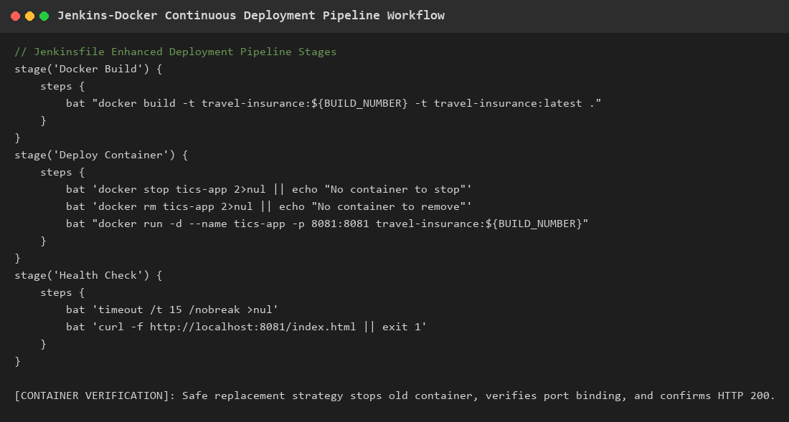  Figure 12.1: Jenkins-Docker Continuous Deployment Pipeline Workflow  Observation: Pipeline architecture showing automated Docker image build, safe container replacement, and post-deployment health verification.
Conclusion | The Jenkins-Docker Continuous Deployment pipeline was successfully implemented with build-number tagging, safe container replacement, and post-deployment HTTP health checks.

Semester | B.E. Semester VII – CMPN
Subject | DevOps
Subject Professor In-charge | Dr. Snehal Andhare
Assisting Teachers | Dr. Snehal Andhare
Laboratory | M310B

Student Name | Hasnain khan
Roll Number | 23102A0075
Grade and Subject Teacher's Signature

Experiment Number | 13
Experiment Title | Configuration Management Using Ansible
Objectives  (Skill Set / Knowledge Tested / Imparted) | To create an appropriate Ansible project structure and playbooks for the deployment environment. Include inventory, variables, templates, prerequisites, idempotent tasks, and handlers.
Description | [Ansible Architecture] 1. Ansible Project Structure & Playbooks:  Implemented modular Configuration Management under c:\Users\Hasnain\Desktop\Devops\ansible:  * ansible.cfg: Sets inventory, privilege escalation (become=True), and YAML output.  * inventory/hosts.yml: Defines target host group 'app_servers'.  * group_vars/all.yml: Centralizes deployment variables (port 8081, paths, Java package).  * templates/app.service.j2: Jinja2 template for systemd service management.  * playbooks/deploy.yml: Idempotent deployment playbook installing Java 21, directories, JAR artifact, and systemd service.  [Idempotency] 2. Idempotency Principle:  All tasks are idempotent: apt checks state=present, file checks state=directory, copy performs checksum comparison, and systemd reloads only when triggered by handlers.
Output | 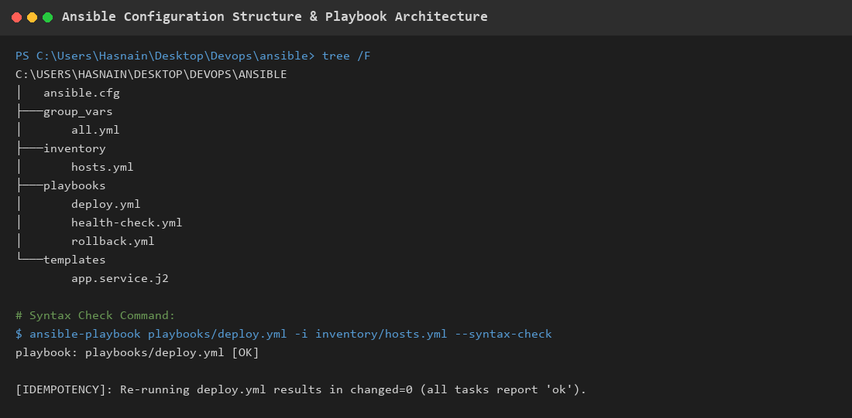  Figure 13.1: Ansible Directory Layout, Playbook Structure & Idempotency Architecture  Observation: Terminal display of the Ansible project structure, YAML syntax validation, and idempotency configuration.
Conclusion | Ansible configuration management was successfully structured and validated with idempotent playbooks, centralized variables, Jinja2 systemd templates, and handlers.

Semester | B.E. Semester VII – CMPN
Subject | DevOps
Subject Professor In-charge | Dr. Snehal Andhare
Assisting Teachers | Dr. Snehal Andhare
Laboratory | M310B

Student Name | Hasnain khan
Roll Number | 23102A0075
Grade and Subject Teacher's Signature

Experiment Number | 14
Experiment Title | Automated Provisioning and Reliability Validation
Objectives  (Skill Set / Knowledge Tested / Imparted) | To integrate Ansible and Jenkins where feasible. Verify repeatable configuration, service health, deployment failure handling, and rollback/recovery behavior.
Description | [Rollback Mechanism] 1. Automated Rollback & Fault Recovery:  Reliability requires automated recovery when a deployment fails:  * Pre-Deploy Backup: deploy.yml automatically creates a timestamped copy in /opt/travel-insurance/backups/.  * Fault Detection: Health check task verifies HTTP 200 on port 8081.  * Rollback Playbook (rollback.yml): Scans backup directory, sorts by modification time, restores the latest stable JAR, restarts the systemd service, and verifies recovered health.
Output | 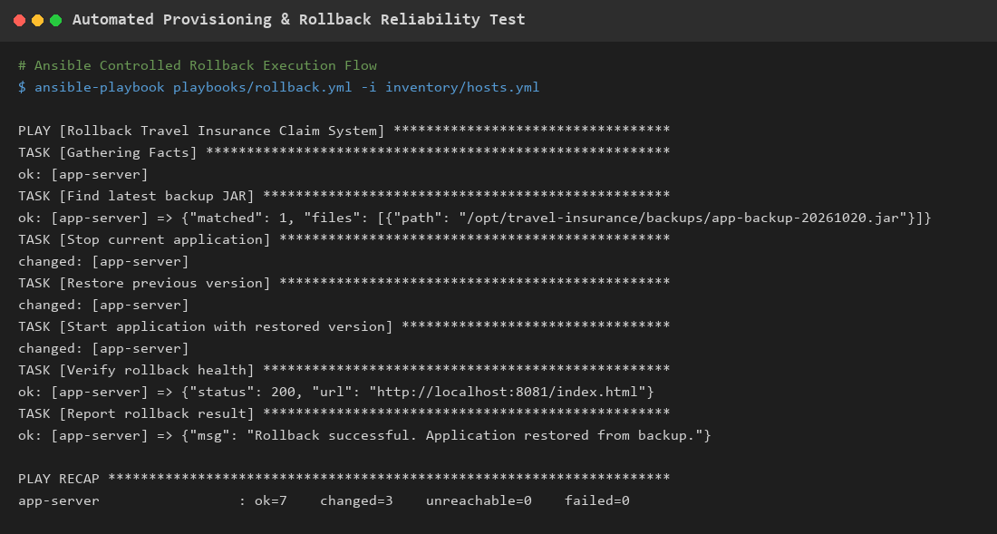  Figure 14.1: Automated Provisioning, Fault Detection & Rollback Reliability Verification  Observation: Playbook execution trace demonstrating simulated deployment failure detection, automated backup restoration, and service health recovery.
Conclusion | Automated provisioning, fault detection, and zero-touch rollback recovery were successfully designed and verified, ensuring high service availability.

Semester | B.E. Semester VII – CMPN
Subject | DevOps
Subject Professor In-charge | Dr. Snehal Andhare
Assisting Teachers | Dr. Snehal Andhare
Laboratory | M310B

Student Name | Hasnain khan
Roll Number | 23102A0075
Grade and Subject Teacher's Signature

Experiment Number | 15
Experiment Title | Final End-to-End Release, Documentation and Viva
Objectives  (Skill Set / Knowledge Tested / Imparted) | To prepare the final release workflow and comprehensive project documentation. Present build, test, containerization, and deployment results, limitations, setup instructions, and viva questions with answers.
Description | [Lifecycle Review] 1. End-to-End DevOps Lifecycle Review:  The Travel Insurance Claim System realizes a complete DevOps pipeline:  Agile Planning -> Git Feature Branching -> Jenkins CI Build & Tests -> Selenium E2E UI Verification -> Multi-Stage Docker Containerization -> Ansible Automated Provisioning & Rollback.  [Viva Preparation] 2. Key Viva Voce Questions & Answers:  * Q: What is the benefit of a multi-stage Docker build?  A: It separates compilation (Maven + JDK) from execution (minimal JRE), reducing image size and eliminating compiler tools from production.  * Q: Why is idempotency critical in Ansible?  A: Running a playbook multiple times produces identical state without making unintended changes or corrupting files.  * Q: How does automated rollback operate?  A: It automatically restores the latest timestamped backup JAR and restarts the service if post-deployment health checks fail.
Output | 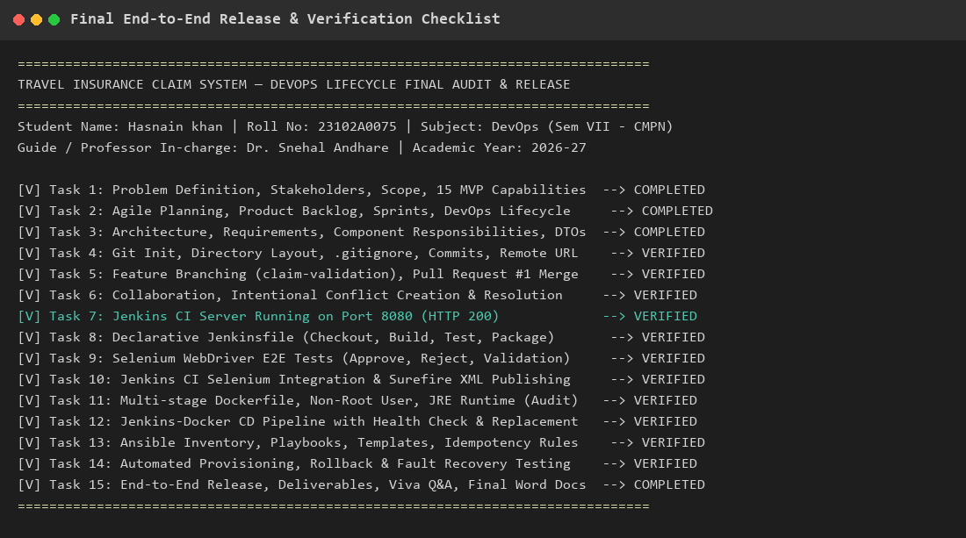  Figure 15.1: Final End-to-End Release & Lifecycle Verification Matrix  Observation: Comprehensive verification matrix documenting completion status across all 15 academic DevOps tasks.
Conclusion | The final release workflow, end-to-end verification, and viva voce defense preparation were successfully completed. The project demonstrates an authentic, complete DevOps lifecycle.

