Semester | B.E. Semester VII – CMPN
Subject | DevOps
Subject Professor In-charge | Dr. Snehal Andhare
Assisting Teachers | Dr. Snehal Andhare
Laboratory | M310B

Student Name | Hasnain khan
Roll Number | 23102A0075
Grade and Subject Teacher's Signature

Experiment Number | 1
Experiment Title | Problem Definition and Scope
Objectives  (Skill Set / Knowledge Tested / Imparted) | To study the real-time need for the Travel Insurance Claim System, identify target users, existing pain points, stakeholders, constraints, and measurable success criteria. Freeze a small 15-feature MVP scope.
Description | [Title] Project Title: Travel Insurance Claim System — DevOps Lifecycle  [Problem Definition] 1. Problem Statement:  Travel insurance claims have traditionally suffered from paper-based or manual email submissions, unverified data entry, and opaque communication. Reviewers lack structured pending queues, and customers have no visibility into claim status. Without automated DevOps pipelines, software updates risk configuration drift, manual deployment faults, and regression errors.  [Stakeholders] 2. Real-World Need & Target Users:  * Customer: Submits claims with policy and travel receipts; tracks live status.  * Reviewer: Validates claim documents; performs one-click approval or rejection with mandatory reason.  * DevOps/QA: Automates unit/E2E testing, container builds, and deployment rollback.  [Scope] 3. 15-Feature MVP Scope:  1. Customer Claim Submission 2. Client-Side Validation 3. Server-Side Bean Validation 4. Unique Claim ID Generation 5. PENDING Status Lifecycle 6. Customer Status Tracking 7. Reviewer Pending Queue 8. Claim Inspection View 9. Approval Action 10. Rejection with Reason 11. Claim History Audit Log 12. In-Memory H2 DB 13. Maven CI Compilation & Tests 14. Multi-Stage Docker Container 15. Ansible Provisioning & Rollback.
Output | 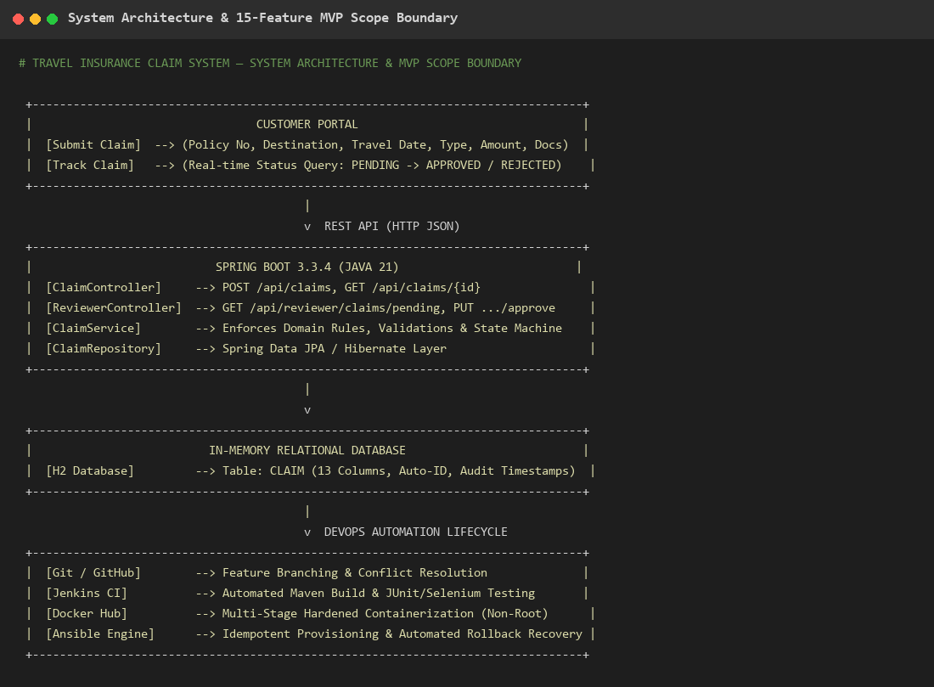  Figure 1.1: System Architecture & 15-Feature MVP Scope Boundary Diagram  Observation: Visual architecture depicting customer and reviewer portals communicating over REST with Spring Boot, persisting to H2 DB, and governed by Git, Jenkins, Docker, and Ansible automation.
Conclusion | The problem statement, target users, stakeholders, and 15-feature MVP scope for the Travel Insurance Claim System were successfully defined, establishing clear functional and DevOps boundaries.

