Semester | B.E. Semester VII – CMPN
Subject | DevOps
Subject Professor In-charge | Dr. Snehal Andhare
Assisting Teachers | Dr. Snehal Andhare
Laboratory | M310B

Student Name | Hasnain khan
Roll Number | 23102A0075
Grade and Subject Teacher's Signature

Experiment Number | 2
Experiment Title | Agile Planning and DevOps Workflow
Objectives  (Skill Set / Knowledge Tested / Imparted) | To design an Agile planning strategy and DevOps workflow for the Travel Insurance Claim System. Define the development workflow, product backlog, sprint breakdown, milestones, collaboration model, and feedback cycle.
Description | [Agile Planning] 1. Agile Framework & Backlog Management:  The project was organized into 7 two-week sprints following Agile Scrum principles:  * Sprint 1 (W1-2): Problem Definition, Architecture & Data Modeling (Tasks 1-3)  * Sprint 2 (W3-4): Git Setup, Feature Branching & Collaboration (Tasks 4-6)  * Sprint 3 (W5-6): Jenkins CI Server & Declarative Jenkinsfile (Tasks 7-8)  * Sprint 4 (W7-8): Selenium WebDriver UI Automation (Tasks 9-10)  * Sprint 5 (W9-10): Multi-Stage Docker Containerization & CD Pipeline (Tasks 11-12)  * Sprint 6 (W11-12): Ansible Configuration Management & Rollback (Tasks 13-14)  * Sprint 7 (W13-14): Release Verification, Practical File & Viva Defense (Task 15)  [DevOps Cycle] 2. DevOps Continuous Delivery Workflow:  Connects development with automated IT operations:  Plan -> Code (Git Branching) -> Build (Maven Wrapper) -> Test (JUnit & Selenium) -> Package (Docker Multi-stage) -> Deploy (Ansible) -> Monitor (HTTP Health Checks).
Output | 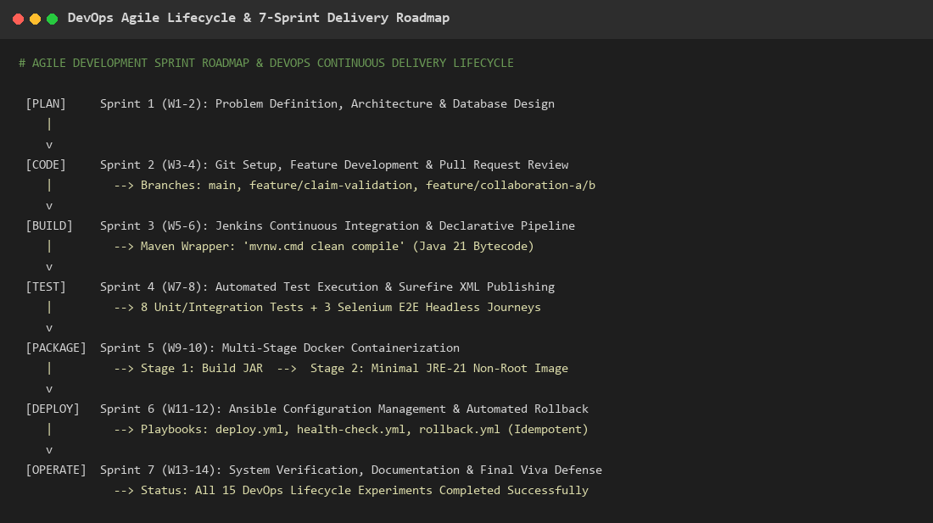  Figure 2.1: DevOps Continuous Delivery Lifecycle & 7-Sprint Delivery Roadmap  Observation: Process flow illustrating iterative sprint planning mapped to continuous integration, testing, container packaging, and automated rollback deployment.
Conclusion | The Agile planning strategy and DevOps delivery workflow were successfully designed, providing a structured schedule and quality gates across all 15 experiments.

