Semester | B.E. Semester VII – CMPN
Subject | DevOps
Subject Professor In-charge | Dr. Snehal Andhare
Assisting Teachers | Dr. Snehal Andhare
Laboratory | M310B

Student Name | Hasnain khan
Roll Number | 23102A0075
Grade and Subject Teacher's Signature

Experiment Number | 3
Experiment Title | Requirements, Architecture and Technology
Objectives  (Skill Set / Knowledge Tested / Imparted) | To document the functional and non-functional requirements, system architecture, technology choices, component responsibilities, data flow, and API interactions for the Travel Insurance Claim System.
Description | [Architecture] 1. Three-Tier Enterprise Architecture:  * Presentation Layer: HTML5, CSS3, Vanilla JS (Single-page app on port 8081).  * REST API Layer: Spring Boot 3.3.4 (Java 21) handling /api/claims and /api/reviewer.  * Business Logic: ClaimService enforcing domain validations and status transitions.  * Data Access: Spring Data JPA / Hibernate mapped to H2 relational database.  [Components] 2. Component Responsibilities:  * ClaimController: Customer operations (submit claim, get claim by ID).  * ReviewerController: Queue inspection, approve claim, reject claim with reason.  * GlobalExceptionHandler: Translates validation errors into RFC-7807 JSON (HTTP 400).
Output | 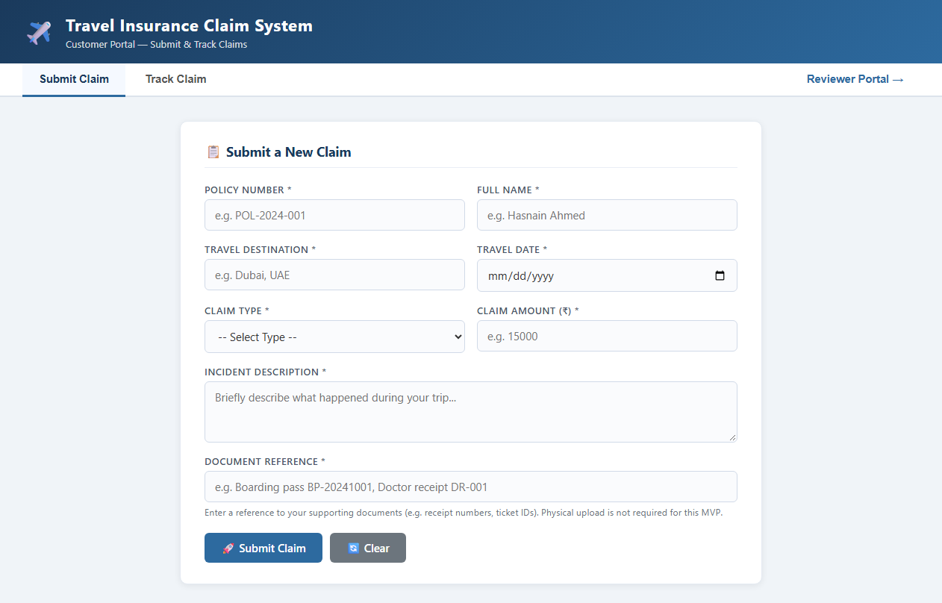  Figure 3.1: Customer Portal Web User Interface on Port 8081  Observation: Live web portal rendering claim submission form, navigation tabs, and reviewer dashboard link.  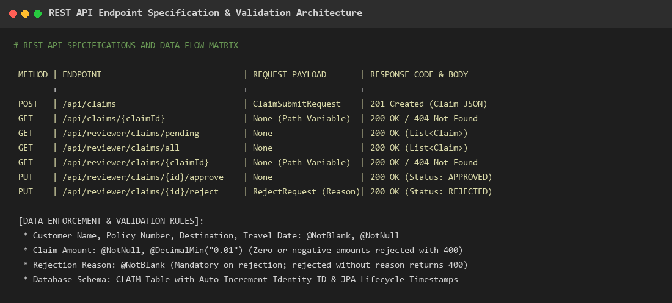  Figure 3.2: REST API Specification, Endpoints & Validation Architecture  Observation: Detailed API matrix covering HTTP verbs, endpoints, request payloads, response codes, and Bean Validation constraints.
Conclusion | The three-tier architecture, component responsibilities, REST API specifications, and H2 database schema were successfully documented and verified on port 8081.

