Semester | B.E. Semester VII – CMPN
Subject | DevOps
Subject Professor In-charge | Dr. Snehal Andhare
Assisting Teachers | Dr. Snehal Andhare
Laboratory | M310B

Student Name | Hasnain khan
Roll Number | 23102A0075
Grade and Subject Teacher's Signature

Experiment Number | 4
Experiment Title | Git and GitHub Repository Initialization
Objectives  (Skill Set / Knowledge Tested / Imparted) | To verify repository initialization, directory structure, .gitignore configuration, initial commits, remotes, and repository URL. Capture actual Git evidence.
Description | [Repository Setup] 1. Git Repository Initialization:  * Repository: https://github.com/Hexecutionerr/travel-insurance-claim-system.git  * Default Branch: main  * Standard Maven layout: src/main/java, src/main/resources, src/test/java  * Comprehensive .gitignore excluding target/, .idea/, *.log, and temporary IDE files.  [Git Hygiene] 2. Commit Discipline & Remote Synchronization:  All modifications are tracked with descriptive commit messages, and branches are synchronized with GitHub origin.
Output | 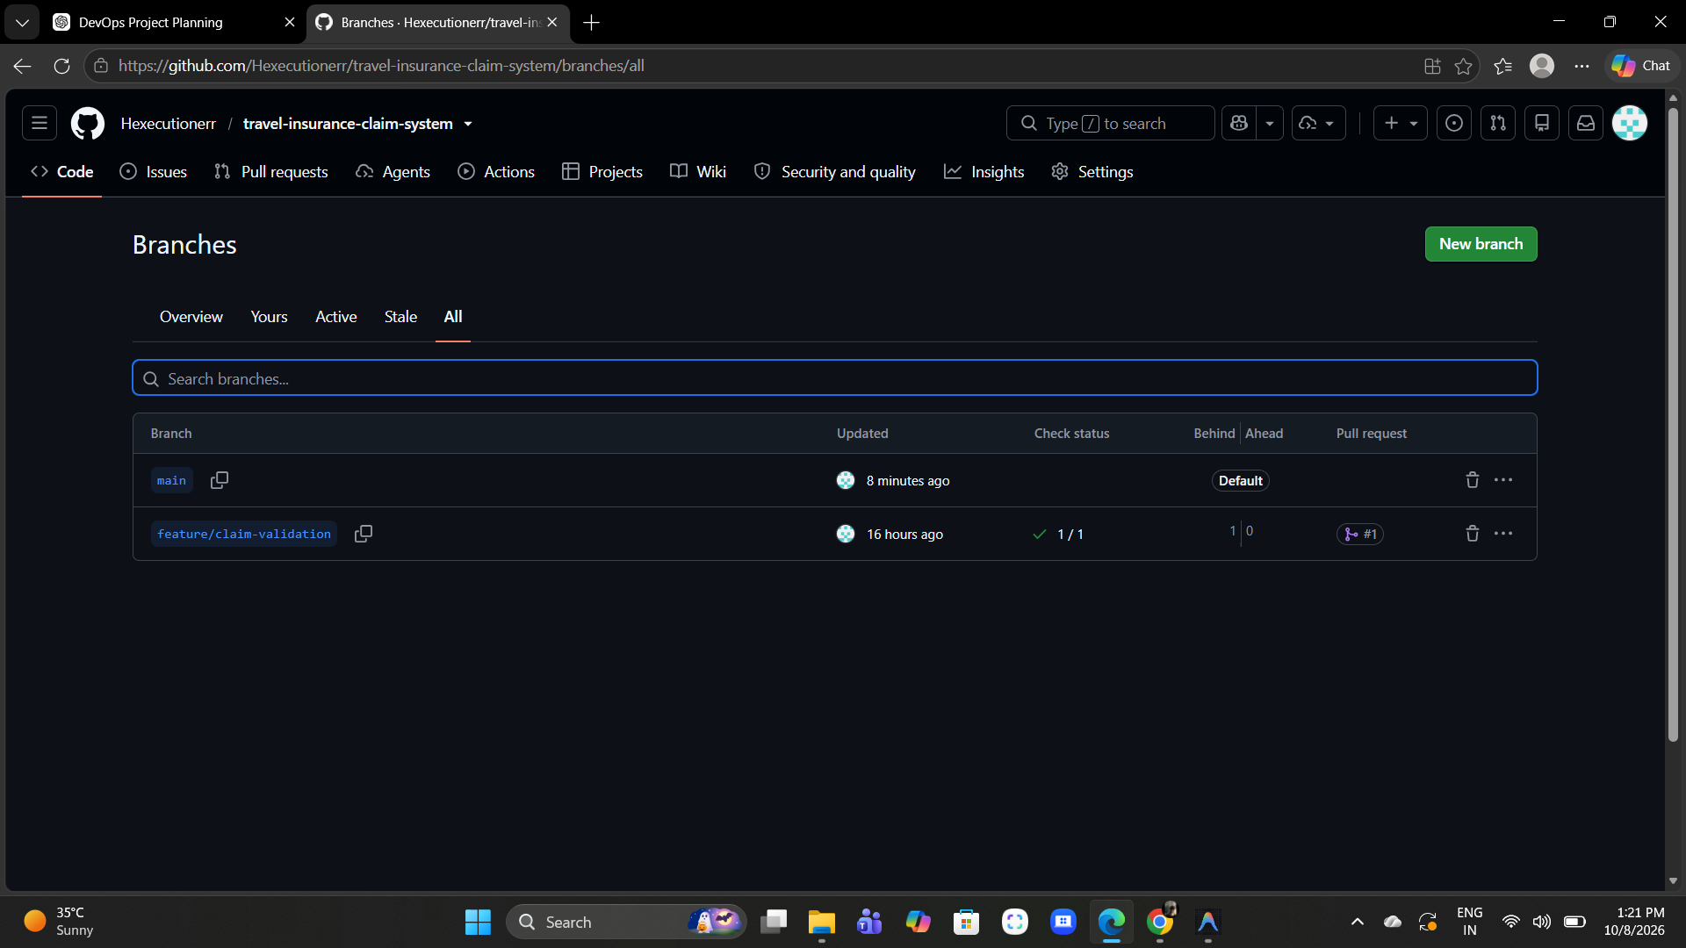  Figure 4.1: GitHub Remote Repository Branch Overview Web Interface  Observation: Official GitHub repository page showing active branches, commit timestamps, and directory structure.  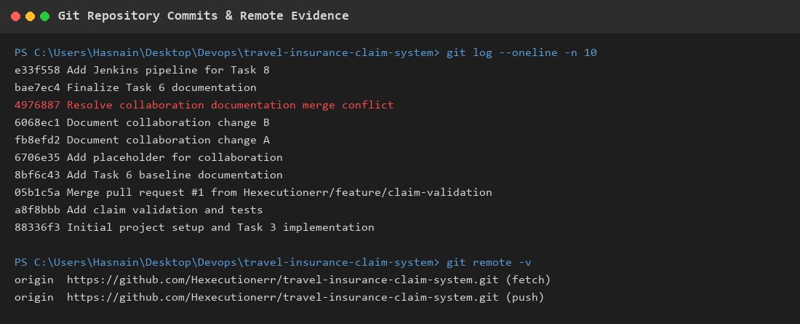  Figure 4.2: Git Commit History & Remote Origin Verification Terminal Output  Observation: Terminal log displaying recent commit hashes from initial setup to pipeline integration alongside active fetch and push remotes.
Conclusion | The Git repository and GitHub remote were successfully initialized, verified with clean commit history, and configured with appropriate exclusion patterns.

