Semester | B.E. Semester VII – CMPN
Subject | DevOps
Subject Professor In-charge | Dr. Snehal Andhare
Assisting Teachers | Dr. Snehal Andhare
Laboratory | M310B

Student Name | Hasnain khan
Roll Number | 23102A0075
Grade and Subject Teacher's Signature

Experiment Number | 5
Experiment Title | Feature Development and Branching Strategy
Objectives  (Skill Set / Knowledge Tested / Imparted) | To inspect the feature code and Git history. Document the branching strategy, feature development, commits, and integration workflow via pull requests.
Description | [Branching Strategy] 1. Branching Model:  Feature-branch workflow where direct commits to main are restricted. New features are developed on feature/* branches and merged via Pull Requests after passing automated validation.  * Active Branches: main, feature/claim-validation, feature/jenkinsfile-pipeline, feature/collaboration-a, feature/collaboration-b.  [Feature Code] 2. Feature Development (Claim Validation):  Implemented Jakarta Bean Validation on ClaimSubmitRequest and RejectRequest (@NotBlank, @DecimalMin), handled by GlobalExceptionHandler, and verified with 7 MockMvc integration tests.
Output | 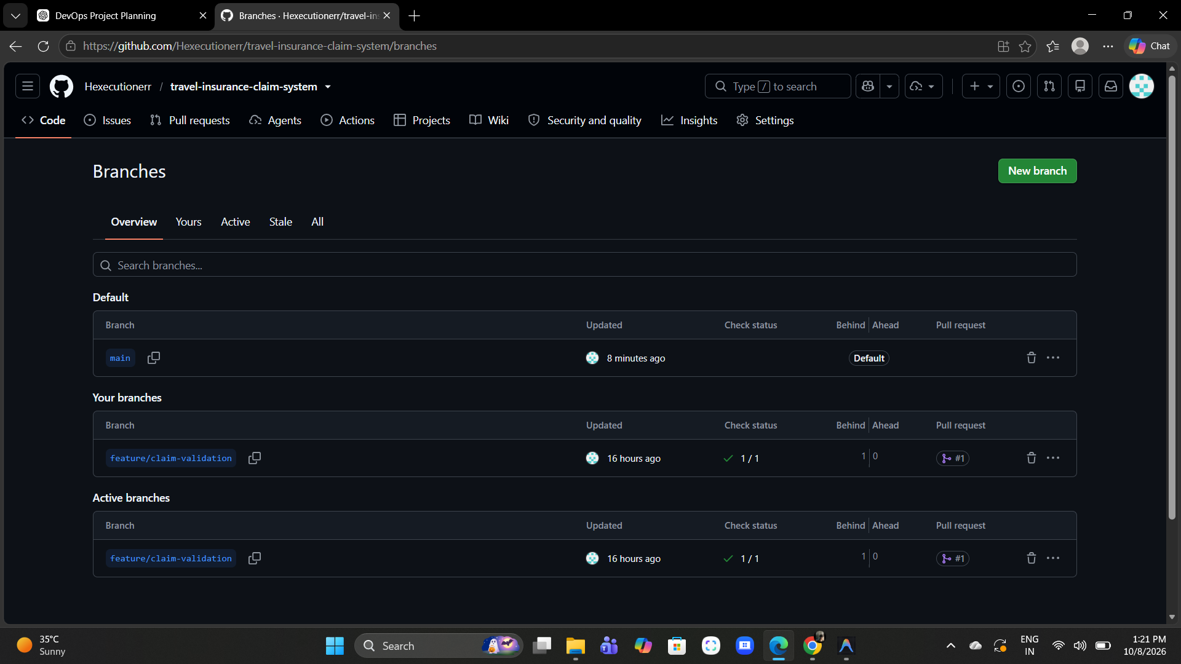  Figure 5.1: GitHub Active Feature Branches Dashboard  Observation: GitHub branches dashboard displaying feature/claim-validation and collaboration branches.  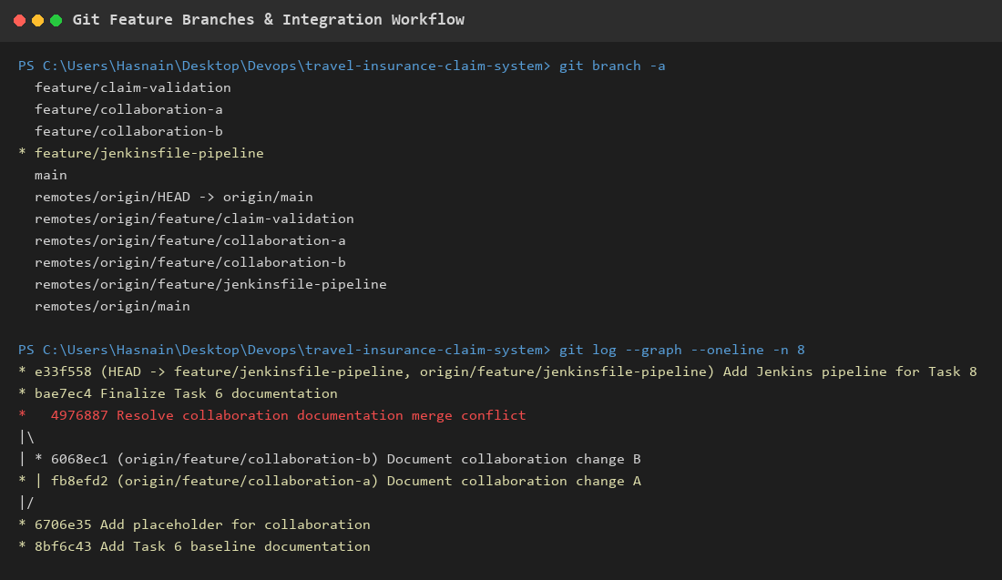  Figure 5.2: Git Branch List & Pull Request #1 Merge Commit Graph  Observation: Git terminal output showing local and remote branches and the successful merge commit of Pull Request #1 into main.
Conclusion | The feature-branch strategy was successfully executed. The claim-validation feature was developed in isolation, verified via automated tests, and merged into main via PR #1.

