Semester | B.E. Semester VII – CMPN
Subject | DevOps
Subject Professor In-charge | Dr. Snehal Andhare
Assisting Teachers | Dr. Snehal Andhare
Laboratory | M310B

Student Name | Hasnain khan
Roll Number | 23102A0075
Grade and Subject Teacher's Signature

Experiment Number | 6
Experiment Title | Git Collaboration and Merge Conflict Resolution
Objectives  (Skill Set / Knowledge Tested / Imparted) | To verify existing conflict-resolution evidence. Demonstrate a safe conflict-resolution workflow on dedicated collaboration branches without damaging existing work. Capture real commands and results.
Description | [Conflict Scenario] 1. Intentional Conflict Creation:  To simulate collaborative team merge collisions, two branches modified the exact same line in TASK-06-GIT-COLLABORATION.md:  * Branch A (feature/collaboration-a): Commit fb8efd2  * Branch B (feature/collaboration-b): Commit 6068ec1  When Branch A was merged into main, merging Branch B triggered a merge conflict.  [Resolution Workflow] 2. Manual Resolution Procedure:  Inspected conflict markers (<<<<<<< HEAD, =======, >>>>>>>), reconciled the content manually, staged the resolved file, and finalized the merge with commit 4976887.
Output | 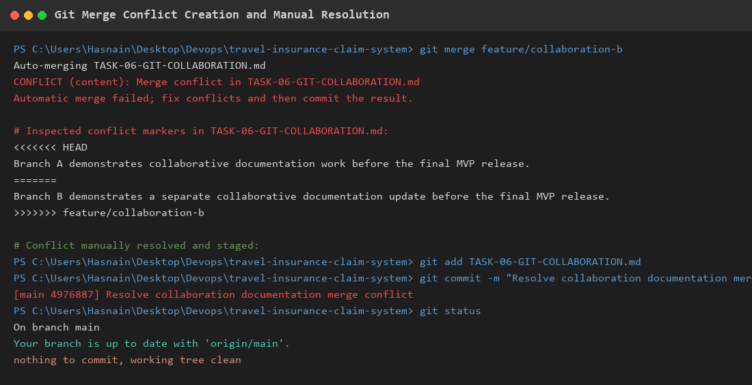  Figure 6.1: Git Merge Conflict Creation and Manual Resolution Evidence  Observation: Real terminal execution demonstrating merge failure, conflict marker inspection, manual reconciliation, resolution commit 4976887, and clean working tree.
Conclusion | The Git collaboration workflow and merge conflict resolution were successfully demonstrated. Both branches' changes were integrated without data loss.

