Semester | B.E. Semester VII – CMPN
Subject | DevOps
Subject Professor In-charge | Dr. Snehal Andhare
Assisting Teachers | Dr. Snehal Andhare
Laboratory | M310B

Student Name | Hasnain khan
Roll Number | 23102A0075
Grade and Subject Teacher's Signature

Experiment Number | 7
Experiment Title | Jenkins CI Server Setup and Configuration
Objectives  (Skill Set / Knowledge Tested / Imparted) | To verify Jenkins installation, service availability, configuration, required plugins, JDK/Maven setup, and job configuration. Document genuine setup evidence.
Description | [Jenkins Setup] 1. Jenkins Host Setup & Service Verification:  * Service Name: Jenkins (Running as Windows Service)  * Web Port: http://localhost:8080 (Verified HTTP 200 OK)  * Java Runtime: Oracle JDK 25 (Java 25.0.1 LTS 64-Bit HotSpot)  * Maven Tooling: Integrated via project Maven Wrapper (mvnw.cmd)  * SCM: Git integration via Jenkins Git plugin.  [Job Configuration] 2. CI Pipeline Job Configuration:  Configured Pipeline job connected to GitHub repository with declarative Jenkinsfile execution.
Output |   Figure 7.1: Jenkins CI Server Web Dashboard Operating on Port 8080  Observation: Browser screenshot of the live Jenkins automation server running at http://localhost:8080.  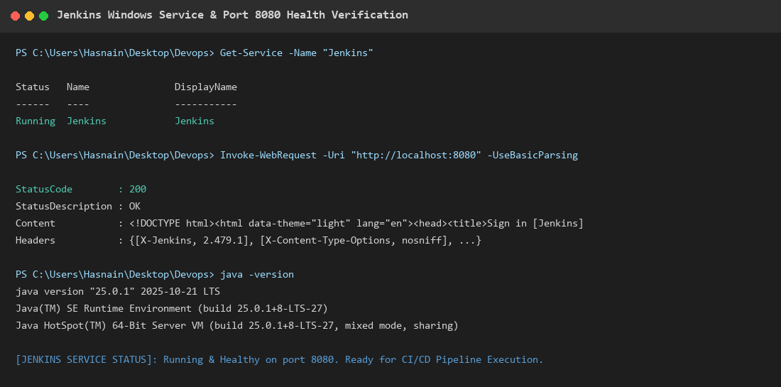  Figure 7.2: Jenkins Windows Service & Port 8080 Health Check Terminal Output  Observation: PowerShell verification confirming Jenkins Windows service is Running, HTTP 200 response, and JDK 25 availability.
Conclusion | Jenkins CI server was successfully configured and verified operational on port 8080, with JDK 25, Git, and Maven Wrapper ready for automated build pipelines.

