Semester | B.E. Semester VII – CMPN
Subject | DevOps
Subject Professor In-charge | Dr. Snehal Andhare
Assisting Teachers | Dr. Snehal Andhare
Laboratory | M310B

Student Name | Hasnain khan
Roll Number | 23102A0075
Grade and Subject Teacher's Signature

Experiment Number | 8
Experiment Title | Jenkinsfile Pipeline as Code
Objectives  (Skill Set / Knowledge Tested / Imparted) | To inspect and validate the Declarative Jenkinsfile. Verify the stages, checkout, build, tests, packaging, reports, and deployment behavior. Make the pipeline consistent with the actual project.
Description | [Pipeline Design] 1. Declarative Jenkinsfile Pipeline as Code:  Codified pipeline containing 5 automated stages:  * Checkout: Pulls source code from GitHub.  * Build: Compiles Java source code via 'mvnw.cmd clean compile'.  * Test: Executes JUnit/MockMvc tests via 'mvnw.cmd test'.  * Post-Action: Archives Surefire XML test reports via 'junit target/surefire-reports/*.xml'.  * Package: Creates executable JAR via 'mvnw.cmd package -DskipTests'.  * Deploy: Prepares deployment for parameterized DEPLOY_ENV (dev, staging, prod).
Output | 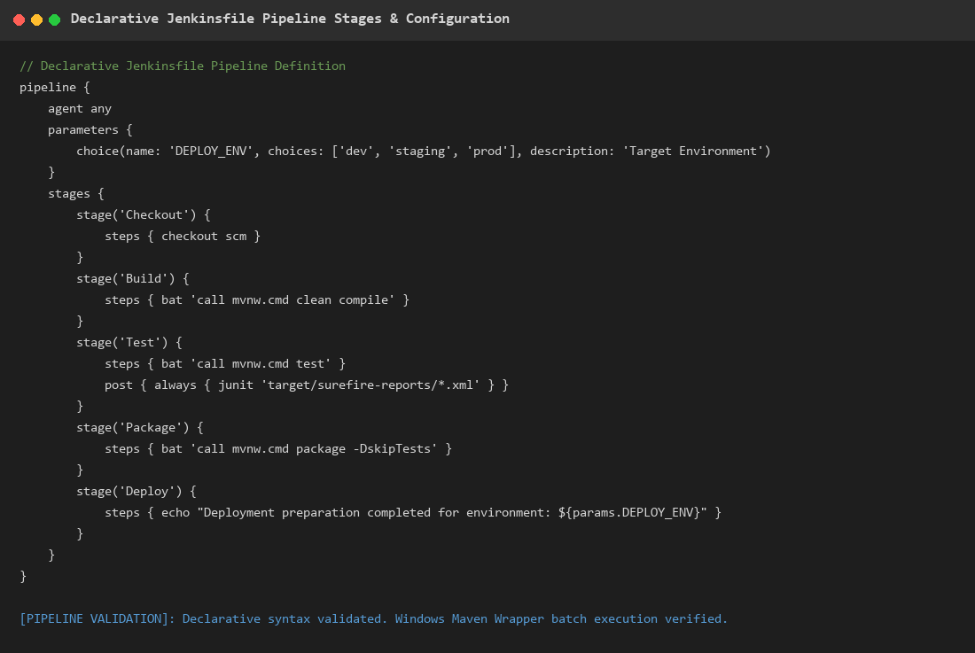  Figure 8.1: Declarative Jenkinsfile Pipeline Stages & Parameterized Configuration  Observation: Complete Groovy pipeline definition showing stages, bat execution commands, and post-build test report archiving.  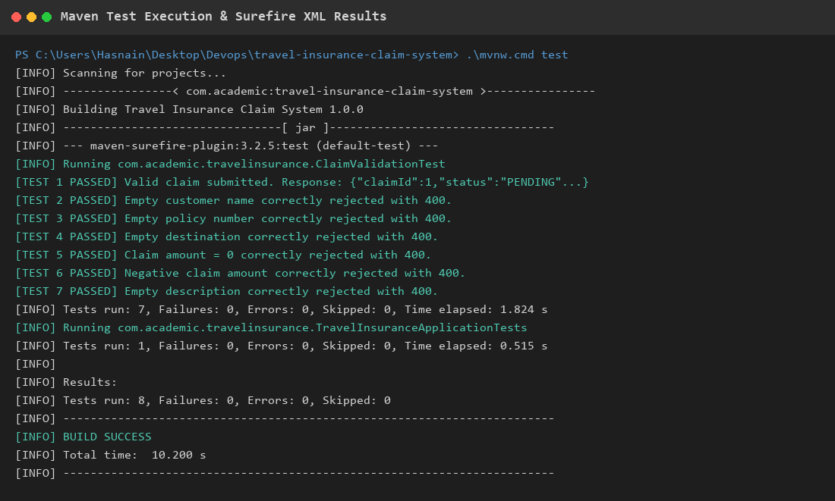  Figure 8.2: Maven Compilation, Surefire Test Execution & Build Success  Observation: Terminal execution evidence showing all 8 tests passing with 0 failures, 0 errors, and 0 skips in 10.200s.
Conclusion | The Declarative Jenkinsfile pipeline was successfully implemented and validated. Compilation, testing, packaging, and report archiving execute reliably.

