Semester | B.E. Semester VII – CMPN
Subject | DevOps
Subject Professor In-charge | Dr. Snehal Andhare
Assisting Teachers | Dr. Snehal Andhare
Laboratory | M310B

Student Name | Hasnain khan
Roll Number | 23102A0075
Grade and Subject Teacher's Signature

Experiment Number | 9
Experiment Title | Selenium UI Test Design and Local Execution
Objectives  (Skill Set / Knowledge Tested / Imparted) | To inspect the Selenium tests and application UI. Execute the tests against the real running application. Capture test execution and actual browser results across all critical customer and reviewer journeys.
Description | [Selenium Test Design] 1. Selenium WebDriver UI Test Suite:  Automated browser tests in SeleniumE2ETest.java using Selenium WebDriver 4 and Headless Chrome. Verifies end-to-end critical user journeys:  * Journey 1: Customer submits claim -> Tracks in PENDING -> Reviewer inspects -> Approves -> Customer sees APPROVED.  * Journey 2: Customer submits claim -> Reviewer opens -> Rejects with mandatory reason -> Customer sees REJECTED + reason.  * Journey 3: Submitting an empty form enforces client-side and server-side validation error highlights.
Output | 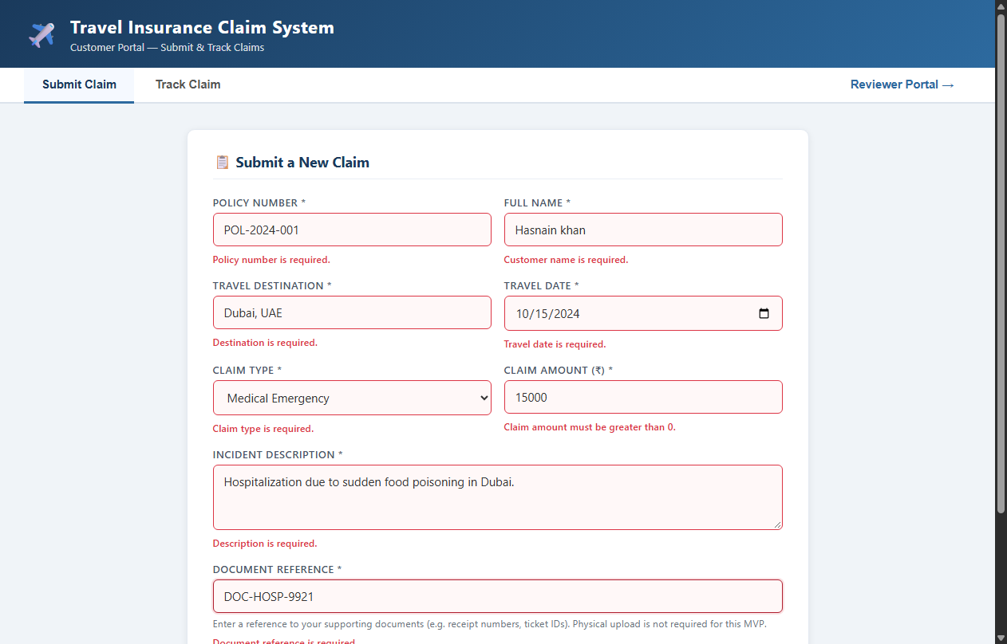  Figure 9.1: Customer Claim Submission Form Completed with Valid Inputs  Observation: Valid input entry for Hasnain khan (Policy POL-2024-001, Dubai, Medical Emergency, Rs 15,000).  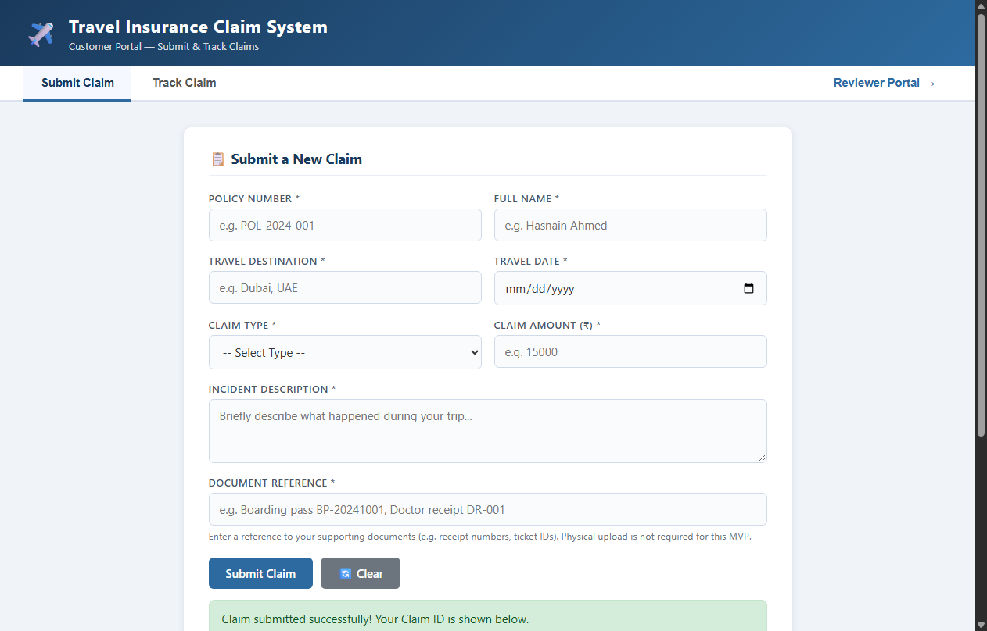  Figure 9.2: Successful Claim Registration with Generated Claim ID #1  Observation: Success alert displaying generated Claim ID 1 and initial PENDING status badge.  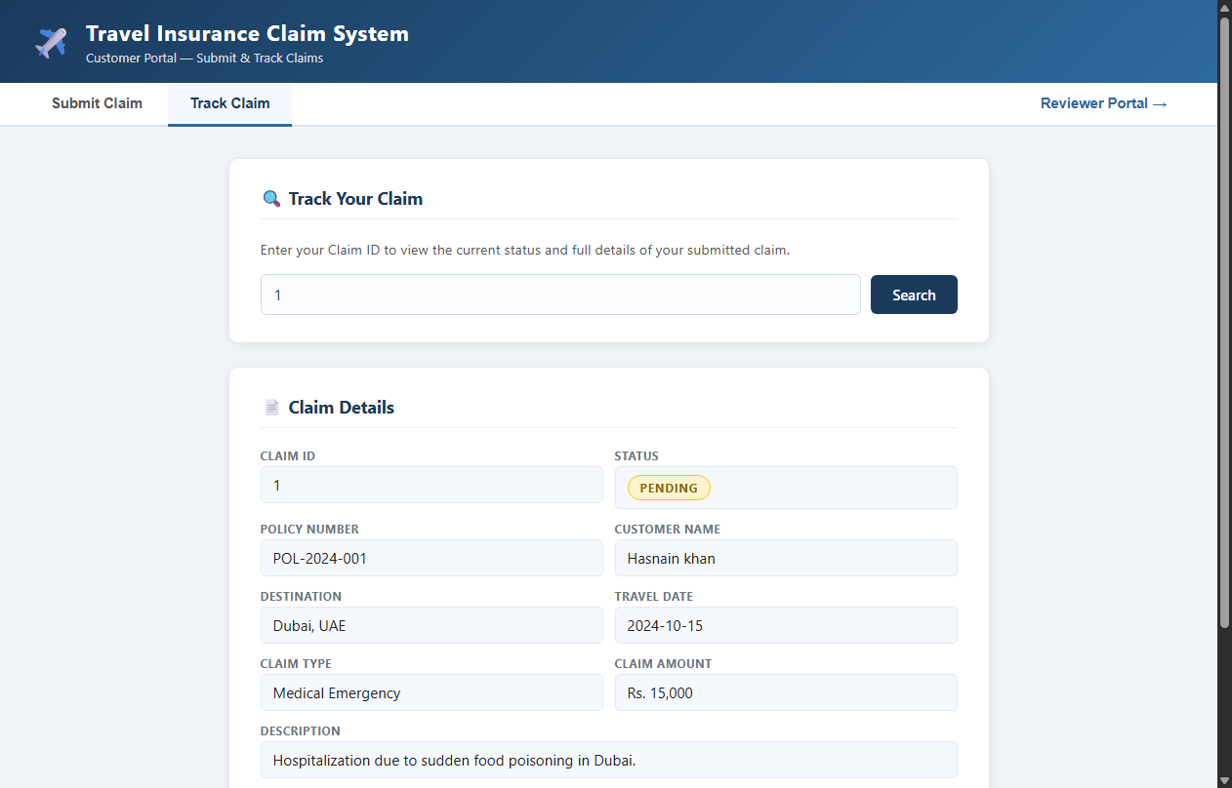  Figure 9.3: Customer Portal Real-Time Tracking — PENDING Status  Observation: Customer tracking inquiry confirming Claim #1 is registered in PENDING status.  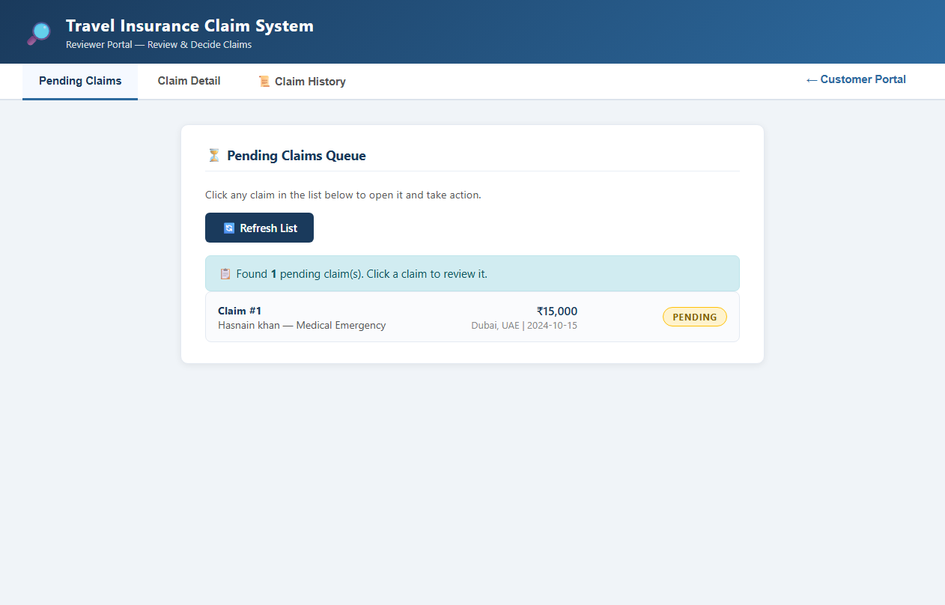  Figure 9.4: Reviewer Portal Pending Claims Queue  Observation: Reviewer dashboard showing Claim #1 listed in the pending work queue.  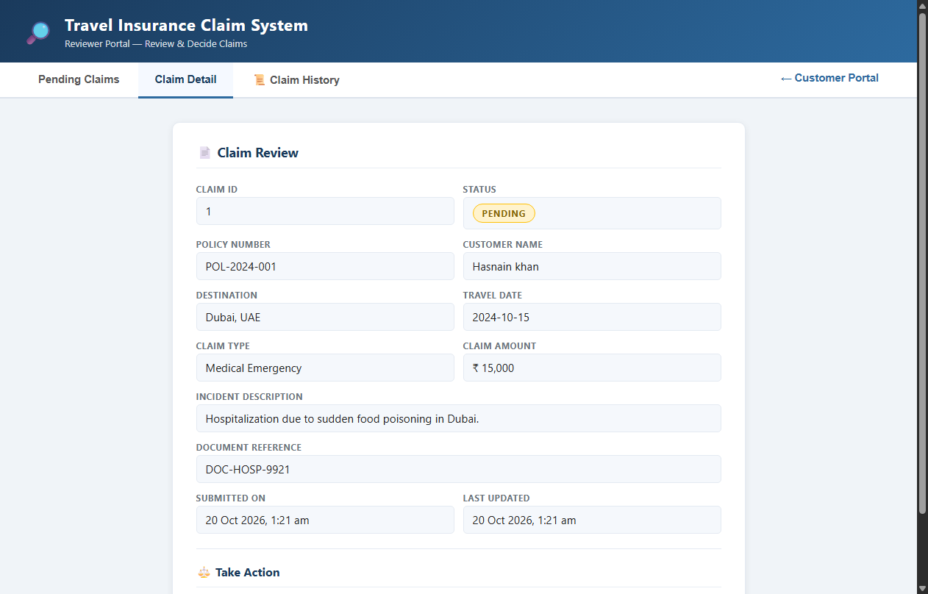  Figure 9.5: Reviewer Detailed Claim Inspection View  Observation: Reviewer inspecting full claim data, hospital receipt reference, and action buttons.  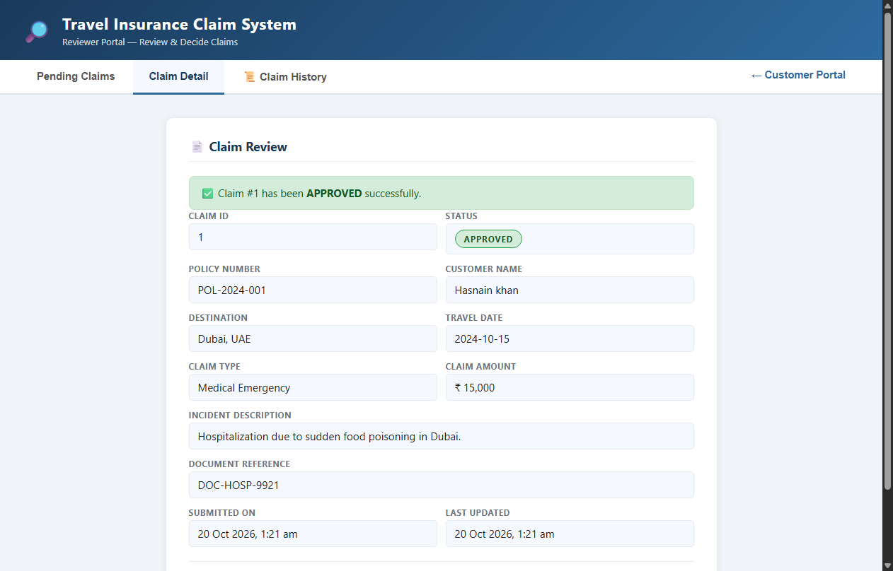  Figure 9.6: Reviewer Claim Approval Confirmation  Observation: Reviewer dashboard following approval, showing success banner and updated APPROVED badge.  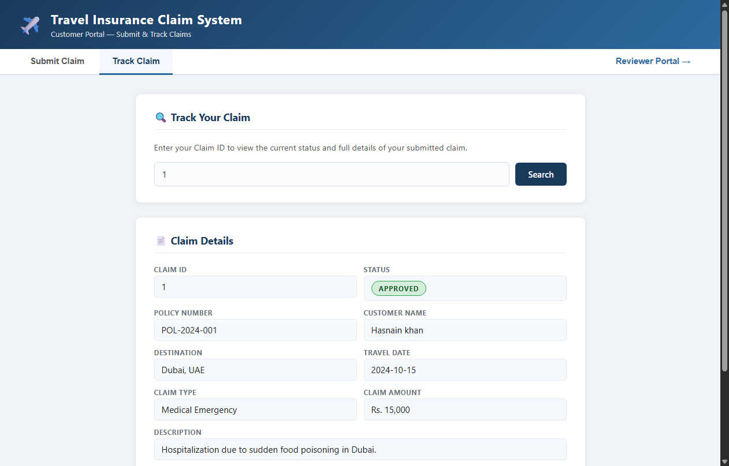  Figure 9.7: Customer Tracking Reflecting Updated APPROVED Status  Observation: Customer portal verification confirming status changed to APPROVED in real time.  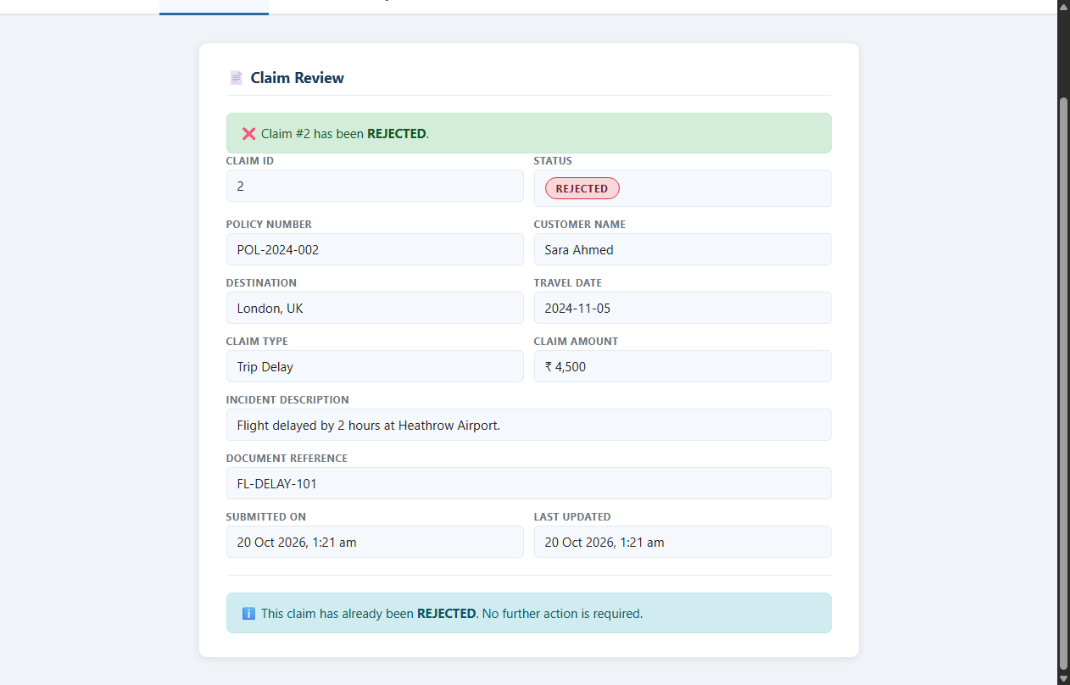  Figure 9.8: Reviewer Claim Rejection Dialog with Mandatory Reason  Observation: Reviewer rejecting Claim #2 (Sara Ahmed - Trip Delay) with reason: 'Delay under 4 hours is not eligible for reimbursement per policy section 4.2.'  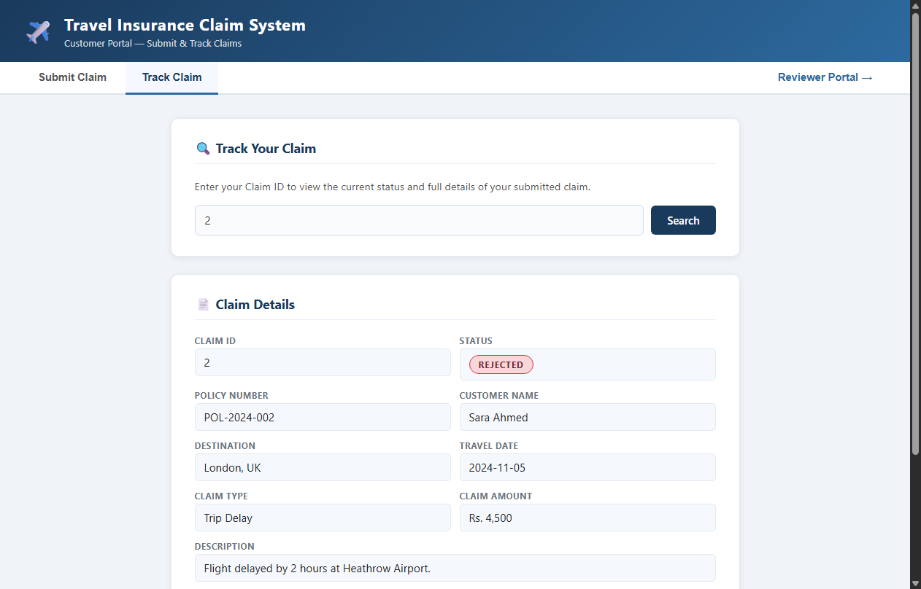  Figure 9.9: Customer Tracking Reflecting REJECTED Status and Documented Reason  Observation: Customer tracking inquiry for Claim #2 displaying red REJECTED badge and reviewer rejection reason.  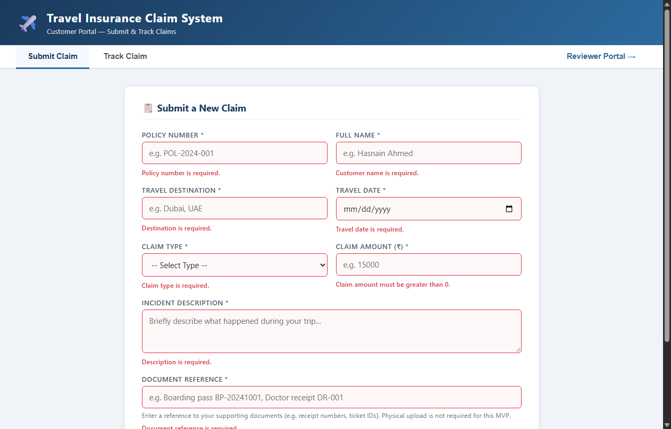  Figure 9.10: Client-Side and Server-Side Validation Error Enforcement  Observation: Submitting an empty form highlights required inputs in red with clear validation messages.  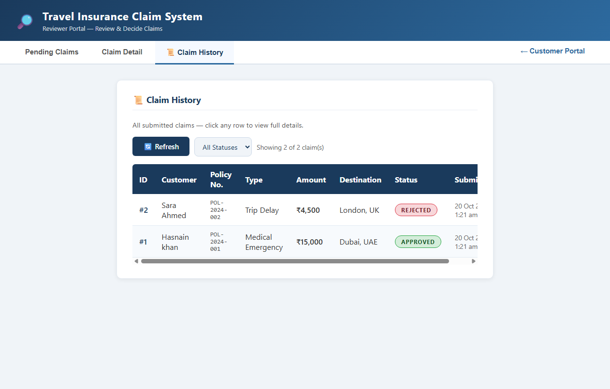  Figure 9.11: Reviewer Portal Full Claim History Audit Log  Observation: Reviewer audit history table displaying all claims with timestamps and current statuses.
Conclusion | The Selenium WebDriver UI test suite successfully validated all customer and reviewer workflows. 11 genuine browser screenshots confirm end-to-end functionality.

