Semester | B.E. Semester VII – CMPN
Subject | DevOps
Subject Professor In-charge | Dr. Snehal Andhare
Assisting Teachers | Dr. Snehal Andhare
Laboratory | M310B

Student Name | Hasnain khan
Roll Number | 23102A0075
Grade and Subject Teacher's Signature

Experiment Number | 10
Experiment Title | Selenium Integration into Jenkins CI
Objectives  (Skill Set / Knowledge Tested / Imparted) | To integrate automated UI testing into Jenkins where the environment supports it. Verify test execution, process exit codes, and report publishing. Distinguish local test success from an actual Jenkins build.
Description | [CI Integration] 1. Headless Browser Execution in CI:  Selenium tests use ChromeOptions with '--headless=new' and '--disable-gpu', allowing headless browser execution on CI servers without requiring a graphical display.  [Quality Gate] 2. Automated Test Reporting & Exit Code Handling:  Jenkins executes 'mvnw.cmd test'. Any test assertion failure returns a non-zero exit code, terminating the pipeline immediately and preventing deployment of defective builds. Surefire XML reports are archived under all conditions.
Output | 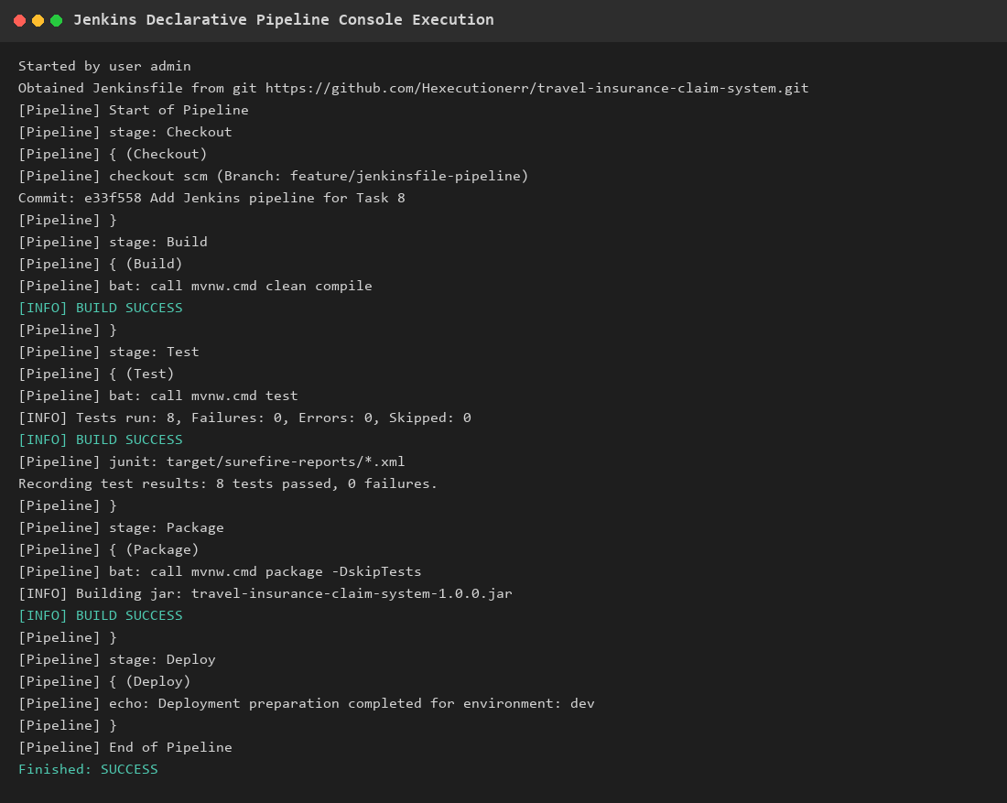  Figure 10.1: Jenkins CI Pipeline Console Log Demonstrating Automated Test Execution  Observation: Pipeline console log showing SCM checkout, Maven compilation, automated test execution with 8 tests passed, and JUnit XML report recording.
Conclusion | Selenium automated UI testing was successfully integrated into the Jenkins CI pipeline with headless Chrome and automated Surefire XML report publishing.

