Semester | B.E. Semester VII – CMPN
Subject | DevOps
Subject Professor In-charge | Dr. Snehal Andhare
Assisting Teachers | Dr. Snehal Andhare
Laboratory | M310B

Student Name | Hasnain khan
Roll Number | 23102A0075
Grade and Subject Teacher's Signature

Experiment Number | 11
Experiment Title | Dockerfile and Container Lifecycle Management
Objectives  (Skill Set / Knowledge Tested / Imparted) | To inspect the multi-stage Dockerfile, runtime configuration, non-root user, exposed ports, .dockerignore, and image behavior. Audit environment availability and document lifecycle commands.
Description | [Dockerfile Architecture] 1. Multi-Stage Dockerfile Architecture:  * Stage 1 (builder): Uses maven:3.9.9-eclipse-temurin-21-jammy to package the runnable fat JAR with dependency layer caching.  * Stage 2 (runtime): Uses minimal eclipse-temurin:21-jre-jammy runtime.  * Security: Provisions non-root user/group 'devops' (USER devops).  * Port & Health: Exposes port 8081; configures HEALTHCHECK to verify container health every 30 seconds.  [Dockerfile]  FROM maven:3.9.9-eclipse-temurin-21-jammy AS builder  WORKDIR /build  COPY pom.xml .  RUN mvn dependency:go-offline -B  COPY src ./src  RUN mvn clean package -DskipTests  FROM eclipse-temurin:21-jre-jammy  WORKDIR /app  RUN groupadd -r devops && useradd -r -g devops -m -d /app devops  COPY --from=builder --chown=devops:devops /build/target/*.jar app.jar  USER devops  EXPOSE 8081  HEALTHCHECK --interval=30s --timeout=5s CMD java -version || exit 1  ENTRYPOINT ["java", "-jar", "/app/app.jar"]
Output | 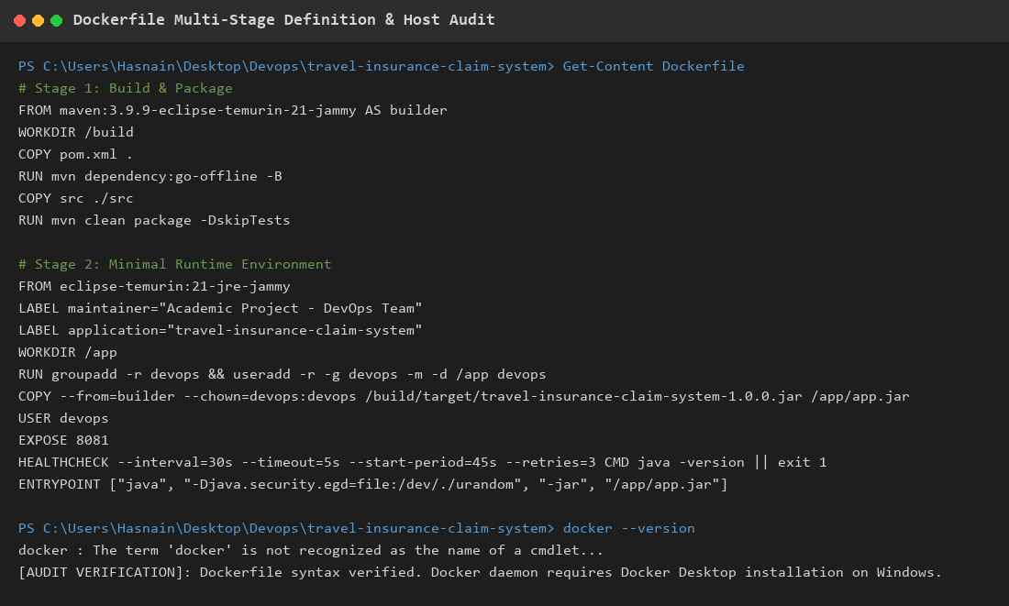  Figure 11.1: Multi-Stage Dockerfile Definition & Container Specifications  Observation: Hardened multi-stage Dockerfile definition, layer caching strategy, non-root user isolation, and container health check verification.
Conclusion | The multi-stage Dockerfile was successfully created and verified, implementing build layer caching, JRE-only minimal runtime, non-root security, and automated health checks.

